Level Editor Guide
1) Introduction
The Level Editor is composed of multiple integrated panels that support a complete workflow for level creation, editing, previewing, and testing.
Each panel has a dedicated role, but they all synchronize through shared scene state and object selection.

This guide explains:
- What each panel is for.
- How to use each feature step-by-step.
- Typical workflows for designers.

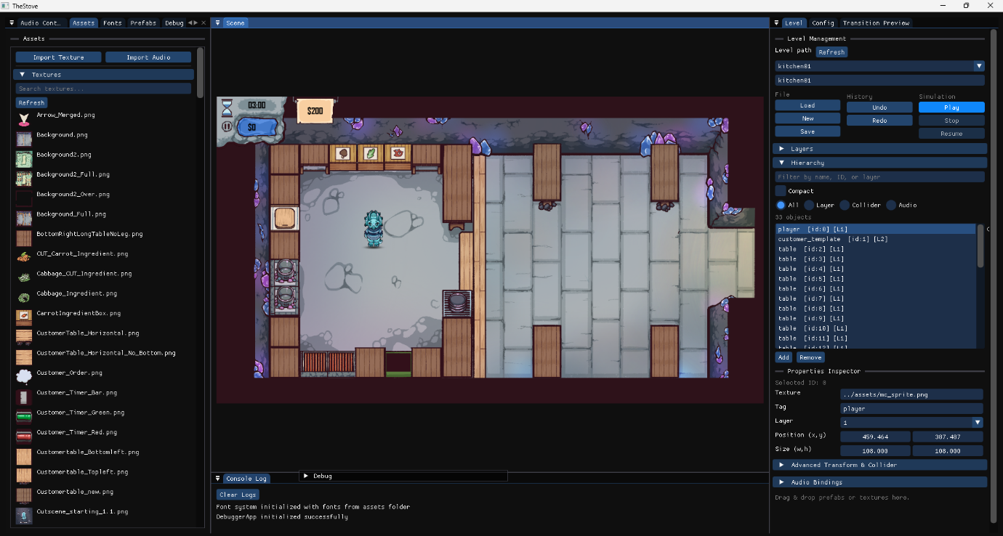

2) Editor Layout Overview
A typical editor session includes:
- Level Panel (load/save/play control)
- Scene View (Viewport) (visual editing area)
- Object Hierarchy Panel (all objects in the current level)
- Properties Inspector Panel (detailed object editing)
- Assets Panel (all asset types)
- Audio Control Panel (audio volume, preview, management)
- Fonts Panel (font asset browsing and assignment)
- Prefabs Panel (instantiate reusable object templates)
- Transition Preview Panel (fade transition testing)

2.1) How to Use Each Editor Panel (Quick Reference)
- Level Panel: Choose a level path, click Load, edit scene content, click Save, then use Play/Stop to test and return safely to edit mode.
- Scene View (Viewport): Click to select objects, drag prefabs into the scene to instantiate, and drop supported assets onto valid targets.
- Object Hierarchy Panel: Select objects by name/ID/layer and use it to confirm that object creation/deletion happened correctly.
- Properties Inspector Panel: Edit transform, tag, collider, velocity, and animation fields for the selected object and verify immediate updates.
- Assets Panel: Browse grouped asset types and drag assets onto scene objects/components for assignment.
- Audio Control Panel: Adjust master volume, tune per-asset volume, preview with Play/Stop, then save and reload settings to confirm persistence.
- Fonts Panel: Choose a font from the loaded list and drag it onto text/UI objects to switch fonts instantly.
- Prefabs Panel: Drag a prefab into the scene to create a preconfigured GameObject, then confirm it appears in hierarchy and inspector.
- Transition Preview Panel: Set fade durations and test transition controls (start, blackout, fade-in, cancel).

3) Level Panel (Core Scene Control)
The Level Panel is the central control hub.

Responsibilities
- Load and save level files (.json).
- Control simulation state (Play / Stop).
- Maintain active scene state and runtime snapshot behaviour.

Key Functions
1. Level Path Input & Dropdown
- Select an existing level path from dropdown.
- Or manually enter a .json path.
2. Load Level
- Parses JSON data.
- Rebuilds scene objects/components.
3. Save Level
- Serializes current scene state into JSON.
4. Play / Stop
- Play: creates editor snapshot, clears edit-only state, runs gameplay logic/physics.
- Stop: restores snapshot and returns to edit mode.

Recommended Usage Sequence
1. Select path.
2. Click Load.
3. Edit scene.
4. Click Save.
5. Click Play to test.
6. Click Stop and continue editing.
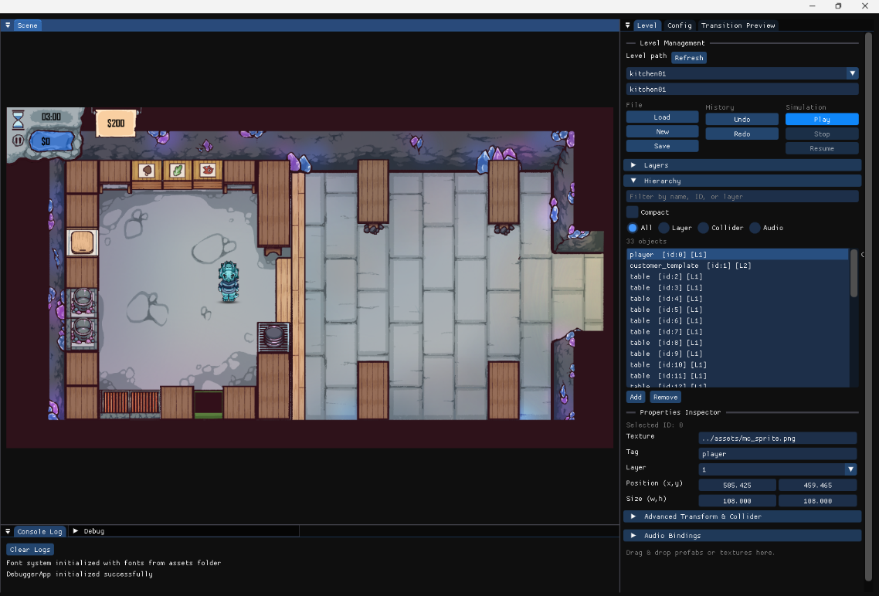

4) Scene View (Viewport)
The Scene View is the main visual editing surface.

Features
- Displays all GameObjects in real time.
- Reflects movement/property changes immediately.
- Primary drop target for drag-and-drop operations.

Interactions
- Click object to select it.
- Drag prefab into scene to instantiate.
- Drag supported asset onto object to apply it.

Best Practices
- Keep hierarchy open while editing to verify object creation.
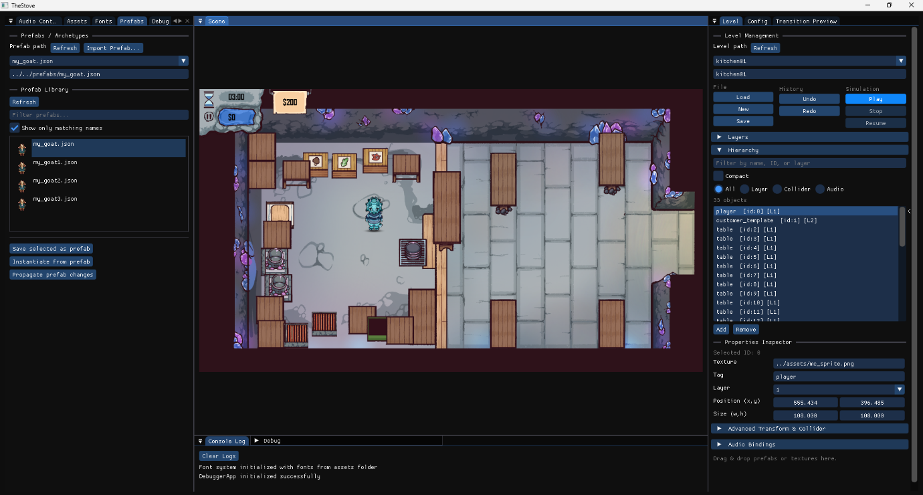
- Confirm object selection also highlights in Hierarchy and Inspector.
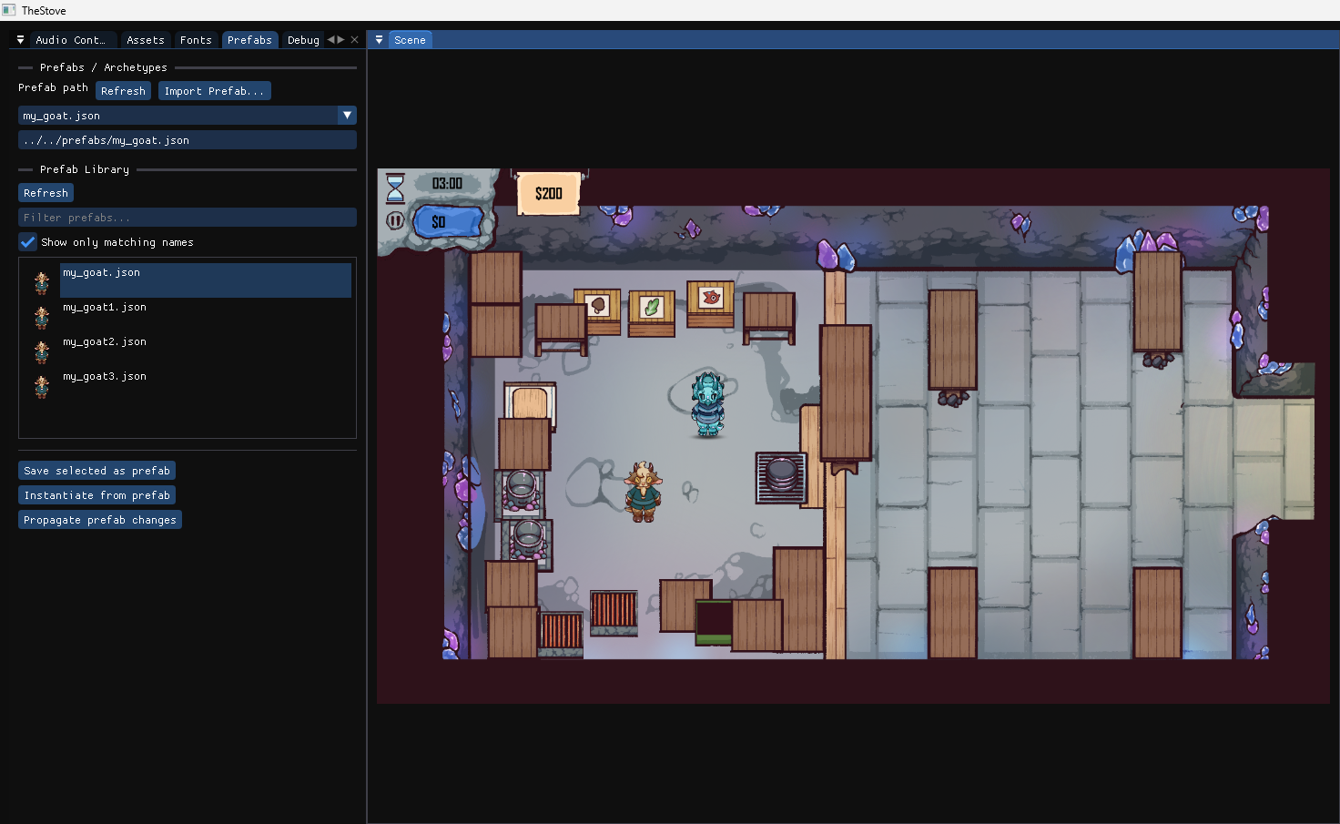

5) Object Hierarchy Panel
The Hierarchy Panel lists all GameObjects currently in the level.

Features
- Shows object name, ID, layer.
- Selecting an entry synchronizes with:
- Scene View
- Properties Inspector

Typical Actions
- Locate objects quickly by list scanning.
- Confirm object creation/deletion after edits.
- Use it as the canonical source of “what exists in scene now.”
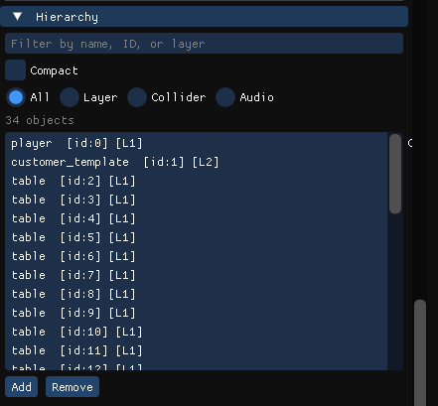

6) Properties Inspector Panel
The Properties Inspector allows detailed editing of selected object data.

Editable Properties
- Texture Path (updates sprite/animation preview)
- Tag (e.g., player, npc, trigger)
- Layer (read-only)
- Position / Size (numeric edit + drag interaction + reset option)
- Rotation (degrees)
- Collider Size / Offset (collision bounds update immediately)
- Animation (auto-detected clips + dropdown selection)

Validation Checklist
- Change each editable field and confirm immediate visual/behaviour feedback.
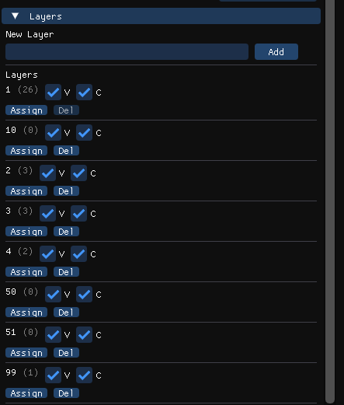
- Save level, reload level, and verify values persist.
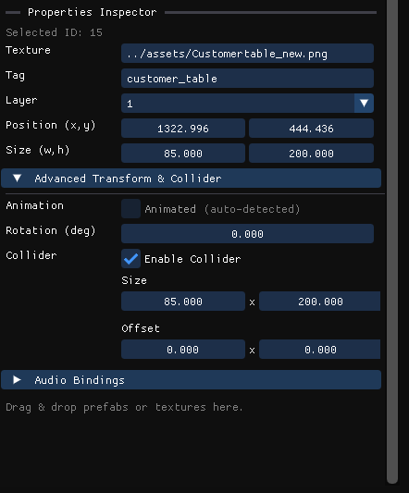
7) Assets Panel
The Assets Panel provides grouped access to all loaded project assets.

Features
- Asset grouping by type (textures, audio, fonts, etc.).
- Drag-and-drop support:
- Drop asset onto compatible target/object.
- Fast reuse of existing assets without file browsing.

Common Workflow
1. Expand desired asset type group.
2. Select asset.
3. Drag to scene object (or relevant panel target).
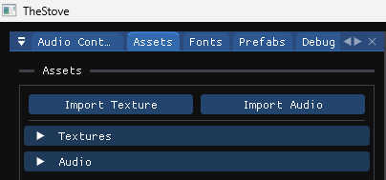
4. Verify assignment in inspector and viewport.

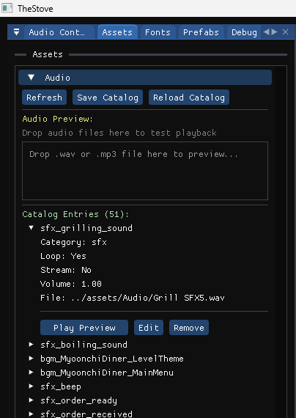
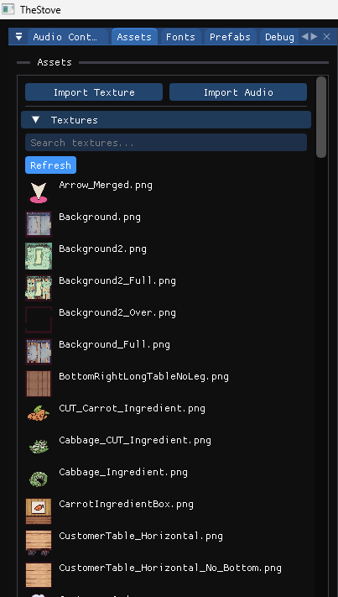

8) Audio Control Panel
The Audio Control Panel is used to preview, tune, and manage audio directly in-editor.

Main Functions
1. Master Volume Control
- Adjust global volume in real time.
- Save as default config value.
2. Per-Audio Asset Volume Editing
- Set individual volume per asset.
3. Audio Preview (Play / Stop)
- Quickly verify each asset from editor UI.
4. Save and Reload Audio Settings
- Save tuned values to audio catalog.
- Reload from file to confirm persistence.
5. Audio Categorization
- Grouped by category (e.g., UI, SFX, BGM).
6. Drag-and-Drop Support
- Drag audio assets to compatible components.

Recommended Test Flow
1. Change master volume.
2. Preview 2–3 assets using Play/Stop.
3. Tune per-asset volume.
4. Save audio settings.
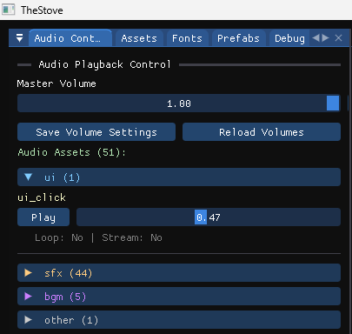
5. Reload settings and verify values retained.

9) Fonts Panel
The Fonts Panel manages loaded font assets and assignment.

Features
- Lists all loaded fonts.
- Drag-and-drop font assignment to text/UI objects.
- Fast font switching without code changes.

Suggested Usage
- Select a text object.
- Drag alternative fonts from panel.
- Validate rendering change in Scene View.
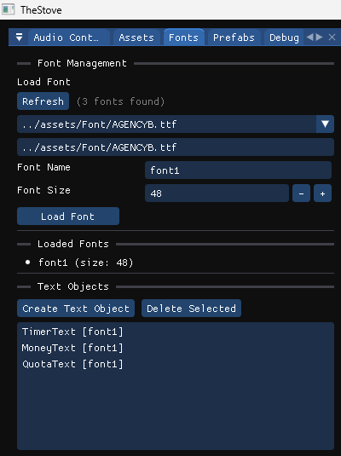

10) Prefabs Panel
The Prefabs Panel manages reusable templates.

Features
- Lists all available prefabs.
- Dragging prefab into scene:
- Instantiates new GameObject.
- Applies predefined components/properties.

Suggested Usage
- Drag prefab into Scene View.
- Verify object appears in hierarchy.
- Select object and inspect applied default components.

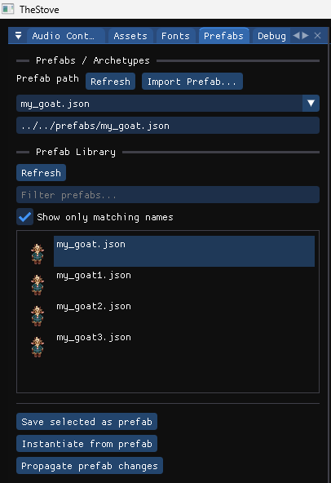

11) Transition Preview Panel
The Transition Preview Panel is used to test fade behaviour.

Features
- Displays transition state (active / blackout).
- Adjustable fade-out and fade-in durations.
- Controls:
- Start transition
- Force blackout
- Continue fade-in
- Cancel transition

Suggested Test Flow
1. Set fade-out/fade-in durations.
2. Start transition.
3. Force blackout.
4. Continue fade-in.
5. Cancel transition to reset.

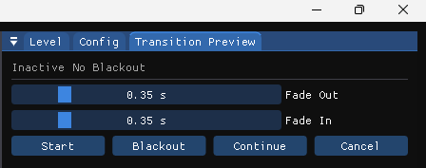

12) End-to-End Example Workflow
Use this sequence in demos/reporting:
1. Load level from Level Panel.
2. Drag prefab into Scene View.
3. Apply texture/audio/font assets using relevant panels.
4. Edit object transform and collider in Inspector.
5. Save level.
6. Run Play mode for behaviour check.
7. Stop and confirm editor state restoration.
8. Save final level + audio settings.

