3 | The stakeholders have conflicting views on the user interface design for an E-Commerce mobile app. Create a prototype using Figma to discuss interface options and obtain stakeholder feedback and approval. | Figma | CO1
E-COMMERCE UI PROTOTYPE – STAKEHOLDER REVIEW

Objective
To design a clickable UI prototype of an E-Commerce mobile application using Figma in order to present multiple interface options and collect stakeholder feedback for approval.

Step 1: Login to Figma
1. Open a web browser and go to figma.com.
2. Log in using a Google account or email.
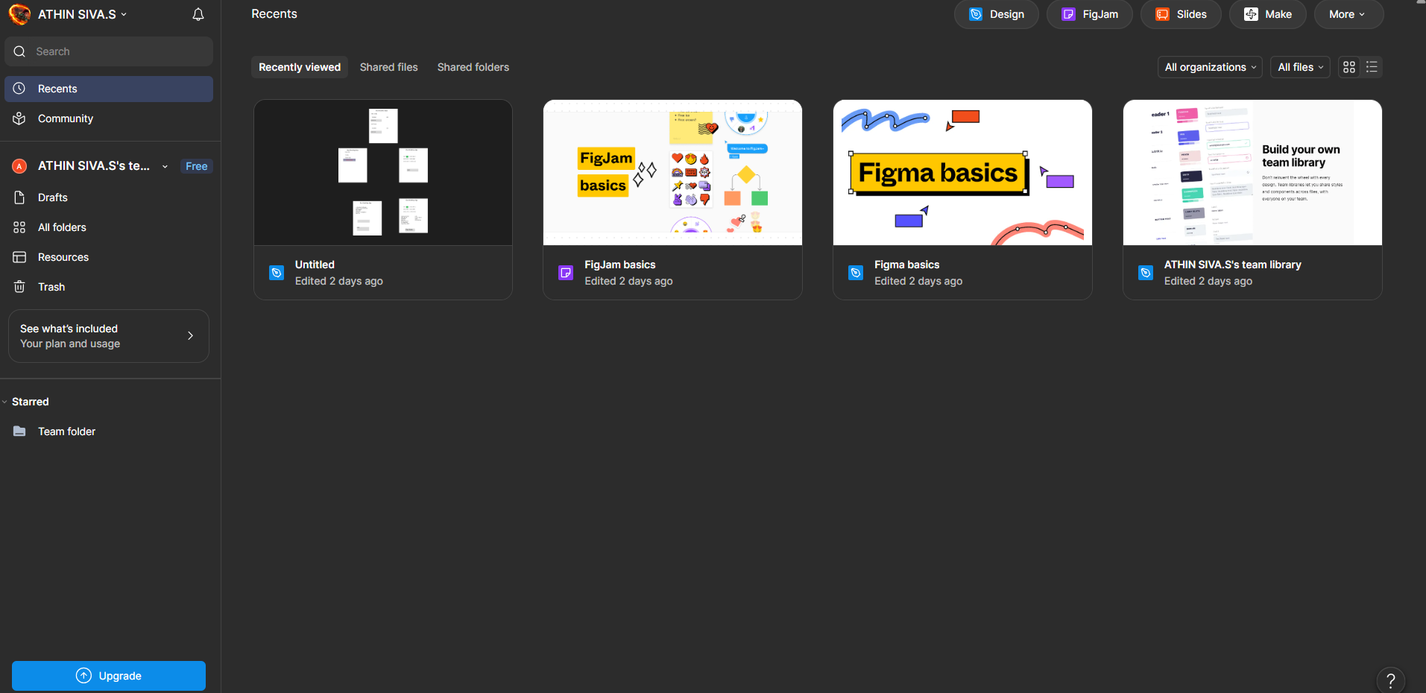
Screenshot – Figma Home page

Step 2: Create a New Design File
1. Click New design file to open a blank canvas.
2. Rename the file as: E-Commerce UI Prototype – Stakeholder Review.
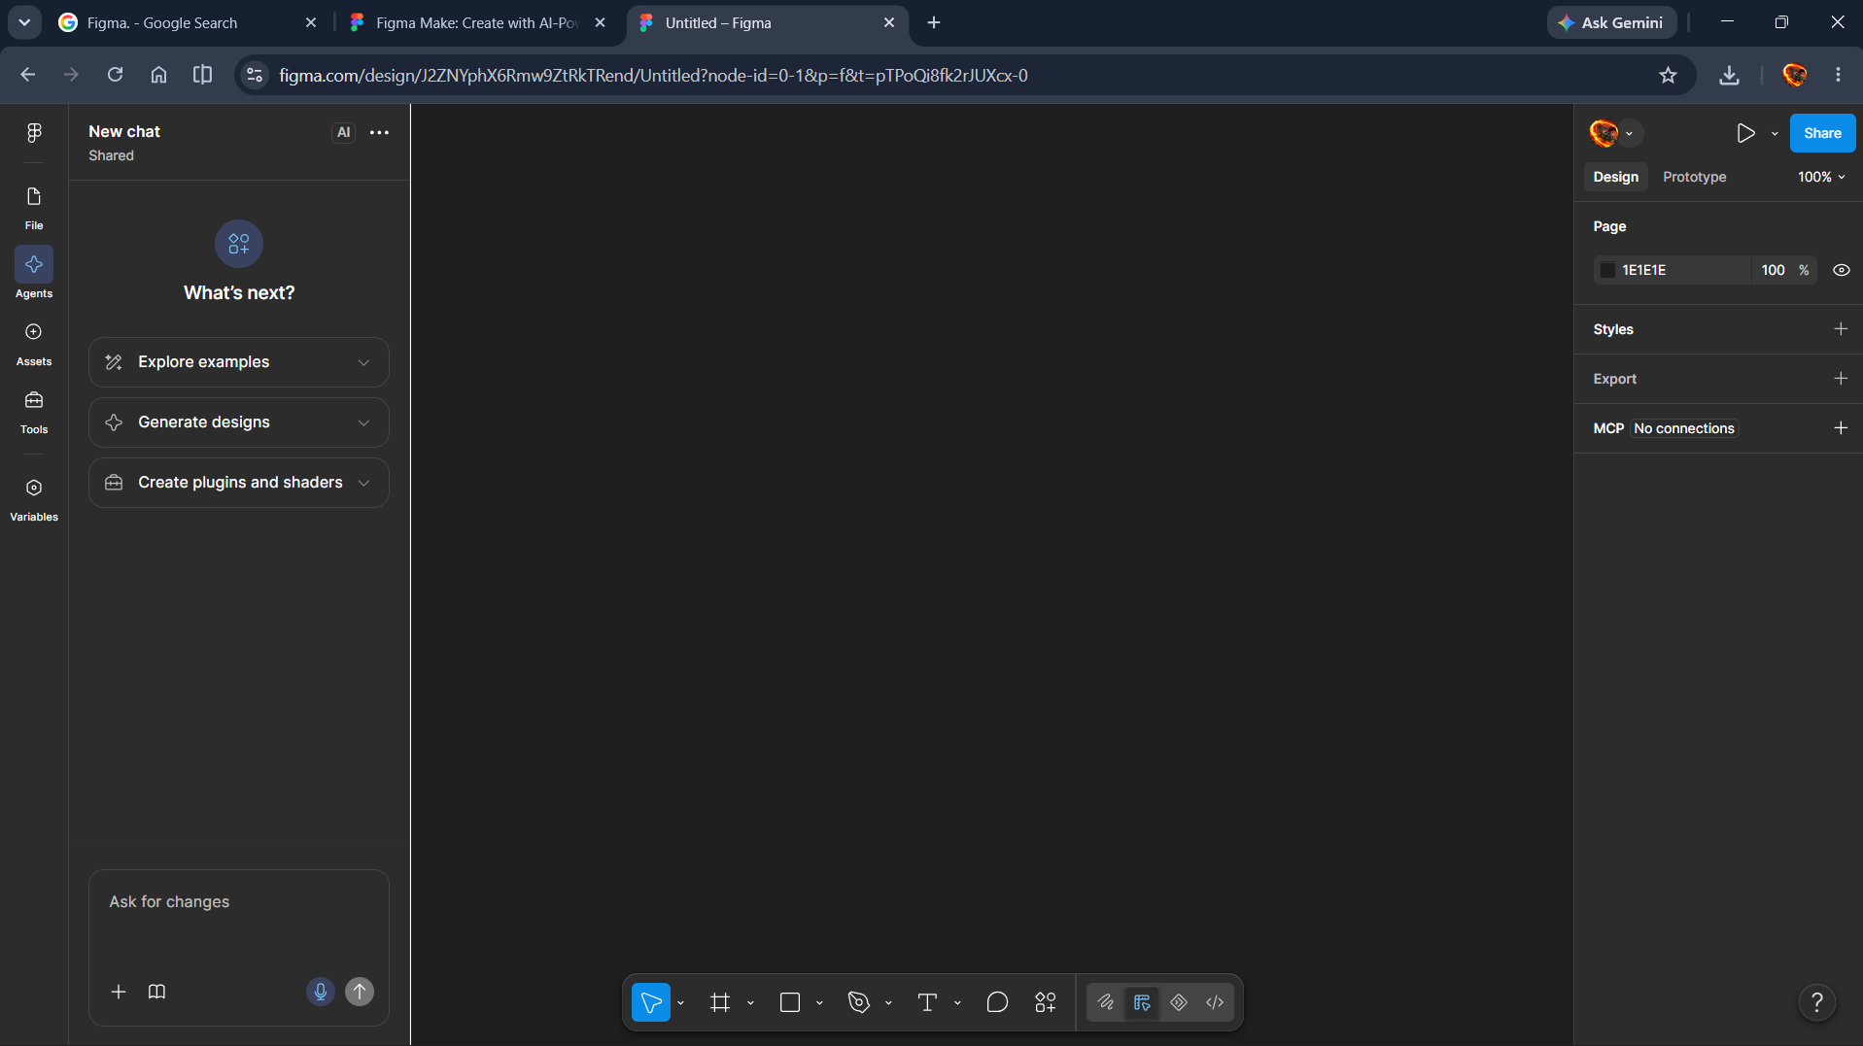
Screenshot – New Figma design canvas

Step 3: Create Mobile Frame
1. Select the Frame Tool (F).
2. Choose iPhone 14 / Android, approximately 375 × 812 px. The frame represents the mobile app screen.
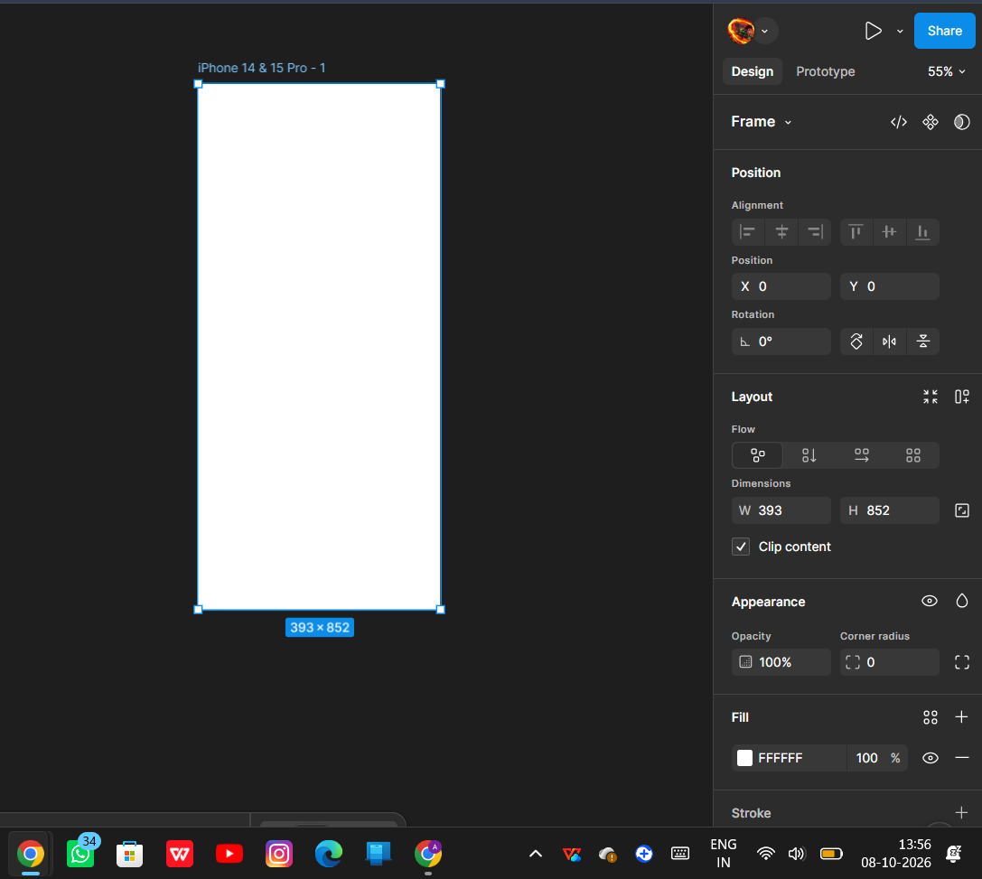
Screenshot – Mobile frame created in Figma

Step 4: Create Home Screen – Version A
Design a clean, minimal user interface. Add the following elements:
- App logo and title: E-Commerce App
- Search bar
- Banner area
- Category icons/labels: Electronics, Fashion, Grocery and Beauty
- Product cards: Wireless Headphones – ₹999 and Smart Watch – ₹1499
- Bottom navigation bar: Home, Categories, Cart and Profile
Label the frame: Home Screen – Version A (Minimal UI).
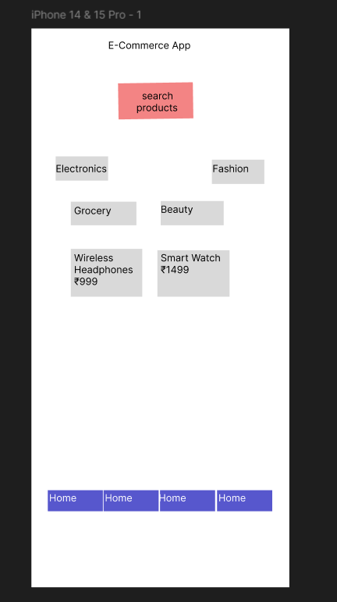
Screenshot – Home Screen Version A

Step 5: Duplicate Frame for Version B
1. Select the Version A frame and press Ctrl + D to duplicate it.
2. Label the duplicate: Home Screen – Version B (Visual UI).
3. Modify the design to show a different visual option, using a larger banner, larger product cards, and a more visually prominent layout.
This helps compare the preferences of stakeholders who have conflicting UI expectations.
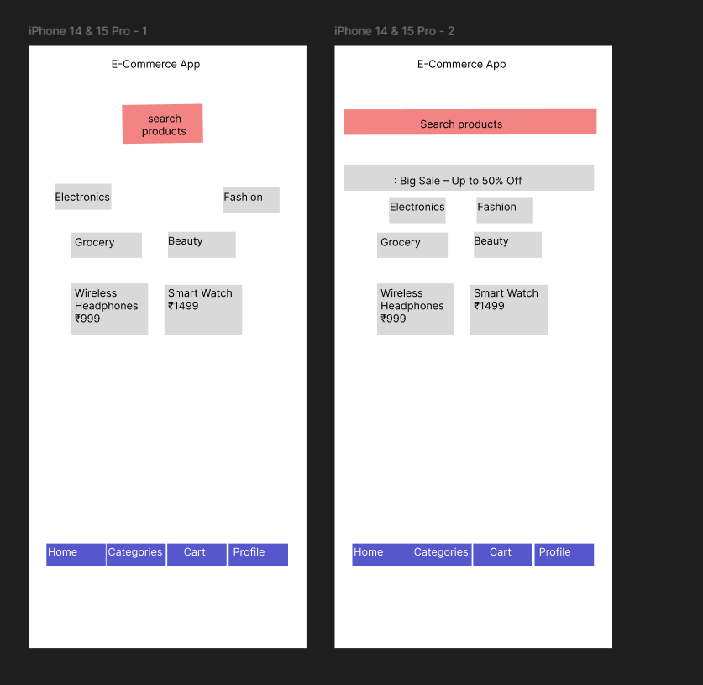
Screenshot – Home Screen Versions A and B

Step 6: Create Product Detail Screen
1. Duplicate a home-screen frame and label it Product Detail Screen.
2. Add a product image or image placeholder, product name, price, rating and description.
3. Add the Add to Cart and Buy Now buttons.
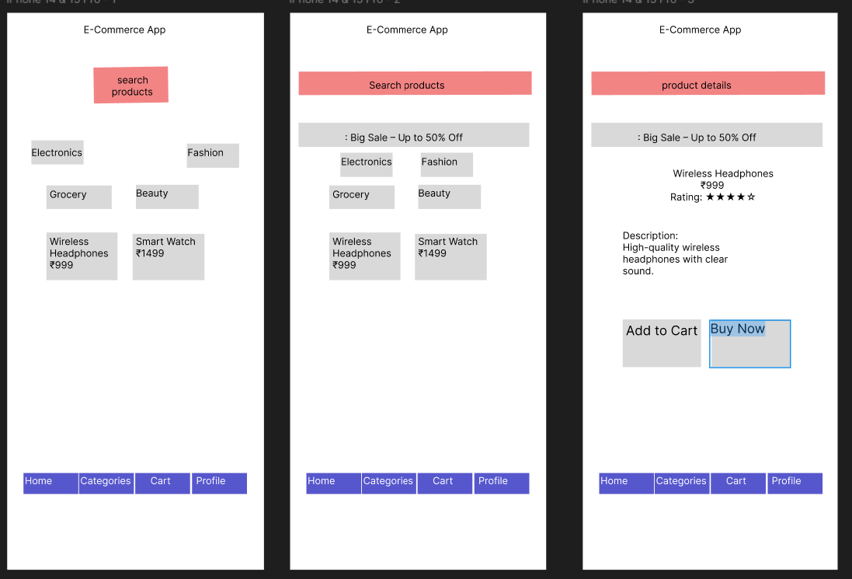
Screenshot – Product Detail Screen

Step 7: Create Cart Screen
1. Duplicate a frame and label it Cart Screen.
2. Add the product list and quantity information.
3. Show the total price and add a Checkout button.

Step 8: Create Payment Screen
1. Create a new frame named Payment Screen.
2. Add a delivery address section and payment options such as Credit Card, Debit Card, UPI and Cash on Delivery.
3. Show the total amount and add a Confirm Order button.
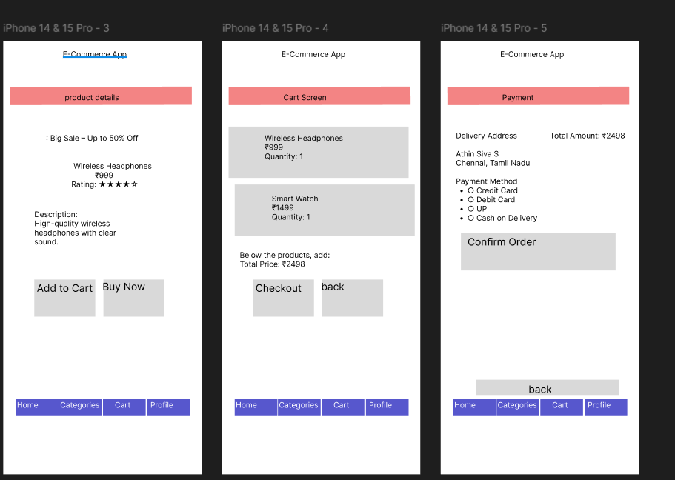
Screenshot – Cart and Payment Screens

Step 9: Create Order Confirmation Screen
1. Duplicate the Payment Screen and label it Order Confirmation Screen.
2. Remove unnecessary payment fields.
3. Add Order Successful, Order ID, delivery date and a Continue Shopping button.
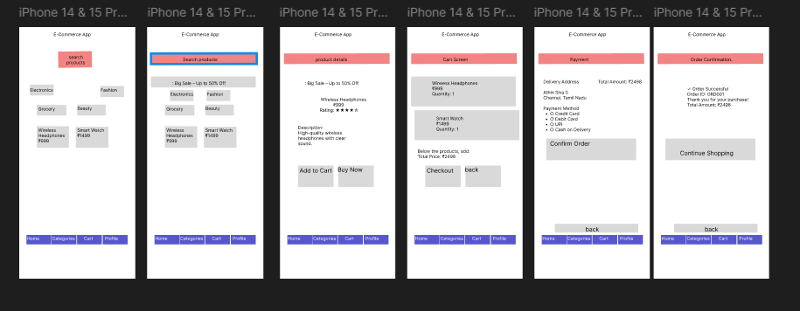
Screenshot – Complete set of designed screens

Step 10: Create Prototype Navigation
Open the Prototype tab and connect the interactive elements as follows:
From | To
Version A Home | Product Detail
Version B Home | Product Detail
Add to Cart | Cart Screen
Checkout | Payment Screen
Confirm Order | Order Confirmation Screen
The navigation flow is: Home Version A / Home Version B → Product Detail → Cart → Payment → Order Confirmation.
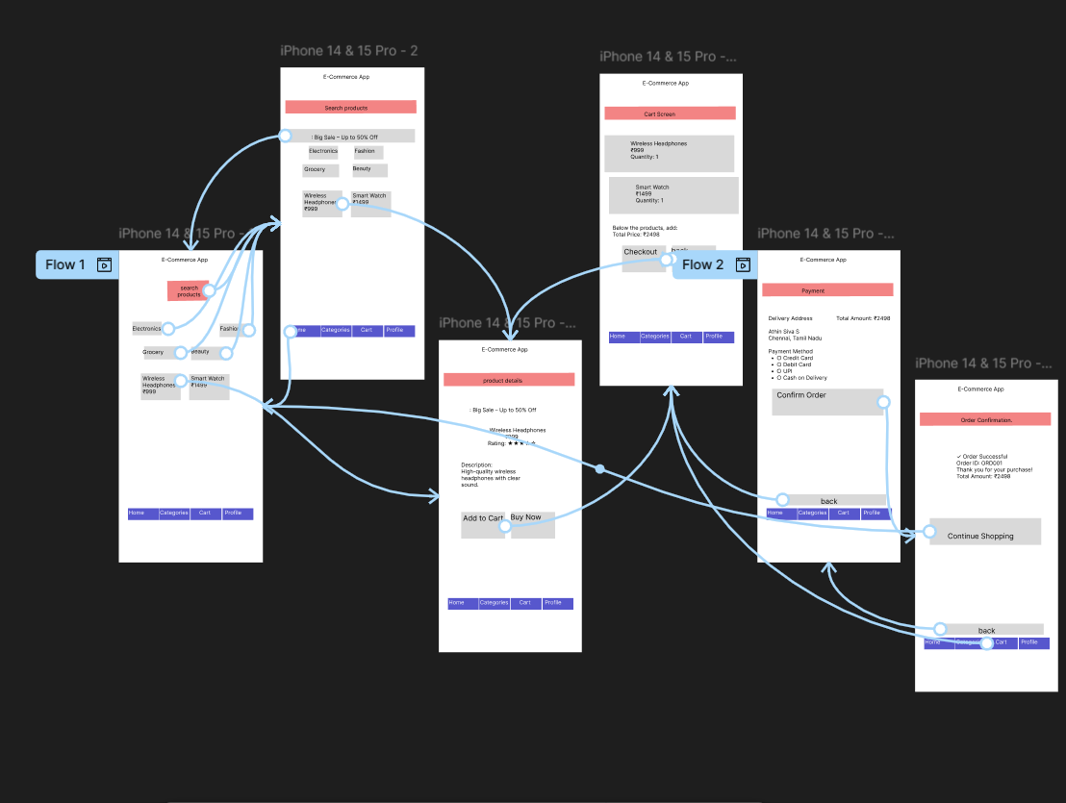
Screenshot – Prototype navigation connections

Step 11: Preview Prototype
1. Click the Play (▶) / Present button in Figma.
2. Test both Version A and Version B flows.
3. Check that Product Detail, Cart, Payment and Order Confirmation open in the expected order.

Step 12: Share for Stakeholder Feedback
1. Click Share in the top-right corner.
2. If allowed by the account, set link access to Anyone with the link – Can comment.
3. Copy the link and share it with stakeholders.

Step 13: Collect Feedback
Stakeholders can:
- Add comments on screens.
- Suggest UI changes.
- Approve the preferred version.

Result
Thus, an interactive E-Commerce mobile app prototype was created using Figma to compare interface options, demonstrate the product-purchase flow, and support stakeholder feedback and design approval.

