Figma Practical – Bus Ticket Booking System
2 | Sketcha Simple Prototype of a BusTicket Booking System using Figma Tool | Figma | CO1

Objective
To design a simple interactive prototype of a Bus Ticket Booking System using Figma.

Step 1: Login to Figma
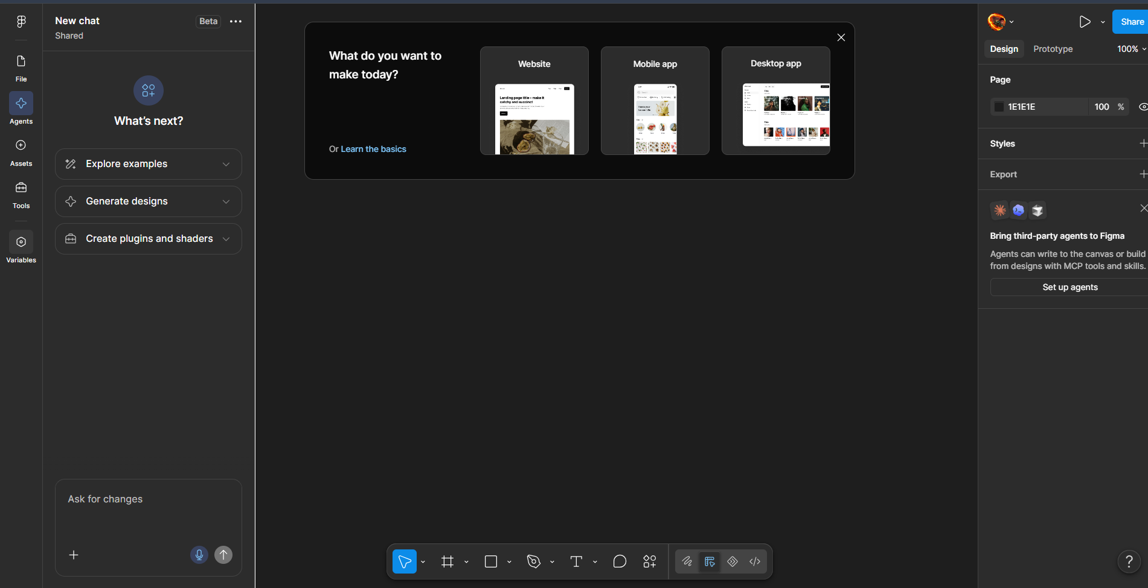
Screenshot
- Open a web browser.
- Go to figma.com.
- Click Log in or Sign up.
- Login using:
  - Google account, or
  - Email and password.
- After successful login, the Figma Home page will appear.

Step 2: Create a New Design File
Screenshot
- From the Figma Home page, click New design file.
- A blank design canvas will open.
- Click the file name at the top-left corner.
- Rename the file as:
Bus Ticket Booking Prototype

Step 3: Create a Mobile Frame
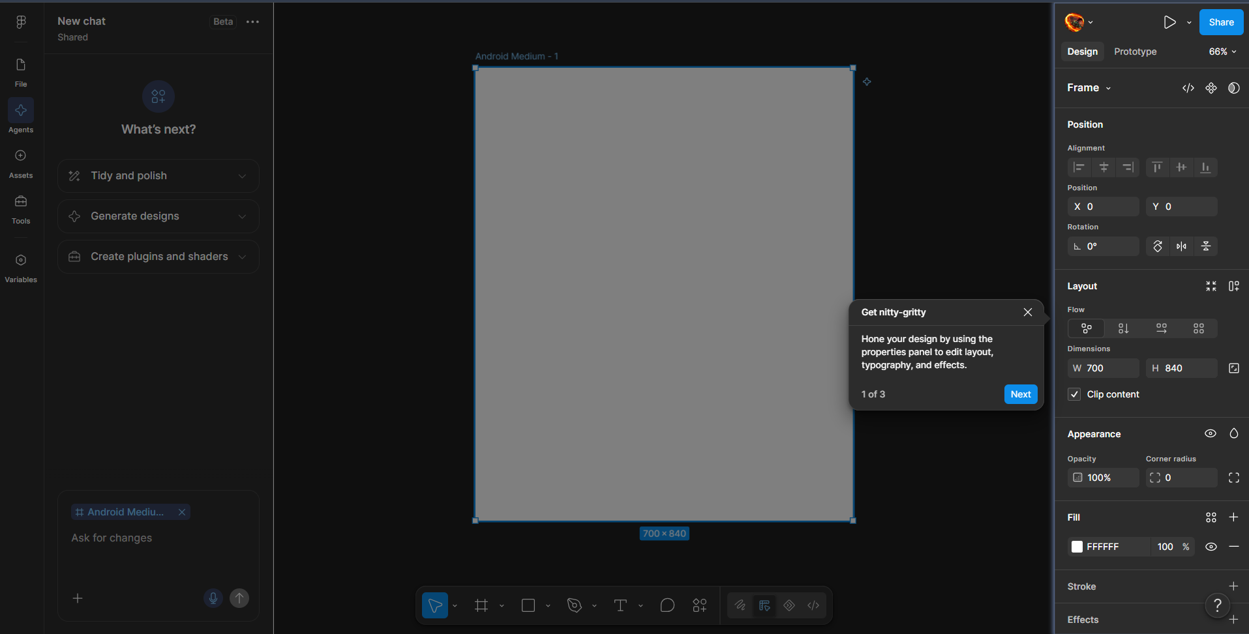
Screenshot
- Select the Frame Tool from the toolbar.
- Alternatively, press F on the keyboard.
- From the right-side panel, select a mobile device.
- Choose a suitable size such as:
375 × 812 px
- Rename the frame:
Home Screen
This frame represents the mobile application screen.

Step 4: Design the Home Screen
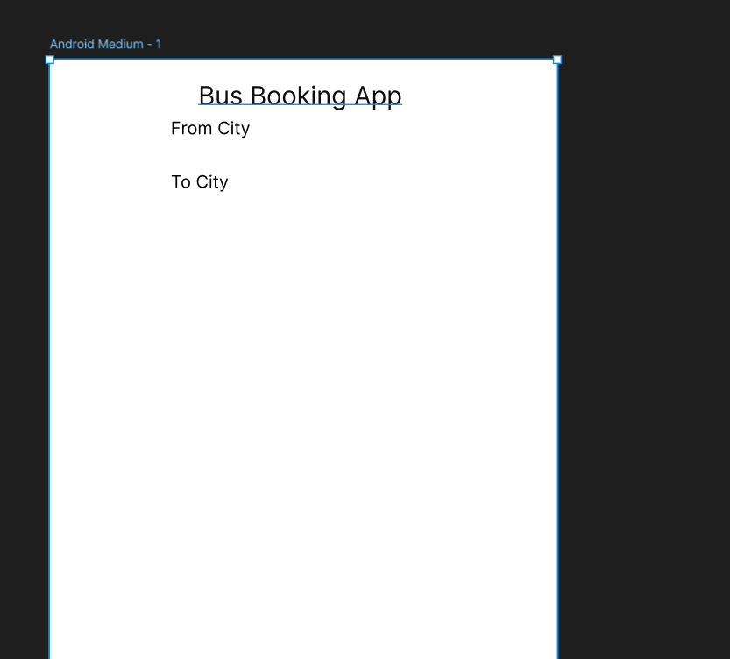
Screenshot
Create the main booking screen.
4.1 Add Header
- Select the Text Tool (T).
- Click near the top of the frame.
- Type:
Bus Booking App
- Increase the font size and make it bold.
4.2 Add From City
- Select Rectangle Tool (R).
- Draw a rectangular input box.
- Add text:
From City
4.3 Add To City
Create another rectangle below the first one.
Add:
To City
4.4 Add Travel Date
Create another input box.
Add:
Travel Date
4.5 Add Search Button
- Draw a rectangle below the input fields.
- Add text:
Search Buses
The completed screen should contain:
Bus Booking App
↓
From City
↓
To City
↓
Travel Date
↓
Search Buses

Step 5: Design the Bus List Screen
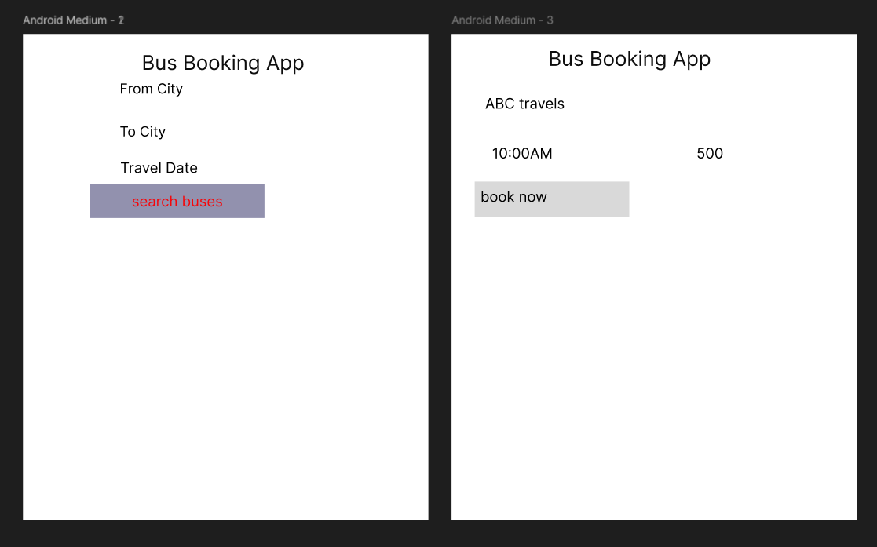
Screenshot
- Select the Home Screen frame.
- Duplicate it using Ctrl + D.
- Move the duplicated frame beside the first frame.
- Rename it:
Bus List Screen
Remove the unnecessary home-screen elements and add the following.
Bus Listing 1
Chennai → Bangalore
ABC Travels
08:00 AM
₹650
Book Now
Bus Listing 2
Chennai → Bangalore
XYZ Travels
10:30 AM
₹750
Book Now
Bus Listing 3
Chennai → Bangalore
Express Travels
01:00 PM
₹600
Book Now
Arrange the bus details neatly using rectangles/cards.

Step 6: Design the Seat Selection Screen
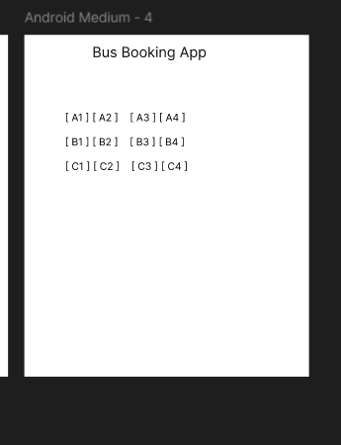
Screenshot
- Duplicate the Bus List Screen.
- Rename it:
Seat Selection Screen
- Remove the bus listings.
- Add the heading:
Select Your Seat
Create Seat Grid
- Select the Rectangle Tool.
- Draw a small rectangle representing one seat.
- Duplicate the seat using Ctrl + D.
- Arrange the seats in rows and columns.
Example:
SEAT SELECTION

[01] [02] [03] [04]

[05] [06] [07] [08]

[09] [10] [11] [12]

[13] [14] [15] [16]
- Make one seat a different color to indicate:
Selected Seat
- Add a button:
Proceed to Payment

Step 7: Design the Payment Screen
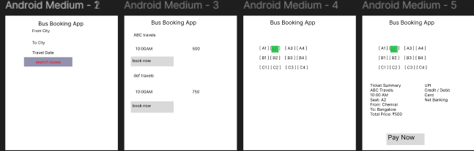
Screenshot
- Duplicate the Seat Selection Screen.
- Rename it:
Payment Screen
- Add the heading:
Payment
- Add a ticket summary:
Bus: ABC Travels
Route: Chennai → Bangalore
Seat: 05
Date: 15-Oct-2026
- Add:
Total Price: ₹650
- Add a payment method field:
Payment Method
Example options:
- UPI
- Credit/Debit Card
- Net Banking
- Add a button:
Pay Now

Step 8: Create Confirmation Screen
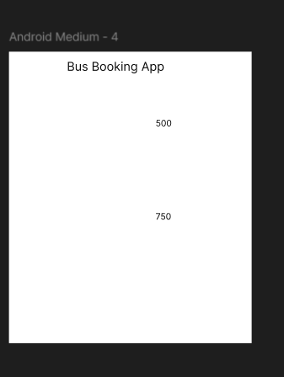
Screenshot
- Duplicate the Payment Screen.
- Rename it:
Booking Confirmation
- Remove unnecessary payment fields.
- Add:
✔ Booking Confirmed
Then add:
Ticket No: BUS20261001
Passenger: Student Name
From: Chennai
To: Bangalore
Date: 15-Oct-2026
Seat: 05
Amount: ₹650
- Add a button:
Download Ticket

Step 9: Create Prototype Links
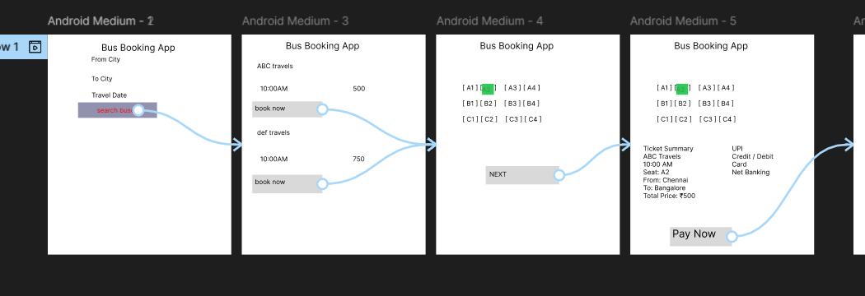
Screenshot
Now connect all the screens.
- Select the Home Screen.
- Click the Prototype tab in the right-side panel.
- Select the Search Buses button.
- Drag the prototype connection arrow to:
Bus List Screen
Create the following connections:
Button | Connect To
Search Buses | Bus List Screen
Book Now | Seat Selection Screen
Proceed to Payment | Payment Screen
Pay Now | Booking Confirmation
Download Ticket | Confirmation/Final Screen
The complete flow is:
Home Screen
↓
Search Buses
↓
Bus List Screen
↓
Book Now
↓
Seat Selection
↓
Proceed to Payment
↓
Payment Screen
↓
Pay Now
↓
Booking Confirmation

Step 10: Preview the Prototype
Screenshot
- Click the Play ▶ / Present button.
- The prototype will open in preview mode.
- Click Search Buses.
- Check whether the Bus List Screen opens.
- Click Book Now.
- Check whether the Seat Selection Screen opens.
- Click Proceed to Payment.
- Click Pay Now.
- Verify that the Booking Confirmation screen appears.
Check the following:
☑ Buttons are clickable
☑ Screens open in the correct order
☑ Seat selection works as designed
☑ Payment screen appears correctly
☑ Confirmation screen is displayed

Step 11: Save and Share
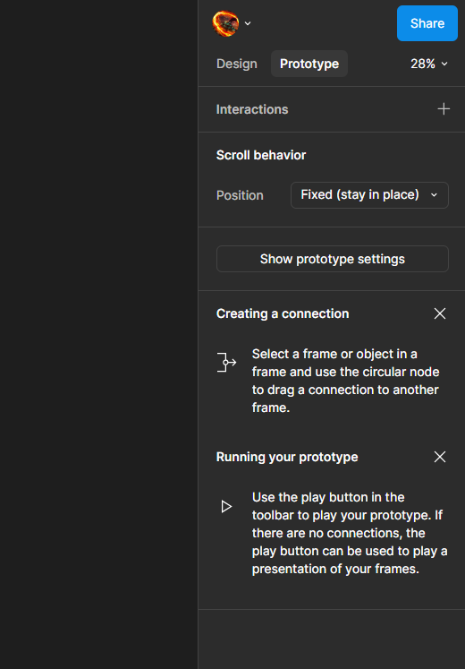
Screenshot
- Figma automatically saves your design.
- Click Share in the top-right corner.
- Select the appropriate sharing permission.
- If permitted by your Figma account/institution, select:
Anyone with the link → Can view
- Click Copy link.
- Submit the Figma link as required.

Expected Screens
Your final prototype should contain at least 5 screens:
- Home Screen
- Bus List Screen
- Seat Selection Screen
- Payment Screen
- Booking Confirmation Screen

Result
Thus, a simple interactive prototype of a Bus Ticket Booking System was successfully designed using Figma. The prototype includes bus search, bus selection, seat selection, payment, and booking confirmation screens with appropriate navigation between them.

