Jira Kanban Board
1 | Create a KanbanBoard toVisualize the Tasks.  - Create Columns for To Do, In-Progress and Done.  - Add at least5SampleTasks  - Move theTasks across the Columns to Simulate the Workflow. | Jira or Trello | CO1

Objective
To create a Kanban Board with To Do, In Progress, and Done columns and simulate the movement of tasks across the workflow.
Step 1: Open Jira
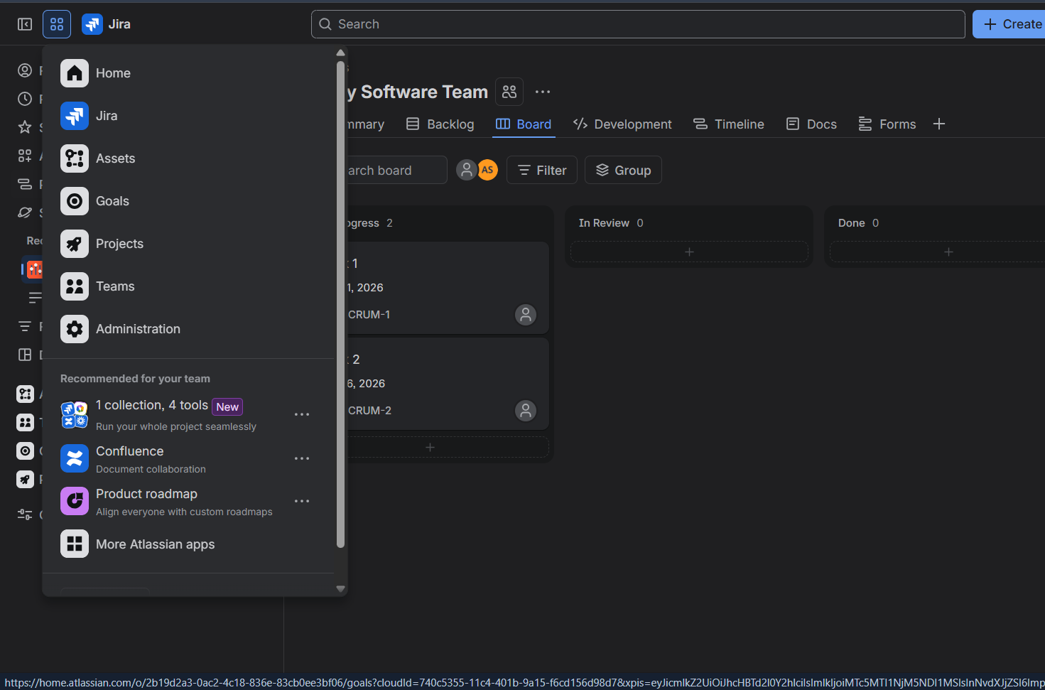
Screenshot
- Open a web browser.
- Go to jira.atlassian.com.
- Click Log in.
- Enter your Jira/Atlassian account credentials.
- After login, Jira Home/Dashboard will appear.
Step 2: Create a Project
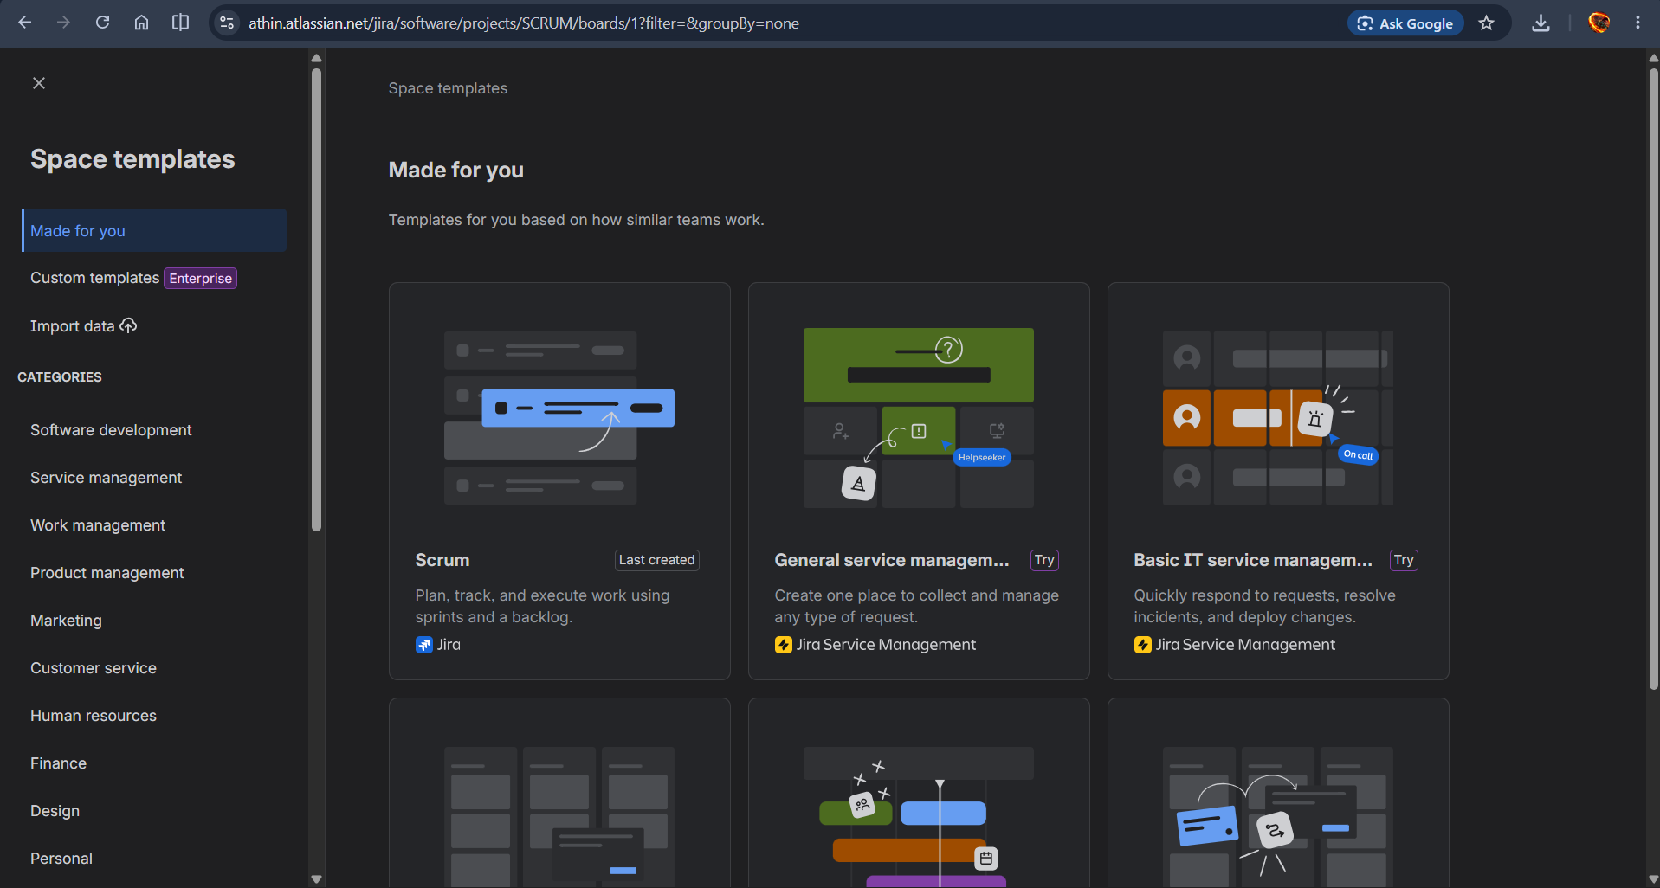
Screenshot
- From the Jira home page, click Projects.
- Select Create project.
- Choose Kanban as the project template.
- Click Use template.
- Enter a project name, for example:
Student Task Management
- Enter/select the project key if required.
- Choose the appropriate project type.
- Click Create project.

Step 3: Open the Kanban Board
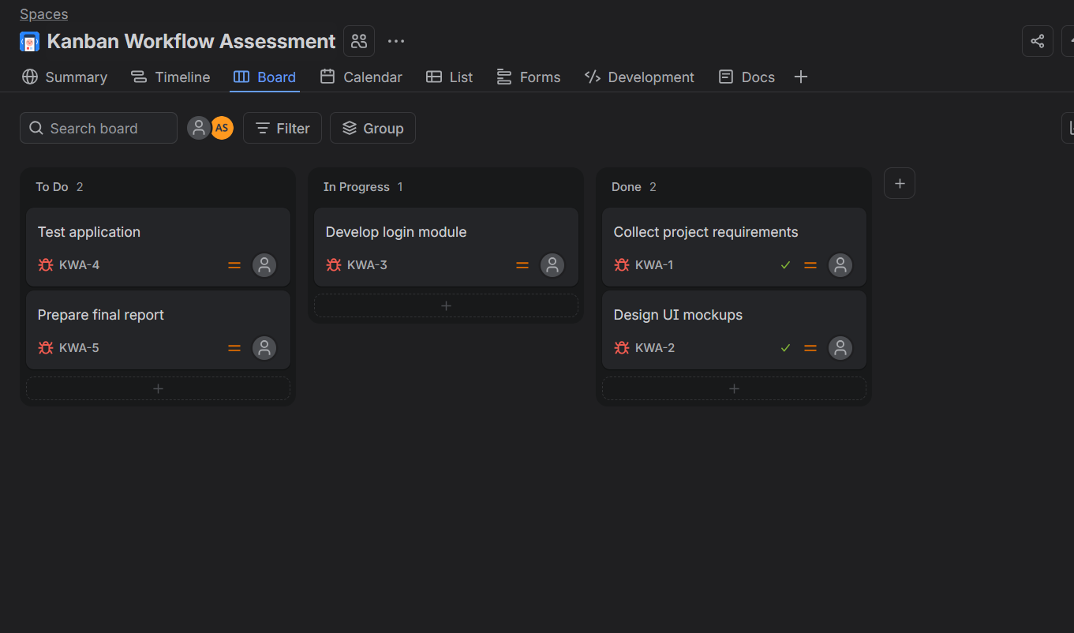
Screenshot
- Open your newly created project.
- From the project menu, select Board or Boards.
- Open the Kanban board.
- You should see workflow columns such as:
  - To Do
  - In Progress
  - Done
If the default columns are different, edit the board columns and rename them accordingly.

Step 4: Create a Task
Screenshot
- Click Create.
- Select the project.
- Select Issue Type → Task.
- Enter the task summary.
Example:
Task: Design Student Registration Form
- Add a description if required.
- Click Create.
The task will initially appear under To Do.

Step 5: Create More Tasks
Screenshot
Create at least 5 tasks for the Kanban demonstration.
Task No. | Task
1 | Design Student Registration Form
2 | Develop Login Module
3 | Create Student Database
4 | Test Application
5 | Prepare Project Report
All newly created tasks should initially appear in To Do.

Step 6: Move a Task to In Progress
Screenshot
- Open the Kanban board.
- Locate Design Student Registration Form under To Do.
- Click and hold the task card.
- Drag it from To Do.
- Drop it into In Progress.
The task status is now changed from To Do → In Progress.

Step 7: Move a Task to Done
Screenshot
- Select a task from In Progress.
- Drag the task card toward Done.
- Drop it in the Done column.
- The task is now completed.
Workflow:
To Do → In Progress → Done

Step 8: Simulate the Complete Workflow
Screenshot
Move the remaining tasks through the Kanban workflow.
Example:
Task 1:
To Do → In Progress → Done
Task 2:
To Do → In Progress
Task 3:
To Do
This demonstrates how tasks are tracked according to their current status.

Step 9: View the Board
Screenshot
Your final Kanban board may look like:
To Do | In Progress | Done
Create Student Database | Develop Login Module | Design Registration Form
Prepare Project Report | Test Application
Check that every task is located in the correct column.

Step 10: Practical Observation
Screenshot
Students should observe that:
- To Do → Task has not started.
- In Progress → Task is currently being worked on.
- Done → Task has been completed.
- Moving cards between columns represents progress in the project.
- Jira provides a visual way to monitor project work.

Result
Thus, a Kanban board was successfully created in Jira with To Do, In Progress, and Done columns, and tasks were successfully moved through the workflow.

