Bikinis or Raincoats Site Plan

# Site Basics

**Site name:** Bikinisorraincoats.com

**Site Purpose:** To keep all fabulous women in the know so they can determine what to wear on any given day.

**Target Audience:** fashion conscientious women trying to decide what to wear based on the weather forecast.

## Personas

**Persona 1:** The mom who is planning the playdates and adventures for the family

**Persona 2:** The college student who wonders if skipping the lecture will be worth it.

## Scenarios:

* What will I need to wear to work?
* Will rain boots or a rain coat be needed?
* Its gray out now but what will the temperature be later?
* Will it be too hot for picnic?
* What is the pollen count?
* How high of an SPF will I need today?

# Color Scheme

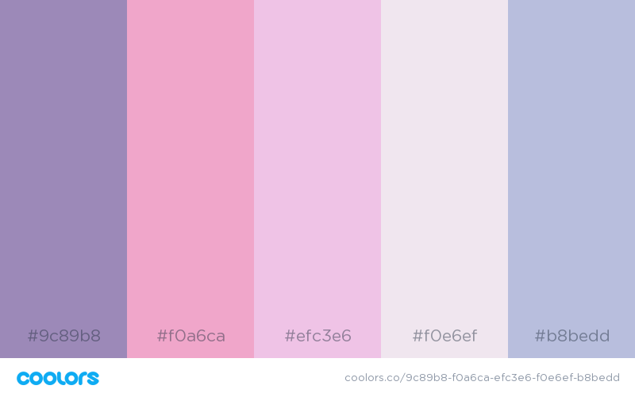

# Typography

|  |  |  |  |  |
| --- | --- | --- | --- | --- |
| Site Header | Amatic SC | 40px | #9c89b8 | Sample |
| Primary Navigation | Amatic SC | 30px | #efc3e6 | Sample |
| Footer Navigation | Amatic SC | 20px | #f0e6ef | Sample |
| Heading 1 (h1) | Amatic SC | 30px | #f0e6ef | Sample |
| Heading 2 (h2) | Amatic SC | 25px | #f0e6ef | Sample |
| Heading 3 (h3) | Amatic SC | 20px | #f0e6ef | Sample |
| Paragraph text (p) | Amatic SC | 16px | #f0e6ef | Sample |

# Site map

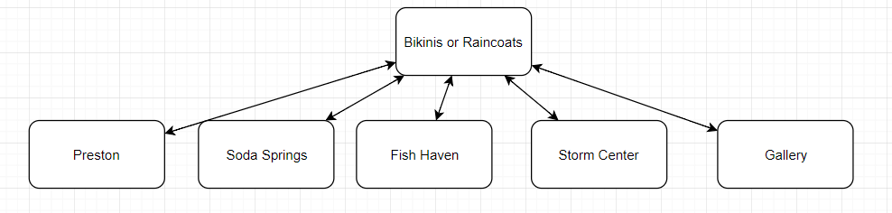

Wireframes

