Temple Inn & Suites Site PLan

Worry Free accommodation for your trip to the Temple.

Site description

The **Temple Inn & Suites**is a hotel chain headquartered in Bethesda, MD that builds and manages specialized hotel accommodations near temple locations of The Church of Jesus Christ of Latter-day Saints around the world. The owner-operated company caters to temple workers, patrons, and their families by providing specialized services and accommodations that meet the needs of those patrons. The hotel accommodations and services are available to anyone willing to abide by the terms and policies outlined by the company.

The overall goal of the website project is to promote and provide information about the specialized services that this hotel chain offers to meet the needs of temple patrons who come to serve in the temple or who participate in events such as sealings, weddings, receptions, and youth trips. The website should reflect the Church culture and be designed to support a temple oriented theme as well as the concept of being a haven of comfort and accessibility.

**Specialized Services**

* Free access to changing rooms and bathroom facilities for temple patrons who have traveled far and need to change to and from church clothes
* A playroom and low-cost, short-term babysitting services for the children of patrons
* Long-term stay accommodations in kitchenette suites for full-time temple missionaries
* Temple history themed reception and sitting area
* A wedding reception hall that can be easily customized with a simple catering menu and kitchen access for food preparation and serving
* A family search center that supports family search and ordinance work
* [Other ideas are welcome]

**Free Amenities**

* Breakfast
* Exercise/workout room
* Indoor pool
* WiFi high-speed internet access and smart TVs
* Parking
* Temple shuttle
* Family history consultation and family ordinance card service

 Target Audience

Personae

**Cael** –

Occupation – Retired

Demographics and Education: 65 years old. Has a master’s degree.

Goals and motivation for visiting site: find a residence for temple mission

Social – very active in church and enjoys ward activities

Technology – very tech savvy

Quote: Looking forward to finding home for our time serving in the temple.

Jay

Occupation – Plumber

Demographics – 45, some college education

Goals and motivation: planning an overnight youth temple trip, need to find a hotel for the trip

Social – not social, but is in the Young Men’s presidency and needs to get this done

Technology – only when required.

Quote - Please help me find a place to house these crazy kids

Scenarios

Scenario 1: Residency for mission

Scenario 2: Youth temple trip

Scenario 3: Wedding Reception

Site Map

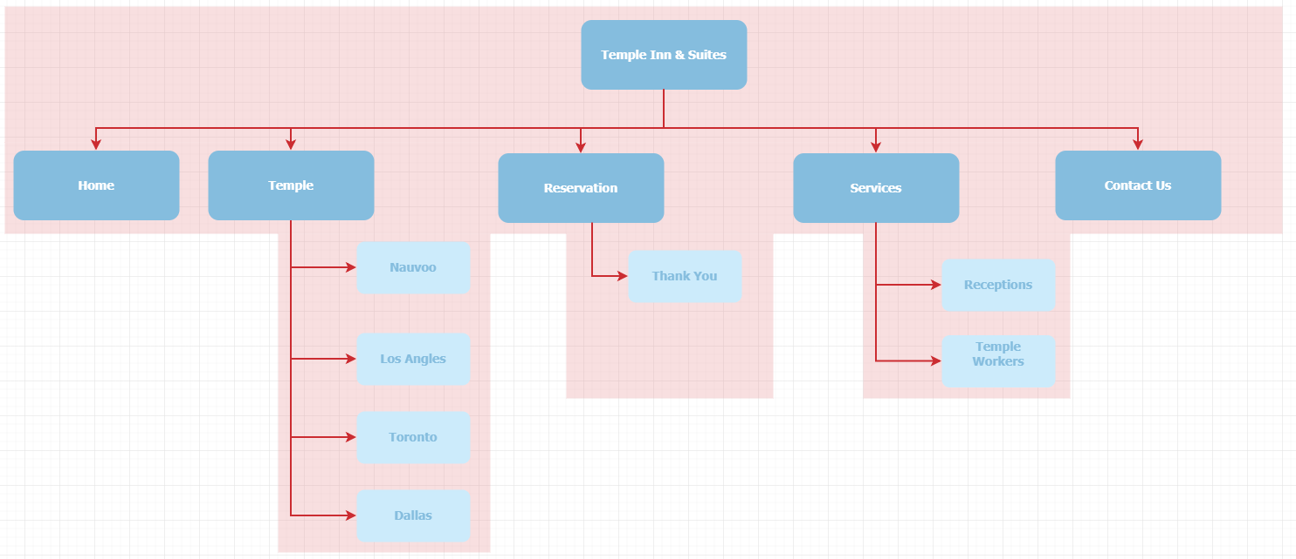

Style Guide

Color scheme

Color scheme here

<https://www.color-hex.com/color-palette/168>



Colors in Palette

|  |  |  |
| --- | --- | --- |
| **Color** | **Hex** | **RGB** |
|  | [#c4e6ff](https://www.color-hex.com/color/c4e6ff) | (196,230,255) |
|  | [#e69598](https://www.color-hex.com/color/e69598) | (230,149,152) |
|  | [#cb2c31](https://www.color-hex.com/color/cb2c31) | (203,44,49) |
|  | [#85bdde](https://www.color-hex.com/color/85bdde) | (133,189,222) |
|  | [#ccebfb](https://www.color-hex.com/color/ccebfb) | (204,235,251) |

Typography

Table with info here

Navigation

Home

Temple

Reservation

Services

Contact

Responsiveness

Must accommodate three different resolutions: mobile, tablet, and computer monitor break points are still to be determined

Wireframes

Home

Small View

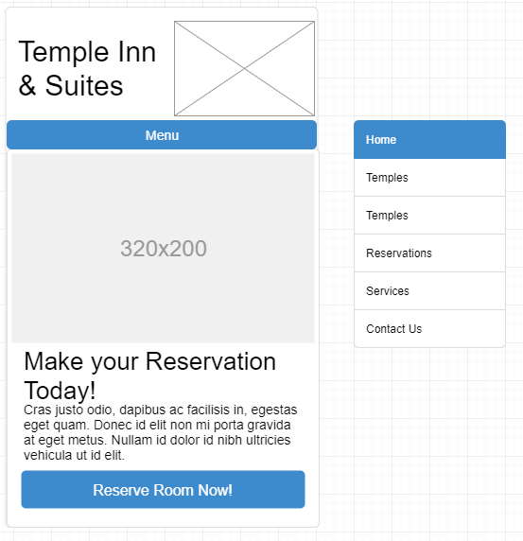

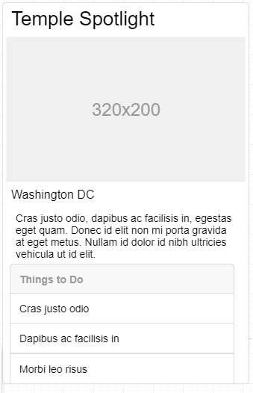

Tablet View

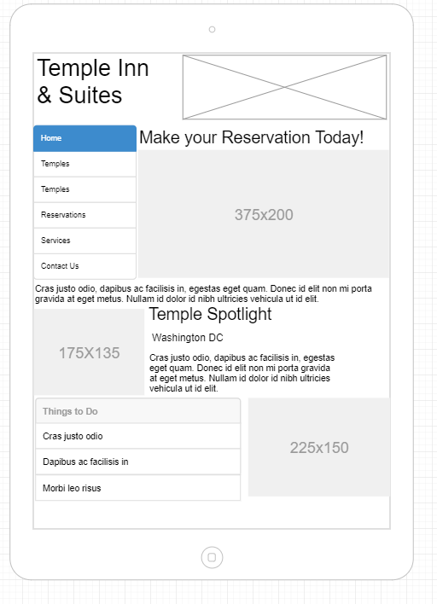

Large View

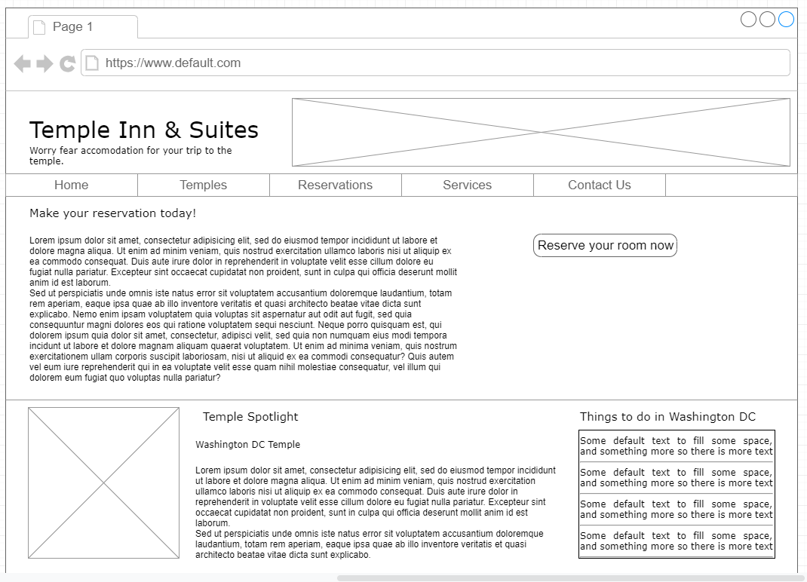

Temples

<insert wireframe here>

Reservation

<insert wireframe here>

Services

<insert wireframe here>

Reception

<insert wireframe here>

Full-time Missionary

<insert wireframe here>

Contacts

<insert wireframe here>