DavesWeather.info

# Site Plan

## Site Description

The purpose of this site is to provide weather information to the covered towns.

## Site Name

The site name will be Davesweather.info. this domain is currently showing available at <https://domains.google.com/m/registrar/search?searchTerm=davesweather&hl=en#>

## Purpose Statement

The purpose of this site is to display weather for a few select communities in Idaho.

## Target Audience

### Personas

#### Joe

**Occupation:** Chief Operations Officer (COO)

**Demographics and Education:** 45 years old. 'C' level executive for a major clothing retail company. Has a Masters level education is Business Administration.

**Goals and motivation for using the site:** View current weather conditions to ensure the team can practice.

**Social**: Very active individual, loves being outdoors. Volunteers as a coach for his son’s pee wee football team.

**Technology**: Heavy user of technology, considers himself a tech geek.

**Quote**: “I need an easy way to check if there are lightning strikes nearby that would necessitate moving the kids off the field.”

#### Joy

**Occupation:** retired waitress

**Demographics and Education:** 65 years old, retired.

**Goals and motivation for using the site:** View current weather conditions to ensure the team can practice.

**Social**: Very active individual, loves being outdoors. Walks daily due to family history of heart conditions.

**Technology**: light user of technology. Rarely uses her cell phone for anything other than making phone calls. Home computer is primarily used to

**Quote**: “I always check the weather first thing in the morning so I know if I can go on my daily walk before breakfast. If there is bad weather, I just wait for the mall so I can do my walk without battling Mother Nature.”

### Scenarios

* The home page contains a current weather story with corresponding image and information sections for all three towns.
* The town weather pages contain weather conditions and other town information or relevant articles/content.
* Images are used to reflect the current weather condition data on the town pages and the towns themselves.

### Site Map

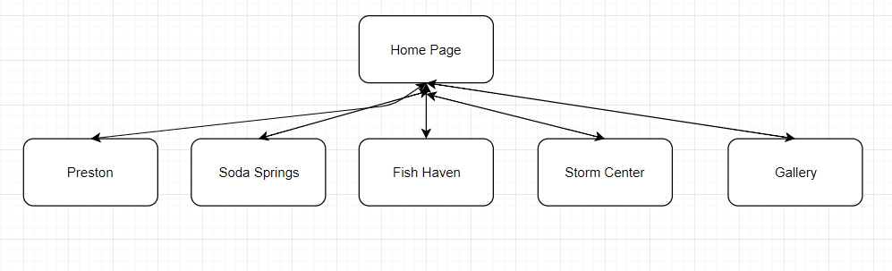

## Style Guide

### Color Scheme

https://coolors.co/d0db97-69b578-3a7d44-254d32-181d27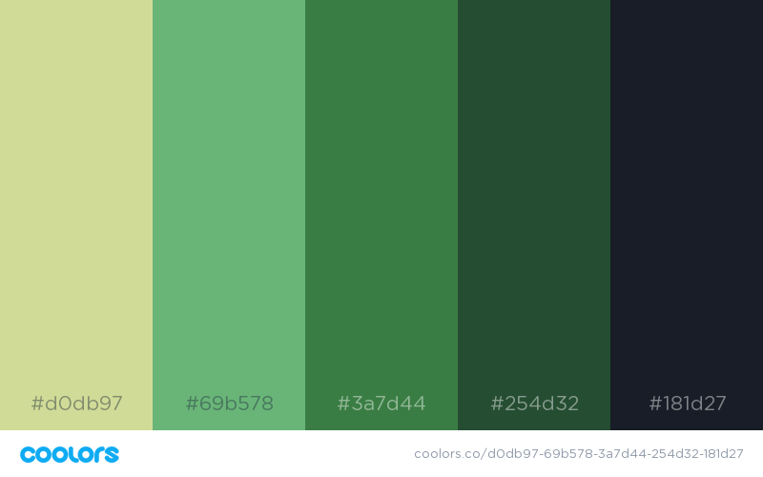

### Typography

|  |  |  |  |  |
| --- | --- | --- | --- | --- |
| Site Header | Exo 2 Semi bold | 40px | #3a7d44 | Sample |
| Primary Navigation | Exo 2 Semi bold | 30px | #69b578 | **Sample** |
| Footer Navigation | Exo 2 Semi bold | 20px | #d0db97 | Sample |
| Heading 1 (h1) | Exo 2 Semi bold | 30px | #d0db97 | Sample |
| Heading 2 (h2) | Exo 2 Semi bold | 25px | #d0db97 | Sample |
| Heading 3 (h3) | Exo 2 Semi bold | 20px | #d0db97 | Sample |
| Paragraph Text (p) | Exo 2 Semi bold | 16px | #d0db97 | Sample |

### Navigation

**Home, Preston, Soda Springs, Fish Haven, Storm Center,** and **Gallery.**

### Responsiveness

The site supports responsive design techniques allowing delivery of the site and its content on all classes of devices—large-wide screens (desktop/laptop), medium-screens (tablet), and small-screens (smartphones).

### Wireframe

