

Higher School Certificate

Course Specifications

Information Processes and Technology Stage 6

Original published version updated:
November 2007 – Notification to Principals D2007/4588

© 1999 Copyright Board of Studies NSW for and on behalf of the Crown in right of the State of New South Wales.

This document contains Material prepared by the Board of Studies NSW for and on behalf of the State of New South Wales. The Material is protected by Crown copyright.

All rights reserved. No part of the Material may be reproduced in Australia or in any other country by any process, electronic or otherwise, in any material form or transmitted to any other person or stored electronically in any form without the prior written permission of the Board of Studies NSW, except as permitted by the Copyright Act 1968. School students in NSW and teachers in schools in NSW may copy reasonable portions of the Material for the purposes of bona fide research or study. Teachers in schools in NSW may make multiple copies, where appropriate, of sections of the HSC papers for classroom use under the provisions of the school’s Copyright Agency Limited (CAL) licence.

When you access the Material you agree:
- to use the Material for information purposes only
- to reproduce a single copy for personal bona fide study use only and not to reproduce any major extract or the entire Material without the prior permission of the Board of Studies NSW
- to acknowledge that the Material is provided by the Board of Studies NSW
- not to make any charge for providing the Material or any part of the Material to another person or in any way make commercial use of the Material without the prior written consent of the Board of Studies NSW and payment of the appropriate copyright fee
- to include this copyright notice in any copy made
- not to modify the Material or any part of the Material without the express prior written permission of the Board of Studies NSW.

The Material may contain third-party copyright materials such as photos, diagrams, quotations, cartoons and artworks. These materials are protected by Australian and international copyright laws and may not be reproduced or transmitted in any format without the copyright owner’s specific permission. Unauthorised reproduction, transmission or commercial use of such copyright materials may result in prosecution.

The Board of Studies has made all reasonable attempts to locate owners of third-party copyright material and invites anyone from whom permission has not been sought to contact the Copyright Officer, ph (02) 9367 8289, fax (02) 9279 1482.

Published by
Board of Studies NSW
GPO Box 5300
Sydney NSW 2001
Australia

Tel: (02) 9367 8111
Fax: (02) 9367 8484
Internet: www.boardofstudies.nsw.edu.au

ISBN 978 174147 7313

2007653

Contents

Foreword 4
Introduction 5
Syllabus Content 6
System and Data Modelling Tools 11
Data Flow Diagram 11
Context Diagrams 12
Decision Tree 12
Decision Table 13
Schemas 13
Data Dictionary 14
Normalisation 14
SQL Syntax 14
Block Diagrams 14
Storyboards 15
Project Tools 16
Journals and Diaries 16
Gantt Charts 16
Requirements Report 16
Feasibility Reports 16
System Development Approaches 17
Application Software Specifications 18
Database Software 18
Website Creation Software and HTML Editors 18
Web Browser Software 18
Presentation Software 18
Word Processing and Desktop Publishing Software 19
Spreadsheet and Charting Software 20
Audio Software 20
Software for Video Processing 20
Animation Software 21
Authoring Software 21
Email Software 21
Graphics Software (Bitmap and Vector) 22
Geographical Information System 22
Neutral Networks 22
Expert Systems 22
Control Software 23

Information Processes and Technology Stage 6

HSC Examination 2009

Foreword

The HSC course specifications for Information Processes and Technology contain information about the Higher School Certificate from 2009. This information is relevant to students studying the Preliminary course from 2008. This document is an integral part of the course content and needs to be referred to regularly in conjunction with the syllabus.

This HSC Course Specifications document should be read in conjunction with:

- Information Processes and Technology Stage 6 Syllabus and support documents
- Official Notices in Board Bulletins
- examination and assessment reports.

The Board of Studies reserves the right to make changes to the course specifications. As they are reviewed, the amendments will be published electronically on the Board of Studies website <www.boardofstudies.nsw.edu.au> and notified in the Official Notices published in the Board Bulletin.

Curriculum advice may be obtained on:

Phone (02) 9367 8246
Fax (02) 9367 8476

Board of Studies publications (syllabuses, support documents, Board Bulletins, specimen examination papers) may be obtained from Client Services on:

Phone (02) 9367 8495
Fax (02) 9262 8178
(fax orders preferred)

Correspondence should be addressed to:

Board of Studies
GPO Box 5300
Sydney
NSW 2001

Information Processes and Technology Course Specifications

Introduction

This document has been produced to present specific content relating to current and emerging technologies as well as providing clarification on the depth of treatment required for some concepts in the Information Processes and Technology Stage 6 Syllabus. Essential and desirable features of software to be used are also identified. The document should be read in conjunction with the Information Processes and Technology Stage 6 Syllabus.

In addition to the content and concepts detailed in this document, students should be exposed to further software and concepts that illustrate syllabus content.

This document is available on the Board’s website so that it can be regularly updated.

Syllabus Content

The section defines content from the syllabus that is likely to change over time (such as current technologies and those that are emerging).

It is intended that this content be taught as an integral mandatory part of the course. Specific content in this section will be reviewed and updated as the need arises to maintain currency in the syllabus.

Preliminary Course

Students learn about: | Syllabus page reference
8.2 Tools for Information Processes  collecting  - hardware used for collection  - scanners and/or digital cameras to collect images  - microphones and/or recording from peripheral devices to collect audio  - video cameras and/or peripheral devices with appropriate interfaces to capture video  - keyboards and/or optical character readers to collect numbers and text  - data capture devices such as counters for counting cars on a road  - software used for collection  - device drivers that allow hardware to interface with the operating system  - software that allows participants to enter or import data  - software that allows participants to move data between applications | 19
organising  - software for organisation, including:  - paint and draw software that allows image manipulation  - mixing software for audio manipulation  - video processing software that allows arrangement of video and audio clips on a timeline  - word processors and desktop publishing for the arrangement of text, images and numbers for display  - spreadsheets for the arrangement of numerical data for processing  - website creation software that uses hyperlinks to organise data to be displayed in web pages  - presentation software allowing data to be arranged on slides, providing control over the sequence in which information is displayed | 19  Dot points have been reworded and new display devices added.  Dot points have been reworded.
storing and retrieving  - hardware for storing and retrieving  - hardware secondary storage devices, including:  Dot points have been reworded and new display devices added.  - magnetic disks  - optical disks  - network storages  - flash memory  - magnetic tapes | 21
displaying  - hardware for displaying, including:  - screens (LCD, CRT and plasma screens) for displaying text, numbers, images and video  - printers and plotters for displaying text, numbers and images  - speakers for audio output  - digital projectors and interactive whiteboards for displaying text, numbers, images and video | 23
HSC Course

Students learn about: | Syllabus page reference
9.2 Information Systems and Databases  issues related to information systems and databases  - current and emerging trends in the organisation, processing, storage and retrieval of data, such as:  - data warehousing and data mining  - Online Analytical Processing (OLAP) and Online Transaction Processing (OLTP) | 34
9.3 Communication Systems  A number of outdated examples have been deleted and newer examples added.  examples of communication systems  - messaging systems, including:  - email  - voice mail  - Voice Over Internet Protocol (VOIP) | `
transmitting and receiving in communication systems  - transmission media, including:  - wired transmission  - twisted pair  - coaxial cable  - optic fibre  - wireless transmission  - microwave  - satellite  - radio  - infrared  - functions performed by the following hardware components used in communication systems:  - hubs and switches  A number of new communication devices have been added.  - routers  - modems  - bridges and gateways  - Network Interface Cards (NIC)  - mobile phones  - cables  - wireless access points  - bluetooth devices | 37
issues related to communication systems  - current and emerging trends in communication systems, including:  - blogs  - wikis  - RSS feeds  A number of areas for studying current and emerging trends have been added.  - podcasts  - online radio, TV and video on demand  - 3G technologies for mobile communications | 39
9.4.1 Transaction Processing Systems  other information processes in transaction processing systems  - collecting in transaction processing:  - hardware, including:  - Automatic Teller Machines (ATM)  - barcode readers  - Radio Frequency Identification (RFID) tags | 42
issues related to transaction processing systems  - current and emerging trends in transaction processing  - data warehousing and data mining  - Online Analytical Processing (OLAP) and Online Transaction Processing (OLTP) | 43
9.4.2 Decision Support Systems  issues related to decision support systems  - current and emerging trends of decision support systems  New areas of study for current and emerging trends have been added.  - data warehousing and data mining  - Online Analytical Processing (OLAP) and Online Transaction Processing (OLTP)  - the emerging trend of group decision support systems and the communication it facilitates | 47
9.4.3 Automated Manufacturing Systems (AMS)  issues related to automated manufacturing systems  - current and emerging trends in automated manufacturing systems, including:  - the use of AMS for quality control | 51
9.4.4 Multimedia Systems  examples of multimedia systems  - advances in technology which are influencing multimedia development, such as:  - increased storage capacity allowing multimedia products to be stored at high resolutions  These advances in technology have been reworded and updated.  - improved bandwidth allowing transmission of higher quality multimedia  - improved resolution of capturing devices  - increases in processing power of CPUs  - improved resolution of displays  - new codecs for handling compression of media while improving quality | 53
displaying in multimedia systems  - hardware for creating and displaying multimedia, including:  - screens including CRT displays, LCD displays, plasma displays and touch screens  - digital projection devices  - speakers, sound systems  - CD, DVD and video tape players  - head-up displays and head-sets  - software for creating and displaying multimedia, including:  - presentation software  - software for video processing  - authoring software  - animation software  - web browsers and HTML editors | 54  New display devices have been specified.
other information processes in multimedia systems  - storing and retrieving  - the different file formats used to store different types of data, including:  Some common file formats have been specified.  - JPEG, GIF, PNG, and BMP for images  - MPG, Quicktime, AVI and WMV for video and animations  - MP3, Wav, WMA, and MID for audio  - SWF for animations | 54
issues related to multimedia systems  - current and emerging trends in multimedia systems, such as:  - virtual worlds | 55

System and Data Modelling Tools

Data Flow Diagram Data flow diagrams represent an information system as a number of processes that together form the single system. This single system can be represented more simply using a context diagram (see below). Data flow diagrams therefore show a further level of detail not seen in the context diagram. Data flow diagrams identify the source of data, its flow between processes and its destination along with data generated by the system. The symbols used are:

Circles used to represent processes. Processes are actions taking place to transform inputs to outputs.

Curved lines represent data flows between processes, data stores and external entities. Data flows should be named to identify the piece of data.

Boxes used to represent external entities. These are any item, person or organisation sitting outside the systems that provides data to the system or receives data from the system.

An open-ended rectangle is used to represent a data store. Data stores include electronic or non computer-based stores of data. They should be named with a logical name.

Process

This section has been reworded and examples provided to give teachers and students appropriate models for implementing data flow diagrams and context diagrams.

External
entity

Data store

The example below shows the processes involved in borrowing a video.

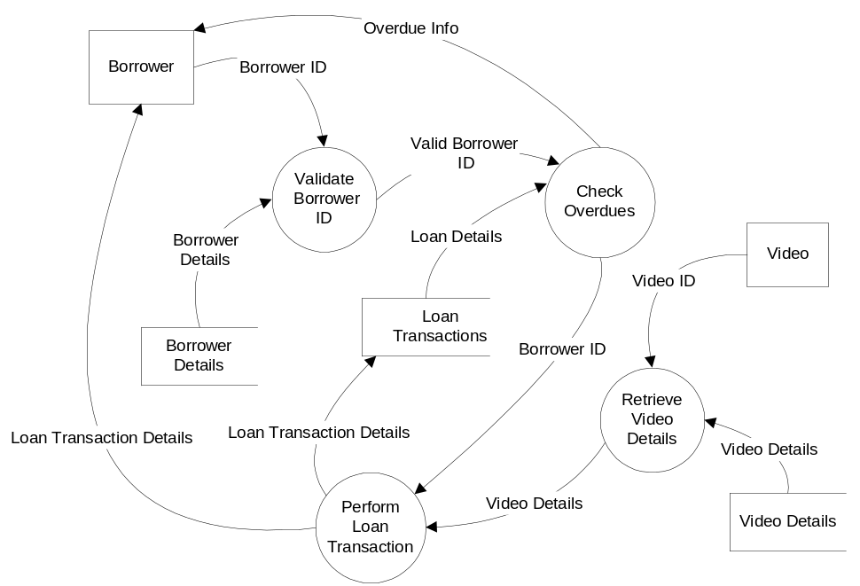

Context Diagrams Context diagrams are used to represent an overview of the entire information systems. The system is shown as a single process along with the inputs and outputs. The external entities are connected to the single process by data flow arrows. Each element represented is labelled. A context diagram does not show data stores and internal processes.

The example below is a context diagram that represents the video borrowing process (shown on the previous page).

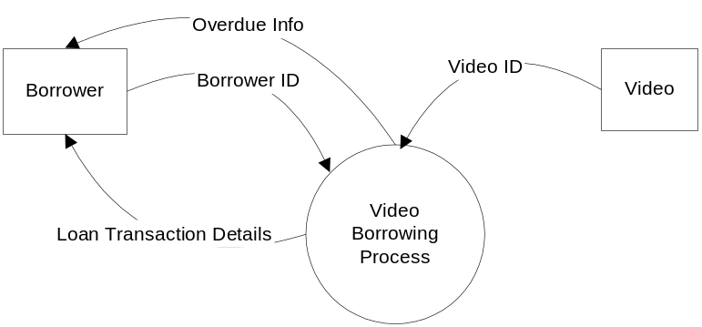

Decision Tree A decision tree is a diagrammatic way of representing all possible combinations of decisions and their resulting actions. Branches are shown to describe the eventual action depending on the condition at the time. Each decision path will lead to either another decision that needs to be made or a final action. This is shown in the example below.
At Christmas, a company pays a gift of money to some of its employees. To be eligible for the gift, an employee must have worked for the company for at least six months. Managers get $500 and other employees get $300 for their first Christmas with the company and $500 thereafter.
Christmas gift payment
Length of
employment

greater than 1 year

greater than 6 months and less than 1 year

less than 6 months
Amount of gift

$500

$500

$300

No gift
Type of employee

manager

other

Decision Table A decision table is a table that represents all possible conditions and the actions that will result. The table is divided into sets of conditions and a resultant corresponding set of actions. It also allows you to see the rules that are based on a combination of known conditions. A decision table provides another way of representing data shown in a decision tree. See the example below.
A store has developed a policy for accepting customer cheques. They will be accepted if all of the following conditions apply:
- cheques must be less than $500;
- the customer must have a current driver’s licence;
- check that signature matches driver’s signature

Conditions | Rules
Cheque < $500 |  | ✓ |  | ✓ |  | ✓ |  | ✓
Customer has licence |  |  | ✓ | ✓ |  |  | ✓ | ✓
Signatures match |  |  |  |  | ✓ | ✓ | ✓ | ✓

Actions
Cheque accepted |  |  |  |  |  |  |  | ✓
Cheque not accepted | ✓ | ✓ | ✓ | ✓ | ✓ | ✓ | ✓ | 

The section on systems flow charts has been deleted.

Schemas A schema shows the organisational structure of a database. It should show the entities (the tables in the database), and their characteristics (ie their properties/attributes/fields). It should clearly identify the primary key in each table and the links and relationships between tables. The example below is just one way a schema can be represented. There are other acceptable methods that students can use to present this information.
This section relating to schemas has been moved from the support documentation and reworded to provide students and teachers with a clear model for developing schemas.
Entities
1 to Many
Relationship
Many to 1
Relationship
1 to Many
Relationship
MovieMovie IDName of videoFilm type codeDate releasedRating
BorrowersBorrower IDSurnameFirst nameAddressSuburbPostcodePhone No. (W)Phone No. (H)Licence IDOther IDPassword
VideosVideo IDMovie ID
LoansLoan IDVideo IDBorrower IDDate borrowedDate dueDate returnedOverdue flag
Primary Keys

Data Dictionary A data dictionary is a table providing a comprehensive description of each field in the database. This commonly includes: field name, data type, data format, field size, description and example. This is shown in the example below.

Field name | Data type | Data format | Field size | Description | Example
UserId  FirstName  Surname  DOB  HourlyPayRate  Height  FeesPaid | Text  Text  Text  Date  Currency  Real  Boolean | NNNNNNNN  DD/MM/YYYY  #####.##  #.## | 8  25  25  10  8  3  1 | Unique eight-digit number represented as text  First name of employee  Surname of employee  Date of birth as a short date format  Rate of pay expressed in dollars per hour  Height in metres, with two decimal places  Y or N for Yes or No | 0001539  Bill  Smith  15/07/1982  34.50  1.58  Y

Normalisation Normalisation is a process used in the design of relational databases where we attempt to minimise data duplication by breaking the database up into a number of smaller linked tables. Each table should include fields, which are solely dependent on the primary key set in each table. If a table were to contain unnecessary data duplication (ie redundant data), there exists the possibility that these data elements would not be kept up to date, leading to a data integrity problem. Databases represented in 3rd Normal Form do not have any integrity issues because their structure prevents redundant data being stored.
This section relating to normalisation has been added.
A sample data dictionary has been added to illustrate the requirements of a data dictionary.

SQL Syntax Structured Query Language (SQL) is a language used to access and manipulate data in relational databases. For the IPT course, the following syntax is to be used:

SELECT (what is to be displayed)
FROM (the tables to be used)
WHERE (the search criteria)
ORDER BY (the sequence in which the results
are displayed)

Block Diagrams (This documentation tool is only relevant for students studying the Automated Manufacturing Systems option.)
A block diagram is yet another way to represent a system. The system is shown inside a rectangle and the edge of the rectangle is the system boundary. Inputs and outputs external to the system are shown as circles. A circle with a line down the middle is used to represent output from one system that is input to another. The following are the symbols used.

External input

System

External output

External output/input
I

System

O

Storyboards A storyboard used to represent systems will show the various interfaces (screens), present in a system as well as the links between them. The representation of each interface should be detailed enough for the reader to identify the purpose, contents and design elements. Areas used for input, output and navigation should be clearly identified and labelled. Any links shown between interfaces should originate from the navigational element that triggers the link. Storyboards can be used in a variety of contexts. They can show the relationship between data entry screens in a database, or scenes in a movie, or slides in a presentation, or pages in a website.
The requirements of a storyboard have been added to provide students and teachers with a clear model.
The storyboard example below shows the relationship between three pages of information aimed at promoting a school canteen on a website. Elements of each screen are clearly identified and the links between screens shown.

Home
Page 2
Page 3
Home
Page 2
Page 3
School Canteen
Weekly Specials
Image of Canteen
Description
of Specials

~~~~~~
~~~~~~~~~~
~~~~~~~~~

~~~~~~~~
~~~~~~~~~
~~~~~~~~~
~~~~~~~~~~`

~~~~~~~~~~~~~~~~~~~~~~~~~~~~~~~~~~~~~~~~~~~~~~~~~~~~~~~~~~~~~~~~~~~~~~~~~~~~~~~~~~~~~~~~~~~~~~~~~~~~~~~~~~~~~~~~~~~~~~~~~~~~~~~~~~~~~~~~~~~~~~~~~~~~~~~~~~~~~~~~~~~~~~~~~~~~~~~~~~~~~~~~~~~~~~~~~~~~~~~~~~~~~~~~~~~~~~~~~~~~~~~~~~~~
~~~~~~~~~~~~~~~~~~~~~~~~~~~~~~~~~~~~~~~~~~~~~~~~~~~~~~~~~~~~~~~~~~~~~~~~~~~~~~~~~~~~~~~~~~~~~~~~~~~~~~~~~~~~~~~~~~~~~~~~~~~~~~~~~~~~~~~~~~~~~~~~~~~~~~~~~~~~~~~~~~~~~~~~~~~~~~~~~~~~~~~~~~~~~~~~~~

~~~~~~~~~~~~~~~~~~~~~~~~~~~~~~~~~~~~~~~~~~~~~~~~~~~~~~~~~~~~~~~~~~~~~~~~~~~~~~~~~~~~~~~~~~~~~
Information ~~~~~~~~~~~~~~~~~~~~~~~~~~~~~~~~~~~~~~~~~~~~~~~~~~~~~~~~~~~~~~~~~~~~~~~~~~~~~~~~~~~~~~~~~~~~~~~~~~~~~~~~~~~~~~~~~~~~~~~~~~~~~~~~~~~~~~~~~~~~~~~~~~~~~~~~~~~~~~~~~~~~~~~~~~~~~~~~~~~~~~~~~~~~~~~~~~~~~~~~~~~~~~~~~~~~~~~~~~~~~~~~~~~~
~~~~~~~~~~~~~~~~~~~~~~~~~~~~~~~~~~~~~~~~~~~~~~~~~~~~~~~~~~~~~~~~~~~~~~~~~~~~~~~~~~~~~~~~~~~~~~~~~~~~~~~~~~~~~~~~~~~~~~~~~~~~~~~~~~~~~~~~~~~~~~~~~~~~~~~~~~~~~~~~~~~~~~~~~~~~~~~~~~~~~~~~~~~~~~~~~~

~~~~~~~~~~~~~~~~~~~~~~~~~~~~~~~~~~~~~~~~~~~~~~~~~~~~~~~~~~~~~~~~~~~~~~~~~~~~~~~~~~~~~~~~~~~~~
Exit
Food and Drink Prices
Price List
~~~~~~~~~~
~~~~~
~~~~~~~~~~~~~
~~~~~
~~~~~~~~~~~
~~~~~~
~`~~~~~~~~~~~~
~~~~~~~~~~
~`~~~
~~~~~~~~~~~~~
~~~~~~~
~~~~~~~~~~~~~~~~~~~~~
~~~~~
Home
Page 2
Page 3
Exit
Exit
The weekly specials screen will be updated each week with new specials and new images to promote healthy foods. The page will contain back links to other canteen pages.
The food and drinks screen will be maintained monthly. The price list will have two columns: one for food and one for drinks. The page will contain links to other canteen pages.
This is the main home page. It will contain a brief description of the services offered by the canteen and personnel information. It will also have an image of the canteen workers. There will be links to other screens.

Image 1
Image 2
Image 3

Project Tools

Journals and Diaries Journals, process diaries and logbooks provide developers with a variety of formats for tracking the development of a system. Entries should include a date, a description of the progress made since the last entry and descriptions of stumbling blocks or issues encountered and how they were managed. Reflective comments may also be included.

Gantt Charts Gantt charts display the overall timeline for a project. They present a sequential breakdown of individual tasks showing the relationship between tasks and the time taken for each task. The duration of tasks are shown as horizontal bars. Gantt charts should have labelled axes (Y-axis for tasks and
X-axis for time). A time scale should be shown, including dates. Milestones should also be included.

The example below shows the main elements of a Gantt chart.
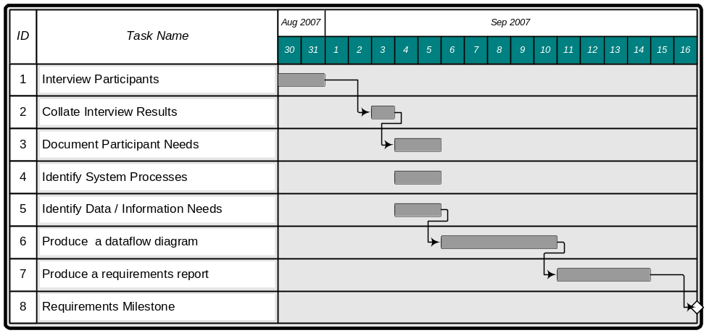

Requirements Report A requirements report is a document that is produced in the early stages of a project that seeks to clarify the purpose of the system. This purpose is usually detailed in terms of what the users/participants needs are. The data inputs should be clearly identified. The information processes performed on the data need to be documented. Finally, the information outputs from the systems need to be detailed. The requirements report provides documentary evidence of the scope of the project.

Feasibility Report A feasibility report is a document that details the potential of different solutions in terms of the known constraints and makes recommendation for moving forward with the project. The constraints that need to be analysed and reported on include economic, technical, scheduling (time) and operational. Evidence supporting recommendations about whether or not to continue with the project should be outlined and a suitable approach should be recommended.
A number of project tools are identified in the syllabus. This section seeks to clarify the requirements of these tools.

System Development Approaches

While there are a variety of different approaches referred to in the syllabus, the framework for managing a project focuses on the traditional approach. Students are expected to know other approaches and compare them, but not in great detail. The traditional model represented in the syllabus is characterised by five end-on stages, best represented by the Waterfall Model (below). Students need an in-depth understanding of what happens in each of these stages.

A single model of the Traditional System Development Approach is provided illustrating the syllabus terminology used to represent each stage.
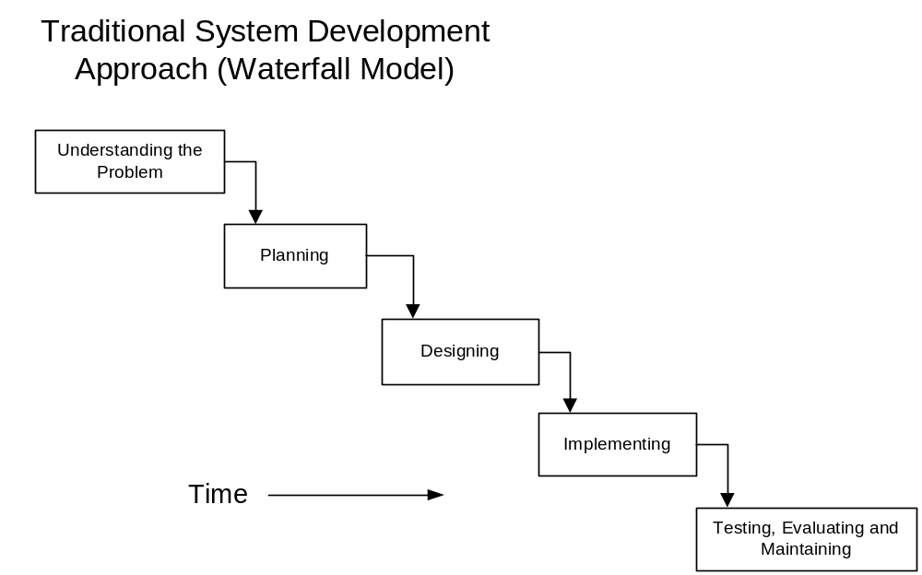

Students will not be examined on models for other approaches because of the huge variability in the implementation of such approaches.

Application Software Specifications
Students should engage in project work, making relevant use of software containing the following features.
Today’s database software allow for the creation of flat file and relational databases. As a result, these two areas have been combined.

Database Software
Database software should allow students to:
- create flat file databases and a relational databases
- use relational operators, including:
- CONTAINS DOES NOT CONTAIN
- EQUALS NOT EQUAL TO
- GREATER THAN GREATER THAN OR EQUAL TO
- LESS THAN LESS THAN OR EQUAL TO
- use logical operators including AND OR NOT
- create queries and use a query language to search on single and multiple fields across one or more tables
- sort data across multiple fields within a data table
- create and customise reports
- create forms (user views) for users to access data and build a graphical front end to the database
- create and display a schema showing the relationship between tables in the database
- create derived (calculated) fields using inbuilt functions
- use macros to automate tasks
- import from, export to or share data with other applications
- restrict access to the database through some form of access control
- use scripts to improve database functionality

Website and web page creation has changed dramatically in the past 10 years. This section has been updated to reflect these changes.

Website Creation Software and HTML Editors
Website creation software should allow students to:
- create, view and edit a web page using HTML
- insert video, images, audio and animations
- insert plugins
- work with templates, themes and style sheets
- create and publish web pages to a website
- provide a WYSIWYG environment for building web pages
- work with forms
- work with scripts other than HTML
- use tables and/or frames to help with page layout
- create internal anchors and links, and links to external HTML pages on the World Wide Web
- use text formatting and editing features
- use spell and grammar checking capabilities

Web Browser Software
Web Browser software should allow students to:
- display web pages authored in HTML and other languages such as Java Script, PHP, ASP etc
- view web pages that include text, images, audio, animations and video content
- work with plugins that provide additional functionality
- use tabs
- navigate forwards and backwards through recently viewed pages
- configure security levels and work with secure pages
- filter out undesirable content
- set privacy levels and manage cookies
- view the HTML source of a page
- add and manage a homepage and bookmark pages
- browse and search the internet or intranet for information
- complete online transactions
- download and save files

Presentation Software
Presentation software should allow students to:
- work with design templates and master slides
- insert and display text, images, audio video and animations
- format and edit text
- import and export data
- embed objects such as charts and tables from other applications
- work with a variety of views
- use hyperlinks to other slides or external resources
- reorder and sequence slides
- apply timings to slide presentations
Because of the convergence of features in word processing and desktop publishing software, these two applications have been treated together.
- print out information in a variety of formats
- apply transitions and effects to slides and slide contents
- use text formatting and editing features
- use spell and grammar checking capabilities
- use macros to automate presentation functions

Word Processing and Desktop Publishing Software
Word processing and desktop publishing software should allow students to:
- work in a WYSIWYG environment
- work with images, clipart, video and audio
- control the layout and placement of different objects on a page
- load and save documents in a variety of different document formats
- print a document
- copy and paste or move copy blocks of text within documents or between documents
- control fonts and style of characters and blocks of text
- format paragraphs by changing margins, line spacing, justification and tabulation
- display the document in a variety of views such as print view and outline view
- perform spelling checks and grammar checks
- use headers and footers
- insert page and section breaks
- work with charts, tables, columns and forms
- carry out a mail merge
- work with templates and style sheets
- embed objects from other applications such as charts
- use hyperlinks and anchors
- produce a table of contents and index
- work with outlines
- insert comments and track document changes
- work with macros
- secure documents
- wrap text around images

Charting has been included with spreadsheets rather than being treated separately.
Spreadsheet and Charting Software
Spreadsheet software should allow students to:
- enter text, numeric values and formulas into cells
- copy (replicate) cells using both absolute and relative referencing
- use arithmetic operators to create formulas
- enter formulas into cells to calculate values
- use built-in functions with a minimum set providing the equivalent of
- Arithmetic: SUM, MAXIMUM, MINIMUM, COUNT, ABSOLUTE VALUE, SQUARE ROOT, INTEGER PART
- Statistical: MEAN, STANDARD DEVIATION
- Logical: IF (allows selection of a value on the basis of a simple relation being TRUE or FALSE)
- Other: LOOKUP
- use the relational operators of LESS THAN OR EQUAL TO, EQUAL TO, NOT EQUAL TO, GREATER THAN and GREATER THAN OR EQUAL TO
- recalculate values after editing a cell
- print all or selected parts of a spreadsheet
- import data from a variety of sources
- export spreadsheet data in a variety of formats
- manipulate rows and columns of a spreadsheet and apply a variety of formats
- change the format of a cell (including text size, text style and number of decimal places displayed)
- record and run macro routines to automate processing
- interchange information with other applications
- sort selected areas of the spreadsheet
- configure page layouts and manipulate page breaks
- work with data across multiple sheets
- sort selected areas of a spreadsheet
- use filters and pivot tables to display information
- generate and configure charts in a variety of formats, including: bar charts, column charts, line charts, scatter graphs and pie charts
- save a chart to a file format for inclusion in other documents
- work with forms

Audio Software
Audio software should allow students to:
- record audio data from a live source and save it in a digital format
- edit single track and multi-track recordings
- play back a recording
- save a recording for use in other applications
- export sound files in a variety of different formats using different codecs
- manipulate and apply effects to wave and midi tracks
- mix audio from a variety of different sources
- create a podcast

Software for Video Processing
Video software should allow students to:
- capture video from a digital or analogue source
- use timeline and storyboard views to assemble a movie from individual clips
- edit video sequences, including: transitions, effects, titles and static images
- save video sequences for manipulation in other applications and the WWW
- save video using a variety of different file formats and codecs
- store video on a variety of different storage media, including: DVD, CD, DV tape, flash memory
- play movies encoded using a variety of codecs
- integrate and manipulate audio tracks during the production of a video
- re-encode a video controlling the frame size, bit rate, aspect ratio and frame rate

Animation Software
Animation software should allow students to:
- create cel-based animations
- create path-based animations incorporating tweening
- manipulate background scenes
- import two images and create a morph from one to the other
- display (play) an animated sequence
- save animations for inclusion in other applications and the WWW
- use multiple layers to control animation of individual objects
- create and use an object library
- incorporate and manipulate vector and bitmap images
- work with scripts to control an animation
- use buttons for interactivity
- control frame rates and frame sizes
- animate text
- work with a variety of vector tools to create vector objects

Authoring Software
Authoring software should allow students to:
- create a multimedia production which incorporates several different types of media elements
- create a multimedia production which incorporates several pages, cards or scenes
- import and incorporate the following media elements:
- background graphics
- images
- animations which are cel-based, path-based and morphed
- video data
- sound, both digitally recorded and MIDI sound
- play back the presentation on a computer which does not have the creating software installed (ie a run-time version should be available)
- work with a scripting language which permits system events such as mouse button presses and keystrokes to be handled
- manipulate multiple tracks

Email Software
Email software should allow students to:
- send and receive mail
- send and receive attachments
- forward mail
- compose mail
- reply to received mail
- send mail to multiple recipients, including CC and BCC
- prioritise mail
- organise mail into folders
Bitmap and vector graphics have been combined because many of today’s graphic applications provide tools for handling both vector and bitmap objects.
- apply filters to block a sender and block spam
- maintain an address book, including email groups
- spell check mail

Graphics Software (Bitmap and Vector)
Graphics software should allow students to:
- create and manipulate bitmapped images
- create and manipulate vector graphics as geometric shapes
- position graphics on screen
- rotate, crop, resize and distort graphics images
- open graphics files stored in a variety of different formats such as jpg, tif, bmp, cad, gif, png
- import and manipulate images from scanners and digital cameras
- save image files in a variety of different formats for inclusion in other applications and the WWW
- work with layers to control individual parts of an image
- use a range of freehand paint tools
- use a range of freehand vector tools
- manipulate text as vector graphics
- manipulate a colour palette and colour gradients
- apply a range of effects to whole images and selected regions
- apply textures, patterns and masks
- adjust the brightness, colour and contrast of a digital image
- group and ungroup vector objects
- work with vector tools in a 3D environment
- create and view wire frame images
- apply an effect to an object to give the impression of three-dimensionality

Geographical Information System software has been added to provide an example of decision support software.

Geographical Information System
GIS software should allow students to:
- display geographical information using multiple layers
- manipulate views of data
- import local data
- use queries and filters
- provide a graphical display of numerical information
- use drill downs and data mining to extract information

Neural Networks
Neural networks software should allow students to:
- enter data and outcomes while in a learning mode
- enter data and have the network make predictions based on the network’s prior learning

Expert Systems
Expert system software should allow students to:
- enter simple IF-THEN rules
- add, remove and edit rules
- query the expert system
- display the rules that the system used to reach a conclusion in both a text format and as a decision tree

Control Software
Control software should allow students to:
- generate signals to an interface controlling a hardware system
- detect and act on signals from an interface to a hardware system
- use a programming language to program responses to sensor inputs

