

DESIGN REPORT

Subsystem Name Here

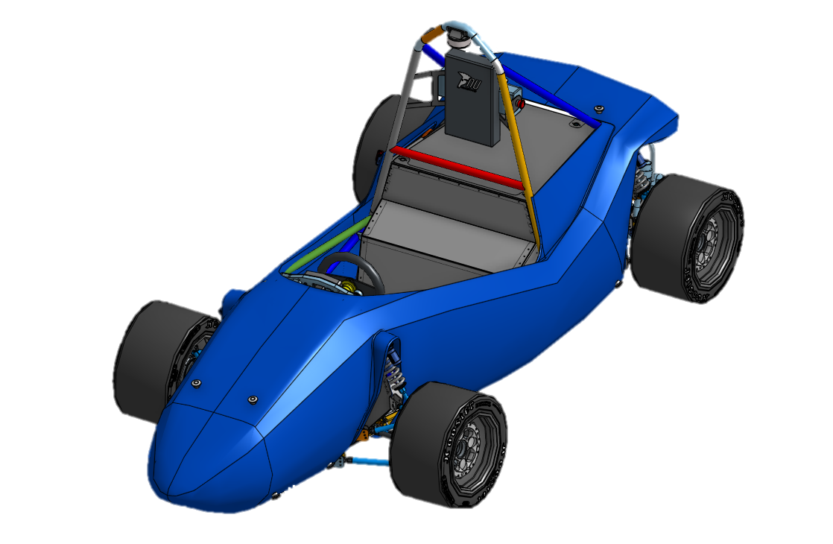
[First Author]
2025

Contents
List of Figures i
List of Tables i
Introduction 1
Justification 1
Design Judging Defence 1
Bill of Materials 1
Drawings 1
Calculations 2
Manufacturing 2
Iterations 2
Cost Report 2
Conclusions and Recommendations 2
Appendix 2

List of Figures
No table of figures entries found.

List of Tables
No table of figures entries found.

Author and Attribution Statement

We, the co-authors, attest that we each contributed to this report in the capacities listed below. We have ensured appropriate attribution (via bylines) to each author in relevant sections, have cited all work that is not our own and have acknowledged work by others where appropriate.

Task/Section | Author
Overall Manuscript Preparation and Oversight | [First Author]
Introduction | [Second Author]
…. | …
Section n | [nth Author]

Signed:
[First Author]
[Second Author]
…
[nth Author]

Introduction

By [Author n]
Introduce the system that this report details. Aim for 3-5 pages. Include pictures. A top-level description of the system and report.
- A good way to start is “This report details the design, manufacture and commissioning of the X system for EV.Three.”
- What is this system and what does it do?
- For the purpose of this report, what does this system entail/include and what is out of scope? Where should people go to learn about out of scope but connected things?
- What are they key features and specifications of this/the EV.Three system? Especially compared to other years/teams/automotive applications/etc.
- How was the system manufacutred? How did the design evolve over the development cycle/did substantial changes have to be made?
- What was the final performance of the system at the competition?

Initial System Design

By [Author n]
Describe the initial design of the system. Aim for 5-15 pages depending on system complexity. Include pictures/graphs/etc.
- Be sure to cite / pay reference to the original designers and their reports.
- Without direct quoting, try to capture the design process undertaken, key considerations/constraints and objectives.
- Feel free to point out potential flaws in the design, but don’t tear anybody down.
- Make very clear what was your work and what wasn’t.

Manufacturing

By [Author n]
Describe the manufacturing process for the system. Aim for 5-15 pages depending on system complexity.
- For most of you this was where you spent most of the year.
- Capture the complexities in manufacture. Where areas of the design aided/complicated this. Especially with multi-stage processes (e.g. Laser cut + machine + weld).
- If you contributed to manufacture (e.g. with jigs or directly) include this information too!

Commissioning/Validation

By [Author n]
Describe the process of validating that the system did the job it set out to do.
- This is the opportunity to include unit test plans / VCRMs etc.
- In some cases it will be a no-brainer (it didn’t break) –
  - Tell us the real-world circumstances under which it was tested
    - How many kms?
    - What conditions
    - Bumps/vibrations?
    - Loads?

Bill of Materials

By [Author n]
This section should include all the parts required to build the comp-ready version of this, ideally in a table. Include info such as:
- name,
- cost,
- quantity, and
- supplier (include a link if you have it).

Drawings/CAD/Schematics/Pinouts

By [Author n]
Include any sketches, manufacturing drawings, CAD model screenshots, schematics/pinout documents, where to find digital copies on onshape etc.

Compliance Report

By [Author n]
Evaluate the system with respect to the 2023 rules. What needs to change to maintain/become compliant?

Conclusions and Recommendations

Wrap up the main points of your work and explain how it all fits together. Summarise your recommendations for how to make this component/system and how to design and manufacture new versions of this in future.

Appendix
If there’s anything else you wanted to add, this is where you put it.

A landscape page if you needed to put large sketches and images here.
Just a portrait page after the landscape page if needed.

