

|  |  |  |  |
| --- | --- | --- | --- |
| Course Code | : |  | |
| Course Name | : |  | |
| Lecturer | : |  | |
| Academic Session | : |  | |
| Assessment Title | : |  | |
| Submission Due Date | : |  | |
| Prepared by |  |  | |
| : | Student ID | Student Name |
|  | SWE1909477 | Li Junyi |
| Date Received | : |  | |
|  |  |  | |
| Feedback from Lecturer:  Mark: | | | |

**Own Work Declaration**

I/We hereby understand my/our work would be checked for plagiarism or other misconduct, and the softcopy would be saved for future comparison(s).

I/We hereby confirm that all the references or sources of citations have been correctly listed or presented and I/we clearly understand the serious consequence caused by any intentional or unintentional misconduct.

This work is not made on any work of other students (past or present), and it has not been submitted to any other courses or institutions before.

Signature: 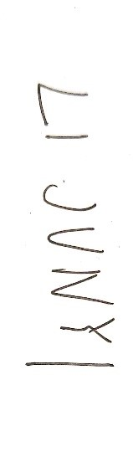

Date: