EE 4163/6163 Computer Hardware Techniques
Fall 2025
Project 2

AND Gate
The propagation delay of the 2-input AND gate was measured using Vivado’s post-implementation timing simulation.
For both rising edge (0→1) and falling edge (1→0) transitions of the inputs were analyzed.
Please find the below screenshots for reference:

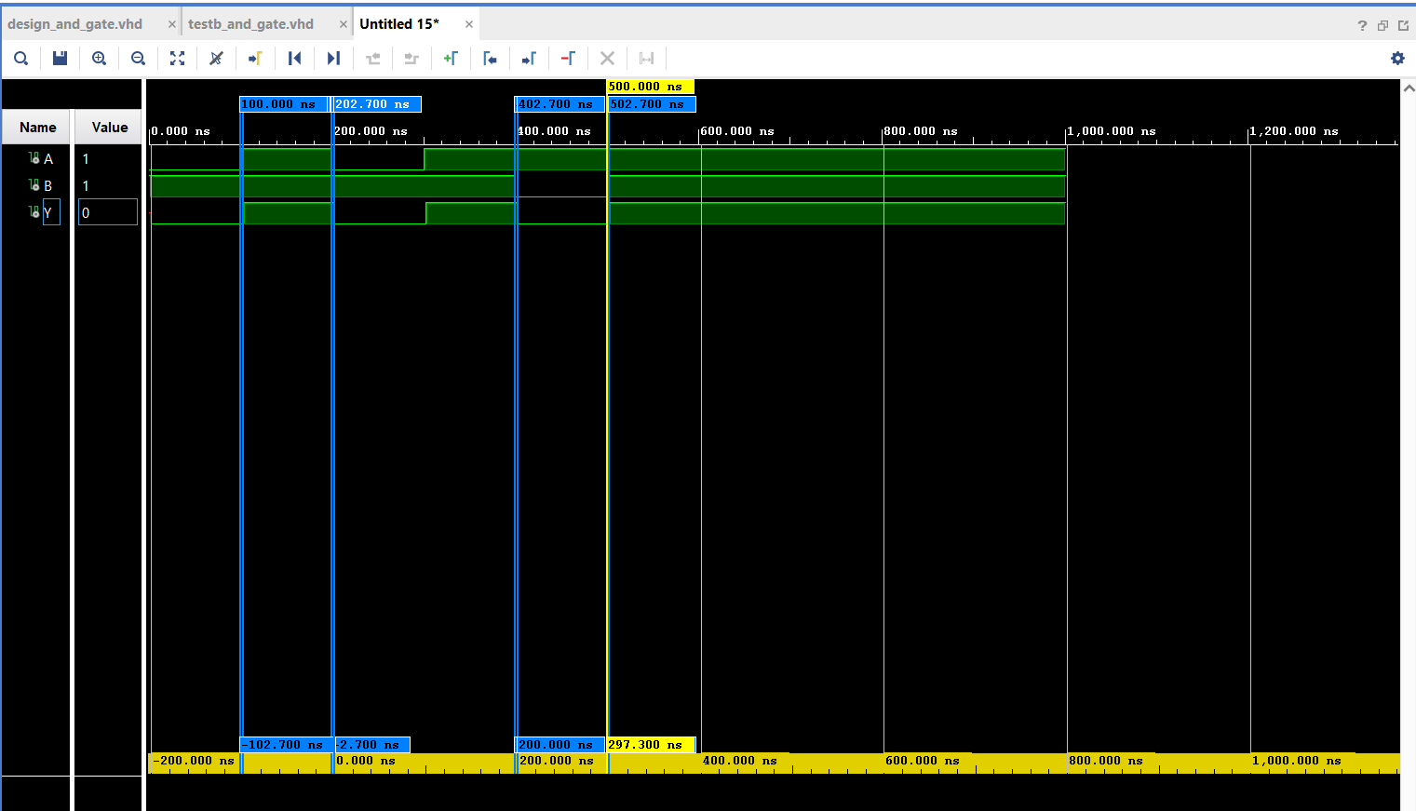

Measurement procedure:
- I/O and O/P signals were analyzed in the waveform window.
- Markers were placed appropriately at the input and its respective output transition.
- Propagation delay was calculated using the formula: tpd = toutput – tinput.

The analytics and its calculated results are as follows:
Propagation Delay Measurement

Input | Input Transition | Output Transition | Input Time (ns) | Output Time (ns) | Propagation Delay tpdt_{pd}tpd​ (ns)
A (and_orA) | 0->1 (Rising) | 0->1 (Rising) | 100,000 | 102,700 | 2,700
A (and_orA) | 1->0 (Falling) | 1->0 (Falling) | 200,000 | 202,700 | 2,700
B (and_orB) | 1->0 (Falling) | 1->0 (Falling) | 400,000 | 400,000 | 2,700
B (and_orB) | 0->1 (Rising) | 0->1 (Rising) | 500,000 | 500,000 | 2,700

OR GATE WAVE FRONT – POST TIME IMPLEMENTATION
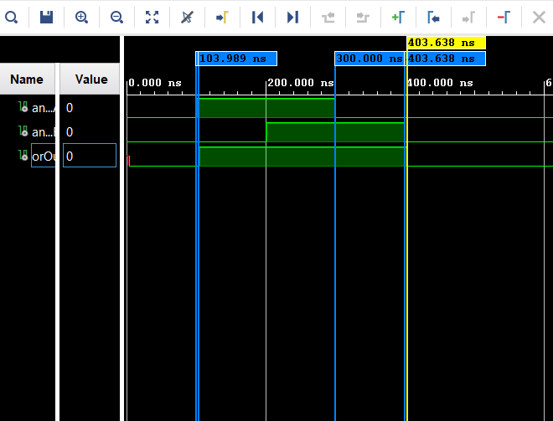

PROPAGATION DELAY MEASUREMENTS
1. Rising Edge (0 → 1)
Input | Edge Time (ns) | Output | Edge Time (ns) | Propagation Delay (ns)
and_orA | 100,000 | orOut | 103,989 | 3,989
and_orB | 200,000 | orOut | 403,638 | 203,638

- Rising edge of and_orB causes the output to rise after 203,638 ns, since it’s dependent on both inputs.
2. Falling Edge (1 → 0)
Input | Edge Time UOM ns | Output | Edge Time UOM (ns) | Propagation Delay UOM (ns)
and_orA | – | – | – | Could not (O/P Remains 1 since and_orB = 1)
and_orB | 400,000 | orOut | 403,638 | 3,638

NAND GATE PROPAGATION DELAY MEASUREMENT:
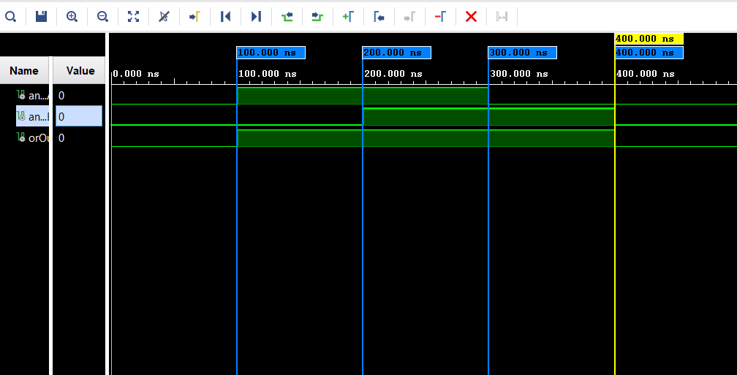

NOR GATE
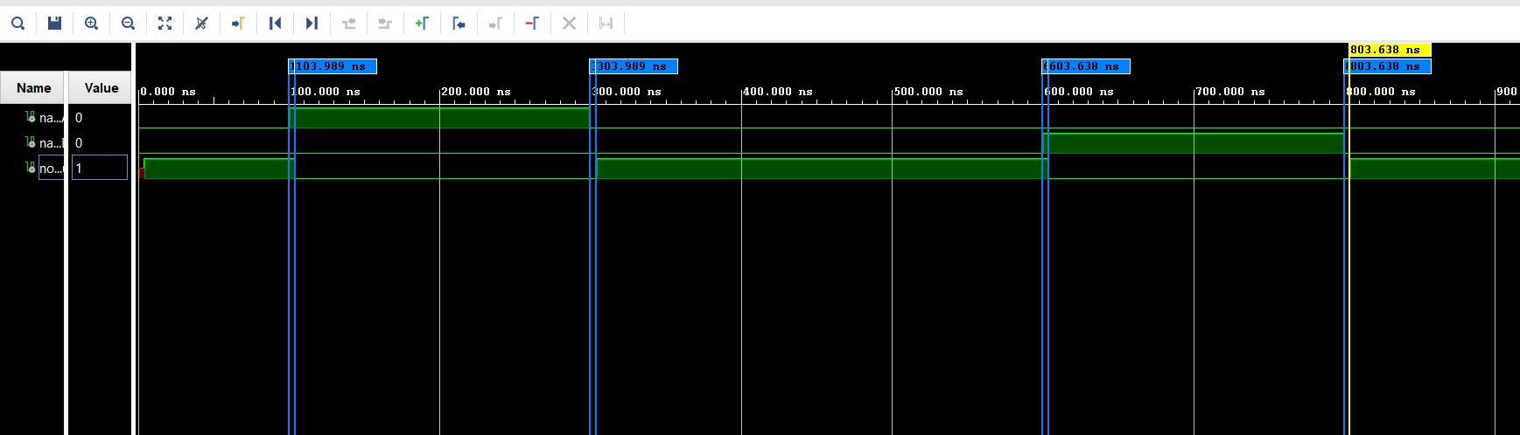

PROPAGATION DELAY MEASUREMENT
Input Condition / Event | Input Edge Time (ns) | Output Event | Output Edge Time (ns) | Propagation Delay (ns)
Initial state: nand_norA = 0, nand_norB = 0 | — | norOut (Rise) | 3.989 | 3.989
nand_norA Fall | 100.000 | norOut (Rise) | 103.989 | 3.989
nand_norA Rise | 300.000 | norOut (Fall) | 303.989 | 3.989
nand_norB Rise | 600.000 | norOut (Fall) | 603.638 | 3.638
nand_norB Fall | 800.000 | norOut (Rise) | 803.638 | 3.638

XOR GATE SIMULATION WAVEFORM – POST TIME IMPLEMENTATION
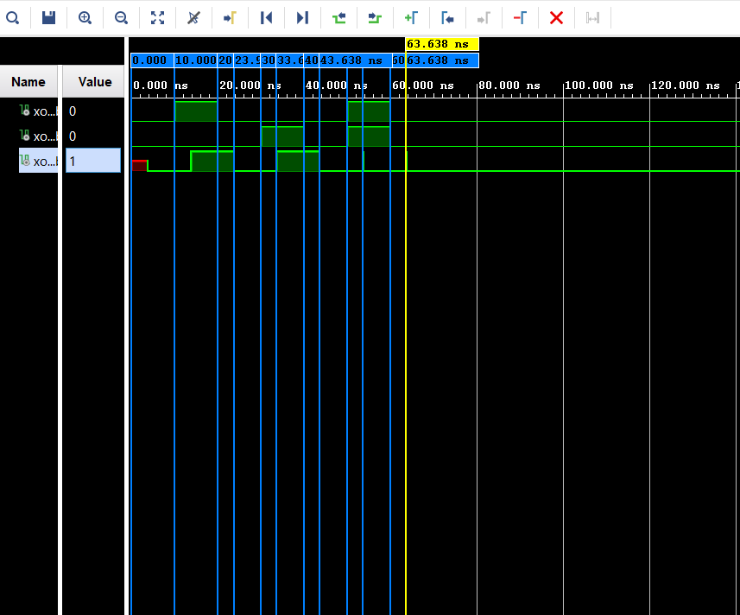

XOR PROPAGATOIN DELAY MEASUREMENTS
I/O | I/P Event | I/P Time (ns) | O/P Event | O/P Time (ns) | Propagation Delay (ns)
xorA | Rising edge | 10.000 | xorOut rises | 13.989 | 3.989
xorA | Falling edge | 20.000 | xorOut falls | 23.989 | 3.989
xorA | Rising edge | 50.000 | xorOut rises | 53.638 | 3.638
xorA | Falling edge | 60.000 | xorOut rises | 63.638 | 3.638
xorB | Rising edge | 30.000 | xorOut rises | 33.638 | 3.638
xorB | Falling edge | 40.000 | xorOut falls | 43.638 | 3.638
xorB | Rising edge | 50.000 | xorOut rises | 53.638 | 3.638
xorB | Falling edge | 60.000 | xorOut rises | 63.638 | 3.638

XNOR GATE – POST IMPLEMENTION SIMULATION WAVEFORM
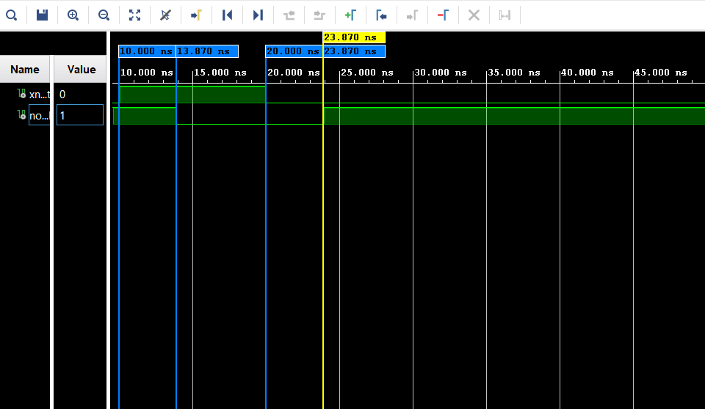

XNOR PROPAGATION DELAY MEASUREMENT
I/P (xnorB) | O/P (notOut) | Edge Type (Input → Output) | Time (ns) | Propagation Delay (ns)
Rising | Falling | 0 → 1 input → 1 → 0 output | 13.870 | 3.870
Falling | Rising | 1 → 0 input → 0 → 1 output | 23.870 | 3.870

