**Sprint 1 Plan**

**“DeliverMe”**

Jeffrey Chan (PO)

Daniel Tjandra (Scrum Master)

Avery Sio

Brian Wan

Hasaan Javed

Justin Lau

**Sprint completion date:** Feb 5, 2018

**Revision date:** Jan 22, 2018

**Goal:** To implement a “transactions page” that consist of real time updates conveying locations of requesters and drivers.

**Task:**

1. (8) As a casual user, I want an aesthetically pleasing interface so that I can easily navigate the website regardless of my computer literacy.
   1. Task 1: Learning Django framework
   2. Task 2: Learning HTML/CSS
   3. Task 3: Making sure that everyone agrees on a website structure
2. (5) As a new user, I want to be given the opportunity to view a tutorial so that I can fully utilize the application.
   1. Task 1: Discuss with team members on what to put onto tutorial
   2. Task 2: Discuss with team members on what UI to include

**Team Members and Role:**

Daniel Tjandra - Scrum Master, Designer

Justin Lau - Programmer

Hasaan Javed - Programmer

Brian Wan - Programmer

Jeffrey Chan: Product Owner

Avery Sio: Programmer

**Task Assignments:**

Daniel Tjandra: U1-Django Setup Environment

Justin Lau: U1-Bootstrap

Hasaan Javed: U1-HTML/CSS

Brian Wan: U1-HTML/CSS

Jeffrey Chan:U1-HTML/CSS

Avery Sio: U1-Django Setup Environment

**Burnup Chart Plan:**

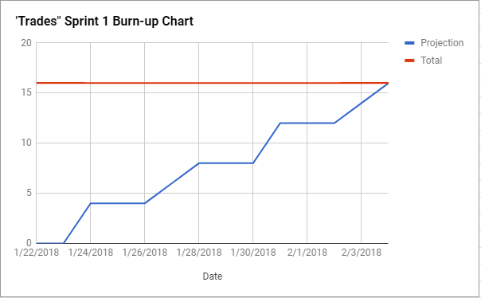

**Initial Scum Board:**

<https://trello.com/b/StPvbOqY/cmps-183-scrum-board>

**Scrum Times:**

Wednesdays 4-8PM

Sat, Sun 1-3PM