**ASSIGNMENT #1**

Lucas Krespi dos Santos

Julian Escobar Echeverri

George Brown College

CRN-49578: ADVANCED GRAPHICS PROGRAMMING

Instructor: Hooman Salamat

February 11, 2021

Contents

1.CASTLE DESIGN 3

1.1Blender model 3

1.2Turrets Broken down 3

1.3Tile Map 4

2.DIRECTX RESULT 5

Figure Table

Figure 1 - Castle Blender Model 3

Figure 2 - Turret Primitives 3

Figure 3 - Tile map txt file 4

Figure 4 -Final Castle Wireframe 5

Figure 5 - Final Castle 5

# CASTLE DESIGN

## Blender model

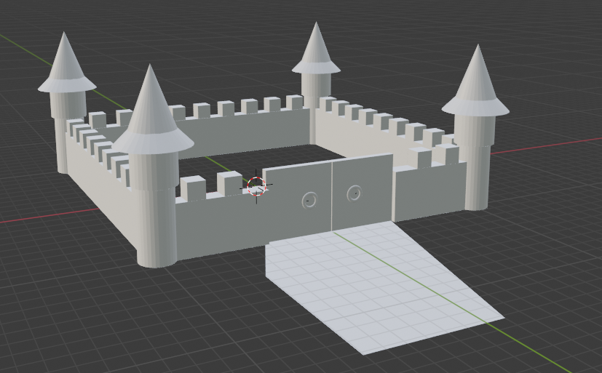

Figure 1 - Castle Blender Model

## Turrets Broken down

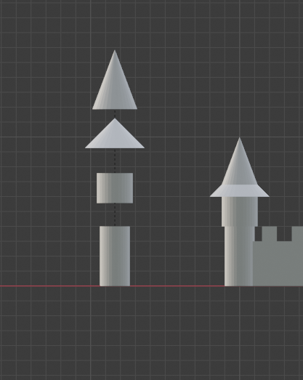

Figure - Turret Primitives

## Tile Map

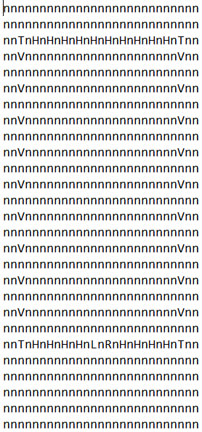

Figure 3 - Tile map txt file

**Where:**

n = empty.

T = turret.

H = Horizontal Wall.

V = Vertical Wall.

L = Left Gate.

R = Right Gate.

Obs: The tiles have an “n” in the middle because in our program walls, turrets and the gate have the size of 2 units.

# DIRECTX RESULT

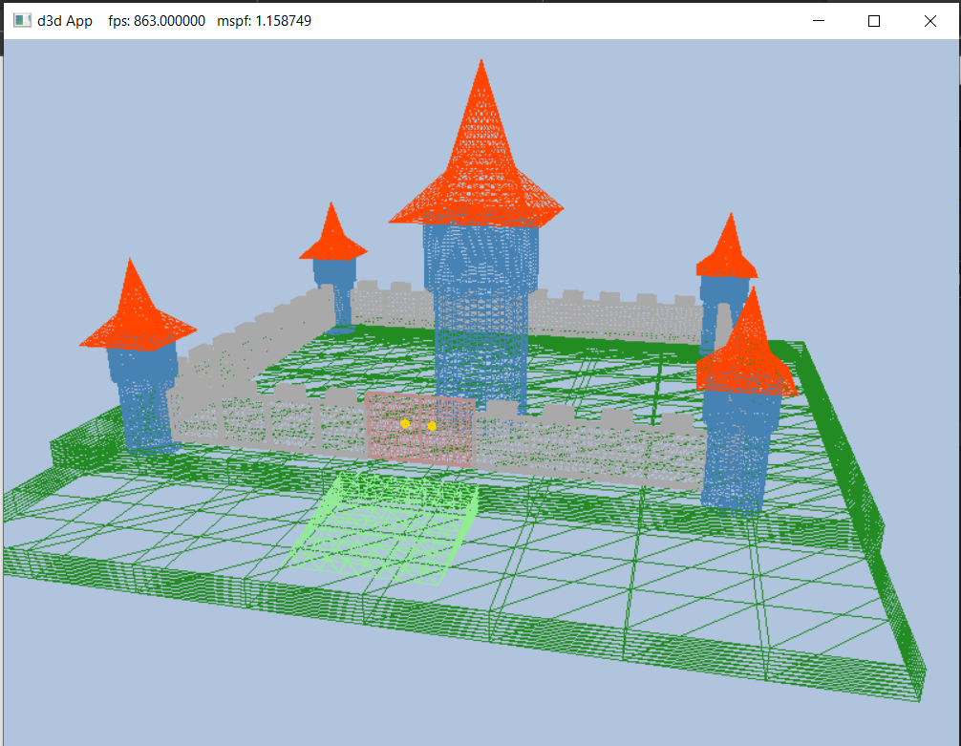

Figure 4 -Final Castle Wireframe

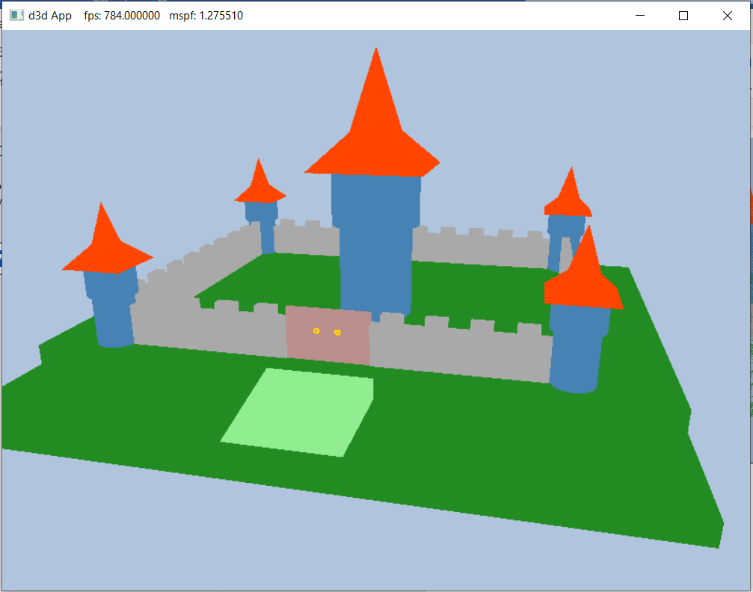

Figure - Final Castle