Project PlaylistApp

Team member:
Lan Luo: julerrie@bu.edu
Yang Ming: yang17@bu.edu
Ziang Xu: zax761@bu.edu
Shuai Han: shuaihan@bu.edu

Summary:
Create a popular playlist application that accepts song playlists along with their popularities, stores the most popular 1024 playlists, and i) suggests playlists given a song and ii) suggests songs when the user starts typing a song name.

App form: website
Reason: Simple, appropriate to accomplish the functions

Using language: Python
Reason: Simple, all members have background of python

Accomplishment:
Until recent days, we have made a simple website and designed algorithms to sort the songs and playlists and search them.

- Algorithm:
- Restore:
We decided to use dictionary to accomplish restoring the data.
- Sort: using quicksort
Quicksort has a higher efficiency in most cases and it causes less data movement.
- Search: using trie
Advantages of trie:
The lookup time is predictable which is O(k) where k is the size of keys;
Lookup can take less than k time if the song we look up is not in the dictionary;
Deletion is straightforward in trie;
We can quickly look up prefixes of keys, enumerate all entries with a given prefix. This is very suitable for accomplish the searching function of the project.

- Website:
Webpage 1:


Webpage 1 gives the function of searching a song on the top and the function of making a new playlist in the medium and shows top 8 most popular playlists on the bottom.
Webpage 2:
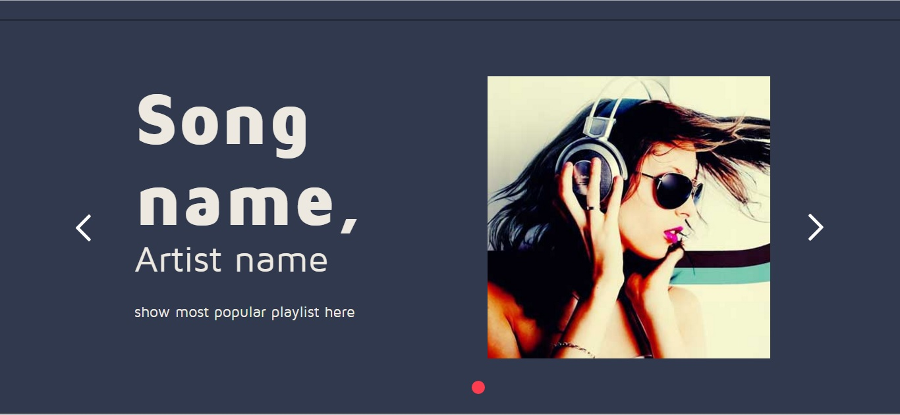
Webpage 2 shows the most popular playlist the song searched in webpage 1 is in.
Webpage 3:


Webpage 3 gives the function of adding the song searched in webpage 1 into user’s own playlist on the top and shows the most popular playlist the song is in on the bottom.
- Database:
We have set up the environment of the database, we are going to add the data in it in the few days.

Plan:
- Finish the program
- Accomplish design and layout of the website
- Transmit the data into the database and upload it into AWS
- Connect the website with the program

