Activity · React JS + PHP + MySQL

Medicine Management
Create, Read, Update and Delete (CRUD) of medicine records

Name | Jules Aron P. Timbas
Section | INF241
Database | dbPharma
Table | tblMedicine

Contents
1 Database – dbPharma.sql and tblMedicine Figures 1–2
2 PHP API – db.php and index.php (htdocs/api) Figures 3–7
3 React JS – App.jsx Figures 8–14
4 Output – Create, Read, Update and Delete in the browser Figures 15–22
5 Database after the CRUD operations Figure 23

tblMedicine structure
Column | Data type | Constraints
id | INT UNSIGNED | PRIMARY KEY, AUTO_INCREMENT, NOT NULL
brand_name | VARCHAR(100) | NOT NULL
generic_name | VARCHAR(100) | NOT NULL
date_manufactured | DATE | NOT NULL
date_expired | DATE | NOT NULL, CHECK (date_expired > date_manufactured)
manufacturer | VARCHAR(150) | NOT NULL
batch_number | VARCHAR(50) | NOT NULL, UNIQUE
Screenshots are full screen (1920 × 1080). The code is shown in the editor; the output is the React app running at localhost:5173 with the PHP API at localhost/api/index.php.

Part 1 · Database

Figure 1. database/dbPharma.sql
Creates the dbPharma database, the tblMedicine table (data types and constraints) and 5 sample records.
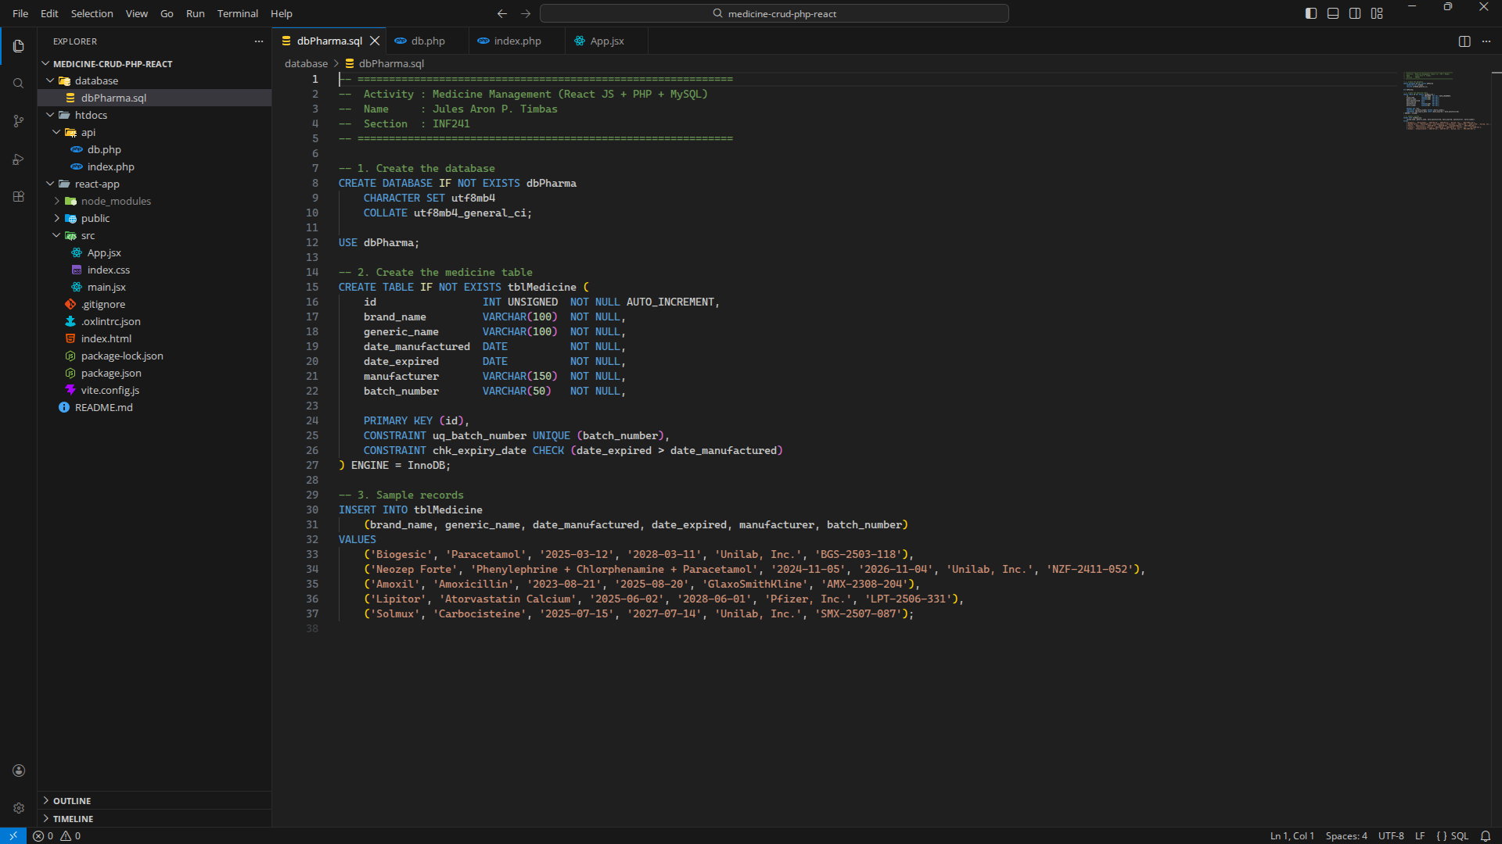
Part 1 · Database

Figure 2. tblMedicine in MySQL (MariaDB)
DESCRIBE shows the data types; the PRIMARY KEY, UNIQUE and CHECK constraints are listed with the sample records.
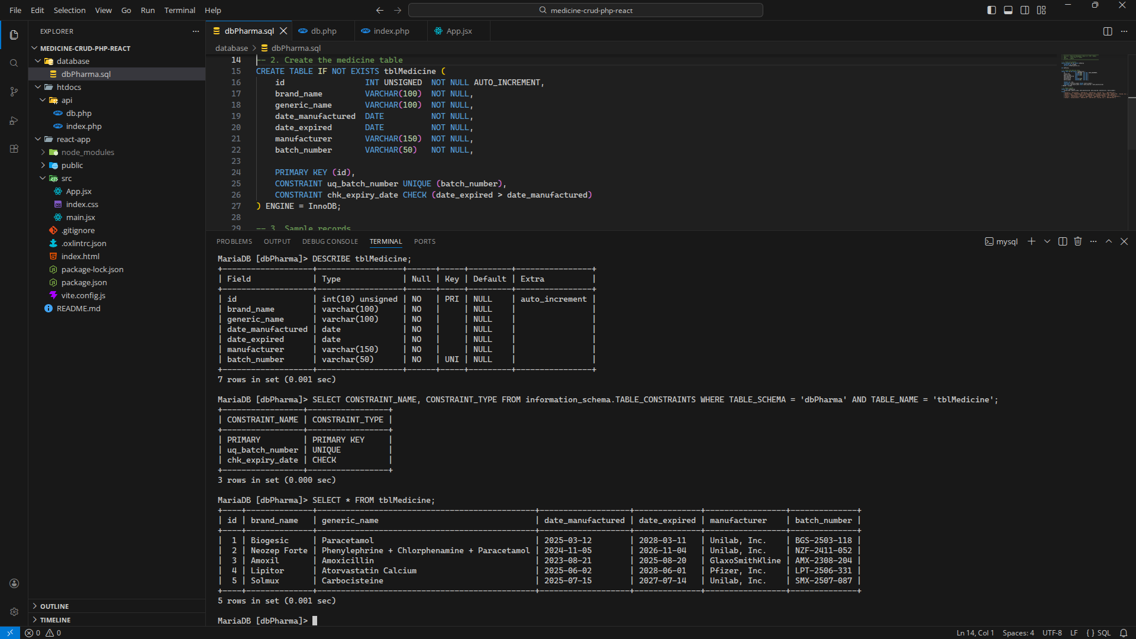
Part 2 · PHP API

Figure 3. htdocs/api/db.php
CORS / JSON headers and the PDO connection to the dbPharma database.
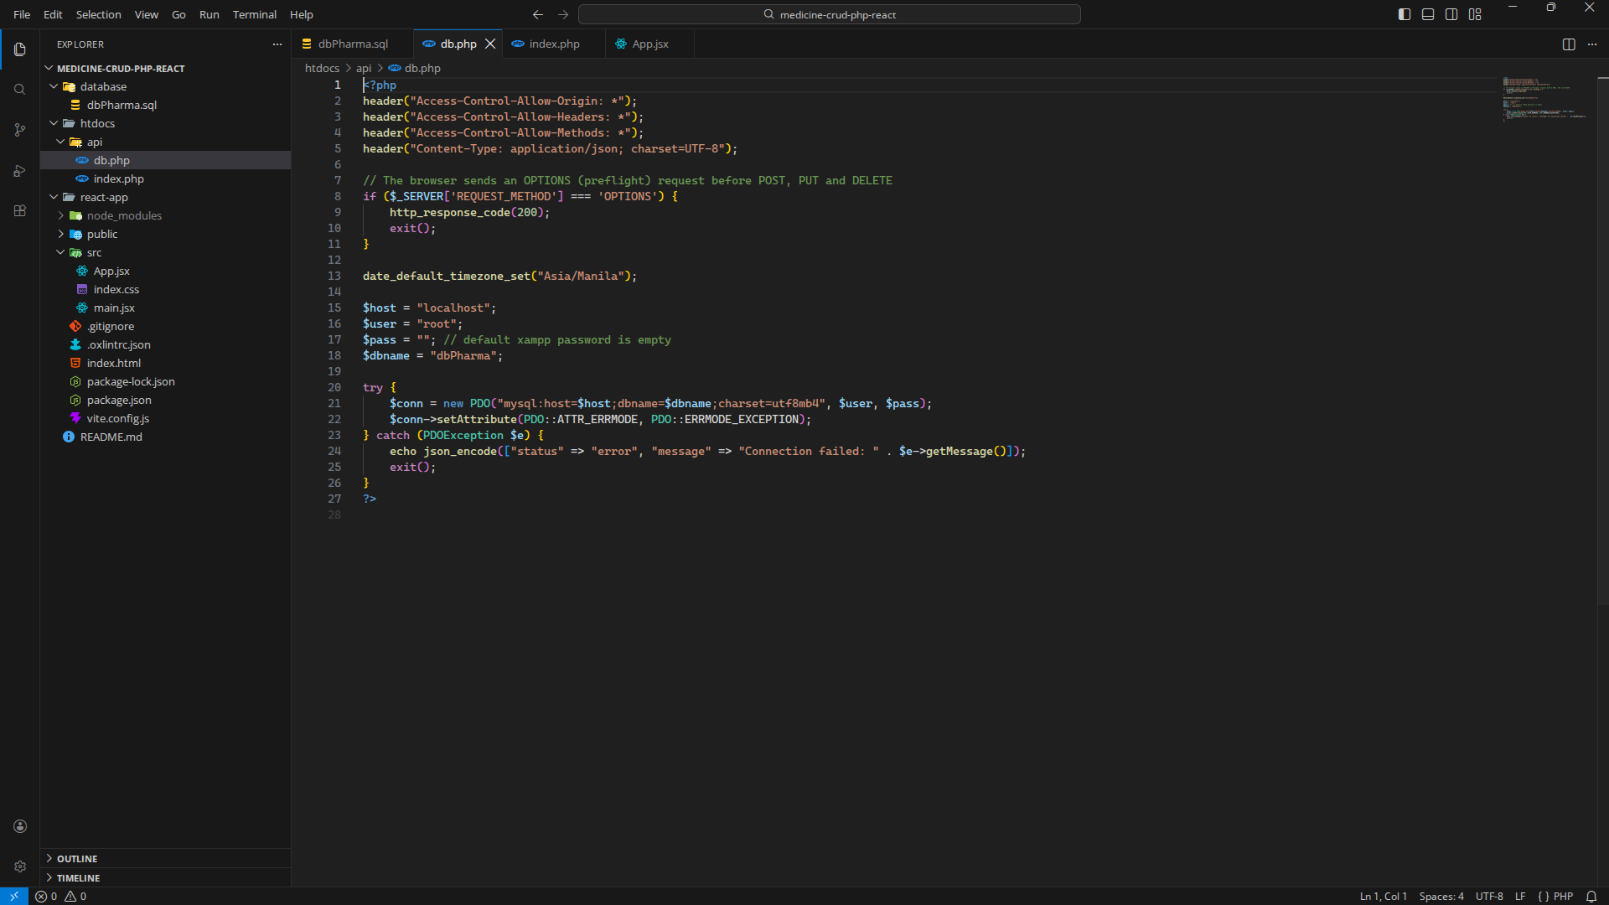
Part 2 · PHP API

Figure 4. htdocs/api/index.php (1 of 4) – lines 1–50
Reads the medicine data sent by React and validates every field.
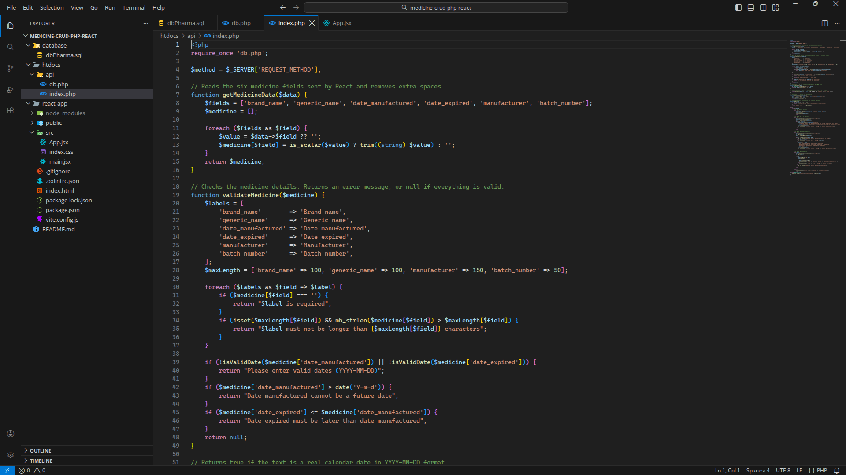
Part 2 · PHP API

Figure 5. htdocs/api/index.php (2 of 4) – lines 51–100
Helper functions, READ (GET) and CREATE (POST).
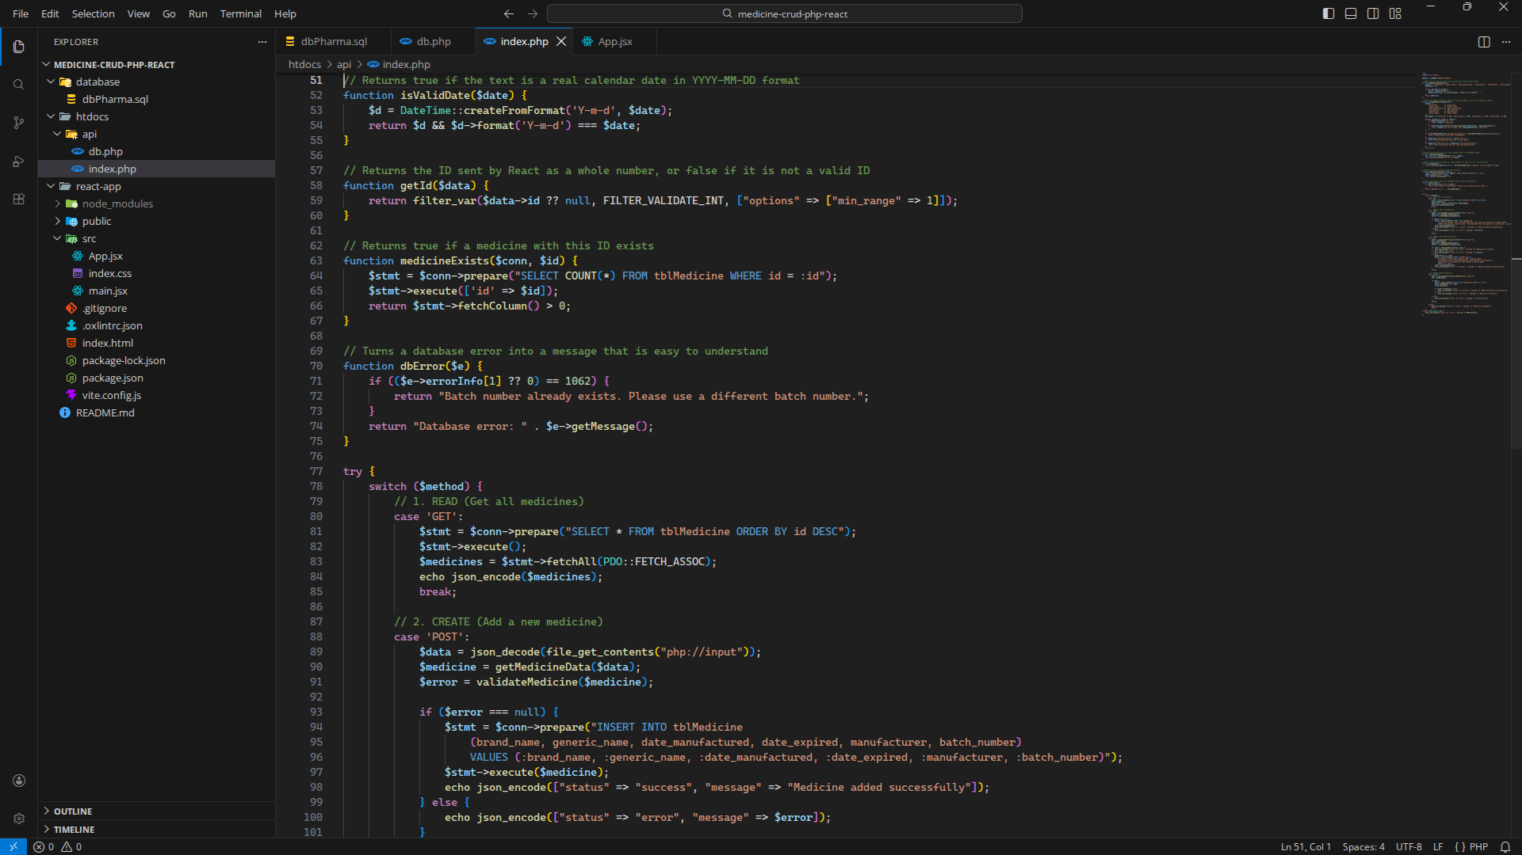
Part 2 · PHP API

Figure 6. htdocs/api/index.php (3 of 4) – lines 87–136
CREATE (POST) and UPDATE (PUT).
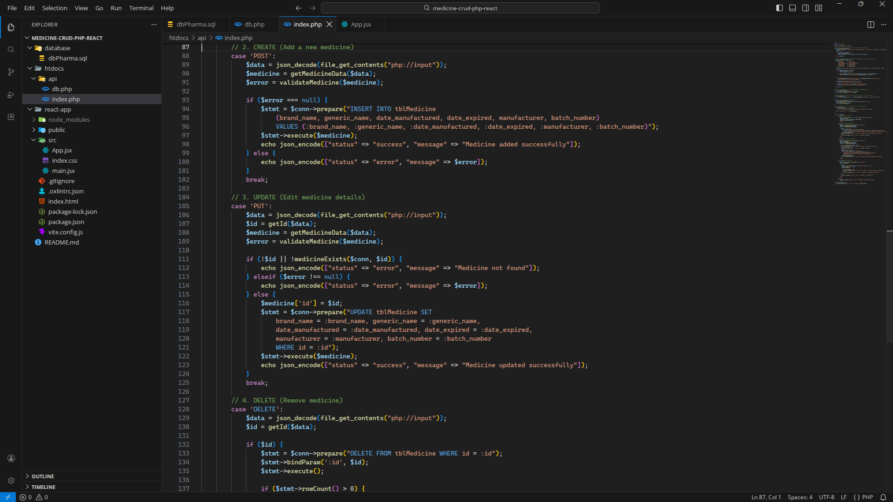
Part 2 · PHP API

Figure 7. htdocs/api/index.php (4 of 4) – lines 127–154
DELETE and database error handling.
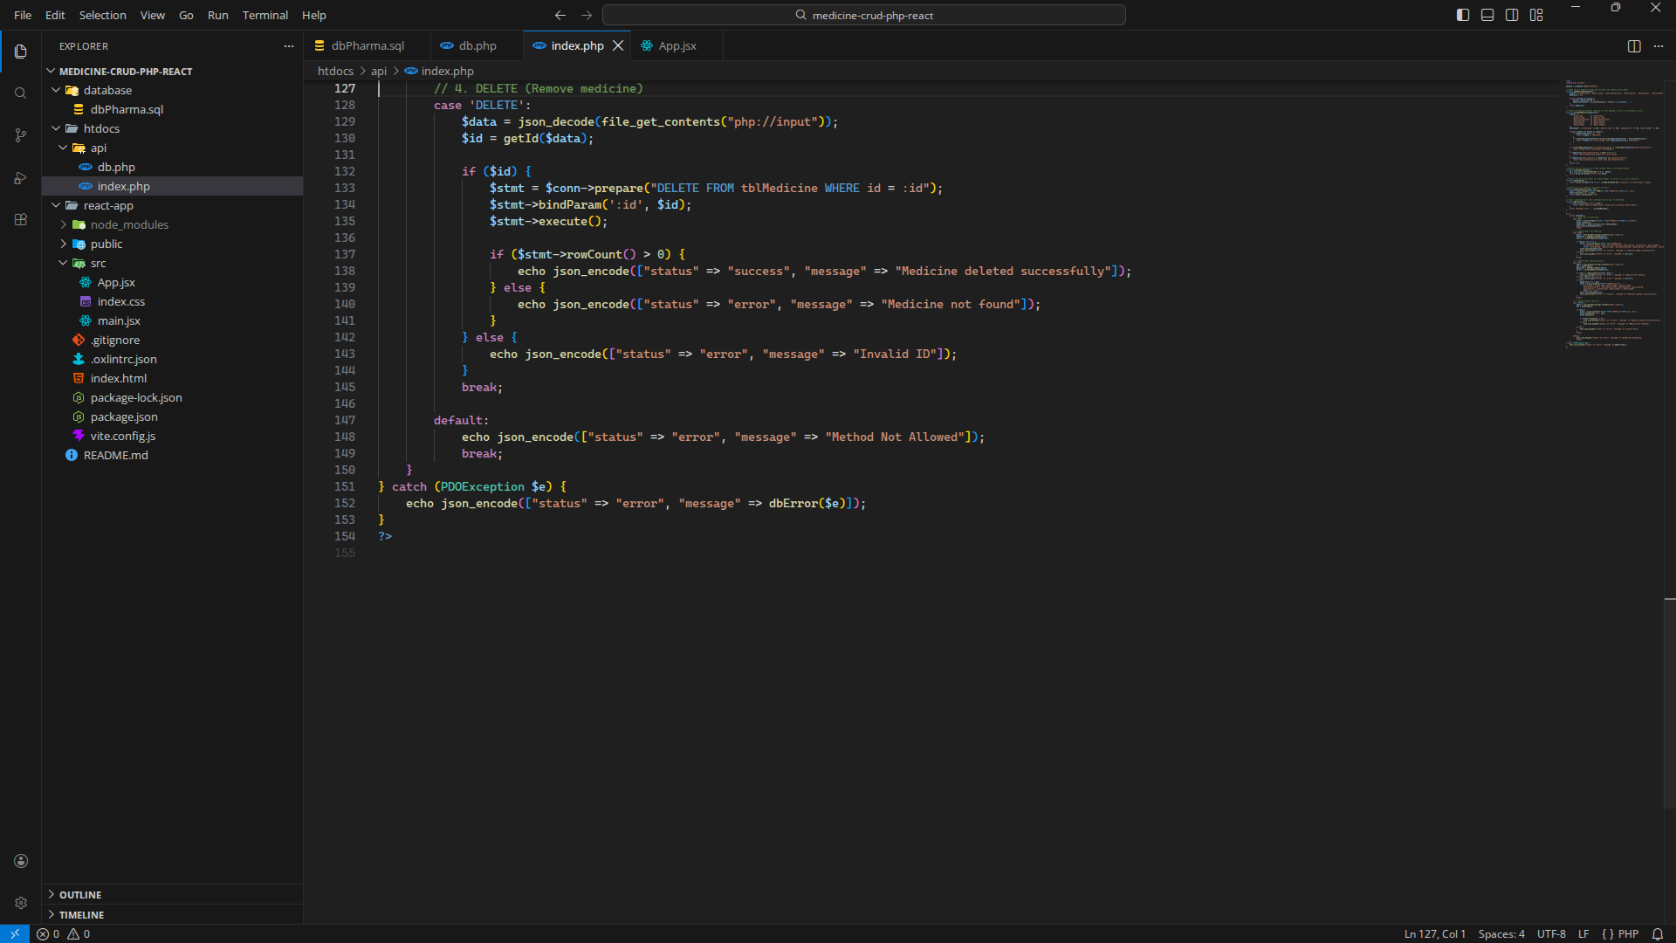
Part 3 · React JS

Figure 8. react-app/src/App.jsx (1 of 7) – lines 1–50
API URL, form fields, date helpers and expiry status.
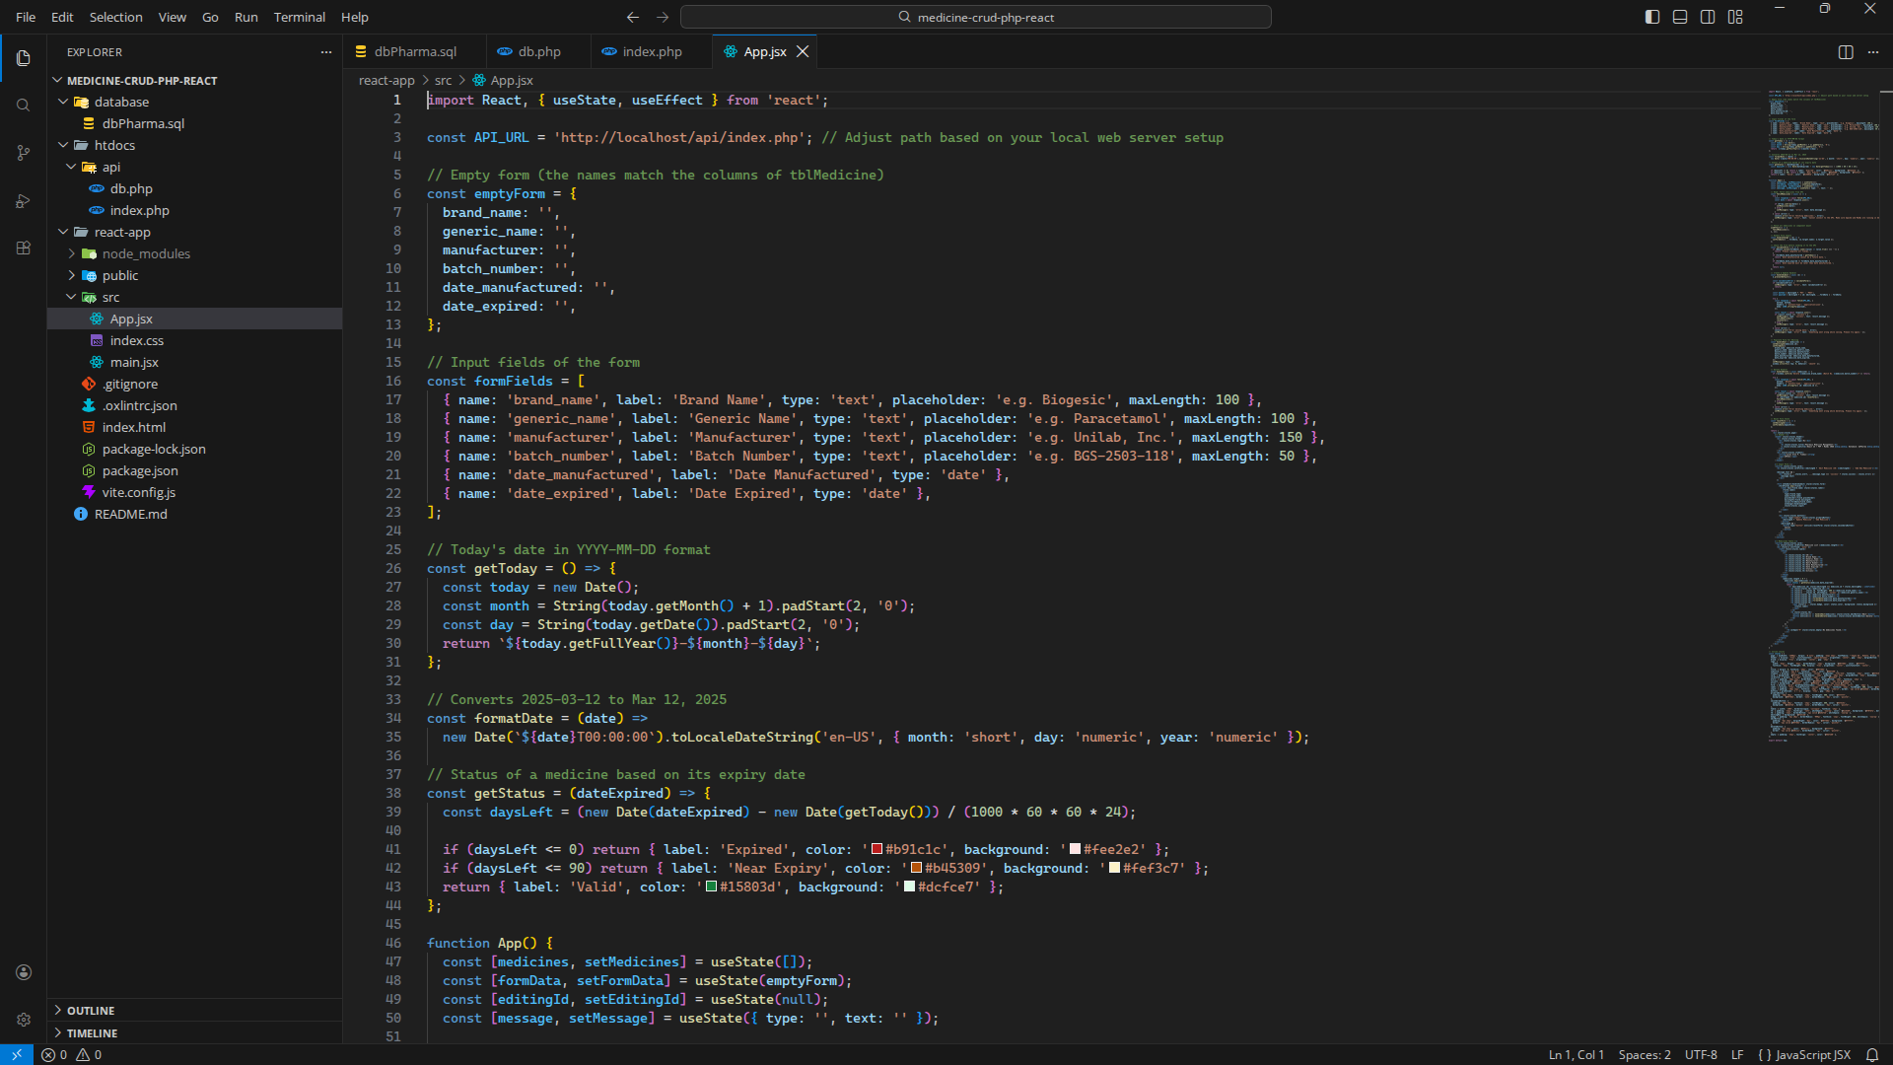
Part 3 · React JS

Figure 9. react-app/src/App.jsx (2 of 7) – lines 52–101
READ: fetch the medicines from the API; form validation.
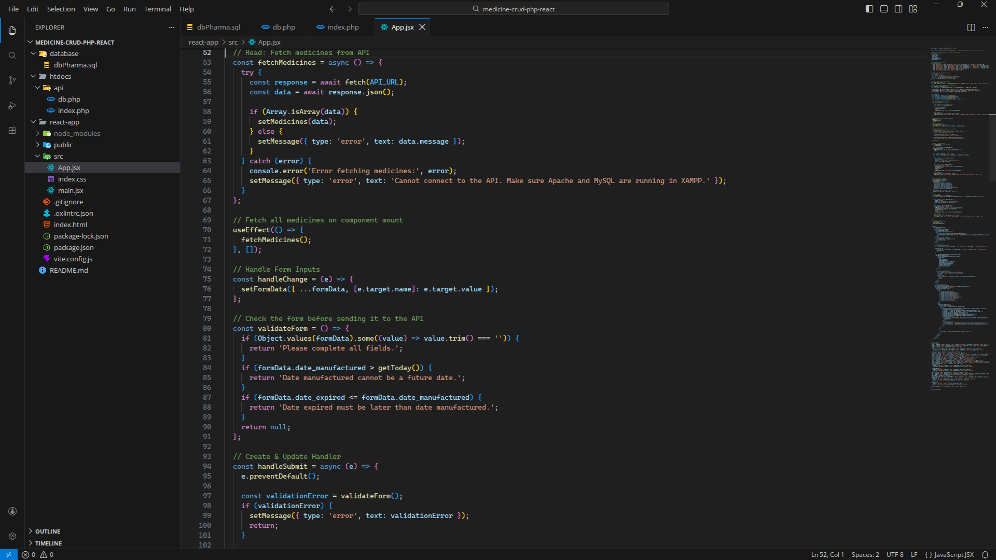
Part 3 · React JS

Figure 10. react-app/src/App.jsx (3 of 7) – lines 93–142
CREATE & UPDATE: send the form to the API (POST / PUT); load a medicine into the form for editing.
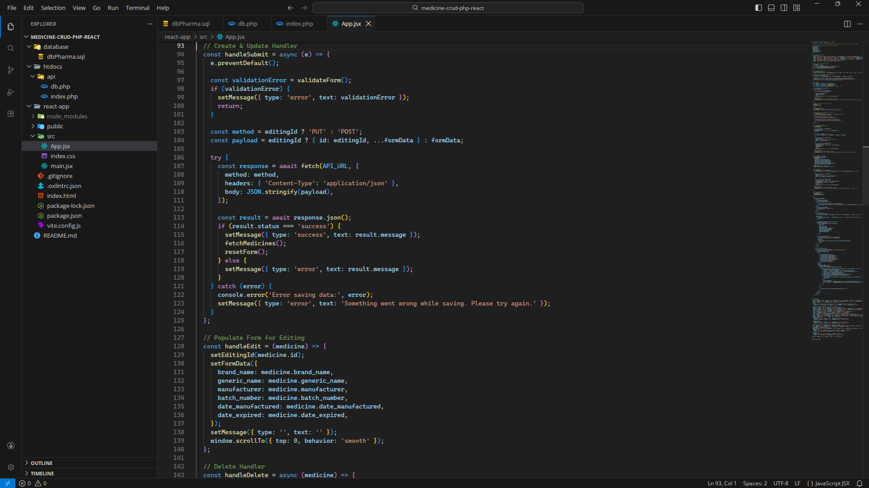
Part 3 · React JS

Figure 11. react-app/src/App.jsx (4 of 7) – lines 142–191
DELETE: remove a medicine (DELETE); reset the form; page header.
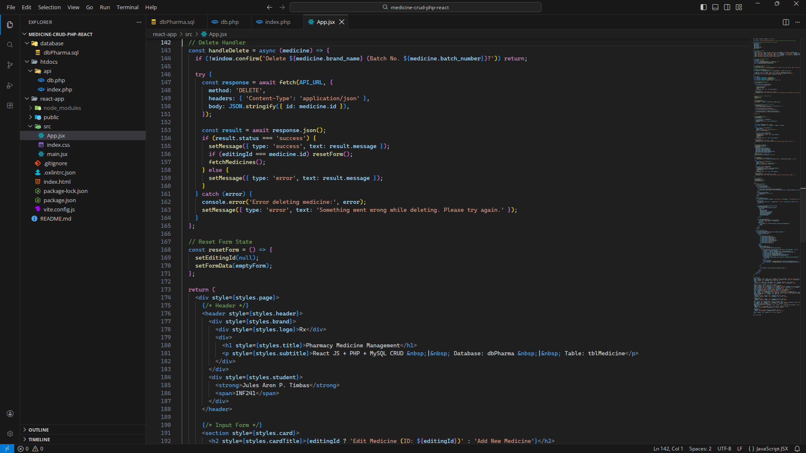
Part 3 · React JS

Figure 12. react-app/src/App.jsx (5 of 7) – lines 190–239
Add / Edit medicine form.
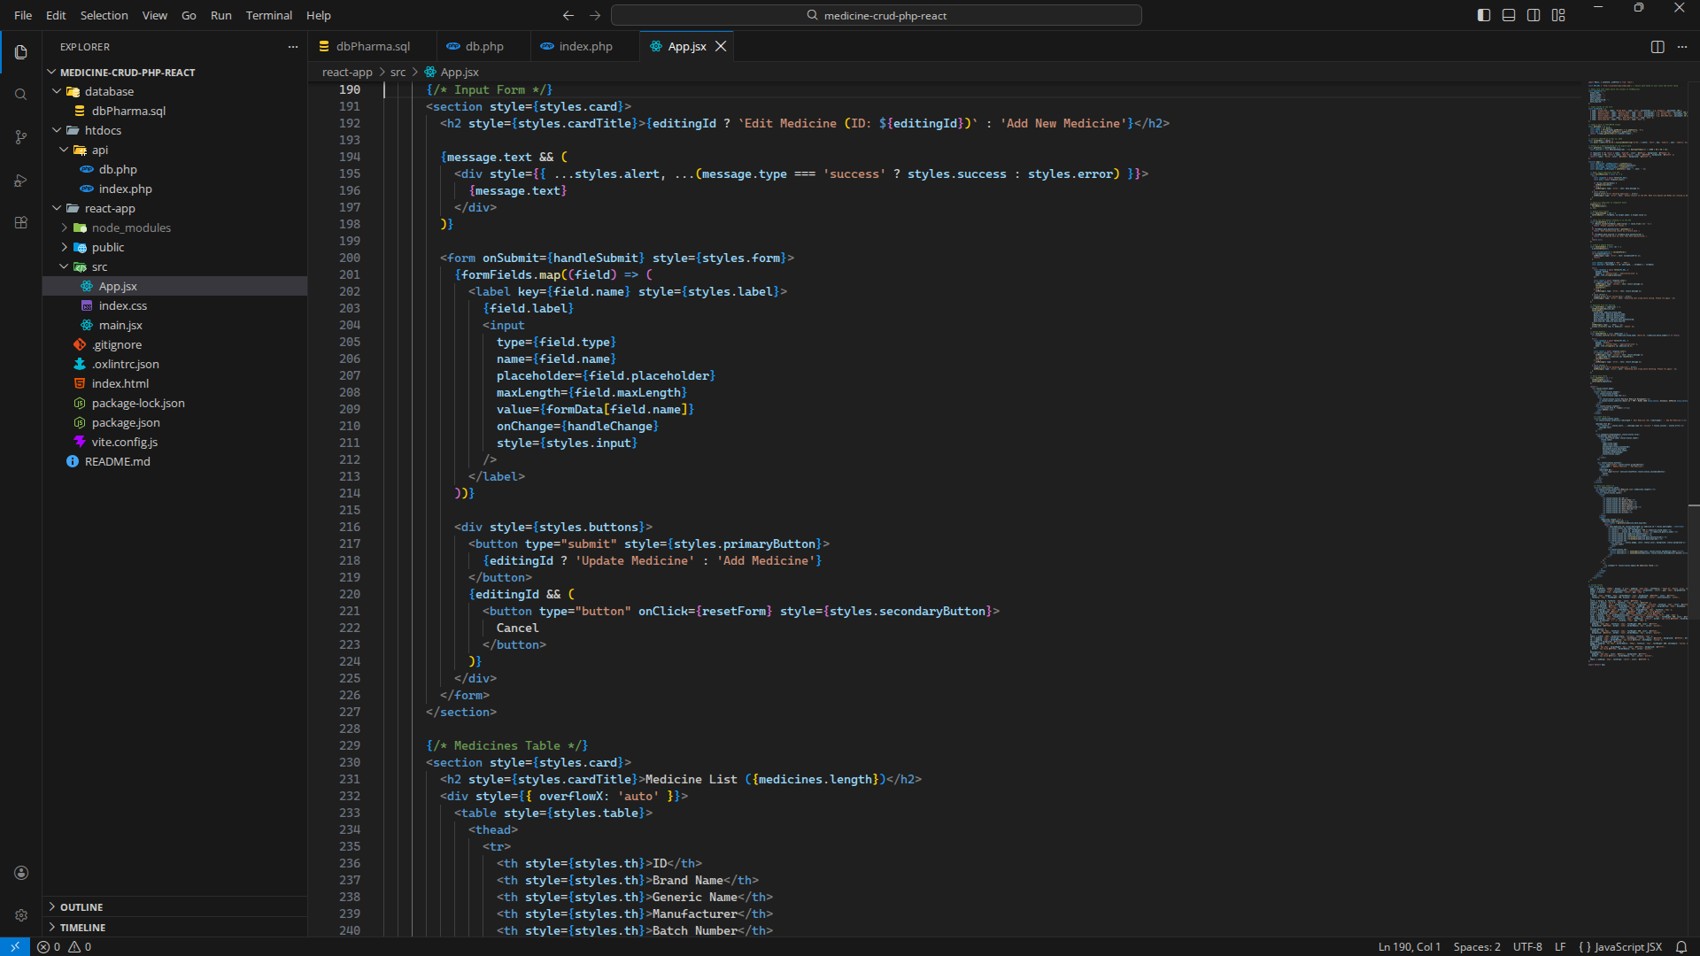
Part 3 · React JS

Figure 13. react-app/src/App.jsx (6 of 7) – lines 231–280
Medicine list table with Edit and Delete buttons.
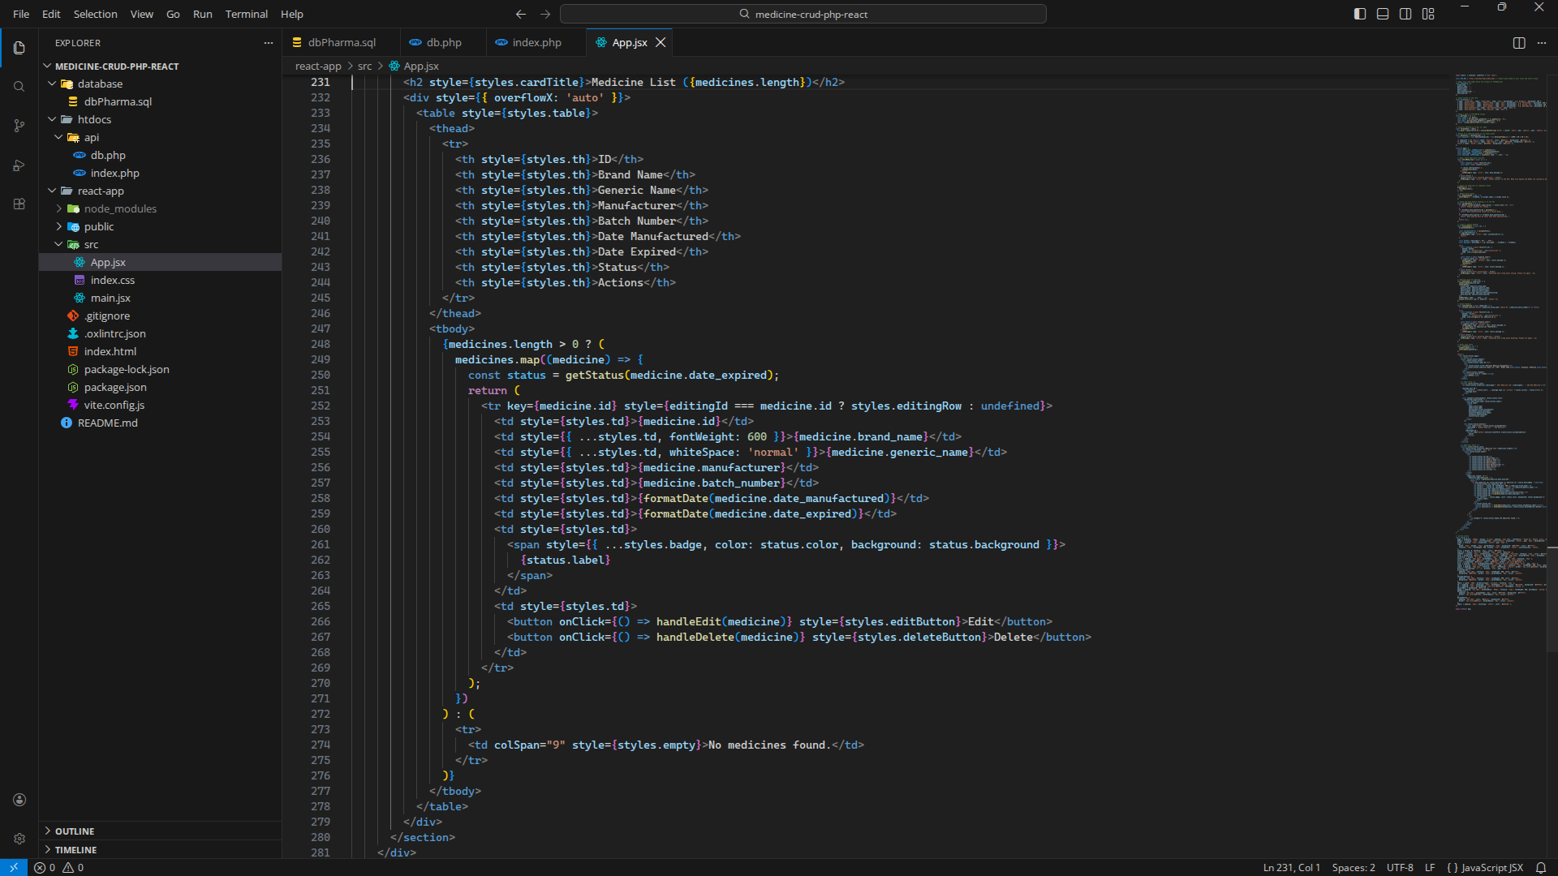
Part 3 · React JS

Figure 14. react-app/src/App.jsx (7 of 7) – lines 281–330
Inline styles.
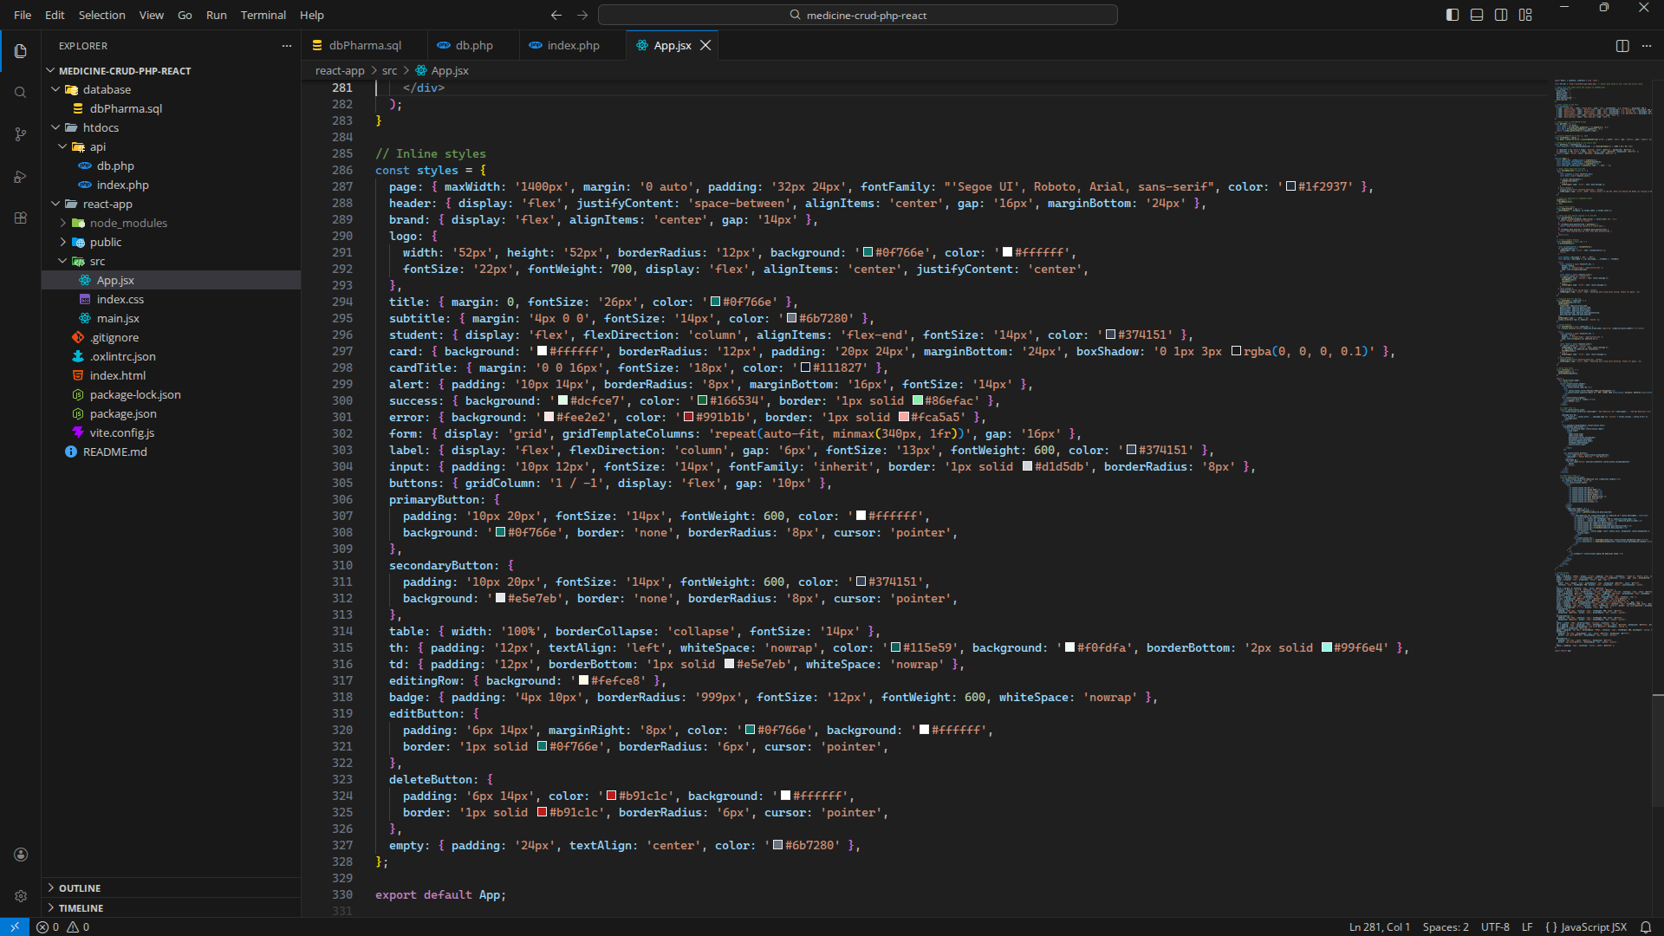
Part 4 · Output (CRUD in the browser)

Figure 15. READ – medicine list
All records of tblMedicine are loaded from the PHP API when the page opens.
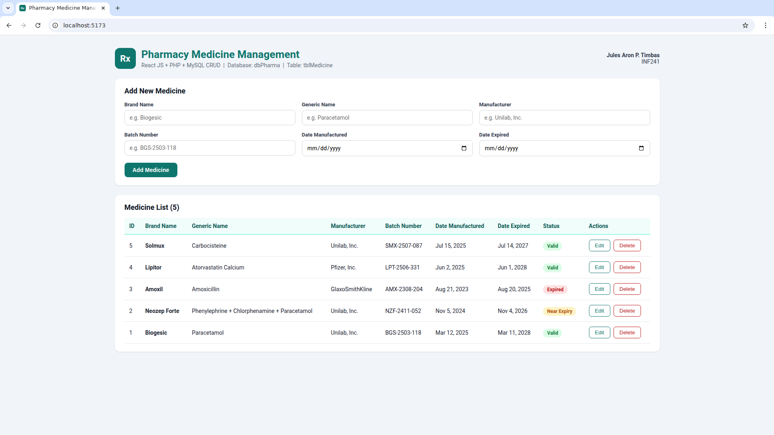
Part 4 · Output (CRUD in the browser)

Figure 16. CREATE – filling in a new medicine
Brand name, generic name, manufacturer, batch number and dates of a new medicine.
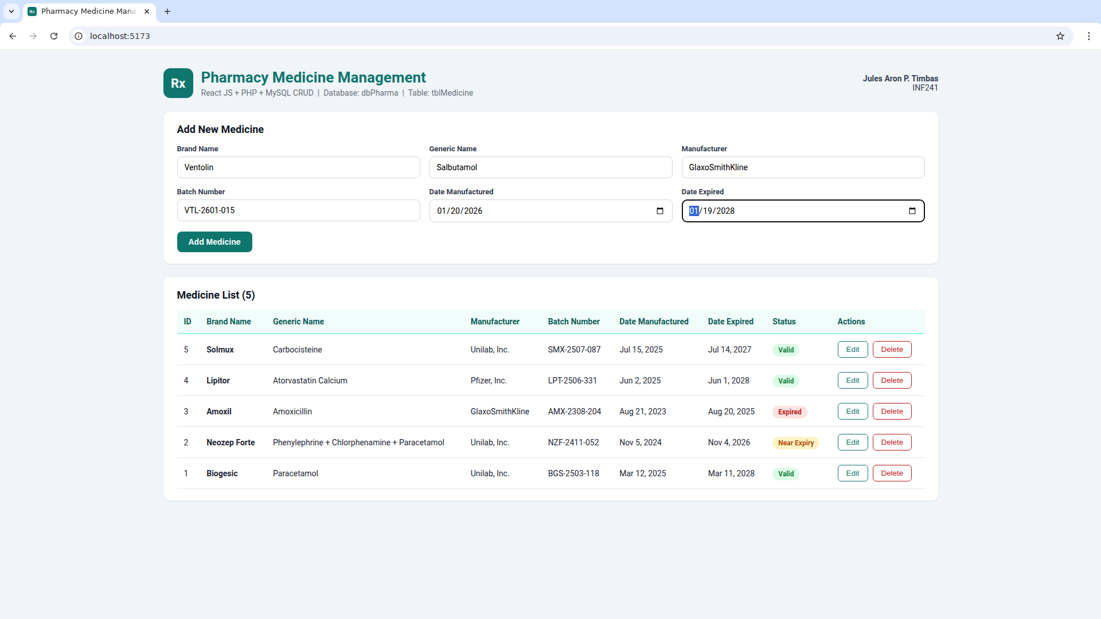
Part 4 · Output (CRUD in the browser)

Figure 17. CREATE – medicine added
The new medicine (ID 6) is saved and shown at the top of the list.
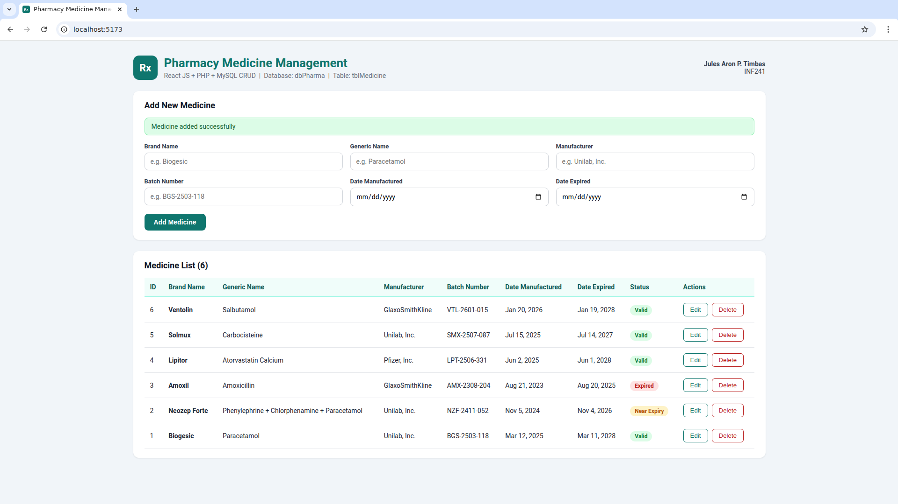
Part 4 · Output (CRUD in the browser)

Figure 18. UPDATE – editing a medicine
Clicking Edit loads the record into the form; the generic name is changed.
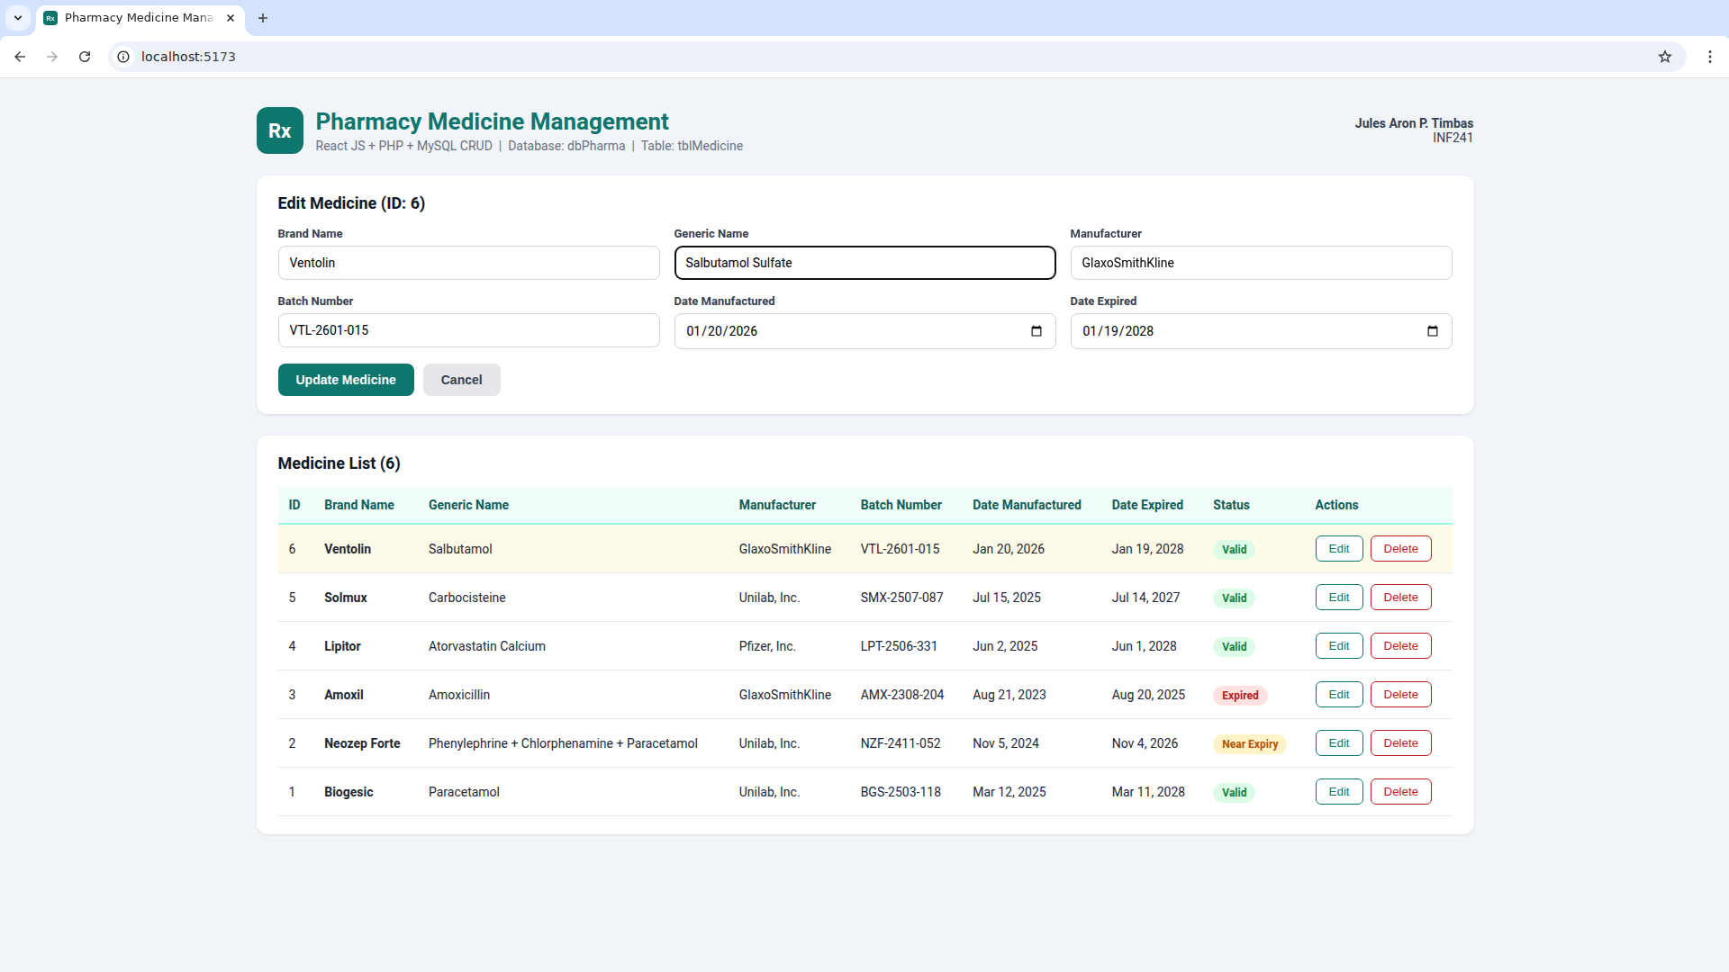
Part 4 · Output (CRUD in the browser)

Figure 19. UPDATE – medicine updated
The change is saved in the database and shown in the list.
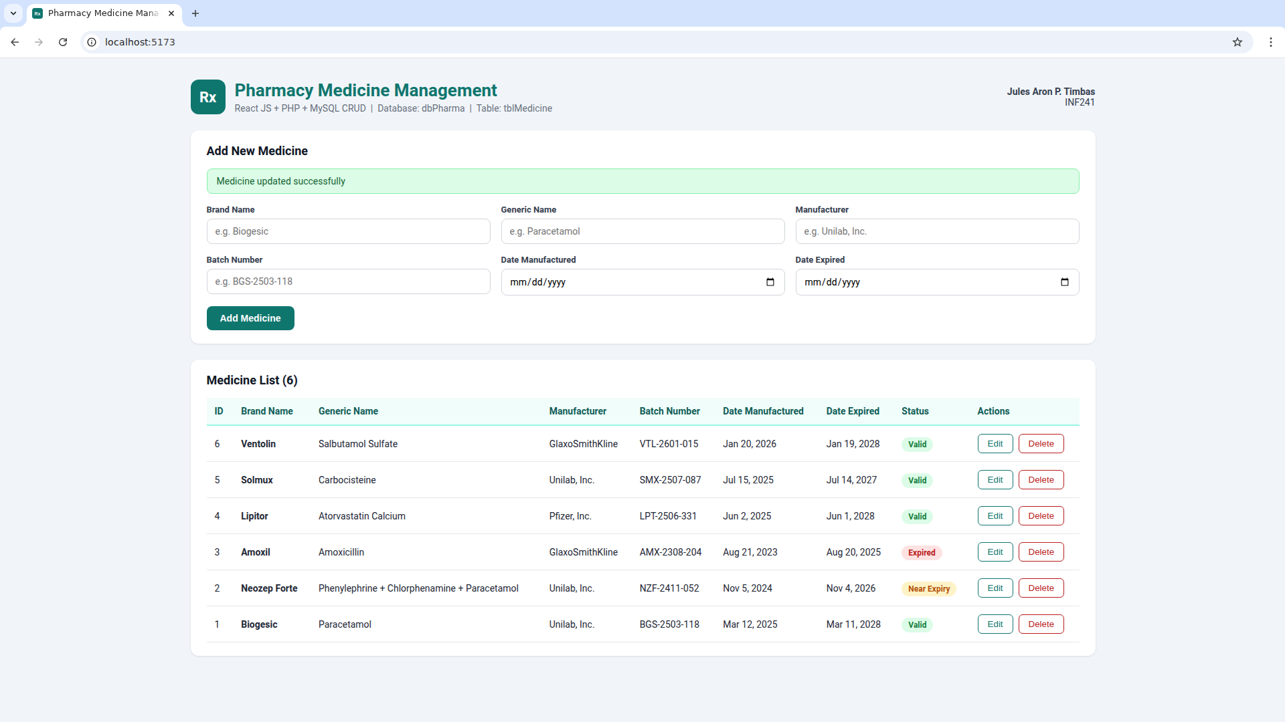
Part 4 · Output (CRUD in the browser)

Figure 20. Validation – duplicate batch number
A batch number that already exists is rejected (UNIQUE constraint on batch_number).
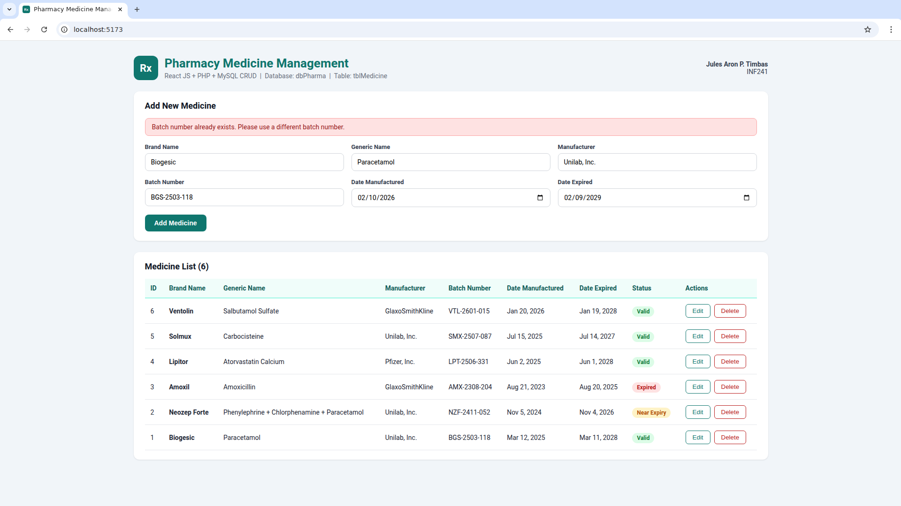
Part 4 · Output (CRUD in the browser)

Figure 21. DELETE – confirmation
The user is asked to confirm before a medicine is deleted.
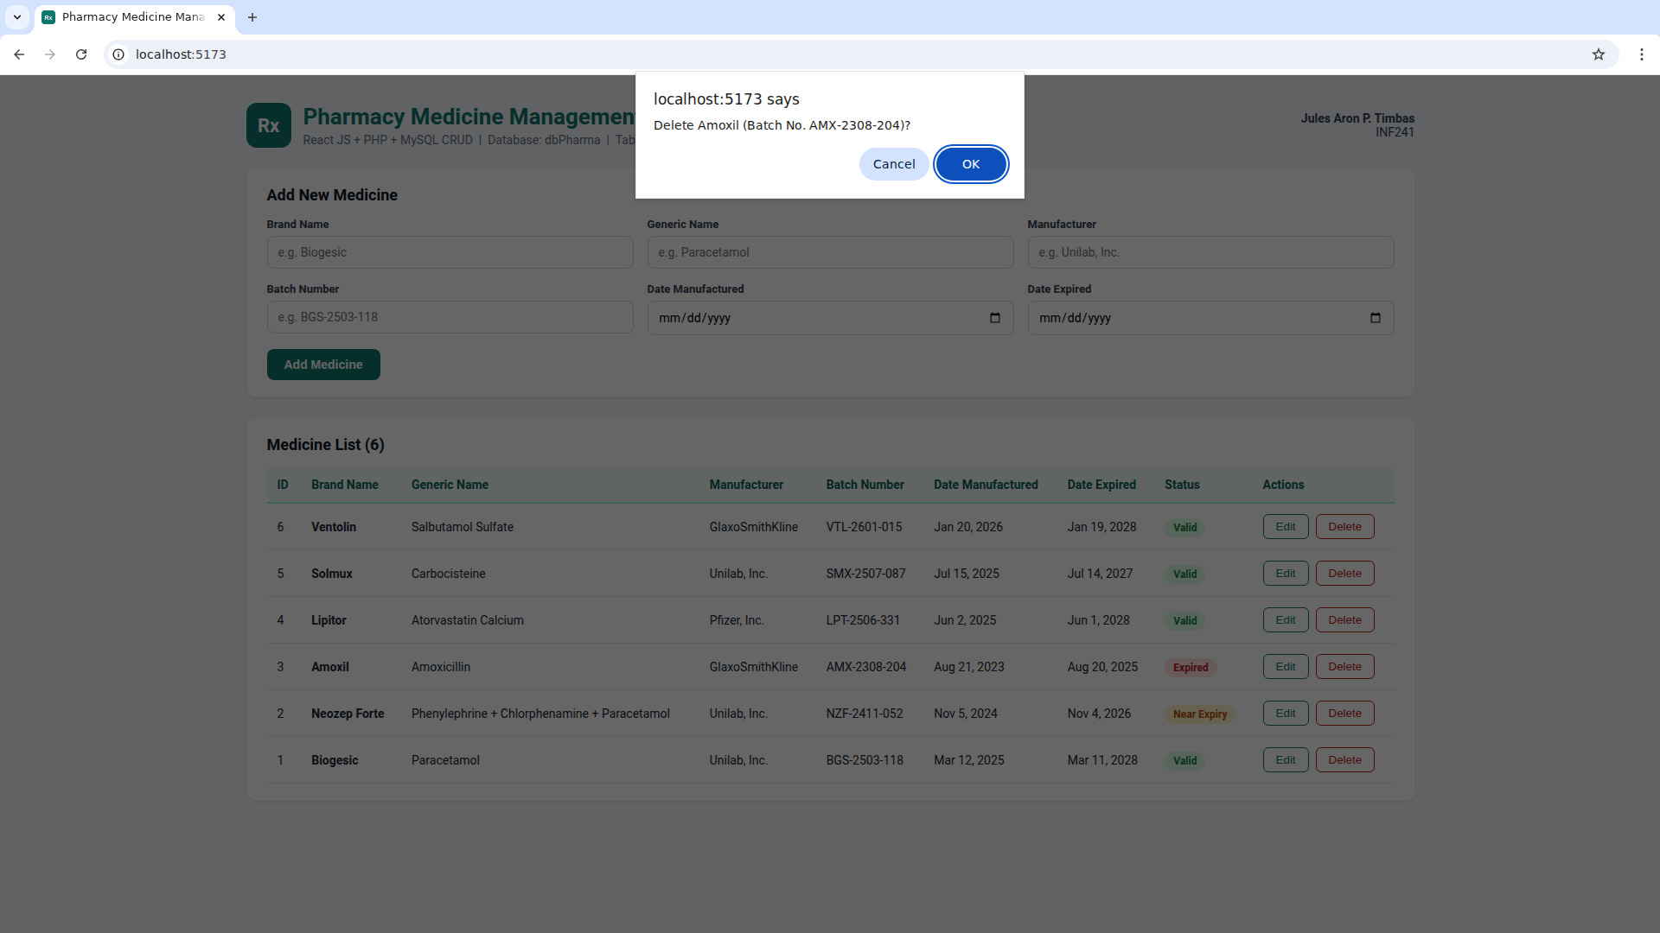
Part 4 · Output (CRUD in the browser)

Figure 22. DELETE – medicine deleted
Amoxil (ID 3) is removed from the database and from the list.
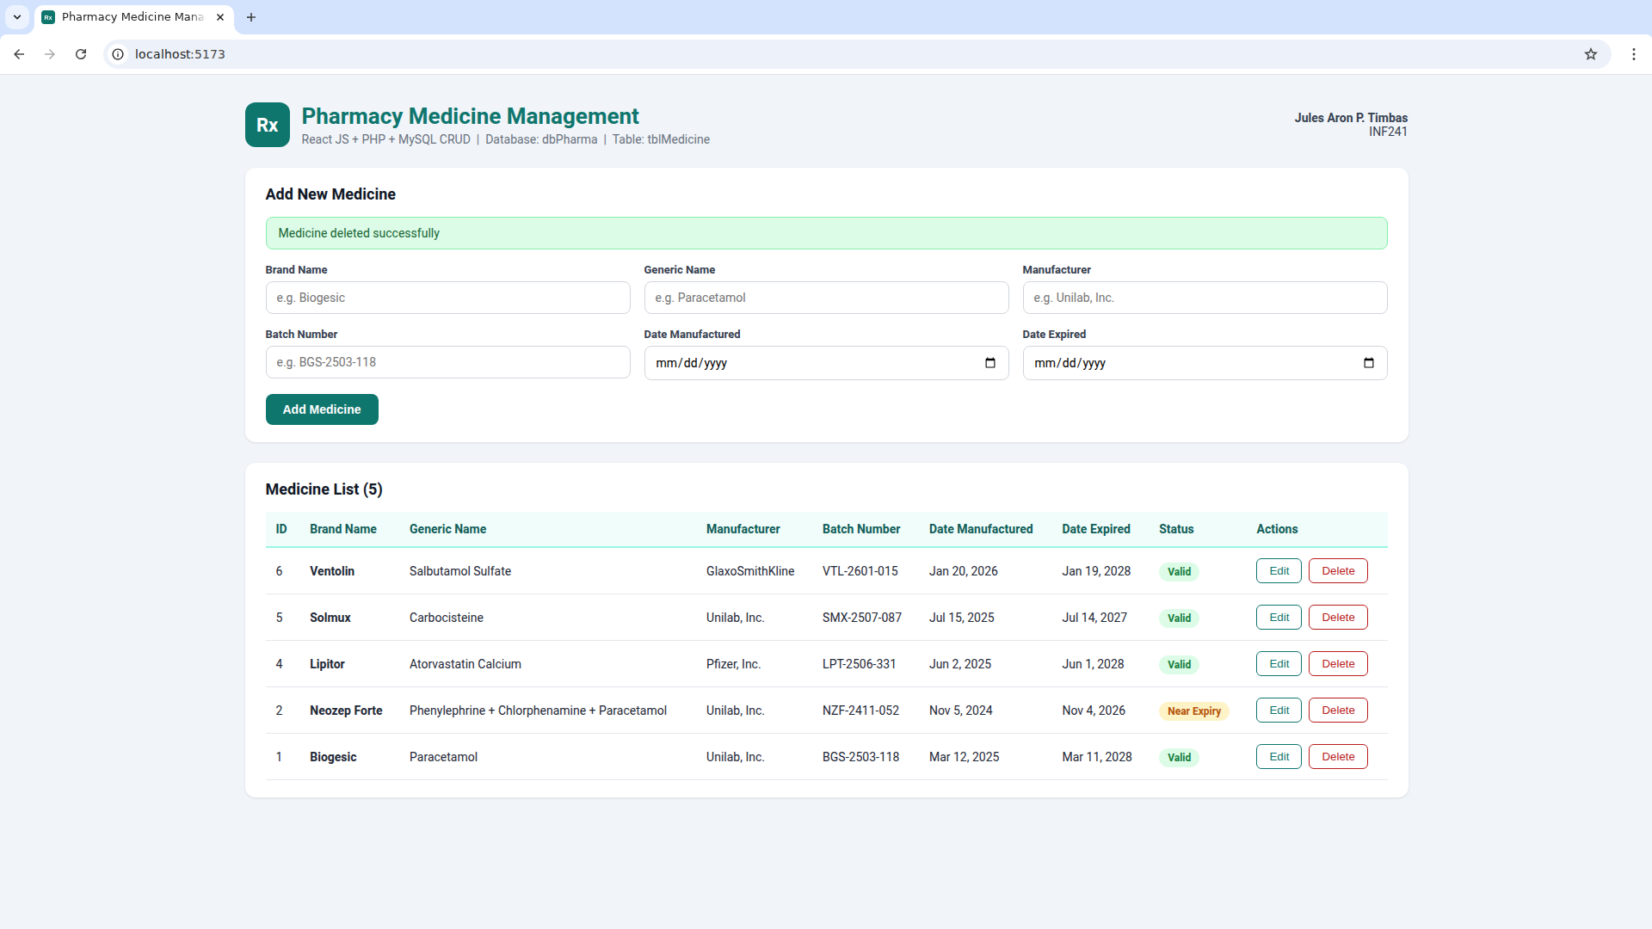
Part 5 · Database after CRUD

Figure 23. tblMedicine after the CRUD operations
SELECT * FROM tblMedicine: Ventolin was added and updated, Amoxil was deleted.
