
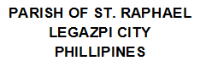


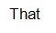
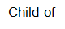
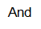
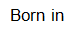
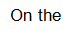
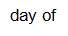
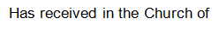
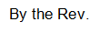
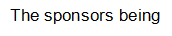
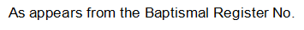
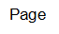
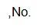
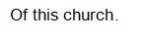
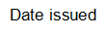

{name}

born

priest

purpose

date

no

page

book

sponsor2

sponsor1

by

month2

year2

day2

Saint Raphael

day1

year1

month1

mother

father

