websites which work for you

JULIAN BLUNDELL

Simple Site Protection

Technical Specification

Document Identifier: |  |  | SSP_TechnicalSpec_a
Issue | Date | Author |  | Checked | Approved
a | 14/12/2004 | Julian Blundell

CHANGE HISTORY

Issue | Date of Issue | No. of Pages | Pages Changed and  Reasons for Change
a | 14/12/2004 | 23 | Created

Distribution List

Copy | Registered Holder
Master | W34u
Copy 1

© Copyright 2004. w34u. All Rights Reserved.

No part of this document may be used, translated into another language, stored in a retrieval system, or transmitted, in any form or by any means, electronic, mechanical, photocopying, recording or otherwise, without the prior written consent of w34u.

While every effort has been made to ensure the accuracy of this document, w34u assumes no responsibility for omissions and errors. Neither is any liability assumed for damages resulting from the use of information contained herein.

W34u reserves the right to revise any information contained in this document without prior notice.

Questions or comment regarding this document or the product to which it relates should be directed to:

w34u
Brighton Media Centre, Suit 103
15-17 Middle Street, Brighton
East Sussex BN1 1AL
United Kingdom
t. +44 (0)1273 201344 m. +44 (0)7833 512221
w. www.w34u.com e. info@w34u.com
CONTENTS

1. Introduction 4
2. Functional Design 4
2.1. Site Visitor Functional Specification 4
2.2. Admin Functional Specification 5
2.3. Configurator Functional Specification 6
3. Technical Design Specification 7
3.1. Introduction 7
3.2. Overview 7
3.3. PHP Session Routines 7
3.4. Session Handling Class 8
3.5. User Logon Routines 11
3.6. User Forgotten Password 17

FIGURES

Figure 3-1 Overview for Main Protection Routine 10
Figure 3-2 Login Screen Creation Method 13
Figure 3-3 Login Check Method 14
Figure 3-5 Anti Bashing Routine 15
Figure 3-6 Login Successful Routine 15
Figure 3-2 Overview Flow Diagram for Logon Routine 16

TABLES

Table 3-1 Session Table Structure 7
Table 3-2 Session Function Definition 8
Table 3-3 Page Protection Class Initialisation Paremeters 8
Table 3-4 SSP Page Protection Properties 8
Table 3-5 SSP Page Protection Methods 9
Table 3-6 SSP Global Variables 9
Table 3-7 Relevent Page Protection Configuration Properties 9
Table 3-8 Relevent Login Configuration Properties 12
Table 3-9 User Table Structure 12

Introduction
This specification covers the functionality of a library of PHP 4.0 routines to supply simple to implement but thorough protection for websites/pages.
The objective of this project is to make the implementation simple, i.e. all the configurer has to do is add two lines at the top of each page, configure some simple files, run a configuration routine and they are in business.
One of the main strengths of this project will be the documentation, which will be clear, concise with a decent index, FAQ and in xhtml with css formatting so anybody can use it.
There will also be an online support via the site and sourceforge.

Functional Design

Site Visitor Functional Specification

Member Joining
Potential memebers can join one of several ways depending on configuration; each starts by clicking on the join link.
- User is prompted for their first name, initials, sirname, email, checked to be unique, and a password to be entered twice. Once completed details are emailed to them.
- User is prompted, as above but also has a user name, checked to be unique, with which to log in. User name is checked to be unique.
- User enters either of the above, but no password, a temporary password is emailed to them, which they then must change at their first login.
- As 1 or 2 but an activation link is emailed to them.
All of the above can be done with a secure server, and can go on to further screens to enter more information. For all options the site admin can check the request to join.
For more specialist sites the site admin might do the whole thing adding remote site addresses etc.

Member Login
Memebers will be able to login by the following methods.
- Prompted to login on attempting to reach a secure part of the site.
- Click on a login link.
- Fill in a login screen that is displayed as a frame as a part of a screen.
The information required is up to the joining method and all can be sent to a secure server.
Recovery of lost passwords and user names etc is simply by clicking on the recover password link and typing in your email, either the password is emailed back (least secure), a temporary password is emailed which must be changed on return or a link is given which then prompts for a new password.

Member Admin
After a successful login a user can access and change their details such as email, user name with check, password with orriginal and double new etc. an email will be issued with new information. They will also be able to access any additional information they presented as part of joining the site.

Admin Functional Specification

Introduction
The administrators log in and have the same functionality as the normal user, but with the highest user level so they can enter any part of the site and a set of special utitlites to list/find any user and edit their details, send them emails/new passwords etc, bulk email selections of users, create/delete users of any level including admin.

Member Listing
The list of members will be in alphabetical order by sirname and seperated into sections by first letter and a selectable number of memebers per page. A list of letters, a-z along the top will allow selection of section and previous and next buttons will allow movement through the section list if it is greater than the specified entries per page which will also be available to change. Pending and disabled members can also be shown.
An advanced search function to allow searching of any field or fields will also be available with just the previous and next page links on the list produced.

Member Editing
The administrator will be able to alter any information the member has entered, such as passwords, email etc, in addition the following functions will be available:
- Join a member.
- Disable a member.
- Modify an members login pass level.
- Send join or login reminder emails to a member, type depends on configuration.
- Set an IP address for higher security, may have to by default.
- Add and delete members.

Email Functions
Admin will be able to email a member individually and do a bulk text email to the current list, this could be to all current members, all pending members, all disabled members or some list developed by the advanced search.

Configurator Functional Specification

Introduction
Essentially this is the meat of this project, the objective is to allow web developers with a basic knowledge of programming to easily develop a secure login scheme without having to learn to use a complex library of routines.

Installation
The assumption is that they have a working database and PHP4 system and do not need advice on configuring this, refer them to the www.php.org.
Installation occurs in several steps as follows: -
- Unzip distribution to a temporary directory.
- Modify the template files in the useradmin and admin directories to fit site.
- Modify configuration file to define database config, paths, type of security etc.
- Put useradmin and renamed admin directory into the site or on secure server.
- Put include directory out of viewable path if possible.
- Set include path in php.ini if you have access, else use full include at top of all files to use this library. Set full include path at top of include file.
- Check and sort out any Pear library problems.
- Execute initialise routine in admin directory to set up tables in database.
- Login as admin using the adminlogin in the admin directory, user name:”admin”, password:”admin”, and then change both. Add other users as needed.
- Create site with instantiations at the top of the page giving the relevant access levels.
The basic configurations should be enough for 80% of websites created; those with more complex needs can modify the login script and database structure accordingly.

Technical Design Specification

Introduction
The objective is to write reliable simple code that can work on all versions of PHP4.0 and above and does not take a genius to extend and enhance. The code should work with most databases using the DB class from the Pear libraries to do database abstraction.

Overview
The code consists of three major areas, the routine which keeps track of the session, user login and admin and finally system admin routines.
The configuration file will be capable of modifying the user configurable parts of the PHP session parameters, setting up the database connection, configuring the built in functionality of the SSP system such as level of session security, where the login and admin file reside and encryption strings for the email and other secure data.
Design elements of the site will be included into the login and user admin pages by setting up template files.

PHP Session Routines
These will be configured to use a database, the pear DB abstraction routines being used to make them applicable to whatever database is in use.
The table structure will be as follows: -

Table Name, configured by sppsessionconfig, default “SSPsessionTable”
Field Name | Type | Description
SessionId | character (64) Key | Session Id created by PHP routines
SessionTime | Timestamp | Standard timestamp yyyy-mm-dd hh:mm:ss
SessionName | Character (20) | Sesson name
SessionIP | Character(30) | IP address of current session, read at logon by program, must remain the same during this session.
SessionUserIP | Character(30) | Valid IP address for session user, supplied at logon time as part of user data, must reamin the same for this user.
SessionCheckIP | int | 0 – default, 1 – check fixed ip address
SessionRandom | Int | Integer number changed each user access to session, must be the same if read back from the users last access.
SessionData | blob | Session variables saved and restored by PHP at the end and beginning of the page respectively. Somewhat dependant on the database, but usually defaults to 65535 bytes, may need to be expanded for some applications.
Table 3-1 Session Table Structure
The PHP session functions will be configured as follows: -

Function | Name | Description
dbopen | SSPdbopen | Opens the database with a persistent connection if possible, puts the DB object created into the global variable SSP_Session_Link.
dbclose | SSPdbclose | If the database selected does not have persistent connections will close, user configured
dbread | SSPdbread | Retrieve session data for user at astrt of page
dbwrite | SSPdbwrite | Store session data at end of page
dbdestroy | SSPdbdestroy | Destroy current users session
dbgc | SSPdbgc | Routine that is called periodically to destroy any abandoned sessions. Works off of the time stamp. Will also call any other cleaning routines.
Table 3-2 Session Function Definition

Session Handling Class
The class SSP_Protec() will be instantiated at the top of each page with parameters specifying what sort of protection that page needs etc. If no parameters are supplied the page will default to public and keep the session alive.

Parameter | Default | Description
pageAccessLevel | public | public - user - admin etc., access levels set up in configuration, public and admin are system and should not be changed
pageCaching | true | true - caches - default, false - no cach
pageValid | 0 | for how long the page will be valid in seconds, 0 means it is valid forever.
pageCheckEquals | false | Normally false, if set to true only users of a particular access can enter this page or admin.
Table 3-3 Page Protection Class Initialisation Paremeters
Not all the parameters will need to be supplied since the defaults will be built into the parameter list.
After successful instantiation of the class and the user is allowed into the page, the following properties will be available: -
Name | Description
userFullName | Name of the user.
userName | Shortened user name used for login in some schemes.
userAccessLevel | What access level the user has
userEmail | The user’s contact email
userId | The unique id that the system generates for a particular user on creation. Can be used to reference the rest of the user’s information by the application developer.
loggedIn | The user is logged in, i.e. a member has entered the page and has a valid session running and has logged in previously to a higher level than public.
admin | User is admin level
sessionToken | Sometimes needs to be appended onto the end of generated links before the cookies kick in, or it you are not using cookies.
userLoginPath | Web path to user login script
userAdminPath | Web path to user admin script
previousPage | Page before the current one.
Table 3-4 SSP Page Protection Properties

Name | Description
SSP_Protect | Constructor that actually does the page protection and configures all of the properties.
isAccess(level, equals) | Does a security check against the specified level and returns true if the users level is greater or equal to that specified, if “equals” is specified to true thaen only the user level specified returns true.
logoff | Log user off without destroying the session
sessionDestroy | Logoff the user and destroy the current session, creating a new one.
Table 3-5 SSP Page Protection Methods
Additionally the following global variables are created by the session routines: -

Name | Description
SSP_Session_Link | The pear db instance used to access the database used for session control.
SSP_Session_Name | The name of the session.
SSP_Session_Config | Instance of the SSP configuration class.
Table 3-6 SSP Global Variables
The following configuration properties are used by the page protection class,

Name | Description
checkIpAddress | Check the IP address is the same as the one used to log on every time a page is requested.
fixedIpAddress | User should be at the specified IP address every time a page is requested.
randomCheck | Additional cookie sent to the users machine with random number, checked and changed each time the user does a page request.
sessionTable | Name of database table used in sessions
Table 3-7 Relevent Page Protection Configuration Properties

SSP_Protect Method
This is the constructor for the SSP_Protect_Page class and therefore executes immediately.
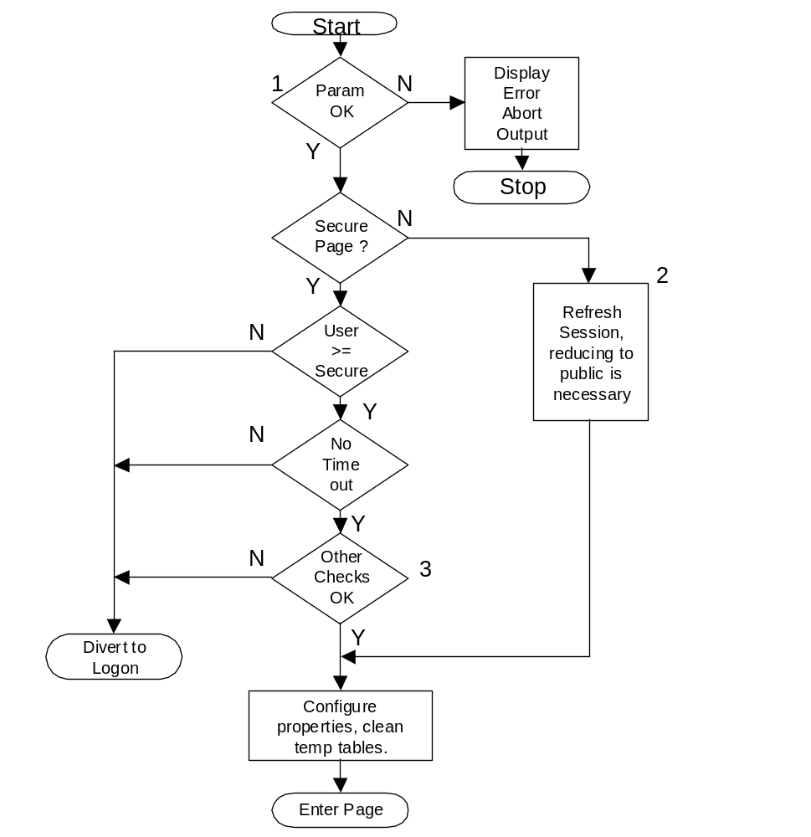
Figure 3-1 Overview for Main Protection Routine
1. Parameter Checking  Parameters check ok if the pageAccessLevel exists, pageCaching and pageCheckEquals are boolean and pageValid is an integer and positive. | 2. Refresh Session  If the user is logged on at a higher level than public and has timed out the session is reduced to public, else the session time is simply refreshed.
3. Other Checks
Other checks configurable by the user could be
- Is the remote address of the user still the same as the one used to log in?
- Does the checking cookie contain the correct random number?
- Is the user logging on from the correct remote address
These specialised checks improve the security and help prevent session stealing, but may cause problems for some users so must be used with caution and possibly with an aware audience.

Method “logoff”
->logoff()
Reduces the session to public security level with “nobody” as the user, displays a logoff screen with link to site home page and auto divert.

Method “isAccess”
->isAccess(string:accessLevel, bool:equals:false)
Returns a boolean depending on weather the current user is logged on at a level greater than or equal to the specified access level. If the equals parameter is specified as true only the user with exactly that access level returns true, this defaults to false.

Method “sessionDestroy”
->sessionDestroy()
Destroys the current session and, if logged on, logges out the user, returns to the home page of the site.

Method “formToken”
->formToken()
Creates a session token in a hidden field for a form if the session handling is not using cookies.

User Logon Routines
How the user joins depends on the configuration of the security software, how the administrator wants to run things and any additional routines added during site development.
The basic routines will have four basic logon methods:-
- User supplies email and password.
- User supplies user name and password.
- User supplies either of the above and must be at a particular ip address.
To join, if that is an option supplied by the admin, the user must always supply an email address, optinally a password, entered twice, optionally a unique username if used for login or other site usage and finally for very secure sites optionally an ip address either entered manually or read by the routines from the users current location.
The system will be extensible in several ways:-
- User may be asked for further information on the logon screen, programmer to write additional fields for login form and questions during user creation.
- User may not use any of the above standard ways to logon, programmer to write whole new way and user creation.
- After basic user creation user might be directed to additional pages for further questions needed for that particular site, these may or may not be mandatory.
Once the user has filled out the joining forms optionally one of several things might happen:-
- The user has joined and has access to the site at whatever level they have chosen or paid.
- The user is emailed a randomly generated password and can then use this to logon and update their information, change the password etc.
- User is emailed a link, can only be used once, which by clicking they can enter a password twice and then use the site.
- User is emailed a link which by clicking enables their account.
If configured the admin may have to enable the account before any of the above happen.

Name | Description
userTable | Name of user table, defualts to “SSPuserLogin”
loginSciptPath | Absolute path to login script. Eg. www.thisdomain.com/logindir/
useSSL | True – puts https:// on the start, false – just http://, used for both login and joining.
loginType | 0 – use user defined login, 1 – email/password, 2 – username/password. If “fixedIpAddress” is true in config, the users IP address will also be prompted for on joining and checked for during logon and each time a page is requested.
userLogin | 0 – no user defined login, 1 – additional user defined login fields, 2 – user defined login script, this will overide anything in loginType.
encryptionString | String used to encrypt personal information, email, passwords etc.
adminCheck | Admin must confirm user is ok before they are allowed to join.
confirmType | 0 – user is instantly a member, 1 – client is emailed a random password which must be used and then changed, 2 – user is emailed link, promted for password, 3 – user is emailed link which enables their account.
userExtendedJoin | True – additional information needed to be entered by user when joining, false – no additional information. If this is true and the primary information is filled in correctly then additiona screens are displayed promting for information.
templateHeader | Absolute path to template header, should contain all parts of page before the form.
templateFooter | Absolute path to template footer. Bottom of page after login form, joining etc.
Table 3-8 Logon Configuration Properties
Table Name, configured by sppsessionconfig, default “SSPuserLogin”
Field Name | Type | Description
UserID | character (64) Key | User id used in all references to this user.
UserEmail | Character (200) | User email, encrypted.
UserName | Character (50) | User name, encrypted, optional.
UserPassword | Character (20) | User password, encrypted.
UserIP | Character (30) | Users IP address for a fixed IP logon.
UserIPCheck | int | 0 – default action, 1 – check for fixed IP address.
UserAccess | int | User access level 1 - 32
UserDateLogon | Timestamp | Date/time this logon
UserDateLastLogon | Timestamp | Date/time last logon
UserDisabled | int | 0 - functioning, 1 - disabled
UserPending | int | 1 - pending program enable, 0 - program enabled
UserAdminPending | int | 1 – pending admin OK, 0 – OK’d by admin
Table 3-9 User Table Structure
The logon class SSP_Logon() will have the following methods associated with it:-
Name | Description
logonForm() | Creates the logon form based on configuration.
logonCheck() | Checks the logon password etc. for validity.
logonAntiBash() | Stops brute force methods of breaking the login.
logonSuccess() | Creates login successful page with re-direct etc.

Method logonForm()
->logonForm(PEAR_Error:error, bool:table, string:id)
Creates the login form displayed in the login script, can also be used in any page needing a login form.

Parameter | Default | Description
error | false | PEAR_Error type, conforms to the pear library error handling.
table | true | Uses a table to format the logon form.
id | logonForm | Id applied to the table or form.
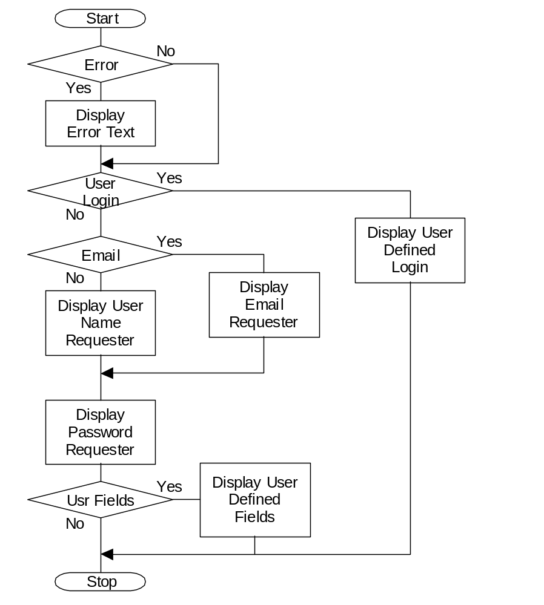
Figure 3-2 Login Screen Creation Method

Method logonCheck()
->logonCheck(array:formResult)PEAR_Error:error
Checks the supplied login details for validity and either returns a PEAR_Error if they do not match or true if login succeeds and the session is configured accordingly.
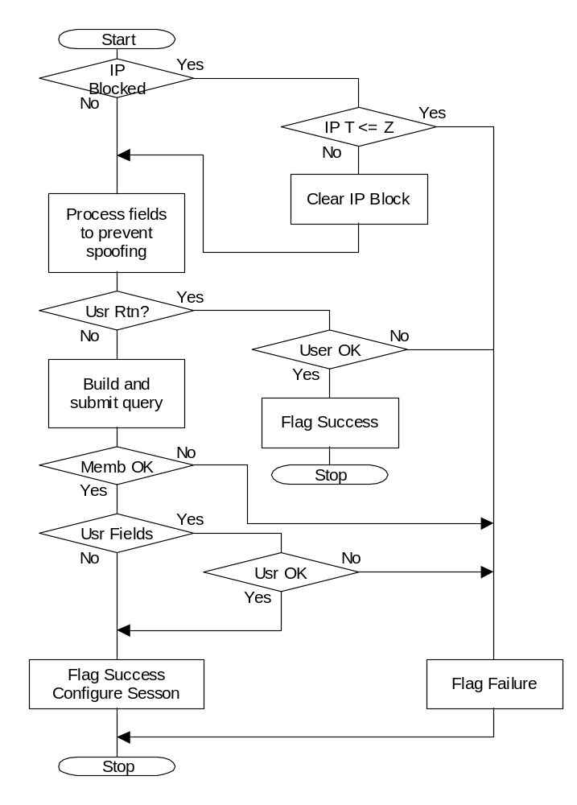
Figure 3-3 Login Check Method

Method logonAntiBash()
->logonAntiBash(Pear_Error:error)
Attemps to stop brute force attempts to find logins, disables IP addresses from loging in after they have failed Y times for Z minutes.

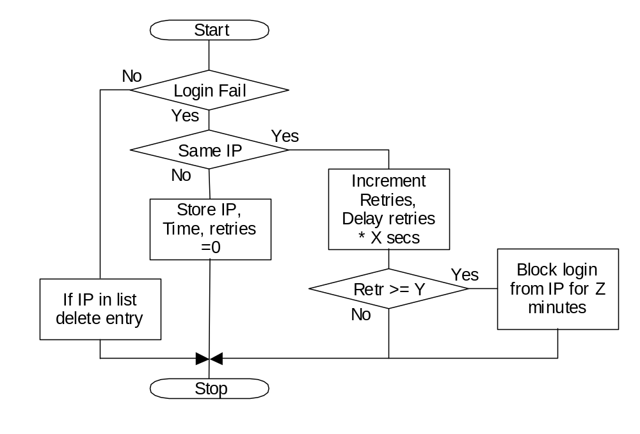
Figure 3-4 Anti Bashing Method

Method logonSuccess()
Simply generates the logon succesful page to finish the sequence.
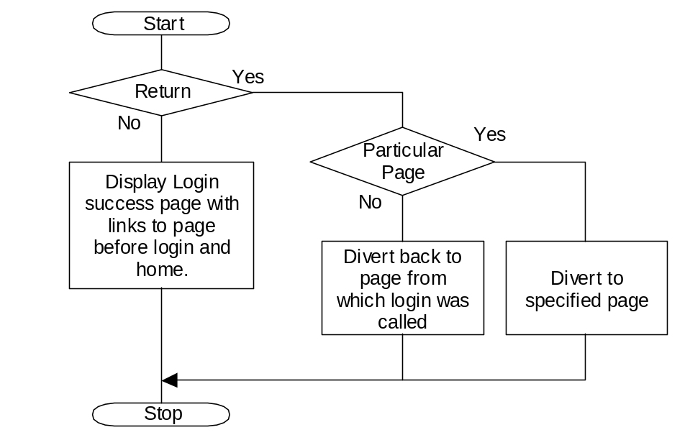
Figure 3-5 Login Successful Method

Logon Routine
The login routine will consist of a script that can be called from a link or used as a target for a login form embeded in a page. The routine will load user defined templates to match a site, handle ssl, user additions to the basic login or completely new defined logins. Once the visitor has cleard the login procces it will setup the session to the required security level and finish by diverting to the specified page.
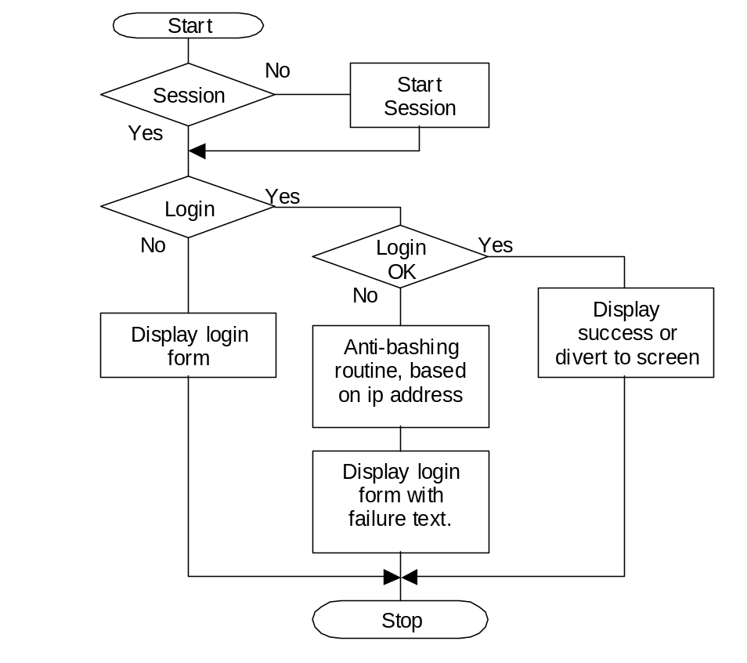
Figure 3-6 Overview Flow Diagram for Logon Routine

User Forgotten Password
Due to the fallability of human nature passwords and user names get forgotten, so it is essential that a method for recovering the said items is implemented.
The main process for recovering the password and user name will be from the users email with, optionally, a check phrase, if the users has a user name it will not be involved since this is one of the things easily forgotten.
The site member will be able to re-gain access to their account in one of three ways:-
- Email will be sent to them with username/password, least safe method.
- Email will be sent with a link to a once only page to display the username and put in a new password.

Name | Description
userTable | Name of user table, defualts to “SSPuserLogin”
recoverTable | Name of recovery table used for link returns “SSPrecovery”
adminScriptsPath | Absolute path to login script. Eg. www.thisdomain.com/admindir/
useSSL | True – puts https:// on the start, false – just http://, used for both login and joining.
encryptionString | String used to encrypt personal information, email, passwords etc.
recoverPassword | 0 – Email with link (default), 1 – Email details to user.
recoverTime | Time link is valid for in minutes.
templateHeader | Absolute path to template header, should contain all parts of page before the form.
templateFooter | Absolute path to template footer. Bottom of page after login form, joining etc.
Table 3-10 Forgotten Password Configuration Properties
The class SSP_RecoverPassword will have the following methods:-
Name | Description
recoverForm() | Creates the recovery form.
recoverStart() | Checks the email given and sends the appropriate message.
recoverFinish() | Deals with any links returned from the email.
recoverClean() | Cleans out any old password recovery entries, called by SSPdbgc.

Method recoverForm()
->recoverForm(PEAR_Error:error, bool:table, string:id);
Creates the password recovery form displayed in the login page, can also be used in any page needing a password recovery form.

Parameter | Default | Description
error | false | PEAR_Error type, conforms to the pear library error handling.
table | true | Uses a table to format the password recovery form.
id | logonForm | Id applied to the table or form.

Method recoverStart()
->recoverStart(string:email);
Takes the email supplied by the recovery form, checks it is a valid email and is present in the database an then emails the user with the specified email type and sets up the recovery table if neccessary. Diverts back to the logon page.
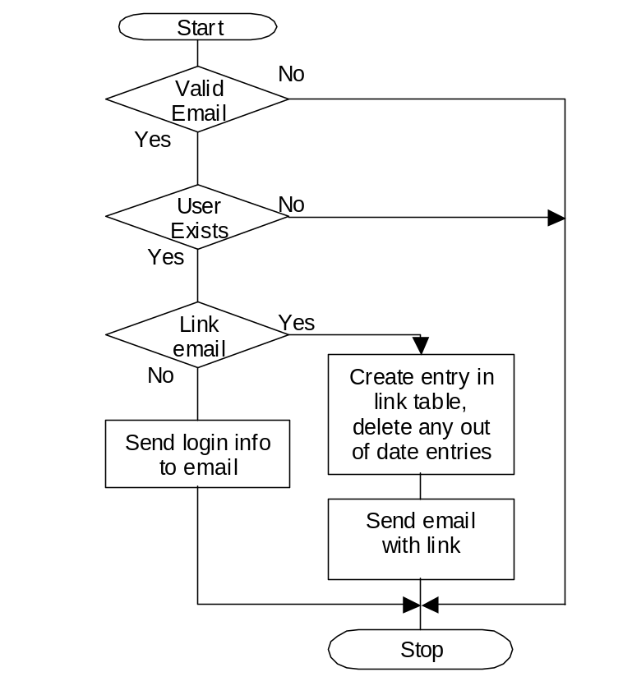
Figure 3-7 Flow Diagram for Method recoverStart()

Method recoverFinish()
->recoverFinish(string:token);
Checks the token exists in the link table and displays the pasword change screen for the user if it does. Will delete any timed out tokens and diverts back to the logon page.

User Creation/Update Routines
These routines are used during the users joining and when they wish to update their entry. There are two distinct parts to a users information, the email, username, userid and password used to access the site and additional miscellaneous information such as full name, address etc. used as part of being a member of the site.

Name | Description
userTable | Name of user table, defualts to “SSPuserLogin”
userMisc | Name of user miscellaneous table “SPPuserMisc”
userTemp | Name of table used for temporary storage “SPPuserTemp”
adminScriptsPath | Absolute path to login script. Eg. www.thisdomain.com/logindir/
useSSL | True – puts https:// on the start, false – just http://, used for both login and joining.
encryptionString | String used to encrypt personal information, email, passwords etc.
loginType | 0 – use user defined login, 1 – email/password, 2 – username/password. If “fixedIpAddress” is true in config, the users IP address will also be prompted for on joining and checked for during logon and each time a page is requested.
minPassword | Minimum number of characters allowed in password
passwordType | 0 – letters and numbers, 1 – can just have letters, 2 – must have capital and lowercase letters with numbers.
getUserName | True - get the user name, even if it is not used for logging in, false – don’t bother.
adminCheck | Admin must confirm user is ok before they are allowed to join.
confirmType | 0 – user is instantly a member, 1 – client is emailed a random password which must be used and then changed, 2 – user is emailed link, promted for password, 3 – user is emailed link which enables their account.
userTimeout | Timeout for such things as user creation, changing password confirmation etc.
templateHeader | Absolute path to template header, should contain all parts of page before the form.
templateFooter | Absolute path to template footer. Bottom of page after login form, joining etc.
Table 3-11 User Creation/Update Configuration Properties
The class SSP_UserAdmin will have the following methods:-
Name | Description
userLoginCreate | Creates and processes a form for user login information.
userEmailChange | Creates and processes a form for user email change.
userChangeConfirm | Executes the change requested, activated by the token sent by email.
userPasswordChange | Password change routine.
userMiscellaneous | Create or modify user miscellaneous information
userFinish
userProgramEnable | Enables the user from their id, used by credit card payment schemes etc.
userDelete | Deletes a user, if the user is currently logged in deletes the session as well.
userChangeClean | Cleans any change requests which have not been acted on within the set time.
userClean | Clean up any users which have been partially created and never finished.

Method userLoginCreate()
->bool:userLoginCreate(array:form,bool:mode);
If called with no form result in the parameters the form is displayed, if a form result is supplied it is checked for validity, the email and user name checked to be unique and the password checked for retype. If there are errors the form is re-displayed with error texts else the new user entry is created in the userTable and the userMisc tables, the miscelleaneous data entry table is then displayed.
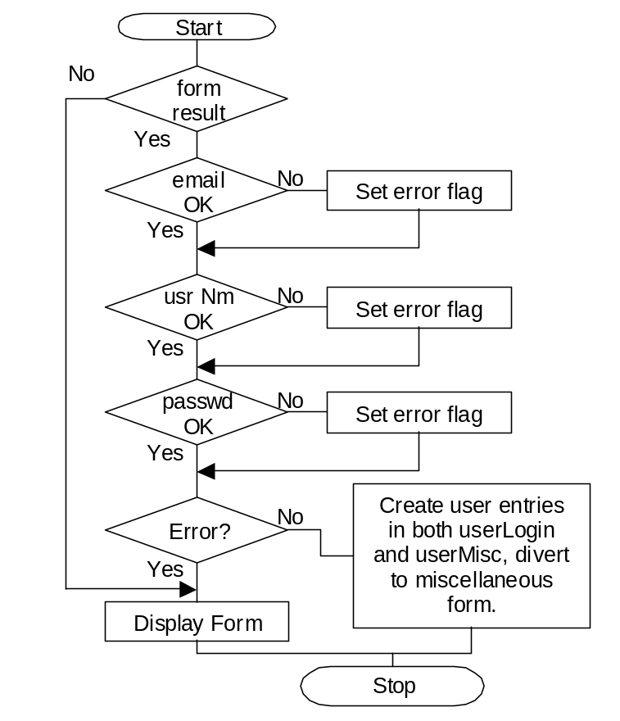
Figure 3-8 Method userLoginCreate Flow Diagram
Function returns true on succesful creation of user.

Method userEmailChange()
->userEmailChange(string:userID,array:form,bool:mode);

Parameter | Default | Description
userID |  | User ID identifying user.
form |  | Posted form result
mode | false | false – email is sent to old address for confirmation, true – address is changed right away.
Displays the form if there is no form data or if there are errors such as the address already being in use.
In normal operation puts in a request to change the users email by putting an entry with the users ID, field to be changed, new address and a date/time stamp. The user receives an email to the old address and needs to click on a link to confirm the address change.
In admin mode the address can be changed immediately without the email.
Function returns true on succesful submission or change.

Method userPasswordChange()
->bool:userPasswordChange(string:userID,array:form,bool:mode);
Similar in function to the email change routine, except it checks that both the passwords entered are identical, are of the required type, have only a-z, A-Z, 0-9 and is long enough.
Function returns true on successful submission or change.

Method userChangeClean()
->bool:usrChangeClean();
Cleans out any unused confirmations for email and password changes.

Method userMiscellaneous()
->bool:userMiscellaneous(string:userID,array:form,integer:mode);
Form for entering the miscellaneous data for the user, can be checked where necessary. Modes 0 – normal update, sends email to user on finish of change, 1 – user creation, no email created.
Function returns true on succesful storage of data.
Routine to be modifed by coder to fit application needs.

Method userFinish();
->bool:userFinish(string:userID,array:form);
Routine to do any finishing for the user to join, this is usually to interface to a credit card system or some such, not called if user is automatically enabled.
Returns true if routine succeeds.
Routine to be modified by coder to fit application needs.

Method userProgramEnable()
->userProgramEnable(string:userID);
Enables the user specified by userID, should check it is being called from the correct ip address i.e. the credit card site.

Method userDelete()
->userDelete(string:userID);
Deletes all information for a particlular user defined by userID.

Method userClean()
->userClean()
Cleans out any partially created users ie. has been created but not program or admin enabled for a week.

Routine createuser.php
Routine to do user creation using the methods outlined in the previous sections. Additional functions will be available for admin users.

Routine useradmin.php
User administration page with change email, password, misc data, unregister etc. Additional funcrions will be available for admin users.

Admin member Routines
The admin routines usable by site administrators are part of the user routines outlined in the previous section, though they will not be visible or executable by anybody under admin login. Some toutines might be useful for membership sites, particularly where users need to find each other and communicate without revealing email addresses.
The class SSP_UserAdmin will have the following additional methods for administration:-
Name | Description
userLoginCreate | Additional fields for admin.
userAdminChange | Changes user fields only accessible to admin.
userEmail | Send an email to a user
emailClean | Cleans out any unsent email tokens
bulkEmail | Sends bulk email to a selected set of users.

Method userLoginCreate()
Additional fields available for admin are UserAccess, UserIP, UserIPCheck, UserDisable, UserPending and UserAdminPending.

Method UserAdminChange()
An administrator can change the same additional fields as in userLoginCreate plus UserName which is checked to be unique before update.

Method userEmail()
->userEmail(string:userID, string:senderID, array:form);
Sends an email to the user identified by userID, when there is no form result a form is generated and an entry is made in the email sent table containing a token and a timestamp. When a form result is supplied with the correct token the email is sent to the user.
The method emailClean is called periodically to clean out any email tokens not used within a set time period.

Method bulkEmail()
->bulkEmail(resourceDB:result, string:senderID, array:form);
Does a bulk email to the users selected by a query that produced result, other than that works in much the same way as userEmail including the token to prevent spamming.

Routine displayusers.php
Designed to display the users of a site in an easily searched and browsed manner.
Filters – UserAccess, UserDisable, UserPending, UserAdminPending also any two other fields in the Miscellaneous information fields can be searched as an ‘and’ or an ‘or’.
Number listed per page can be 25, 50, 75, 100.
Can be ordered by family name, join date.
List can be broken down into alphabetical segments based on family name.
For each entry there is name and links to display, edit and email the user.
There will be link to bulk email the current selection without limits and alpphabetical blocking.

