SAE 3.02  
Develop communicating applications

16 décembre 2022

Jules brutschy

rt211

Cyber - FI

documentation

User part

Table des matières

1. Introduction 2

a. Use of the application 2

b. Presentations of the different functionalities 2

2. Prerequisites 3

3. GUI presentation 4

a. Connexion 4

b. Command section 5

c. Disconnection 6

## Introduction

### Use of the application

This application enables us to monitor servers or clients’ machines trough a simple graphical interface.   
To launch the GUI, just launch the GUI.py file.  
To start a server, uses the command “python .\mainserveur.py” and enter the desired port.

### Presentations of the different functionalities

1. Simple commands

OS: displays the server OS  
IP: displays the IP address of the server  
Name: displays the name of the server  
CPU: displays the % of CPU usage (+ a graphic)  
RAM: displays total memory, used memory and free memory remaining  
getall: displays all previous information

1. Advanced commands

Disconnect: disconnects the client  
connexion information: displays the connections information  
Kill: kills the server  
Reset: reset the server

1. Free commands

All commands available in a classical terminal.

## Prerequisites

In order to use this application, you will have to install several libraries, such as “sys”, “psutil”, “socket”, “threading”, “time”, “platform”, “subprocess”,” Qt”.

To install theses libraries, you just need to type “pip install” followed by the name of the library.

For example:

Here is the complete list of commands:

pip install sys  
pip install psutil  
pip install socket  
pip install threading  
pip install time  
pip install platform  
pip install subprocess  
pip install os

## GUI presentation

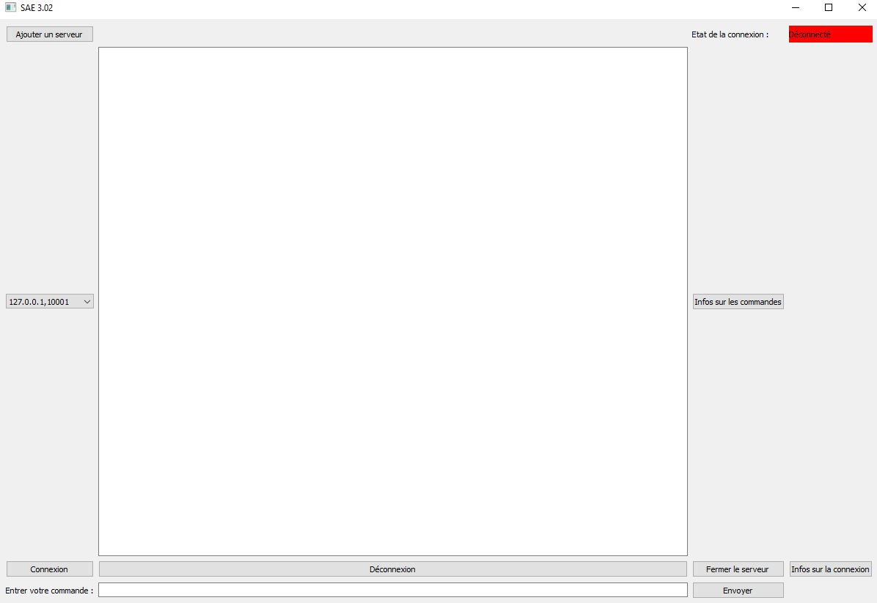The application’s interface is as follows: (I know it’s all written in French but no worries you’ll make it)

### Connexion

The begin with, you will have to add a new server (your server). To do so, you must click the button at the top left of the GUI which says “Ajouter un serveur”.

A new window appears, there you must fill in the address of your server and the port you want to use for the connection. Once done, click the “Ajouter” button.

Then you will have to select your server, which is located in the drop-down menu on the left side.

One you have selected your server; all you have to do is connect. Nothing easier, you must click the “Connexion” button on the bottom left.



You can verify that the client has logged in by checking if the background of the text in the top right corner has changed from red to green.

The message “Connexion réussie” also appears in the console.

(You can also use your own list of servers and port by implementing your .txt file in the code, c.f. the developer documentation.)

### Command section

You can enter all the commands seen previously (cf. b above) in the command section.   
(You can also find the list of commands by clicking on the button “Info sur les commandes” in the middle on the right).

Once the command is entered, press the enter key on your keyboard, or the "Envoyer" button to send the command to the server.

The server’s response will appear in the console.

(e.g.)

### Disconnection

You have 3 different ways to disconnect. The first one using a command (cf. b above). The second one is by clicking either the “Déconnexion” button or the “Fermer le serveur” button.  
The first one disconnects the client from the server moreover the second one close the server.  
The last way is to close the window by clicking on the cross at the top right



If you have any other questions, feel free to contact me at: [jules.brutschy@uha.fr](mailto:jules.brutschy@uha.fr),

Enjoy!