Extreme Events and Stock Market Behavior: Why Crashes Differ, 2000–2026
DATA 400 · Jules Dao Vu Anh · October 16, 2026

Abstract
Why the market falls matters more than how far it falls. This study identifies 17 extreme market episodes in the S&P 500 between 2000 and 2026, classifies each by the economic channel through which it hit prices, and examines how stocks, bonds, gold, sectors and portfolios behaved.
Fear-driven sudden events recovered in a median of 10 trading days; growth and credit crises in 77; rate and inflation shocks in 115; and valuation unwinds in about 900. The differences remain after an exploratory control for crash depth. Treasury bonds protected investors when growth collapsed but fell alongside stocks when inflation and rising rates caused the crash, as in 2022. A balanced portfolio's protection came mainly from owning fewer stocks rather than from hedging. Finally, scenarios built from past crises did not predict new ones better than a generic crash scenario, because the next crisis may come from a regime history has not yet shown.

1. Introduction and research question
The 2008 financial crisis and the 2020 COVID crash both cut the S&P 500 by more than 30%. One took about four years to recover; the other about five months. In 2008 Treasury bonds cushioned a balanced portfolio; in 2022 they deepened its losses. Size alone does not tell an investor what to expect from a crash.
How do different types of extreme events move the U.S. stock market, why do some crashes recover quickly while others take years, and what does this mean for protecting a portfolio?

1.1 Three channels of a crash
A stock index is worth the present value of the profits companies are expected to earn:
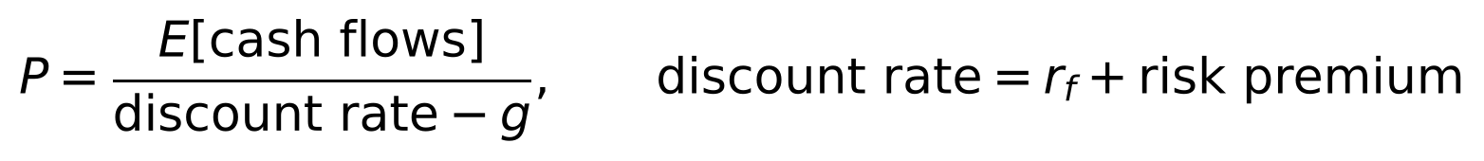
A crash must therefore come through at least one of three channels, and each implies different behavior:
Channel | What changes | Typical trigger | What else should happen | Expected recovery
Cash flows | Expected profits fall | Recession, credit crisis, pandemic | Yields fall as investors seek safety and expect rate cuts | Slow, unless policy replaces lost income
Risk-free rate | Interest rates rise | Inflation, monetary tightening | Stocks and bonds fall together | Slow, because the central bank cannot ease
Risk premium | Investors demand more reward for risk | War, panic, forced selling | Safe havens rally, volatility spikes | Fast, once the fear fades

Campbell and Vuolteenaho (2004) show that news about cash flows moves prices permanently, while news about discount rates tends to reverse. If that is right, the cause of a crash should shape its depth, its recovery and which assets protect investors. The study tests five hypotheses:
- H1: cash-flow and credit shocks fall deeper and recover more slowly than fear-driven shocks.
- H2: Treasuries hedge stocks in growth shocks but not in rate and inflation shocks.
- H3: defensive sectors hold up better in a fall, and the worst-hit sector reveals the channel.
- H4: recovery is faster when monetary policy can ease.
- H5: stress scenarios built by shock type predict portfolio losses better than a generic crash scenario.

2. Disciplinary motivation
The question sits between financial economics, econometrics and risk management. Financial economics explains why prices fall: the split between cash-flow and discount-rate news (Campbell and Vuolteenaho, 2004) and the effect of uncertainty shocks (Bloom, 2009). Econometrics supplies the tools to define "extreme" when volatility itself changes over time (J.P. Morgan, 1996; Lee and Mykland, 2008; Longin, 1996). Risk management asks the practical question: since correlations rise in falling markets (Longin and Solnik, 2001), which protections actually work when they are needed?
The question is also current. In 2022 stocks and bonds fell together across the whole year, an outcome the previous two decades had made seem unlikely, and the 60/40 portfolio on which many retirement savers rely offered little protection. Understanding why that happened, and whether it could have been anticipated, is the motivation for this study.

3. Data
Daily data cover 6,737 trading days from January 2000 to October 15, 2026, downloaded once and frozen so every result can be reproduced.
Data | Source | Used for
S&P 500 index and total-return fund (VFINX) | Yahoo Finance | Finding crises; portfolio equity
Intermediate and long Treasury funds (VFITX, VUSTX) | Yahoo Finance | Bond hedges
Gold, crude oil, U.S. dollar index | Yahoo Finance (futures, DXY) | Safe havens and commodity shocks
VIX, 10-year and 3-month Treasury yields | Yahoo Finance | Fear, interest rates, policy stance
Nine Select Sector SPDR funds | Yahoo Finance | Sector behavior
Baa credit spread, CPI, official yields | FRED | Credit stress, inflation, verifying yield data

Yahoo Finance yields matched the official FRED series to within 0.01 percentage points. Oil's negative settlement price on April 20, 2020 was removed; oil is used only as a market indicator, never as a portfolio holding.

4. Analysis

4.1 Finding the crises
A 2.5% daily drop is routine in late 2008 and rare in 2017, so each day's move is compared with the volatility the market expected that day, estimated only from past returns:
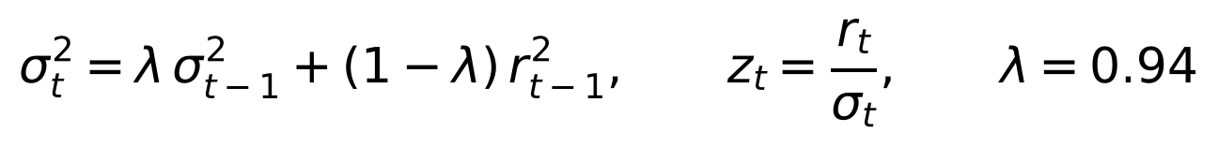
A day was flagged as extreme if it was a surprise relative to recent volatility (|z| > 3), large in absolute terms (|return| > 2.5%), or among the largest 1% of all days. Each rule follows earlier research (Lee and Mykland, 2008; Baker et al., 2021; Longin, 1996). The first two rules use only data available at the time; the top-1% cut-off is computed over the full sample and is therefore retrospective, which suits building a historical list. A version that uses only past data is tested in Section 4.5. Extreme days fewer than 20 trading days apart were merged into 73 episodes, and each episode was labelled from news coverage. Episodes from the same crisis were then grouped into 17 crises. The list includes every episode in which the index fell 10% or more, together with smaller episodes that had a distinct, well-documented trigger (such as Brexit or the yen carry unwind); this is why some crises in the appendix fell only 5% to 9%. That second criterion is a judgement, so the 17 crises are a documented selection of major episodes rather than an exhaustive algorithmic census.

4.2 Classifying them by channel
Each crisis was assigned, before examining the results, to one of four families matching the channels in Section 1.1:
Family | Channel | Crises
Growth & credit | Cash flows | 2008 financial crisis, Euro crisis 2010, U.S. downgrade 2011, China 2015–16, COVID 2020
Rates & inflation | Risk-free rate | Volmageddon 2018, Q4 2018 Fed tightening, 2022
Valuation unwind | Bubble deflating | Dot-com 2000–01, 2002 accounting scandals
Sudden event | Risk premium | 9/11, Iraq 2003, China 2007, Brexit 2016, yen carry unwind 2024, tariffs 2025, Iran war 2026

Detecting extreme days is fully rule-based; grouping episodes into crises and assigning families involves documented judgement.

4.3 Measuring behavior
For each crisis, the fall was measured from the last close before the event to the trough, and recovery as the trading days needed to regain the pre-event level. This measures an investor's waiting time to break even, not how long the original shock's effect lasted: in long episodes such as 2000–02 and 2007–09, later shocks fall inside the recovery period. Over the same window, the returns of Treasuries, gold, oil, the dollar and nine sectors were recorded.

4.4 Stress-testing portfolios
Five portfolios were tested: the S&P 500; a 60/40 stock–bond mix; a technology tilt; defensive sectors; and a diversified mix of stocks, long and intermediate Treasuries and gold. Each was replayed through all 17 crises, its losses were broken down by holding, and it was tested against five hypothetical future scenarios. To check whether shock types help predict, each crisis was also predicted using only crises that came before it.

4.5 Checking the results
The crisis list was rebuilt under 57 alternative settings, including a version of the detection rules that uses only past data; at least 15 of the 17 crises were found every time, and all 17 under the main and past-data-only settings. The main conclusions were recomputed after reclassifying debatable crises and after dropping each crisis in turn.

5. Findings

5.1 H1: the type of shock is associated with depth and recovery
Family | Crises | Median fall | Median days to recover | Range (days)
Sudden event | 7 | −7.8% | 10 | 8 to 28
Growth & credit | 5 | −14.6% | 77 | 14 to 971
Rates & inflation | 3 | −18.4% | 115 | 70 to 318
Valuation unwind | 2 | −27.8% | 896 | 320 to 1,472
S&P 500 price index, event leg. Recovery = trading days from the trough back to the pre-event level. On a total-return basis recoveries are shorter, but the ordering is the same.
The ordering is consistent with the channel framework. A sudden event raises the risk premium for a few days; once the uncertainty clears, nothing about future profits has changed, so prices come back within weeks. A growth or credit crisis damages expected earnings, so recovery waits for the economy. A rate shock recovers more slowly still because the central bank, fighting inflation, cannot cut rates to help. A valuation unwind takes years because the pre-crash price was itself too high: the market is not recovering to a fair level but returning to one.
The VIX confirms the difference in mood. It rose about 2.1 points per 1% fall in growth and credit crises but only 0.6 in valuation unwinds. Bubbles deflate slowly and without panic.
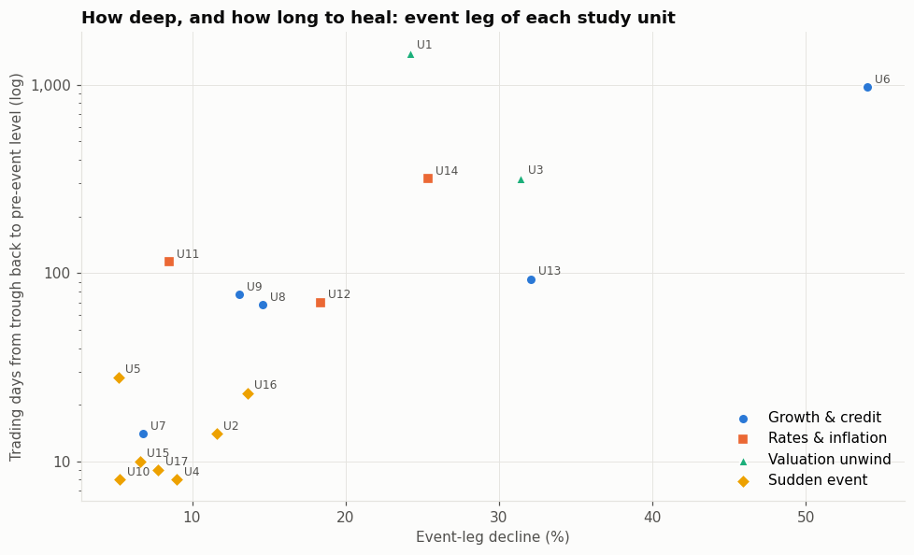
Figure 1. Event-leg decline against trading days to recover (log scale), by shock family. Point labels U1–U17 match the crisis numbers in the appendix.
Figure 1 shows the families in separate regions: sudden events in the lower left, valuation unwinds at the top, and growth and credit crises along a diagonal from the 2010 Euro crisis to 2008. Two crises break the pattern, and both point to policy. COVID fell 32% yet recovered in 93 days, during unprecedented monetary and fiscal support. Volmageddon in 2018 fell only 8.5% but needed 115 days while the Federal Reserve was still raising rates.
Is it the type of shock, or only the size of the fall? Families differ in depth as well as type, so slower recoveries might simply reflect deeper falls. To separate the two, the log of recovery time was regressed on the log of the decline plus family indicators, with sudden events as the baseline (17 crises):
Model | R² (log recovery time)
Depth only | 0.68
Family only | 0.71
Depth and family | 0.84

Effect in the depth-and-family model | Estimate
Depth: decline 1% larger in relative terms (e.g. 20% → 20.2%) | about 1.2% longer recovery
Growth & credit vs. sudden event, same depth | about 2.6× as long
Rates & inflation vs. sudden event, same depth | about 4.7× as long
Valuation unwind vs. sudden event, same depth | about 12× as long
Family terms jointly, residual (Freedman–Lane) permutation test, 20,000 draws | p = 0.035
Same test, dropping each crisis in turn | p from 0.009 to 0.095; below 0.05 in 7 of 17

Adding shock type to depth raises the explained share of variation from 0.68 to 0.84. With only 17 crises, conventional standard errors are unreliable, so significance was judged by a Freedman–Lane permutation test: the residuals of the depth-only model are shuffled, which keeps the depth–recovery link intact, and the test asks how often the family terms then add as much explanatory power as they do in the real data. A simpler test that shuffles the family labels gives the same p-value. The result is significant at 5% in the full sample but not robust to dropping single crises: this is an exploratory association, not a proven effect. The case for H1 therefore rests mainly on the size and consistency of the differences in the first table, with the regression as supporting evidence.

5.2 H2: Treasuries hedge growth shocks, not rate shocks
This is the study's strongest result.
Family | Intermediate Treasuries gained | Gold gained | Stock–bond correlation on crisis days
Growth & credit | 5 of 5 | 4 of 5 | −0.52
Sudden event | 6 of 7 | 5 of 7 | −0.38
Valuation unwind | 2 of 2 | 1 of 1 | −0.32
Rates & inflation | 1 of 3 | 1 of 3 | +0.05
Gold data begin in August 2000, so the dot-com bust has no gold observation; the valuation-unwind gold result rests on the 2002 crisis alone.
The reason sits in the price equation. In a growth crisis, investors expect weaker earnings and lower interest rates: stocks fall through the cash-flow channel while bond prices rise. In a rate shock, rising rates are the cause of the stock decline, and the same rising rates push bond prices down. In 2022 an S&P 500 index fund fell 24.5%, intermediate Treasuries 11.1% and long Treasuries 27.9% (fund total returns, which include dividends; the S&P 500 price index fell 25.4%, the figure in the appendix). A Fisher exact test comparing rate shocks with all other crises gives p = 0.063: striking, but based on three rate shocks.
Oil is a useful early signal of which world an investor is in. It collapsed in demand-driven crises (−39% in 2008, −57% in COVID), exactly when bonds protected, and rose in 2022 (+13%) and the 2026 Iran war (+54%), when they did not. Falling oil signals weaker demand and coming rate cuts; rising oil signals inflation that keeps rates high. The Iran war is a mixed case that shows why the trigger and the channel must be kept apart. It is classified by its trigger, a sudden geopolitical event, but it was transmitted through oil and inflation expectations, so Treasuries and gold both fell as in a rate shock. Its quick recovery fits its family; its asset behavior fits the inflation channel.
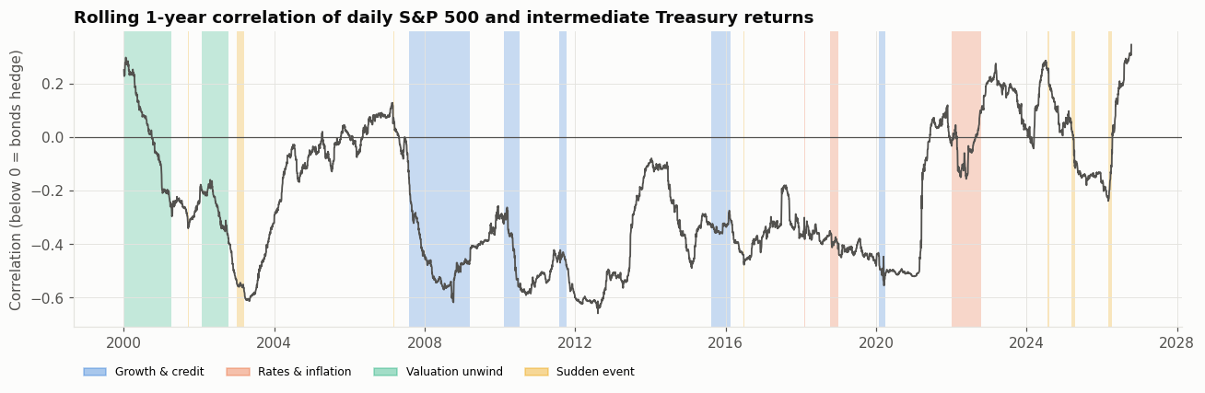
Figure 2. Rolling one-year correlation of daily S&P 500 and intermediate Treasury returns, with crises shaded by family. Below zero, bonds tend to rise when stocks fall.
Figure 2 shows that the stock–bond relationship is a regime, not a constant. It was negative for most of 2001–2020, reaching about −0.6 in 2008, which is the era that built the reputation of the 60/40 portfolio. It turned positive in 2021 as inflation returned and has mostly stayed positive. The two positive periods, around 2000 and after 2021, were both times when the market worried about inflation and interest rates rather than growth. An investor who learned from 2002–2020 had been trained on the wrong regime for 2022.

5.3 H3: defensive sectors cushion, and the worst sector reveals the channel
Defensive sectors (staples, health care, utilities) beat cyclical sectors during the fall in every family, by a median 11.2 points in growth and credit crises and 4.6 in rate shocks. The worst sector names the channel: financials in 2008, energy in oil-collapse growth scares, technology in valuation unwinds, consumer discretionary in 2022. In the dot-com bust, technology fell 60% while utilities, energy, financials and staples all rose; money rotated rather than left. In 2008 every sector fell, because a banking crisis hits everyone. Sector diversification therefore helps most when a shock is concentrated, and least when it is system-wide.

5.4 H4: policy easing is associated with faster recovery, weakly
In the five crises where short-term rates fell more than 0.5 points within six months, the median recovery took 28 trading days, against 69 in the others. The evidence is weak because causation runs both ways: the Fed eases hardest in the worst crises, and 2008 still took 971 days. Starting conditions (VIX level, yield curve, prior returns, credit spreads, inflation) showed no strong link to depth or recovery. Crashes are hard to see coming from the dashboard alone.

5.5 Stress test: which portfolio wins depends on the shock
Median portfolio return over the S&P 500's fall, by family. Portfolios use total-return funds, so S&P 500 figures here differ slightly from the price-index falls in Section 5.1 and the appendix:
Family | S&P 500 | 60/40 | Tech tilt | Defensive | Diversified
Growth & credit | −14.3% | −7.1% | −12.2% | −5.8% | +0.5%
Rates & inflation | −18.1% | −9.7% | −19.4% | −9.1% | −4.2%
Sudden event | −7.7% | −4.4% | −8.3% | −7.2% | −2.6%
Valuation unwind | −26.9% | −9.7% | −41.4% | −8.7% | −3.1%

The medians hide the most important case. Diversified gained in the typical growth crisis yet lost 21.0% in 2022, close to the S&P 500's 24.5%. The 60/40 portfolio cut the 2008 loss from 52% to 24%, but in 2022 it lost 19% against 24.5%.
Where protection comes from. Breaking the losses down shows that most of a balanced portfolio's protection comes from holding fewer stocks, not from hedging. In 2008, 60/40 lost 28.4 points less than the S&P 500: 20.9 points came from holding 40% less equity and only 7.5 from bond gains. In rate shocks, bonds offset none of the stock loss. In 2022 Diversified's hedges more than doubled its stock loss instead of reducing it. The more hedges a portfolio holds, the more its outcome depends on the type of shock.
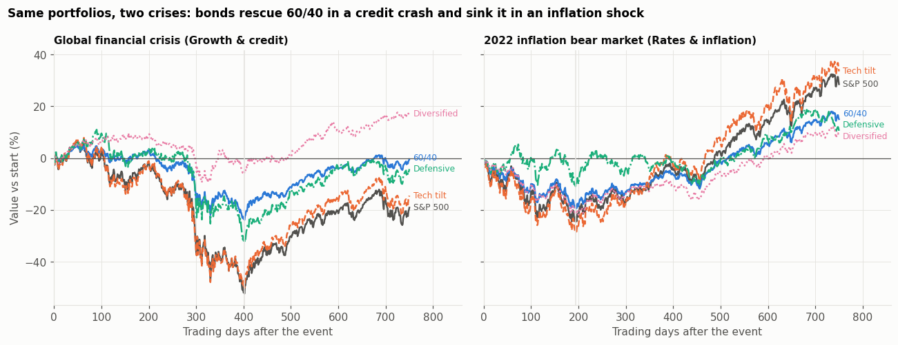
Figure 3. Value of each portfolio relative to its starting value in trading days after the event: 2008 (left) and 2022 (right).
Figure 3 puts the two regimes side by side. In 2008 the portfolios fan out: at the trough the S&P 500 was down about 52% and Diversified less than 10%. In 2022 they fall together, and only Defensive stays near break-even. Three years later the order had reversed: the S&P 500 and Tech tilt were up about 30% to 35%, while Diversified, the winner of 2008, finished lowest at about +9%. The same portfolio can be the best or worst choice depending on the channel.
Looking forward. Because history contains only one true inflation bear market, five hypothetical scenarios were also tested. The key results:
Scenario | S&P 500 | 10-year yield | 60/40 | Diversified
Deflationary bust | −35% | −150 bp | −18.0% | −5.2%
Dash for cash | −30% | +25 bp | −18.5% | −14.6%
Stagflation | −25% | +150 bp | −18.0% | −16.5%

Diversified is far safer in a deflationary bust but no safer than 60/40 in stagflation. 60/40's worst case is a dash for cash, when investors sell everything at once. The scenario model was checked by feeding it the market moves that actually occurred in each crisis: with sensitivities estimated only from earlier data, it reproduced realised portfolio losses with an average error of 1.5 points. This is a test of conditional loss reconstruction (given the market moves, what does each portfolio lose?), not a forecast of the market moves themselves. The scenario sizes remain assumptions.

5.6 H5: knowing the shock family did not improve prediction
Each crisis was predicted from earlier crises only (walk-forward) or from all other crises (leave-one-out), comparing a scenario built from the same family with a generic crash scenario. The level test predicts each portfolio's loss directly. The conditional test is also given the crisis's actual S&P 500 decline and predicts only how each portfolio moves relative to it.
Validation design | Crises scored | Mean error, family scenario | Mean error, generic scenario | Family scenario closer
Walk-forward, level | 12 | 7.8 pts | 6.5 pts | 6 of 12
Walk-forward, conditional on depth | 12 | 2.6 pts | 2.6 pts | 8 of 12
Leave-one-out, level | 17 | 7.9 pts | 7.1 pts | 9 of 17
Leave-one-out, conditional on depth | 17 | 3.9 pts | 3.3 pts | 9 of 17
Mean absolute error per crisis, in percentage points of portfolio return. Walk-forward starts once three earlier crises are available, and a crisis is scored only if an earlier crisis of its family exists.
Both tests assume the crisis's family is known at the outset, using the label assigned with hindsight, and the conditional test also uses the realised market fall. They are therefore the best case for shock-family scenarios, not a real-time forecasting system: an investor would first have to identify the family as the crisis begins, which this study does not test. Even in this best case, family scenarios were closer in only about half of crises, with similar or larger average errors, so H5 is not supported. They worked for sudden events, which are numerous and alike, and failed when one extreme crisis dominated a family's history (the 2010 Euro crisis, predicted from 2008 alone, missed by 29.8 points against 8.6 for the generic scenario) or when the regime changed. Most of the error came from how deep a crisis would go, which no historical average anticipates. Shock types explain crises well after the fact; they do not forecast them.
A related finding on risk models. Separately from H5, a 99% Value-at-Risk estimated from the prior year was exceeded by a median 1.27 times in rate shocks and 1.20 times in sudden events. Because these windows were selected as crises, this does not measure how often VaR fails in general; it shows that fast shocks arriving in calm markets outrun calm-market risk estimates.

6. What the crises teach about how markets work
The numbers above can be read as five lessons about market behavior.
1. A crash is a repricing, and the reason for the repricing helps explain what happens next. Every stock price is expected future cash flows divided by a discount rate. A crash means one of these changed sharply. If only fear rose (the risk premium), fear fades and prices return quickly, as after 9/11, Brexit and the yen carry unwind. If expected profits fell, prices wait for the economy to heal. If the discount rate rose because of inflation, prices wait for inflation to fall. If prices were too high to begin with, they never “recover” to the old level in any meaningful sense; the old level was the mistake. This is why the same 20% fall can mean a two-week dip or a six-year wait.
2. Safe assets are only safe relative to a particular danger. Treasuries are not a hedge in themselves. Over a few weeks, most of a Treasury fund's return comes from changes in interest rates (coupon income is small over such a short window, and longer bonds react more), so holding them in a crash works largely like a position on rates falling. That position pays off when the danger is weak growth, because central banks cut rates and investors flee to safety. It loses when the danger is inflation, because rates rise instead. Gold behaves similarly in this sample: it rose 38% in 2008 but fell in 2022 and in the Iran war when rate cuts became less likely. An asset's protective value is a property of the regime, not of the asset.
3. Correlations are not fixed; they are a summary of what investors are afraid of. The stock–bond correlation was negative for two decades because, in that period, the main fear was weak growth and low inflation. When inflation returned in 2021, the dominant fear changed and the correlation turned positive. Most portfolio models estimate correlations from recent history, so they quietly assume that the market will fear the same thing tomorrow as it did yesterday. The 2022 experience shows how costly that assumption can be.
4. Policy is part of the market's price. Recoveries were fastest when the central bank was able and willing to ease, most dramatically in COVID, and slowest when it was constrained by inflation. Investors therefore price not only the shock but the expected policy response. An inflation shock is doubly damaging: it raises discount rates directly and removes the policy support that usually ends a crisis.
5. Understanding is easier than prediction. The same framework that explains every crisis after the fact did not forecast portfolio losses better than a generic crash, and starting conditions such as the VIX or the yield curve said little about what was coming. Markets price known risks quickly, so what moves them most is the part that was not known. The practical value of the framework is diagnostic: once a crisis begins, identifying its channel (by watching oil, yields and which sectors lead the decline) tells an investor which protections are likely to work, even though it cannot say how deep the fall will be. Whether the channel can be identified reliably in the first days of a crisis was not tested here and is the natural next step.

7. Stakeholders
Stakeholder | What the study shows | Implication
Individual and retirement investors | A 60/40 portfolio protects mainly by holding fewer stocks; bonds fail in inflation shocks | Choose equity exposure for the loss you can bear, not on the assumption that bonds will offset it
Asset managers and advisers | The value of hedges depends on the shock channel | Report risk by scenario type, not as one number
Risk managers | History-based scenarios miss new regimes; calm-period VaR is exceeded in fast shocks | Add hypothetical scenarios such as stagflation and a dash for cash
Pension funds and endowments | Recoveries range from two weeks to six years | Plan liquidity for long, rate-driven or valuation-driven drawdowns
Regulators and central banks | Recovery is associated with easing, and inflation removes that option | Include scenarios in which stocks and bonds fall together

8. Limitations
- Small sample. Seventeen crises in four families, with two to seven per family, can describe patterns but not prove them. The p-values near 0.05 move when single crises are dropped.
- Judgement and hindsight. Crisis grouping and family labels were assigned by hand from news, and some crises mix channels (the 2025 tariffs and the Iran war both had inflationary elements). Crisis windows and troughs are known only afterwards. The 17 crises are a selection rather than a census, so family comparisons depend partly on which smaller episodes were included, and recovery times can include later, unrelated shocks. The main conclusions held under reclassification and when each crisis was dropped in turn.
- Prices, not fundamentals. The channels are inferred from how markets moved, not measured from earnings forecasts or surveys.
- Simplified portfolios and scenarios. Portfolios are buy-and-hold with no rebalancing or trading costs, and scenario sizes are assumptions.
- Scope. U.S. stocks since 2000 only. The sample contains a single true inflation bear market and none of the 1970s experience.

9. Conclusion
Extreme market events since 2000 differ according to the channel through which they hit prices. Sudden fear-driven events fell least and recovered in about two weeks; growth and credit crises took months; rate and inflation shocks recovered more slowly still, while policy could not help; and bubble deflations took years. The channel was also closely associated with which assets protected an investor. Treasuries and gold hedged growth shocks but fell with stocks when rising rates or inflation caused the decline, as in 2022 and the 2026 Iran war. Most of a balanced portfolio's protection came from simply holding fewer stocks.
The framework explains crises well but does not forecast them: knowing the type of shock did not predict losses better than a generic crash. Its value lies in diagnosis and stress-test design. Three lessons follow for anyone holding a portfolio:
- Ask why the market is falling before deciding what will protect you.
- Do not assume bonds will offset stock losses; inflation shocks remove that protection.
- Test portfolios against scenarios history has not yet shown, because the next crisis may belong to a new regime.
With only 17 crises, these conclusions are well-supported patterns rather than proven laws. A longer sample including the 1970s, other markets and direct measures of earnings expectations would test them further.

References
- Baker, S. R., Bloom, N., Davis, S. J., & Sammon, M. C. (2021). What triggers stock market jumps? NBER Working Paper No. 28687.
- Bloom, N. (2009). The impact of uncertainty shocks. Econometrica, 77(3), 623–685.
- Campbell, J. Y., & Vuolteenaho, T. (2004). Bad beta, good beta. American Economic Review, 94(5), 1249–1275.
- Freedman, D., & Lane, D. (1983). A nonstochastic interpretation of reported significance levels. Journal of Business & Economic Statistics, 1(4), 292–298.
- J.P. Morgan/Reuters. (1996). RiskMetrics—Technical document (4th ed.).
- Lee, S. S., & Mykland, P. A. (2008). Jumps in financial markets: A new nonparametric test and jump dynamics. Review of Financial Studies, 21(6), 2535–2563.
- Longin, F. M. (1996). The asymptotic distribution of extreme stock market returns. Journal of Business, 69(3), 383–408.
- Longin, F., & Solnik, B. (2001). Extreme correlation of international equity markets. Journal of Finance, 56(2), 649–676.
- Data: Yahoo Finance daily prices via yfinance (0.2.59), downloaded October 16, 2026; Federal Reserve Bank of St. Louis, FRED series BAA10Y, CPIAUCSL, DGS10 and DTB3.
- Events: Dunya News, Iran war timeline and key moments, explained; BusinessDay (2026, March 31), Dashed rate-cut hopes sets gold up for worst month in 17 years.

Appendix. The 17 crises
# | Crisis | Family | Fall | Days to recover
1 | Dot-com bust (2000) | Valuation unwind | −24.2% | 1,472
2 | September 11 (2001) | Sudden event | −11.6% | 14
3 | Accounting scandals (2002) | Valuation unwind | −31.4% | 320
4 | Iraq war (2003) | Sudden event | −9.0% | 8
5 | Shanghai spillover (2007) | Sudden event | −5.2% | 28
6 | Global financial crisis (2007–09) | Growth & credit | −54.0% | 971
7 | Euro crisis (2010) | Growth & credit | −6.8% | 14
8 | U.S. downgrade (2011) | Growth & credit | −14.6% | 68
9 | China (2015–16) | Growth & credit | −13.1% | 77
10 | Brexit (2016) | Sudden event | −5.3% | 8
11 | Volmageddon (2018) | Rates & inflation | −8.5% | 115
12 | Q4 2018 Fed tightening | Rates & inflation | −18.4% | 70
13 | COVID-19 (2020) | Growth & credit | −32.1% | 93
14 | Inflation bear market (2022) | Rates & inflation | −25.4% | 318
15 | Yen carry unwind (2024) | Sudden event | −6.6% | 10
16 | Tariff shock (2025) | Sudden event | −13.6% | 23
17 | Iran war (2026) | Sudden event | −7.8% | 9
Event-leg fall on the S&P 500 price index; days to recover = trading days from trough back to the pre-event level. The accompanying notebook, extreme_events_full.ipynb, reproduces every result with Restart and run all.

