Cmprsr Documentation

1. Conceptual Flowchart of the Compression algorithm
2. Conceptual Architecture

# 1 Conceptual Flowchart of the Compression algorithm

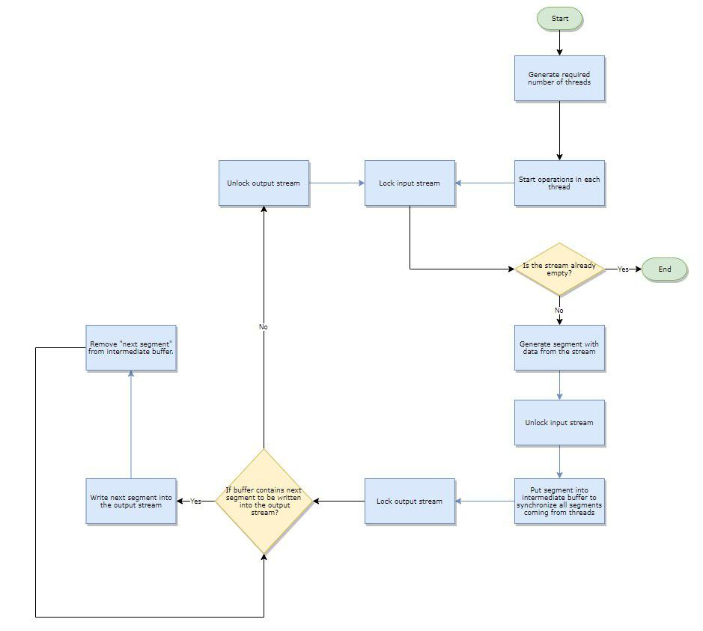

The main magic in provided algorithm happens when all segments are coming to the “intermediate buffer” which is built to have an intermediate storage for data coming from all threads, to be able to send those segments in a right order to the output stream, by using Id of each of the segments.

# 2 Conceptual Architecture

