PMSM Project 1 Report Outline and Initial Results
Visualization and report working draft

Purpose. This document combines the report plan with the first numerical figures. It is meant to guide the next stage of writing, not to act as the final submitted report. The main result so far is that the three numerical methods behave as expected when the step size is suitable, while explicit methods become unstable when their stability limits are crossed.
Project question | How do voltage coupling and electrical speed affect PMSM current response, and what step sizes are suitable for common ODE solvers?
Methods | Explicit Euler, classical RK4, implicit Euler with Newton iteration, and adaptive RK4.
Reference | Matrix-exponential solution checked against a tight-tolerance Radau solution.
Current evidence | Transient response, convergence order, stability regions, unstable test cases, and adaptive step-size behaviour.

Scope. The parameter values are illustrative. The model assumes fixed electrical speed and does not include a complete controller, inverter switching, saturation, temperature change, or mechanical acceleration.

1 Proposed report structure
The final report can follow the eight main sections below. Each section has a clear job, so the report should read as one connected study rather than separate pieces written by different members.
Section | Main content | Evidence to include
1 Background and question | Explain the PMSM application and state the numerical question. | Short motivation and the project question.
2 Model and assumptions | Derive the d-q voltage equations and define current as the state. | Equations, units, parameter table, assumptions.
3 Reference solution | Write the model in matrix form and explain the exact solution. | Equilibrium, matrix exponential, Radau check.
4 Numerical methods | Describe Euler, RK4 and implicit Euler, followed by adaptive RK4. | Update formulas, Newton residual, short pseudocode.
5 Stability analysis | Connect each stability function with the complex eigenvalues of this model. | Stability-region plot and critical step sizes.
6 Numerical experiments | Compare accuracy, stability and computational behaviour. | Figures 1 to 5, result tables and code outputs.
7 Model comparison | Compare the simple ODE replay with saved Simulink signals. | Replay errors and a discussion of possible causes.
8 Conclusions and limitations | Summarise which method works best and what the model cannot prove. | Method recommendation and next validation steps.

Appendices
- AI transparency log with a small number of important claim checks rather than a long prompt transcript.
- One genuine individual contribution statement for each member, linked to real files, tasks and commits.

2 Planned content by section

1 Background and question
Start with the practical issue: currents change after a voltage input, and a numerical method must reproduce this transient without adding artificial growth. The report should then ask how voltage coupling and electrical speed affect the current response, and how the time step changes the accuracy and stability of the simulation.

2 Model and assumptions
- Use the d-q currents i_d and i_q as the two state variables.
- Treat u_d and u_q as voltage inputs and omega_e as a prescribed constant speed.
- State the main parameter values and units before showing numerical results.
- Explain that the model is an open-loop electrical subsystem, not a full motor-drive model.

3 Reference solution
For constant voltage and speed, the model has the form i' = A i + b. This gives an equilibrium current and a matrix-exponential solution. We use this solution as the main reference and compare it with a tight-tolerance Radau calculation. The maximum difference is about 9.0 x 10^-13 A, so the reference error is much smaller than the errors shown in the main experiments.

4 Numerical methods
Describe explicit Euler first because its stability limit is easy to understand. Then introduce classical RK4 as a higher-order explicit method. For implicit Euler, define the nonlinear residual and explain that Newton iteration is used even though the present benchmark is linear. Finally, describe adaptive RK4 using one full step and two half steps.

5 Stability analysis
Show the three stability functions and plot their stability regions. The important point is to use the actual complex eigenvalues of the PMSM matrix. At 500 rad/s, the estimated critical steps are about 0.800 ms for Euler and 5.756 ms for RK4. Implicit Euler is stable for this linear problem for any positive step, although a large step may still give a poor waveform.

6 Numerical experiments
- Use the transient plot to introduce the physical behaviour.
- Use log-log error plots to estimate the observed orders.
- Run Euler and RK4 below and above the predicted stability limits.
- Show that the adaptive method changes step size and rejects unsuitable trial steps.

7 Model comparison
The saved Simulink replay does not closely match the simple two-state model. This should be reported as an unresolved comparison, not hidden. Step refinement shows that the RK4 integration itself has converged, so the remaining difference is more likely related to model assumptions, signal definitions, scaling, timing, or input reconstruction.

8 Conclusions and limitations
A reasonable conclusion is that adaptive RK4 gives good accuracy for the smooth benchmark, while implicit Euler is useful as a stable reference when damping is more important than phase accuracy. The report should not claim that these simulations validate a real motor because no independent hardware data are used.

Initial result summary
Check | Current result | Meaning
Reference check | 8.99 x 10^-13 A | Matrix exponential and Radau agree closely.
Euler order | 1.016 | Close to the expected first order.
RK4 order | 3.995 | Close to the expected fourth order.
Implicit Euler order | 0.984 | Close to the expected first order.
Euler stability limit | 0.800 ms | A smaller step is required at the baseline speed.
RK4 stability limit | 5.756 ms | RK4 permits a larger stable step.
Adaptive RK4 | 99 accepted, 2 rejected | Maximum measured global error is 6.24 x 10^-6 A.

Figure 1 Voltage step response and physical outputs
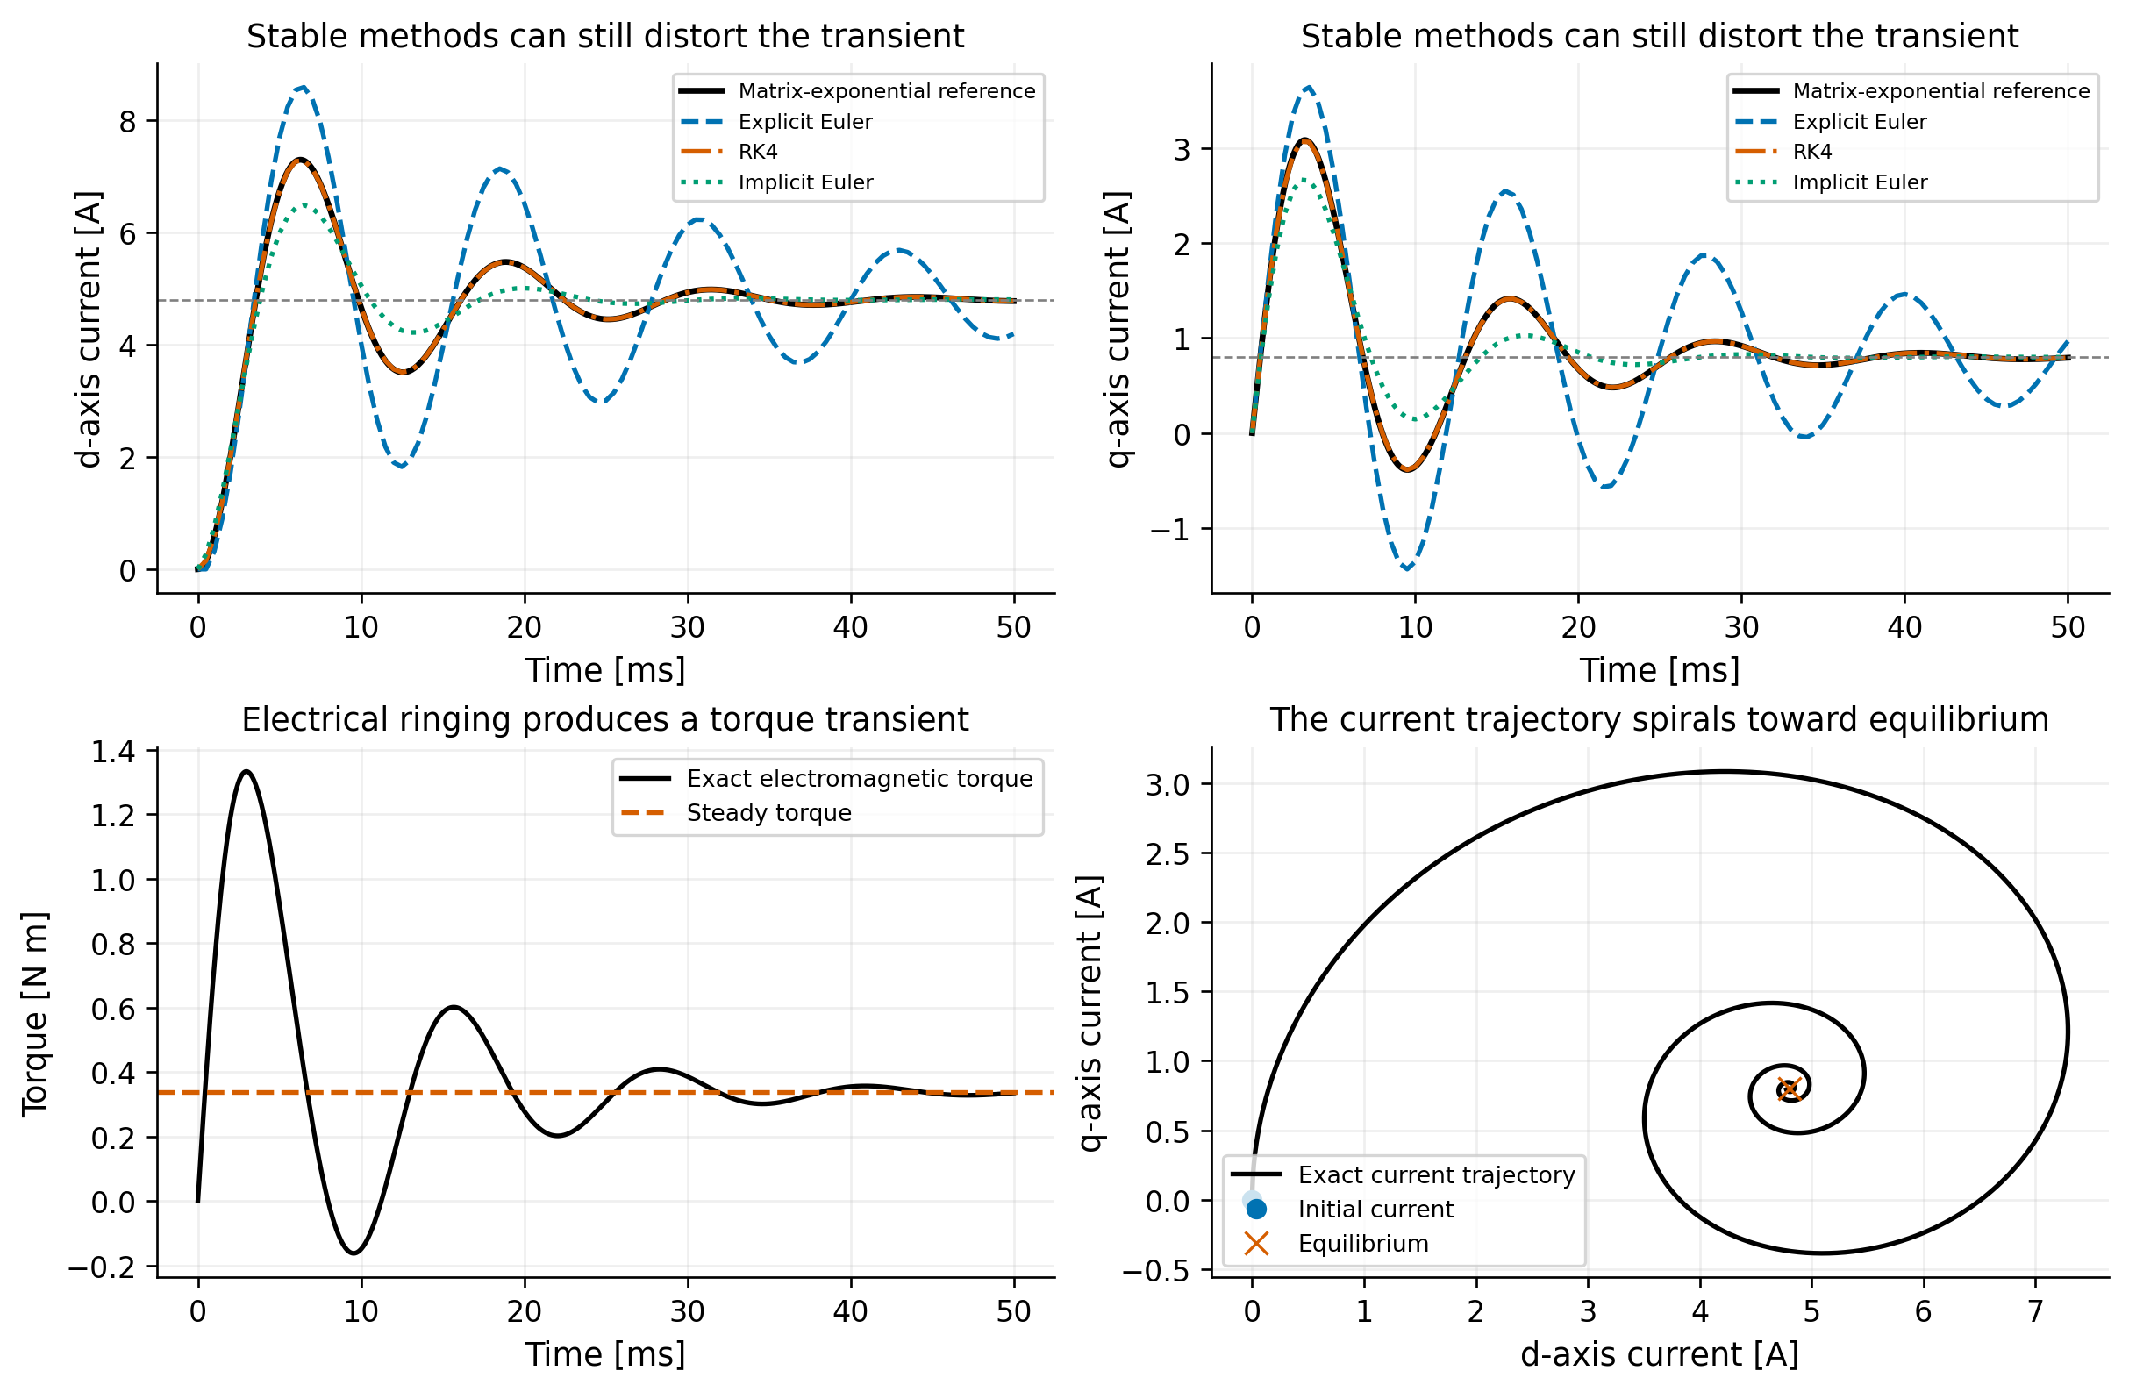
Figure 1. Current, torque and phase-plane responses for the baseline voltage step. The three fixed-step solutions use h = 0.5 ms.
How we read this result. The two current components are coupled. Even with u_d = 0, the d-axis current changes after the q-axis voltage is applied. The trajectory approaches the steady current while the torque shows a damped oscillation and briefly becomes negative.
What we should not claim. This plot does not show that all three numerical methods have the same accuracy. The step is stable, but the visible differences still need to be measured using an error calculation.

Figure 2 Convergence order
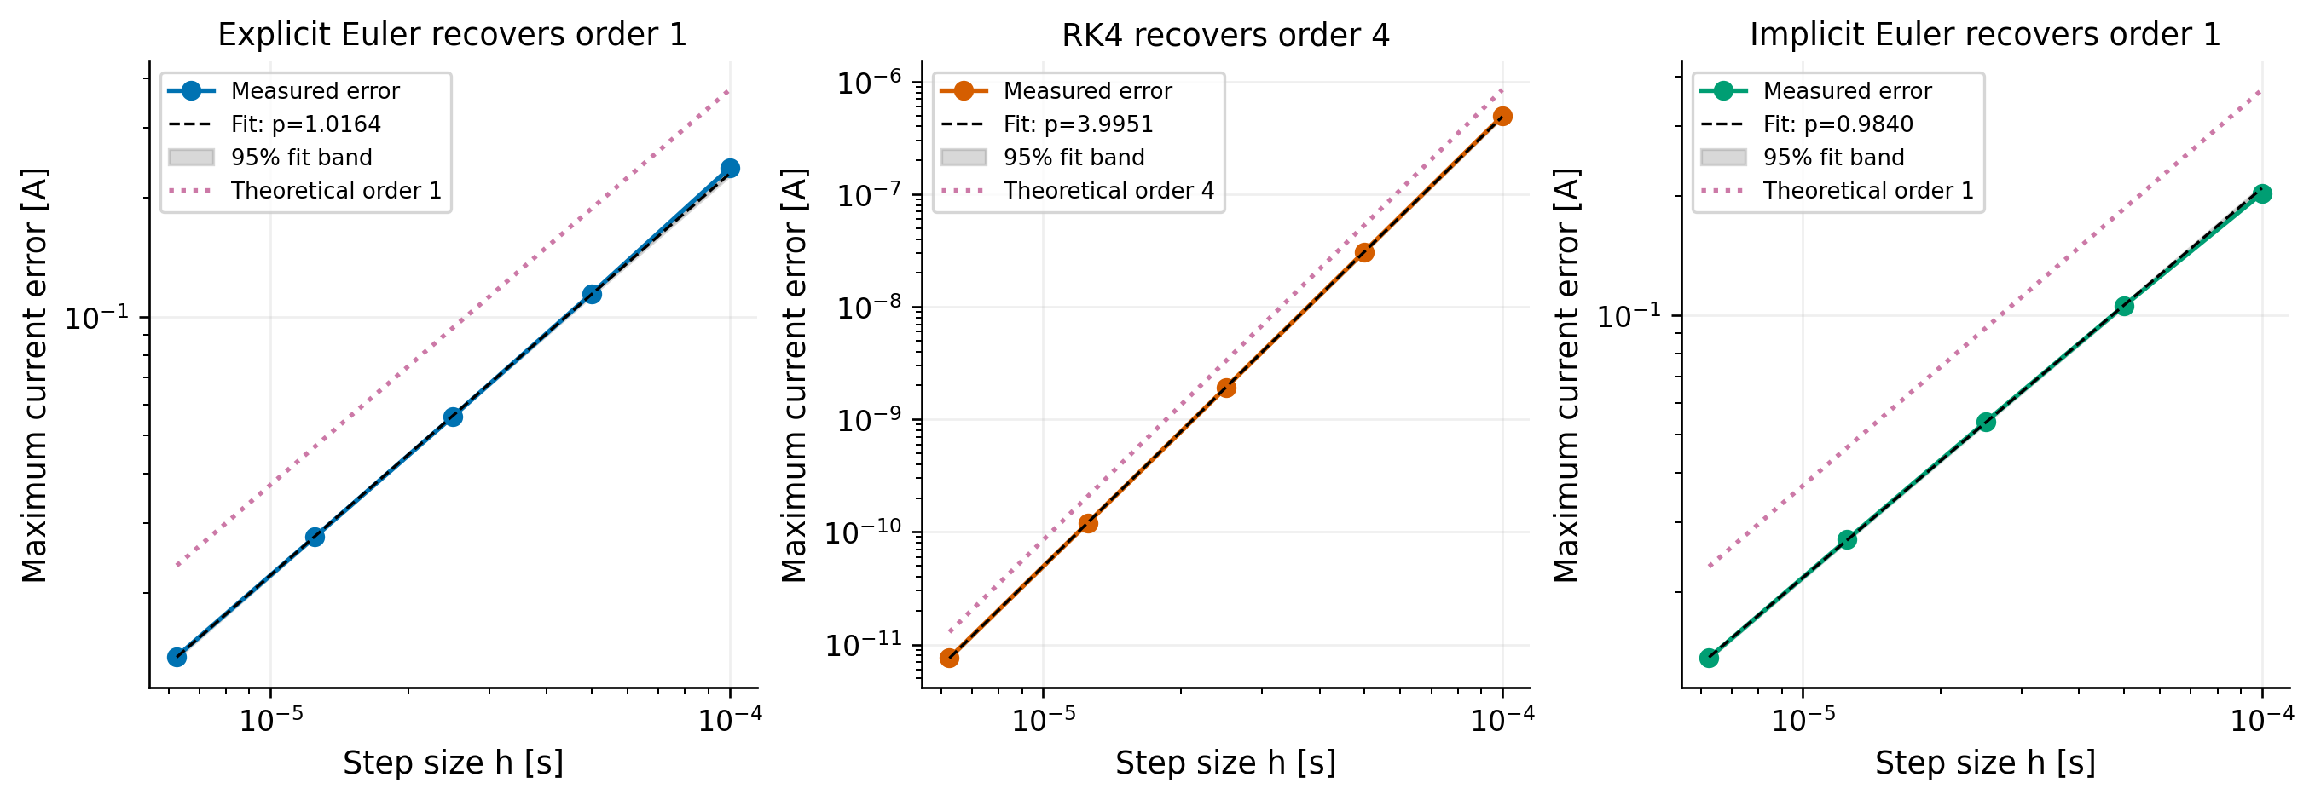
Figure 2. Maximum current error against step size for explicit Euler, RK4 and implicit Euler on log-log axes.
How we read this result. The fitted slopes are 1.016 for Euler, 3.995 for RK4 and 0.984 for implicit Euler. These values are close to the expected orders 1, 4 and 1. This supports the implementation and also explains why RK4 reaches a much smaller error at the same fine step size.
What we should not claim. The shaded regression bands are not uncertainty bands from repeated physical experiments. They only describe the fit of deterministic numerical data.

Figure 3 Stability regions
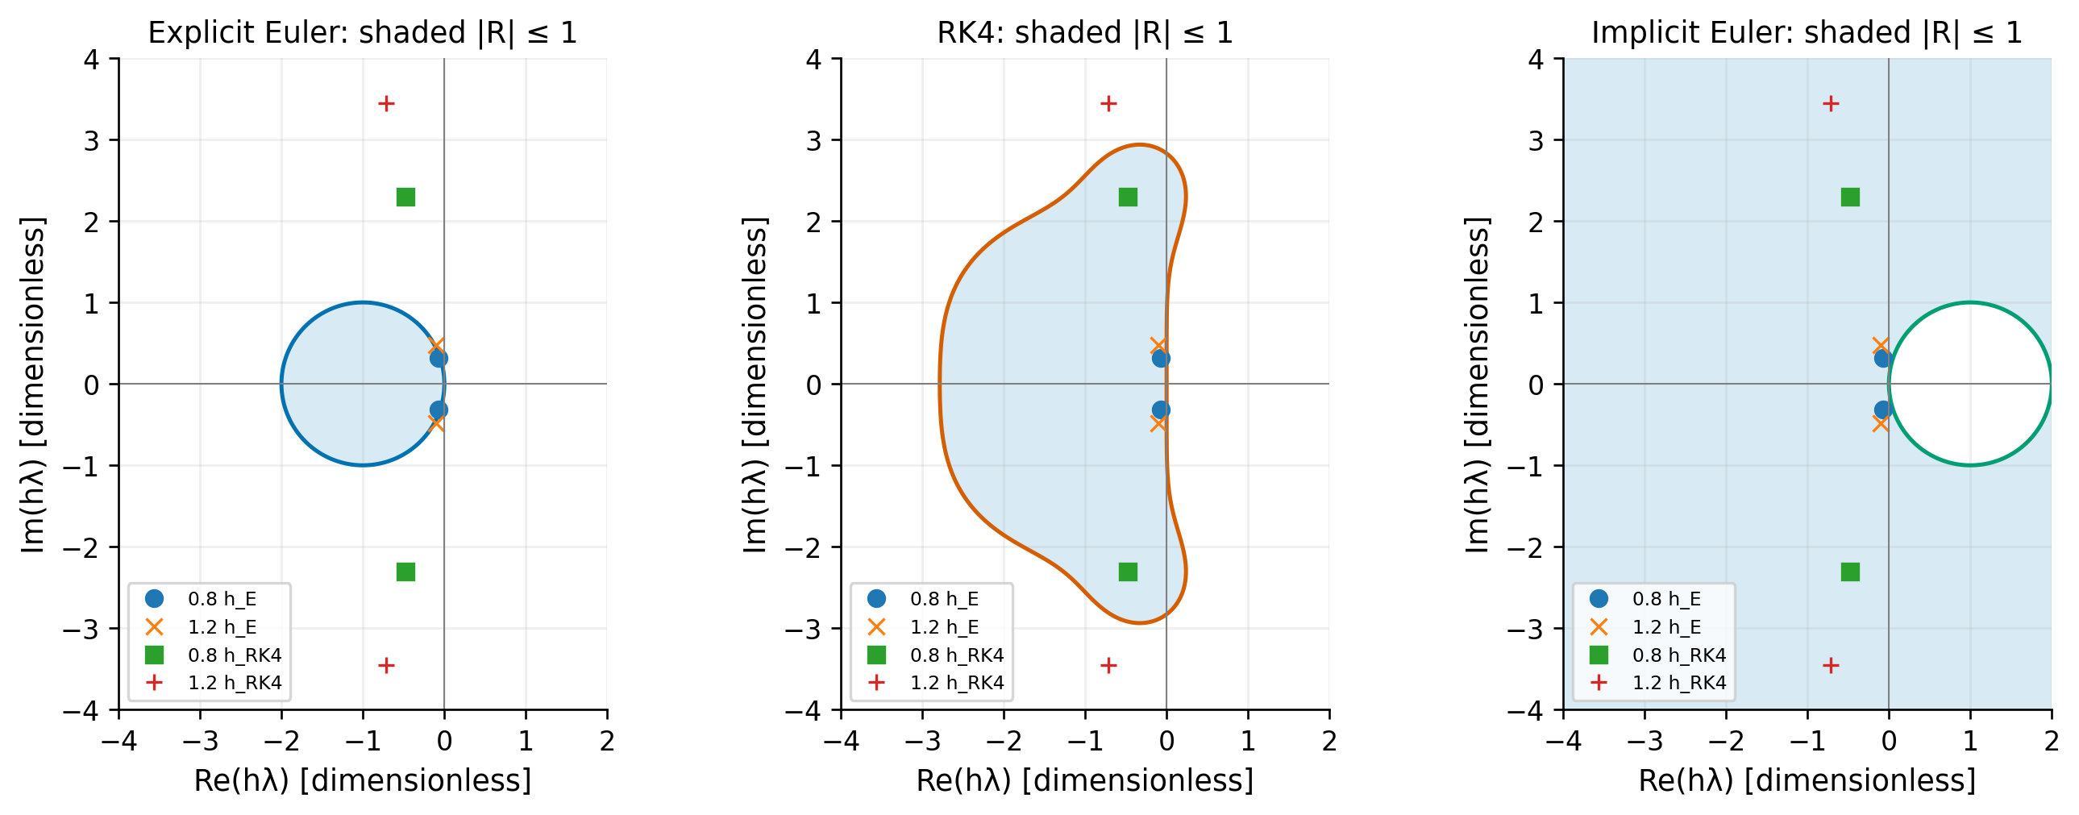
Figure 3. Absolute-stability regions for the three methods with the actual complex h lambda values marked.
How we read this result. The eigenvalues are complex, so the direction of h lambda matters. The Euler points leave its stability disk at a much smaller step than the RK4 points leave the RK4 region. Implicit Euler includes the left half-plane and therefore remains stable for this linear benchmark.
What we should not claim. A point inside a stability region only predicts decay of the numerical mode. It does not guarantee small phase error or an accurate transient.

Figure 4 Tests below and above the stability limit
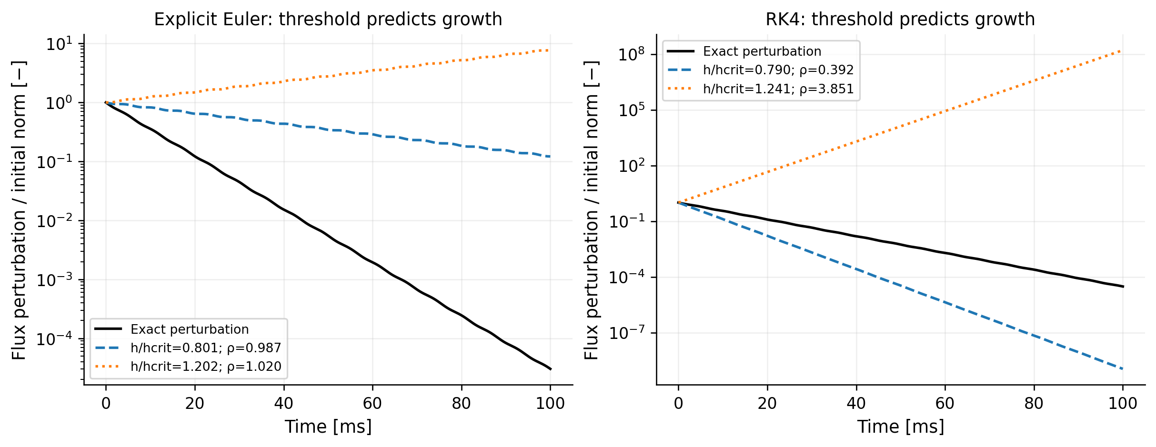
Figure 4. Perturbation tests for Euler and RK4 using steps below and above the calculated critical values.
How we read this result. Both methods decay when the step is below the predicted limit and grow when the step is above it. The above-limit RK4 test grows very quickly. This is useful because it checks a case where the method is expected to fail, rather than only showing successful runs.
What we should not claim. The stable run should not automatically be called physically accurate. A method can be stable but still damp the transient too strongly or shift its phase.

Figure 5 Adaptive RK4 step size
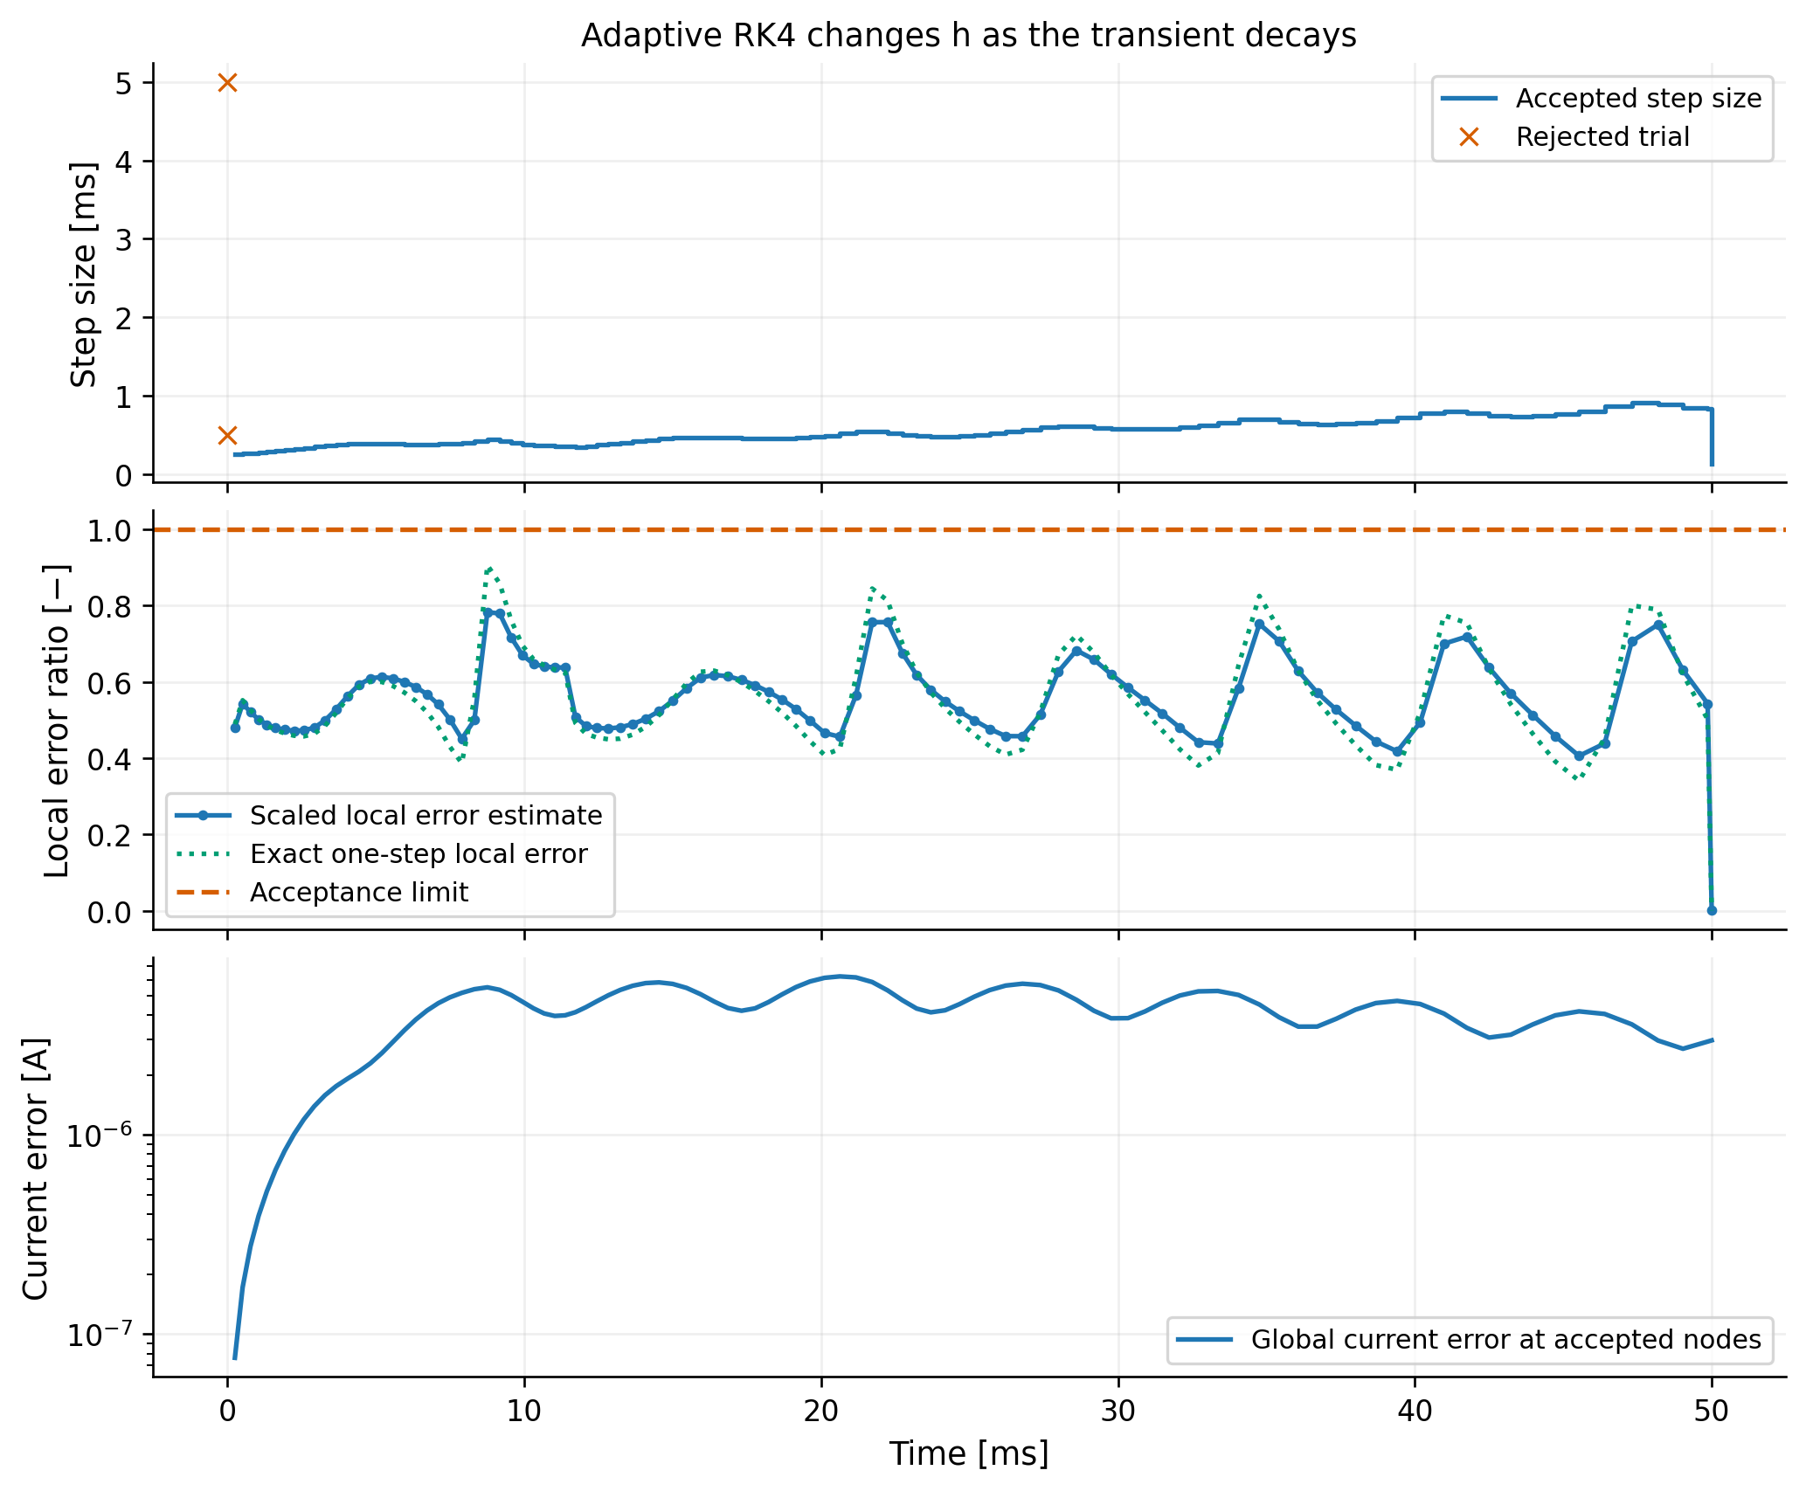
Figure 5. Accepted step sizes, rejected trials, local error ratios and measured global current error for adaptive RK4.
How we read this result. For atol = 10^-7 A and rtol = 10^-7, the method accepts 99 steps and rejects two trial steps. The largest measured global current error is 6.24 x 10^-6 A, which is below the separate 10^-5 A target used for this test. The changing accepted step size shows that the controller is actually adapting to the transient.
What we should not claim. The local tolerance is not a theorem about the total error over the whole interval. The global error must still be checked against the reference solution.

3 Writing plan and remaining work

How to keep the writing at undergraduate level
- Explain each equation in words before moving to the next result.
- Use one main point per paragraph and avoid adding technical terms that are not used later.
- State what each plot supports and also what it cannot prove.
- Keep detailed proof steps in the stability section or an appendix instead of repeating them in every figure discussion.
- Use consistent notation and units throughout the report.

Work still needed before submission
- Confirm the team number, names, student IDs and presentation wave.
- Ask the mathematics members to check the model signs, eigenvalues and stability calculations.
- Ask the implementation and validation members to reproduce every figure from code and record the command used.
- Decide whether all five initial figures will remain in the final report or whether some will move to an appendix.
- Complete the saved-model discussion without presenting simulation data as hardware measurements.
- Write the final abstract and conclusion only after the main results are fixed.

Short AI transparency plan
The final report should state that AI tools helped with drafting, code review and presentation of results. For important claims, the team should record the assumption, the possible error, the independent check, where the evidence is stored, and whether the claim was accepted or changed. The team should only sign work that members have checked and can explain.

Suggested report flow
The simplest story is: the voltage step creates a coupled transient; the numerical methods reproduce the reference at their expected orders; the complex eigenvalues explain the step-size limits; tests above the limits become unstable; and adaptive RK4 changes its step while meeting the separately checked accuracy target. The saved-model mismatch then shows why a converged numerical solver is not the same as a validated physical model.

