Journal of Geophysical Research: Space Physics
Supporting Information for
Electron Backscatter in Energetic Particle Precipitation: Data Analysis and Simulation
Julia Luna Claxton (she/they)¹, Robert Marshall¹
¹Ann and H. J. Smead Department of Aerospace Engineering Sciences, University of Colorado Boulder
¹Boulder, CO, USA

Contents of this file

Text S1 to S2
Figures S1 to S4

Introduction
We present a curvefit of backscatter ratios as a function of loss cone filling and residuals of our data-model comparison in terms of energy for completeness.

Text S1.
In this section, we present a power law fit for backscatter ratio as a function of loss cone filling derived from ELFIN data. The data we are fitting to is shown in Figure S1 (reproduced from manuscript). For this fit, we will only consider the case with low precipitating fluxes excluded, shown in the right panel.

First we find the median backscatter ratio for every J_{precip}/J_{trap} bin. This series, along with the 25th and 75th percentile of the r_{N} distribution for each J_{precip}/J_{trap} bin, is shown in Figure S2.

We then fit a power law to each curve using a least-squares regression. The formulae for these fits and their coefficient of determination R² are given below.
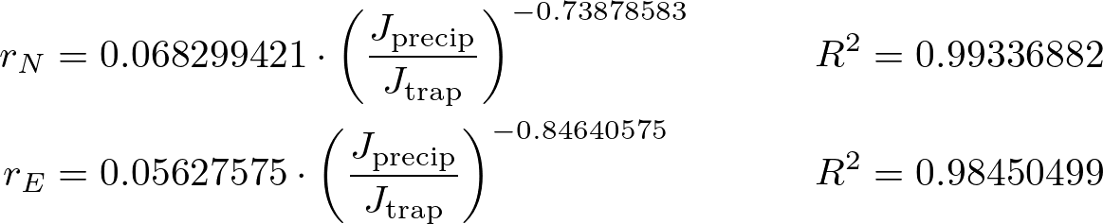

These fits are plotted over the data in Figure S3.

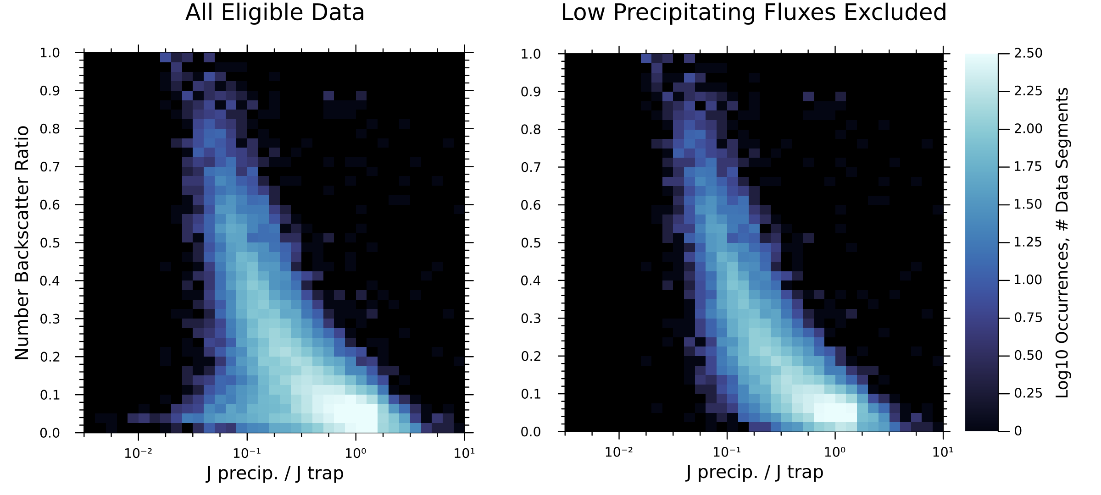
Figure S1. Number backscatter ratio vs. loss cone filling strength derived from 63 hours (69,510 spacecraft spins) of ELFIN data. Any measurement of backscatter ratio with absolute uncertainty greater than σ ≈ 0.025 was discarded. Left: Results all eligible ELFIN data (see manuscript). Right: Measurements with precipitating flux less than 10^{2.75} electrons cm⁻²-s⁻¹ removed. Energy backscatter ratio has a similar pattern to number backscatter ratio and is not shown for brevity.

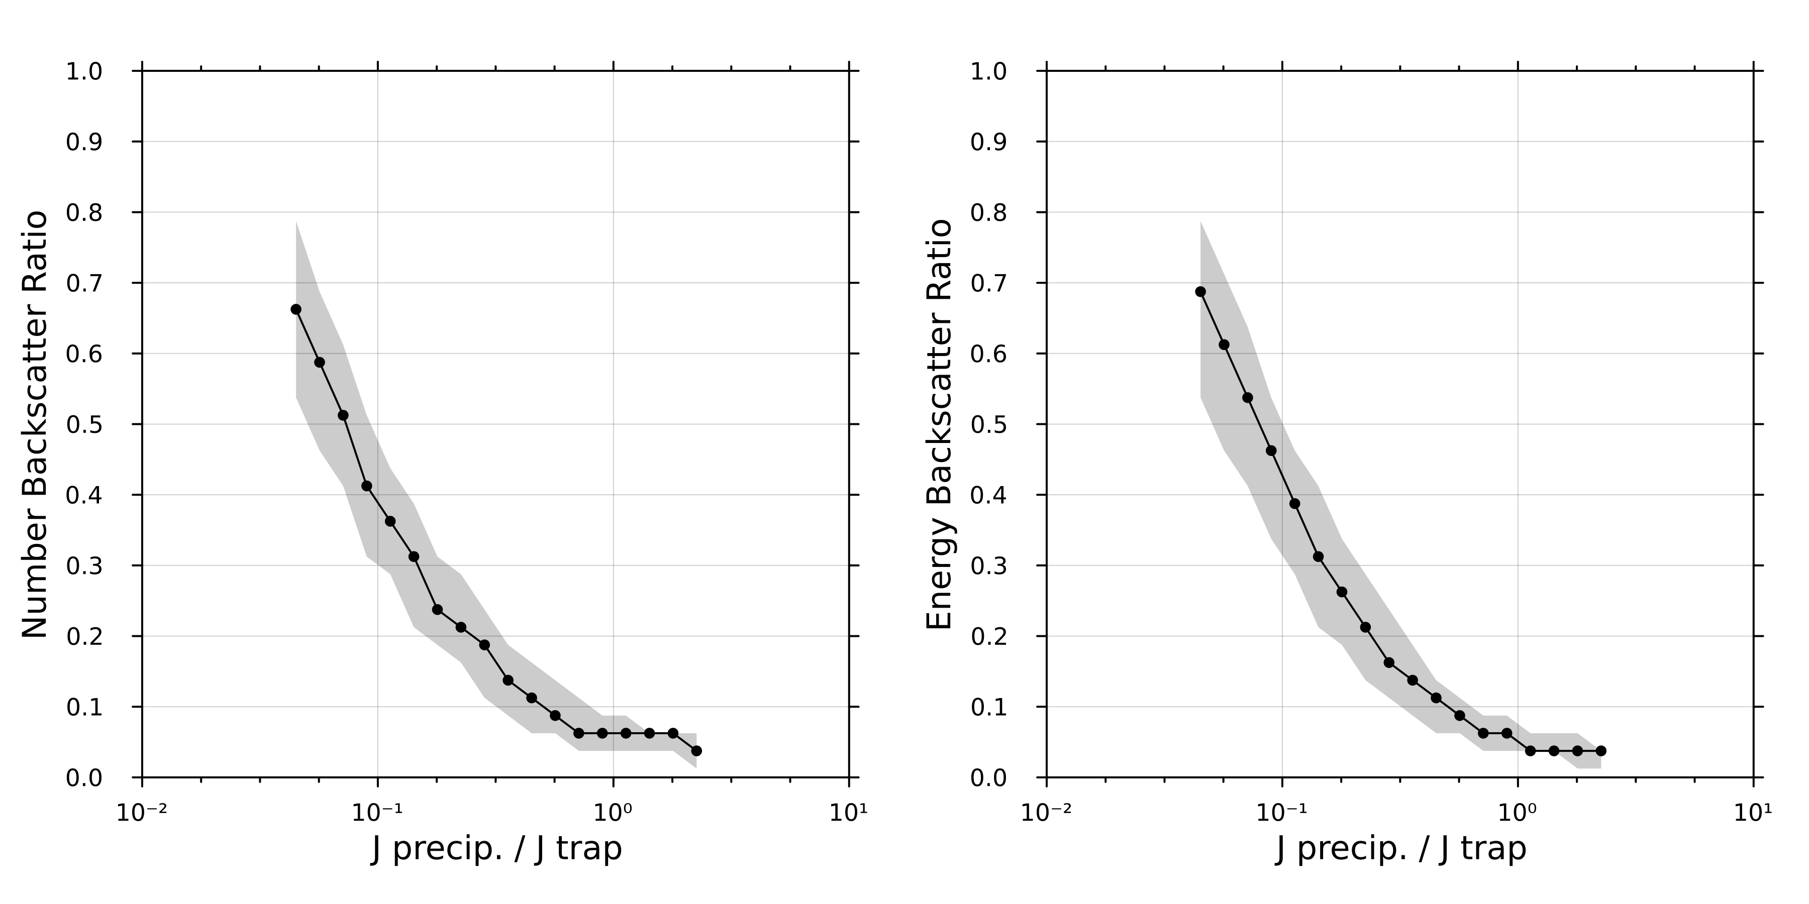
Figure S2. Median backscatter (black line) as well as the 25th and 75th percentile (grey ribbon below and above, respectively) as a function of precipitation strength. Left panel shows the number backscatter ratio r_{N}, right panel shows the energy backscatter r_{E}.

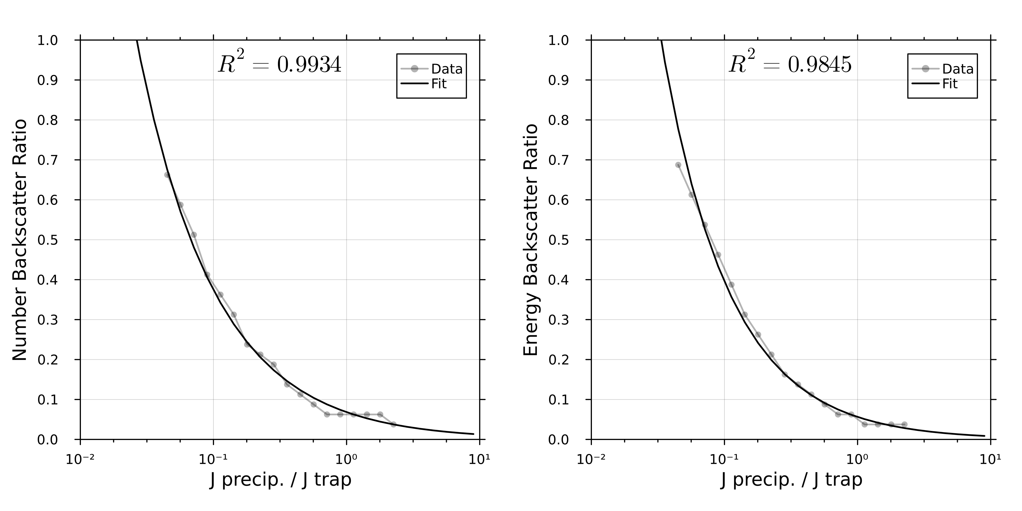
Figure S3. Median backscatter rates (grey line with dots) at a variety of loss cone filling levels with a power law curvefit (black line) overlaid. Left: Number backscatter ratio as a function of loss cone filling. Right: Energy backscatter ratio as a fucntion of loss cone filling.

Text S2.
ELFIN-derived energy backscatter plotted against simulation-predicted energy backscatter is shown in Figure S4.

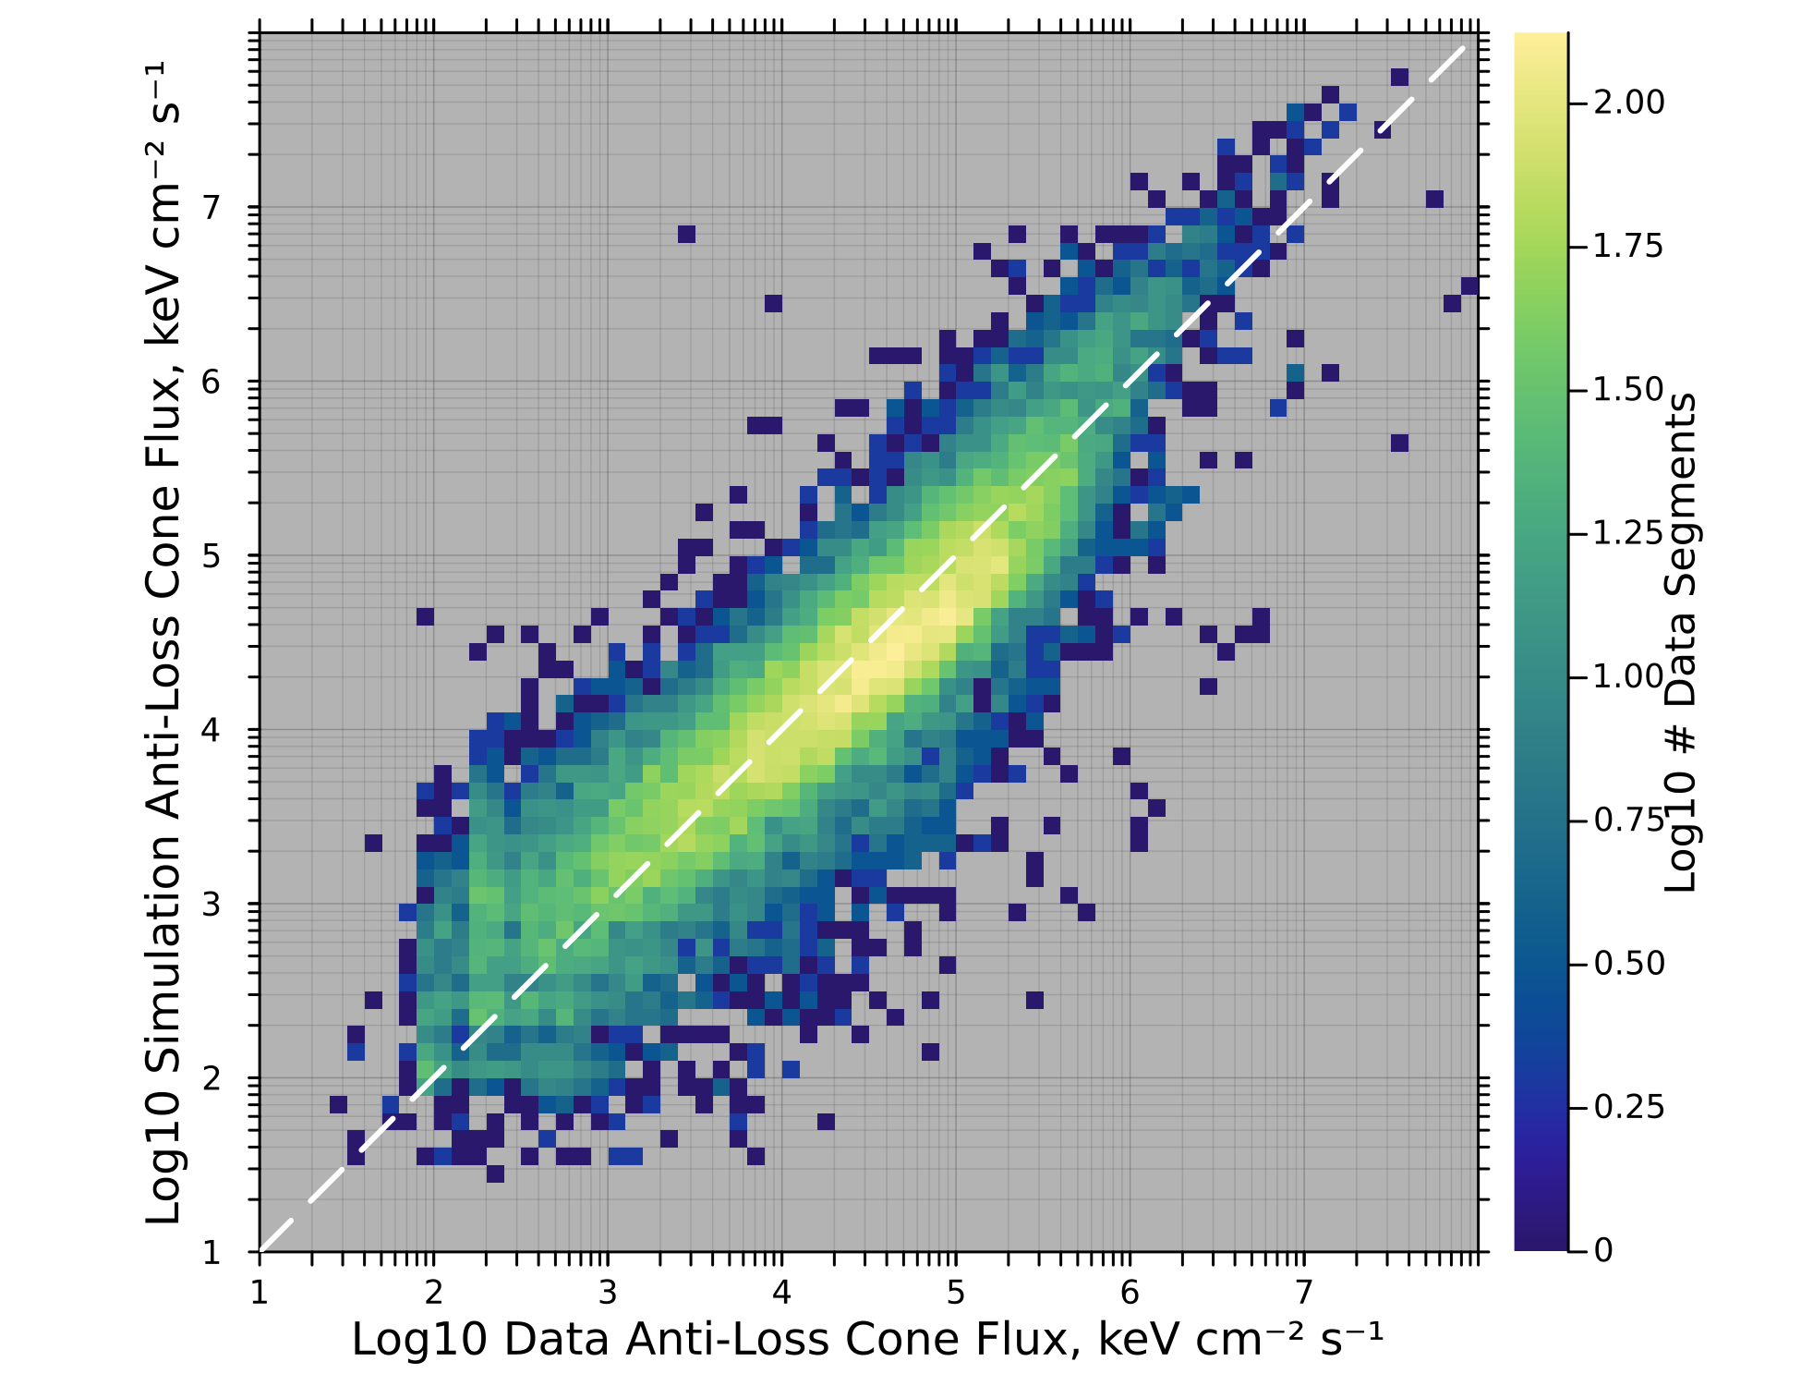
Figure S4. Anti-loss cone energy flux predicted by lookup tables derived from our Monte Carlo simulation vs. ELFIN-measured anti-loss cone energy for all ELFIN data segments that were simulated. The dashed white line indicates where predicted backscatter was equal to ELFIN-measured backscatter.

