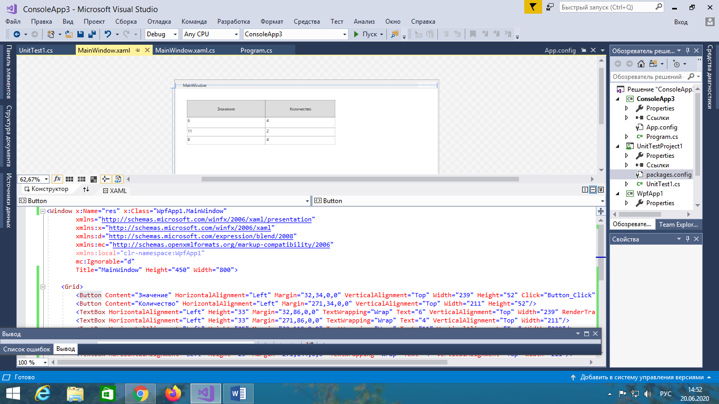

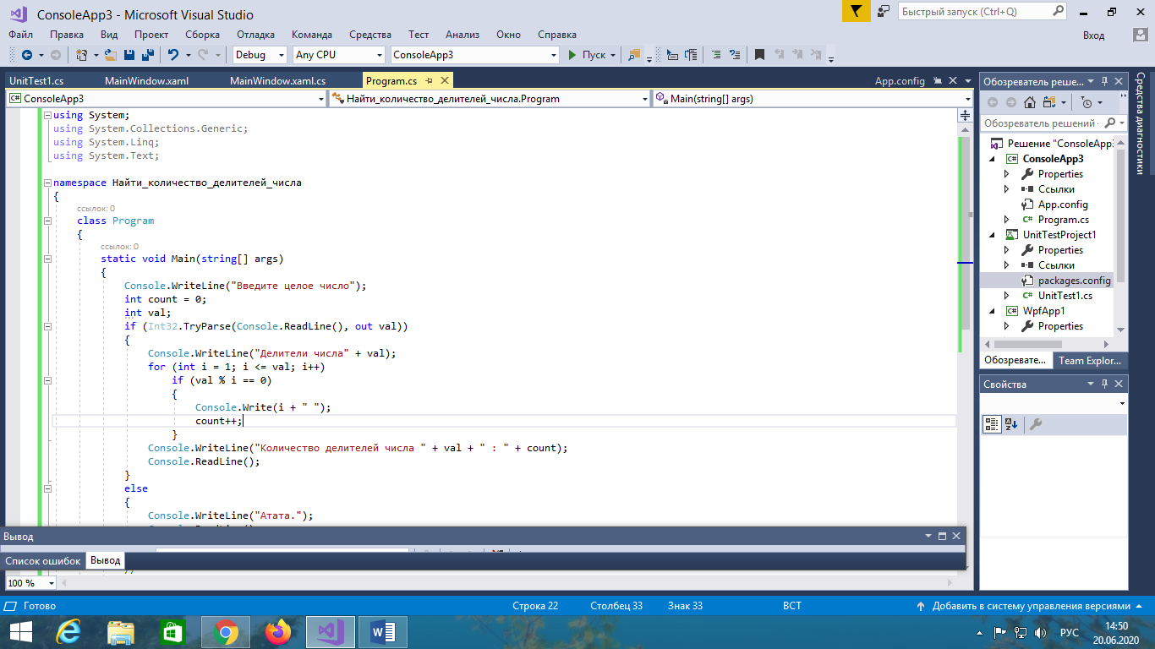

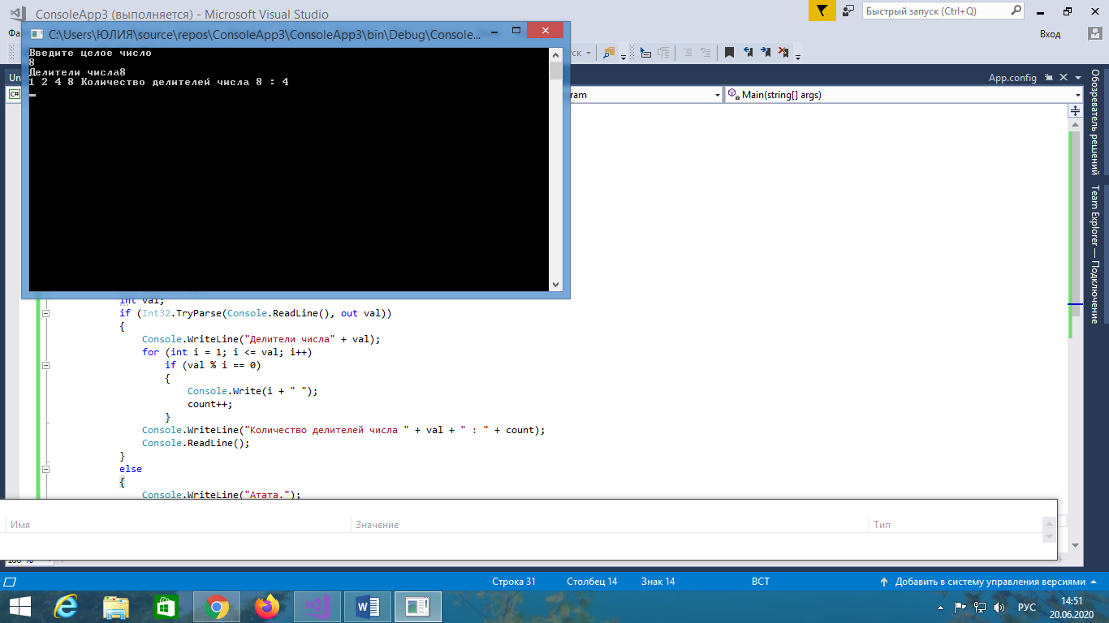  
using System;

using System.Collections.Generic;

using System.Linq;

using System.Text;

namespace Найти_количество_делителей_числа

{

class Program

{

static void Main(string[] args)

{

Console.WriteLine("Введите целое число");

int count = 0;

int val;

if (Int32.TryParse(Console.ReadLine(), out val))

{

Console.WriteLine("Делители числа" + val);

for (int i = 1; i <= val; i++)

if (val % i == 0)

{

Console.Write(i + " ");

count++;

}

Console.WriteLine("Количество делителей числа " + val + " : " + count);

Console.ReadLine();

}

else

{

Console.WriteLine("Атата.");

Console.ReadLine();

}

//

}

}

}

<Window x:Name="res" x:Class="WpfApp1.MainWindow"

xmlns="http://schemas.microsoft.com/winfx/2006/xaml/presentation"

xmlns:x="http://schemas.microsoft.com/winfx/2006/xaml"

xmlns:d="http://schemas.microsoft.com/expression/blend/2008"

xmlns:mc="http://schemas.openxmlformats.org/markup-compatibility/2006"

xmlns:local="clr-namespace:WpfApp1"

mc:Ignorable="d"

Title="MainWindow" Height="450" Width="800">

<Grid>

<Button Content="Значение" HorizontalAlignment="Left" Margin="32,34,0,0" VerticalAlignment="Top" Width="239" Height="52" Click="Button_Click"/>

<Button Content="Количество" HorizontalAlignment="Left" Margin="271,34,0,0" VerticalAlignment="Top" Width="211" Height="52"/>

<TextBox HorizontalAlignment="Left" Height="33" Margin="32,86,0,0" TextWrapping="Wrap" Text="6" VerticalAlignment="Top" Width="239" RenderTransformOrigin="0.5,0.5"/>

<TextBox HorizontalAlignment="Left" Height="33" Margin="271,86,0,0" TextWrapping="Wrap" Text="4" VerticalAlignment="Top" Width="211"/>

<TextBox HorizontalAlignment="Left" Height="25" Margin="32,119,0,0" TextWrapping="Wrap" Text="11" VerticalAlignment="Top" Width="239"/>

<TextBox HorizontalAlignment="Left" Height="25" Margin="271,119,0,0" TextWrapping="Wrap" Text="2" VerticalAlignment="Top" Width="211"/>

<TextBox HorizontalAlignment="Left" Height="25" Margin="32,144,0,0" TextWrapping="Wrap" Text="8" VerticalAlignment="Top" Width="239"/>

<TextBox HorizontalAlignment="Left" Height="25" Margin="271,144,0,0" TextWrapping="Wrap" Text="4" VerticalAlignment="Top" Width="211"/>

</Grid>

</Window>