**Study for new tablet behavioural tasks for Social, Cognitive and Emotional development**

**Parent Information Sheet**

We would like to tell you about a new research study that we are carrying out as at the Institute of Psychiatry, Psychology and Neuroscience, King’s College London. We wish to explore whether you may be interested in your child taking part. Your child’s participation is entirely voluntary, choosing not to participate will not disadvantage you or your child in any way. Please take time to read the following information and discuss with others if you wish. Alternatively, please do not hesitate to contact us (see contact details below) if you have further questions.

**What is the aim of the study?**



This study is a study to test some new tablet tasks and make them accessible to children with neurodevelopmental disorders and/or intellectual disability. The aim of these tasks is to reliably measure a child’s social, emotional, behavioural and cognitive development. Our ultimate goal is to use these tablet tasks in the future to create of a profile of (relative) strengths and difficulties for each child.

**Who is the research team?**

This study is carried out as part of the AIMS-2-TRIALS, which is currently the largest project world-wide focused on neurodevelopmental disorders, such as autism. The research team that is developing the new tablet tasks consists of experts in child development/ cognitive neuroscience (Dr Eva Loth), programmers with expertise in artificial intelligence (Prof Robert Leech), and puppeteers/ set designers to make the tasks as fun and enjoyable as possible for children (Oliver Smart, Folded Feathers).

This pilot phase is carried out by researchers at King’s College London, under the supervision of Dr Eva Loth. Eva is a Senior Lecturer at the Institute of Psychiatry, Psychology and Neuroscience with over 15 years of experience in child development.

**Why have we been chosen?**



We are seeking to enrol typically developing children and children with autism between the ages of 2 and a half to 5 years to participate in this study.

**What exactly does participation involve?**

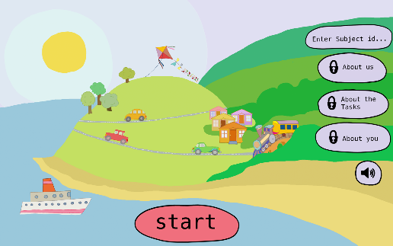Your child playing tablet tasks/ games! We will ask your son/daughter to play some games on a tablet. Although these tasks are game-like, they were designed to measure children’s attention, memory, processing of emotions or understanding of social situations.

We will also ask you to fill in some questionnaires about your child’s behaviour in everyday situations. These should take about 30-45 minutes.

**What are the benefits of taking part?**

There are no immediate benefits for you or your child to taking part. However, by taking part in the study, you and your child help us in validating the tasks and ensuring that they are reliable measures of the underlying cognitive or emotional processes. This will allow us to eventually use the app to inform clinicians or teachers about any additional support required by children. You will also be reimbursed with a 15-pound e-voucher for your participation.  **What are the disadvantages of taking part?**

There are no known risks associated with the tasks that your child will be carrying out. However, if you or your child do not enjoy the experience or prefer not to answer certain questions, you are welcome to stop participation at any given time.

**Will our data be kept confidential?**

Yes, all information collected about you and your child will be held in confidence. As soon as you begin participation in the study, you and your child will be assigned a research code. This will only be known to the researcher on this study to identify you and your child’s data. Information will be securely stored according to the UK Data Protection Act 1998 and will be

kept confidential on a password-protected computer file. You may withdraw at any time and stop your participation.

**Can we change our mind after agreeing to take part?**

Yes! Your participation is entirely voluntary, and if you or your child no longer wish to take part then you can withdraw at any time. You do not have to provide a reason. You will be

given this information sheet if you wish to continue and asked to sign a consent form. Please feel free to ask any questions about your rights as a participant.

**Contact Info**

If you would like to take part in the study, please contact us on our email:

pip-tabletstudy@kcl.ac.uk

If you have any questions or would like to raise a concern, please do not hesitate to contact any of the research team.

Project Supervisor: [Eva.Loth@kcl.ac.uk](mailto:Eva.Loth@kcl.ac.uk)

Project Members: julia.koziel@kcl.ac.uk

**Thank you for reading this information sheet and for considering taking part in this research.**