**Data-driven multivariate identification of transdiagnostic gyrification patterns: A cluster analysis approach**

**Supplementary Information**

Contents

**Supplement S1.** *Clustering procedure* **2**

**Supplement S2. Table 1** *Descriptives of gyrification data in our sample* **4**

**Supplement S3. Figure 1** *Correlation matrix of DK-40 brain regions* **7**

**Supplement S4. Figure 2** *Correlation matrix of subjects* **8**

**Supplement S5. Figure 3 9**

a) Screeplot/Elbow point plot for k=10 clusters. Elbow appears to be at k=3. 9

b) Dendrogram with cut at k=3 clusters. 9

**Supplement S6. Cluster stabilities for other cluster solutions k=2 to k=10. 10**

**Supplement S7. Re-run of cluster analysis on 80% of the initial dataset. 11**

a) Screeplot/Elbow point plot for k=10 clusters. Elbow appears to be at k=3. 11

b) Dendrogram. 11

c) Cluster stability assessment for k=2 to k=10: 11

d) Decriptives for chosen k=3 cluster solution 12

e) Plot of mean gyrification per cluster for every region, ordered frontal-parietal-temporal-occipital. 12

**Supplement S8. Table 2** *Binomial tests for diagnostic groups within clusters* **13**

**Supplement S9. Table 3** *Results of ANOVA post-hoc tests between data-driven cluster* **14**

**Supplement S10. Table 4** *Results of ANOVA between DSM-labelled groups* **20**

**Supplement S11. Figure 4** *Plot of mean gyrification for DSM-labelled groups* **22**

**Supplement S12. Figure 5** *Plot of mean gyrification for cluster groups together with HCs* **23**

**Supplement S13. – Table 5** *Effect sizes for brain areas and output regression analyses* **24**

# Supplement S1.

Decision for applying *hierarchical agglomerative* cluster analysis using *ward-algorithm* on a computed dissimilarity-matrix using Euclidean distance was made due to following reasons:

1. *Hierarchical:* As there is no other study comparable to our goal, namely finding groups based solely on their gyrification and not including other kind of variables (e.g. other kind of brain data, psychometric data) for clustering, the structure and number of clusters was completely unknown. This excluded cluster approaches with pre-defined number of clusters like k-means. This applies also to model-based clustering. as clustering with only one kind of variable follows a more heuristic approach than a formal model-based one and purpose of this study was an explorative one.
2. *Agglomerative:* Given that there is a high correlation between subjects as well as high-dimensionality (thus less chance to detect clusters by eyes), an agglomerative approach for clustering our data is more appropriate than a divisive one. Agglomerative clustering works by clustering the data in a bottom-up manner. This means that every data point is considered a cluster by itself at the beginning and then successively gets fused with similar data points and ending this process with one single cluster. This also means that agglomerative clustering does not initially take into account the global pattern of the data but only considers the local patterns when fusing the data points.
3. *Ward*-*algorithm:* Using the *agnes*-function implemented in the R-package *cluster*. we computed the agglomerative coefficient (AC) for every possible algorithm in hierarchical clustering. AC describes the strength of the clustering structure that has been obtained by group average linkage. Results indicated the ward-algorithm to be the best suited for our kind of dataset (computed ACs: average linkage=0.45. single linkage=0.29. complete linkage=0.64. **ward=0.9**)

# Supplement S2. Table 1

Descriptives of gyrification data in our sample n=1028.

|  |  |  |  |  |  |  |  |
| --- | --- | --- | --- | --- | --- | --- | --- |
| **Region** | **Min** | **Max** | **Range** | **Mean** | **Std.-Error** | **SD** | **Variance** |
| ***Left Hemisphere*** |  |  |  |  |  |  |  |
| Banks of the superior temporal sulcus | 19.8945 | 32.2927 | 12.3982 | 26.11452 | 0.065448 | 2.098425 | 4.403 |
| CC – caudal anterior division | 20.5238 | 20.5238 | 17.4353 | 28.87328 | 0.075337 | 2.415488 | 5.835 |
| MFG – caudal division | 8.5984 | 22.8985 | 31.4969 | 27.21655 | 0.033993 | 1.089886 | 1.188 |
| Cuneus | 25.0565 | 34.9533 | 9.8968 | 30.24512 | 0.043961 | 1.409492 | 1.987 |
| Entorhinal cortex | 20.1474 | 33.3801 | 13.2327 | 25.74212 | 0.058623 | 1.879588 | 3.533 |
| Fusiform gyrus | 23.9116 | 30.5804 | 6.6688 | 27.60943 | 0.032064 | 1.028046 | 1.057 |
| Inferior parietal cortex | 25.4888 | 31.4345 | 5.9457 | 28.49539 | 0.029999 | 0.961854 | 0.925 |
| Inferior temporal gyrus | 24.666 | 31.1169 | 6.4509 | 28.18085 | 0.030448 | 0.976251 | 0.953 |
| CC – isthmus division | 22.8819 | 33.4588 | 10.5769 | 28.39356 | 0.055737 | 1.787051 | 3.194 |
| Lateral occipital cortex | 27.8104 | 33.008 | 5.1976 | 30.49684 | 0.026364 | 0.845297 | 0.715 |
| OFC – lateral division | 25.6337 | 31.6303 | 5.9966 | 28.9231 | 0.030092 | 0.964831 | 0.931 |
| Lingual gyrus | 25.0503 | 32.9022 | 7.8519 | 28.9047 | 0.03174 | 1.017659 | 1.036 |
| OFC – medial division | 25.8238 | 32.5971 | 6.7733 | 29.58658 | 0.034892 | 1.118721 | 1.252 |
| Middle temporal gyrus | 24.4073 | 30.54 | 6.1327 | 27.58409 | 0.03218 | 1.031764 | 1.065 |
| Parahippocampal gyrus | 19.1368 | 30.2494 | 11.1126 | 24.03875 | 0.056468 | 1.810486 | 3.278 |
| Paracentral lobule | 21.805 | 30.2745 | 8.4695 | 25.80467 | 0.043193 | 1.384861 | 1.918 |
| IFG – Pars opercularis | 23.2233 | 29.6004 | 6.3771 | 26.6872 | 0.035001 | 1.122205 | 1.259 |
| IFG – Pars orbitalis | 24.8422 | 33.0371 | 8.1949 | 28.78404 | 0.045292 | 1.452155 | 2.109 |
| IFG – Pars triangularis | 24.4991 | 33.8462 | 9.3471 | 28.35401 | 0.040672 | 1.304056 | 1.701 |
| Pericalcarine cortex | 25.8946 | 34.5778 | 8.6832 | 30.3873 | 0.040991 | 1.314274 | 1.727 |
| Postcentral gyrus | 22.5281 | 29.8118 | 7.2837 | 25.84919 | 0.030813 | 0.987949 | 0.976 |
| CC – posterior division | 22.7725 | 33.5427 | 10.7702 | 28.78539 | 0.04795 | 1.537408 | 2.364 |
| Precentral gyrus | 23.664 | 29.2505 | 5.5865 | 26.15827 | 0.026452 | 0.848128 | 0.719 |
| Precuneus cortex | 25.837 | 32.0995 | 6.2625 | 29.19594 | 0.028682 | 0.919624 | 0.846 |
| CC – rostral anterior division | 24.5774 | 35.1345 | 10.5571 | 30.55786 | 0.046446 | 1.489163 | 2.218 |
| MFG – rostral division | 26.6555 | 32.8253 | 6.1698 | 30.03718 | 0.027249 | 0.873667 | 0.763 |
| Superior frontal gyrus | 24.9752 | 30.1785 | 5.2033 | 27.39978 | 0.024335 | 0.780246 | 0.609 |
| Superior parietal cortex | 25.6803 | 31.8251 | 6.1448 | 28.68991 | 0.030193 | 0.968065 | 0.937 |
| Superior temporal gyrus | 21.8656 | 28.7118 | 6.8462 | 25.23601 | 0.032096 | 1.029085 | 1.059 |
| Supramarginal gyrus | 25.5241 | 31.4614 | 5.9373 | 28.48499 | 0.027232 | 0.873116 | 0.762 |
| Frontal pole | 24.8075 | 38.612 | 13.8045 | 31.23879 | 0.062755 | 2.012077 | 4.048 |
| Temporal pole | 19.5726 | 32.0845 | 12.5119 | 24.7155 | 0.054856 | 1.758827 | 3.093 |
| Transverse temporal cortex | 18.2053 | 32.5562 | 14.3509 | 25.23957 | 0.072421 | 2.322006 | 5.392 |
| Insula | 23.2404 | 32.5851 | 9.3447 | 26.78594 | 0.034952 | 1.120639 | 1.256 |
| ***Right Hemisphere*** |  |  |  |  |  |  |  |
| Banks of the superior temporal sulcus | 19.2091 | 31.855 | 12.6459 | 25.81762 | 0.057697 | 1.849918 | 3.422 |
| CC – caudal anterior division | 21.6757 | 33.6321 | 11.9564 | 29.18142 | 0.054439 | 1.745431 | 3.047 |
| MFG – caudal division | 22.7686 | 30.9304 | 8.1618 | 26.65201 | 0.037839 | 1.213206 | 1.472 |
| Cuneus | 26.0026 | 34.5985 | 8.5959 | 30.42487 | 0.041334 | 1.325275 | 1.756 |
| Entorhinal cortex | 19.0398 | 32.1109 | 13.0711 | 25.60442 | 0.059173 | 1.897227 | 3.599 |
| Fusiform gyrus | 23.3973 | 30.8473 | 7.45 | 27.16285 | 0.033964 | 1.088976 | 1.186 |
| Inferior parietal cortex | 25.1041 | 31.745 | 6.6409 | 28.48579 | 0.029488 | 0.945453 | 0.894 |
| Inferior temporal gyrus | 24.9485 | 31.2963 | 6.3478 | 28.25733 | 0.029622 | 0.949744 | 0.902 |
| CC – isthmus division | 22.3083 | 32.8463 | 10.538 | 28.55165 | 0.049526 | 1.58792 | 2.521 |
| Lateral occipital cortex | 27.59 | 33.2559 | 5.6659 | 30.61797 | 0.026568 | 0.851818 | 0.726 |
| OFC – lateral division | 26.4036 | 32.9443 | 6.5407 | 29.61598 | 0.030485 | 0.977437 | 0.955 |
| Lingual gyrus | 25.7015 | 32.247 | 6.5455 | 29.23276 | 0.032777 | 1.050922 | 1.104 |
| OFC – medial division | 24.5213 | 33.0212 | 8.4999 | 29.16433 | 0.041415 | 1.327873 | 1.763 |
| Middle temporal gyrus | 23.992 | 29.9342 | 5.9422 | 27.03137 | 0.030266 | 0.970388 | 0.942 |
| Parahippocampal gyrus | 18.3569 | 32.4915 | 14.1346 | 24.04178 | 0.057344 | 1.838592 | 3.38 |
| Paracentral lobule | 22.1221 | 30.3622 | 8.2401 | 26.56887 | 0.04027 | 1.291152 | 1.667 |
| IFG – Pars opercularis | 23.0504 | 30.9235 | 7.8731 | 27.16857 | 0.036773 | 1.179035 | 1.39 |
| IFG – Pars orbitalis | 24.8109 | 33.7721 | 8.9612 | 28.92649 | 0.043218 | 1.385679 | 1.92 |
| IFG – Pars triangularis | 24.0907 | 31.8446 | 7.7539 | 28.16771 | 0.037439 | 1.20038 | 1.441 |
| Pericalcarine cortex | 24.9924 | 34.7114 | 9.719 | 30.04471 | 0.039993 | 1.28227 | 1.644 |
| Postcentral gyrus | 22.4183 | 28.8618 | 6.4435 | 25.4079 | 0.03174 | 1.017661 | 1.036 |
| CC – posterior division | 21.8286 | 32.8438 | 11.0152 | 29.05237 | 0.04156 | 1.332519 | 1.776 |
| Precentral gyrus | 23.1535 | 28.7094 | 5.5559 | 26.01857 | 0.028286 | 0.906902 | 0.822 |
| Precuneus cortex | 26.0935 | 31.8384 | 5.7449 | 29.13695 | 0.028003 | 0.897835 | 0.806 |
| CC – rostral anterior division | 25.8634 | 35.7284 | 9.865 | 30.80885 | 0.047501 | 1.523002 | 2.32 |
| MFG – rostral division | 26.6097 | 32.8136 | 6.2039 | 29.95306 | 0.027683 | 0.887577 | 0.788 |
| Superior frontal gyrus | 24.8779 | 29.8095 | 4.9316 | 27.52362 | 0.024388 | 0.781935 | 0.611 |
| Superior parietal cortex | 25.7706 | 31.3002 | 5.5296 | 28.61343 | 0.029789 | 0.955116 | 0.912 |
| Superior temporal gyrus | 21.6771 | 28.6584 | 6.9813 | 25.21442 | 0.033228 | 1.065358 | 1.135 |
| Supramarginal gyrus | 25.1275 | 31.1615 | 6.034 | 28.27057 | 0.029839 | 0.956717 | 0.915 |
| Frontal pole | 25.5418 | 37.6298 | 12.088 | 31.5722 | 0.061419 | 1.96923 | 3.878 |
| Temporal pole | 20.4634 | 32.0221 | 11.5587 | 25.37649 | 0.057368 | 1.83936 | 3.383 |
| Transverse temporal cortex | 15.6109 | 32.2582 | 16.6473 | 24.70599 | 0.080597 | 2.584129 | 6.678 |
| Insula | 22.9593 | 31.3407 | 8.3814 | 26.87595 | 0.038122 | 1.222297 | 1.494 |

*CC=Cingulate cortex; IFG=Inferior frontal gyrus; MFG=Middle frontal gyrus; OFC=Orbitofrontal cortex*

# Supplement S3. Figure 1

Correlation matrix for DK40-regions; shown in CAT12 order, sorted by left and right hemisphere and scaled by correlation coefficient. Figure shows low to mid-high correlations between brain regions.

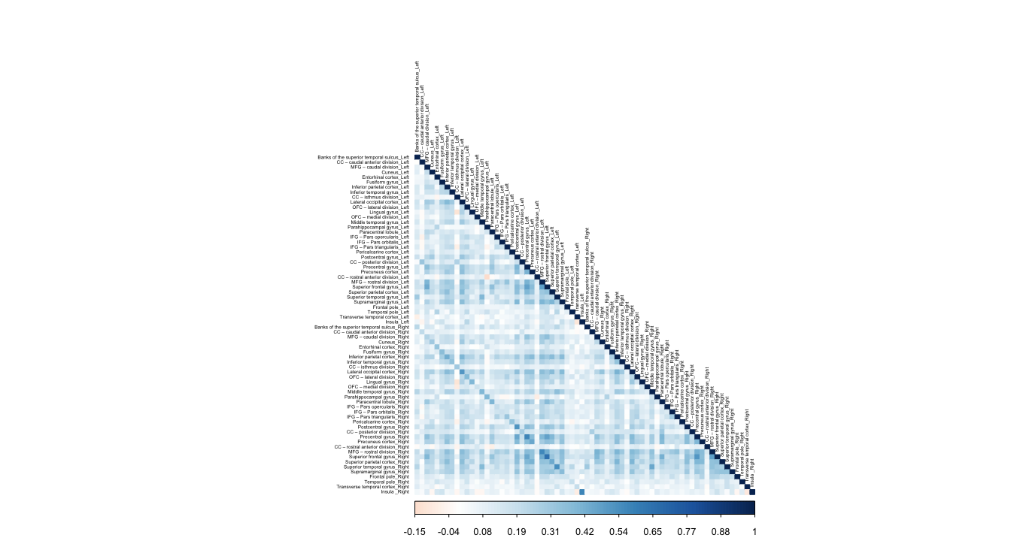

# Supplement S4. Figure 2

Correlation matrix for subjects. Scaled by correlation coefficient. Figure shows overall high correlations between subjects.

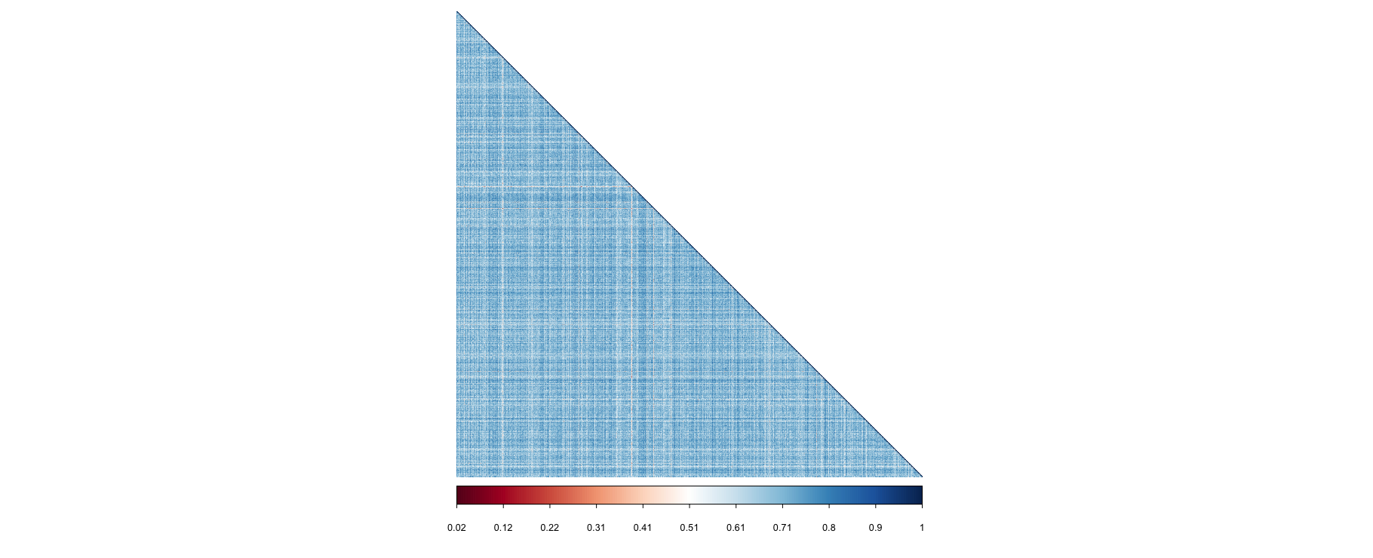

# Supplement S5. Figure 3

## Screeplot/Elbow point plot for k=10 clusters. Elbow appears to be at k=3.

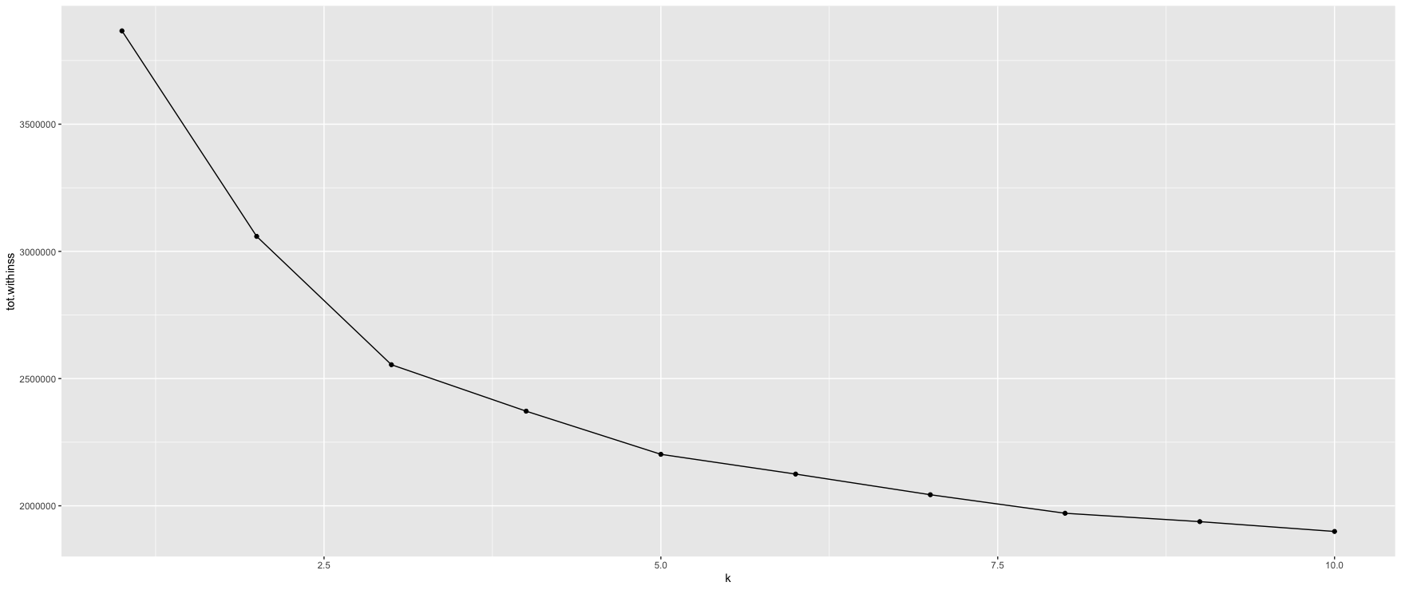

## Dendrogram with cut at k=3 clusters.

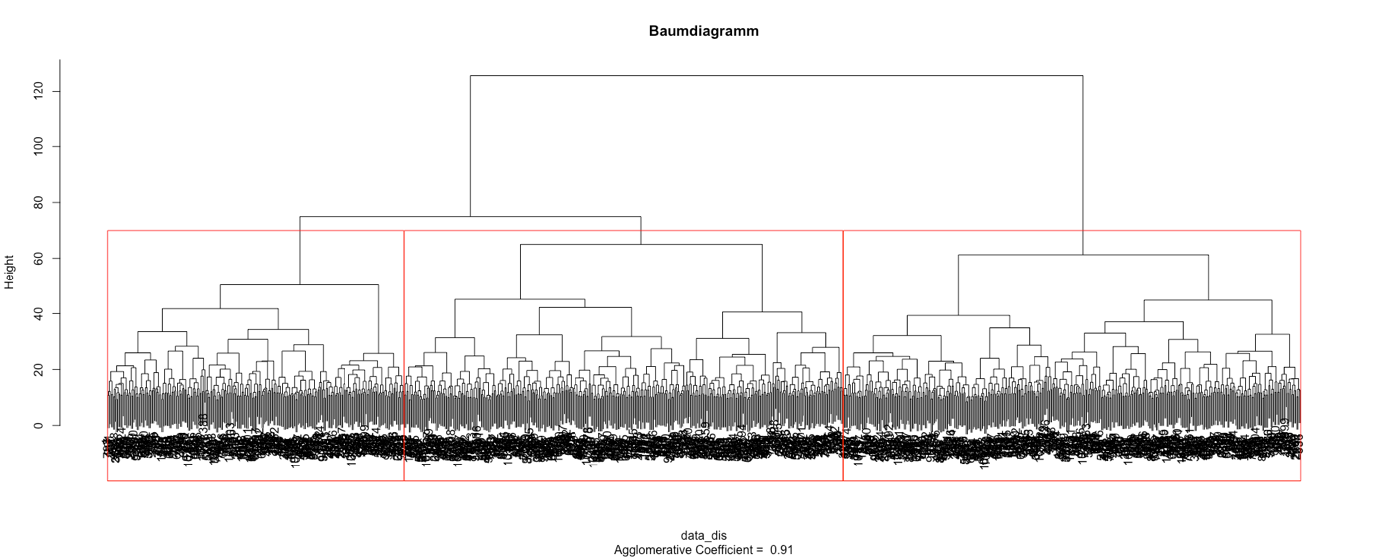

# Supplement S6. Cluster stabilities for other cluster solutions k=2 to k=10.

2 Cluster: 0.74, 0.72

4 Cluster: 0.70, 0.54, 0.56, 0.33

5 Cluster: 0.66, 0.55, 0.48, 0.45, 0.48

6 Cluster: 0.37, 0.57, 0.44, 0.49, 0.45, 0.64

7 Cluster: 0.38, 0.53, 0.37, 0.47, 0.42, 0.39, 0.60

8 Cluster: 0.40, 0.26, 0.38, 0.49, 0.51, 0.44, 0.41, 0.62

9 Cluster: 0.27, 0.33, 0.26, 0.38, 0.49, 0.49, 0.42, 0.44, 0.63

10 Cluster: 0.26, 0.36, 0.26, 0.38, 0.48, 0.45, 0.43, 0.40, 0.45, 0.62

# Supplement S7. Re-run of cluster analysis on 80% of the initial dataset.

## Screeplot/Elbow point plot for k=10 clusters. Elbow appears to be at k=3.

## Dendrogram.

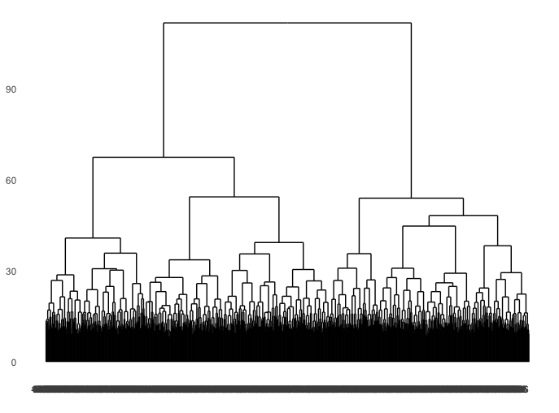

## Cluster stability assessment for k=2 to k=10:

* 1. 2 cluster: 0.76, 0.73
  2. 3 cluster: 0.77, 0.56, 0.59
  3. 4 cluster: 0.73, 0.55, 0.51, 0.42
  4. 5 cluster: 0.37, 0.56, 0.54, 0.50, 0.
  5. 6 cluster: 0.41, 0.58, 0.54, 0.52, 0.48, 0.39
  6. 7 cluster: 0.41, 0.57, 0.41, 0.50, 0.49, 0.34, 0.46
  7. 8 cluster: 0.33, 0.37, 0.53, 0.44, 0.48, 0.50, 0.34, 0.49
  8. 9 cluster: 0.33, 0.37, 0.26, 0.44, 0.49, 0.47, 0.50, 0.35, 0.49

## Decriptives for chosen k=3 cluster solution

|  |  |  |  |  |
| --- | --- | --- | --- | --- |
| **Cluster** | **n** | **Frequency DSM-groups within cluster** | **Mean age** | **Sex** |
| 1 | 267 | MDD=210, *78.7%*  BD=32, *12%*  SZA=10, 3*.7%*  SZ=15, *5.6%* | 37.47 | 93 male, 174 female |
| 2 | 255 | MDD=189, *74.1%*  BD=36, *14.1%*  SZA=11, 4.3*%*  SZ=19, *7.5%* | 36.56 | 88 male, 167 female |
| 3 | 300 | MDD=235, *78.3%*  BD=33, *11%*  SZA=12, 4*%*  SZ=20, 6.7*%* | 38.35 | 132 male, 168 female |

## Plot of mean gyrification per cluster for every region, ordered frontal-parietal-temporal-occipital.

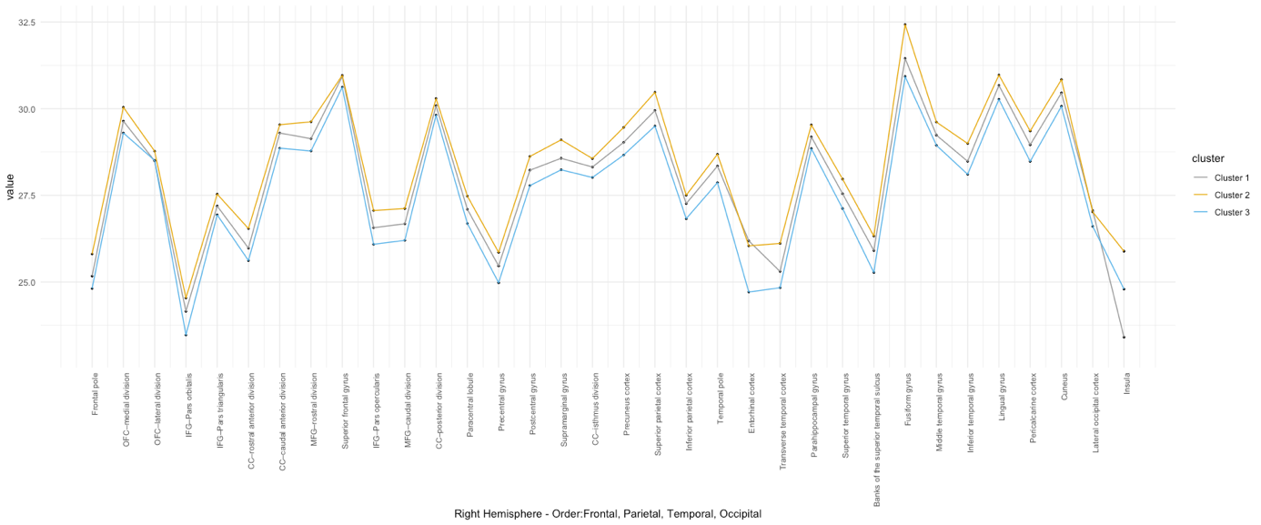

# Supplement S8. Table 2

Results of binomial tests for distribution of diagnostic groups within the clusters.

Sample N=1028

MDD = 783 = 76%

BD = 129 = 13%

SZA = 44 = 4%

SZ = 72 = 7%

|  |  |  |  |  |
| --- | --- | --- | --- | --- |
|  | **MDD** | **BD** | **SZA** | **SZ** |
|  | **Test proportion: .76** | **Test proportion: .13** | **Test proportion: .04** | **Test proportion: .07** |
| **Cluster 1** | Observed proportion: .75  *p*=.434 | Observed proportion: .14  *p*=.333 | Observed proportion: .05  *p*=.329 | Observed proportion: .06  *p*=.285 |
| **Cluster 2** | Observed proportion: .77  *p*=.308 | Observed proportion: .13  *p*=.468 | Observed proportion: .03  *p*=.172 | Observed proportion: .07  *p*=.485 |
| **Cluster 3** | Observed proportion: .76  *p*=.452 | Observed proportion: .11  *p*=.197 | Observed proportion: .05  *p*=.114 | Observed proportion: .08  *p*=.343 |

# Supplement S9. Table 3

Results of ANOVA post-hoc tests between data-driven cluster groups. *bold=p<0.05 after Bonferroni-correction for multiple comparisons.

|  |  |  |  |  |  |
| --- | --- | --- | --- | --- | --- |
| **Region (CAT12 order)** | **Vs.** | | **Mean difference** | **Std.-Error** | ***p*** |
| *Left Hemisphere* |  |  |  |  |  |
| Banks of the superior temporal sulcus | Cluster 1 | Cluster 2 | -.5459498 | 0.1627035 | **0.002\*** |
|  |  | Cluster 3 | .8491057 | 0.1613641 | **<0.001\*** |
|  | Cluster 2 | Cluster 3 | 1.3950555 | 0.1447215 | **<0.001\*** |
| CC – caudal anterior division | Cluster 1 | Cluster 2 | -2.1963240 | 0.1795216 | **<0.001\*** |
|  |  | Cluster 3 | -0.3712906 | 0.1780437 | 0.112 |
|  | Cluster 2 | Cluster 3 | 1.8250334 | 0.1596808 | **<0.001\*** |
| MFG – caudal division | Cluster 1 | Cluster 2 | -.4098841 | 0.0835443 | **<0.001\*** |
|  |  | Cluster 3 | .4045845 | 0.0828565 | **<0.001\*** |
|  | Cluster 2 | Cluster 3 | .8144686 | 0.0743109 | **<0.001\*** |
| Cuneus | Cluster 1 | Cluster 2 | -.2985751 | 0.1092895 | 0.019 |
|  |  | Cluster 3 | .6285264 | 0.1083898 | **<0.001\*** |
|  | Cluster 2 | Cluster 3 | .9271015 | 0.0972108 | **<0.001\*** |
| Entorhinal cortex | Cluster 1 | Cluster 2 | -.7956835 | 0.1497683 | **<0.001\*** |
|  |  | Cluster 3 | -0.1706556 | 0.1485353 | 0.753 |
|  | Cluster 2 | Cluster 3 | .6250279 | 0.1332158 | **<0.001\*** |
| Fusiform gyrus | Cluster 1 | Cluster 2 | -.2389315 | 0.0803308 | **0.009\*** |
|  |  | Cluster 3 | .3832086 | 0.0796695 | **<0.001\*** |
|  | Cluster 2 | Cluster 3 | .6221401 | 0.0714526 | **<0.001\*** |
| Inferior parietal cortex | Cluster 1 | Cluster 2 | 0.0038135 | 0.0726894 | 1.000 |
|  |  | Cluster 3 | .7152357 | 0.0720909 | **<0.001\*** |
|  | Cluster 2 | Cluster 3 | .7114222 | 0.0646557 | **<0.001\*** |
| Inferior temporal gyrus | Cluster 1 | Cluster 2 | -.1875234 | 0.0766866 | **0.044\*** |
|  |  | Cluster 3 | .3569558 | 0.0760553 | **<0.001\*** |
|  | Cluster 2 | Cluster 3 | .5444792 | 0.0682112 | **<0.001\*** |
| CC – isthmus division | Cluster 1 | Cluster 2 | -.5486514 | 0.1427553 | **<0.001\*** |
|  |  | Cluster 3 | 0.1060539 | 0.1415800 | 1.000 |
|  | Cluster 2 | Cluster 3 | .6547053 | 0.1269779 | **<0.001\*** |
| Lateral occipital cortex | Cluster 1 | Cluster 2 | -.1830238 | 0.0639523 | **0.013\*** |
|  |  | Cluster 3 | .4955828 | 0.0634259 | **<0.001\*** |
|  | Cluster 2 | Cluster 3 | .6786065 | 0.0568843 | **<0.001\*** |
| OFC – lateral division | Cluster 1 | Cluster 2 | -.2103449 | 0.0743754 | **0.014\*** |
|  |  | Cluster 3 | .4620692 | 0.0737631 | **<0.001\*** |
|  | Cluster 2 | Cluster 3 | .6724141 | 0.0661554 | **<0.001\*** |
| Lingual gyrus | Cluster 1 | Cluster 2 | -0.1035765 | 0.0804328 | 0.594 |
|  |  | Cluster 3 | .3911011 | 0.0797706 | **<0.001\*** |
|  | Cluster 2 | Cluster 3 | .4946775 | 0.0715433 | **<0.001\*** |
| OFC – medial division | Cluster 1 | Cluster 2 | 0.0040953 | 0.0899262 | 1.000 |
|  |  | Cluster 3 | .2906551 | 0.0891858 | **0.003\*** |
|  | Cluster 2 | Cluster 3 | .2865599 | 0.0799875 | **0.001\*** |
| Middle temporal gyrus | Cluster 1 | Cluster 2 | -0.0900450 | 0.0813024 | 0.805 |
|  |  | Cluster 3 | .4345266 | 0.0806331 | **<0.001\*** |
|  | Cluster 2 | Cluster 3 | .5245716 | 0.0723168 | **<0.001\*** |
| Parahippocampal gyrus | Cluster 1 | Cluster 2 | -1.0771248 | 0.1427711 | **<0.001\*** |
|  |  | Cluster 3 | -.6051719 | 0.1415958 | **<0.001\*** |
|  | Cluster 2 | Cluster 3 | .4719528 | 0.1269920 | **0.001\*** |
| Paracentral lobule | Cluster 1 | Cluster 2 | -.5930097 | 0.1049621 | **<0.001\*** |
|  |  | Cluster 3 | .5361917 | 0.1040980 | **<0.001\*** |
|  | Cluster 2 | Cluster 3 | 1.1292014 | 0.0933617 | **<0.001\*** |
| IFG – Pars opercularis | Cluster 1 | Cluster 2 | 0.1072647 | 0.0880468 | 0.670 |
|  |  | Cluster 3 | .6333383 | 0.0873219 | **<0.001\*** |
|  | Cluster 2 | Cluster 3 | .5260736 | 0.0783158 | **<0.001\*** |
| IFG – Pars orbitalis | Cluster 1 | Cluster 2 | -0.0627049 | 0.1155406 | 1.000 |
|  |  | Cluster 3 | .5240094 | 0.1145894 | **<0.001\*** |
|  | Cluster 2 | Cluster 3 | .5867143 | 0.1027710 | **<0.001\*** |
| IFG – Pars triangularis | Cluster 1 | Cluster 2 | .2874252 | 0.1028920 | **0.016\*** |
|  |  | Cluster 3 | .7364913 | 0.1020449 | **<0.001\*** |
|  | Cluster 2 | Cluster 3 | .4490661 | 0.0915203 | **<0.001\*** |
| Pericalcarine cortex | Cluster 1 | Cluster 2 | -0.1442775 | 0.1038444 | 0.495 |
|  |  | Cluster 3 | .5009053 | 0.1029895 | **<0.001\*** |
|  | Cluster 2 | Cluster 3 | .6451828 | 0.0923675 | **<0.001\*** |
| Postcentral gyrus | Cluster 1 | Cluster 2 | -.3068813 | 0.0738295 | **<0.001\*** |
|  |  | Cluster 3 | .5631267 | 0.0732217 | **<0.001\*** |
|  | Cluster 2 | Cluster 3 | .8700080 | 0.0656698 | **<0.001\*** |
| CC – posterior division | Cluster 1 | Cluster 2 | -.6435428 | 0.1187429 | **<0.001\*** |
|  |  | Cluster 3 | .4235715 | 0.1177653 | **0.001\*** |
|  | Cluster 2 | Cluster 3 | 1.0671143 | 0.1056193 | **<0.001\*** |
| Precentral gyrus | Cluster 1 | Cluster 2 | -.3208728 | 0.0616757 | **<0.001\*** |
|  |  | Cluster 3 | .5342569 | 0.0611680 | **<0.001\*** |
|  | Cluster 2 | Cluster 3 | .8551297 | 0.0548593 | **<0.001\*** |
| Precuneus cortex | Cluster 1 | Cluster 2 | -.2339294 | 0.0677683 | **0.002\*** |
|  |  | Cluster 3 | .6241729 | 0.0672104 | **<0.001\*** |
|  | Cluster 2 | Cluster 3 | .8581023 | 0.0602785 | **<0.001\*** |
| CC – rostral anterior division | Cluster 1 | Cluster 2 | 0.0724924 | 0.1201323 | 1.000 |
|  |  | Cluster 3 | .3219345 | 0.1191433 | **0.021\*** |
|  | Cluster 2 | Cluster 3 | 0.2494421 | 0.1068552 | 0.059 |
| MFG – rostral division | Cluster 1 | Cluster 2 | -.2300586 | 0.0637837 | **0.001\*** |
|  |  | Cluster 3 | .6201032 | 0.0632585 | **<0.001\*** |
|  | Cluster 2 | Cluster 3 | .8501617 | 0.0567342 | **<0.001\*** |
| Superior frontal gyrus | Cluster 1 | Cluster 2 | -.4562228 | 0.0553569 | **<0.001\*** |
|  |  | Cluster 3 | .4130609 | 0.0549011 | **<0.001\*** |
|  | Cluster 2 | Cluster 3 | .8692837 | 0.0492388 | **<0.001\*** |
| Superior parietal cortex | Cluster 1 | Cluster 2 | -.2912990 | 0.0727053 | **<0.001\*** |
|  |  | Cluster 3 | .5363870 | 0.0721067 | **<0.001\*** |
|  | Cluster 2 | Cluster 3 | .8276860 | 0.0646698 | **<0.001\*** |
| Superior temporal gyrus | Cluster 1 | Cluster 2 | -0.0904832 | 0.0796141 | 0.768 |
|  |  | Cluster 3 | .5704517 | 0.0789587 | **<0.001\*** |
|  | Cluster 2 | Cluster 3 | .6609349 | 0.0708151 | **<0.001\*** |
| Supramarginal gyrus | Cluster 1 | Cluster 2 | -0.0717510 | 0.0659755 | 0.831 |
|  |  | Cluster 3 | .6024128 | 0.0654324 | **<0.001\*** |
|  | Cluster 2 | Cluster 3 | .6741638 | 0.0586839 | **<0.001\*** |
| Frontal pole | Cluster 1 | Cluster 2 | -.8988736 | 0.1572788 | **<0.001\*** |
|  |  | Cluster 3 | 0.2868043 | 0.1559840 | 0.199 |
|  | Cluster 2 | Cluster 3 | 1.1856779 | 0.1398963 | **<0.001\*** |
| Temporal pole | Cluster 1 | Cluster 2 | -.7805456 | 0.1395236 | **<0.001\*** |
|  |  | Cluster 3 | -0.0673927 | 0.1383749 | 1.000 |
|  | Cluster 2 | Cluster 3 | .7131529 | 0.1241033 | **<0.001\*** |
| Transverse temporal cortex | Cluster 1 | Cluster 2 | 0.0502856 | 0.1840342 | 1.000 |
|  |  | Cluster 3 | 1.0202311 | 0.1825191 | **<0.001\*** |
|  | Cluster 2 | Cluster 3 | .9541635 | 0.1698500 | **<0.001\*** |
| Insula | Cluster 1 | Cluster 2 | -0.0745555 | 0.0898786 | 1.000 |
|  |  | Cluster 3 | .2768706 | 0.0891387 | **0.006\*** |
|  | Cluster 2 | Cluster 3 | .3514261 | 0.0799452 | **<0.001\*** |
| *Right Hemisphere* |  |  |  |  |  |
| Banks of the superior temporal sulcus | Cluster 1 | Cluster 2 | -0.2009365 | 0.1456500 | 0.504 |
|  |  | Cluster 3 | .7634919 | 0.1444509 | **<0.001\*** |
|  | Cluster 2 | Cluster 3 | .9644284 | 0.1295527 | **<0.001\*** |
| CC – caudal anterior division | Cluster 1 | Cluster 2 | -.4736731 | 0.1395865 | **0.002\*** |
|  |  | Cluster 3 | 0.1539585 | 0.1384373 | 0.799 |
|  | Cluster 2 | Cluster 3 | .6276316 | 0.1241593 | **<0.001\*** |
| MFG – caudal division | Cluster 1 | Cluster 2 | -.4988259 | 0.0928638 | **<0.001\*** |
|  |  | Cluster 3 | .4183418 | 0.0920993 | **<0.001\*** |
|  | Cluster 2 | Cluster 3 | .9171677 | 0.0826004 | **<0.001\*** |
| Cuneus | Cluster 1 | Cluster 2 | -.3609698 | 0.1022269 | **0.001\*** |
|  |  | Cluster 3 | .5677623 | 0.1013853 | **<0.001\*** |
|  | Cluster 2 | Cluster 3 | .9287321 | 0.0909287 | **<0.001\*** |
| Entorhinal cortex | Cluster 1 | Cluster 2 | -.6933904 | 0.1516502 | **<0.001\*** |
|  |  | Cluster 3 | -0.0904392 | 0.1504017 | 1.000 |
|  | Cluster 2 | Cluster 3 | .6029512 | 0.1348897 | **<0.001\*** |
| Fusiform gyrus | Cluster 1 | Cluster 2 | -.2337578 | 0.0857366 | **0.020\*** |
|  |  | Cluster 3 | .3556535 | 0.0850308 | **<0.001\*** |
|  | Cluster 2 | Cluster 3 | .5894113 | 0.0762609 | **<0.001\*** |
| Inferior parietal cortex | Cluster 1 | Cluster 2 | -0.1410748 | 0.0685088 | 0.119 |
|  |  | Cluster 3 | .7782412 | 0.0679448 | **<0.001\*** |
|  | Cluster 2 | Cluster 3 | .9193160 | 0.0609372 | **<0.001\*** |
| Inferior temporal gyrus | Cluster 1 | Cluster 2 | -0.0885498 | 0.0743927 | 0.703 |
|  |  | Cluster 3 | .4414258 | 0.0737803 | **<0.001\*** |
|  | Cluster 2 | Cluster 3 | .5299757 | 0.0661708 | **<0.001\*** |
| CC – isthmus division | Cluster 1 | Cluster 2 | -0.2025458 | 0.1268817 | 0.332 |
|  |  | Cluster 3 | .3951576 | 0.1258371 | **0.005\*** |
|  | Cluster 2 | Cluster 3 | .5977034 | 0.1128587 | **<0.001\*** |
| Lateral occipital cortex | Cluster 1 | Cluster 2 | -.2098753 | 0.0635119 | **0.003\*** |
|  |  | Cluster 3 | .5396689 | 0.0629891 | **<0.001\*** |
|  | Cluster 2 | Cluster 3 | .7495442 | 0.0564926 | **<0.001\*** |
| OFC – lateral division | Cluster 1 | Cluster 2 | -0.0342979 | 0.0751164 | 1.000 |
|  |  | Cluster 3 | .6154261 | 0.0744980 | **<0.001\*** |
|  | Cluster 2 | Cluster 3 | .6497239 | 0.0668145 | **<0.001\*** |
| Lingual gyrus | Cluster 1 | Cluster 2 | -0.1528767 | 0.0829834 | 0.197 |
|  |  | Cluster 3 | .3774567 | 0.0823003 | **<0.001\*** |
|  | Cluster 2 | Cluster 3 | .5303334 | 0.0738121 | **<0.001\*** |
| OFC – medial division | Cluster 1 | Cluster 2 | -0.0293562 | 0.1068416 | 1.000 |
|  |  | Cluster 3 | .3023630 | 0.1059621 | **0.013\*** |
|  | Cluster 2 | Cluster 3 | .3317191 | 0.0950334 | **0.002\*** |
| Middle temporal gyrus | Cluster 1 | Cluster 2 | -.3824950 | 0.0733599 | **<0.001\*** |
|  |  | Cluster 3 | .4223910 | 0.0727559 | **<0.001\*** |
|  | Cluster 2 | Cluster 3 | .8048860 | 0.0652521 | **<0.001\*** |
| Parahippocampal gyrus | Cluster 1 | Cluster 2 | -1.2766957 | 0.1434766 | **<0.001\*** |
|  |  | Cluster 3 | -.6623154 | 0.1422954 | **<0.001\*** |
|  | Cluster 2 | Cluster 3 | .6143802 | 0.1276194 | **<0.001\*** |
| Paracentral lobule | Cluster 1 | Cluster 2 | -.6027034 | 0.0959679 | **<0.001\*** |
|  |  | Cluster 3 | .5830300 | 0.0951778 | **<0.001\*** |
|  | Cluster 2 | Cluster 3 | 1.1857335 | 0.0853615 | **<0.001\*** |
| IFG – Pars opercularis | Cluster 1 | Cluster 2 | -0.0297772 | 0.0937187 | 1.000 |
|  |  | Cluster 3 | .4511228 | 0.0929471 | **<0.001\*** |
|  | Cluster 2 | Cluster 3 | .4809000 | 0.0833608 | **<0.001\*** |
| IFG – Pars orbitalis | Cluster 1 | Cluster 2 | -0.0894124 | 0.1081439 | 1.000 |
|  |  | Cluster 3 | .7086249 | 0.1072536 | **<0.001\*** |
|  | Cluster 2 | Cluster 3 | .7980373 | 0.0961918 | **<0.001\*** |
| IFG – Pars triangularis | Cluster 1 | Cluster 2 | 0.0367430 | 0.0935192 | 1.000 |
|  |  | Cluster 3 | .6988536 | 0.0927493 | **<0.001\*** |
|  | Cluster 2 | Cluster 3 | .6621107 | 0.0831834 | **<0.001\*** |
| Pericalcarine cortex | Cluster 1 | Cluster 2 | 0.0434500 | 0.1016919 | 1.000 |
|  |  | Cluster 3 | .5644280 | 0.1008547 | **<0.001\*** |
|  | Cluster 2 | Cluster 3 | .5209780 | 0.0904528 | **<0.001\*** |
| Postcentral gyrus | Cluster 1 | Cluster 2 | -.2696760 | 0.0767977 | **0.001\*** |
|  |  | Cluster 3 | .5700633 | 0.0761655 | **<0.001\*** |
|  | Cluster 2 | Cluster 3 | .8397393 | 0.0683100 | **<0.001\*** |
| CC – posterior division | Cluster 1 | Cluster 2 | -.3945380 | 0.1042987 | **<0.001\*** |
|  |  | Cluster 3 | .3995961 | 0.1034401 | **<0.001\*** |
|  | Cluster 2 | Cluster 3 | .7941341 | 0.0927716 | **<0.001\*** |
| Precentral gyrus | Cluster 1 | Cluster 2 | -.3503479 | 0.0647746 | **<0.001\*** |
|  |  | Cluster 3 | .6263926 | 0.0642414 | **<0.001\*** |
|  | Cluster 2 | Cluster 3 | .9767405 | 0.0576157 | **<0.001\*** |
| Precuneus cortex | Cluster 1 | Cluster 2 | -.2553012 | 0.0656996 | **<0.001\*** |
|  |  | Cluster 3 | .6139336 | 0.0651587 | **<0.001\*** |
|  | Cluster 2 | Cluster 3 | .8692348 | 0.0584384 | **<0.001\*** |
| CC – rostral anterior division | Cluster 1 | Cluster 2 | 0.0501332 | 0.1226432 | 1.000 |
|  |  | Cluster 3 | .3730289 | 0.1216335 | **0.007\*** |
|  | Cluster 2 | Cluster 3 | .3228957 | 0.1090886 | **0.009\*** |
| MFG – rostral division | Cluster 1 | Cluster 2 | -.1568993 | 0.0635893 | **0.041\*** |
|  |  | Cluster 3 | .7494929 | 0.0630658 | **<0.001\*** |
|  | Cluster 2 | Cluster 3 | .9063922 | 0.0565614 | **<0.001\*** |
| Superior frontal gyrus | Cluster 1 | Cluster 2 | -.3995028 | 0.0554747 | **<0.001\*** |
|  |  | Cluster 3 | .4707182 | 0.0550180 | **<0.001\*** |
|  | Cluster 2 | Cluster 3 | .8702210 | 0.0493436 | **<0.001\*** |
| Superior parietal cortex | Cluster 1 | Cluster 2 | -.2092106 | 0.0707215 | **0.009\*** |
|  |  | Cluster 3 | .6549686 | 0.0701393 | **<0.001\*** |
|  | Cluster 2 | Cluster 3 | .8641792 | 0.0629053 | **<0.001\*** |
| Superior temporal gyrus | Cluster 1 | Cluster 2 | -0.0991040 | 0.0804364 | 0.655 |
|  |  | Cluster 3 | .7316133 | 0.0797742 | **<0.001\*** |
|  | Cluster 2 | Cluster 3 | .8307174 | 0.0715466 | **<0.001\*** |
| Supramarginal gyrus | Cluster 1 | Cluster 2 | -0.1619839 | 0.0737226 | 0.085 |
|  |  | Cluster 3 | .4973763 | 0.0731157 | **<0.001\*** |
|  | Cluster 2 | Cluster 3 | .6593603 | 0.0655748 | **<0.001\*** |
| Frontal pole | Cluster 1 | Cluster 2 | -.6231160 | 0.1493922 | **<0.001\*** |
|  |  | Cluster 3 | .9614175 | 0.1481623 | **<0.001\*** |
|  | Cluster 2 | Cluster 3 | 1.5845336 | 0.1328813 | **<0.001\*** |
| Temporal pole | Cluster 1 | Cluster 2 | -0.3329520 | 0.1464988 | 0.070 |
|  |  | Cluster 3 | .4430913 | 0.1452928 | **0.007\*** |
|  | Cluster 2 | Cluster 3 | .7760433 | 0.1303077 | **<0.001\*** |
| Transverse temporal cortex | Cluster 1 | Cluster 2 | 1.7682452 | 0.1909544 | **<0.001\*** |
|  |  | Cluster 3 | 2.7224088 | 0.1893824 | **<0.001\*** |
|  | Cluster 2 | Cluster 3 | .9541635 | 0.1698500 | **<0.001\*** |
| Insula | Cluster 1 | Cluster 2 | -0.1787147 | 0.0986793 | 0.211 |
|  |  | Cluster 3 | 0.0513424 | 0.0978669 | 1.000 |
|  | Cluster 2 | Cluster 3 | .2300572 | 0.0877732 | **0.027\*** |

# Supplement S10. Table 4

Results of the ANOVA between DSM-labeled groups. df = 3. * bold =p<0.05. ** bold and italic=p<0.001.

|  |  |  |  |  |  |
| --- | --- | --- | --- | --- | --- |
| **Region (CAT12 order)** | **Sum of Square** | **Mean Square** | | **F** | ***p*** |
| *Left Hemisphere* |  |  |  | |  |
| Banks of the superior temporal sulcus | 38.664 | 12.888 | 2.943 | | **0.032\*** |
| CC – caudal anterior division | 13.006 | 4.335 | 0.742 | | 0.527 |
| MFG – caudal division | 6.464 | 2.155 | 1.818 | | 0.142 |
| Cuneus | 7.537 | 2.512 | 1.266 | | 0.285 |
| Entorhinal cortex | 11.261 | 3.754 | 1.063 | | 0.364 |
| Fusiform gyrus | 3.832 | 1.274 | 1.207 | | 0.306 |
| Inferior parietal cortex | 1.086 | 0.362 | 0.391 | | 0.760 |
| Inferior temporal gyrus | 0.969 | 0.323 | 0.338 | | 0.798 |
| CC – isthmus division | 29.847 | 9.949 | 3.135 | | **0.025\*** |
| Lateral occipital cortex | 0.790 | 0.263 | 0.368 | | 0.776 |
| OFC – lateral division | 1.858 | 0.619 | 0.665 | | 0.574 |
| Lingual gyrus | 3.427 | 1.142 | 1.104 | | 0.347 |
| OFC – medial division | 6.004 | 2.001 | 1.602 | | 0.187 |
| Middle temporal gyrus | 4.789 | 1.596 | 1.502 | | 0.213 |
| Parahippocampal gyrus | 33.631 | 11.210 | 3.444 | | **0.016\*** |
| Paracentral lobule | 2.376 | 0.792 | 0.412 | | 0.744 |
| IFG – Pars opercularis | 1.050 | 0.350 | 0.277 | | 0.842 |
| IFG – Pars orbitalis | 5.247 | 1.749 | 0.829 | | 0.478 |
| IFG – Pars triangularis | 1.032 | 0.344 | 0.202 | | 0.895 |
| Pericalcarine cortex | 16.508 | 5.503 | 3.206 | | **0.023\*** |
| Postcentral gyrus | 2.517 | 0.839 | 0.859 | | 0.462 |
| CC – posterior division | 1.983 | 0.661 | 0.279 | | 0.840 |
| Precentral gyrus | 1.319 | 0.440 | 0.611 | | 0.608 |
| Precuneus cortex | 1.126 | 0.375 | 0.443 | | 0.722 |
| CC – rostral anterior division | 14.034 | 4.678 | 2.116 | | 0.097 |
| MFG – rostral division | 7.619 | 2.540 | 3.350 | | **0.019\*** |
| Superior frontal gyrus | 2.475 | 0.825 | 1.357 | | 0.255 |
| Superior parietal cortex | 2.467 | 0.822 | 0.877 | | 0.452 |
| Superior temporal gyrus | 5.880 | 1.960 | 1.856 | | 0.135 |
| Supramarginal gyrus | 2.088 | 0.696 | 0.913 | | 0.434 |
| Frontal pole | 9.219 | 3.073 | 0.758 | | 0.518 |
| Temporal pole | 13.695 | 4.565 | 1.478 | | 0.219 |
| Transverse temporal cortex | 23.670 | 7.890 | 1.465 | | 0.222 |
| Insula | 12.865 | 4.288 | 3.439 | | **0.016\*** |
| *Right Hemisphere* |  |  |  | |  |
| Banks of the superior temporal sulcus | 16.140 | 5.380 | 1.575 | | 0.194 |
| CC – caudal anterior division | 15.765 | 5.255 | 1.729 | | 0.159 |
| MFG – caudal division | 1.172 | 0.391 | 0.265 | | 0.851 |
| Cuneus | 9.542 | 3.181 | 1.815 | | 0.143 |
| Entorhinal cortex | 20.906 | 6.969 | 1.941 | | 0.121 |
| Fusiform gyrus | 0.699 | 0.233 | 0.196 | | 0.899 |
| Inferior parietal cortex | 1.505 | 0.502 | 0.561 | | 0.641 |
| Inferior temporal gyrus | 2.489 | 0.830 | 0.919 | | 0.431 |
| CC – isthmus division | 52.046 | 17.349 | 7.001 | | ***<0.001\*\**** |
| Lateral occipital cortex | 2.969 | 0.990 | 1.366 | | 0.252 |
| OFC – lateral division | 6.726 | 2.242 | 2.356 | | 0.070 |
| Lingual gyrus | 0.571 | 0.190 | 0.172 | | 0.915 |
| OFC – medial division | 9.397 | 3.132 | 1.780 | | 0.149 |
| Middle temporal gyrus | 3.108 | 1.036 | 1.101 | | 0.348 |
| Parahippocampal gyrus | 7.210 | 2.403 | 0.710 | | 0.546 |
| Paracentral lobule | 0.177 | 0.059 | 0.035 | | 0.991 |
| IFG – Pars opercularis | 2.600 | 0.867 | 0.623 | | 0.600 |
| IFG – Pars orbitalis | 12.855 | 4.285 | 2.240 | | 0.082 |
| IFG – Pars triangularis | 0.760 | 0.253 | 0.175 | | 0.913 |
| Pericalcarine cortex | 3.707 | 1.236 | 0.751 | | 0.522 |
| Postcentral gyrus | 0.576 | 0.192 | 0.185 | | 0.907 |
| CC – posterior division | 3.731 | 1.244 | 0.700 | | 0.552 |
| Precentral gyrus | 0.661 | 0.220 | 0.267 | | 0.849 |
| Precuneus cortex | 3.886 | 1.295 | 1.610 | | 0.185 |
| CC – rostral anterior division | 0.577 | 0.192 | 0.083 | | 0.969 |
| MFG – rostral division | 5.822 | 1.941 | 2.474 | | 0.060 |
| Superior frontal gyrus | 1.103 | 0.368 | 0.600 | | 0.615 |
| Superior parietal cortex | 0.525 | 0.175 | 0.191 | | 0.902 |
| Superior temporal gyrus | 4.061 | 1.354 | 1.193 | | 0.311 |
| Supramarginal gyrus | 4.188 | 1.396 | 1.528 | | 0.206 |
| Frontal pole | 6.519 | 2.173 | 0.560 | | 0.642 |
| Temporal pole | 4.026 | 1.342 | 0.396 | | 0.756 |
| Transverse temporal cortex | 11.827 | 3.942 | 0.590 | | 0.622 |
| Insula | 10.583 | 3.528 | 2.371 | | 0.069 |

# Supplement S11. Figure 4

Plot of mean gyrification per DSM-group for every region, ordered frontal-parietal-temporal-occipital.

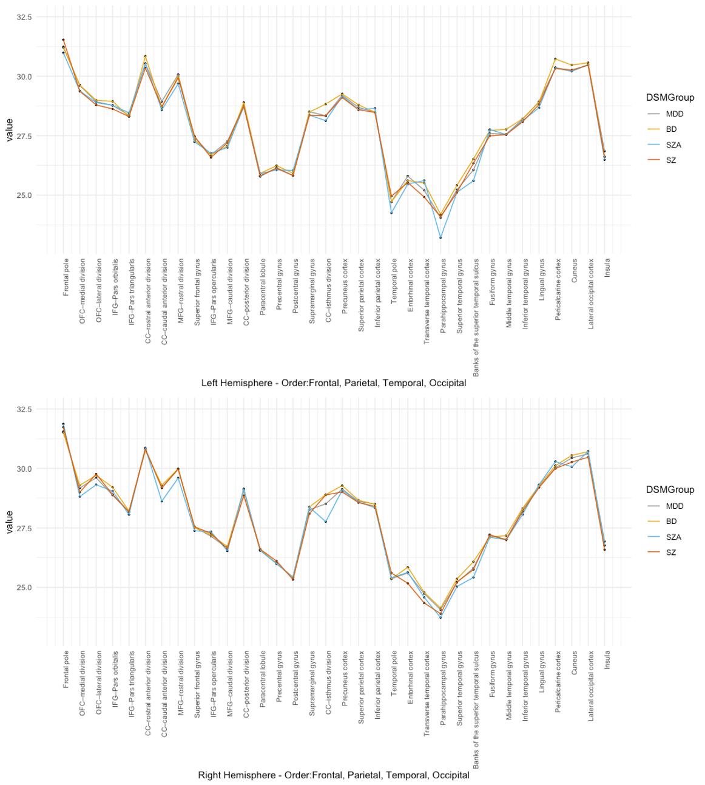

# Supplement S12. Figure 5

Distribution plot of gyrification in our newly formed cluster groups plotted together with the distribution of gyrification in a healthy control group (n=901; mean age 34,91; m=332, w=569).

a) left hemisphere

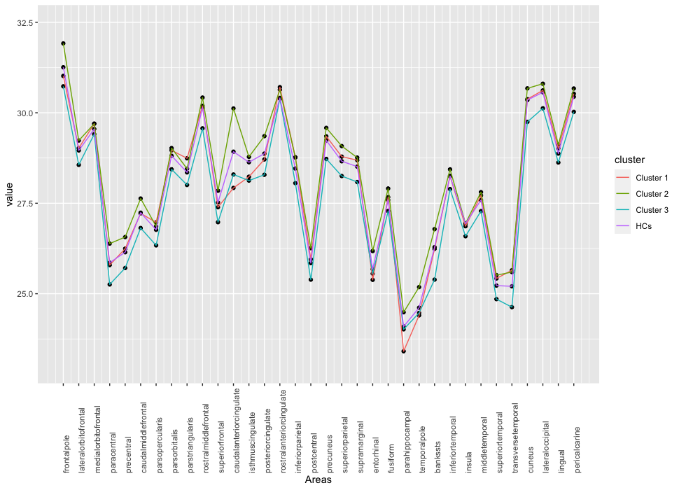

b) right hemisphere

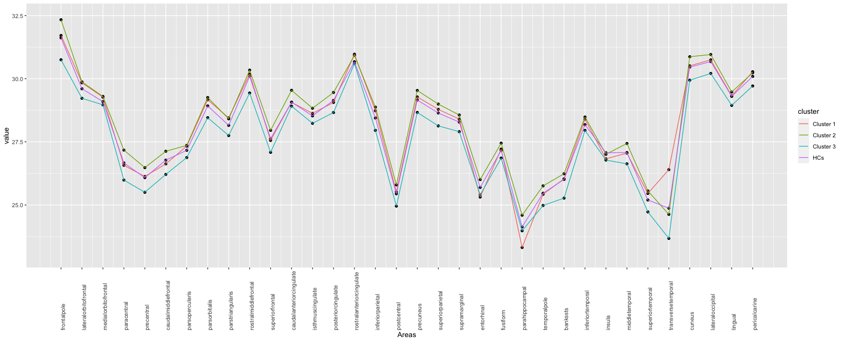

# Supplement S13. – Table 5

Table shows the effect sizes of the brain areas included in the cluster analyses plus beta-coefficient and *p*-values (sig. *p*<0.05) for the additional regression analyses with age as the independent variable. Table is sorted descending for effect sizes.

|  |  |  |  |
| --- | --- | --- | --- |
|  | Effect size Eta-squared of brain areas contributing to our cluster solution | Beta coefficient of age regression | *p*-value age regression |
| Gyrification_rsuperiorfrontal | 0,233 | -0,015 | <0,001 |
| Gyrification_lsuperiorfrontal | 0,233 | -0,015 | <0,001 |
| Gyrification_rprecentral | 0,223 | -0,011 | <0,001 |
| Gyrification_rrostralmiddlefrontal | 0,218 | 0,001 | 0,547 |
| Gyrification_rinferiorparietal | 0,200 | 0,003 | 0,238 |
| Gyrification_lprecentral | 0,194 | -0,009 | <0,001 |
| Gyrification_lrostralmiddlefrontal | 0,188 | -0,002 | 0,406 |
| Gyrification_rprecuneus | 0,184 | -0,006 | 0,007 |
| Gyrification_lprecuneus | 0,173 | -0,002 | 0,293 |
| Gyrification_rtransversetemporal | 0,168 | -0,007 | 0,268 |
| Gyrification_rsuperiorparietal | 0,165 | -0,006 | 0,013 |
| Gyrification_lcaudalanteriorcingulate | 0,159 | -0,024 | <0,001 |
| Gyrification_rparacentral | 0,158 | -0,014 | <0,001 |
| Gyrification_rlateraloccipital | 0,153 | -0,004 | 0,084 |
| Gyrification_lpostcentral | 0,149 | -0,013 | <0,001 |
| Gyrification_lsuperiorparietal | 0,141 | -0,008 | <0,001 |
| Gyrification_rpostcentral | 0,132 | -0,016 | <0,001 |
| Gyrification_rsuperiortemporal | 0,132 | 0,000 | 0,912 |
| Gyrification_lsupramarginal | 0,130 | -0,001 | 0,744 |
| Gyrification_linferiorparietal | 0,130 | 0,006 | 0,016 |
| Gyrification_rmiddletemporal | 0,129 | 0,004 | 0,94 |
| Gyrification_llateraloccipital | 0,128 | 0,000 | 0,951 |
| Gyrification_lparacentral | 0,125 | -0,015 | <0,001 |
| Gyrification_rfrontalpole | 0,123 | -0,002 | 0,719 |
| Gyrification_rcaudalmiddlefrontal | 0,107 | -0,01 | <0,001 |
| Gyrification_lcaudalmiddlefrontal | 0,105 | -0,01 | <0,001 |
| Gyrification_rlateralorbitofrontal | 0,100 | 0,007 | 0,002 |
| Gyrification_rsupramarginal | 0,095 | -0,01 | <0,001 |
| Gyrification_llateralorbitofrontal | 0,095 | 0,001 | 0,749 |
| Gyrification_rcuneus | 0,094 | -0,11 | <0,001 |
| Gyrification_lposteriorcingulate | 0,091 | -0,016 | <0,001 |
| Gyrification_lsuperiortemporal | 0,088 | -0,002 | 0,396 |
| Gyrification_lbankssts | 0,084 | 0,008 | 0,097 |
| Gyrification_lcuneus | 0,084 | -0,13 | <0,001 |
| Gyrification_rparstriangularis | 0,075 | 0,012 | <0,001 |
| Gyrification_rparahippocampal | 0,072 | -0,022 | <0,001 |
| Gyrification_rparsorbitalis | 0,072 | 0,006 | 0,088 |
| Gyrification_lfusiform | 0,070 | 0,002 | 0,478 |
| Gyrification_lfrontalpole | 0,069 | -0,01 | 0,03 |
| Gyrification_rposteriorcingulate | 0,067 | -0,011 | <0,001 |
| Gyrification_rinferiortemporal | 0,065 | 0,007 | 0,004 |
| Gyrification_lparsopercularis | 0,062 | 0,003 | 0,213 |
| Gyrification_linferiortemporal | 0,060 | 0,002 | 0,299 |
| Gyrification_rfusiform | 0,056 | 0,000 | 0,905 |
| Gyrification_rbankssts | 0,056 | 0,001 | 0,818 |
| Gyrification_lmiddletemporal | 0,054 | 0,003 | 0,176 |
| Gyrification_lparahippocampal | 0,053 | -0,021 | <0,001 |
| Gyrification_lparstriangularis | 0,052 | 0,013 | <0,001 |
| Gyrification_rlingual | 0,050 | 0,000 | 0,914 |
| Gyrification_lpericalcarine | 0,049 | 0,012 | <0,001 |
| Gyrification_llingual | 0,048 | 0,003 | 0,18 |
| Gyrification_ltransversetemporal | 0,043 | -0,016 | 0,004 |
| Gyrification_rpericalcarine | 0,042 | 0,007 | 0,016 |
| Gyrification_ltemporalpole | 0,041 | -0,013 | 0,003 |
| Gyrification_rparsopercularis | 0,038 | 0,007 | 0,011 |
| Gyrification_lparsorbitalis | 0,036 | 0,013 | <0,001 |
| Gyrification_rtemporalpole | 0,034 | -0,003 | 0,494 |
| Gyrification_lentorhinal | 0,033 | -0,02 | <0,001 |
| Gyrification_listhmuscingulate | 0,028 | -0,009 | 0,29 |
| Gyrification_risthmuscingulate | 0,027 | 0,009 | 0,019 |
| Gyrification_rentorhinal | 0,027 | -0,21 | <0,001 |
| Gyrification_rcaudalanteriorcingulate | 0,026 | -0,004 | 0,306 |
| Gyrification_linsula | 0,020 | -0,011 | <0,001 |
| Gyrification_lmedialorbitofrontal | 0,016 | 0,015 | <0,001 |
| Gyrification_rmedialorbitofrontal | 0,014 | 0,01 | 0,002 |
| Gyrification_rrostralanteriorcingulate | 0,012 | 0,015 | <0,001 |
| Gyrification_lrostralanteriorcingulate | 0,009 | 0,015 | <0,001 |
| Gyrification_rinsula | 0,007 | -0,014 | <0,001 |