Cluster analysis with MDD-only patients

a) Screeplot for k=10 clusters. Elbow appears to be at k=3

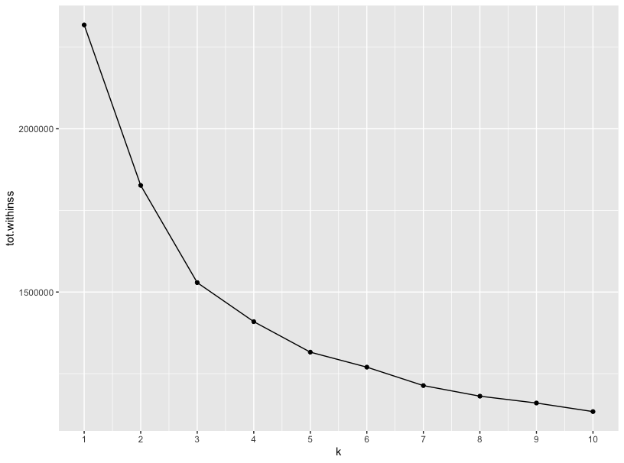

b) Cluster stability assessment. Cluster appear to be unstable.

Clusterwise Jaccard bootstrap (omitting multiple points) mean:

[1] 0.6013954 0.5541870 0.5864037

dissolved:

[1] 10 41 28

recovered:

[1] 4 3 10

c) Descriptives

|  |  |  |  |  |  |  |
| --- | --- | --- | --- | --- | --- | --- |
| **Cluster** | **n** | **Mean age** | **Sex** | **Mean Age of Onset** | **Mean Hospitalization Duration in Weeks** | **Mean Medication-Index** |
| 1 | 265 | 37.42 | 108 m, 157 f | 26.71 | 12.24 | 1.42 |
| 2 | 345 | 35.46 | 90 m, 255 f | 25.03 | 12.21 | 1.27 |
| 3 | 173 | 38.24 | 72 m, 101 f | 26.91 | 11.44 | 1.52 |
| *p* Welch-ANOVA/χ2 |  | .045 | <.001** | .144 | .870 | .191 |

d) Plot of mean gyrification per cluster for every region, ordered frontal-parietal-temporal-occipital.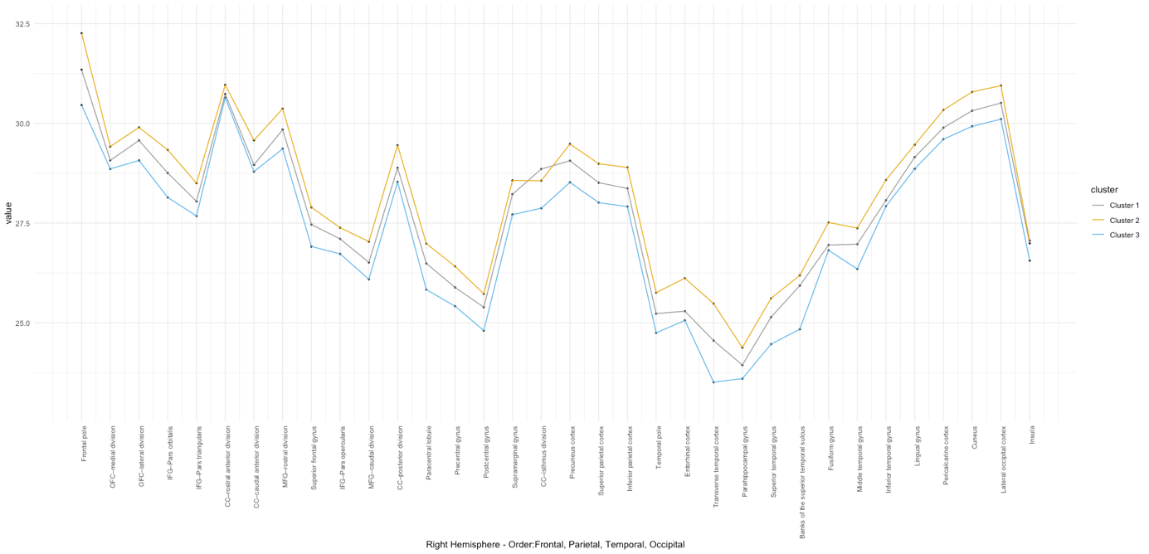

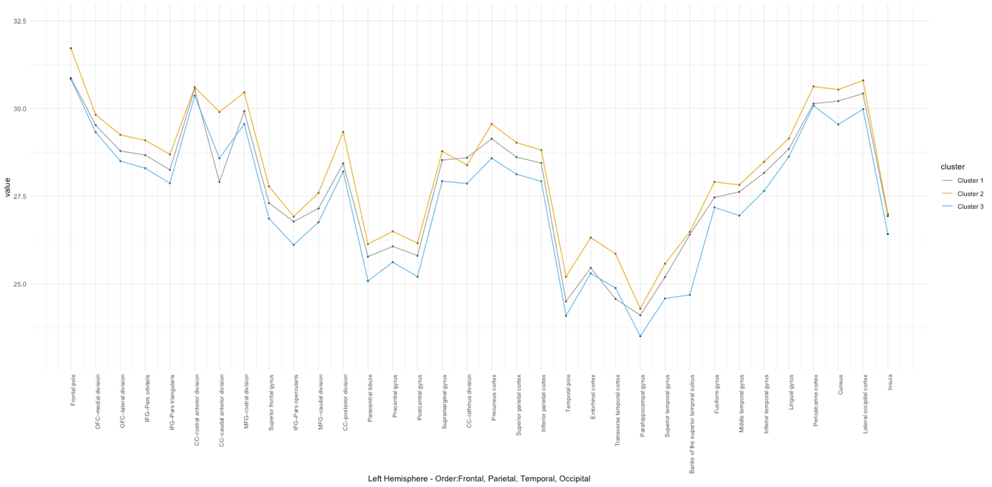

e) Post-hoc analyses: Associations with risk and neuropsychological measurements.

ANOVA Neuropsychological measurements

|  |  |
| --- | --- |
| CBTT=Corsi block-tapping test | *p*=.46 |
| d2=d2 Test of Attention | *p*=.107 |
| DSST=Digit Symbol Substitution Test | *p*=.919 |
| VF=Verbal fluency | *p*=.005 |

χ2  risk:

Birth complications: χ2 (6)=8.38, *p*=.212

Prenatal risk: χ2(8)=6.362, *p*=.607