SEAL 2.3.1

Windows:

Build failed in Visual Studio: Set environment variable TRACEDESIGNTIME=true and restart Visual Studio to investigate.

* Follow this tutorial: <https://ourcodeworld.com/articles/read/414/visual-studio-2017-ide0006-compiler-error-encountered-while-loading-the-project>
* 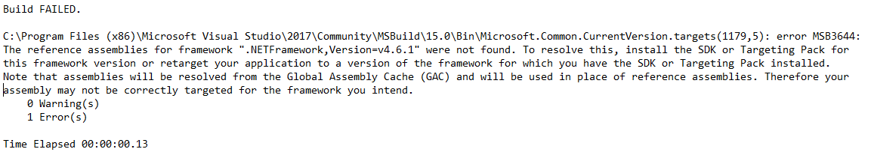Will probably end up with the error message below:

The build failed because it could not find the framework “.NETFramework,Version-v4.6.1”

* Install the latest .NET Framework SDK from Microsoft at <https://www.microsoft.com/en-us/download/details.aspx?id=49978>
* Install the Windows standalone SDK at <https://developer.microsoft.com/en-us/windows/downloads/windows-10-sdk>

^^^ still not fixed

Linux:

Installing: Download SEAL and follow the instructions in INSTALL.txt

* Step 1: cd SEAL
* Step 2: cmake .

For this, cmake version 3.10 or higher is required; if you don’t have this, download the most recent version from <https://cmake.org/download/>, then extract the files from the compressed folder. To install it, navigate to the directory where cmake was downloaded, and run the following commands:

* cmake .
* make
* sudo make install

Then run “cmake --version" to check that cmake 3.10 or higher is being used. If you were using an earlier version before, you may get this error message:

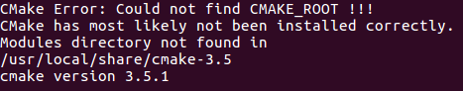

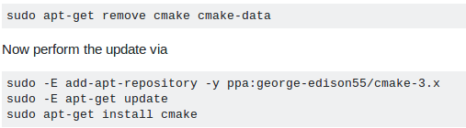If this occurs, run these commands:

Now, run cmake --version again and it should show the correct version (3.10 or higher), and we can try Step 2 again. Now the command ‘cmake .’ should be successful.

**It didn’t work for me. I need to download the library from:**

[**https://cmake.org/download/**](https://cmake.org/download/)

**and run these commands:**

**./bootstrap**

**make**

**make install**

**We should also correct the path to cmake_root:**

**export CMAKE_ROOT=/usr/local/share/cmake-3.12**

**source ~/.bashrc**

* Step 3: make

If you aren’t using the proper GCC version, the following error will occur: 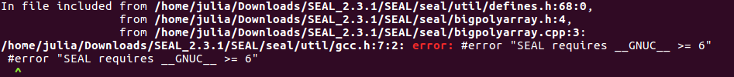

To get GCC 6, run the commands found at (screenshot below as well): <https://gist.github.com/application2000/73fd6f4bf1be6600a2cf9f56315a2d91>

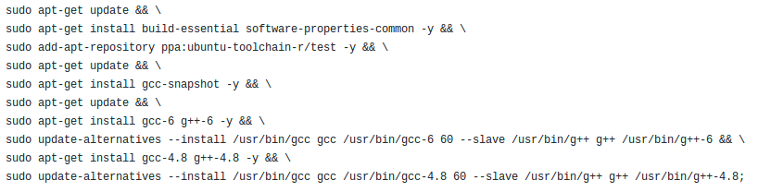

Running ‘make’ again should be successful now

* Step 4: sudo make install

SEAL should now be installed successfully!

Building SEALExamples:

Navigate to /usr/local/include/seal/util and access the locks.h file by entering “sudo gedit locks.h” and change all instances of shared_mutex to shared_timed_mutex, then save.

Now navigate back to SEALExamples and try to compile the main.cpp file by entering the command: “g++ -o “main.o” main.cpp /home/<username>/Downloads/SEAL_2.3.1/SEALExamples/libseal.a -lpthread”

**Note: the path may need to be edited if you have downloaded SEAL somewhere else

After running this, you should be able to execute main.o by saying ./main.o