Assignment 4: Wheat Data Exploration and Basic Statistical Analysis
Julia Jainarine
September 10, 2026
Table of Contents

Research question and hypothesis
The goal of this study is to determine whether wheat yield can be predicted from six measurements taken during the growing season: the number of overwintering plants, the number of ears, soil pH, phosphorus, potassium, and magnesium.
Research hypothesis: Wheat yield is associated with at least one of the six measured biological or soil variables. A model containing these variables will predict yield better than a model containing no predictors.
Null hypothesis: None of the six predictors is associated with wheat yield after the other predictors are held constant. In a multiple linear regression, this means that all six predictor slopes equal zero.

Variables
The response variable is yield. The six focal predictors are winter, ears, pH, P, K, and Mg. There are no separately designated covariates because the study treats all six measured variables as predictors of interest.
Variable | Study meaning | Role | Variable type
yield | Wheat yield at harvest (t/ha) | Response | Numerical, continuous
winter | Mean overwintering plants per m2 | Focal predictor | Numerical, count/density
ears | Mean ears per m2 | Focal predictor | Numerical, count/density
pH | Soil pH | Focal predictor | Numerical, continuous
P | Soil phosphorus (mg/kg) | Focal predictor | Numerical, continuous
K | Soil potassium (mg/kg) | Focal predictor | Numerical, continuous
Mg | Soil magnesium (mg/kg) | Focal predictor | Numerical, continuous
No categorical or ordinal variables are included in this dataset.

Import and check the data
# The R Markdown file and wheat.csv must be saved in the same folder.
if (!file.exists("wheat.csv")) {
stop("wheat.csv was not found. Put wheat.csv in the same folder as this Rmd file.")
}
wheat <- read.csv("wheat.csv", header = TRUE)
required_columns <- c("yield", "winter", "ears", "pH", "P", "K", "Mg")
if (!all(required_columns %in% names(wheat))) {
stop("The CSV column names do not match the expected wheat dataset.")
}
# Keep the variables in the order used in the assignment.
wheat <- wheat[required_columns]
dim(wheat)
## [1] 100 7
head(wheat)
## yield winter ears pH P K Mg
## 1 7.060 235 628 7.0 118 222 62
## 2 7.094 307 764 6.9 117 114 47
## 3 7.171 213 636 6.0 60 127 46
## 4 7.305 202 556 5.5 41 72 50
## 5 7.313 204 748 5.2 55 60 50
## 6 7.366 308 648 5.2 45 98 53
str(wheat)
## 'data.frame': 100 obs. of 7 variables:
## $ yield : num 7.06 7.09 7.17 7.3 7.31 ...
## $ winter: int 235 307 213 202 204 308 236 210 204 298 ...
## $ ears : int 628 764 636 556 748 648 572 736 740 584 ...
## $ pH : num 7 6.9 6 5.5 5.2 5.2 6.5 5.8 5.8 6.5 ...
## $ P : int 118 117 60 41 55 45 97 55 46 88 ...
## $ K : int 222 114 127 72 60 98 92 97 105 110 ...
## $ Mg : int 62 47 46 50 50 53 48 46 50 45 ...
The data contain 100 plots and 7 variables. Every variable was imported as numerical.
missing_table <- data.frame(
Variable = names(wheat),
Missing_values = colSums(is.na(wheat))
)
knitr::kable(missing_table, caption = "Missing values in each variable")
Missing values in each variable
 | Variable | Missing_values
yield | yield | 0
winter | winter | 0
ears | ears | 0
pH | pH | 0
P | P | 0
K | K | 0
Mg | Mg | 0
There are 0 missing values in the dataset, so all observations can be used in the analyses below.

Descriptive statistics
summary(wheat)
## yield winter ears pH
## Min. :7.060 Min. :162.0 Min. :556.0 Min. :5.200
## 1st Qu.:8.187 1st Qu.:234.8 1st Qu.:643.0 1st Qu.:5.575
## Median :8.587 Median :273.5 Median :710.0 Median :5.800
## Mean :8.527 Mean :275.6 Mean :710.1 Mean :5.852
## 3rd Qu.:8.938 3rd Qu.:315.8 3rd Qu.:764.0 3rd Qu.:6.100
## Max. :9.738 Max. :401.0 Max. :968.0 Max. :7.000
## P K Mg
## Min. : 33.00 Min. : 60.0 Min. :38.00
## 1st Qu.: 50.00 1st Qu.: 84.0 1st Qu.:47.00
## Median : 61.00 Median : 97.5 Median :50.00
## Mean : 65.34 Mean :106.7 Mean :50.87
## 3rd Qu.: 77.50 3rd Qu.:114.2 3rd Qu.:54.00
## Max. :120.00 Max. :324.0 Max. :72.00
descriptive_statistics <- data.frame(
Variable = names(wheat),
N = sapply(wheat, function(x) sum(!is.na(x))),
Mean = sapply(wheat, mean, na.rm = TRUE),
SD = sapply(wheat, sd, na.rm = TRUE),
Minimum = sapply(wheat, min, na.rm = TRUE),
Q1 = sapply(wheat, quantile, probs = 0.25, na.rm = TRUE),
Median = sapply(wheat, median, na.rm = TRUE),
Q3 = sapply(wheat, quantile, probs = 0.75, na.rm = TRUE),
Maximum = sapply(wheat, max, na.rm = TRUE),
Missing = sapply(wheat, function(x) sum(is.na(x)))
)
numeric_columns <- 3:ncol(descriptive_statistics)
descriptive_statistics[numeric_columns] <- round(
descriptive_statistics[numeric_columns], 3
)
knitr::kable(
descriptive_statistics,
row.names = FALSE,
caption = "Descriptive statistics for the wheat data"
)
Descriptive statistics for the wheat data
Variable | N | Mean | SD | Minimum | Q1 | Median | Q3 | Maximum | Missing
yield | 100 | 8.527 | 0.600 | 7.06 | 8.187 | 8.587 | 8.938 | 9.738 | 0
winter | 100 | 275.640 | 50.944 | 162.00 | 234.750 | 273.500 | 315.750 | 401.000 | 0
ears | 100 | 710.150 | 88.834 | 556.00 | 643.000 | 710.000 | 764.000 | 968.000 | 0
pH | 100 | 5.852 | 0.381 | 5.20 | 5.575 | 5.800 | 6.100 | 7.000 | 0
P | 100 | 65.340 | 19.677 | 33.00 | 50.000 | 61.000 | 77.500 | 120.000 | 0
K | 100 | 106.660 | 40.397 | 60.00 | 84.000 | 97.500 | 114.250 | 324.000 | 0
Mg | 100 | 50.870 | 6.149 | 38.00 | 47.000 | 50.000 | 54.000 | 72.000 | 0
Yield ranges from 7.06 to 9.738 t/ha, with a mean of 8.527 t/ha. The predictor ranges are broad enough to compare plots with different plant densities and soil conditions.

Visual exploration of every variable

Histograms
old_par <- par(mfrow = c(4, 2), mar = c(4, 4, 3, 1))
for (v in names(wheat)) {
hist(
wheat[[v]],
main = paste("Distribution of", v),
xlab = v,
col = "lightsteelblue",
border = "white"
)
}
plot.new()
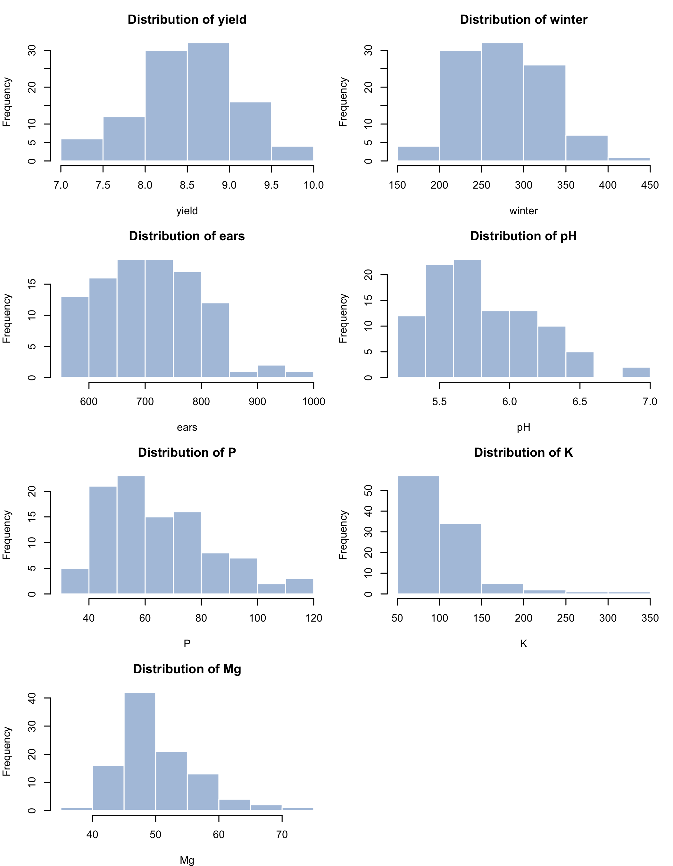
par(old_par)
The histograms show that most variables are reasonably centered without extreme gaps. Potassium (K) is strongly right-skewed because a few plots have much higher potassium values than the rest. Phosphorus and magnesium also have some higher values. Yield is roughly unimodal, although the smallest yield value is separated somewhat from most observations.

Boxplots and possible outliers
old_par <- par(mfrow = c(4, 2), mar = c(4, 4, 3, 1))
for (v in names(wheat)) {
boxplot(
wheat[[v]],
main = paste("Boxplot of", v),
ylab = v,
col = "wheat",
border = "gray30"
)
stripchart(
wheat[[v]],
method = "jitter",
vertical = TRUE,
add = TRUE,
pch = 16,
col = rgb(0.15, 0.25, 0.45, 0.45)
)
}
plot.new()
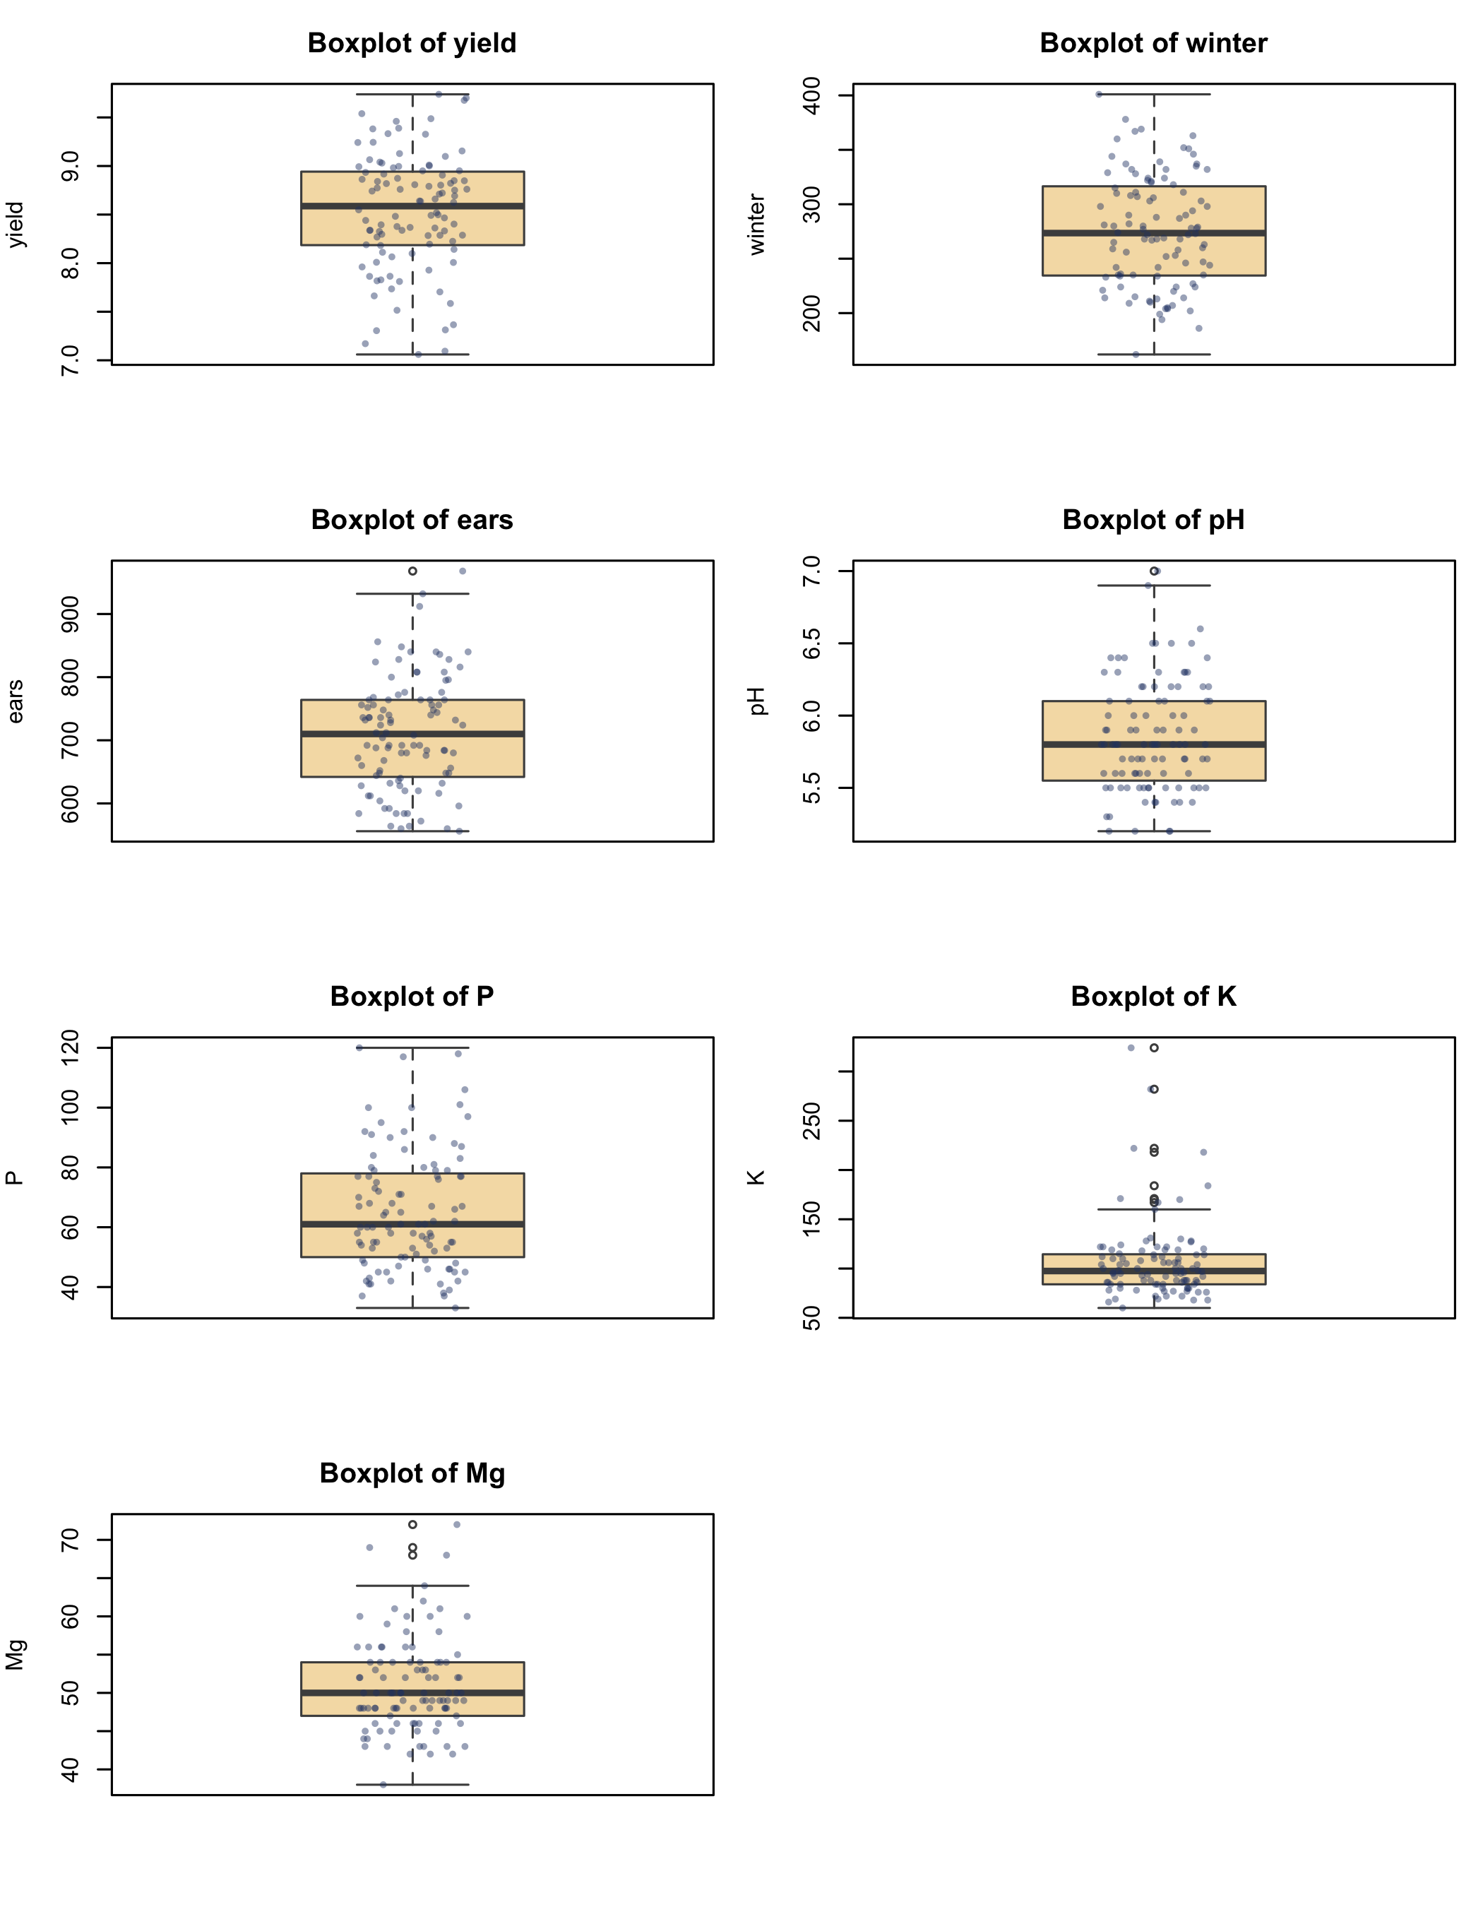
par(old_par)
outlier_rows <- do.call(
rbind,
lapply(names(wheat), function(v) {
x <- wheat[[v]]
limits <- boxplot.stats(x)$stats[c(1, 5)]
rows <- which(x < limits[1] | x > limits[2])
if (length(rows) == 0) return(NULL)
data.frame(Variable = v, Row = rows, Value = x[rows])
})
)
knitr::kable(
outlier_rows,
row.names = FALSE,
caption = "Possible outliers flagged by the standard boxplot rule"
)
Possible outliers flagged by the standard boxplot rule
Variable | Row | Value
ears | 60 | 968
pH | 1 | 7
K | 1 | 222
K | 20 | 170
K | 21 | 218
K | 30 | 167
K | 36 | 171
K | 45 | 324
K | 49 | 184
K | 81 | 282
Mg | 35 | 69
Mg | 94 | 72
Mg | 97 | 68
The boxplots flag possible unusual values in several variables. The clearest pattern is the group of high potassium values, including values of 324 and 282 mg/kg. The data also contain a low yield value, a high ears value, high pH values, a high phosphorus value, and a few high magnesium values. These observations should be checked for data-entry or measurement problems, but they should not be deleted only because a boxplot labels them as outliers.

Pairwise scatterplots involving the response
predictors <- c("winter", "ears", "pH", "P", "K", "Mg")
old_par <- par(mfrow = c(2, 3), mar = c(4, 4, 3, 1))
for (v in predictors) {
plot(
wheat[[v]], wheat$yield,
xlab = v,
ylab = "Yield (t/ha)",
main = paste("Yield vs", v),
pch = 19,
col = rgb(0.10, 0.35, 0.60, 0.60)
)
simple_model <- lm(yield ~ x, data = data.frame(
yield = wheat$yield,
x = wheat[[v]]
))
abline(simple_model, col = "firebrick", lwd = 2)
}
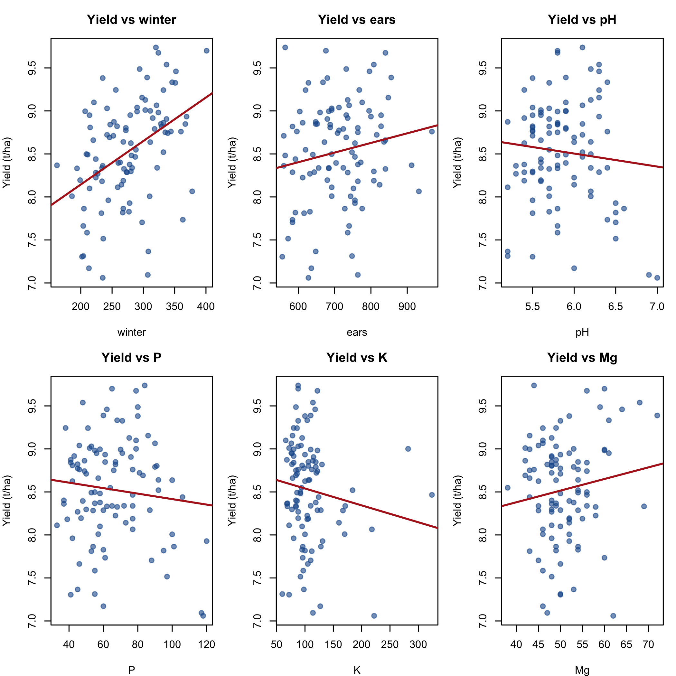
par(old_par)
The clearest bivariate pattern is a positive association between winter and yield: plots with more overwintering plants tend to have higher yield. The association between ears and yield is positive but weaker. The plots for pH, phosphorus, potassium, and magnesium show weak relationships with yield when each predictor is viewed alone. Potassium also shows several high-value observations.

Complete scatterplot matrix
pairs(
wheat,
pch = 19,
col = rgb(0.10, 0.35, 0.60, 0.40),
main = "Scatterplot matrix for all wheat variables"
)
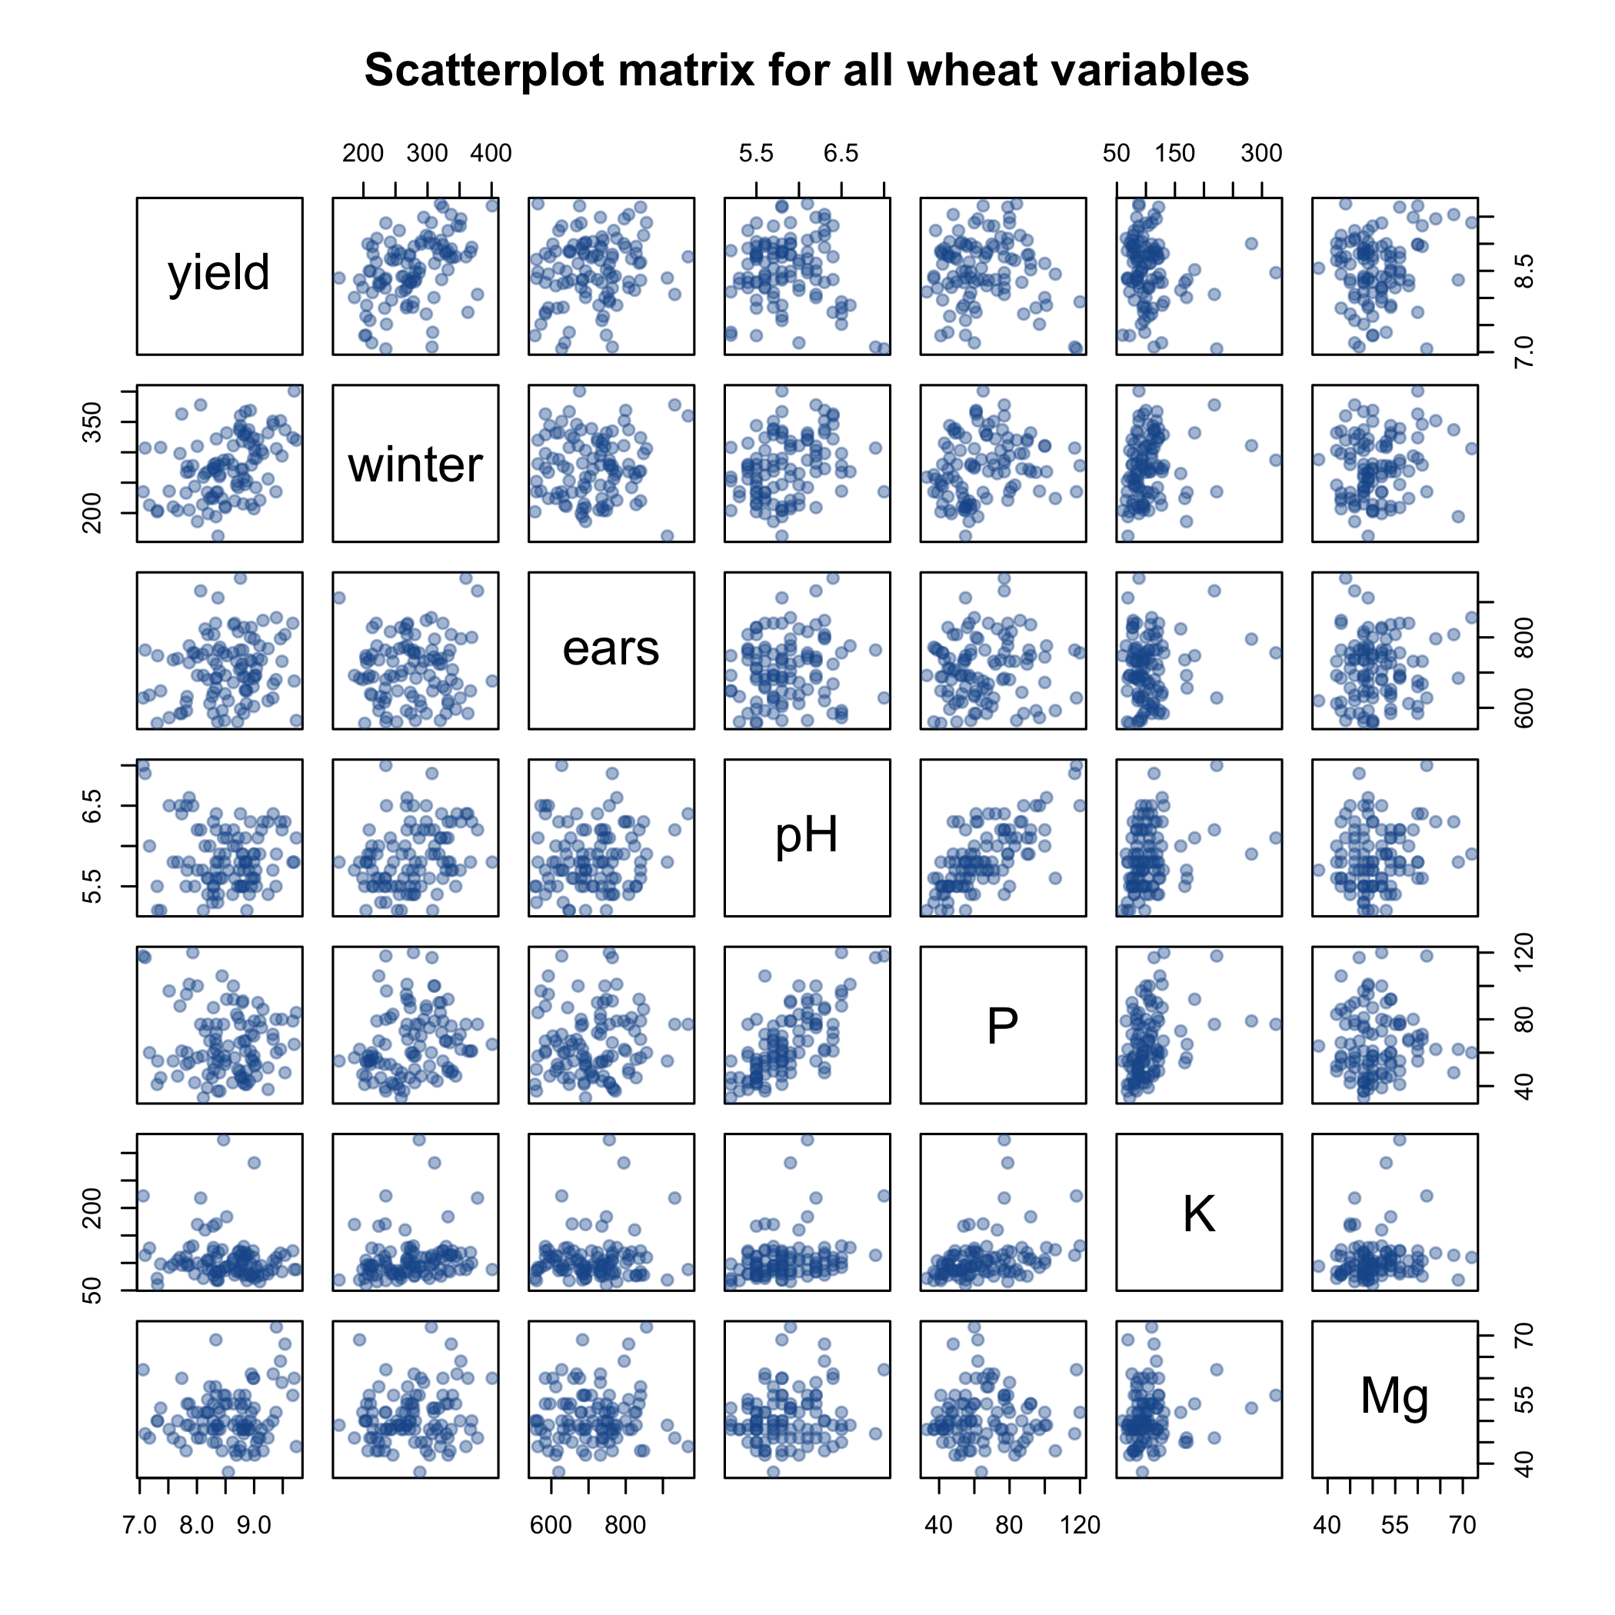
The scatterplot matrix confirms the positive relationship between winter and yield. It also shows a strong positive association between pH and phosphorus. Other predictor pairs show weaker associations. The high potassium observations are visible across several panels and may have substantial leverage in analyses involving potassium.

Correlation matrix
correlation_matrix <- cor(wheat, use = "complete.obs", method = "pearson")
knitr::kable(
round(correlation_matrix, 3),
caption = "Pearson correlation matrix"
)
Pearson correlation matrix
 | yield | winter | ears | pH | P | K | Mg
yield | 1.000 | 0.430 | 0.166 | -0.096 | -0.105 | -0.132 | 0.139
winter | 0.430 | 1.000 | 0.054 | 0.296 | 0.205 | 0.169 | 0.143
ears | 0.166 | 0.054 | 1.000 | 0.097 | 0.079 | 0.096 | 0.062
pH | -0.096 | 0.296 | 0.097 | 1.000 | 0.703 | 0.275 | 0.161
P | -0.105 | 0.205 | 0.079 | 0.703 | 1.000 | 0.337 | 0.015
K | -0.132 | 0.169 | 0.096 | 0.275 | 0.337 | 1.000 | 0.119
Mg | 0.139 | 0.143 | 0.062 | 0.161 | 0.015 | 0.119 | 1.000
heatmap(
correlation_matrix,
Rowv = NA,
Colv = NA,
scale = "none",
margins = c(7, 7),
col = colorRampPalette(c("firebrick", "white", "steelblue"))(100),
main = "Correlation matrix heatmap"
)
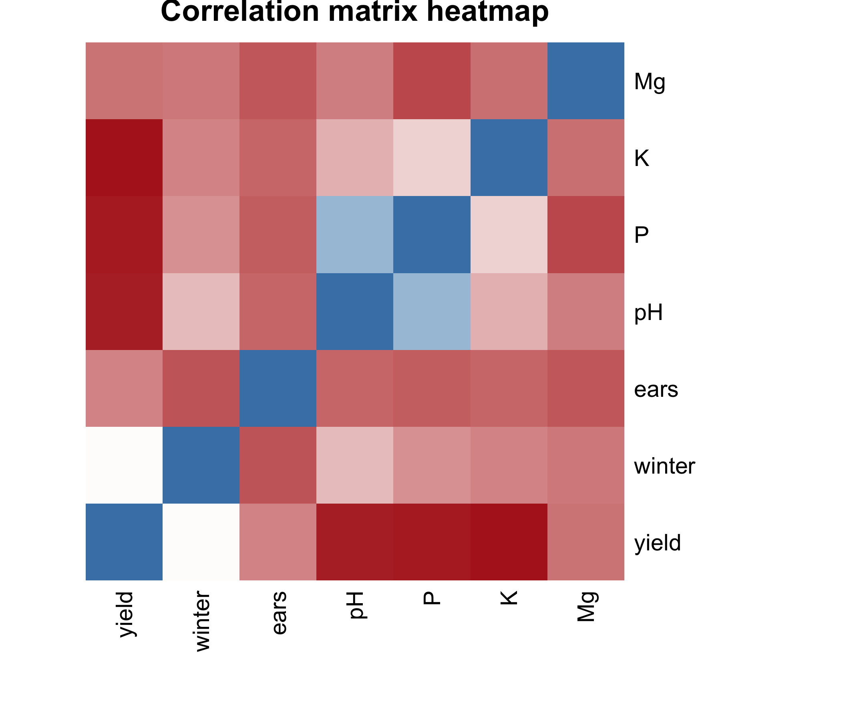
The strongest correlation with yield is for winter (0.43). The correlation between yield and ears is weaker (0.166). All other correlations with yield have small absolute values. The largest predictor-predictor correlation is between pH and phosphorus (0.703), which means those two predictors contain overlapping information.

Basic statistical analysis

Individual Pearson correlations with yield
correlation_tests <- do.call(
rbind,
lapply(predictors, function(v) {
test <- cor.test(wheat$yield, wheat[[v]], method = "pearson")
data.frame(
Predictor = v,
Correlation = unname(test$estimate),
P_value = test$p.value
)
})
)
correlation_tests$Correlation <- round(correlation_tests$Correlation, 3)
correlation_tests$P_value <- signif(correlation_tests$P_value, 3)
knitr::kable(
correlation_tests,
row.names = FALSE,
caption = "Individual Pearson correlations with wheat yield"
)
Individual Pearson correlations with wheat yield
Predictor | Correlation | P_value
winter | 0.430 | 0.0000081
ears | 0.166 | 0.0987000
pH | -0.096 | 0.3400000
P | -0.105 | 0.3000000
K | -0.132 | 0.1890000
Mg | 0.139 | 0.1690000
When each predictor is tested by itself, winter has the clearest association with yield. These correlations do not adjust for the other predictors, so a multiple regression is also needed.

Multiple linear regression
wheat_model <- lm(yield ~ winter + ears + pH + P + K + Mg, data = wheat)
summary(wheat_model)
##
## Call:
## lm(formula = yield ~ winter + ears + pH + P + K + Mg, data = wheat)
##
## Residuals:
## Min 1Q Median 3Q Max
## -1.56409 -0.29872 0.06243 0.35284 1.23284
##
## Coefficients:
## Estimate Std. Error t value Pr(>|t|)
## (Intercept) 7.91134815 1.04658342 7.559 0.0000000000279 ***
## winter 0.00592307 0.00107338 5.518 0.0000003073087 ***
## ears 0.00116044 0.00058756 1.975 0.0512 .
## pH -0.36265198 0.19926695 -1.820 0.0720 .
## P 0.00003812 0.00383204 0.010 0.9921
## K -0.00273799 0.00137978 -1.984 0.0502 .
## Mg 0.01122399 0.00871146 1.288 0.2008
## ---
## Signif. codes: 0 '***' 0.001 '**' 0.01 '*' 0.05 '.' 0.1 ' ' 1
##
## Residual standard error: 0.515 on 93 degrees of freedom
## Multiple R-squared: 0.3073, Adjusted R-squared: 0.2626
## F-statistic: 6.876 on 6 and 93 DF, p-value: 0.000004607
anova(wheat_model)
## Analysis of Variance Table
##
## Response: yield
## Df Sum Sq Mean Sq F value Pr(>F)
## winter 1 6.5802 6.5802 24.8098 0.000002908 ***
## ears 1 0.7288 0.7288 2.7480 0.10074
## pH 1 2.1735 2.1735 8.1950 0.00519 **
## P 1 0.0964 0.0964 0.3637 0.54795
## K 1 0.9223 0.9223 3.4776 0.06536 .
## Mg 1 0.4403 0.4403 1.6600 0.20080
## Residuals 93 24.6658 0.2652
## ---
## Signif. codes: 0 '***' 0.001 '**' 0.01 '*' 0.05 '.' 0.1 ' ' 1
The overall regression model is statistically significant, F(6, 93) = 6.876, p = 0.00000461. Together, the six predictors explain 30.7% of the variation in wheat yield. The adjusted R-squared is 0.263.
After all other predictors are held constant, winter has a statistically significant positive slope (b = 0.0059, p < 0.001). An increase of 100 overwintering plants per m2 is associated with an estimated increase of about 0.592 t/ha in yield, holding the other variables constant. The p-values for ears and potassium are close to 0.05, but neither is below the conventional 0.05 cutoff in this model. pH, phosphorus, and magnesium are also not statistically significant after adjustment for the other predictors.
Because the data are observational, these results show associations and predictive relationships. They do not by themselves prove that changing a predictor would cause yield to change.

Collinearity check
# Base-R calculation of variance inflation factors (VIFs).
vif_values <- sapply(predictors, function(v) {
other_predictors <- setdiff(predictors, v)
auxiliary_formula <- reformulate(other_predictors, response = v)
auxiliary_model <- lm(auxiliary_formula, data = wheat)
1 / (1 - summary(auxiliary_model)$r.squared)
})
vif_table <- data.frame(
Predictor = predictors,
VIF = round(vif_values, 3)
)
knitr::kable(vif_table, row.names = FALSE, caption = "Variance inflation factors")
Variance inflation factors
Predictor | VIF
winter | 1.116
ears | 1.017
pH | 2.154
P | 2.122
K | 1.160
Mg | 1.071
All VIF values are well below 5. The pH and phosphorus VIFs are somewhat higher than the others because those variables are correlated, but the values do not indicate severe multicollinearity.

Regression diagnostic plots
old_par <- par(mfrow = c(2, 2))
plot(wheat_model)
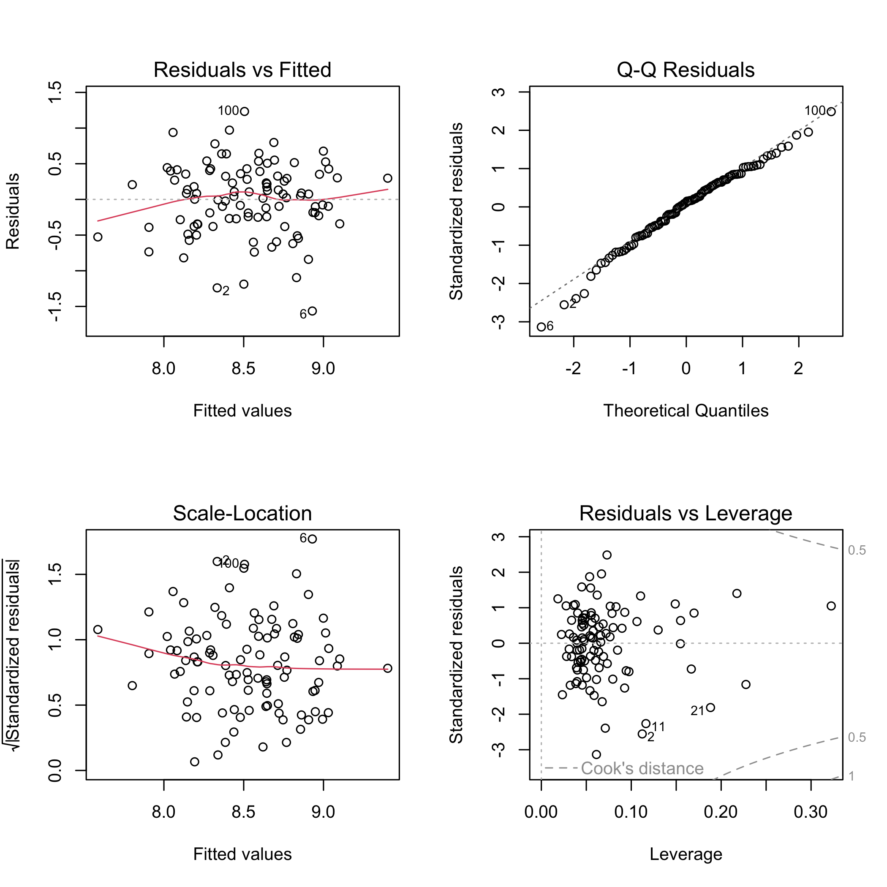
par(old_par)
diagnostic_table <- data.frame(
Row = seq_len(nrow(wheat)),
Studentized_residual = rstudent(wheat_model),
Cooks_distance = cooks.distance(wheat_model)
)
flagged_diagnostics <- diagnostic_table[
abs(diagnostic_table$Studentized_residual) > 3 |
diagnostic_table$Cooks_distance > 4 / nrow(wheat),
]
flagged_diagnostics$Studentized_residual <- round(
flagged_diagnostics$Studentized_residual, 3
)
flagged_diagnostics$Cooks_distance <- round(
flagged_diagnostics$Cooks_distance, 3
)
knitr::kable(
flagged_diagnostics,
row.names = FALSE,
caption = "Observations flagged for closer diagnostic inspection"
)
Observations flagged for closer diagnostic inspection
Row | Studentized_residual | Cooks_distance
1 | -1.164 | 0.057
2 | -2.636 | 0.118
5 | -2.457 | 0.063
6 | -3.297 | 0.092
11 | -2.317 | 0.096
21 | -1.835 | 0.109
45 | 1.051 | 0.075
81 | 1.410 | 0.078
100 | 2.560 | 0.070
The residual plots do not show a major curved pattern, and the normal Q-Q plot is reasonably close to a straight line. Row 6 has a studentized residual slightly larger than 3 in absolute value. Several rows exceed the common Cook’s distance screening rule of 4/n, but no Cook’s distance is close to 1. These plots suggest checking the flagged rows and reporting them, not automatically removing them.

Conclusion
The results support the broad research hypothesis that at least one measured variable is associated with wheat yield. The complete six-predictor model is statistically significant and explains about 30.7% of the observed yield variation. The number of overwintering plants is the clearest predictor and has a positive relationship with yield. The other variables provide weaker evidence once all predictors are analyzed together. The model has moderate predictive value, but most yield variation remains unexplained, so additional biological, environmental, or management variables may improve prediction.

