BIO 620 Week 2 Data Exploration
Julia Jainarine
08/30/2026
Table of Contents

Purpose
This report presents an initial data exploration of the oat and bacteria datasets. The analysis identifies the variables and experimental structure, checks data quality, summarizes distributions, and explores patterns visually. Because this is exploratory analysis, the figures identify possible patterns and problems rather than provide final statistical conclusions.

Oat dataset

Research hypothesis
Plots with a greater mean number of grains per ear are expected to have greater oat yield. Therefore, grain number should positively predict yield.

Variables and roles
- yield is the response variable. It is a continuous numerical variable measured in tonnes per hectare.
- grain is the focal predictor. Although individual grains are counts, this column contains a mean with decimal values and is treated as a continuous numerical variable.
- There are no categorical variables, ordinal variables, or additional covariates in this dataset.

Import and inspect the data
oat <- read.csv("oat.csv", header = TRUE)
names(oat)
## [1] "grain" "yield"
str(oat)
## 'data.frame': 20 obs. of 2 variables:
## $ grain: num 18.1 23 28.9 27 17.8 ...
## $ yield: num 4.91 5.17 5.82 5.82 5.05 ...
head(oat)
## grain yield
## 1 18.07 4.913
## 2 22.98 5.170
## 3 28.94 5.820
## 4 26.99 5.820
## 5 17.76 5.050
## 6 18.53 5.234
summary(oat)
## grain yield
## Min. : 17.76 Min. :4.913
## 1st Qu.: 20.29 1st Qu.:5.192
## Median : 23.15 Median :5.337
## Mean : 148.07 Mean :5.382
## 3rd Qu.: 25.64 3rd Qu.:5.574
## Max. :2528.00 Max. :5.858
sum(is.na(oat))
## [1] 0
The oat dataset contains 20 observations and two variables. There are no missing values.

Check for possible data errors
which(oat$grain > 100)
## [1] 16
oat[oat$grain > 100, ]
## grain yield
## 16 2528 5.417
Row 16 contains a grain value of 2528, while every other observation ranges from 17.76 to 28.94. This is an extreme outlier and may be a data-entry or decimal-place error, possibly 25.28. It should be checked against the original source before it is corrected or removed. The supplied value is retained in the analysis below.

Numerical summaries
oat_summary <- data.frame(
Variable = c("grain", "yield"),
N = c(length(oat$grain), length(oat$yield)),
Mean = c(mean(oat$grain), mean(oat$yield)),
SD = c(sd(oat$grain), sd(oat$yield)),
Minimum = c(min(oat$grain), min(oat$yield)),
Median = c(median(oat$grain), median(oat$yield)),
Maximum = c(max(oat$grain), max(oat$yield))
)
knitr::kable(
oat_summary,
digits = 3,
caption = "Numerical summaries for the raw oat data"
)
Numerical summaries for the raw oat data
Variable | N | Mean | SD | Minimum | Median | Maximum
grain | 20 | 148.071 | 560.186 | 17.760 | 23.150 | 2528.000
yield | 20 | 5.382 | 0.283 | 4.913 | 5.336 | 5.858
The mean and standard deviation of grain are severely affected by the value 2528. Therefore, the median and graphs are more informative until that observation is verified.

Dot charts and boxplots
par(mfrow = c(2, 2), mar = c(4, 4, 3, 1))
dotchart(
oat$grain,
main = "Dot Chart of Mean Grains per Ear",
xlab = "Mean grains per ear",
pch = 19,
color = "steelblue"
)
boxplot(
oat$grain,
main = "Boxplot of Mean Grains per Ear",
ylab = "Mean grains per ear",
col = "lightblue"
)
dotchart(
oat$yield,
main = "Dot Chart of Oat Yield",
xlab = "Yield (t/ha)",
pch = 19,
color = "darkgreen"
)
boxplot(
oat$yield,
main = "Boxplot of Oat Yield",
ylab = "Yield (t/ha)",
col = "palegreen"
)
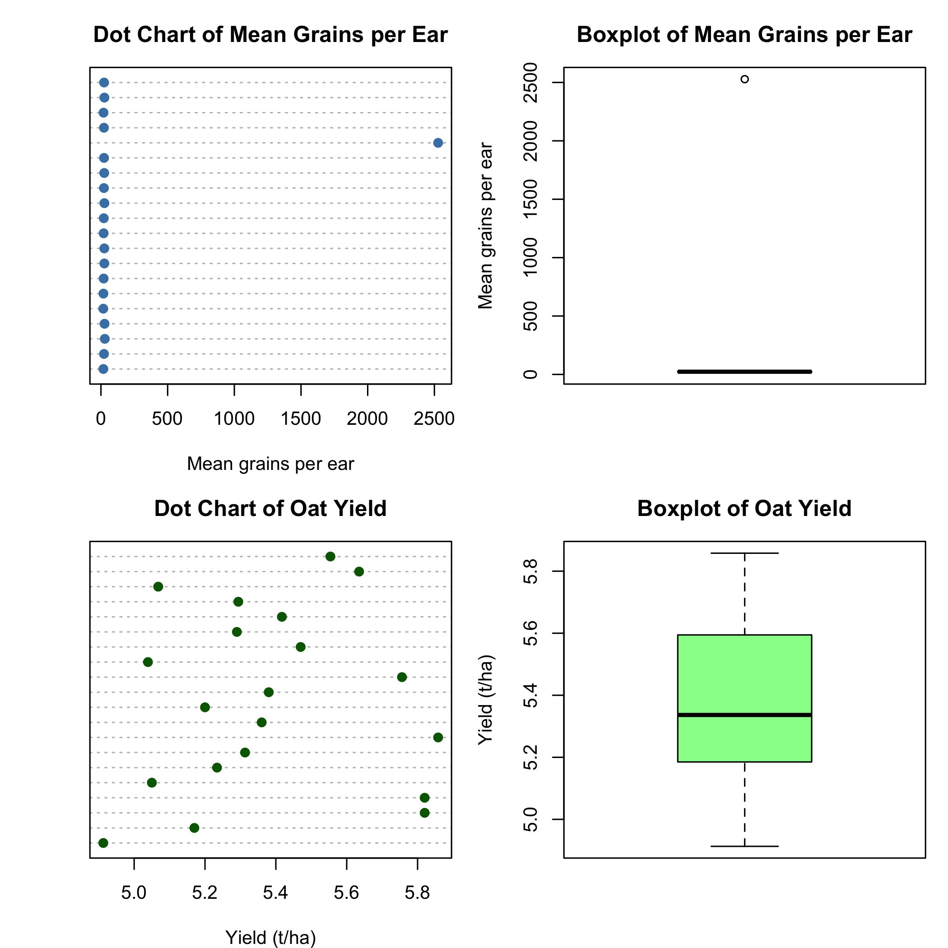
par(mfrow = c(1, 1))

Histograms
par(mfrow = c(1, 2), mar = c(4, 4, 3, 1))
hist(
oat$grain,
main = "Histogram of Mean Grains per Ear",
xlab = "Mean grains per ear",
col = "lightblue",
border = "white"
)
hist(
oat$yield,
main = "Histogram of Oat Yield",
xlab = "Yield (t/ha)",
col = "palegreen",
border = "white"
)
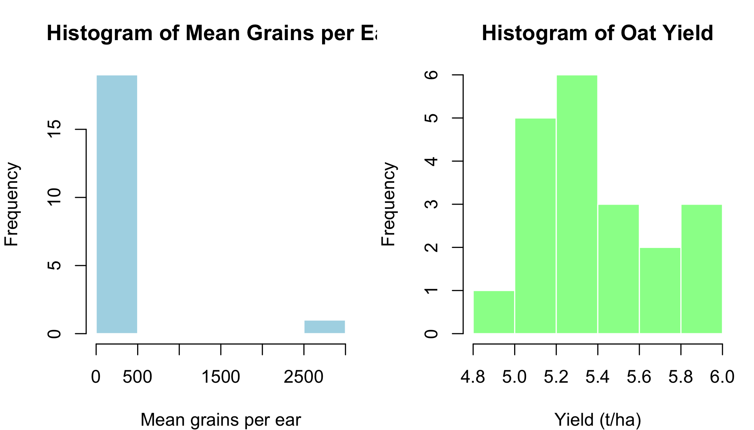
par(mfrow = c(1, 1))
Yield ranges from 4.913 to 5.858 tonnes per hectare and does not contain an observation as extreme as the grain value in row 16. The grain graphs clearly isolate the value 2528 from all the other measurements.

Relationship between grain number and yield
plot(
oat$grain,
oat$yield,
main = "Oat Yield versus Mean Grains per Ear: Raw Data",
xlab = "Mean grains per ear",
ylab = "Yield (t/ha)",
pch = 19,
col = "steelblue"
)
text(
oat$grain[16],
oat$yield[16],
labels = "Row 16",
pos = 3
)
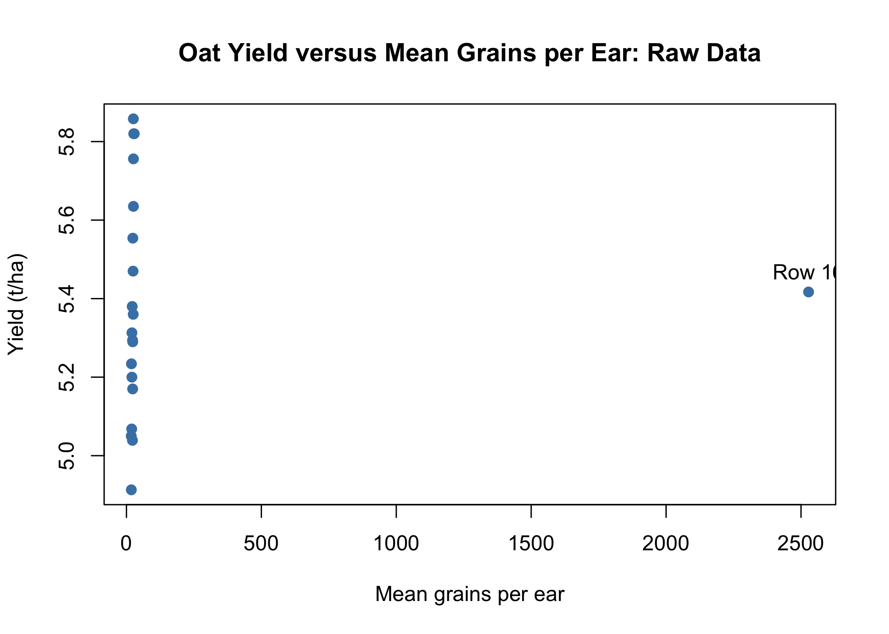
The raw scatterplot is compressed by row 16, making the relationship among the other observations difficult to see.
cor(oat$grain, oat$yield)
## [1] 0.03384596
The raw Pearson correlation is approximately 0.034. However, this result is strongly affected by the questionable grain value.

Diagnostic graph
The following graph excludes grain values above 100 only to reveal the pattern among the remaining observations. It does not permanently remove or correct row 16.
oat_diagnostic <- oat[oat$grain < 100, ]
plot(
oat_diagnostic$grain,
oat_diagnostic$yield,
main = "Diagnostic View Excluding Unverified Row 16",
xlab = "Mean grains per ear",
ylab = "Yield (t/ha)",
pch = 19,
col = "darkgreen"
)
abline(
lm(yield ~ grain, data = oat_diagnostic),
col = "black",
lwd = 2
)
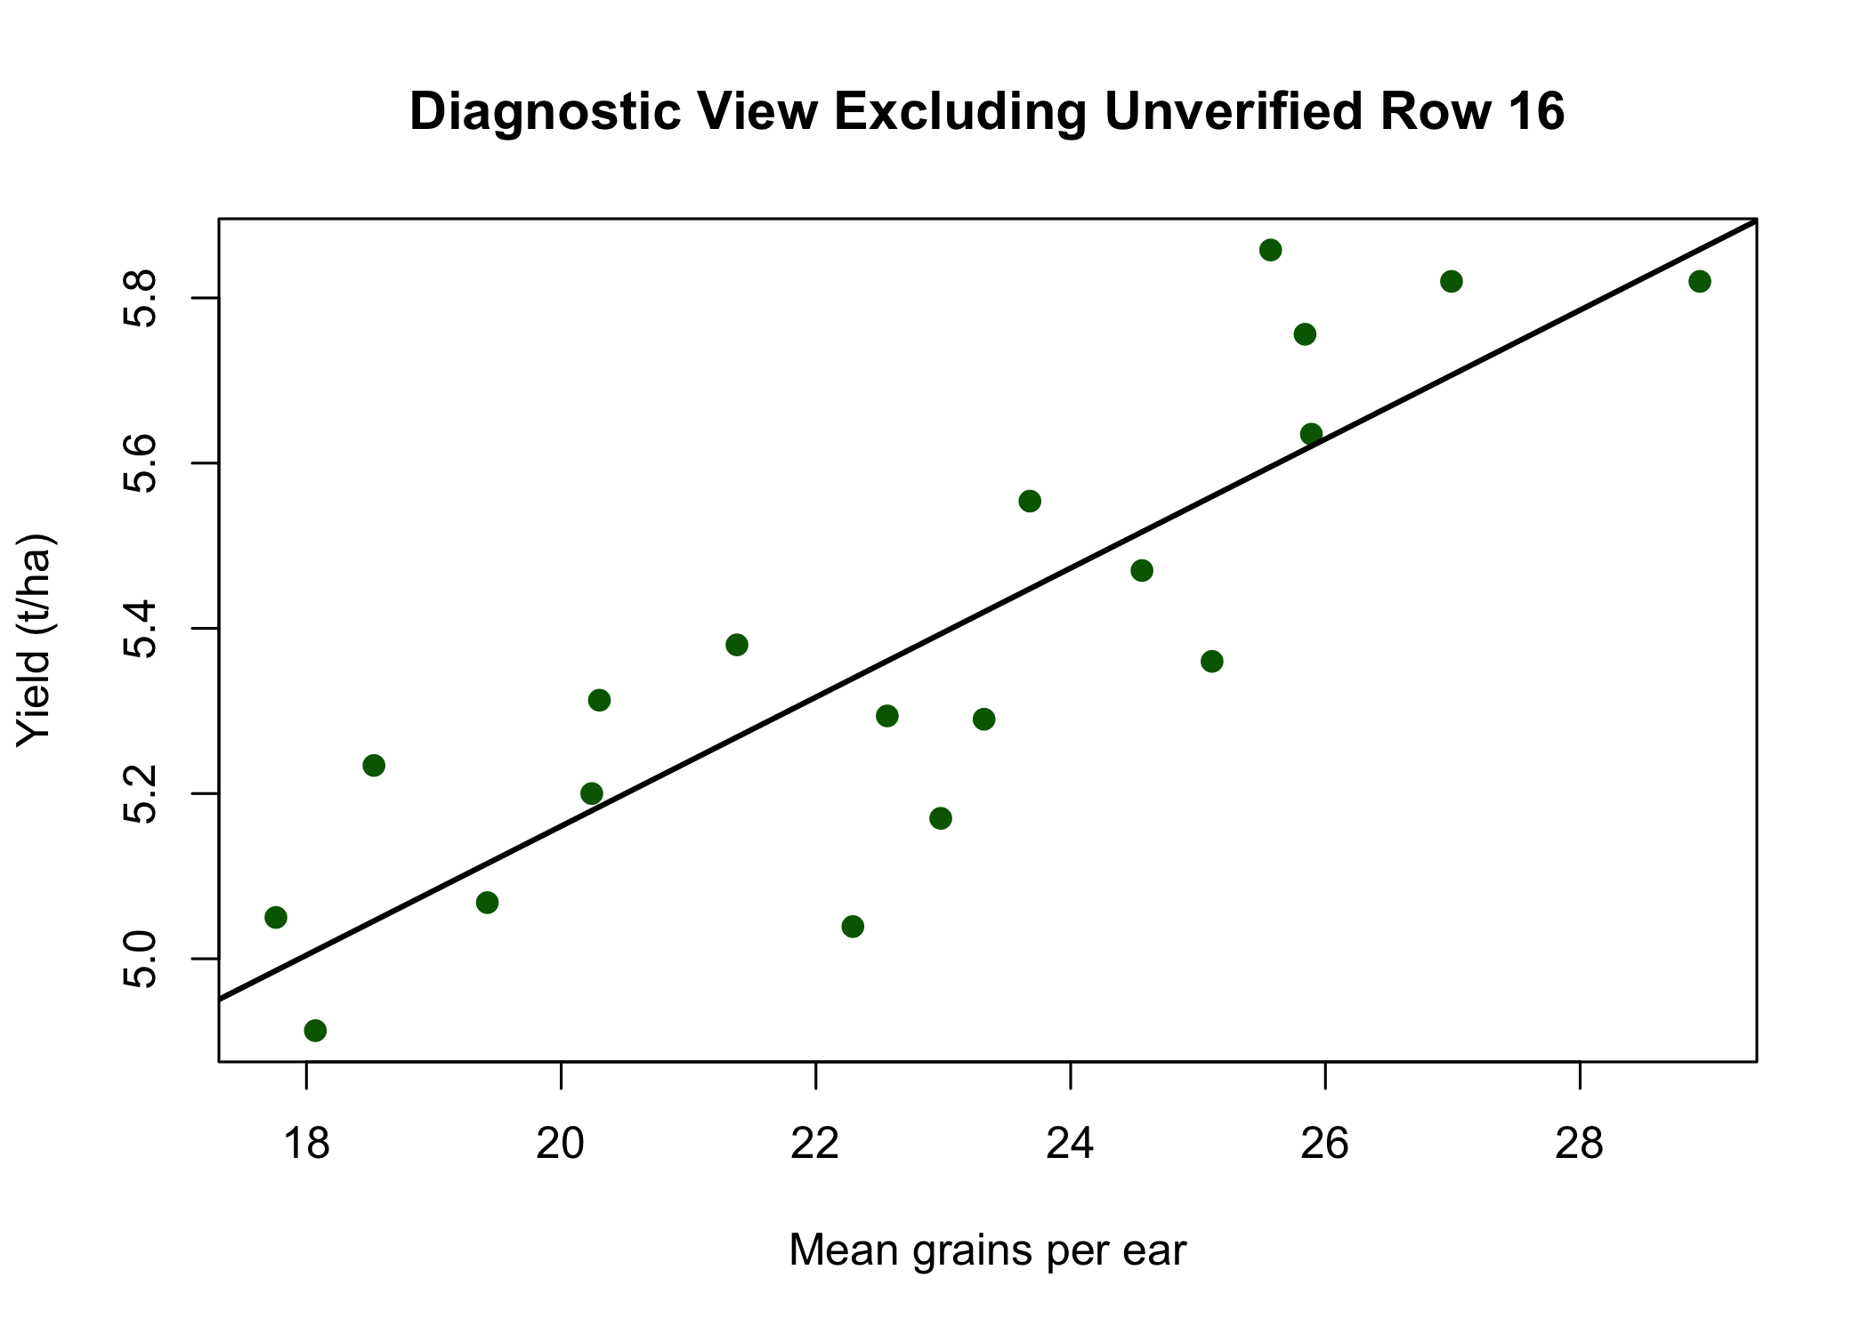
cor(oat_diagnostic$grain, oat_diagnostic$yield)
## [1] 0.8589791
The remaining 19 observations show a clear positive and approximately linear relationship. Their correlation is approximately 0.859. This supports the proposed positive association, but row 16 must be verified before formal statistical analysis or a final biological conclusion.

Bacteria dataset

Research hypotheses
The amount of toxin may differ among bacterial species, among patient diagnoses, or through an interaction between species and diagnosis. A potentially useful indicator would be a bacterial species whose toxin measurements distinguish carcinoma diagnoses from non-carcinoma diagnoses.

Variables and roles
- toxin is the response variable. It is a continuous numerical measurement in units per microliter.
- species is a categorical nominal predictor with four levels: bacterA, bacterB, bacterC, and bacterD.
- diagnosis is a categorical nominal predictor with four levels.
- There are no ordinal variables or additional covariates.
- The spellings apendicitis and skin.absces are retained because those are the labels used in the supplied dataset.

Import and inspect the data
bacteria <- read.csv("bacteria.csv", header = TRUE)
bacteria$species <- as.factor(bacteria$species)
bacteria$diagnosis <- as.factor(bacteria$diagnosis)
names(bacteria)
## [1] "species" "diagnosis" "toxin"
str(bacteria)
## 'data.frame': 80 obs. of 3 variables:
## $ species : Factor w/ 4 levels "bacterA","bacterB",..: 1 1 1 1 1 2 2 2 2 2 ...
## $ diagnosis: Factor w/ 4 levels "apendicitis",..: 2 2 2 2 2 2 2 2 2 2 ...
## $ toxin : num 1.74 2.08 1.65 1.91 2.16 ...
head(bacteria)
## species diagnosis toxin
## 1 bacterA carc.intestine 1.735
## 2 bacterA carc.intestine 2.076
## 3 bacterA carc.intestine 1.648
## 4 bacterA carc.intestine 1.907
## 5 bacterA carc.intestine 2.159
## 6 bacterB carc.intestine 1.323
summary(bacteria)
## species diagnosis toxin
## bacterA:20 apendicitis :20 Min. :0.886
## bacterB:20 carc.intestine:20 1st Qu.:1.159
## bacterC:20 carc.rectum :20 Median :1.288
## bacterD:20 skin.absces :20 Mean :1.397
## 3rd Qu.:1.641
## Max. :2.159
sum(is.na(bacteria))
## [1] 0
The bacteria dataset contains 80 observations and three variables. There are no missing values.

Tables for the categorical variables
species_table <- table(bacteria$species)
diagnosis_table <- table(bacteria$diagnosis)
combined_table <- table(bacteria$species, bacteria$diagnosis)
knitr::kable(
as.data.frame(species_table),
col.names = c("Species", "Count"),
caption = "Observations by bacterial species"
)
Observations by bacterial species
Species | Count
bacterA | 20
bacterB | 20
bacterC | 20
bacterD | 20
knitr::kable(
as.data.frame(diagnosis_table),
col.names = c("Diagnosis", "Count"),
caption = "Observations by diagnosis"
)
Observations by diagnosis
Diagnosis | Count
apendicitis | 20
carc.intestine | 20
carc.rectum | 20
skin.absces | 20
knitr::kable(
as.data.frame(combined_table),
col.names = c("Species", "Diagnosis", "Count"),
caption = "Observations in each species-by-diagnosis group"
)
Observations in each species-by-diagnosis group
Species | Diagnosis | Count
bacterA | apendicitis | 5
bacterB | apendicitis | 5
bacterC | apendicitis | 5
bacterD | apendicitis | 5
bacterA | carc.intestine | 5
bacterB | carc.intestine | 5
bacterC | carc.intestine | 5
bacterD | carc.intestine | 5
bacterA | carc.rectum | 5
bacterB | carc.rectum | 5
bacterC | carc.rectum | 5
bacterD | carc.rectum | 5
bacterA | skin.absces | 5
bacterB | skin.absces | 5
bacterC | skin.absces | 5
bacterD | skin.absces | 5
There are 20 observations for each species and 20 observations for each diagnosis. Every species-by-diagnosis combination contains five observations, so the study design is balanced.

Numerical summaries
group_summary <- function(values, groups) {
pieces <- split(values, groups)
data.frame(
Group = names(pieces),
N = sapply(pieces, length),
Mean = sapply(pieces, mean),
SD = sapply(pieces, sd),
Minimum = sapply(pieces, min),
Median = sapply(pieces, median),
Maximum = sapply(pieces, max),
row.names = NULL
)
}
species_summary <- group_summary(
bacteria$toxin,
bacteria$species
)
diagnosis_summary <- group_summary(
bacteria$toxin,
bacteria$diagnosis
)
knitr::kable(
species_summary,
digits = 3,
caption = "Toxin summaries by bacterial species"
)
Toxin summaries by bacterial species
Group | N | Mean | SD | Minimum | Median | Maximum
bacterA | 20 | 1.519 | 0.394 | 0.886 | 1.465 | 2.159
bacterB | 20 | 1.261 | 0.196 | 0.932 | 1.260 | 1.526
bacterC | 20 | 1.274 | 0.187 | 0.958 | 1.274 | 1.639
bacterD | 20 | 1.533 | 0.425 | 0.931 | 1.607 | 2.109
knitr::kable(
diagnosis_summary,
digits = 3,
caption = "Toxin summaries by diagnosis"
)
Toxin summaries by diagnosis
Group | N | Mean | SD | Minimum | Median | Maximum
apendicitis | 20 | 1.172 | 0.134 | 0.886 | 1.192 | 1.428
carc.intestine | 20 | 1.656 | 0.281 | 1.294 | 1.644 | 2.159
carc.rectum | 20 | 1.658 | 0.289 | 1.175 | 1.659 | 2.109
skin.absces | 20 | 1.101 | 0.103 | 0.931 | 1.106 | 1.294
Mean toxin levels are approximately 1.519 for bacterA, 1.261 for bacterB, 1.274 for bacterC, and 1.533 for bacterD.
By diagnosis, mean toxin levels are approximately 1.656 for carc.intestine, 1.658 for carc.rectum, 1.172 for apendicitis, and 1.101 for skin.absces.

Overall toxin distribution
par(mfrow = c(1, 2), mar = c(4, 4, 3, 1))
dotchart(
bacteria$toxin,
main = "Dot Chart of Toxin",
xlab = "Toxin (units/microliter)",
pch = 19,
color = "steelblue"
)
hist(
bacteria$toxin,
main = "Histogram of Toxin",
xlab = "Toxin (units/microliter)",
col = "lightblue",
border = "white"
)
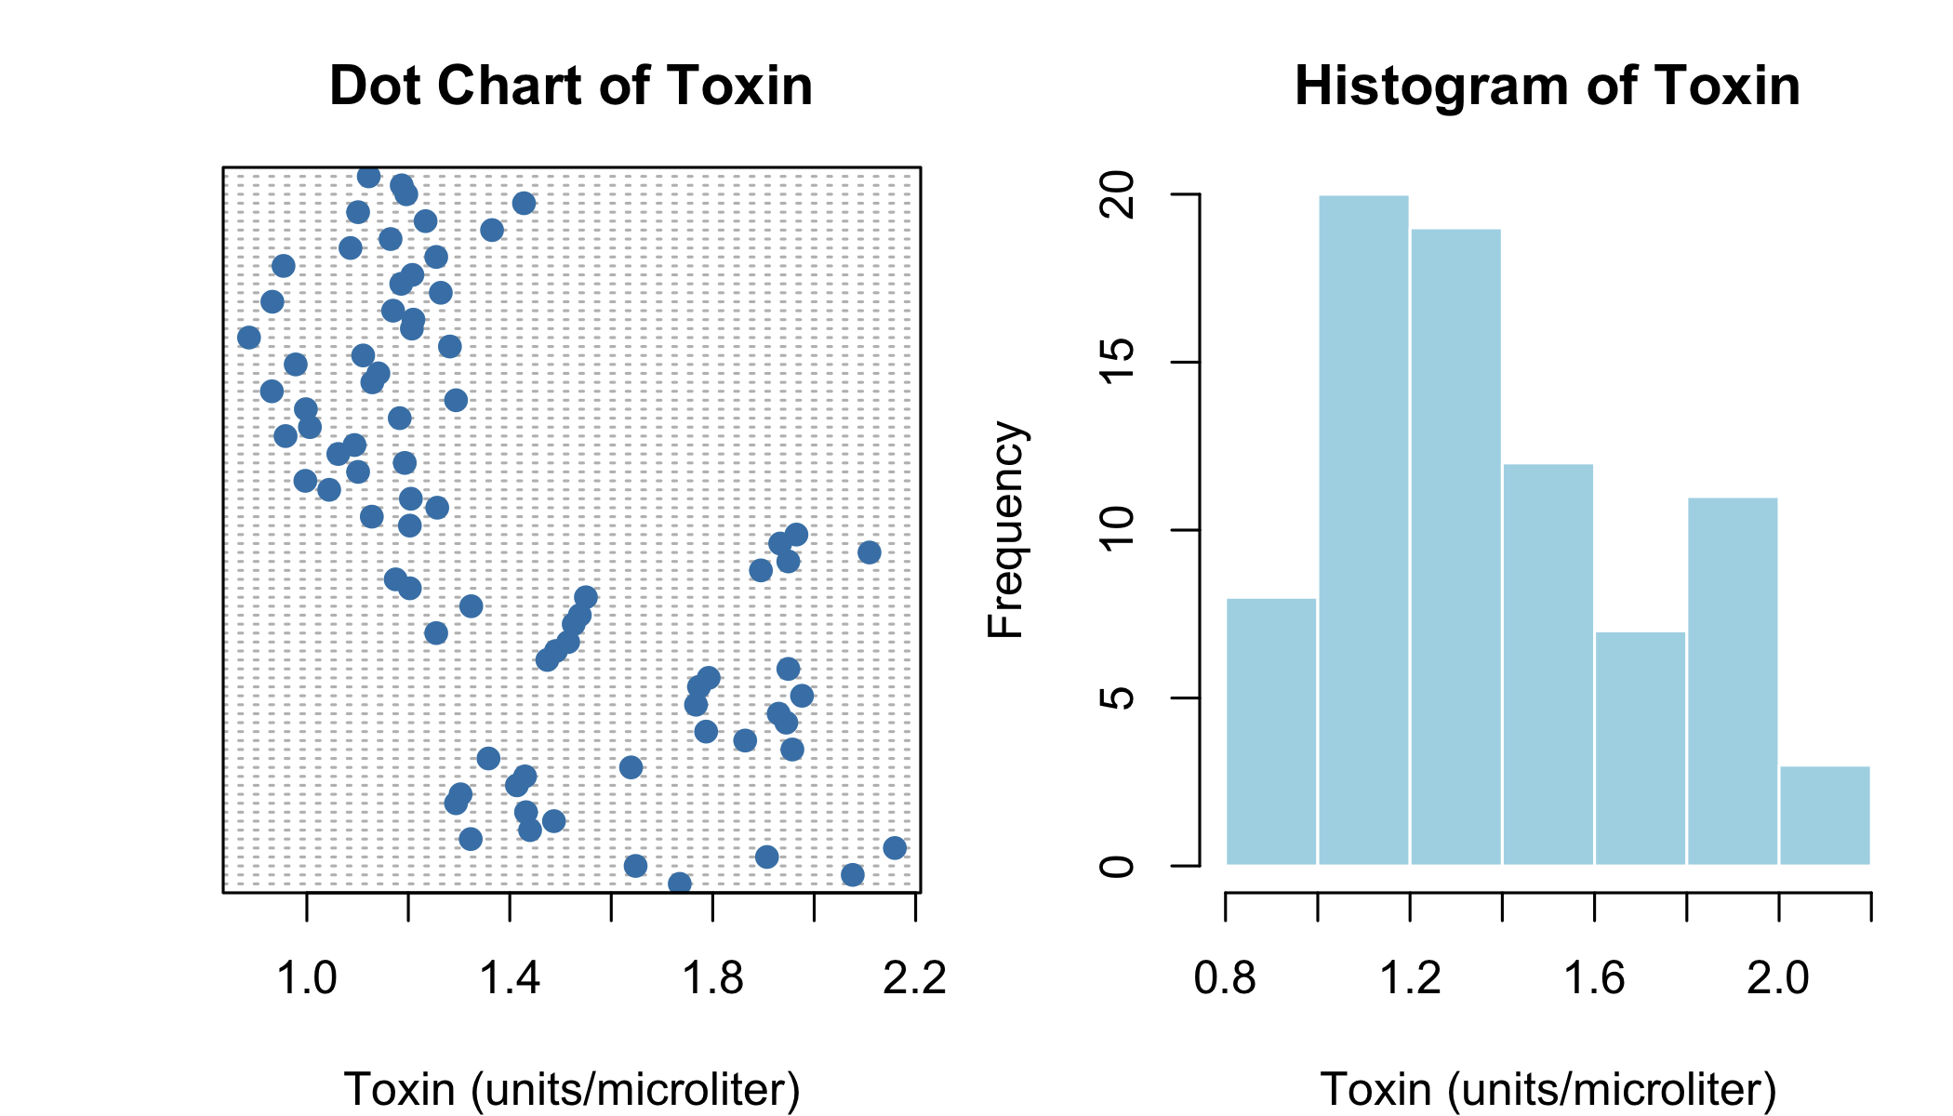
par(mfrow = c(1, 1))
The toxin measurements range from 0.886 to 2.159 units per microliter. The overall shape reflects a mixture of lower-toxin and higher-toxin diagnosis groups rather than one uniform population.

Toxin by bacterial species
par(mfrow = c(1, 2), mar = c(6, 4, 3, 1))
stripchart(
toxin ~ species,
data = bacteria,
vertical = TRUE,
method = "jitter",
pch = 19,
col = c("red", "blue", "darkgreen", "purple"),
main = "Toxin by Bacterial Species",
xlab = "Species",
ylab = "Toxin (units/microliter)"
)
boxplot(
toxin ~ species,
data = bacteria,
col = c("mistyrose", "lightblue", "palegreen", "plum"),
main = "Toxin by Bacterial Species",
xlab = "Species",
ylab = "Toxin (units/microliter)"
)
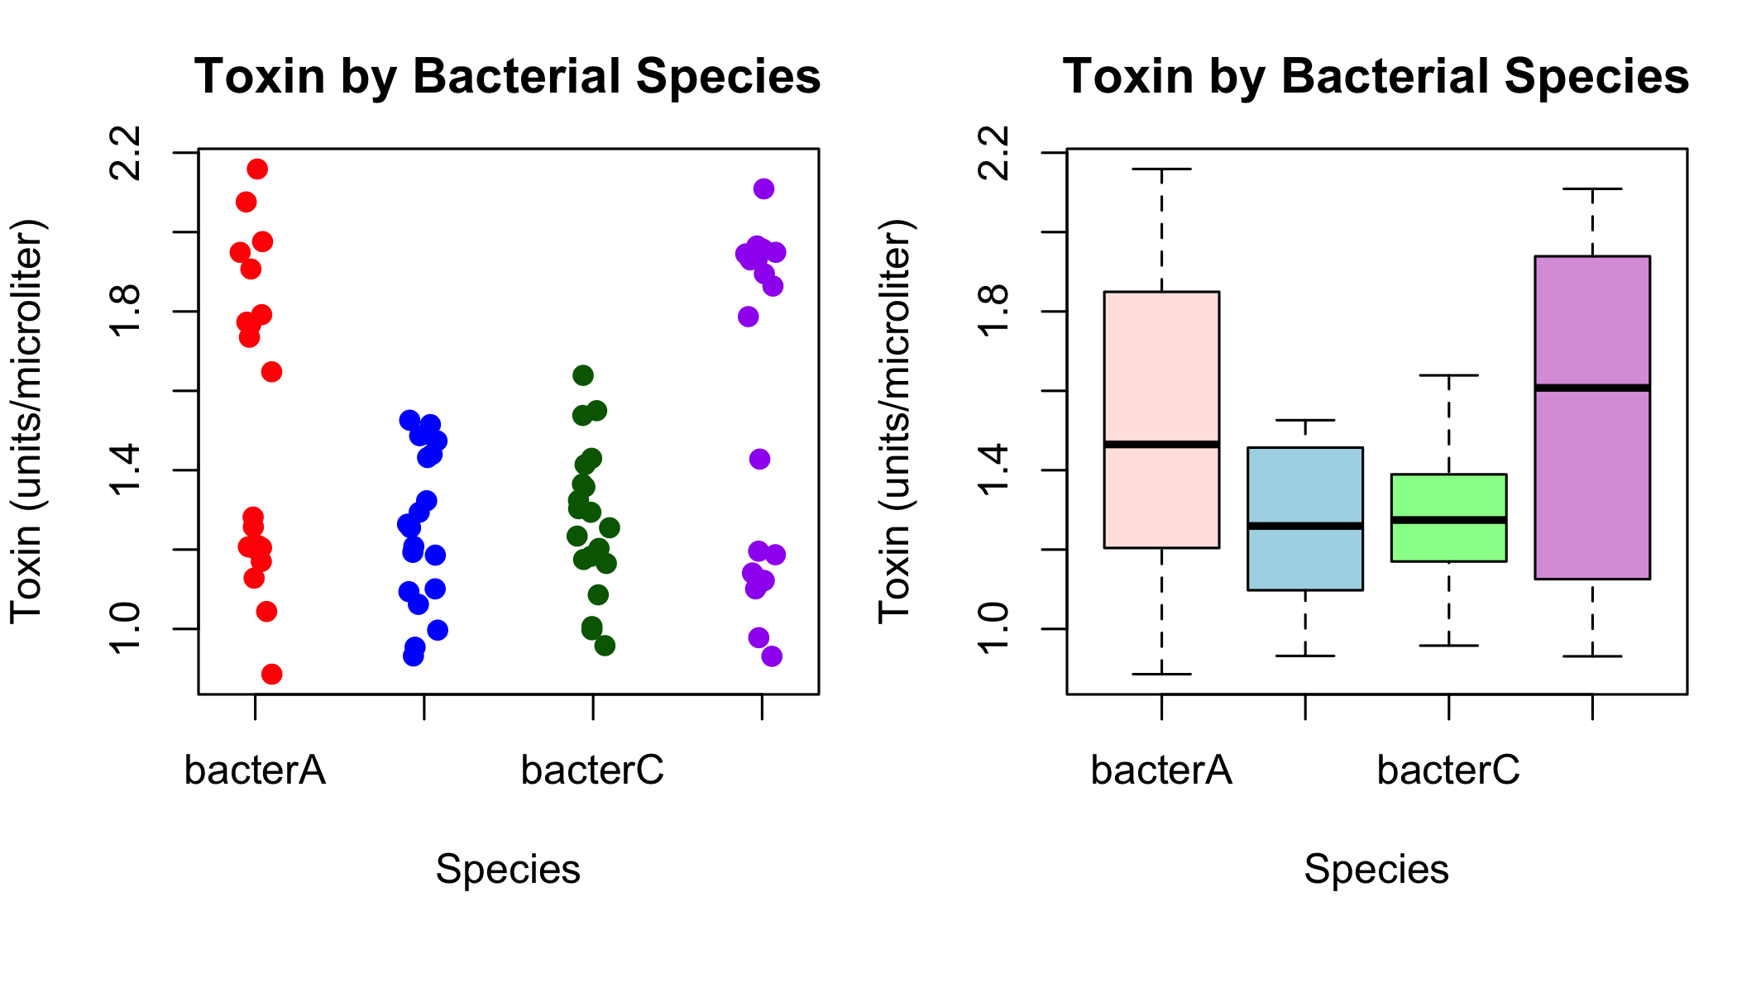
par(mfrow = c(1, 1))
BacterA and bacterD have higher overall means and greater variation than bacterB and bacterC. However, these graphs combine all diagnoses, so diagnosis must also be examined before interpreting the pattern.

Toxin by diagnosis
par(mfrow = c(1, 2), mar = c(9, 4, 3, 1))
stripchart(
toxin ~ diagnosis,
data = bacteria,
vertical = TRUE,
method = "jitter",
pch = 19,
col = c("darkgreen", "red", "red", "blue"),
las = 2,
main = "Toxin by Diagnosis",
xlab = "Diagnosis",
ylab = "Toxin (units/microliter)"
)
boxplot(
toxin ~ diagnosis,
data = bacteria,
col = c("palegreen", "mistyrose", "mistyrose", "lightblue"),
las = 2,
main = "Toxin by Diagnosis",
xlab = "Diagnosis",
ylab = "Toxin (units/microliter)"
)
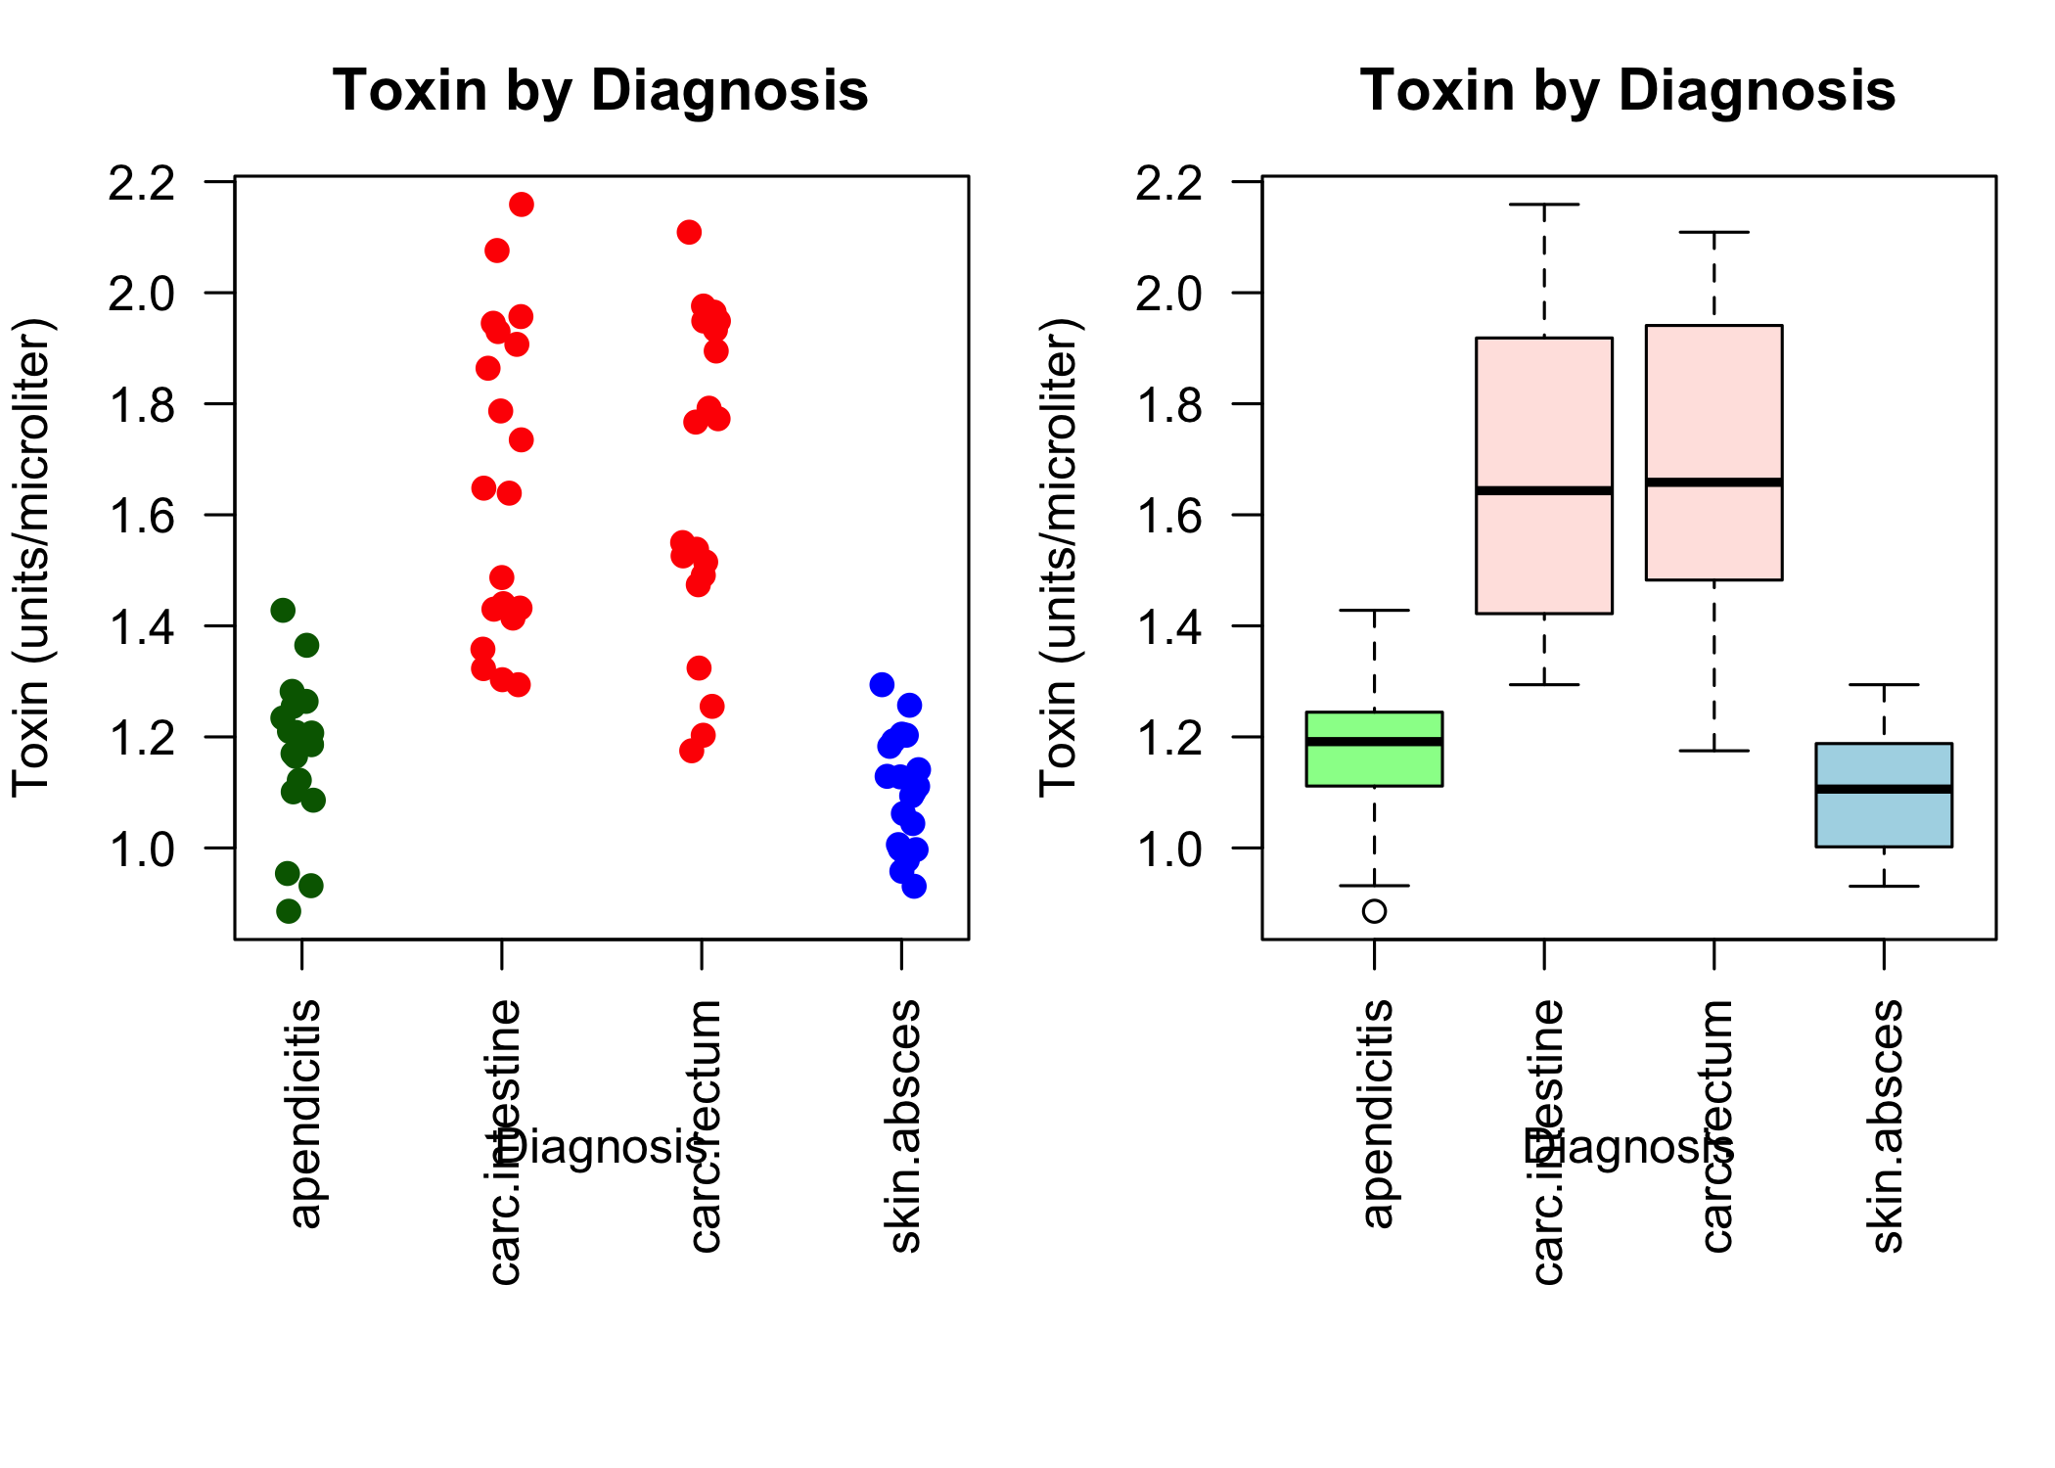
par(mfrow = c(1, 1))
Both carcinoma groups show noticeably higher toxin measurements than the apendicitis and skin.absces groups. The two carcinoma groups have very similar overall means, while skin.absces has the lowest mean.

Species-by-diagnosis pattern
interaction.plot(
x.factor = bacteria$diagnosis,
trace.factor = bacteria$species,
response = bacteria$toxin,
fun = mean,
type = "b",
pch = c(16, 17, 15, 18),
col = c("red", "blue", "darkgreen", "purple"),
fixed = TRUE,
xlab = "Diagnosis",
ylab = "Mean toxin (units/microliter)",
trace.label = "Species",
main = "Mean Toxin by Species and Diagnosis"
)
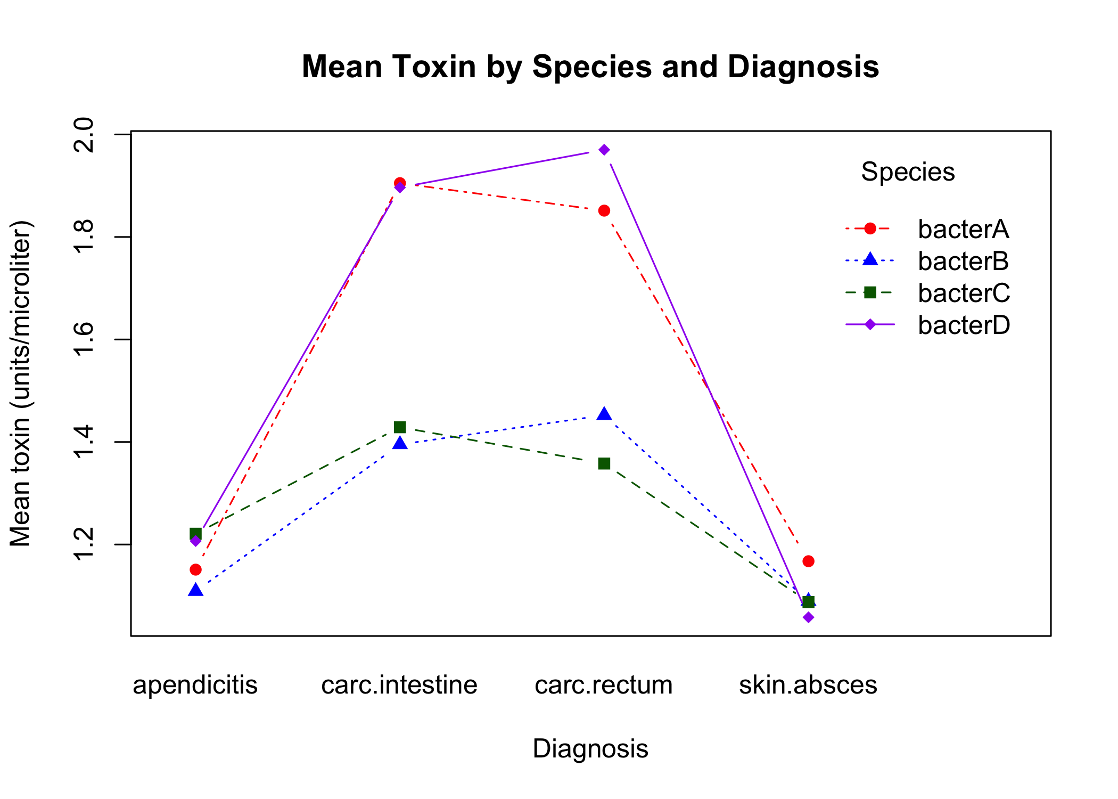
There is only one numerical variable in this dataset, so a scatterplot between two numerical variables is not applicable. The interaction plot is more appropriate because it displays mean toxin across both categorical predictors.
The exploratory pattern suggests that bacterA and bacterD produce particularly high toxin measurements in the carcinoma groups, while all four species are more similar in the non-carcinoma groups. This may indicate an interaction between bacterial species and diagnosis. No individual observation appears severely isolated from the rest of its relevant group, although formal statistical testing and model diagnostics would be required later.

Overall conclusions
The oat exploration identified a probable data-quality problem in row 16. A positive relationship between grain number and yield is visible among the other observations, but the questionable value must be verified before modeling.
The bacteria experiment is balanced and displays clear visual separation between carcinoma and non-carcinoma diagnoses. BacterA and bacterD appear to have the largest toxin increases within the carcinoma groups, making them possible candidates for further investigation as biological indicators.
These observations are exploratory and should be followed by appropriate statistical modeling before firm biological conclusions are made.

