Lab: Blocks

Background: Location location =new Location(0, 0);

In this lab, you will complete the implemention for a class called MyBoundedGrid<E> to represent a grid of objects of type E. Throughout the year, we will put various objects into this grid: bugs, critters, chess pieces, blocks, etc. (The grid is "bounded" in the sense that it is not infinite in size.) The MyBoundedGrid<E> class makes use of the Location class, which simply remembers a row and column index. A summary of the Location class is given below, but you will probably only use getRow, getCol, and equals in this lab.

Location Class (implements Comparable)

public Location(int r, int c)
public int getRow()
public int getCol()
public Location getAdjacentLocation(int direction)
public int getDirectionToward(Location target)
public boolean equals(Object other)
public int hashCode()
public int compareTo(Object other)
public String toString()

NORTH, EAST, SOUTH, WEST, NORTHEAST, SOUTHEAST, NORTHWEST, SOUTHWEST, LEFT, RIGHT, HALF_LEFT, HALF_RIGHT, FULL_CIRCLE, HALF_CIRCLE, AHEAD

Go ahead and download all the posted lab files.

Background: MyBoundedGrid<E>

The MyBoundedGrid<E> class will allow us to place objects into a grid, as shown in the following example.

MyBoundedGrid grid = new MyBoundedGrid<String>(3, 2);
grid.put(new Location(2, 0), "$");
This code creates a grid with 3 rows and 2 columns, containing a "$" in the lower left corner, as the following diagram shows.

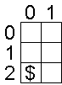

Here is a summary of MyBoundedGrid<E>'s constructor and methods.

MyBoundedGrid<E> class

public MyBoundedGrid<E>(int rows, int cols)
public int getNumRows()
public int getNumCols()
public boolean isValid(Location loc)
public E put(Location loc, E obj)
public E remove(Location loc)
public E get(Location loc)
public ArrayList<Location> getOccupiedLocations()

In this lab, we'll use a 2-dimensional array of Objects to represent the grid. Your MyBoundedGrid<E> class therefore has only a single instance variable. (Don't add any others!)

private Object[][] occupantArray;

The following instance diagram shows the result of executing the code segment shown earlier.

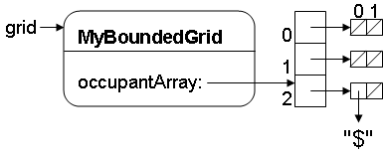

Exercise 1: Growing a Grid

Go ahead and complete the MyBoundedGrid<E> class you downloaded. You may test your work if you like, or wait to use the automated tester at the end of the lab.

Background: The Block Class

The first kind of thing we'll place in our grid is a colored Block—an object which keeps track of its color, location, and the MyBoundedGrid<Block> that contains it. When the Block is not in a grid, its grid and location instance variables are both null. When the Block is in a grid, its location instance variable must match the Block's location within the MyBoundedGrid associated with its grid instance variable. This means that both the Block and its grid are keeping track of the Block's location. It's up to the Block class to keep these consistent.

The following example shows how to place a Block in a MyBoundedGrid<Block>.

MyBoundedGrid<Block> grid;
grid = new MyBoundedGrid<Block>(3, 2);
Block block = new Block();
block.putSelfInGrid(grid, new Location(2, 0));

The following instance diagram shows the result of executing this code.

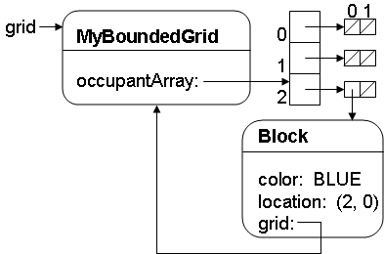
Here is a summary of the Block class.

Block Class

public Block()
public Color getColor()
public void setColor(Color newColor)
public MyBoundedGrid<Block> getGrid()
public Location getLocation()
public void putSelfInGrid(MyBoundedGrid<Block> gr, Location loc)
public void removeSelfFromGrid()
public void moveTo(Location newLocation)
public String toString()

Exercise 2: Coder's Block

Go ahead and complete the Block class you downloaded. You may test your work if you like, or wait to use the automated tester in the next exercise.

Exercise 3: Monster Test

Now that you've completed the MyBoundedGrid<E> and Block classes, it's time to see if you have what it takes to beat the dreaded GridMonster!

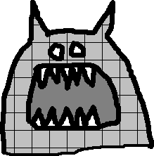

Go ahead and run the GridMonster class you downloaded. Your code must pass each of the GridMonster's tests in order to complete the lab. But beware! The GridMonster has a nasty habit of insulting any code that displeases him (or her). Good luck!

