**Kelp Canopy Fish Stomach Processing, Dissection, and Content Analysis**

*Oxyjulis californica* - senoritas

*Paralabrax clathratus -* kelp bass

*Sebastes atrovirens -* kelp rockfish

**Processing**

Materials: Mesh bags, dissection tools (scalpel, scissors, tongs) , ruler, fish scale, gloves.

1. Prepare the following:

* Aluminium bags for isotope samples labeled with fish ID# and date collected
* Waterproof paper tags with fish ID#
* Empty nalgene labeled with date and site
* Prepared 10% formalin

2. Take measurements

* Weigh the fish in grams
* Take a total length of the fish from mouth to end of caudal fin
* Take the standard length from the mouth to where caudal fin meets the end of the fish.

3. Isotope sample

**NOTE: Isotope samples are prone to contamination. Be sure to clean each tool and tray between fish.**

* Remove a 1 inch square of muscle from the highlighted area shown below.
* Remove the attached skin and scales as they should not be included in the aluminum bag with the sample.
* Place the bit of muscle in an aluminium bag with proper fish ID number, and store in a labeled ziplock bag in the freezer.

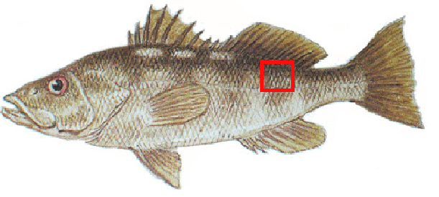

Figure 1.

4. Removal of Stomach  
  
- Place half of the scissors in the anus of the fish and cut along the belly of the fish, staying close to the skin in order to avoid puncturing the stomach. If the stomach is punctured, make sure to record in the note section of the data set.

- Cut all the way up through the bony section between the pectoral fins. Splay the fish to reveal the insides.

- Puncture the air bladder to make more room in the internal cavity. **Now is a good time to sex the fish.** Look for the gonad near the anus.This can be a difficult task to do as it looks different in some of the species and is very small, especially in the Oxyjulis.

- Cut out the entire digestive system from the esophagus to the anus including liver and intestines.

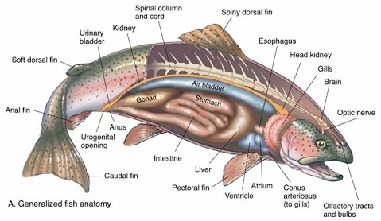

5.Bag and Tag and Put in formalin  
Place the stomach inside a mesh bag with the proper waterproof tag with the fish ID written in pencil. Cover the bag with the 10% formalin inside a nalgene bottle in the fume hood.

7. Repeat steps 2-5 with each fish be sure to make notes of any punctured stomachs.

6. Enter data both in dissection and collection tabs of the Fish Guts data sheet.