Live Coding Quiz 2 Master

SY

10 March 2022

# Overview

Question 1: Import data and show first six lines. Code is already written. This tests a student’s data management practices/understanding of troubleshooting.

Question 2: Summary statistics for central tendency and variation

Question 3: Troubleshoot an error for a data summary table

Question 4: Complete the steps for a graph

Question 5: Render to word doc (DOCX)

Three versions (A, B, C):

* A. 11:35 and 11:50 time slots
* B. 12:05 and 12:20 time slots
* C. 12:35 time slot

Some options for alternatives that are correct are marked as comments; not exhaustive.

# Task 1: Import data set and show first 6 lines of data frame

(1 point)

# A Task 2: What is the mode of Litter_fate?

(1 point)

# option 1  
tab <- table(cheetah$Litter_fate)   
tab # not required

##   
## all_survived none_survived some_survived   
## 19 61 39

names(tab)[which(tab==max(tab))]

## [1] "none_survived"

# option 2  
mode = function(x){   
 ta = table(x)  
 tam = max(ta)  
 if (all(ta == tam))  
 mod = NA  
 else  
 if(is.numeric(x))  
 mod = as.numeric(names(ta)[ta == tam])  
 else  
 mod = names(ta)[ta == tam]  
 return(mod)  
}  
  
mode(cheetah$Litter_fate)

## [1] "none_survived"

# A Task 3: Troubleshoot this error.

(1 point)

The goal is to get the prey density median values of the different Litter_fate possibilities

#preytable <- tapply(cheetah$Litter_fate, cheetah$Prey, median)  
preytable <- tapply(cheetah$Prey, cheetah$Litter_fate, median)  
preytable

## all_survived none_survived some_survived   
## 38.46241 39.55399 37.40635

# A Task 4: Complete the graph

(1 point)

The goal is to have a barplot of the median prey density (Prey, individuals/km2) on the y-axis and Litter_fate on the x-axis. Make sure the graph has all of the proper elements of a scientific graph.

bar <- barplot(preytable, ylab = "Median Prey Density", xlab = "Litter Fate", main = "How Prey Denisty affects Litter Fate", ylim = c(0, 50), col = c("pink","yellow", "orange")) # needs labels, title; optional: adjusting ylim and colors

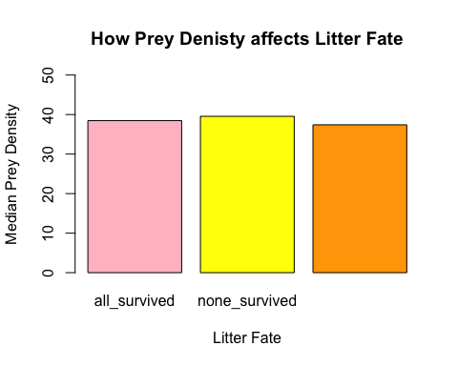 ***

# B Task 2: What is the range of Lion?

(1 point)

# option 1  
max(cheetah$Lion) - min(cheetah$Lion)

## [1] 0.0730057

# option 2  
diff(range(cheetah$Lion))

## [1] 0.0730057

# B Task 3: Troubleshoot this error.

(1 point)

The goal is to find out the total number of cheetah cubs that survived in each litter (40 litters)

# Ltable <- table(cheetah$Survive[cheetah$Litter_ID])  
Ltable <- tapply(cheetah$Survive, cheetah$Litter_ID, sum)   
  
Ltable

## 1 2 3 4 5 6 7 8 9 10 11 12 13 14 15 16 17 18 19 20 21 22 23 24 25 26   
## 0 3 0 1 0 2 0 3 2 2 0 0 1 0 0 0 0 0 0 0 0 2 0 0 0 0   
## 27 28 29 30 31 32 33 34 35 36 37 38 39 40   
## 3 2 2 1 4 2 3 3 1 0 0 0 2 0

# B Task 4: Complete the graph

(1 point)

The goal is to have an XY scatterplot of the prey densities (individuals per km2) on the y-axis and density of lions (individuals per km2) on the x-axis, with the those that survived in transparent blue and those who did not survive in transparent black. Make sure the graph has all of the proper elements of a scientific graph.

plot(cheetah$Lion[cheetah$Survive==1],  
 cheetah$Prey[cheetah$Survive==1],  
 pch = 19,  
 col = adjustcolor("blue", alpha = 0.5),  
 xlab= "Lion Density",  
 ylab= "Prey Density",  
 main= ""  
 ) # needs labels, title  
points(cheetah$Lion[cheetah$Survive==0],cheetah$Prey[cheetah$Survive==0], pch = 19, col = adjustcolor("black", alpha = 0.5))  
legend("bottomleft", c("survived", "did not survive"),   
 pch = 19,   
 col = c("blue", "black"),   
 bty = "n")

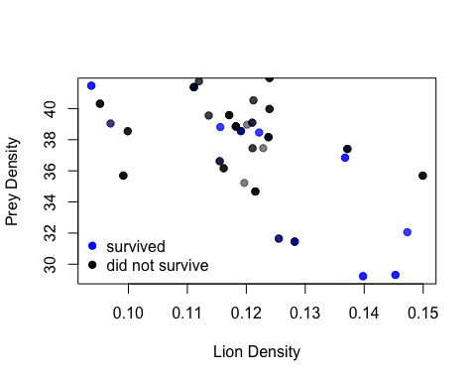 ***

# C Task 2: What is the skewness of Cheetah (individuals per km2)? Interpret.

(1 point)

#install.packages("e1071")  
library(e1071)  
skewness(cheetah$Cheetah)

## [1] 0.473923

Positive value, right skew

# C Task 3: Troubleshoot this error.

(1 point)

The goal is to make a summary table of the mean Cheetah (individuals per km2) for each Litter_fate

#CHtable <- aggregate(cheetah$Litter_fate, cheetah$Cheetah, mean)  
CHtable <- aggregate(cheetah$Cheetah, list(cheetah$Litter_fate), mean)  
names(CHtable) <- c("Litter_fate", "Cheetah_density")  
CHtable

## Litter_fate Cheetah_density  
## 1 all_survived 0.1260197  
## 2 none_survived 0.1463013  
## 3 some_survived 0.0967238

# C Task 4: Complete the graph

(1 point)

The goal is to have an XY scatterplot of Cheetah (cheetah density; individuals per km2) on the y-axis and Lion (lion density; individuals per km2) on the x-axis. Make sure the graph has all of the proper elements of a scientific graph.

plot(cheetah$Lion, cheetah$Cheetah,   
 pch = 19,  
 xlab= "Lion Density (individuals/km2)",  
 ylab= "Cheetah Density (individuals/km2",  
 main= "Effect of Predator Density on Prey Density"  
 ) # needs labels, title

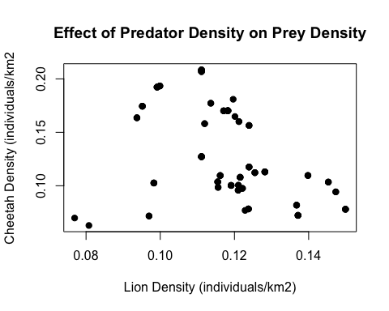

# Task 5

(1 point)

Knit this RMD to DOCX, and upload (1) Revised RMD and (2) DOCX to Canvas in the Quiz 2 assignment in the next five minutes.

If you are unable to render your Rmd file into a DOCX because of a problem in a particular code chunk, you may use {r eval = FALSE} instead of {r} for that code chunk. This should skip the chunks with the errors.