Student Tax Help Site Plan

Jayden Anderson

WDD 130

Overview

Purpose

To help explain the tax filing process, including necessary documents and available filing methods.

Audience
BYU-Idaho Students

Branding

Website Logo
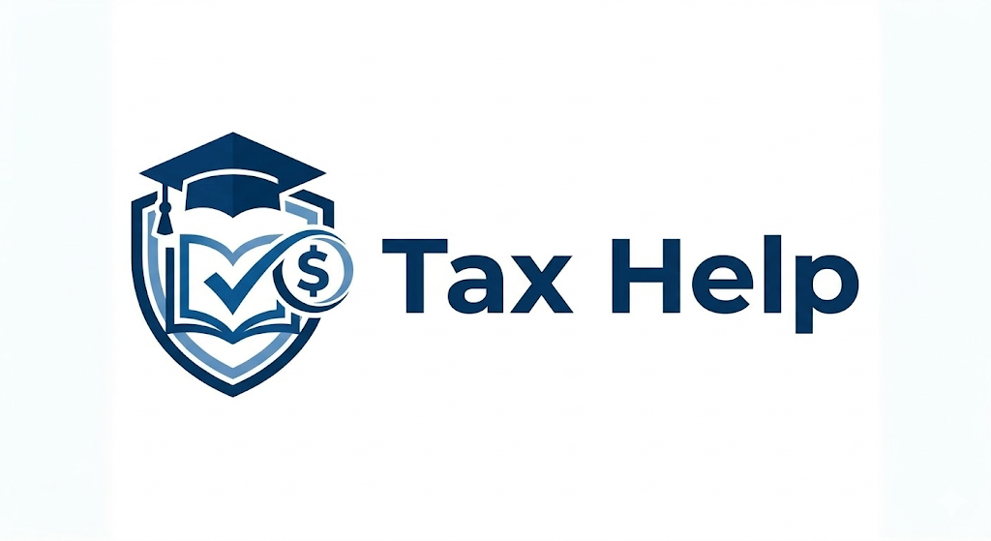

Style Guide

Color Palette
Primary | Secondary | Accent 1 | Accent 2
#6F97B7 | #2E4E6B | #DBE5EA | #0C3458
steel-blue: #6F97B7
yale-blue: #2E4E6B
alice-blue: #DBE5EA
deep-space-blue: #0C3458

Typography

Heading Font: Gelasio / Generic Serif Font

Paragraph Font: Open Sans / Generic Sans Serif Font

Navigation
Home Filing Decisions Documents & Resources

Content
Home Page:

BYU-I Tax Help: Taxes Simplified for Students
Filing taxes can feel like navigating a Rexburg roundabout for the first time—confusing and slightly stressful. Whether you are a freshman with your first part-time job or a senior prepping for graduation, this site is designed to help you understand the basics of filing without the headache.

Should I File My Taxes?
The most common question students ask is: "Do I even have to do this?" Generally, you should file if any of the following apply to you:
- You earned more than $14,600: For the 2025 tax year, if your gross income exceeded this amount, the IRS requires you to file a return.
- You want your money back: Even if you made less than the threshold, you should file if your employer withheld federal income tax from your paychecks. Filing is the only way to get that refund.
- You qualify for credits: Many students qualify for the American Opportunity Tax Credit (AOTC), which can reduce your tax bill or even put money back in your pocket just for being a student.

Important Dates to Remember
Don't let the deadline sneak up on you between midterms and finals.
- Tax Season Opens: Late January 2026
- The Big Deadline: Tuesday, April 15, 2026
  - Note: This is the final day to submit your federal and Idaho state returns without a penalty.

How This Site Works
We’ve broken the process down into two simple steps to help you get through tax season as quickly as possible:
Step 1: Gather Your Documents
Before you start, you need the right paperwork. Check our list of common forms like the W-2 and the 1098-T so you aren't searching for them at the last minute.
Step 2: Choose a Filing Resource
You don't have to do this alone. We’ve compiled a list of free and paid services—including local Rexburg resources—to help you file your return accurately.

Quick Tip: If your parents still claim you as a dependent on their taxes, make sure to check the "Someone can claim me as a dependent" box on your own forms. It’s a small detail that makes a big difference!

Document Page:

Your Tax Season Checklist: Documents You’ll Need
Before you sit down to file, you’ll want to have all your paperwork in one place. Most of these forms are mailed to you or made available in your online portals by the end of January or early February. Having these ready will make the filing process much faster and ensure you don’t miss out on any potential refunds.

1. Personal Information
- Social Security Number (SSN) or ITIN: You will need this for yourself and your spouse (if filing jointly).
- Government-Issued ID: A driver’s license or state ID to verify your identity.
- Bank Account & Routing Numbers: If you are expecting a refund, having your bank info ready allows the IRS to deposit your money directly into your account—much faster than a paper check.

2. Education-Related Documents
- Form 1098-T (Tuition Statement): This is the most important form for a BYU-I student. It shows how much tuition you paid and is used to claim the American Opportunity Tax Credit.
  - Where to find it: Log into your BYU-I account and search for "Student Tax Information" or check the "Financial Services" section.
- Form 1098-E (Student Loan Interest): If you are currently paying back student loans, this form shows the interest you paid, which may be tax-deductible.
- Receipts for Required Materials: Keep records of what you spent on required textbooks, software, or lab equipment, as these are often "qualified expenses" for tax credits.

3. Income Documents
- Form W-2 (Wage and Tax Statement): You’ll get one of these from every employer you had during the year. It shows your total earnings and the taxes already taken out of your paycheck.
- Form 1099-NEC (Gig Work/Freelancing): If you did side work (like DoorDash, tutoring, or freelance design) and earned over $600, you should receive this form.
- Form 1099-INT (Interest Income): If you have a savings account that earned a significant amount of interest, your bank will provide this.
- Form 1099-B (Stocks or Crypto): If you sold any stocks or cryptocurrency during the year, you will need this statement from your brokerage (like Robinhood or Coinbase).

4. Health & Other Forms
- Form 1095-A: If you or your family used the Health Insurance Marketplace (rather than a plan through an employer or the school), you will need this to report your coverage.
- Form 1042-S (International Students): If you are an international student who received a scholarship that exceeded your tuition costs, BYU-I will issue this form, usually by mid-March.

Check your portals! Many students forget that they won't get a paper copy of their 1098-T in the mail. Be sure to check your BYU-I student account electronically to download your forms as soon as they are available.

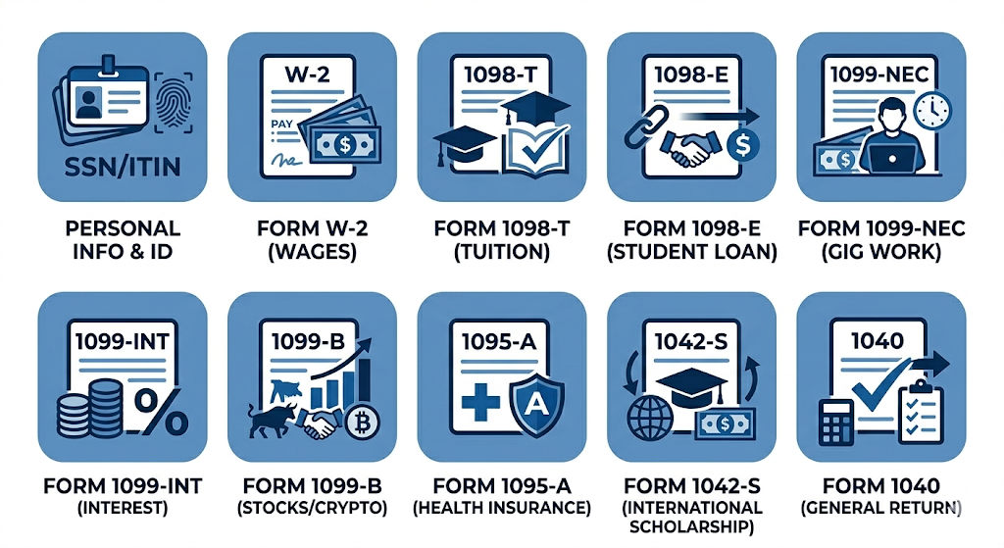
Images will need to be separated into their own individual icons

Resources Page:

Filing Resources: Where to Get Help
You don’t have to be a tax expert to file a successful return. Depending on how much you earned and how complex your finances are, there are several tools available to help you. We’ve broken these down into Free Resources (best for most students) and Paid Resources (best for those with unique financial situations).

Free Resources
Most BYU-I students will qualify for at least one of these free options.
BYU-I Volunteer Tax Review Center
- What it is: A service provided by the BYU-Idaho Department of Accounting where student volunteers (accounting majors) review your prepared return for accuracy.
- The Perk: They often provide a special code to file your Idaho State return for free if you use their partner software.
- Who should use it: Any student who wants a second pair of eyes on their return before they hit "submit."
- Where: Located in the Smith Building (SMI), typically open from late January through March.
IRS Free File
- What it is: A partnership between the IRS and brand-name tax software providers. If your income is below a certain limit (usually $79,000–$89,000), you can use their full-featured software for $0.
- Who should use it: Students with a standard income who want a guided, step-by-step digital experience without the price tag of commercial software.
FreeTaxUSA
- What it is: A highly-rated tax website that offers free federal filing for almost everyone, regardless of complexity.
- Who should use it: Students who have slightly more complex situations (like a small side business or stock sales) but still don't want to pay for the "premium" tiers of bigger brands.

Paid Resources
While these charge a fee, they often offer more robust support and specialized tools.
TurboTax or H&R Block (Paid Tiers)
- What it is: The most popular tax software platforms. They are very user-friendly and can import your W-2 data automatically from many large employers.
- The Cost: Usually ranges from $60 to $120+ depending on the complexity of your forms.
- Who should use it: Students who value extreme convenience, have multiple high-value investments, or own a complex business and want "Audit Defense" or live expert chat support.
Local Rexburg CPA (Certified Public Accountant)
- What it is: A professional tax preparer who does the work for you from start to finish.
- The Cost: Typically the most expensive option, often starting at $150–$300+.
- Who should use it: Students who are married with complicated business holdings, own rental properties, or have complex multi-state filing requirements that software might struggle with.

Note on State Taxes: Idaho requires its own tax return. While federal filing is often free, many commercial sites charge a separate fee (around $40–$60) for the state return. Always check if the BYU-I Tax Review Center has a discount code before you pay!

Wireframes

Top Left: Home

Bottom Left: Documents

Top Right: Resources
