Report concepts based on case study needs

* Create a month-to-month report of delivery times to see where there are gaps
* Create a sales report to see which wine is selling the most
* Create a timesheet report that totals number of hours each employee worked

Report #1

The purpose of this report is to gather all of the data for delivery times and see how frequently the deliveries deviated from the expected time and average the total amount of time month-to-month to check for problem areas or an overall issue with the supplier’s performance.

*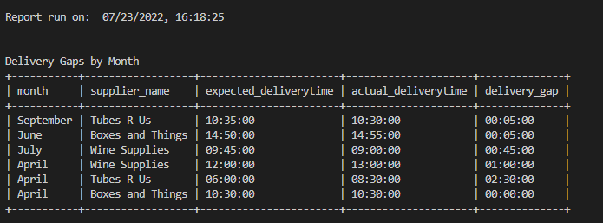*

The Results from Report #1 was that Tubes R Us was the supplier who was late the most in April by 2 and a half hours. As far as best delivery record goes to Boxes and Things, they were late by 5 minutes in June and the only supplier to deliver on time in April.

Report #2

This report observes which wine is selling the most based on sales records kept for each individual wine. Each of the wine’s records will be compared to the others to see which wine is the most popular and which distributor carries it.

*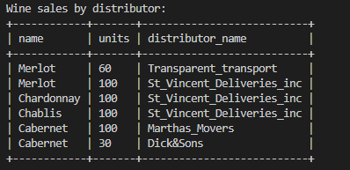*

The results for the wine sales were that the Merlot sold the most units, followed by the Cabernet, and then Chardonnay and Chablis which sold the same amount of units. These results show that while there is a clear preference for the Merlot, there is not one wine that sticks out as performing poorly compared to the rest. However, both of the lowest performing wines are being handled by the same distributor, which may be important to note moving forward.

Report #3

In order to determine how many hours each employee has worked within each quarter, this report will generate a table of employee records that has kept track of the hours clocked. Therefore, the employers may see if the work has been unequally shared amongst their employees.

*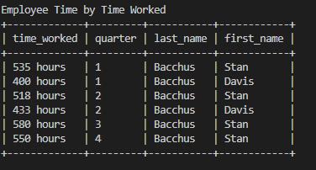*

The results for the time each employee worked was that Davis worked for far less time than Stan had. In order to even the spread of hours Davis will need to take over some of the hours Stan typically works. This will provide better time worked equality among staff.

Github link:   
https://github.com/juliadelightly/csd-310.git