Julia Delightly

Professor Sampson

CSD340

14 August 2022

Assignment 1.2: GitHub Repository Setup

**GitHub Repository Link**

<https://github.com/juliadelightly/csd-340.git>

**GitHub Repository Screenshot**

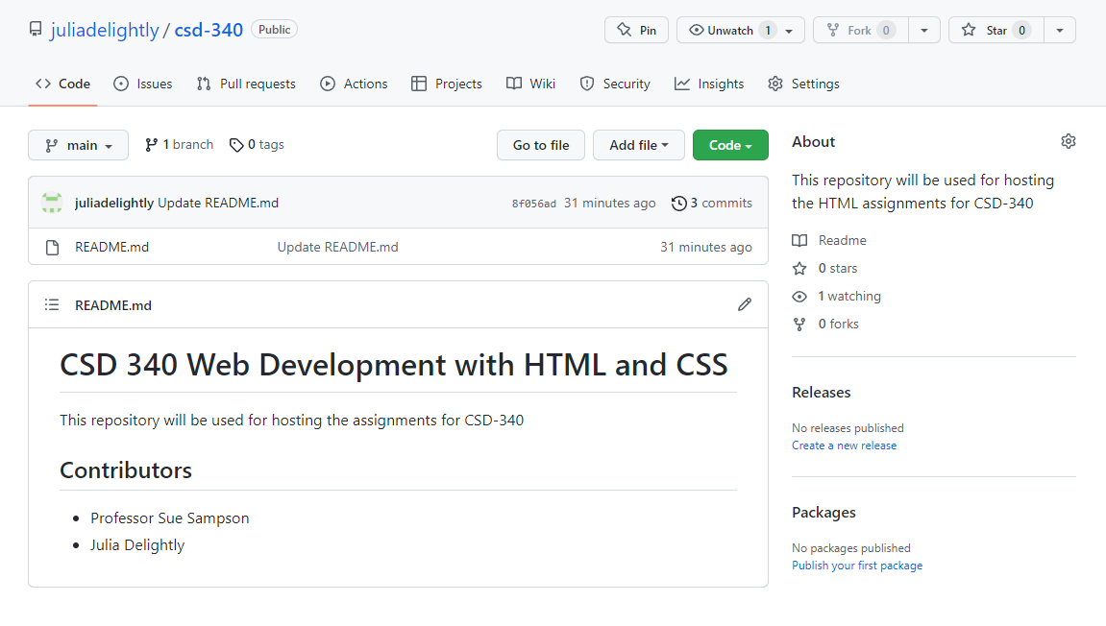

**Local Directory Screenshot**

