Julia Delightly

Professor Sampson

CSD340

14 August 2022

Assignment 2.2: Building a Web Page Exercise, Part 1

**GitHub Repository Link**

<https://github.com/juliadelightly/csd-340.git>

**Validator Results**

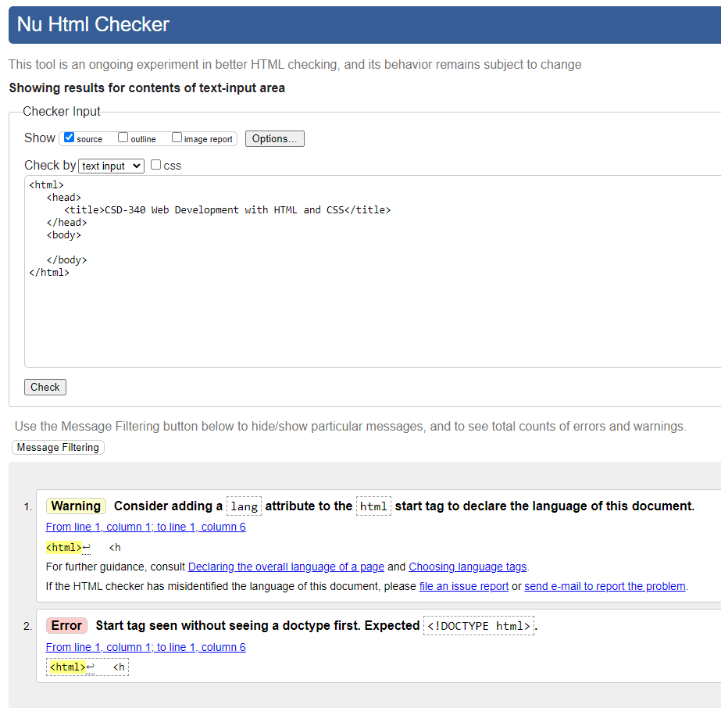

**Validator Results After Fixing Errors**

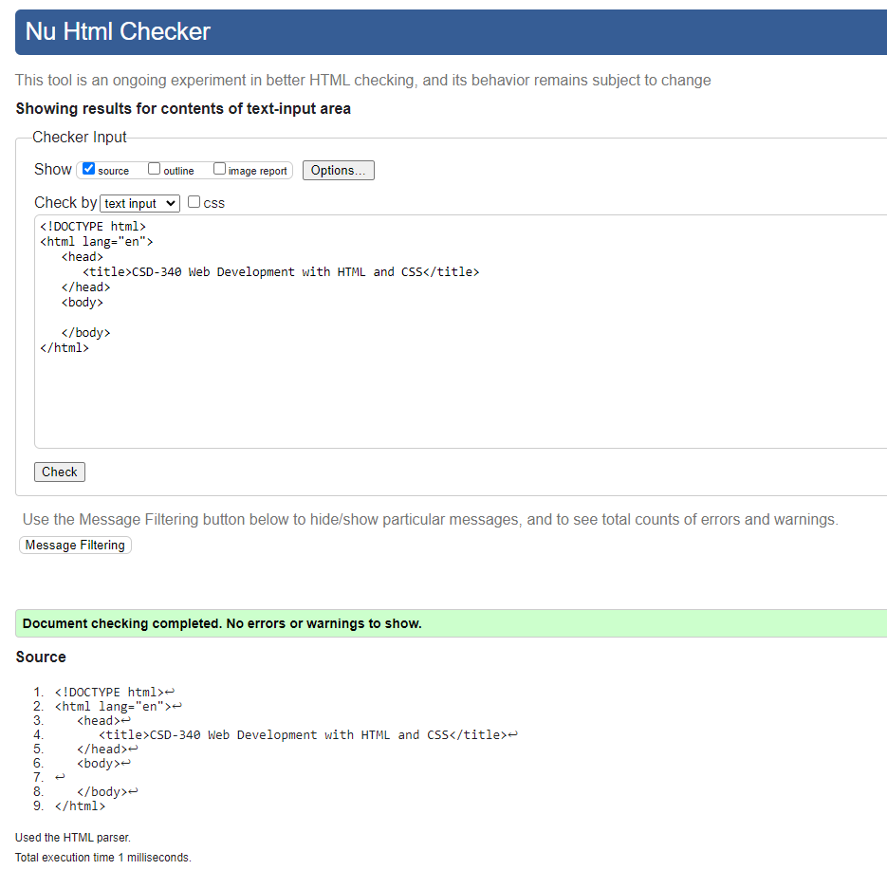

**Validator Results After Adding Heading**

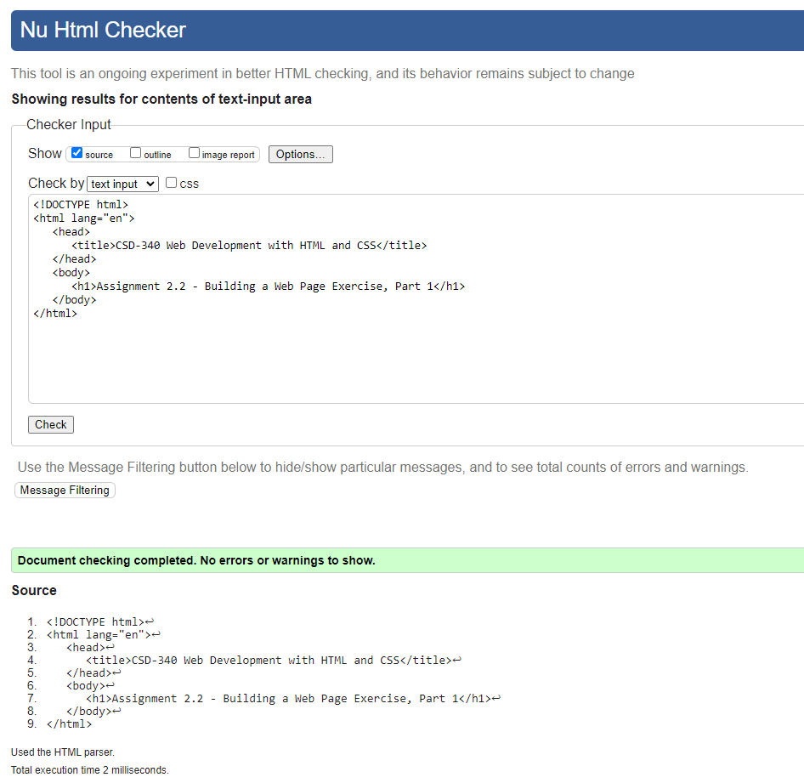

**Webpage Output**

