Julia Delightly

Professor Sampson

CSD340

28 August 2022

Assignment 4.2: GitHub Pages

**GitHub Repository Link**

<https://github.com/juliadelightly/csd-340.git>

**GitHub Landing Page Link**

[**https://juliadelightly.github.io/csd-340/**](https://juliadelightly.github.io/csd-340/)

**HTML Validator Results**

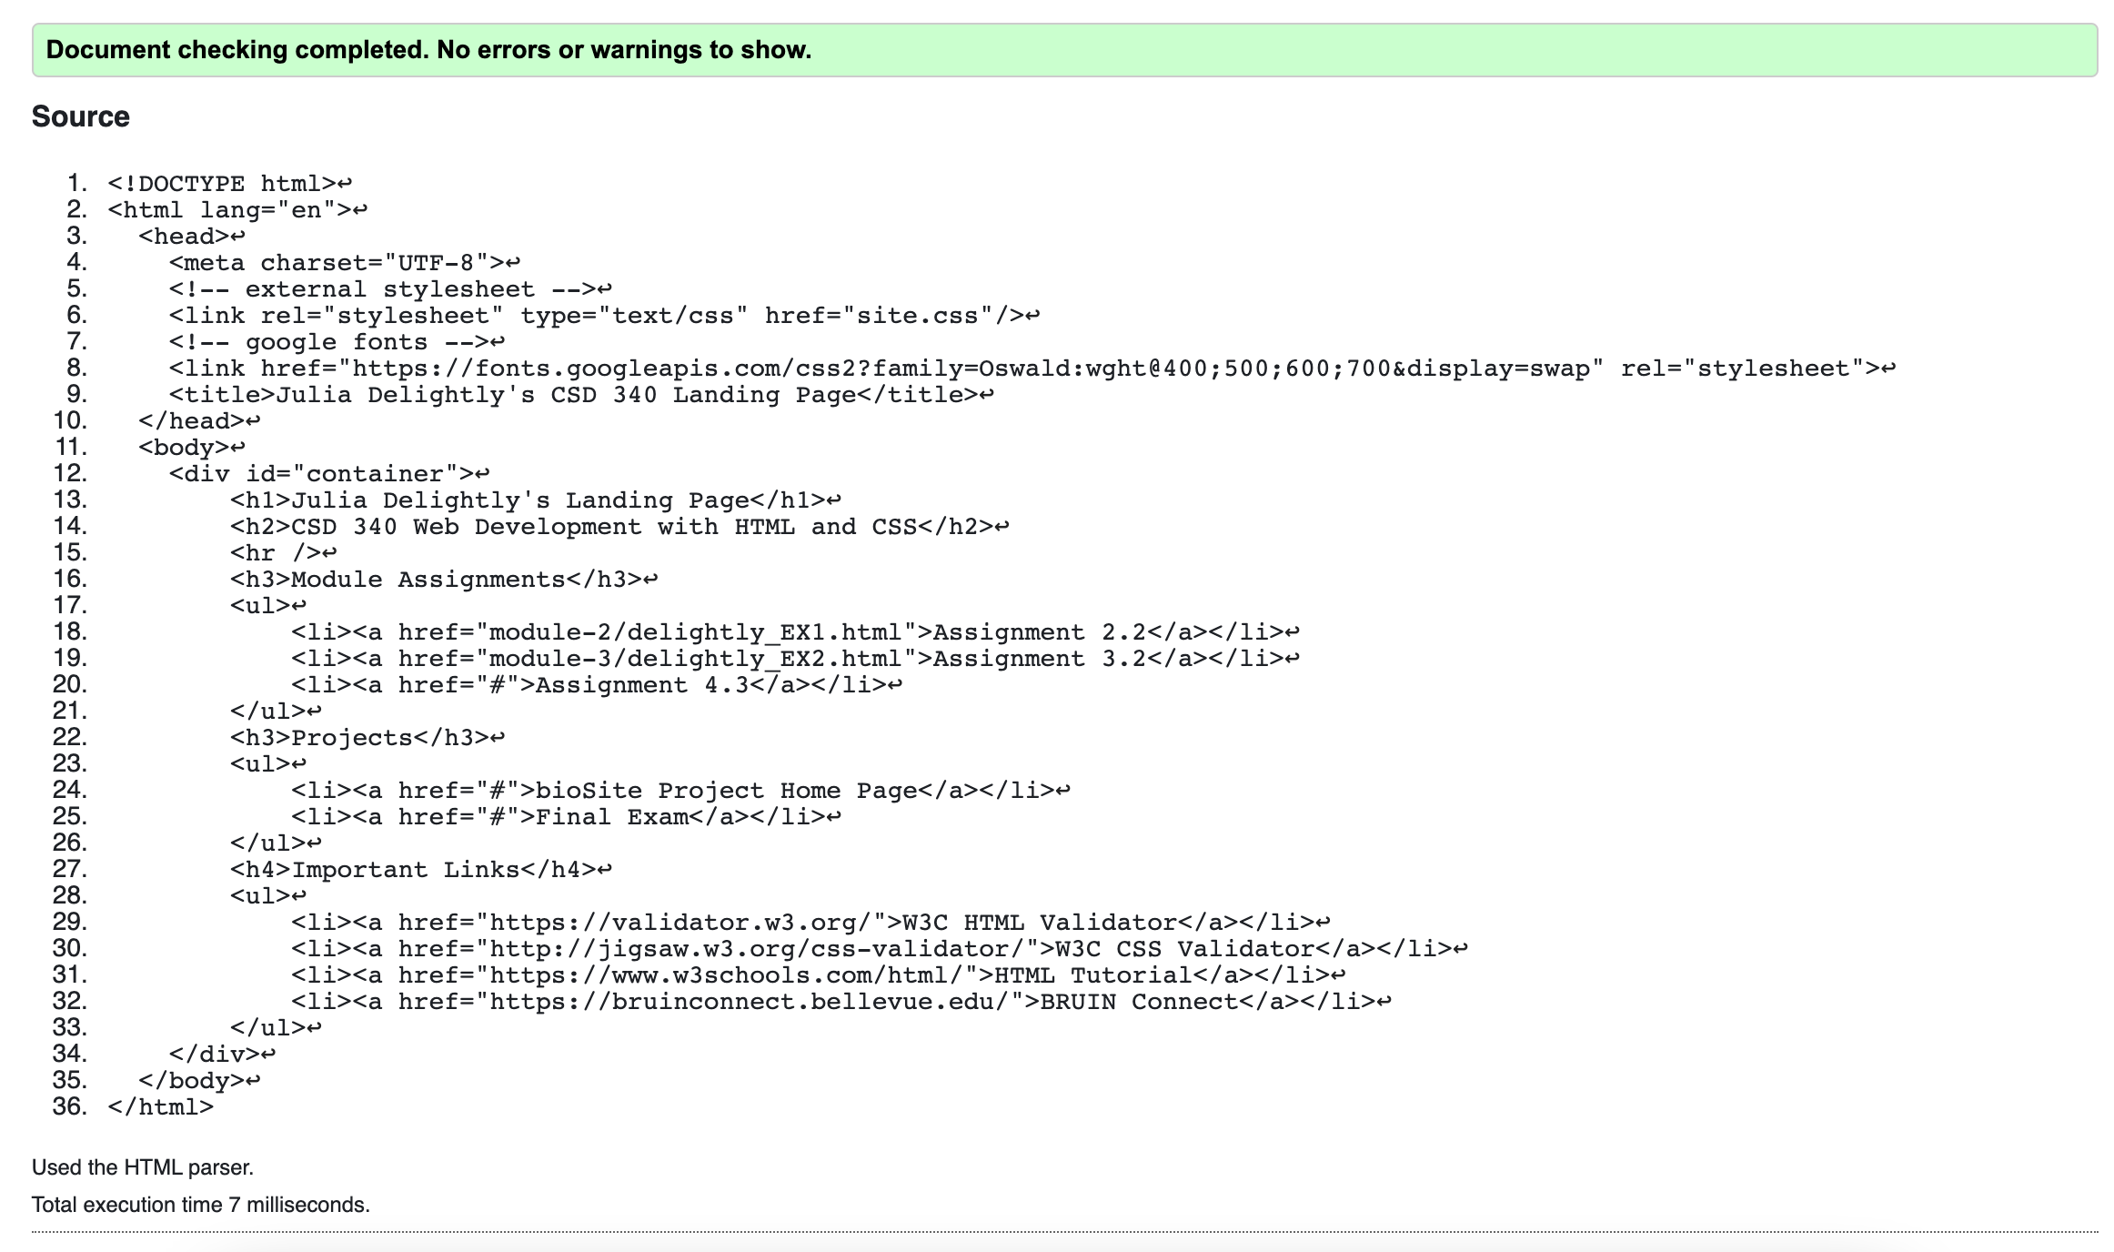

**CSS Validator Results**

