**This set of problems should be attempted during the first lab session.**

**The marked components are highlighted with * and should be submitted by 15/11.**

**In general always write your name and date of creation as comments in the files and try to be “user friendly” when you write the code:**

* **Add comments on the code to remember yourself and the other what the code does**
* **Manage the possible errors in the input given by the user**

1. Create the program HelloWorld, compile it and run it
2. In the same program, define two variables, x and y, and assign them the values x=2.3 and y=4.5. Assuming these are x and y components of a 2-D vector, compute the magnitude of the vector and have your program print the answer to the screen.
   * *Learn: Data types, creating and assigning variables, cout.*
3. Extend the same program by creating a function to calculate the magnitude of the vector which takes as input the x and y components. Think about the return type you would like your function to have. Use this function to calculate the magnitude of the vector in part 1 and make sure the answer which is printed out is the same. Test for different values of x and y, including negative values
   * *Learn how to create a function*
4. * Using what was learnt in the first part of this problem set, **write a new program** to read the first 5 lines in file input2D_float.txt and for each line print the value from the first column (x value) and second column (y value) and the magnitude of the vector.
   * Ask the user to insert the number of lines that he wants to read by the file and retrieve the answer with cin. If the user provides 0 or a number larger than the number of lines (100) just read 20 lines. Pass the number of lines to read as an argument to the function.
   * *Learn how to read from a file*
5. * Now assume that the coordinates provided in the previous file are points of a graph (x,y) and are the results of an experiment. We are interested in knowing if the relation between the points is linear or not, so if it follows the relation y=px+q. 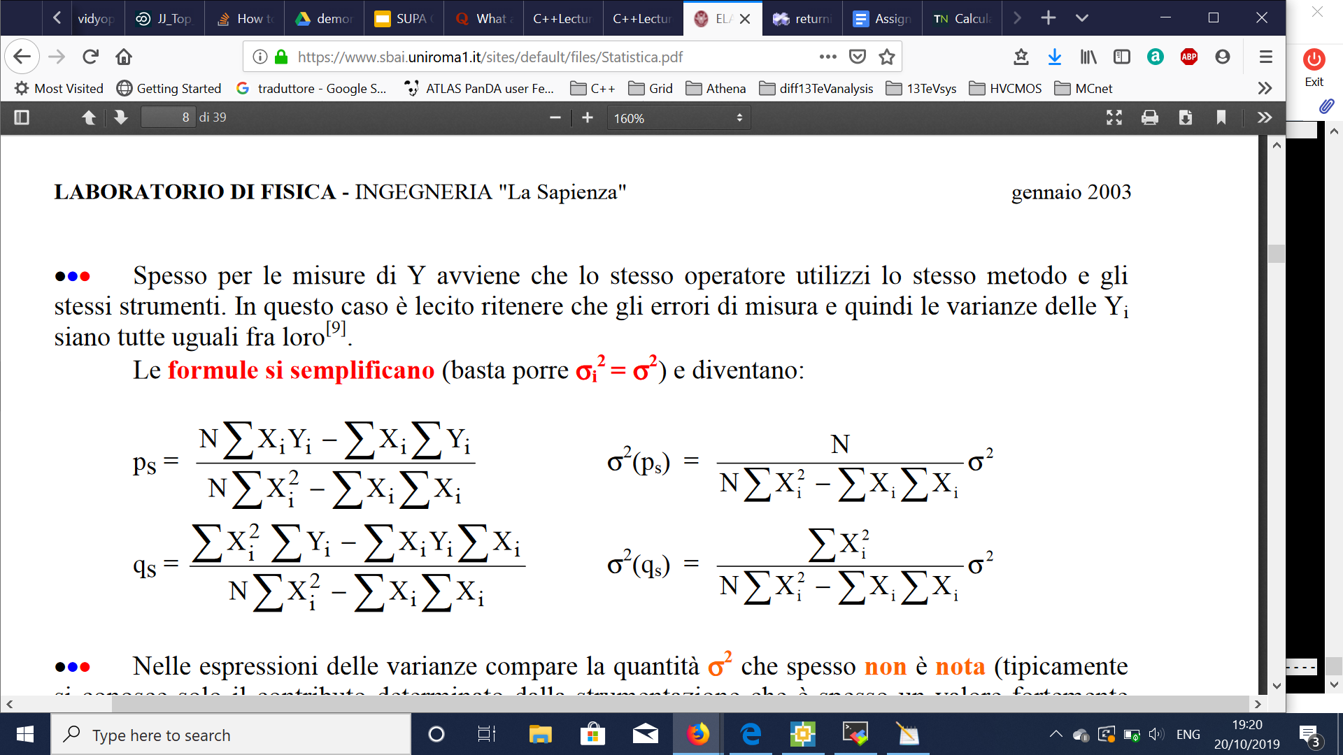
   * Code a function that takes the values from the file, calculates p and q with the least square method (use the formulas given here) and prints on the terminal the equation of the line.
   * Assuming that the error on every point is a flat 0.5 can you estimate the chi-square/(number of points) between the data and the line we derived and return it together with the line equation?
6. * Now use the functions created in line 4 and 5 and declare them in a file called **CustomFunctions.h**, with the implementation in the file **CustomFunctions.cxx**. Then write a code that based on an int given by the user decides which function to use to elaborate the data in the input file input2D_float.txt
   * *Learn how to use header files and structure a code that calls multiple functions, learn how to take input from the terminal*

**Your submission should be a single executable for Q6 which uses the work done in Q4 and Q5 to construct the required functions.**