ASSIGNMENT ON

Advanced Software Engineering

# SOFTWARE REQUIREMENTS SPECIFICATION DOCUMENT

**HAND SIGN LANGUAGE RECOGNITION SYSTEM**

#### Submitted by,

**Julia George**

**Roll No - 4**

**Submitted to,**

**Anit Miss**

**TABLE OF CONTENTS**

1. **Introduction**
   1. Project Description
   2. Existing System
   3. Objectives
   4. Purpose, Scope and Applicability
      1. Purpose
      2. Scope
      3. Applicability
   5. Overview of the Report

#### System Analysis and Requirements

* 1. Problem Definition
  2. Requirements Specification
  3. Block Diagram
  4. System Requirements
     1. User Characteristics
     2. Software and Hardware Requirements
        1. Software requirements
        2. Hardware requirements
     3. Constraints
  5. Conceptual Models
     1. Data Flow Diagram
     2. ER Diagram

#### System Design

* 1. System Architecture
  2. Module Design
  3. Database Design
     1. Tables and Relationships
     2. Data Integrity and Constraints
  4. System Configuration (optional)
  5. Interface Design and Procedural Design
     1. User Interface Design
     2. Application Flow/Class Diagram
  6. Reports Design

#### References

1. **Introduction**

Image processing has many interesting applications ranging from industrial applications to social applications. It has also been applied in many support for physically challenged people. For deaf-mute people, computer vision can generate English alphabets based on the sign language symbols. It can recognize the hand symbols and predict the correct corresponding alphabet through sign language classification.

The project Hand sign recognition system is a method of interpreting human gestures using various inputs and giving output in the form of a common language such as English. This application is aimed to support the specially-abled people to communicate with others easily by interpreting their sign language to the human-understandable language. This project is aimed to create a mobile application detecting the hand signs shown by specially-abled people.

* 1. **Project Description**

The project Hand Sign Recognition System creates a mobile application that can be used to identify sign languages from differently-abled people. The application captures the image of the signs used by the specially-abled person and is sent to the machine learning model. The model will identify the letter (or a word from the sequence of images) from the image uploaded. Later the letters are combined to form words and later are converted to speech.

## Existing System

Sign language recognition system is currently available and developed using python on web cameras but there is no dedicated application available on the app store or play store to identify the hand signs that can be used by the people in a user-friendly manner. The limitation of the existing system is that only alphabets are identified and given as output and text to speech is not available as of now.

## Objectives

The main objective of the project is to identify sign language and convert it to text and speech as output, in an application that can be used in cross-platform devices as there is no such application that supports the recognition of hand signs available in play store or app store. Thus the project is aimed at creating an application with Flutter, that gives cross-platform availability for android as well as IOS application and the help of firebase. To support the big community of specially-abled people to easily communicate with others.

## Purpose, Scope and Applicability

### Purpose

Sign languages are the main language for the specially-abled people, the sign language uses different means of signs made with the help of fingers for communication. We propose a mobile application that can be used to consistently classify the letters A-Z of the English language with respect to their hand signs.

There are 3.8 billion smartphone users across the world, a lame man who comes in contact with a person using sign language may not understand what the person is conveying and it would be hard to use laptops during this time. Using the Hand Sign recognition application would be much easier for everyone as the sign is outputted on their smartphone and as a voice.

The project is much refined compared to the existing system as the existing system had usage of webcams. So portability in handheld devices is high as compared to using laptops and speech output is another feature that is unavailable in the existing system. Thus this project is concentrating on creating a mobile application that the specially-abled people could easily handle to identify the hand signs easily and quickly.

### Scope

One million specially-abled people use American Sign Language as their primary language. Many people use their native sign language for the process of communicating. Thus the application has a wide scope for specially-abled people, who are facing difficulty in communicating with others with the help of sign languages and making their life easier. The specially-abled people can easily take the images of the hand signs and upload in the

application for the analysis and to identify the sign and hence the word for easy and quick communication with others. There are a huge number of specially-abled people who are facing the issue of communication with others with sign languages, this application will help them to communicate easily.

### Applicability

The application is created to identify the sign languages that are used for communication by a huge community of specially-abled people. The application is intended to help those people to communicate with other people. The application is easy to use and manage, with the help of images of the hand signs the people can identify the words and letters and this is available in text and audio, which is a great help for the specially-abled people to communicate.

## Overview of the Report

The project is aimed to create an application for the specially-abled people to communicate with other people, with the help of hand signs. the images of the hand signs can be uploaded to the application and the corresponding word or letter is returned to the application. This application can bridge the problem that the specially-abled people face during communication. The application also gives the feature of history search, where the users can look for the previous searches and quickly access the words for effective communication. The project is aimed to be a cross-platform application, which means the IOS users and Android users can use the same application. The application is created to support the specially-abled people in their communication.

# System Analysis and Requirements

The Hand Sign recognition application is having the following requirements. The following section analyses the various features required for the application and understanding the requirements for the problem. The specially-abled people can quickly communicate with other people easily with the help of this application. The various features and functional requirements of the application are discussed in detail in this section along with the detailed description of the application workflow.

## Problem Definition

There is a huge community of specially-abled people who have the difficulty of communicating with other people, with the help of the sign language, which they know. There are many codes that help in identifying the hand signs and those are not in proper for handy use. Through this project aims to create an application for the specially-abled people to translate their sign language to the normal text or speech, with the help of images, and the application can be used in their phones, thereby helping the specially-abled people to make their life easier. The solution must be reliable and quite easy to use.

### Requirements Specification

The main requirement for the application is the easy conversion of the hand sign to the speech and text to help the specially-abled people for better and effective communication. the inputs can be taken as images and the output is in the form of text and speech. There are a huge number of specially-abled people who have issues in communicating with others due to normal people won't understand sign language and there is no proper application in handy to support these people. The application is aimed to be the handy solution for the specially-abled people for better communication with normal people. The application should focus on easy availability and quite applied to most conditions to help differently-abled people for better communication. the application should be available with ease of use and support. the system should be able to be incorporated with all kinds of mobile devices with

faster and optimized performance with maximum reliability. The model created for the prediction of the result should also be adaptable with the mobile devices easily.

### Block Diagram

The following is the block diagram of the application, it describes the main workflow of the application. The application is aimed to take input as an image and give text and voice as output. the entire application workflow is summarized in the block diagrams given below.

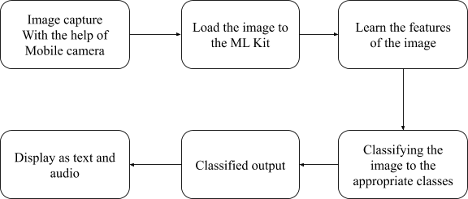

Fig 2.1 Block diagram for analysis

Fig 2.1 shows the block diagram of the application workflow. The application takes the input as images of the hand signs from the specially-abled persons mobile application with the help of the mobile camera. The image is then transferred to the Convolutional neural network model created with the help of TensorFlow and TensorFlow Lite, where the model learns the features from the image and makes a classification of the class of symbol the image represents. then the output is transferred back to the application and displayed and as the corresponding character, the output is then converted into the form of text and audio. The predictions and usage details of the user is stored in the database and made available for the users for quick access for the same word.

## System Requirements

The application system requirements include only a smartphone with internet connectivity. the application should be able to upload the image and obtain the result with low network

latency for effective usage. the user must also be able to use the phone to capture the image and upload it into the application for identifying the character.

### User Characteristics

The specially-abled people who are going to use the application must be able to understand the functionality and working of the application. they have to use the application with at most simple and basic usage knowledge. also the application should be able to help them in their most tough conditions with quick accessibility and ease of use. the application users are expected to know how to handle a smartphone to process some of the basic functions such as capturing the images and understanding the application usage.

### Software and Hardware Requirements

The application is used to create simple and effective software tools and languages. The software and hardware requirements for the development of the application include the following. The application is expected to work in smartphones both Android and IOS phones. The software and hardware requirements for the development of the application are described in detail in the following section

#### Software Requirements

* + - * 1. **Android Studio**

Android Studio is the official integrated development environment (IDE) for Google's Android operating system, built on JetBrains' IntelliJ IDEA software and designed specifically for Android development. It is available for download on Windows, macOS and Linux based operating systems or as a subscription-based service in 2020. It is a replacement for the Eclipse Android Development Tools (ADT) as the primary IDE for native Android application development. Though the Android Studio is specifically designed for developing android applications, the application acts as an editor for the flutter applications and with the support for the dart language by installing the official plugins. and the application helps to run the application created in the android virtual machines installed for android application development.

#### Firebase

Firebase is Google's mobile platform that helps you quickly develop high-quality apps. The main functionality of the firebase includes things like analytics, authentication, databases, configuration, file storage, push messaging, and the list goes on. The services are hosted in the cloud and scale with little to no effort on the part of the developer. The firebase helps easily implement the different account signups easily, and it serves as an easy to create a database for any application. it supports different sets of data, either text or images easily and available for all time. the application can easily store the basic details in the database and retrieve them quickly in no time.

#### GitHub

GitHub provides hosting for software development version control using Git. It offers the distributed version control and source code management (SCM) functionality of Git, plus its own features. It provides access control and several collaboration features such as bug tracking, feature requests, task management, and wikis for every project. GitHub is a Git repository hosting service, but it adds many of its own features. While Git is a command-line tool, GitHub provides a Web-based graphical interface. It also provides access control and several collaboration features, such as wikis and basic task management tools for every project. This platform effectively allows the developers to code together and integrate their code into one. This platform is a version control system that is famous and quickly and effectively dependent to develop the application

#### Flutter

Flutter is Google’s UI toolkit for building beautiful, natively compiled applications for mobile, web, and desktop from a single codebase. Flutter is an app SDK for building high-performance, high-fidelity apps for iOS, Android, web, and desktop from a single codebase. The goal is to enable developers to deliver high-performance apps that feel natural on different platforms. This toolkit helps developers to create the applications as quickly as possible with good UI, it allows developers to create the expressive and flexible UI for the applications. The tool helps developers in creating applications that work well with the native languages and codes. Flutter is an app SDK for building high-performance, high-fidelity apps

for iOS, Android, web, and desktop from a single codebase. The goal is to enable developers to deliver high-performance apps that feel natural on different platforms. The applications created using flutter are supported by material design concepts by google.

#### Dart

Dart is a client-optimized programming language for apps on multiple platforms. It is developed by Google and is used to build mobile, desktop, server, and web applications. Dart is an object-oriented, class-based, garbage-collected language with C-style syntax. Dart can compile to either native code or JavaScript. Dart is the programming language used to code Flutter apps. Dart is another product by Google and released version 2.1, before Flutter, in November. Dart looks a bit like C and is an object-oriented programming language. Dart language helps the developers to create applications that are optimized for UI, Develop with a programming language specialized around the needs of user interface creation. The language is supporting more productive development. Make changes iteratively: use hot reload to see the result instantly in your running app. and the applications that are Fast on all platforms, by Compile]ing to machine code for mobile, desktop, and backend. or compile to JavaScript for the web

#### Tensorflow lite

TensorFlow Lite is an open-source deep learning framework to run TensorFlow models on-device. TensorFlow Lite is a set of tools to help developers run TensorFlow models on mobile, embedded, and IoT devices. The TensorFlow Lite interpreter, which runs specially optimized models on much different hardware. TensorFlow Lite is a lightweight and the next step from TensorFlow Mobile. Tensorflow lite is focused on mobile and embedded device developers, so that they can make next level apps on systems like Android, iOS, Raspberry PI etc. It enables on-device machine learning inference with low latency and small binary size. Tensorflow lite is used to create the machine learning Convolutional neural network model for the prediction of the hand signs. The model created by TensorFlow lite can be incorporated with the firebase ML kit.

#### Firebase ML Kit

Firebase ML Kit is a mobile SDK that brings Google's machine learning expertise to Android and iOS apps in a powerful yet easy-to-use package. Whether you're new or experienced in machine learning, you can implement the functionality you need in just a few lines of code. There's no need to have deep knowledge of neural networks or model optimization to get started. On the other hand, if you are an experienced ML developer, ML Kit provides convenient APIs that help you use your custom TensorFlow Lite models in your mobile apps. The firebase ml kit allows the developers to incorporate the machine learning TensorFlow lite models with the applications quickly and effectively.

#### Hardware Requirements

The hardware requirements for the development of the project include the following:

* **Mobile devices**: IOS/Android Phone with 4GB+ Ram
* **Laptop**: Windows 10 / Ubuntu 20.04
* **Ram**: 16 GB
* **HDD**: 256 GB SSD

All the devices are expected to have internet connectivity and sufficient space for installing the application.

### Constraints

There are certain constraints regarding the usage of these applications as we assume that all the expected users are having a Google account. The google account helps in the smooth operation of the application and easy management and user registration and login. Another constraint is that the user is having a good quality mobile camera with the quality of at least 8 megapixels, for taking good quality photos for the analysis. thus the application is subject to have a google account or apple account in the case of IOS users. and a good quality mobile camera. The low-quality images with low-quality cameras will lead to issues with accurate predictions of the images that the user upload.

## Conceptual Models

The design of the application contains the workflow of the application and the data structure of the database the application is dealing with. The conceptual model helps in the easy digest of the application workflow and makes it easy for the developer to develop the application. The conceptual model consists of the data flow diagram and the ER diagram associated with the application.

### Data Flow Diagram

The Data Flow diagram depicts the data flow of the application. It also gives insight into the inputs and outputs of each entity and the process itself. Data Flow diagrams help in understanding and visualize the major steps and data involved in software-system processes.

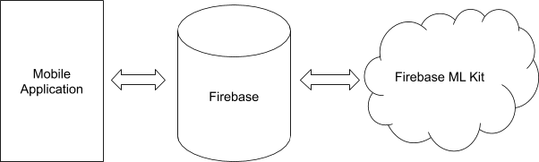

Fig 2.2 Data flow diagram

Fig 2.2 shows the data flow diagram of the hand sign recognition system. The diagram contains the overall flow of data in the application. The data flow from the mobile application to the firebase database then to the machine learning model that is deployed with the help of a firebase machine learning kit. the model returns the output as the predicted class of the image of the hand sign. The prediction and search are recorded in the database for the purpose of documenting and for delivering history. the output then is transferred to the mobile application and the result is converted to the human-readable form.

### ER Diagram

The ER Diagram shows the relationship between entity sets. An entity set is a group of similar entities and these entities can have attributes. In the ER diagram an entity is a table or attribute of a table in a database, so by showing the relationship among tables and their

attributes, the ER diagram shows the complete logical structure of a database. Here in the development of the application, we use the unstructured database, the google firebase, which stores the data in an unstructured form. Still, we have a relationship with the attribute stored and can be represented in the Entity relationship diagram, which shows the relationship with the attributes that are connected to each other. This diagram helps to design the database easily.

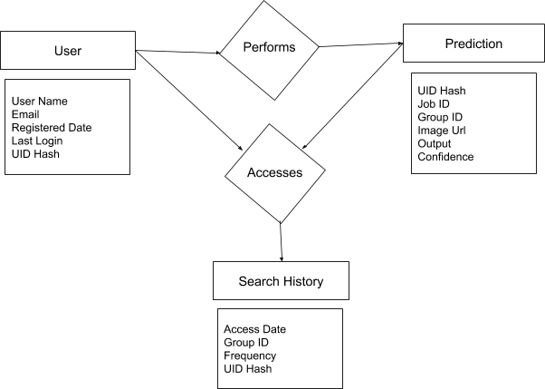

Fig 2.3 Entity relationship diagram

Fig 2.3 shows the relationship between the entities. Although we use a non-relational database, the entity-relationship helps easily identify the relationship between the entities in the application. It helps to design and develop the application quickly and efficiently. The image depicts the relationship between the user and the prediction. The user table stores basic information about the user. and the prediction table stores the information of the user prediction for the historical purpose. The search history tables connect between the entities and store the information regarding the access of the frequently uploaded images this helps

the user to find the appropriate search quickly without uploading the images again and processing again.

# System Design

This chapter discusses the important and required features, functionalities, and operations of the application in detail. The overall working and design of the application are described in detail in this section. The application provides specially-abled people to communicate with others. The main part of the application is to identify the sign language they are using for communication and translate to the text and audio output. the system architecture, modules, database design, system configuration are added in this section for better understanding the application for the development.

## System Architecture

The system is having a 2 tier architecture. the client-side application and the firebase backend where the user information is processed and the result is provided. The following image gives a detailed description of the two-tier architecture the application follows.

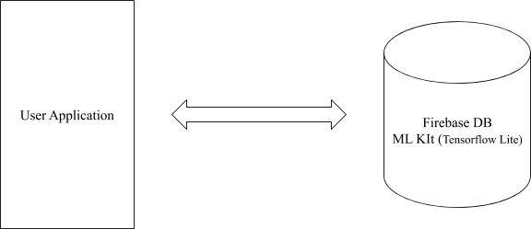

Fig 3.1 Architecture Diagram

Fig 3.1 shows the architecture diagram of the application. The architecture contains user-specific applications and the firebase database along with the firebase ML kit, with the help of TensorFlow lite. the application interacts with the user. it collects the inputs from the

user in the form of images, which is processed with the help of the firebase ML kit model created with TensorFlow lite. The application also contains a small database for storing the user details and the history of the search, in the firebase datastore. The application is designed for IOS and Android platforms and does not require a server. The input for the application is the images captured with the help of the users mobile application and the processing happens in the cloud - Firebase ML Kit - it handles the prediction of the image classification and returns to the application. The firebase also acts as the database for the application thereby stores the user specific details in one place.

## Module Design

The application is divided into three main modules, these include the account, image processing and the report modules. The following section will give a breakdown of the functionalities of the different modules in the application.

### Accounts

The accounts module is the module that deals with user registration, login, forgot password, and other functionalities that are responsible for the user account in the application. The user can create an account with the help of Gmail using the google sign-in API. the user can either log in with the help of the Google API services or with the email id and password.

### Image Processing

The image processing module is responsible for collecting the image from the user, either from the gallery or from the camera. the user can either select the image or capture the image. either a single image for a letter or action. or a sequence of images that will give the word as output. The captured image is then processed with the model created with the firebase ML kit. The model has been created with the help of TensorFlow lite and deployed over the firebase ml kit.

The model is created using the google tensor flow lite that is comparable with the firebase ML kit. The image is then processed to identify the sign and give the output to the user in

their mobile application. the user can hear the speech and can see the word or letter he was trying to analyze with the help of the application.

### 3.2.1 Reports

The report module is aimed to store information regarding the search history of the user. It also is aimed to give a quick review of the previous searches and the prediction accuracy is also included in the reports module. The module consists of the user feedback and support assistant. The module uses the database to store the information related to the application usage and other relevant information.

## Database Design

The application has a small database attached to the firebase to store the basic information of the users and the search history. The following tables give the idea of the tables or the entities involved in the database, which is stored in the firebase database. There are three main tables in the database that include the user details table, the user prediction history table and the user search history table. Below are the descriptions on each of the tables in the database.

Table 3.1 User details

|  |  |  |  |  |
| --- | --- | --- | --- | --- |
| email | service provider | created on | last sign in | user UID |
| Email | Icon | Date | Date | SHA256 |

Table 3.1 shows the table for storing the user details. The table contains the email of the user, then the email service provider information, the user profile created date, last login date, and the user id in the form of hash. These details come from the API used for sign in. This table stays as the authentication factor for user login and is created with the firebase authentication system. The table is created and managed by the firebase as the user is login in to the application and updates automatically as the user logs in to the application again.

Table 3.2 User prediction history

|  |  |  |  |  |  |
| --- | --- | --- | --- | --- | --- |
| user UID | Search Image | Search time | Search Group | Confidence | Output |
| SHA256 | String | timestamp | Integer | Float | Character |

Table 3.2 shows the user prediction history, it stores the attributes related to the user predictions. the user id serves as a foreign key. the image URL is also saved. then the timestamp of the event occurring is also saved. The group id is an attribute that helps the system identify whether the image is part of the sequence of images for a particular user. Then the output predicted character is identified and saved. The prediction accuracy and other required fields can be added to this table in the development phase for testing purposes. This table serves as the log for all the predictions that happen with the application. The result of the prediction is updated upon the prediction that comes to the application.

Table 3.3 User search history

|  |  |  |  |  |
| --- | --- | --- | --- | --- |
| user UID | Search Group | Search time | Use Frequence | Output |
| SHA256 | Integer | timestamp | Integer | String |

Table 3.3 shows the table that stores the history of the user searches in the application. This table is accessed on the history page of the application, where the user can easily identify the recent searches. The table contains the hashed UID from the firebase authentication table, the search group identification, the time search time stamp, the search frequency of the particular word or words, the output string in consolidation other than the characters. This table helps in easy access to the details on the report page.

### Tables and Relationships

There are three main tables in the database, the user details table is the main table that has the details of the users. The other tables store the user searches and search history and all tables are connected to the hastened UID column that is used to identify the users in the firebase database. The user prediction history and the user search history tables store the details of the prediction searches by the user. The user prediction history table has the UID of the user to identify the user and each image will have an entry in this table. The user search history table stores the frequency and the frequently accessed words or phrases for quick and easy access.

### Data Integrity and Constraints

The data is unique for any user in the user table that creates the user with the google account. the user can be identified with the UID that is SHA256 hashed user ID created by the google API. the id is used to refer as a foreign key in the other tables. the user search history and user prediction tables will get this as a foreign key. the columns are unique and not null. Each record can be identified and retrieved with the combination of keys.

## System Configuration

To run the application in the smartphone the device should be either in android or IOS. Since the application is created in cross-platform application development technologies, the application can be installed in Android and IOS devices. For the better user experience, we expect the smartphone to be a min of 5 inches in screen size with almost a minimum of 3GB ram with a minimum of 8 Megapixel cameras. the phones are expected to be having the proper network connectivity for better performance and operations.

## Interface Design and Procedural Design

The design specifications specify the overall design of the application. The user interface and the application data flow and workflow gives a clear picture of the entire application. the different screens in the application are included in the user interface design section and the architecture diagram of the application id shown in the application flow section. This helps the development of the application easily with the entire application described in brief.

### User Interface Design

The user interface design consists of the various user interfaces of the application. User interfaces are the different screens the user details with the application to use the application. This helps the developers to create the user interfaces for the application quickly and easily according to the design given. Here some of the user interfaces for the application includes the following:

* + - 1. Login Screen
      2. Image Capture Screen
      3. History Screen
      4. Options Screen

The above user interface helps the designers to create the application quickly and efficiently. The application has the main interfaces as the login screen, where the user interacts with to log in to the application. The image capture screen is the screen where the user captures a new image, or picks from the gallery or picks a sequence of images. The other main screen that the users will interact with is the history page, where the user can see the recent uploads and the frequent searches. The options window shows the various options available for the user. More detailed descriptions of the different screens are given below.

#### Login Screen

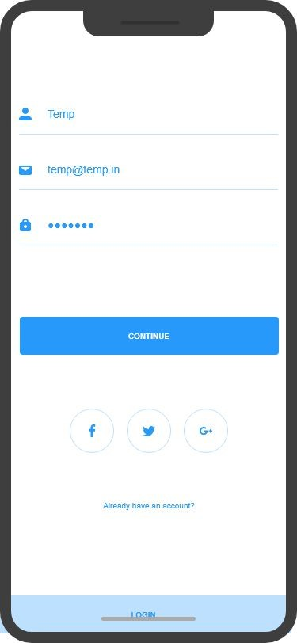

Fig 3.2 Login Screen

Fig 3.2 shows the login screen of the application. This screen is the primary screen the users interact with to log in to the application. the users can log in with the email id and password with a new username or the users can use the existing accounts of Facebook, Twitter, or google for easy login without creating a new account with the application. The application prefers the usage of the google account for sign in to the application and will collect the username, email, and profile image of the users since it is closely associated with the firebase. Though the users can use any of their existing accounts from Facebook or Twitter.

#### Image Capture Screen

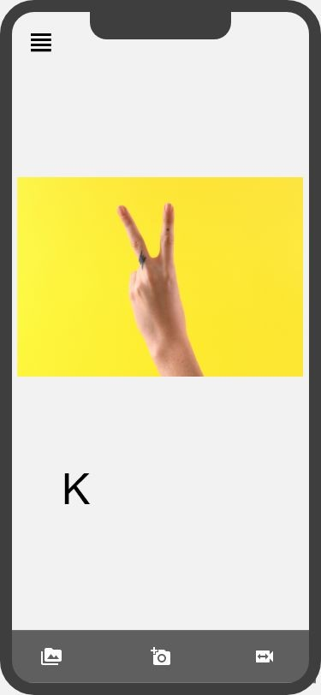

Fig 3.3 Image Capture Screen

Fig 3.4 shows the image capture screen of the application. this screen stays as the home screen of the application. Here the user is able to capture the new image for the prediction and the result of the search is also shown in this screen there will be an audio button also to speak out the output of the search in the form of sound. There are options to select an image from the gallery and to capture an image or a video or sequence of images, that can be used to identify the words. This screen is optimized for the productivity of the application and ease of use with maximum concentration for the user experience.

#### History Screen

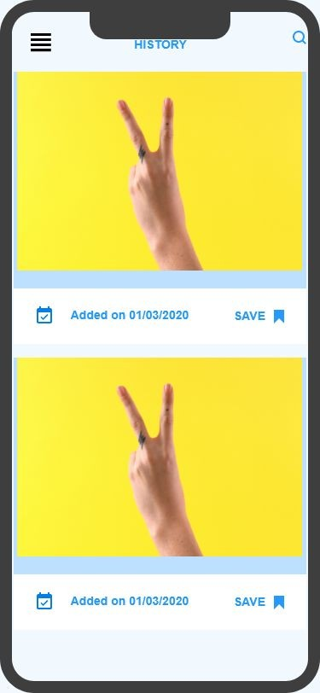

Fig 3.4 History Screen

Fig 3.4 shows the history of the user searches for images or words. There are various opinions associated with the history pages to pin the searches to the top of the page for quick reference and access. All the users' searches appear in this window. The users can easily reuse this information on the search results page to communicate with other people. also, the images he can remove from his account. the image, the date the image is added are shown on the screen, on clicking the images the user can use the audio or text. This screen helps the users to keep the words or sentences ready for future reference and quick access. This screen has more options to edit the image prediction and to give the feedback regarding the prediction to make the system more accurate.

#### Options Screen

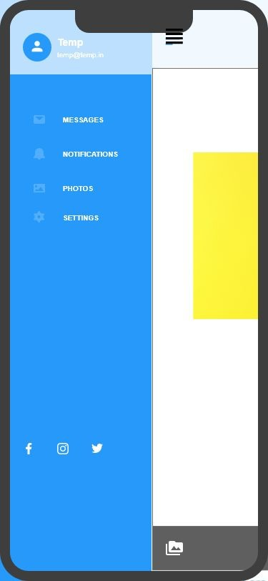

Fig 3.5 Options Screen

Fig 3.5 shows the options screen for the application, The screen contains the access to the user profile, the messages, notifications, recent uploads, and reports. also the user is provided with the basic settings. also, the user can share the application on social media platforms. This screen stays as a navigation drawer in the application. The navigation drawer allows the user access to different options available in the application. The user can access the navigation drawer from the top of the application showing the menu icon. It supports the users with all the essential and most important features and settings that the user can perform in the application.

### Application Flow/Class Diagram

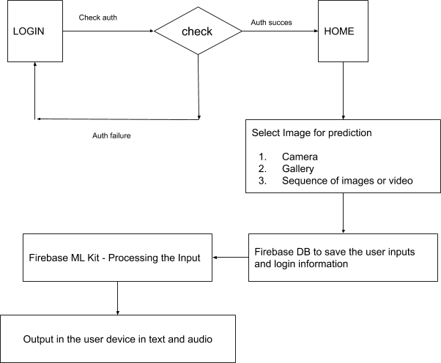

Fig 3.6 Application Flow Diagram

Fig 3.6 Shows the application workflow diagram. The image depicts the entire application workflow in a nutshell. the user logins and enters the application home, where the user can select an image from his gallery, and pass to the firebase Machine Learning Kit. The user also gets an option to upload an image live with the help of his camera and also a sequence of images or a video. The input is passed to the firebase Machine Learning kit. The image is tested with the model created using the tensorflow lite and deployed in the cloud. The classification report is then sent to the user application and displayed in the output. The output is delivered in the form of text as well as the voice to the user. Meanwhile the input and the output is documented in appropriate tables created in the firebase application which then appears for the user in his history page.

## Reports Design

There are few reports associated with the application. The reports always help the user to understand the usage statistics and gain insights from his application usage. In this application there are a few reports that include the history and frequency of the usage of certain words. The history contains the list of the words that he has recently encountered with the application. also the application stores the frequent accessed words. The user can also give suggestions for new words that he can get associated with. The reports can also be presented in different tabs in the history page. Along with the history, the users can pin the frequently used words or add new words to a list which he can frequently access. The reports help the users to use the application quickly and more effectively in urgent situations.

# References

[1]. https://[www.hindawi.com/journals/tswj/2014/267872/](http://www.hindawi.com/journals/tswj/2014/267872/)

1. Lim, Kian & Tan, Alan & Lee, Chin-Poo & Tan, Shing. (2019). Isolated sign language recognition using Convolutional Neural Network hand modeling and Hand Energy Image. Multimedia Tools and Applications. 78. 10.1007/s11042-019-7263-7.
2. Praveen, Nikhita & Karanth, Naveen & Megha, M. (2017). Sign language interpreter using a smart glove. 1-5. 10.1109/ICAECC.2014.7002401.
3. Liang, Zhi-jie & Liao, Sheng-bin & Hu, Bing-zhang. (2018). 3D Convolutional Neural Networks for Dynamic Sign Language Recognition. Computer Journal. 61. 1725-1736. 10.1093/comjnl/bxy049.
4. SG, Prateek & J, Jagadeesh & R, Siddarth & Y, Smitha & Hiremath, P. & Pendari, Neha. (2018). Dynamic Tool for American Sign Language Finger Spelling Interpreter. 596-600. 10.1109/ICACCCN.2018.8748859.
5. Tao, Wenjin & Leu, Ming & Yin, Zhaozheng. (2018). American Sign Language Alphabet Recognition Using Convolutional Neural Networks with Multiview Augmentation and Inference Fusion. Engineering Applications of Artificial Intelligence. 76. 10.1016/j.engappai.2018.09.006.
6. Sharma, Shanu & goyal, Sakshi & Sharma, ishita. (2013). Sign Language Recognition System For Deaf And Dumb People. International Journal of Engineering Research and Technology. 2. 382-387.