
Laboratory of Data Analysis
Nome do Professor: Fátima Leal

Data: 15/04/2023



Content
Content 2
Introduction 3
Description of dataset’s characteristics 3
Statistical analysis 4
Graph analysis 5
Graphs 8
1. Pregnancies by age 8
2. Skin thickness by bmi 8
3. Glucose by insulin 9
4. Glucose level by outcome 10
Data Transformation 10
5. Normalization 10
6. Standardization 11
7. Linear Transformation 11
Part II 12

Introduction
The aim of the project is to anlyze the phenomenon of diabetes and factors that may cause it. “Diabetes mellitus is a group of chronic metabolic conditions, all of which are characterized by elevated blood glucose levels resulting from the body's inability to produce insulin or resistance to insulin action, or both.” In this project, machine learning algorithms will be used to analyze phenomenon of diabetes.
The project begins with the presentation and preparation of data. The next step will be the analysis of variables including correlations, covariances and graph analysis. Last part of the project involves applying machine learning algorithms for classification.

Description of dataset’s characteristics
The domain of our project is healthcare. Data comes from Kaggle website. The study included women aged 21 and older of Pima Indian heritage. Dataset contains 9 variables and each of them has 768 entries. All variables are quantitative. The first table shows all the variables with short description and type of each variable used in the project.
Table 1. Representation of variables used in the project
Variables | Description | Variable type
Pregnancies | Number of times pregnant | Discrete (int)
Glucose | Glucose level in blood | Discrete (int)
Blood pressure | Blood pressure measurement (mm Hg) | Discrete (int)
Skin thickness | Thickness of the skin (mm) | Discrete (int)
Insulin | Insulin level in blood (mu U/ml) | Discrete (int)
BMI | Body mass index (weight in kg / (height in m)^2) | Continuous (float)
DiabetesPedigreeFunction | Likelihood of diabetes based on family history | Continuous (float)
Age | Age (years) | Discrete (int)
Outcome | Final result (0 if no, 1 if yes) | Discrete (int)

The cleaning of data was not necessary, because there are no missing values in any of the columns. However, some of the variables such as: glucose, blood pressure, skin thickness, insulin, BMI, age and diabetes pedigree function contained values equal to zero, which is biologically impossible. These values have been replaced with the average of its column. Values equal to zero for such columns as pregnancies and outcome remained unchanged.

Statistical analysis
Table 2. Data description
 | Pregnancies | Glucose | Blood Pressure | Skin Thickness | Insulin | BMI | Diabetes Pedigree Function | Age | Outcome
Count | 768.000000 | 768.000000 | 768.000000 | 768.000000 | 768.000000 | 768.000000 | 768.000000 | 768.000000 | 768.000000
Mean | 3.845052 | 121.686763 | 72.405184 | 29.153420 | 155.548223 | 32.457464 | 0.471876 | 33.240885 | 0.348958
Std | 3.369578 | 30.435949 | 12.096346 | 8.790942 | 85.021108 | 6.875151 | 0.331329 | 11.760232 | 0.476951
Min | 0.000000 | 44.000000 | 24.000000 | 7.000000 | 14.000000 | 18.200000 | 0.078000 | 21.000000 | 0.000000
25% | 1.000000 | 99.750000 | 64.000000 | 25.000000 | 121.500000 | 27.500000 | 0.243750 | 24.000000 | 0.000000
50% | 3.000000 | 117.000000 | 72.202592 | 29.153420 | 155.548223 | 32.400000 | 0.372500 | 29.000000 | 0.000000
75% | 6.000000 | 140.250000 | 80.000000 | 32.000000 | 155.548223 | 36.600000 | 0.626250 | 41.000000 | 1.000000
max | 17.000000 | 199.000000 | 122.000000 | 99.000000 | 846.000000 | 67.100000 | 2.420000 | 81.000000 | 1.000000

Table number 2, which presents data description, confirms that each variable contains 768 values. As shown in table 2 women included in the study were between 21 and 81 years old and the average age was 33.

Graph analysis
Using histogram, we can check the distribution of Age for women who has diabetes.
Figure 1. Distribution of Age for the women who has diabetes
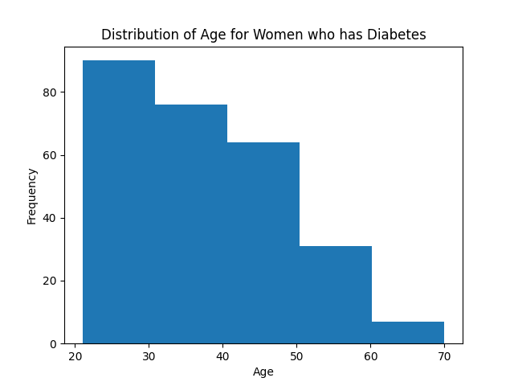
As shown on the histogram (Figure 1), the largest number of women with diabetes were women aged from 21 to 30. What is interesting, with increasing age, the number of women with diabetes decreased.
Figure 2. Distribution of BMI for women who has Diabetes
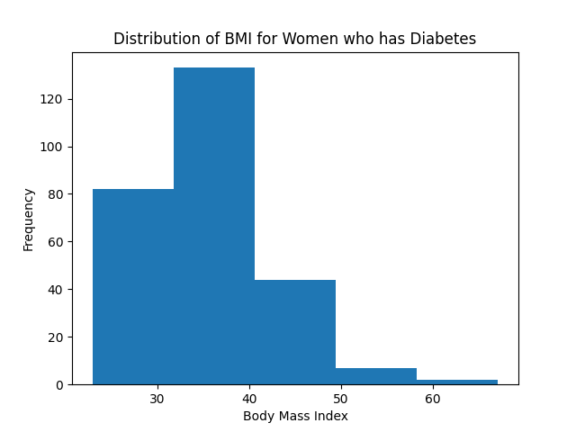
From figure 2, which shows distribution of BMI for women who has diabetes, can be read that among the respondents, the largest number of women suffering from diabetes had a BMI in the range of 30-40, which means obesity of the 1st degree.
Boxplots for variables
Boxplot displays the five-number summary of each variable (minimum, first quartile, median, third quartile and maximum). The boxplot shows that data contains many outliers (figure 3).
Figure 3. Boxplots for all variables
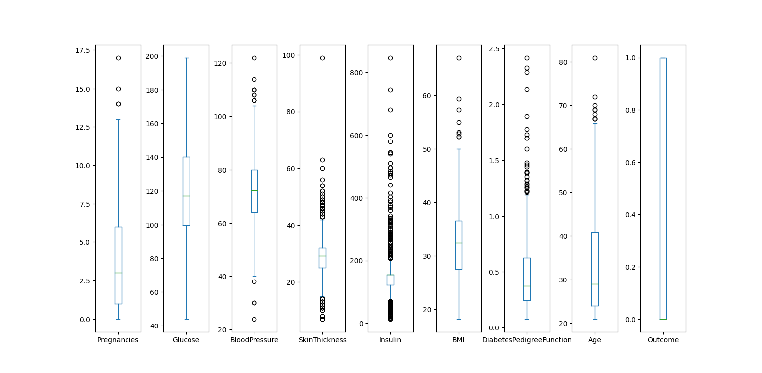
Covariances
Table 3. Covariance between variables
 | Pregnancies | Glucose | Blood Pressure | Skin Thickness | Insulin | BMI | Diabetes Pedigree Function | Age | Outcome
Pregnancies | 11.354056 | 13.118128 | 8.499282 | 2.458283 | 16.050914 | 0.499584 | -0.037426 | 21.570620 | 0.356618
Glucose | 13.118128 | 926.346983 | 80.394788 | 51.636823 | 1087.239699 | 48.324859 | 1.382151 | 95.401356 | 7.155569
Blood Pressure | 8.499282 | 80.394788 | 146.321591 | 20.503705 | 74.579607 | 23.391407 | -0.011075 | 46.175523 | 0.958140
Skin Thickness | 2.458283 | 51.636823 | 20.503705 | 77.280660 | 118.195534 | 32.782007 | 0.294084 | 13.219905 | 0.902718
Insulin | 16.050914 | 1087.239699 | 74.579607 | 118.195534 | 7228.588766 | 97.375072 | 2.778511 | 136.715802 | 8.694564
BMI | 0.499584 | 48.324859 | 23.391407 | 32.782007 | 97.375072 | 47.267706 | 0.349435 | 2.063312 | 1.022835
Diabetes Pedigree Function | -0.037426 | 1.382151 | -0.011075 | 0.294084 | 2.778511 | 0.349435 | 0.109779 | 0.130772 | 0.027472
Age | 21.570620 | 95.401356 | 46.175523 | 13.219905 | 136.715802 | 2.063312 | 0.130772 | 138.303046 | 1.336953
Outcome | 0.356618 | 7.155569 | 0.958140 | 0.902718 | 8.694564 | 1.022835 | 0.027472 | 1.336953 | 0.227483

Covariance is a statistical measure that shows whether two variables are related. Positive covariance means that both variables either increase or decrease, while negative value of this measure means that values of the variables change in opposite directions. In analysed dataset, positive covariance occurrs between for example blood pressure and glucose, which means that as the level of glucose in blood rises, the blood pressure also rises (table 3.).
Correlations
Next step is correlation to determine the strength of a relationship between variables.
Figure 4. Heatmap of correlation coefficients for all diabetes feature
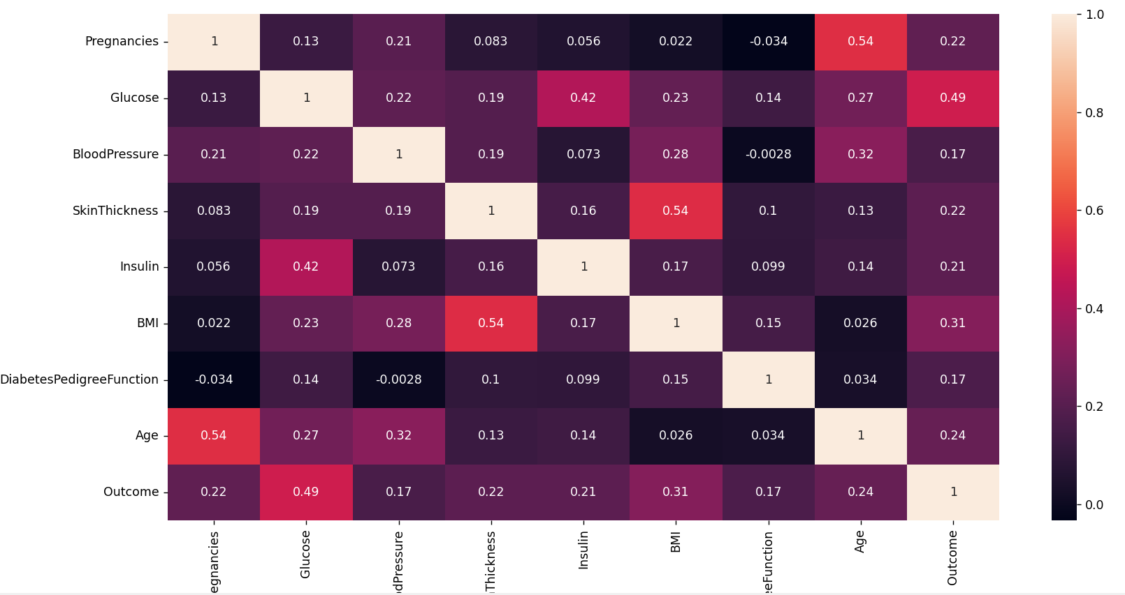
According to the heatmap presented in figure 4 generated for all variables, the highest, positive correlation occurred between:
- Age and pregnancies (0,54)
- BMI and skin thickness (0,54)
- Glucose and outcome (0,49)
The correlation between age and pregnancies is logic. As women get older, their fertility declines and the likelihood of having a successful pregnancy decreases. Therefore, women who are older may have a higher number of pregnancies because they have been trying to conceive for a longer period of time.
The positive correlation between BMI and skin thickness means that people who have higher BMI tend to have thicker skin and people who weigh less are more likely to have thinner skin.
The positive correlation between Glucose and outcome shows that people with higher glucose level in blood are more likely to be diagnosed with diabetes. However it doesn’t mean that increase in glucose level cause diabetes and the other way round.

Graphs
  - Pregnancies by age
Figure 5. Pregnancies by age
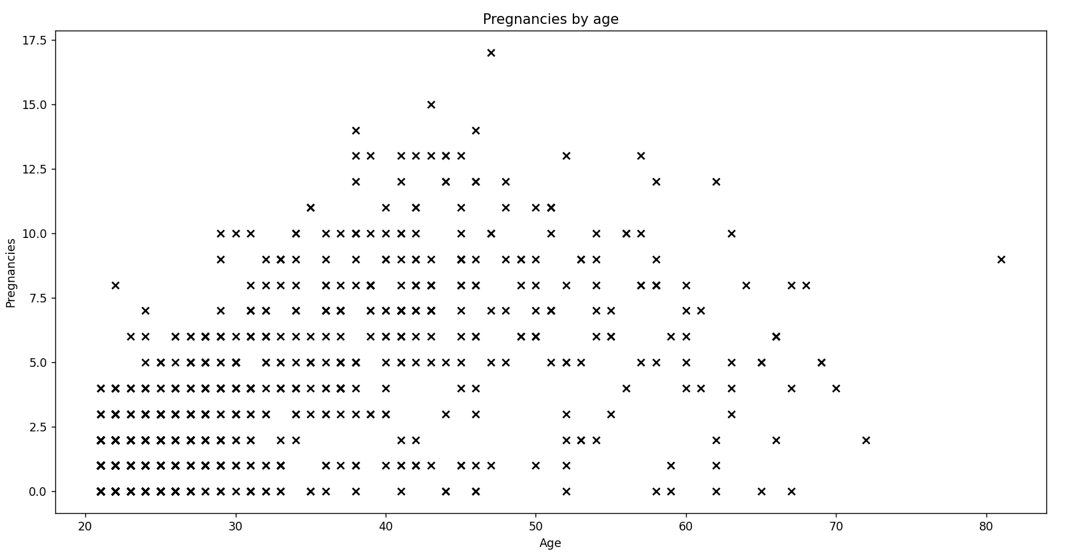
As shown on the graph 5, which is presented above, relationship between pregnancies and age is linear. It is also positive, because the number of pregnancies rise along with rise of age.
  - Skin thickness by bmi
Figure 6. Skin thickness by BMI
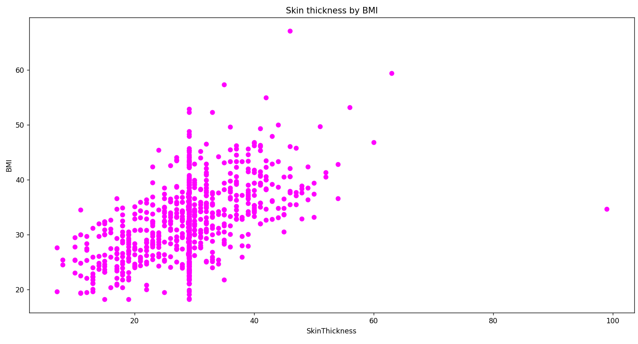
On figure 6, the shape of the scatterplot demonstrates that the relationship between skin thickness and BMI also presents a positive linear relationship. We can also see outliers, one of which shows that skin thickness equals 99 mm with relatively low BMI.
The sequence of points on the average level visible on the chart is caused by the replacement of zero values ​​with the average value
  - Glucose by insulin
Figure 7. Glucose by insulin
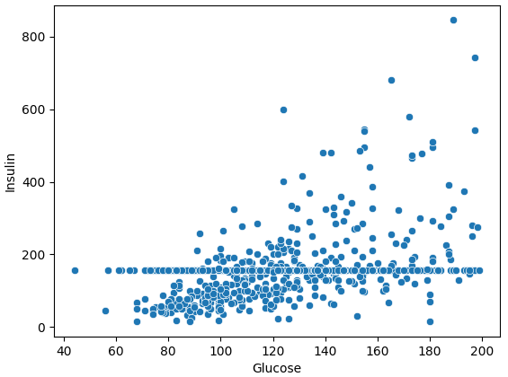
A positive relationship can be seen from the chart presented on figure 7. However, it is much lower than relation between skin thickness and BMI which means that increase in glucose does relatively little change in insulin levels. The scatterplot contains some outliers, which may distort the result.
  - Glucose level by outcome
Figure 8. Glucose level by outcome
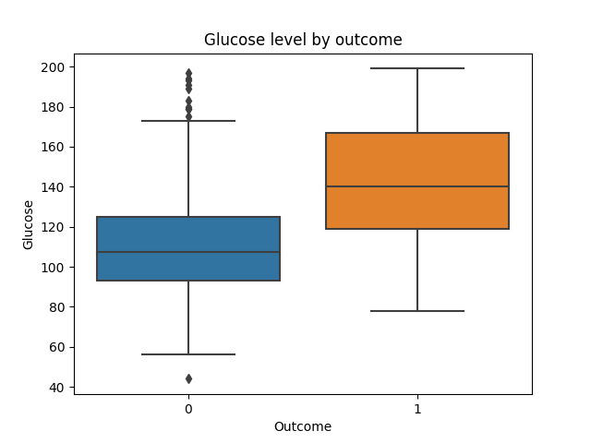
As figure 8 shows, the median of glucose level for people with diabetes was higher than for healthy people. However we can see that in the case of healthy people there is significant number of outliers.

Data Transformation
  - Normalization
Normalization scales features between 0 and 1, retaining their proportional range to each other.
Example of normalization for insulin variable (figure 9):
Figure 9. Insulin variable before and after normalization
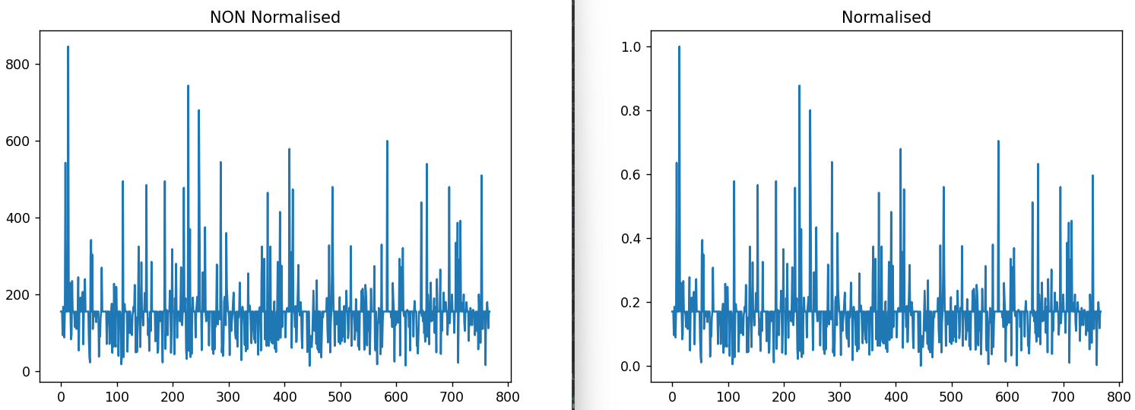
  - Standardization
Standardization scales features to have a mean of 0 and standard deviation of 1.
Example of standardization for glucose variable (figure 10):

Figure 10. Glucose variable before and after standarization
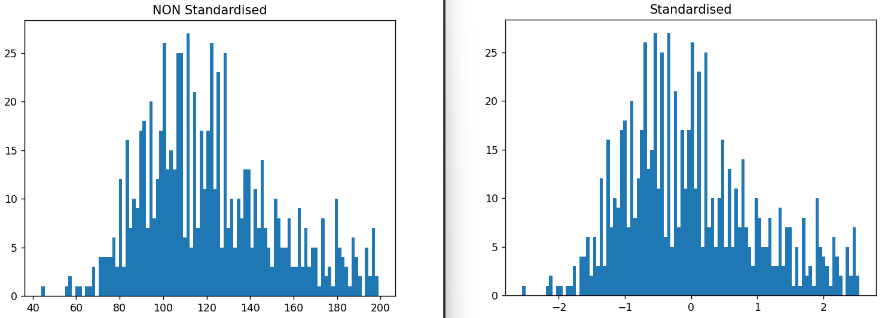
  - Linear Transformation
Linear transformation is a function which changes the original value into new variable.
For example, linear transformation can be used to convert skin thickness unit from mm to cm (figure 11)
Figure 11. Skin thickness before and after linear transformation
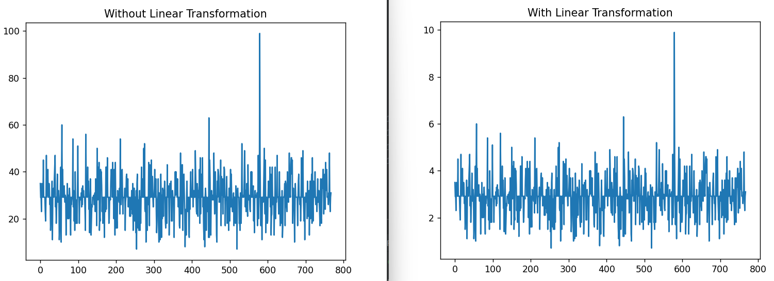
Summary of part I
The first part of the project involved the presentation, preparation and analysis of diabetes dataset. The analysis showed that diabetes affects women mainly at a young age with 1st degree of obesity. Heatmap showed highest correlation between: age and pregancies, BMI and skin thickness and also between glucose and outcome. It has been observed that the average glucose level is higher for people with diabetes. The second part of the project will be about the implementation of machine learning algorithms.

Part II
The final goal of this project will be to use the best machine learning algorithm for classification. Based on patient’s health information including age, number of pregnancies or insulin level the algorithm will classify if the patient is likely to suffer from diabetes.
The algorithms implemented for this purpose are:
- Logistic regression
- Naïve bayes
- PCA
- KNN
- SVM
- Decision tree
- Random forest classifier
- Multi layer classifier
- K-means

- Logistic regression
Logistic regression is one of the most common algorithms used for classification. For our dataset its accuracy was 0.59 which was one of the lowest scores. After using cross-validation techniques accuarcy of this algorithm increased to 0.77.
- Naïve bayes
The next used algorithm was the naïve bayes. Results of the implementation can be seen on the confusion matrix displayed below (figure 12).
Figure 12. Confusion matrix
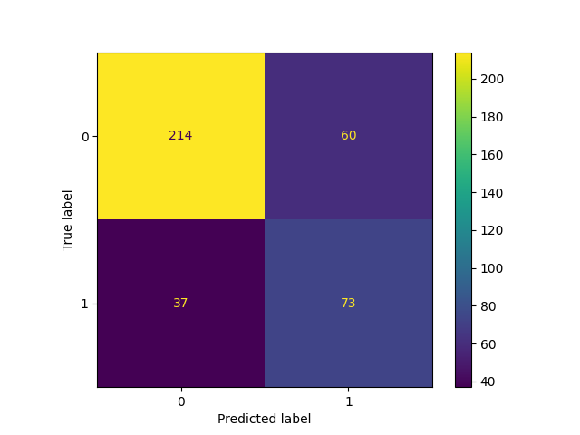
From all 384 cases, algorithm classified correctly 214 as 0 and 73 as 1.
- KNN and KNN with PCA
Third used algorithm was KNN. The plot between error rate and K was created to find the best number of neighbours. Graph shows that the best number of neighbours should be around 8. KNN was implemented for original x-values as well as after transforming them with PCA algorithm.
Figure 13. Error rate vs K-value
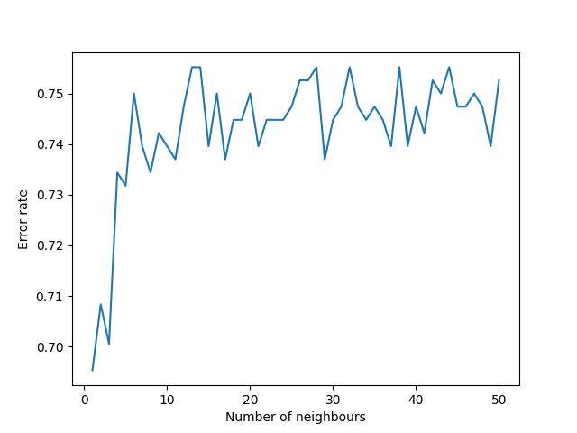
- SVM
The accuracy for Support Vector Classification was 0.74 and after using cross-validation increased to 0.76.
- Decision tree
Decision tree Classiffier is based on sequential decision process. The results of implementing this algorithm to the dataset are shown in the figure below.
Figure 14. Binary decision tree
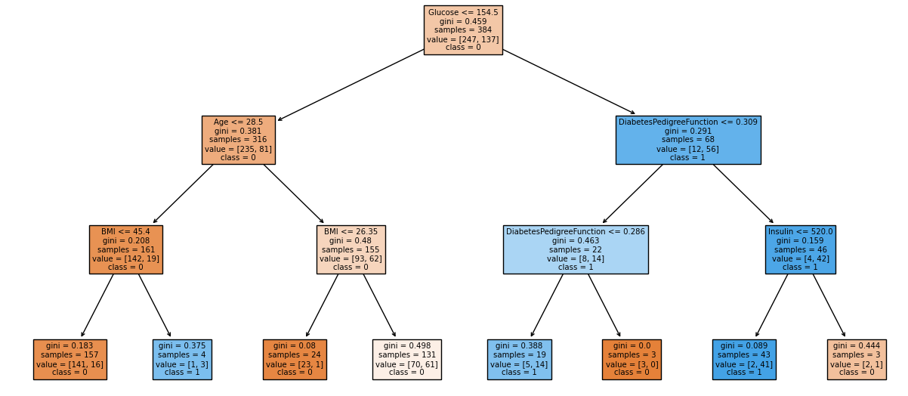
According to the decision tree, exemplary patient with glucose level higher than 154.5, diabetes pedigree function higher than 0.309 and insulin lower or equal to 520 is likely to have diabetes. What’s more, patient with glucose level below or equal to 154.5, age higher than 28.5 and BMI lower or equal to 26,35 is likely to have diabetes. These conclusions are consistent with the analysis conducted in the first part of the project.
- Random forest classifier
From ensemble methods, random forest classifier and random forest classifier connecter with KNN algorithm have been used. The accuracy of these algorithm was similar with a slight advantage of the first one.
- Multi layer classifier
From neural networks a multi layer classifier was used. However, its accuracy was about 70%, which was one of the lowest value.
- K-means
From unsupervised machine learning, the k-mean algorithm was used. The number of clusters was selected on the basis of the elbow method graph which shows that the number of clusters should be 2.
Figure 15 The Elbow Method Graph
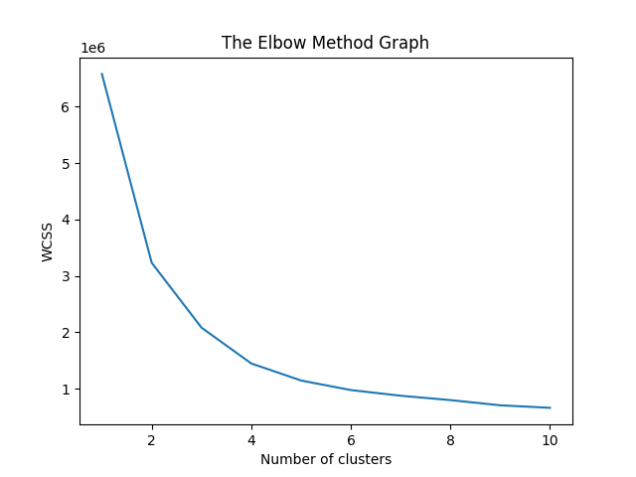
On the basis of the chart above (figure 15), following visualizations were created:
Figure 16. Insulin and diabetes pedigree funtion clustering
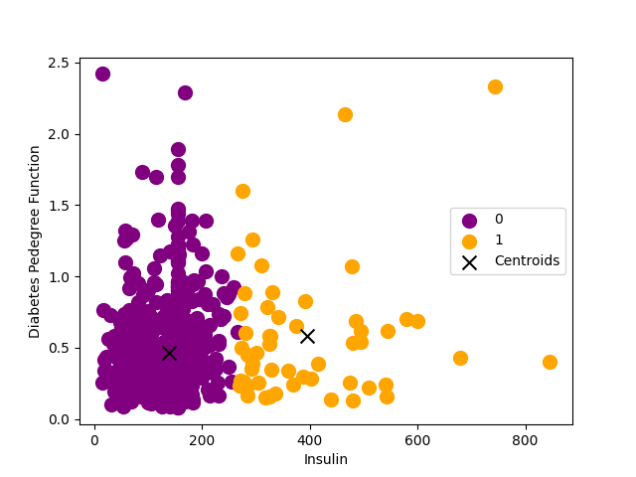
Figure 17. Skin thickness and insulin clustering
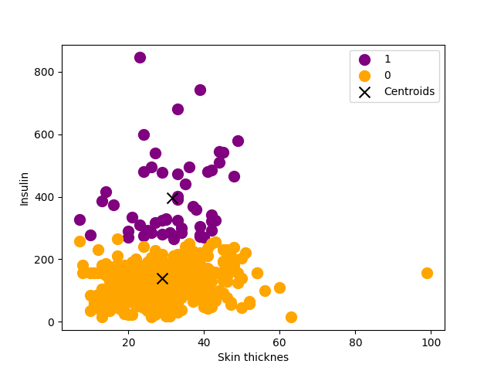
The dendrogram below (figure 18) shows how the aggregation was performed.
Figure 18. Hierarchical clustering dendrogram
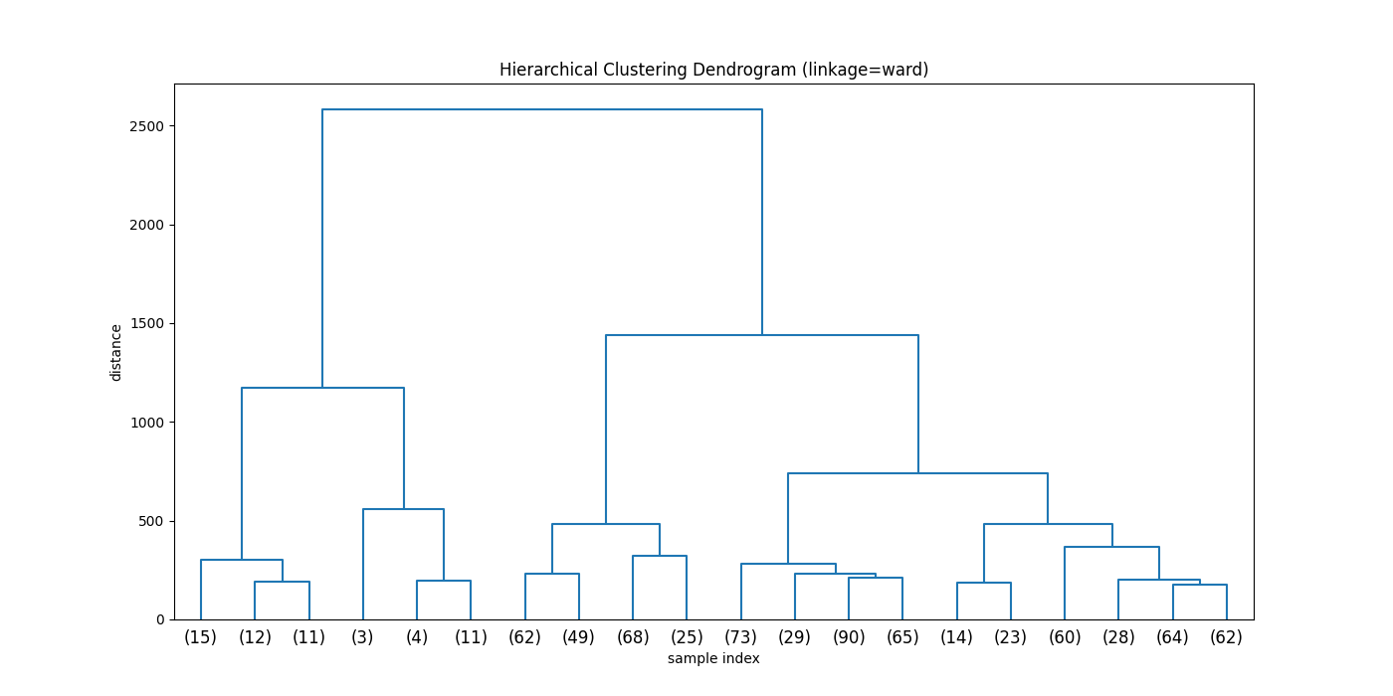
To summarize, the accuracy for each algorithms is shown in the table below:
Table 4. Classification report for each implemented algorithm
Algorithm | F-measure score | Macro average | Weighted average | With cross-validation (mean)
Logistic regression | 0,59 | 0,55 | 0,59 | 0,77
Naïve Bayes | 0,75 | 0,71 | 0,75 | 0,75
KNN | 0,73 | 0,68 | 0,72 | 0,75
KNN with PCA | 0,86 | 0,83 | 0,85 | 0,81
SVM | 0,74 | 0,68 | 0,72 | 0,76
Decision Tree Classifier | 0,74 | 0,64 | 0,70 | 0,72
Random Forest Classifier | 0,77 | 0,72 | 0,76 | 0,76
Random forest with KNN | 0,73 | 0,69 | 0,73 | 0,73
Multi layer classifier (MLPClassifier) | 0,72 | 0,69 | 0,72 | 0,70
K-means | 0,70

As shown in the table above (table 6), the highest score was noted for K-nearest neighbours altorithm that used data scaled and transformed by PCA algorithm as an input. Therefore, this algorithm has been used later in the project to check if patient with exemplary data will suffer from diabetes.
After adding cross-validation to each model the best model in terms of accuracy remained the same (figure 19).
Figure 19. Algorithm Accuracy Comparision after cross-validation
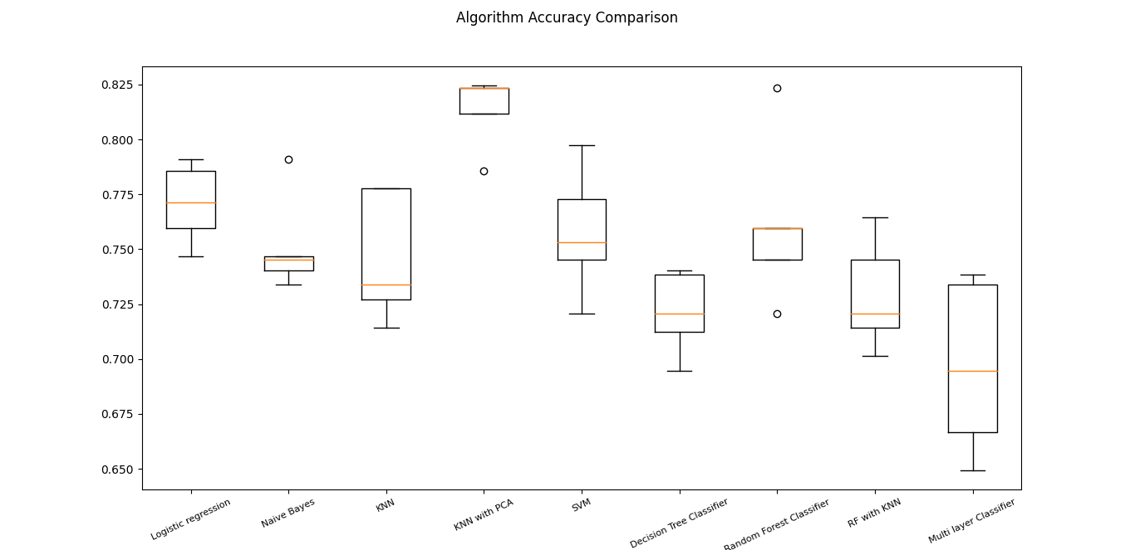
The last part of the project contains a small menu which enables users to interact with the program by entering information about their health such as number of pregnancies, glucose level, blood pressure, skin thickness, insulin level, BMI, diabetes pedigree function and age. Then, the chosen algorithm classifies the user based on this data into a diabetic or non-diabetic group.
Summary
To summarize, 9 algorithms have been implemented to get the best results in terms of classification for diabetes dataset. As it had been proved, the KNN with PCA algorithm obtained the highest accuracy and as a result, it was chosen for the interactive feature which enables users to enter data about their health and find out if they are likely to suffer from diabetes. It is also worth to mention that using cross-validation technique did influence some algorithm’s accuracy, but the best algorithm remained the same.

CAMPUS PBS
Polo dos Salazares
Rua de Salazares, 842
4149-002 Porto

T 226 153 270 /
F 226 100 861
E geral@pbs.up.pt
www.pbs.up.pt

1American Diabetes Association. Diagnosis and classification of diabetes mellitus. Diabetes Care. 2006;29:S43–S48.

