|  |
| --- |
| A Tutorial | By: Julia Keffer |

9/3/2013

|  |  |
| --- | --- |
|  | Quicken 2012: Creating a Household Budget |

Table of Contents

Introduction 5

About Quicken 2012 Home and Business 5

Who is this Tutorial For? 5

How the Tutorial is Organized 5

Objectives of this Tutorial 5

Before you Begin 5

Lesson 1 – Categorizing Your Expenses 6

Lesson Overview 6

Creating Expense Categories 6

Entering Transactions 8

Lesson Summary 12

Exercises 12

Lesson 2 – Creating Your Budget 13

Lesson Overview 13

Creating an Initial Budget 13

Adding Categories to Your Budget 14

Assigning Amounts to Budget Categories 16

Lesson Summary 18

Exercises 18

Lesson 3 Analyzing Your Spending Error! Bookmark not defined.

Lesson Overview 19

Budgeting at a Glance 19

Creating Spending Reports 20

Lesson Summary 22

Exercises 22

Tutorial Summary 23

Lesson 1 23

Where to go from here 23

Lesson 2 23

Where to go from here 23

Lesson 3 23

Where to go from here 23

Table of Figures

Figure 1 - Select Category List 6

Figure 2 - List of Default Categories 7

Figure 3 - Set Up Category Window 8

Figure 4 – Chequing Account Transaction Register 9

Figure 5 - Transaction Entry 10

Figure 6 - Visa Account Transaction Register 11

Figure 7 - Visa Transactions 12

Figure 8 - Initial Planning Window 13

Figure 9 - Create a New Budget 14

Figure 10 - Main Budget Window 14

Figure 11- Advanced Budget Setup Window 15

Figure 12 - Select Categories to Budget 15

Figure 13 – Advanced Budget Setup Window 16

Figure 14 - Set Yearly Budget Amount 17

Figure 15 - Monthly Budget Overview 17

Figure 16 - Change to Year to Date Budget View 19

Figure 17 - Year to date View 20

Figure 18 - Create a Spending Report 20

Figure 19 - Spending Report 21

Figure 20 - Gas & Fuel Transactions 21

Figure 21 - Report Options 22

# Introduction

## About Quicken 2012 Home and Business

Quicken Home and Business is a software program designed for personal and business users. You can use it to find out where your money goes, monitor your investments, and manage your home-based business finances.

## Who is this Tutorial For?

This tutorial is for home users who want to learn how to track their expenses, prepare a household budget, and compare their spending against their budget.

## How the Tutorial is Organized

This tutorial is organized into three lessons, each with its own set of topics. You should do the lessons in the order they are written because each one builds on tasks done in the previous lesson. Each lesson should take about 10 minutes.

## Objectives of this Tutorial

At the end of this tutorial, you will know how to:

* Create categories for your expenses
* Enter expense transactions and assign a category to each transaction
* Create an initial budget
* Customize your budget
* Analyze your spending

## Before you Begin

This tutorial assumes that you are familiar with the following:

* Using a computer and the Windows environment
* How to start Quicken and open a Quicken file

It also assumes you have completed the previous lessons to create an initial Quicken file and have created two accounts: **Chequing**, and **Visa**

.

# Lesson 1 – Categorizing Your Expenses

## Lesson Overview

You use categories to group transactions of a similar nature. For example, expenses related to home improvement might include buying wood to build a deck, or buying paint for the living room. If you assign a category called **Home Improvement** to each of those transactions, at any given time, you can see how much money you spent on home improvement.

In this lesson, you will learn how to:

* Create a category for each type of expense
* Enter a transaction into Quicken and assign it a category

## Creating Expense Categories

Quicken provides a set of default categories you can use. You can also create custom categories. This topic teaches you how to create custom categories.

Under the **Tools** menu, click **Category List**, as shown in .

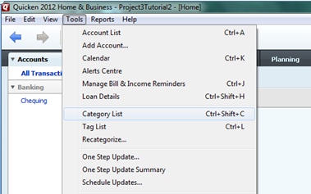

Figure - Select Category List

In the windows that appears (), you can see the list of default categories that Quicken provides.

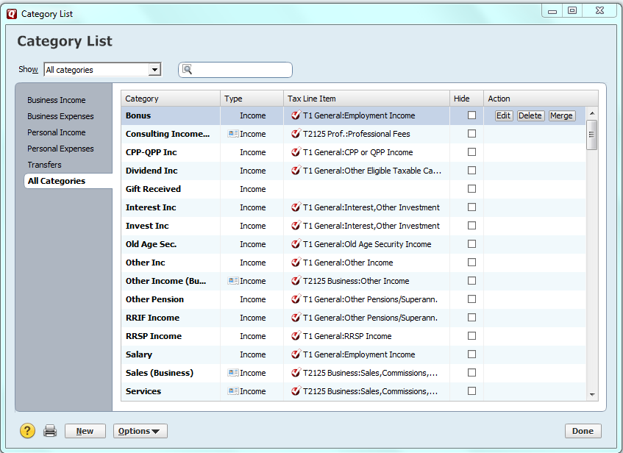

Figure - List of Default Categories

On the bottom of the left side of the screen shown in , click **New**. In the **Set Up Category** window () that appears, enter a new category for hydro expenses.

.

In the **Category Name** box, type **Hydro**. Select **Subcategory of:** and select **Bills & Utilities** from the list. In the **Description** box, type **Home Electricity Use**. Click **OK**.

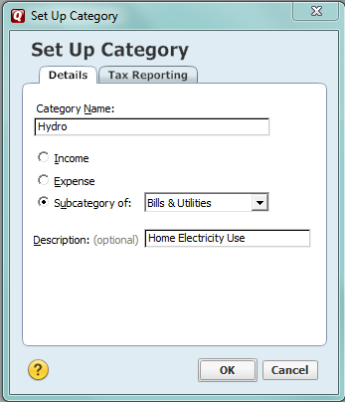

Figure - Set Up Category Window

In the next section, you’ll enter some transactions and use the new category you created, as well as the default categories that Quicken provides.

## Entering Transactions

To track your expenses, you need to keep a list of transactions in each account, such as your **Chequing** account or your **Visa** account. The transactions correspond to the items on your bank statement or your credit card bill.

When you enter a transaction, you assign it to a category. The category is the basis for the budget you’ll create in the next lesson. In this lesson, you will use both the **Chequing** account and the **Visa** account and manually add some transactions.

In the left panel, click **Chequing**. The account transaction register () for the **Chequing** account appears in the main window.

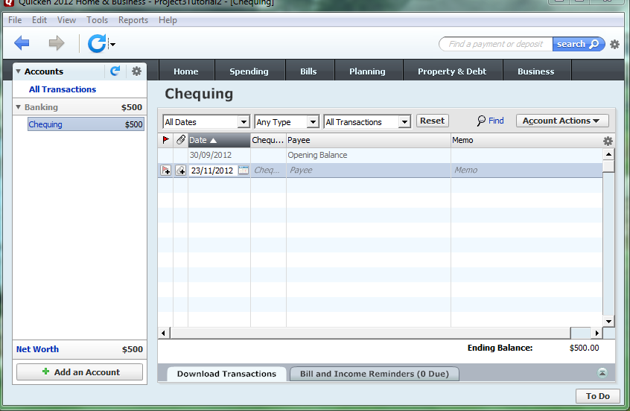

Figure – Chequing Account Transaction Register

Tip: You don’t have to fill in the Memo field, but it may help you later when you analyze your spending.

Tip: When you open the account transaction register, in the date field, Quicken always shows the current date. If you change the date to add a transaction that occurred in the past, after you enter the transaction, the date window for the next transaction shows the date you set instead of today’s date. You need to change it manually if you want to use a different date for the next transaction.

To enter the transaction, perform the following steps.

1. In the main window shown in , click the calendar iconCropperCapture[70].png in the **Date** column, and click today’s date.
2. Click in the **Payee** field and type **Hydro One**.
3. Press the **Tab** key to move to the **Memo** field and type **Monthly bill**.
4. Press the **Tab** key and the category list appears. Scroll down in the category list and click **Hydro**.
5. Press **Tab** twice to move to the **Payment** field and type **100**.
6. Press the **Enter** key to save the transaction.

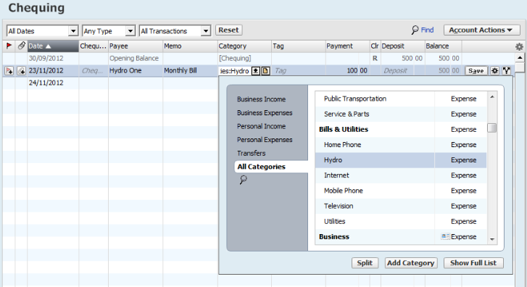

Figure - Transaction Entry

If you make a mistake when you type the values, you can go back and change them. When you finish, press **Enter** to save the changes.

Let’s add three more transactions and assign them to Quicken’s default categories, **Fuel**, **Restaurants**, and **Home Improvement**. You’ll add these transactions in the **Visa** account. You’ll use the default date, which is today.

In the left panel, click **Visa**. The account transaction register () for the **Visa** account appears in the main window.

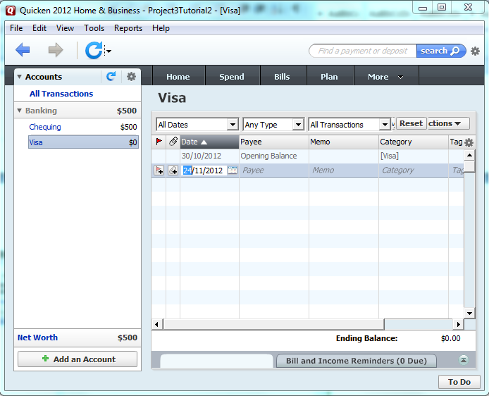

Figure - Visa Account Transaction Register

To enter the first transaction, a $50 tank of gas at Esso, perform the following steps:

1. Click in the **Payee** field and type **Esso**. Press **Tab** to move to the **Memo** field and type **Fill tank**.
2. Press **Tab**, scroll down in the category list and click **Fuel**.
3. Press **Tab** twice to move to the **Payment** field and type.
4. Press **Enter** to save the transaction.

**Enter the second transaction, an $80 dinner at Kelsey’s:**

1. Click in the **Payee** field and type **Kelsey’s**.
2. Press **Tab** to move to the **Memo** field and type **Dinner out with friends**.
3. Press **Tab**, scroll down in the category list and click **Restaurants**.
4. Press **Tab** twice to move to the **Payment** field and type **80**.
5. Press **Enter** to save the transaction.

Enter the third transaction, a $500 purchase at Home Depot:

1. Click in the **Payee** field and type **Home Depot**.
2. Press **Tab** to move to the **Memo** field and type **Wood for deck**.
3. Press **Tab**, scroll down in the category list and click **Home Improvement**.
4. Press **Tab** twice to move to the **Payment** field and type **500**.
5. Press **Enter** to save the transaction.

In the **Visa** register, shown in below, you can see that you have three transactions.

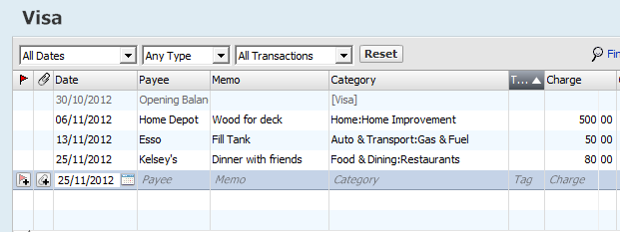

Figure - Visa Transactions

## Lesson Summary

In this lesson, you learned how to enter transactions in the account register and classify them according to a custom category and using Quicken’s built-in categories.

Tip: Some banks provide the ability to download transactions from your accounts directly into Quicken so you don’t need to enter them manually. You can set up the link from your bank’s website. See Quicken Help for details.

## Exercises

1. Follow the steps in section to add a new category called **Christmas**. Use the subcategory **Gifts and Donations**.
2. Follow the steps in section to do the following:

* In your **Visa** account, enter a transaction for a $45 lunch at East Side Mario’s, using the category **Restaurants**.
* In your **Visa** account, enter a transaction for a $30 tank of gas at Shell, using the category **Fuel**.
* In your **Chequing** account, enter a transaction for your home phone bill for $60, using Quicken’s built-in category **Home Phone**.

# Lesson 2 – Creating Your Budget

## Lesson Overview

Now that you have a history of categorized transactions, you can use them to create a budget.

In this lesson you will learn how to:

* Create an initial budget
* Customize the budget

## Creating an Initial Budget

First, you need to create an initial budget. Click the **Planning** tab at the top of the main window. shows the contents of the main window

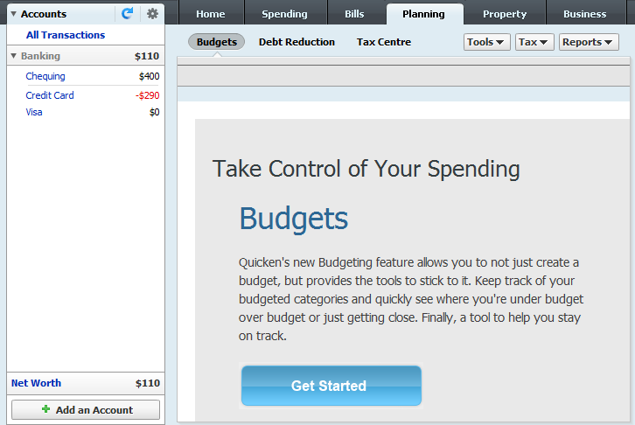

Figure - Initial Planning Window

Click the **Get Started** button. The **Create a New Budget** dialogue box () appears.

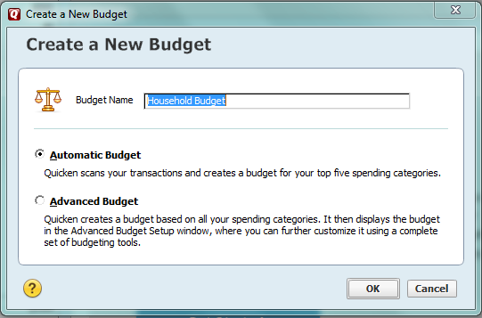

Figure - Create a New Budget

In the **Budget Name** field, type **Household Budget** and click **OK**. Quicken creates a skeleton budget, but you need to add the categories and amounts.

## Adding Categories to Your Budget

To customize your budget, you need to add the categories that you want to track. Click the **Advanced Budget Setup** link in the bottom right corner of the main window as shown in .

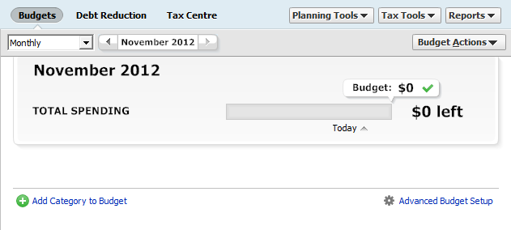

Figure - Main Budget Window

In the **Advanced Budget Setup** window that appears (), click the link **Select Categories to Budget**.

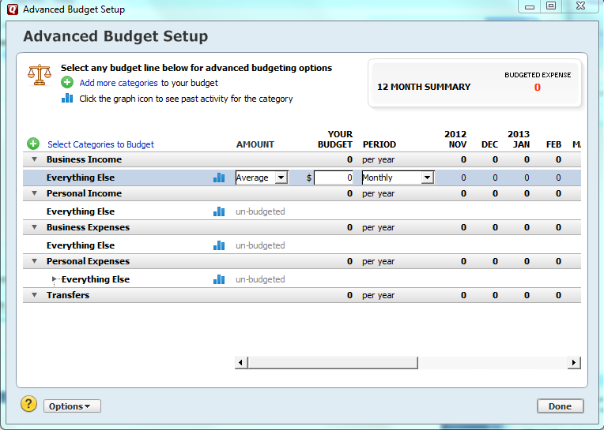

Figure - Advanced Budget Setup Window

The **Select Categories to Budget** dialogue box appears ().

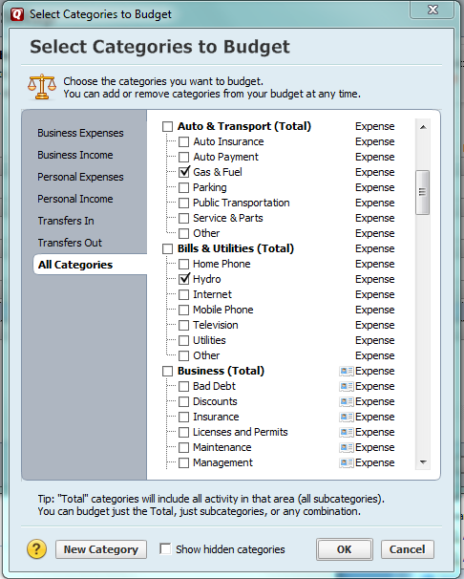

Figure - Select Categories to Budget

You’ll include the categories for the transactions you added: **Gas & Fuel**, **Hydro, Home Improvement**, and **Restaurants**. Click the checkboxes beside each of the categories and then click **OK** to return to the **Advanced Budget Setup** window.

## Assigning Amounts to Budget Categories

Once you’ve added categories to your budget, you need to specify the target amount for each category. Quicken gives you several options to specify your budget amount.

When you return to the **Advanced Budget Setup** window (), you can see that the categories you selected are now included in the budget. Now you need to fill in the amounts. For the first category, you’ll use the average amount per month. In the **Amount** column for **Gas & Fuel**, leave the default setting, **Average**. In the column **Your Budget**, type **100**. Leave the default setting as **Monthly**.

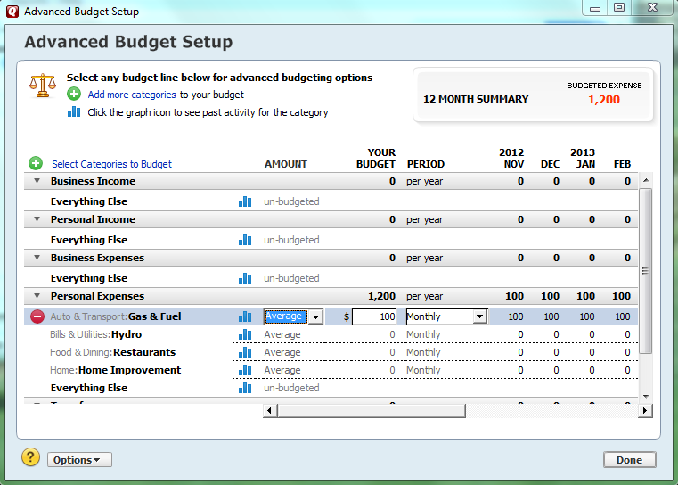

Figure – Advanced Budget Setup Window

Now perform the same steps for two more categories:

* For the category **Hydro**, and assign the amount **100**
* For the category **Restaurants** assign the amount **150**

For the category **Home Improvement**, assign a yearly amount. As shown in , in the **Your Budget** column, type **1000**, and in the **Period** menu, select **Yearly**.

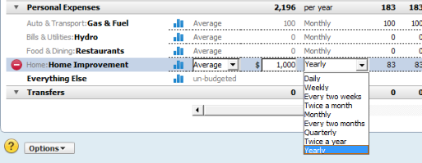

Figure - Set Yearly Budget Amount

Quicken automatically divides the yearly amount evenly for each month. You’re finished entering our data, so click **Done** in the bottom right corner of the window, which brings us back to the main **Planning** view. In below, you can see the budget categories and how you’re doing this month.

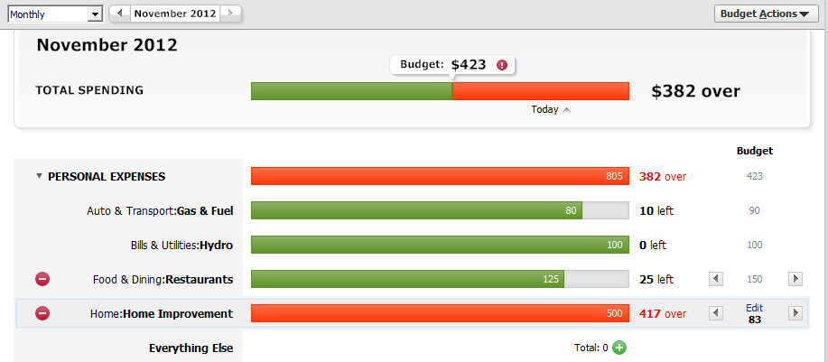

Figure - Monthly Budget Overview

In the example, **Gas & Fuel** and **Restaurants** are under budget, **Hydro** matches the budget, and **Home Improvement** is over budget. As a result, November spending is over budget by $382.

## Lesson Summary

In this lesson you learned how to:

* Create an initial budget.
* Add categories to your budget.
* Assign monthly and yearly values to the categories you included in your budget.

## Exercises

Follow the same steps you used in this lesson to do the following:

1. Add the category **Christmas** to your budget and set the yearly amount to $600.
2. Add the category **Home Phone** to your budget and set the monthly amount to $65

# Lesson 3: Analyzing Your Spending

## Lesson Overview

In this lesson, you will learn how to:

* View at a glance how you’re tracking to your budget
* Create customized reports for detailed analysis of your spending

## Budgeting at a Glance

In the previous lesson, you saw the current monthly overview of your budget status. You can easily see how you’re doing this year by changing the view setting to **Year to Date**. In the top left corner of the main window, select **Year to Date** from the menu as shown in .

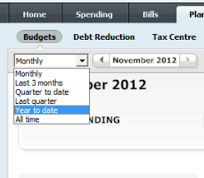

Figure - Change to Year to Date Budget View

shows the main window with the totals for the year in each category.

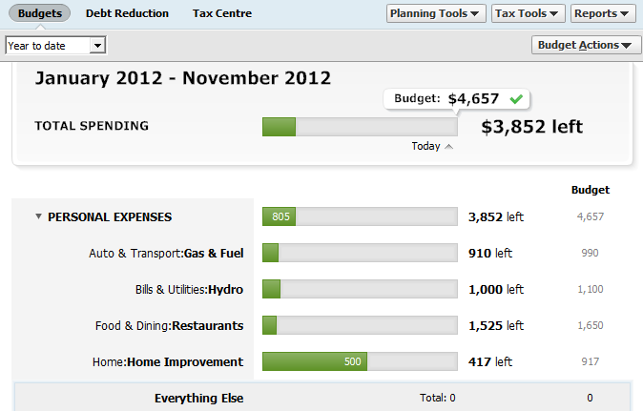

Figure - Year to date View

## Creating Spending Reports

To analyze your budget in more detail, you can create different reports:

* View your spending by category
* View the transactions in an individual category

To create a report that shows your spending by category, on the menu bar in the top right corner of the main window, click **Reports**. In the list that appears (), click **Spending by Category**.

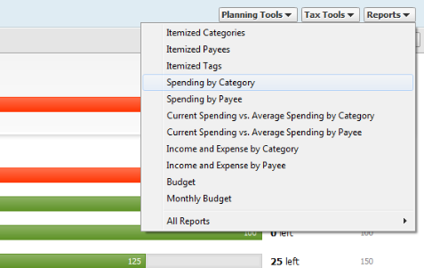

Figure - Create a Spending Report

Tip: To return to the main report, click the **Back** button in the top left corner of the report window.

shows an example report based on the transactions you entered in Lesson 1.

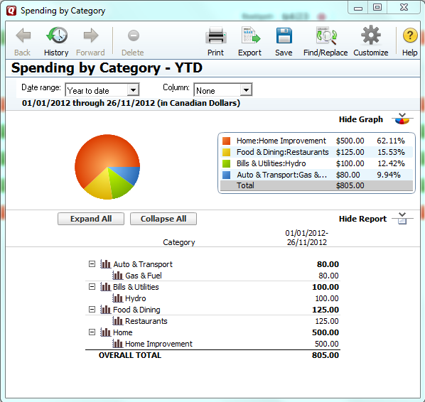

Figure - Spending Report

The graph and the associated report show how your spending is divided between the categories. From this report, you can get detailed information about spending in the individual categories. Each line in the report is a link. Double-click **Gas & Fuel** and a report appears, which shows the transactions assigned to the category ().

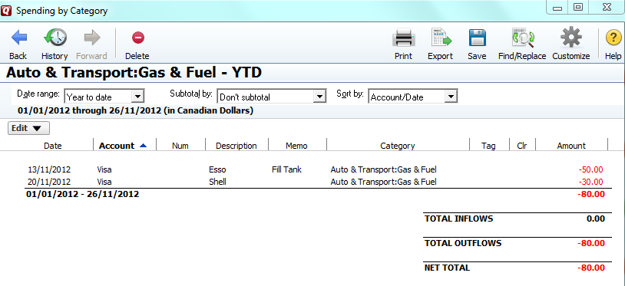

Figure - Gas & Fuel Transactions

You can see in the report that there are two transactions: the gas purchase at Esso that you entered in Lesson 1, and the transaction at Shell that you entered in the exercise for Lesson 1.

Other things you can do:

Show monthly subtotals

Export data to Excel

Change the date range

Export to Excel

Change the date range

Subtotal the current report by month, week, etc.

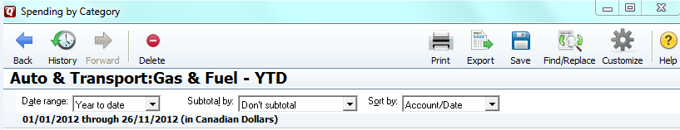

Figure - Report Options

## Lesson Summary

In this lesson, you learned:

* How to change the view in the main budget window to see a different breakdown of your budget, and how you’re tracking to it
* How to create a customized report to see where your money goes

## Exercises

Let’s try out some different ways to view your spending information. In the **Spending by Category** report:

1. Use the **Subtotal by** menu to view monthly subtotals for the categories.
2. Double-click the **Restaurants** category to view the individual transactions

# Tutorial Summary

Congratulations! You have successfully completed the tutorial. To summarize, here’s what you learned.

## Lesson 1

You learned how to add custom spending categories and use Quicken’s built-in categories to group your spending. You learned how to enter transactions into the account register and categorize them.

### Where to go from here

To get more practice with Quicken, you may find it helpful to enter some transactions from your last few credit card bills. You can categorize them using Quicken’s built-in categories.

## Lesson 2

You learned how to create a starting budget, add categories to it, and specify how much money you want to allocate to the individual categories each month or each year.

### Where to go from here

If you add more transactions from your last few bills, you should have data in more categories that you can add to your budget.

## Lesson 3

You learned how to get a snapshot of how you’re tracking to your budget for the current month and for the year. You also learned how to see a detailed breakdown of your spending and the individual transactions in each category.

### Where to go from here

You can customize the reports in many different ways. Quicken’s Help menu can show you other options.