Upgrade Proposal

# Background

*Summary of current state of the field and context within which the research is located, covering current theory/state of the evidence and referring to relevant literature (500-1,000 words).*

The NMDA hypofunction hypothesis of schizophrenia proposes that decreased activity of NMDA receptors has a key role in the development of schizophrenia pathology. The affected NMDA receptors are primarily localised at GABA-ergic fast-spiking PV interneurons; where decreased activity of PV interneurons causes a disinhibition of their activity on pyramidal neurons, disrupting the EI balance, and leading to increased excitation. Hyperactivity in the hippocampus is observed in the early stages in schizophrenia, as well as in people at clinical high risk of schizophrenia that subsequently develop the disorders, suggesting this region might be implicated in the development of the pathology at early stages of the disorder. This is consistent with the observations that administation of NMDA antagonists like phencyclidine and ketamine induces behaviours comparable to all three schizoprenia symptom dimensions (positive, negative, and cognitive symptoms) (citations from1), and repeated administration results in increased release of DA in rodent striatum citations from1, suggesting that hyperdopaminergia is caused by decreased NMDA activity2,3.

Alterations in synaptic function have also been implicated in the aetiology of schizophrenia4. Excitotoxicity caused by increased glutamatergic activity might be one of the contributing factors in the reduction in synaptic connections in schizophrenia.

Levetiracetam (LEV) is an anticonvulsant drug that selectively binds to SV2A, and works by normalising the excitation inhibition imbalance in epilepsy, although it is not clear whether its action is due to increase in the release of GABA or decrease in Glutamate. It was also found to be helpful in treating subclinical epileptiform discharges in autism spectrum disorder (ASD)5. Only one study tested the effects of LEV in schizophrenia; their findings suggesting that LEV can normalise hippocampal hyperactivity6 where E/I imbalance is understood to originate.

# Aims and objectives

* The aim of my project is to examine the relationship between synaptic connectivity and glutamatergic function. To do this I will measure the difference in glutamate levels (MRS) after administration of LEV and placebo in healthy controls and people with schizophrenia.
* The recruitment target is 50 participants: 25 healthy controls (HC) and 25 people with schizophrenia (SZ).

# Hypotheses under investigation

**I will aim to answer the following questions**:

1. Does modulating SV2A lead to lower glutamate levels in healthy people?
2. Does modulating SV2A lead to lower glutamate levels in people with schizophrenia? Is the change different to that in healthy controls?
3. Does modulating SV2A lead to change in symptoms in schizophrenia?

I hypothesise that modulating SV2A with levetiracetam will lead to decreased glutamate levels compared to baseline (placebo) in both healthy people and in people with schizophrenia. Based on evidence that levetiracetam normalised E/I imbalance in epilepsy, I believe that the change will be greated in people with schizophrenia than healthy controls.

# Methodology

## Study design and data collection

### Study design

* Single-blind, randomised, placebo-controlled trial with cross-over design.
* Participants undergo two MRI scans- one after taking placebo and the other taking levetiracetam.
* They are randomised to the order in which they receive them.

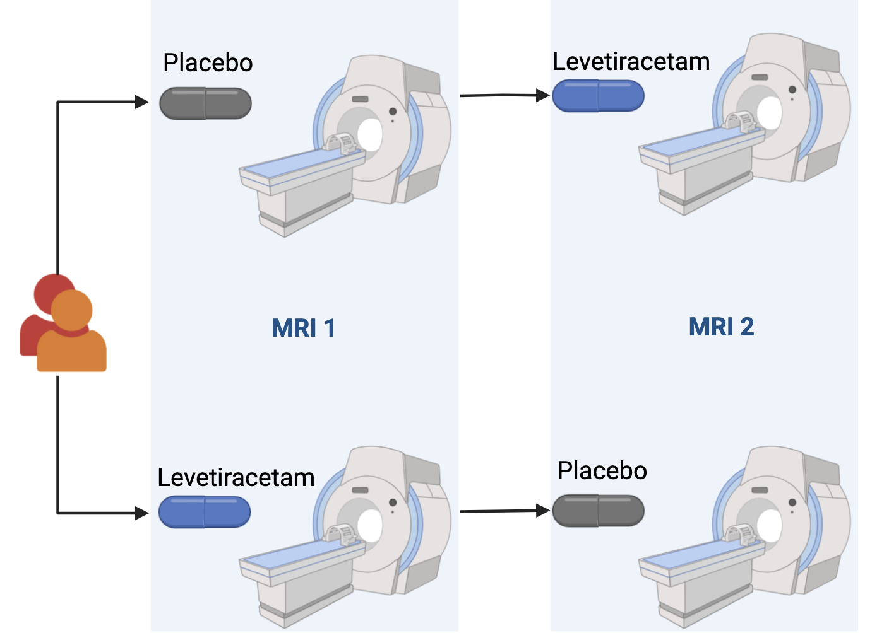

### Measuring glutamate

* Glutamate is measured in two voxels localised in the ACC and in the Hippocampus. The choice of those regions was based on previous findings of decreased SV2A density ([11C]UCB-J V $​_{T}$) in the ACC in patients with schizophrenia7, and an alter relationship between glutamate and SV2A density in the hippocampus8.
* Single voxel spectroscopy (svs) PRESS sequence is used to acquire the signal
* I will also report Glx levels to verify if similar differences are observed compared to glutamate signal [^This is due to limited ability to separate glutamine and glutamate using the PRESS sequence at 3T].

### Behavioural measures

* Change is symptoms is assessed using Positive and Negative Syndrome Scale (PANSS).
* PANSS is administered at the screening appointment, and before and after every scan, to assess any change in symptoms related to levetiracetam.

## Analysis

### Change in glutamate

* MRS data processing will be done in Osprey, and values of Glu (and Glx) will be extracted for each participant’s scans.
* To compare the changes in levels of glutamate between participants with schizophrenia and healthy controls I will do a 2x2 ANOVA.
* I will aso do power calculations. (mention the ones already done).
* I will compare the effect of levetiracetam on Glx levels in healthy controls (HC) and patients with schizophrenia (SZ). This will be visualised on a raincloud plot such as the one below.
* Below is example of data visualisation. The data used in this graph is made up.

|  |
| --- |
| Figure 1: Comparison of Glu levels change between placebo and levetiracetam in HC and SZ |

Source: [Plots](https://juliam98.github.io/phd-upgrade-proposal/notebooks/plots-preview.html#cell-fig-lev_hc_vs_sz)

### Change in symptoms

* PANSS score for each symptom group and overall PANSS score will be calculated for all participants.

# Progress made to date, including pilot work, if applicable

# Planned future work

# Contribution to existing knowledge.

**How the research will form a distinct contribution to existing knowledge on the subject and afford evidence of originality shown by discovery of new facts or exercise of independent critical power**

# Personal share in investigations

**Where work is done in conjunction with the supervisor and/or with collaborators or other students, a statement of the candidate’s own personal share in the investigations**

# Timeline for the remainder of studies.

|  |
| --- |
| Figure 2: Gantt chart of planned work during my PhD |

Source: [Plots](https://juliam98.github.io/phd-upgrade-proposal/notebooks/plots-preview.html#cell-fig-gantt-chart)

# References

1. Nakazawa, K. & Sapkota, K. [The origin of NMDA receptor hypofunction in schizophrenia](https://doi.org/10.1016/j.pharmthera.2019.107426). *Pharmacology & Therapeutics* **205**, 107426 (2020).

2. Grace, A. A. [Dopamine system dysregulation by the hippocampus: Implications for the pathophysiology and treatment of schizophrenia](https://doi.org/10.1016/j.neuropharm.2011.05.011). *Neuropharmacology* **62**, 1342–1348 (2012).

3. Grace, A. A. [Dysregulation of the dopamine system in the pathophysiology of schizophrenia and depression](https://doi.org/10.1038/nrn.2016.57). *Nat Rev Neurosci* **17**, 524–532 (2016).

4. Howes, O. D. & Onwordi, E. C. The synaptic hypothesis of schizophrenia version III: A master mechanism. *Mol Psychiatry* (2023) doi:[10.1038/s41380-023-02043-w](https://doi.org/10.1038/s41380-023-02043-w).

5. Wang, M., Jiang, L. & Tang, X. [Levetiracetam is associated with decrease in subclinical epileptiform discharges and improved cognitive functions in pediatric patients with autism spectrum disorder](https://doi.org/10.2147/NDT.S143966). *NDT* **Volume 13**, 2321–2326 (2017).

6. Roeske, M. J. *et al.* Modulation of hippocampal activity in schizophrenia with levetiracetam: A randomized, double-blind, cross-over, placebo-controlled trial. *Neuropsychopharmacol.* (2023) doi:[10.1038/s41386-023-01730-0](https://doi.org/10.1038/s41386-023-01730-0).

7. Onwordi, E. C. *et al.* [Synaptic density marker SV2A is reduced in schizophrenia patients and unaffected by antipsychotics in rats](https://doi.org/10.1038/s41467-019-14122-0). *Nat Commun* **11**, 246 (2020).

8. Onwordi, E. C. *et al.* [The relationship between synaptic density marker SV2A, glutamate and N-acetyl aspartate levels in healthy volunteers and schizophrenia: A multimodal PET and magnetic resonance spectroscopy brain imaging study](https://doi.org/10.1038/s41398-021-01515-3). *Transl Psychiatry* **11**, 393 (2021).