Dislikes: Results

Klaus Frieler

13.01.2022

## Participants

We collected data from a total of 639 participants. After inspecting the rating behaviour for anomnalities, we excluded 12 participants, who showed 90% of all their ratings on the extreme end of the ratings scales (low or high). After this step, 627 participants (402 female, 225 male) stayed in the study, with a median age of 26 (range: 18-75, IQR = 12). The age distribution appeared to be a bimodal distribution, which is rather typical for this kind of online study with a convenience sample. Fitting a Gaussian Mixture Model (using the MClust package for R) corroborated this visual impression. We found one age group with participants up to 30 years (N = 417, 66.5%), and another one with participants older than 30 years (N = 210, 33.5%).

The participant were mainly highly educated, with a 48.6% having an university or college degree (bachelor, master, or PhD), and 94.7% having a school degree of A-levels (“Abitur”), with 56.6% of the sample being students. This rather homogeneous group prohibited deeper analyses with respect to education.

## Virtual Disklike Scale

In order to reduce the number of variables and thus the complexity of the analysis, we first applied an exploratory factor analysis to the rating scales, across all four conditions. The resulted in an oblique factor solution with eight factors (explaining a total of 53% of variance, see Supplementary Material). After inspecting this factor solution, it became clear that the factors did not neatly represent distinct psychological constructs (or judgment strategies), but that different constructs had been merge in to some of the factors due to strong correlations. As using these impure factors would have made the interpretation of results blurry, we decided to “purify” the original factors manually by constructing a scale with a conceptually disentangled set of subscales. This led finally to a “virtual dislike scale” with nine subscales with a clearer semantic separation The definition of the subscales in terms of the original items can be found in Tab. 1. (A list of item names and item wording as well as a full correlation matrix of all single items, can be found in the Supplementary Material). Subscale scores were calculated as the mean value of all involved items after using the R package mice for imputing missing values. The subscales were named **Too Niche**, **Too Complex**, **Too Emotional**, **Too Simple**, **Not Authentic**, **Too Mainstream**, **Social Incongruence**, **No Impact**, and **Displeasure**. The **Not Authentic** subscale consists of only one item, which is basically suboptimal for a subscale, but this choice can be justified by the items unique semantic position within all items. Authenticity is a very specific cultural concept, which cannot be grouped *a priori* with any of the other items in our view.

The subscales can be grouped into “descriptions” and “consequences”. The latter group comprises the subscales **No Impact** and **Displeasure**. Either the music has no effect or causes displeasure, and both are (conceptually disjunct) reasons to dislike music. This also implies that people expect impact from music, and when this impact is not provided, then it is a reason for disapproval (though more often, lack of impact might, in fact, cause indifference, but since the participants in our study were only asked for disliked music, we cannot make any statements about this from our data).

The descriptive subscales can be further divided into descriptors of musical content (**Too Niche**, **Too Complex**, **Too Simple**, **Too Emotional**) and of social aspects (**Too Mainstream**, **Not Authentic**, **Social Incongruence**).

**Table** : Definition of the virtual Dislike scale with subscales

| Subscale | No. Items | Items |
| --- | --- | --- |
| Too Niche | 10 | body.missing_danceability, music.bad_vocals, music.disliked_instruments, music.too_chaotic, music.too_disharmonic, music.too_fast, music.too_little_melodious, music.too_loud, music.too_niche, music.too_unrhythmic |
| Too Complex | 5 | lyrics.too_complex, lyrics.too_realistic, music.too_complex, music.too_much_change, music.too_variable |
| Too Emotional | 5 | emo.too_emotional, music.too_melodious, music.too_rhythmic, music.too_slow, music.too_soft |
| Too Simple | 6 | lyrics.too_simple, lyrics.too_unrealistic, music.too_little_tension, music.too_schematic, music.too_simple, music.too_uniform |
| Not Authentic | 1 | social.not_authentic |
| Too Mainstream | 3 | music.too_little_change, music.too_mainstream, social.too_often_heard |
| Social Incongruence | 4 | social.incongruent_ideology, social.no_identification, social.not_peer_approved, social.reject_fanbase |
| No Impact | 3 | emo.expressionless, emo.no_feelings, emo.no_impact |
| Displeasure | 4 | body.displeasure, emo.bad_feelings, emo.bad_mood, social.bad_experiences |

## Correlation and causal analysis

The scale distributions and correlations across all conditions can be seen in the panel plot in Fig. 1 (see Supplementary Material for panel plots for all four conditions). All scales differ viusally from normality, which was also the case for most original items. They show either strong (mostly left) skewness or bimodality. Only **Social Incongruence** and **No Impact** are unimodal with a mode not at an extreme end of the scale. The two scales **Too Complex** and **Too Emotional** are rarely used. The scale **Not Authentic** shows a clearly bimodal distibrution, indicating that artists and styles are typically considered as either authentic or not; there does not seem to be a strong middle ground for authenticity in the view of the respondents.

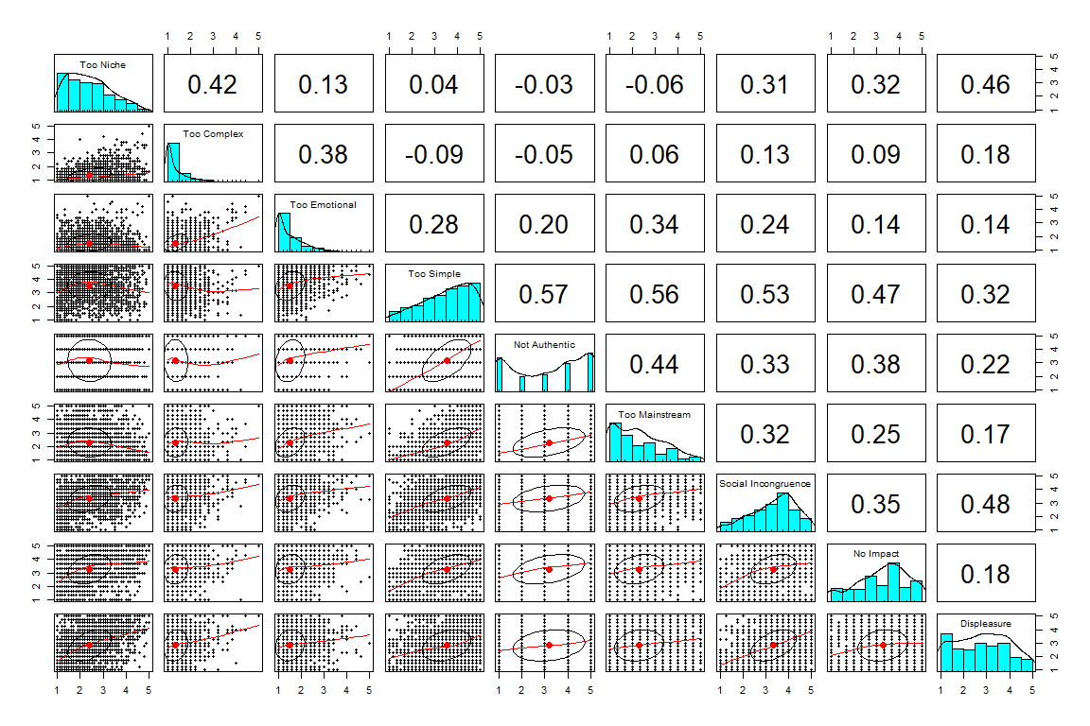

Fig. 1. Panel plot of Dislike subscales

However, the correlation matrices of subscales differ significantly between the four main conditions (Jennrich’s test for correlation matrices: *p < .001* for all condition pairs). The distributions are partly also different, but the general observations from above still hold up (see Supplementary Material).

In order to find the most stable correlations, we used the correlation matrices for the complete data set and the four conditions and selected all pairs of correlations that were highly significant in all four correlation matrices (using Holm adjustment and an significance level of *.002*, because there was one adjusted p-value of *p = .00125*). This left us with 14 correlations, which can be found in Tab. 2

**Table** : Stable correlations across all conditions of the virtual Dislike subscales

| Subscale Pair | Range | Mean |
| --- | --- | --- |
| Too Simple - Too Mainstream | 0.527-0.620 | 0.566 |
| Too Simple - Not Authentic | 0.501-0.591 | 0.559 |
| Too Simple - Social Incongruence | 0.326-0.612 | 0.496 |
| Too Simple - No Impact | 0.292-0.619 | 0.465 |
| Not Authentic - Too Mainstream | 0.416-0.470 | 0.436 |
| Too Niche - Too Complex | 0.409-0.460 | 0.435 |
| Too Niche - Displeasure | 0.308-0.527 | 0.435 |
| Social Incongruence - Displeasure | 0.242-0.530 | 0.422 |
| Not Authentic - No Impact | 0.289-0.457 | 0.382 |
| Too Complex - Too Emotional | 0.311-0.436 | 0.374 |
| Too Emotional - Too Mainstream | 0.298-0.383 | 0.346 |
| Too Mainstream - Social Incongruence | 0.259-0.431 | 0.326 |
| Not Authentic - Social Incongruence | 0.209-0.443 | 0.309 |
| Too Emotional - Too Simple | 0.256-0.315 | 0.284 |

Because of the specific semantic structure, some cautious and preliminary causal statements can be derived from these stable correlations. The reason is that consequences of music cannot cause the structure of music (though it could partly influence the perception or judgment of musical properties). The same holds for the perceived **Social Incongruence** between oneself and the fans of this music (even though people might believe in an implicit homology between musical and social/personal characteristics of its fans). We summarized these ideas in some sort of causal network, that can be found in Fig. 2. Nodes represent the subscales, shape encodes the classification into descriptive and reactive variables. Node color further classified the nodes into interpretations. Arrows indicate causal influence, if the arrows goes both ways between nodes, no causal idenfication is available. Distances between nodes roughly represent mean correlation between variables. There is a cluster of three (or four) subscales, **Too Simple**, **Not Authentic**, **Too Mainstream**, and, possibly, also **Too Emotional**, at the center of the network. We interpret this as a typical “highbrow” reasoning complex of disliking music. The results of this stance is a lessened impact of the music as well as a perceived **Socal Incongruence** to the audience of the disliked music. In our data set, this is a very common attitude towards *Schlager* and *Traditional* music, which are the top disliked styles. On the other side, there is another reasoning complex, consisting of **Too Niche** and **Too Complex**, which can be dubbed “Lowbrow”, Here, only **Too Niche** leads to **Displeasure**, while **Too Complex** is linked to **Too Emotional**. (The latter correlation is somewhat puzzling, but seems to be genuine and not an artefact of the extremely left-skewed distributions of the two variables.)

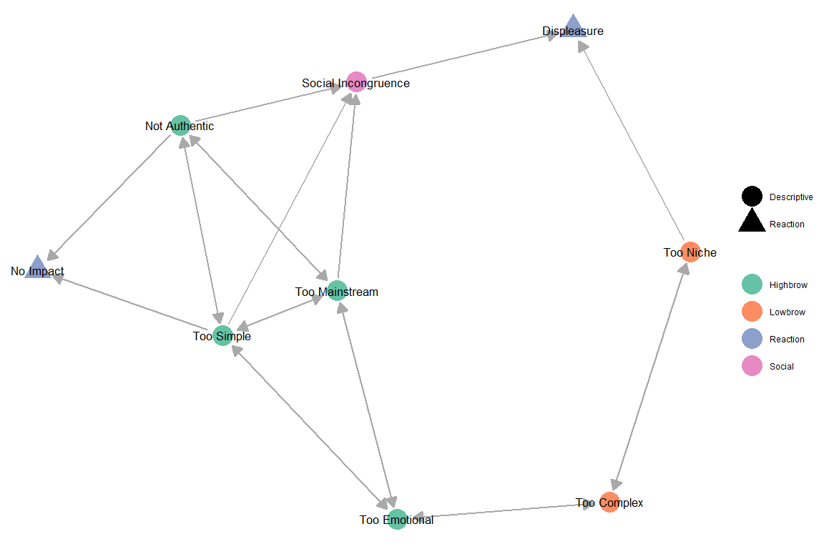

Fig. 2. Network of stable correlations between subscales

It also interesting to have a short look at the correlations that are nearly fully stable, i.e., those which occur in 4 of the 5 correlation matrices. There are five such correlations, neither of which did not appear in the full correlation matrix. The correlation **Too Niche** - **Social Incongruence** (mean *r = .35*), **Too Niche** - **No Impact** (mean *r = .346*), **Too Mainstream** - **No Impact** (mean *r = .294*) did not show up in the Style/Strong condition. The correlation **Too Emotional** - **Social Incongruence** (mean *r = .268*) was not present in the Artist/String conditions, whereas **Social Incongruence** - **No Impact** (mean *r = .375*) did not make it into the Artist/Slight condition (*KF: Interpretation anyone?*).

## Latent Profile Analysis

**Table** : Latent Profile Classes by type and degree

| Type | Degree | Cases | No. Lowbrow | No. Highbrow | Lowbrow (%) | Highbrow (%) |
| --- | --- | --- | --- | --- | --- | --- |
| artist | slight | 348 | 130 | 218 | 37.4 | 62.6 |
| artist | strong | 489 | 150 | 339 | 30.7 | 69.3 |
| style | slight | 591 | 260 | 331 | 44.0 | 56.0 |
| style | strong | 582 | 215 | 367 | 36.9 | 63.1 |

The observation of two principal strategies, dubbed “Highbrow” and “Lowbrow”, which is pretty much in line with results from previous research on musical taste, led as to look for latent profiles in the rating behaviours. To this end, we used the R package tidyLPA to extract two latent profiles for each of the four conditions (Artist/Style, Strong/Slight). Two profiles are not the optimal solution according to standard model estimators (AIC, BIC), but it is the most simple solution which produced the most balanced group sizes and also has the easiest interpretation in accordance with the stable correlations. Overview statistics of **Highbrow** and **Lowbrow** profiles can be found in Tab. 2. Mean values of the Dislike subscales can be seen in Fig. 3.

**Table** : Overall Latent Profile Classes of participants

| Overall LPA class | N | Percentage (%) |
| --- | --- | --- |
| Lowbrow | 87 | 13.9 |
| Mainly Lowbrow | 89 | 14.2 |
| Mixed | 96 | 15.3 |
| Mainly Highbrow | 142 | 22.6 |
| Highbrow | 213 | 34.0 |

The **Highbrow** profile is generally more frequent, they account for about 60-70% in the four conditions. Interestingly, not all participant belong to the same LPA class across the four conditions. We defined a total LPA class by investigating the profile statistics of each participant, defining five classes “lowbrow”, “mainly lowbrow”, “mixed”, “mainly highbrow”, and “highbrow”. The extreme classes are assigned if a participant uses the same profile in all conditions, the mainly highbrow/lowbrow classes are used when the majority but all not profiles are present, and the mixed class is applied to participant with an equal split of **Lowbrow** and **Highbrow** profiles. The distribution can be seen in Tab. 3. Highbrow and Mainly Highbrow profiles are prevalent, only 14% of all participants did not show at least one Highbrow profile. This might be due to our overall well-educated sample.

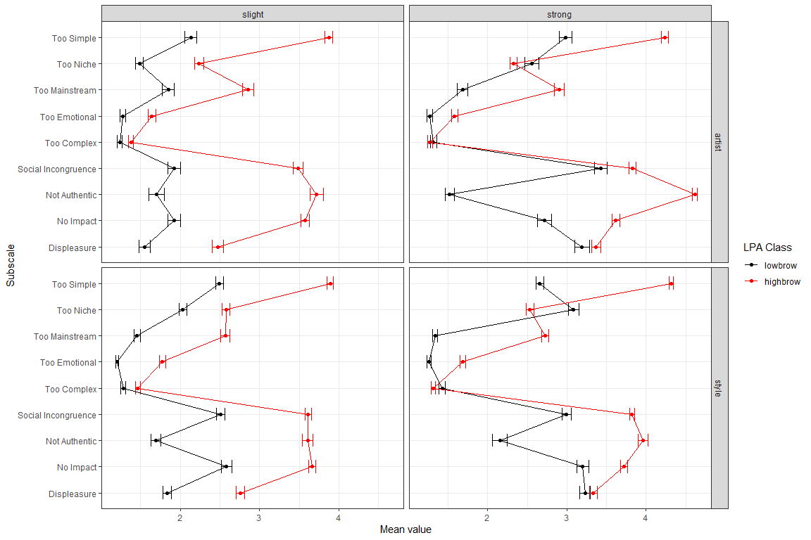

Fig. 3. Latent Profile Class means by conditions. Errorbars represent standard errors.

## Differences in style selections

Next, we analysed the distribution of styles and their assessment. In the two Style conditions, participants had to explicitly select disliked styles from the list with 15 suggestions. In the two Artist conditions, participants were also asked to provide a style descriptor for the chosen artist, even though sometimes there were not able to do so (42 out of 837). The distribution of styles is rather inbalanced, see Tab. 4. The top disliked styles were *Schlager*, *Traditional* and *HipHop*. *Schlager* occurs about twice as often as the next styles, either *HipHop* or *Tradtional*, which highlights the special role *Schlager* plays in the German music culture.

There are clear differences between the Artist and Style conditions. In the Artist condition, there were much more mentions of *HipHop*, *Pop*, and *Rock* artists than in the Style conditions, whereas the opposite was true for *Traditional*, *Metal*, *Techno*, and *Country*. This can be explained by the fact, that *Pop*, *HipHop*, and *Rock* are very broad and prominent styles that seldom generally disliked in its entirety, whereas single artists from these styles can easily draw very negative judgments. It also more likely that people actually know artists from these style due to their higher popularity, whereas for more generally disliked styles such as *Metal*, *Techno*, and *Traditional* people are less likely to know names of specific artists, because these are (1) disliked styles, and (2) they are not (anymore) strongly present in public media, or operate generally without a prominent star system such as *Techno*.

**Table** : Style counts and percentages by main condition (Style and Artist)

| Style | Count (Artist) | Count (Style) | Perc. (Artist, %) | Perc. (Style, %) | Count |
| --- | --- | --- | --- | --- | --- |
| Schlager | 233 | 270 | 27.8 | 23.0 | 503 |
| Traditional | 63 | 197 | 7.5 | 16.8 | 260 |
| HipHop | 115 | 116 | 13.7 | 9.9 | 231 |
| Pop | 186 | 41 | 22.2 | 3.5 | 227 |
| Metal | 46 | 151 | 5.5 | 12.9 | 197 |
| Techno | 17 | 145 | 2.0 | 12.4 | 162 |
| Rock | 82 | 14 | 9.8 | 1.2 | 96 |
| EDM | 25 | 59 | 3.0 | 5.0 | 84 |
| Jazz | 2 | 48 | 0.2 | 4.1 | 50 |
| Country | 5 | 43 | 0.6 | 3.7 | 48 |
| Reggae | 8 | 37 | 1.0 | 3.2 | 45 |
| NA | 42 | 0 | 5.0 | 0.0 | 42 |
| Classical | 10 | 14 | 1.2 | 1.2 | 24 |
| House | 1 | 22 | 0.1 | 1.9 | 23 |
| Blues | 0 | 10 | 0.0 | 0.9 | 10 |
| World | 2 | 6 | 0.2 | 0.5 | 8 |

Style diversity was rather high, 48.8% selected all different styles in all conditions (or only took part in one condition), whereas nobody mentioned only one style.

To check whether the style distibributions were different in the different conditions and degrees of dislike, we used a bootstrap Chi-squared test (with 100 samples) to alleviate the repeated measurement problem. This became highly significant (all *p < .001*, mean *Cramers V = .365*) with a strong effect. The same held true for comparing Style vs. Artist conditions (all *p < .001*, mean *Cramer’s V = .502*) and also for Strong vs. Slight degrees (all *p < .001*, mean *Cramer’s V = .282*).

The main differences in the Strong/Slight subconditions is that *Pop*, *Country*, and *Reggae* artists were chosen more frequently in the Slight conditions, whereas *Metal*, *Schlager*, and *Traditional* occurred more often in the Strong conditions.

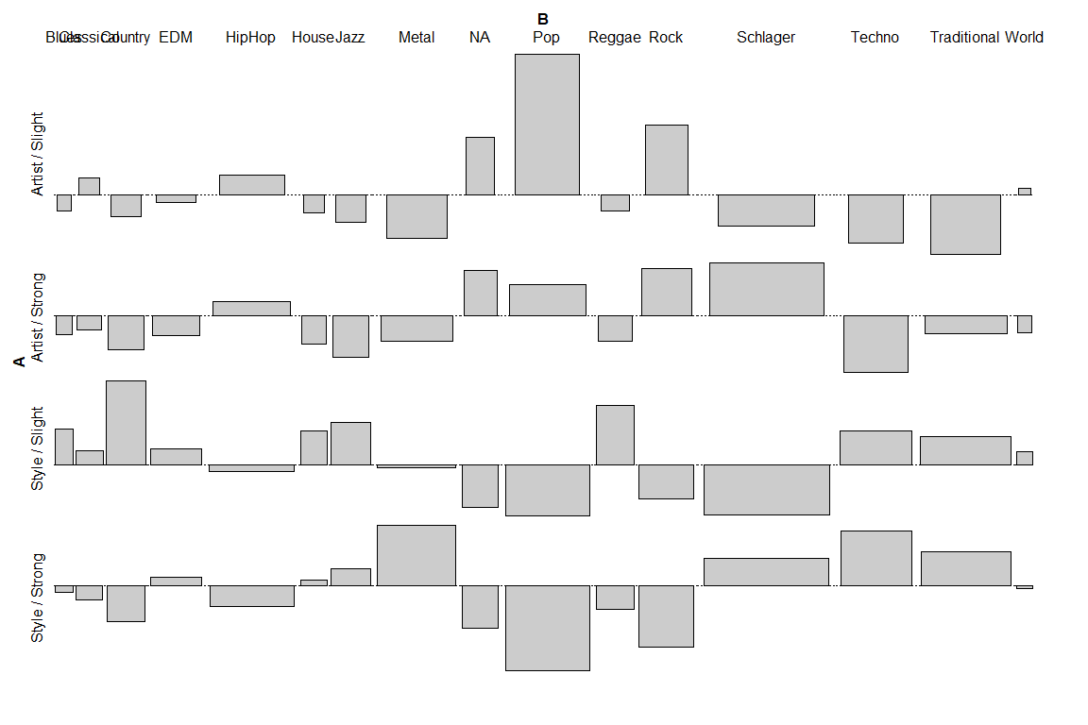

Fig. 4. Chi-Square Residuals of Styles by the four conditions.

We further checked for differences in style distributions with respect to the demographic variables **Age Group** and **Gender** (dropping the “diverse” gender group) as well as for assigned **LPA Class**. Results of the Chi-Squared tests can be found in Tab. 6. There are strong differences for **Age Group** and **LPA Class** in all four conditions, but only one for **Gender** (in the Style/Strong condition). Chi-Squared residual plots of styles for the Style/Strong conditions according to the demographic variables can be found in Fig. 5a, b and c, from which some noteworthy observations can be made.

**Table** : Chi-Square tests of differences in style distribution for condition by age group, gender (with diverse), and LPA class. All p-values Bonferroni adjusted.

| Type | Degree | Group | Statistic | Df | Cramers V | P Value Adj |
| --- | --- | --- | --- | --- | --- | --- |
| artist | slight | age_group | 37.2 | 14 | 0.33 | 0.001** |
| artist | strong | age_group | 45.2 | 11 | 0.30 | 0.000*** |
| style | slight | age_group | 25.6 | 14 | 0.21 | 0.029* |
| style | strong | age_group | 48.8 | 14 | 0.29 | 0.000*** |
| artist | slight | gender | 17.4 | 14 | 0.22 | 0.471 |
| artist | strong | gender | 16.3 | 11 | 0.18 | 0.387 |
| style | slight | gender | 6.8 | 14 | 0.11 | 0.942 |
| style | strong | gender | 36.6 | 14 | 0.25 | 0.003** |
| artist | slight | lpa_class | 51.5 | 14 | 0.38 | 0.000*** |
| artist | strong | lpa_class | 99.1 | 11 | 0.45 | 0.000*** |
| style | slight | lpa_class | 77.7 | 14 | 0.36 | 0.000*** |
| style | strong | lpa_class | 199.8 | 14 | 0.59 | 0.000*** |

With respect to **Age Group**, the younger (less than 30 years) group clearly more dislikes *Schlager*, *Metal*, and *Pop*, whereas the elder group more dislikes *Traditional*, *Jazz*, *Country*, and *Techno*. On the other hand, the elder age group are more open to *Schlager*, *Metal*, and *Pop*, whereas the younger group has fewer reservations against *Traditional*, *Techno*, and *Jazz*.

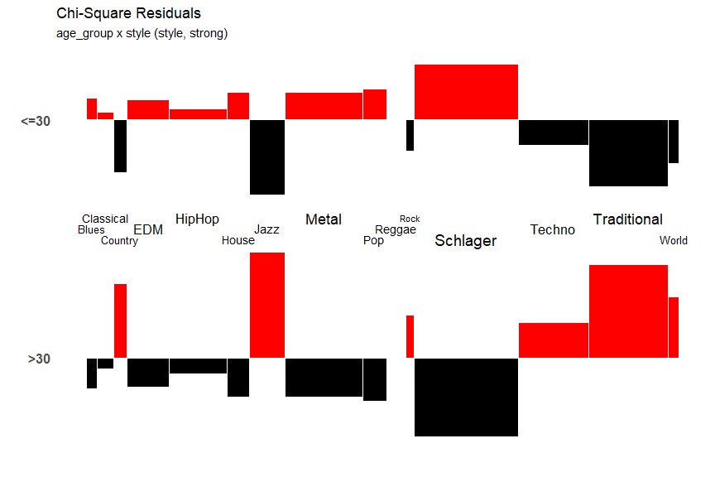

Fig. 5a. Chi-Squared Residuals for styles in Style/Strong conditions for Age Group

There are some stereotypes to be corroborated in the style preferences of males and females. Males dislike more strongly and often *Schlager*, *Pop*, *HipHop*, and *EDM*, but are more fond of *Jazz*, *Metal*, *Techno*, and also *House*. The female respondents show the clear opposite: more dislikes for styles traditionally often regarded as “virile”, such as *Jazz* and *Metal* as well as *Techno*, and fewer reservations against *Schlager*, *EDM*, *HipHop*, and *Pop*.

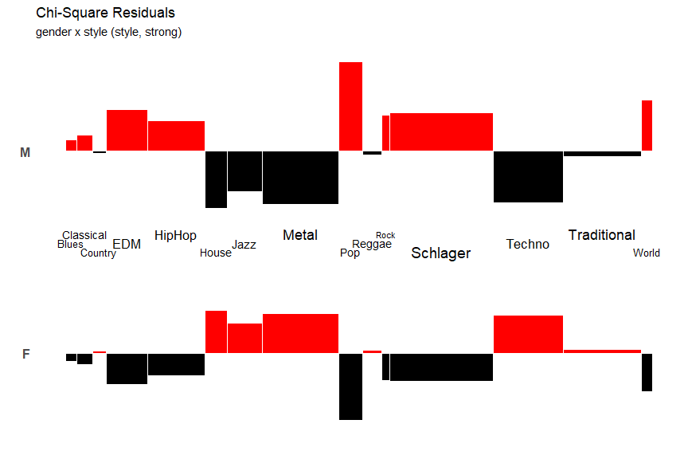

Fig. 5b. Chi-Squared Residuals for styles in Style/Strong conditions for Gender

Finally, the differences for **LPA Class** justify their denomination as *Highbrow* and *Lowbrow* reasoning styles. **Highbrows** have more dislikes for *Schlager*, *Traditional*, *EDM*, and *Pop*, whereas *Lowbrow* profiles more strongly dislike *Jazz*, *Metal*, and *Techno*.

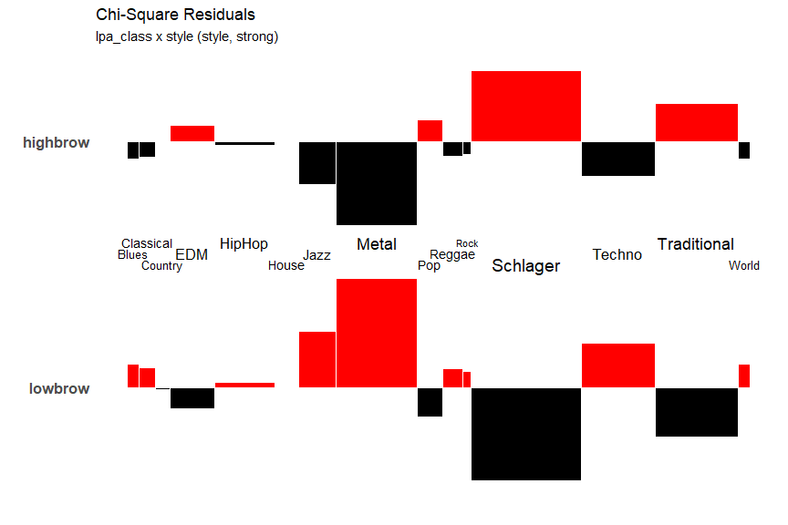

Fig. 5c. Chi-Squared Residuals for styles in Style/Strong conditions for LPA classes

## Rating differences between styles by condition

Besides the clearly different distributions of styles in all conditions and demographics, we were also interested in difference in ratings in the Slight and Strong subconditions. As the distribution of styles was rather different in the Style vs. Artist main conditions (cf. Tab. 4), we treated both cases separately and stratified also for styles. Furthermore, as the style distribution are very skewed and the Dislike subscales clearly differ from normality, we used an permutation test (independence_test from the coin package for R) as an omnibus test and then resorted to a battery of Kruskal-Wallis tests to check for differences in the Strong and Slight subconditions on all subscales while using Holm adjustment of p-values to account for multiple testing. The results can be found in Tab. 7, where only significant differences at the 5% level are shown (in the Artist condition the cases with no assigned style are omitted, for a complete table please refer to the Supplementary Material). Both omnibus tests resulted in highly significant differences (*p < .001*). A graphical display of mean values and 95% confidence intervals can be seen in Fig. 6 and 7.

**Table** : Significant differences in style ratings on the Dislike subscales. Last column, p-values are Holm adjusted.

| Condition | Style | Dislike Subscale | d (Strong - Slight) | Statistic | N (slight) | N (strong) | p (adj) |
| --- | --- | --- | --- | --- | --- | --- | --- |
| Artist | HipHop | Displeasure | 1.207 | 706.0 | 50 | 65 | 0.000*** |
| Artist | Pop | Displeasure | 1.168 | 1,797.0 | 112 | 74 | 0.000*** |
| Artist | Rock | Displeasure | 1.923 | 161.5 | 40 | 42 | 0.000*** |
| Artist | Schlager | Displeasure | 0.813 | 3,274.5 | 63 | 170 | 0.001*** |
| Artist | Pop | Not Authentic | 0.705 | 2,838.5 | 112 | 74 | 0.015* |
| Artist | Schlager | Not Authentic | 0.622 | 3,798.5 | 63 | 170 | 0.020* |
| Artist | Pop | Social Incongruence | 0.639 | 2,667.5 | 112 | 74 | 0.004** |
| Artist | Rock | Social Incongruence | 1.588 | 242.0 | 40 | 42 | 0.000*** |
| Artist | Pop | Too Niche | 0.335 | 2,702.5 | 112 | 74 | 0.006** |
| Artist | Schlager | Too Simple | 0.360 | 3,589.0 | 63 | 170 | 0.010* |
| Style | HipHop | Displeasure | 0.832 | 852.5 | 63 | 53 | 0.001*** |
| Style | Metal | Displeasure | 0.673 | 1,685.0 | 56 | 95 | 0.021* |
| Style | Schlager | Displeasure | 0.988 | 3,774.0 | 97 | 173 | 0.000*** |
| Style | Techno | Displeasure | 0.774 | 1,558.5 | 67 | 78 | 0.004** |
| Style | Traditional | Displeasure | 0.766 | 2,933.0 | 97 | 100 | 0.000*** |
| Style | Schlager | Social Incongruence | 0.432 | 5,508.5 | 97 | 173 | 0.000*** |
| Style | Schlager | Too Simple | 0.461 | 5,311.0 | 97 | 173 | 0.000*** |

The main differences are, expectedly, to be found on the subscale **Displeasure**, where values in the Strong subcondition are higher than in the Slight subcondition, with overall larger differences in the Artist main condition. Other differences pertain to **Social Incongruence** (Artist: *Pop* and *Rock*, Style: *Schlager*) and **Not Authentic** (Artist: *Pop* and *Schlager*). All in all, the main differences between the two main and two subconditions lie mostly in the selection of styles as well as in the higher **Displeasure** ratings in the Strong vs. the Slight conditions.

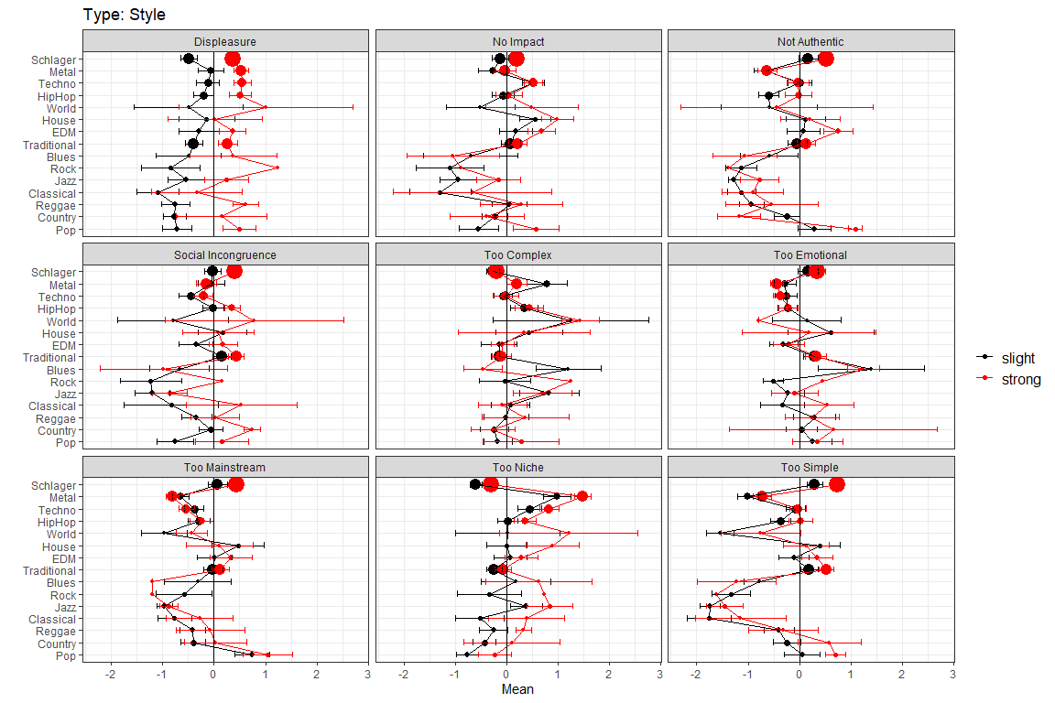

Fig. 6. Mean value of style ratings in the Style main conditions for the Strong/Slight subconditions. Error bars are 95% CI, dot size is proportional to total count of style.

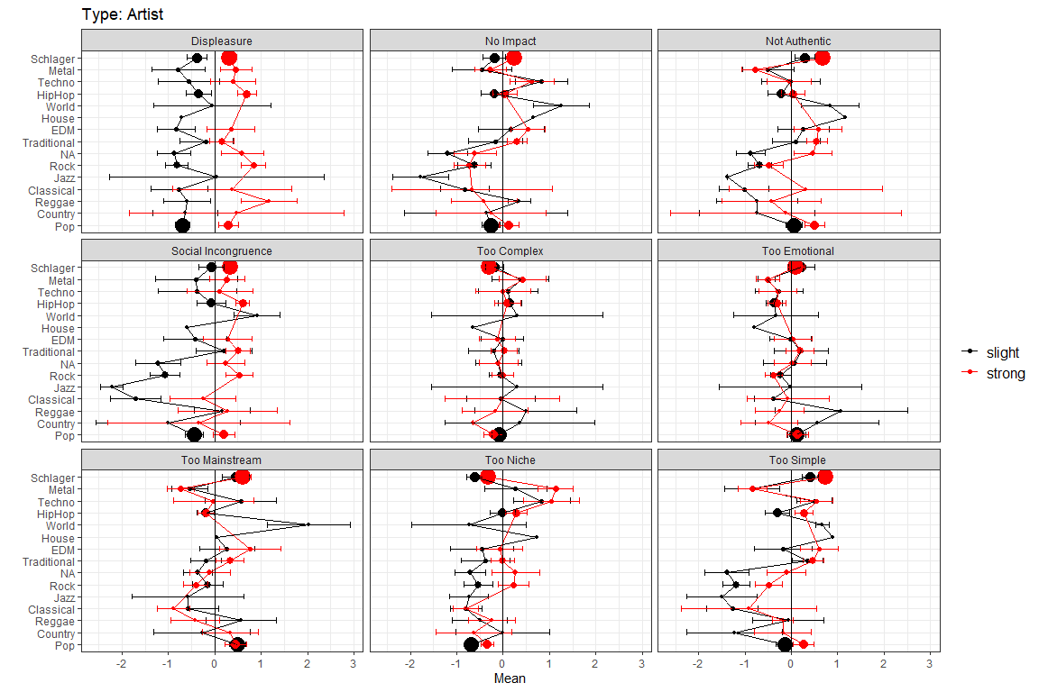

Fig. 7. Mean value of style ratings in the Artist main conditions for the Strong/Slight subconditions. Error bars are 95% CI, dot size is proportional to total count of style.