Dislikes: Panels

Klaus Frieler

12.01.2022

## Participants

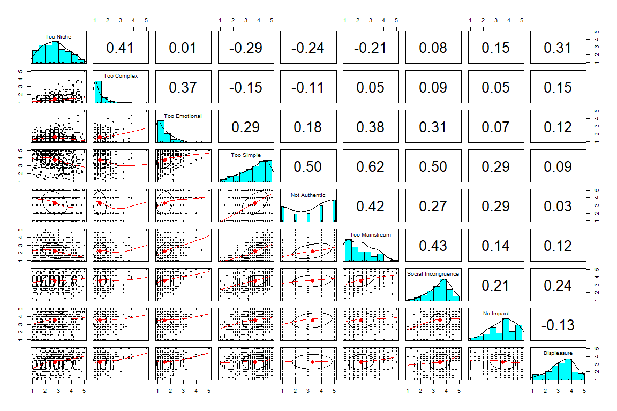

Fig. 1. Panel plot of Dislike subscales (style/strong)

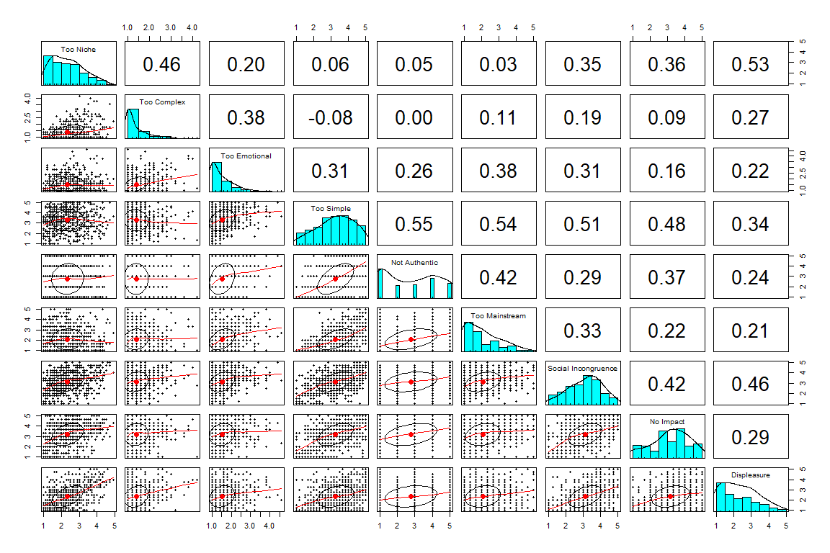

Fig. 2. Panel plot of Dislike subscales (style/slight)

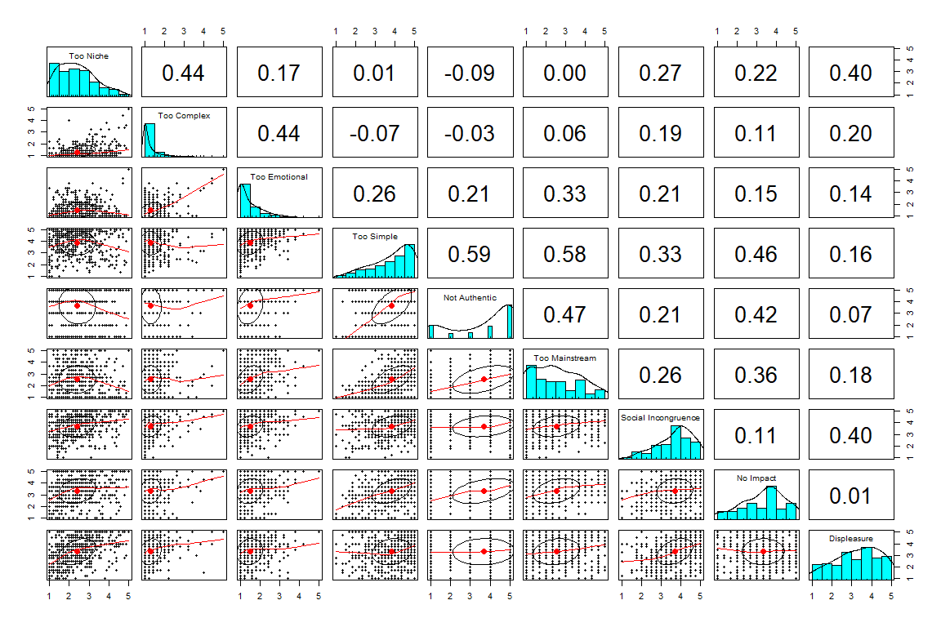

Fig. 3. Panel plot of Dislike subscales (artist/strong)

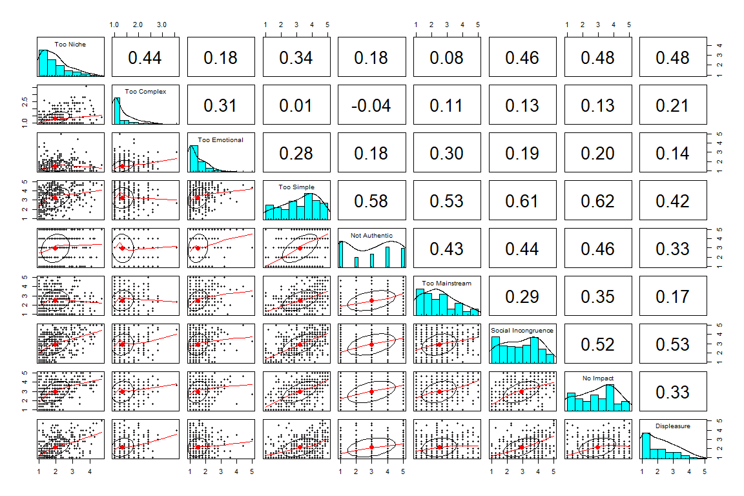

Fig. 4. Panel plot of Dislike subscales (artist/slight)

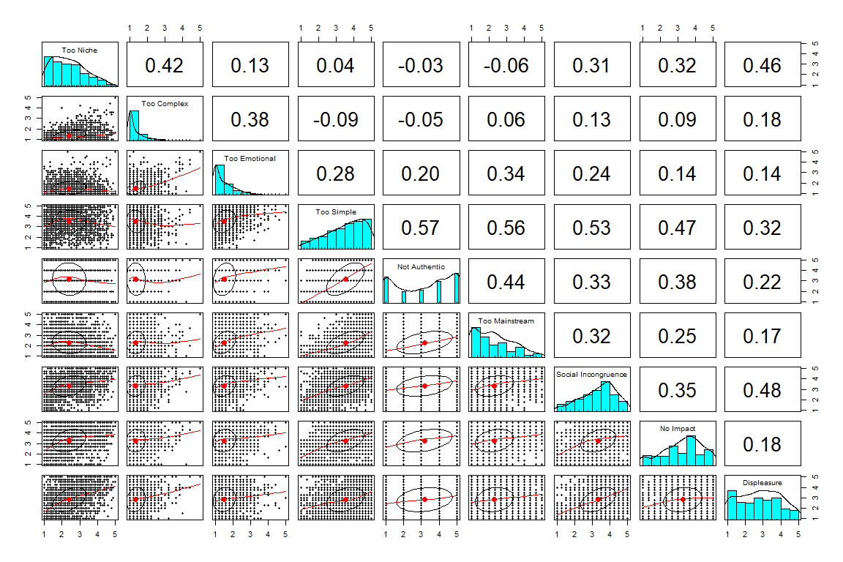

Fig. 5. Panel plot of Dislike subscales (style/strong)