Dislikes: Supplementary Material

Klaus Frieler, Julia Merrill

18.01.2022

## Panel Plots for Dislike Subscales

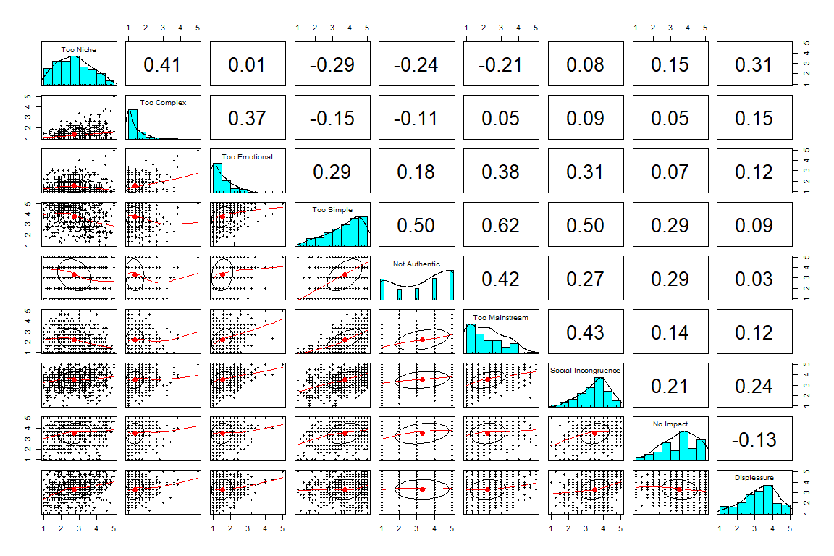

Fig. SP1. Panel plot of Dislike subscales (style/strong)

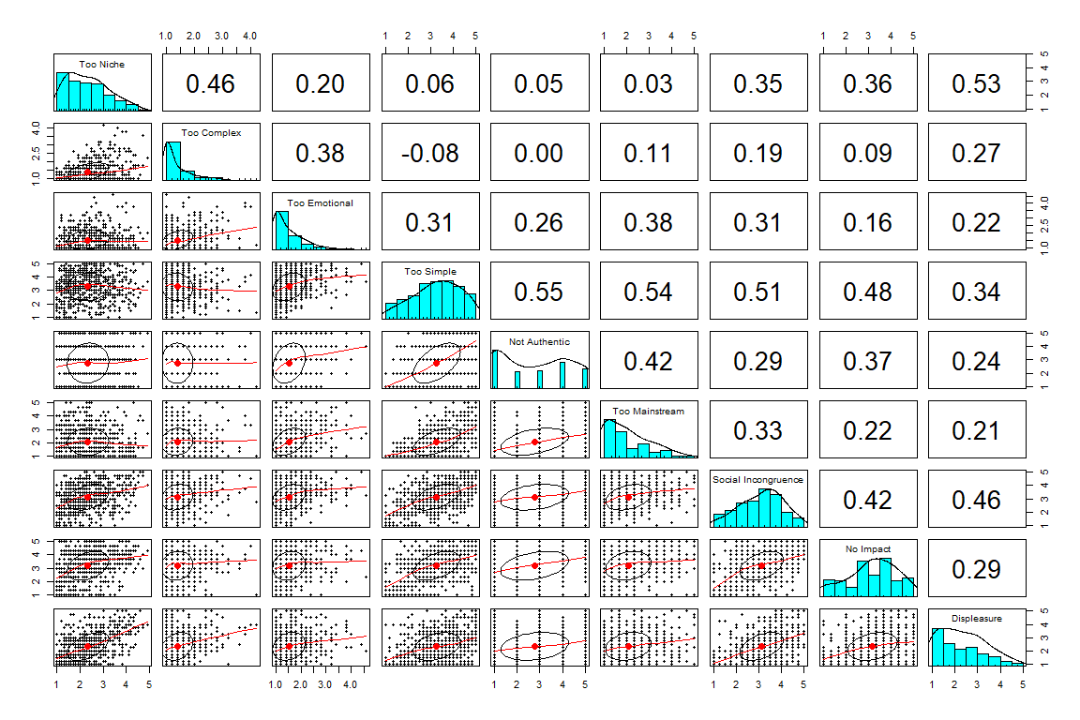

Fig. SP2. Panel plot of Dislike subscales (style/slight)

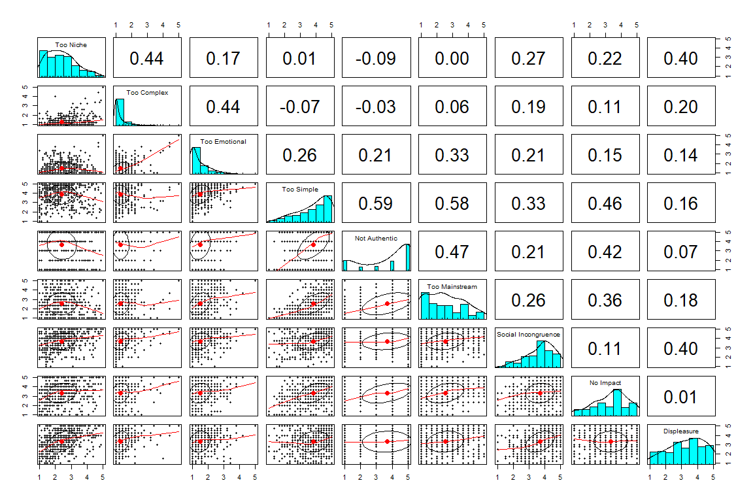

Fig. SP3. Panel plot of Dislike subscales (artist/strong)

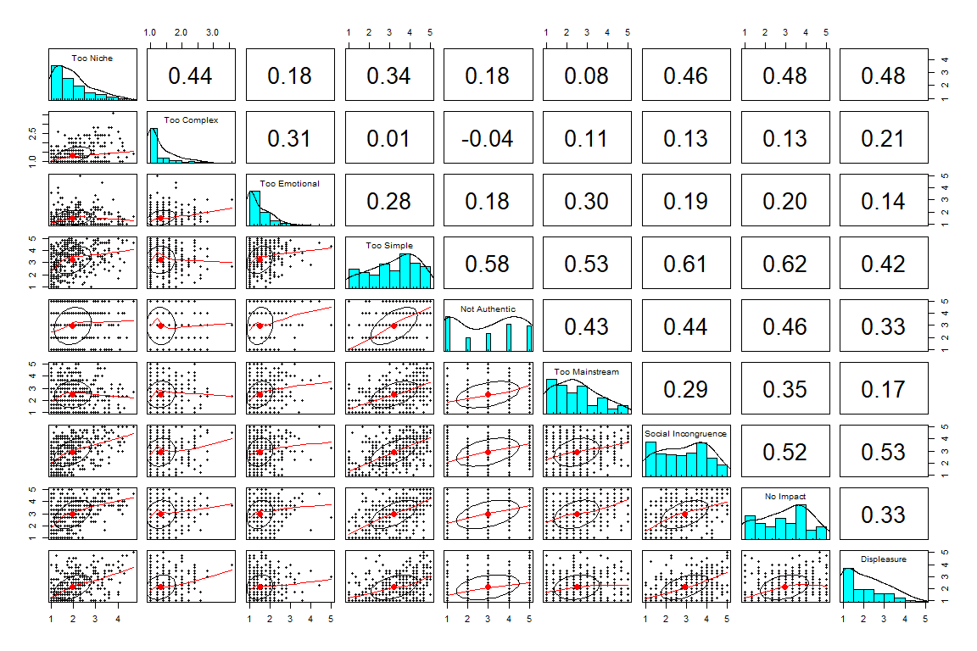

Fig. SP4. Panel plot of Dislike subscales (artist/slight)

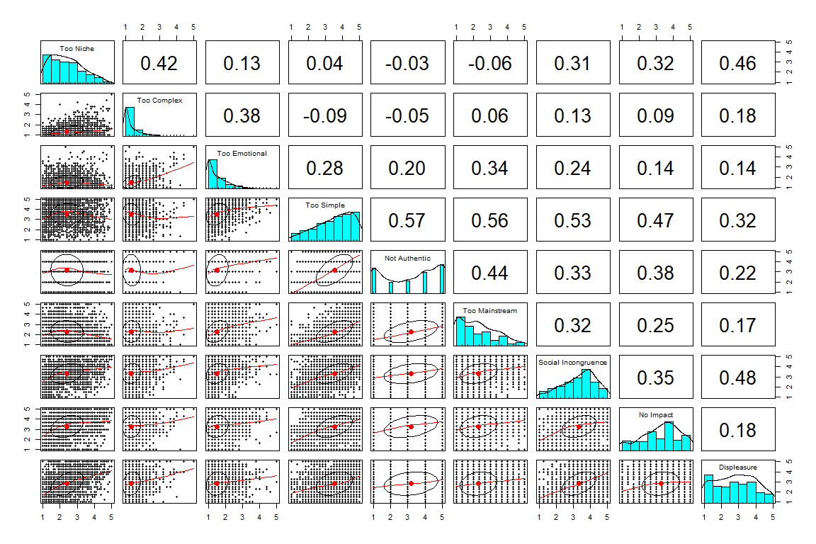

Fig. SP5. Panel plot of Dislike subscales (style/strong)

## Original eight factors solution

## All Kruskal-Wallis values for differences between styles on Dislike subscales in all four conditions

**Table** : Significant differences in style ratings on the Dislike subscales. Last column, p-values are Holm adjusted.

| Condition | Style | Dislike Subscale | d (Strong - Slight) | Statistic | N (slight) | N (strong) | p (adjusted) |
| --- | --- | --- | --- | --- | --- | --- | --- |
| Artist | Classical | Displeasure | 1.321 | 5.0 | 7 | 3 | 1.000 |
| Artist | Country | Displeasure | 1.292 | 2.0 | 3 | 2 | 1.000 |
| Artist | EDM | Displeasure | 1.377 | 27.0 | 12 | 13 | 0.508 |
| Artist | HipHop | Displeasure | 1.207 | 706.0 | 50 | 65 | 0.000*** |
| Artist | Metal | Displeasure | 1.452 | 82.5 | 13 | 33 | 0.113 |
| Artist | Pop | Displeasure | 1.168 | 1,797.0 | 112 | 74 | 0.000*** |
| Artist | Reggae | Displeasure | 2.062 | 0.0 | 4 | 4 | 1.000 |
| Artist | Rock | Displeasure | 1.923 | 161.5 | 40 | 42 | 0.000*** |
| Artist | Schlager | Displeasure | 0.813 | 3,274.5 | 63 | 170 | 0.001*** |
| Artist | Techno | Displeasure | 1.096 | 14.0 | 7 | 10 | 1.000 |
| Artist | Traditional | Displeasure | 0.396 | 247.5 | 12 | 51 | 1.000 |
| Artist | Classical | No Impact | 0.175 | 10.5 | 7 | 3 | 1.000 |
| Artist | Country | No Impact | 0.111 | 3.0 | 3 | 2 | 1.000 |
| Artist | EDM | No Impact | 0.400 | 73.5 | 12 | 13 | 1.000 |
| Artist | HipHop | No Impact | 0.236 | 1,428.0 | 50 | 65 | 1.000 |
| Artist | Metal | No Impact | 0.185 | 198.5 | 13 | 33 | 1.000 |
| Artist | Pop | No Impact | 0.420 | 3,259.5 | 112 | 74 | 1.000 |
| Artist | Reggae | No Impact | -0.833 | 13.5 | 4 | 4 | 1.000 |
| Artist | Rock | No Impact | -0.116 | 878.5 | 40 | 42 | 1.000 |
| Artist | Schlager | No Impact | 0.479 | 4,020.0 | 63 | 170 | 0.292 |
| Artist | Techno | No Impact | -0.224 | 39.5 | 7 | 10 | 1.000 |
| Artist | Traditional | No Impact | 0.510 | 228.0 | 12 | 51 | 1.000 |
| Artist | Classical | Not Authentic | 2.095 | 4.5 | 7 | 3 | 1.000 |
| Artist | Country | Not Authentic | 1.000 | 2.0 | 3 | 2 | 1.000 |
| Artist | EDM | Not Authentic | 0.494 | 62.0 | 12 | 13 | 1.000 |
| Artist | HipHop | Not Authentic | 0.411 | 1,386.5 | 50 | 65 | 1.000 |
| Artist | Metal | Not Authentic | -0.445 | 235.0 | 13 | 33 | 1.000 |
| Artist | Pop | Not Authentic | 0.705 | 2,838.5 | 112 | 74 | 0.015* |
| Artist | Reggae | Not Authentic | 0.500 | 7.0 | 4 | 4 | 1.000 |
| Artist | Rock | Not Authentic | 0.305 | 798.0 | 40 | 42 | 1.000 |
| Artist | Schlager | Not Authentic | 0.622 | 3,798.5 | 63 | 170 | 0.020* |
| Artist | Techno | Not Authentic | -0.043 | 36.0 | 7 | 10 | 1.000 |
| Artist | Traditional | Not Authentic | 0.706 | 211.5 | 12 | 51 | 1.000 |
| Artist | Classical | Social Incongruence | 1.440 | 1.5 | 7 | 3 | 1.000 |
| Artist | Country | Social Incongruence | 0.667 | 2.0 | 3 | 2 | 1.000 |
| Artist | EDM | Social Incongruence | 0.699 | 49.0 | 12 | 13 | 1.000 |
| Artist | HipHop | Social Incongruence | 0.682 | 1,047.0 | 50 | 65 | 0.094 |
| Artist | Metal | Social Incongruence | 0.664 | 162.5 | 13 | 33 | 1.000 |
| Artist | Pop | Social Incongruence | 0.639 | 2,667.5 | 112 | 74 | 0.004** |
| Artist | Reggae | Social Incongruence | 0.125 | 6.0 | 4 | 4 | 1.000 |
| Artist | Rock | Social Incongruence | 1.588 | 242.0 | 40 | 42 | 0.000*** |
| Artist | Schlager | Social Incongruence | 0.415 | 4,278.0 | 63 | 170 | 1.000 |
| Artist | Techno | Social Incongruence | 0.486 | 27.0 | 7 | 10 | 1.000 |
| Artist | Traditional | Social Incongruence | 0.301 | 256.5 | 12 | 51 | 1.000 |
| Artist | Classical | Too Complex | 0.019 | 11.0 | 7 | 3 | 1.000 |
| Artist | Country | Too Complex | -0.533 | 5.0 | 3 | 2 | 1.000 |
| Artist | EDM | Too Complex | -0.056 | 85.0 | 12 | 13 | 1.000 |
| Artist | HipHop | Too Complex | -0.026 | 1,755.5 | 50 | 65 | 1.000 |
| Artist | Metal | Too Complex | 0.025 | 223.5 | 13 | 33 | 1.000 |
| Artist | Pop | Too Complex | -0.063 | 4,640.5 | 112 | 74 | 1.000 |
| Artist | Reggae | Too Complex | -0.350 | 11.0 | 4 | 4 | 1.000 |
| Artist | Rock | Too Complex | 0.013 | 799.0 | 40 | 42 | 1.000 |
| Artist | Schlager | Too Complex | -0.061 | 5,950.0 | 63 | 170 | 1.000 |
| Artist | Techno | Too Complex | -0.060 | 37.5 | 7 | 10 | 1.000 |
| Artist | Traditional | Too Complex | 0.120 | 269.0 | 12 | 51 | 1.000 |
| Artist | Classical | Too Emotional | 0.210 | 7.5 | 7 | 3 | 1.000 |
| Artist | Country | Too Emotional | -0.667 | 4.5 | 3 | 2 | 1.000 |
| Artist | EDM | Too Emotional | 0.038 | 72.5 | 12 | 13 | 1.000 |
| Artist | HipHop | Too Emotional | 0.039 | 1,589.5 | 50 | 65 | 1.000 |
| Artist | Metal | Too Emotional | 0.019 | 250.5 | 13 | 33 | 1.000 |
| Artist | Pop | Too Emotional | 0.013 | 4,133.0 | 112 | 74 | 1.000 |
| Artist | Reggae | Too Emotional | -0.850 | 12.5 | 4 | 4 | 1.000 |
| Artist | Rock | Too Emotional | -0.098 | 914.5 | 40 | 42 | 1.000 |
| Artist | Schlager | Too Emotional | -0.075 | 5,933.5 | 63 | 170 | 1.000 |
| Artist | Techno | Too Emotional | -0.023 | 35.0 | 7 | 10 | 1.000 |
| Artist | Traditional | Too Emotional | -0.019 | 317.5 | 12 | 51 | 1.000 |
| Artist | Classical | Too Mainstream | -0.333 | 10.5 | 7 | 3 | 1.000 |
| Artist | Country | Too Mainstream | 0.667 | 1.5 | 3 | 2 | 1.000 |
| Artist | EDM | Too Mainstream | 0.545 | 60.0 | 12 | 13 | 1.000 |
| Artist | HipHop | Too Mainstream | 0.017 | 1,631.0 | 50 | 65 | 1.000 |
| Artist | Metal | Too Mainstream | -0.223 | 266.0 | 13 | 33 | 1.000 |
| Artist | Pop | Too Mainstream | -0.048 | 4,220.0 | 112 | 74 | 1.000 |
| Artist | Reggae | Too Mainstream | -1.083 | 14.5 | 4 | 4 | 1.000 |
| Artist | Rock | Too Mainstream | -0.276 | 940.0 | 40 | 42 | 1.000 |
| Artist | Schlager | Too Mainstream | 0.173 | 4,938.0 | 63 | 170 | 1.000 |
| Artist | Techno | Too Mainstream | -0.638 | 45.0 | 7 | 10 | 1.000 |
| Artist | Traditional | Too Mainstream | 0.570 | 221.0 | 12 | 51 | 1.000 |
| Artist | Classical | Too Niche | -0.010 | 8.5 | 7 | 3 | 1.000 |
| Artist | Country | Too Niche | -0.600 | 5.0 | 3 | 2 | 1.000 |
| Artist | EDM | Too Niche | 0.364 | 48.5 | 12 | 13 | 1.000 |
| Artist | HipHop | Too Niche | 0.283 | 1,315.0 | 50 | 65 | 1.000 |
| Artist | Metal | Too Niche | 0.820 | 117.5 | 13 | 33 | 1.000 |
| Artist | Pop | Too Niche | 0.335 | 2,702.5 | 112 | 74 | 0.006** |
| Artist | Reggae | Too Niche | 0.250 | 5.5 | 4 | 4 | 1.000 |
| Artist | Rock | Too Niche | 0.729 | 490.5 | 40 | 42 | 0.109 |
| Artist | Schlager | Too Niche | 0.282 | 4,171.0 | 63 | 170 | 0.808 |
| Artist | Techno | Too Niche | 0.200 | 29.0 | 7 | 10 | 1.000 |
| Artist | Traditional | Too Niche | 0.352 | 236.5 | 12 | 51 | 1.000 |
| Artist | Classical | Too Simple | 0.389 | 8.5 | 7 | 3 | 1.000 |
| Artist | Country | Too Simple | 1.111 | 1.0 | 3 | 2 | 1.000 |
| Artist | EDM | Too Simple | 0.846 | 45.0 | 12 | 13 | 1.000 |
| Artist | HipHop | Too Simple | 0.610 | 1,063.0 | 50 | 65 | 0.137 |
| Artist | Metal | Too Simple | 0.008 | 216.0 | 13 | 33 | 1.000 |
| Artist | Pop | Too Simple | 0.439 | 3,077.5 | 112 | 74 | 0.267 |
| Artist | Reggae | Too Simple | -0.125 | 10.5 | 4 | 4 | 1.000 |
| Artist | Rock | Too Simple | 0.754 | 541.5 | 40 | 42 | 0.490 |
| Artist | Schlager | Too Simple | 0.360 | 3,589.0 | 63 | 170 | 0.010* |
| Artist | Techno | Too Simple | 0.045 | 37.0 | 7 | 10 | 1.000 |
| Artist | Traditional | Too Simple | 0.136 | 246.5 | 12 | 51 | 1.000 |
| Style | Blues | Displeasure | 1.000 | 3.5 | 8 | 2 | 1.000 |
| Style | Classical | Displeasure | 0.888 | 9.5 | 10 | 4 | 1.000 |
| Style | Country | Displeasure | 1.069 | 20.0 | 40 | 3 | 1.000 |
| Style | EDM | Displeasure | 0.757 | 257.5 | 31 | 28 | 0.866 |
| Style | HipHop | Displeasure | 0.832 | 852.5 | 63 | 53 | 0.001*** |
| Style | House | Displeasure | 0.183 | 52.0 | 14 | 8 | 1.000 |
| Style | Jazz | Displeasure | 0.916 | 163.5 | 28 | 20 | 1.000 |
| Style | Metal | Displeasure | 0.673 | 1,685.0 | 56 | 95 | 0.021* |
| Style | Pop | Displeasure | 1.397 | 32.5 | 32 | 9 | 0.053 |
| Style | Reggae | Displeasure | 1.582 | 12.0 | 31 | 6 | 0.102 |
| Style | Rock | Displeasure | 2.404 | 0.0 | 13 | 1 | 1.000 |
| Style | Schlager | Displeasure | 0.988 | 3,774.0 | 97 | 173 | 0.000*** |
| Style | Techno | Displeasure | 0.774 | 1,558.5 | 67 | 78 | 0.004** |
| Style | Traditional | Displeasure | 0.766 | 2,933.0 | 97 | 100 | 0.000*** |
| Style | World | Displeasure | 1.750 | 1.0 | 4 | 2 | 1.000 |
| Style | Blues | No Impact | -0.375 | 8.5 | 8 | 2 | 1.000 |
| Style | Classical | No Impact | 0.683 | 16.0 | 10 | 4 | 1.000 |
| Style | Country | No Impact | -0.169 | 67.0 | 40 | 3 | 1.000 |
| Style | EDM | No Impact | 0.530 | 286.5 | 31 | 28 | 1.000 |
| Style | HipHop | No Impact | 0.119 | 1,563.0 | 63 | 53 | 1.000 |
| Style | House | No Impact | 0.470 | 31.0 | 14 | 8 | 1.000 |
| Style | Jazz | No Impact | 0.860 | 158.5 | 28 | 20 | 1.000 |
| Style | Metal | No Impact | 0.261 | 2,330.5 | 56 | 95 | 1.000 |
| Style | Pop | No Impact | 1.218 | 59.0 | 32 | 9 | 0.875 |
| Style | Reggae | No Impact | 0.246 | 80.5 | 31 | 6 | 1.000 |
| Style | Rock | No Impact | 0.231 | 5.0 | 13 | 1 | 1.000 |
| Style | Schlager | No Impact | 0.352 | 6,574.5 | 97 | 173 | 0.361 |
| Style | Techno | No Impact | 0.002 | 2,672.5 | 67 | 78 | 1.000 |
| Style | Traditional | No Impact | 0.152 | 4,374.0 | 97 | 100 | 1.000 |
| Style | World | No Impact | 1.083 | 0.5 | 4 | 2 | 1.000 |
| Style | Blues | Not Authentic | -0.750 | 10.5 | 8 | 2 | 1.000 |
| Style | Classical | Not Authentic | 0.350 | 15.5 | 10 | 4 | 1.000 |
| Style | Country | Not Authentic | -1.467 | 99.0 | 40 | 3 | 1.000 |
| Style | EDM | Not Authentic | 1.067 | 232.5 | 31 | 28 | 0.143 |
| Style | HipHop | Not Authentic | 0.913 | 1,116.0 | 63 | 53 | 0.195 |
| Style | House | Not Authentic | 0.143 | 48.0 | 14 | 8 | 1.000 |
| Style | Jazz | Not Authentic | 0.771 | 187.0 | 28 | 20 | 1.000 |
| Style | Metal | Not Authentic | 0.047 | 2,633.5 | 56 | 95 | 1.000 |
| Style | Pop | Not Authentic | 1.264 | 60.5 | 32 | 9 | 0.614 |
| Style | Reggae | Not Authentic | 0.624 | 76.0 | 31 | 6 | 1.000 |
| Style | Rock | Not Authentic | -0.385 | 8.0 | 13 | 1 | 1.000 |
| Style | Schlager | Not Authentic | 0.546 | 6,491.0 | 97 | 173 | 0.149 |
| Style | Techno | Not Authentic | -0.038 | 2,653.0 | 67 | 78 | 1.000 |
| Style | Traditional | Not Authentic | 0.277 | 4,342.5 | 97 | 100 | 1.000 |
| Style | World | Not Authentic | 0.250 | 3.5 | 4 | 2 | 1.000 |
| Style | Blues | Social Incongruence | -0.312 | 11.0 | 8 | 2 | 1.000 |
| Style | Classical | Social Incongruence | 1.350 | 8.0 | 10 | 4 | 1.000 |
| Style | Country | Social Incongruence | 0.790 | 17.0 | 40 | 3 | 1.000 |
| Style | EDM | Social Incongruence | 0.527 | 278.0 | 31 | 28 | 1.000 |
| Style | HipHop | Social Incongruence | 0.369 | 1,202.0 | 63 | 53 | 1.000 |
| Style | House | Social Incongruence | -0.080 | 54.5 | 14 | 8 | 1.000 |
| Style | Jazz | Social Incongruence | 0.339 | 206.0 | 28 | 20 | 1.000 |
| Style | Metal | Social Incongruence | -0.091 | 2,830.5 | 56 | 95 | 1.000 |
| Style | Pop | Social Incongruence | 0.898 | 75.5 | 32 | 9 | 1.000 |
| Style | Reggae | Social Incongruence | 0.359 | 68.5 | 31 | 6 | 1.000 |
| Style | Rock | Social Incongruence | 1.365 | 1.5 | 13 | 1 | 1.000 |
| Style | Schlager | Social Incongruence | 0.432 | 5,508.5 | 97 | 173 | 0.000*** |
| Style | Techno | Social Incongruence | 0.238 | 2,232.0 | 67 | 78 | 1.000 |
| Style | Traditional | Social Incongruence | 0.285 | 3,985.0 | 97 | 100 | 1.000 |
| Style | World | Social Incongruence | 1.562 | 1.0 | 4 | 2 | 1.000 |
| Style | Blues | Too Complex | -0.875 | 14.5 | 8 | 2 | 1.000 |
| Style | Classical | Too Complex | -0.080 | 23.0 | 10 | 4 | 1.000 |
| Style | Country | Too Complex | -0.015 | 49.5 | 40 | 3 | 1.000 |
| Style | EDM | Too Complex | 0.035 | 337.5 | 31 | 28 | 1.000 |
| Style | HipHop | Too Complex | 0.050 | 1,548.0 | 63 | 53 | 1.000 |
| Style | House | Too Complex | -0.046 | 66.0 | 14 | 8 | 1.000 |
| Style | Jazz | Too Complex | -0.069 | 281.5 | 28 | 20 | 1.000 |
| Style | Metal | Too Complex | -0.314 | 3,186.0 | 56 | 95 | 1.000 |
| Style | Pop | Too Complex | 0.239 | 112.0 | 32 | 9 | 1.000 |
| Style | Reggae | Too Complex | 0.198 | 66.5 | 31 | 6 | 1.000 |
| Style | Rock | Too Complex | 0.677 | 1.5 | 13 | 1 | 1.000 |
| Style | Schlager | Too Complex | 0.036 | 8,473.0 | 97 | 173 | 1.000 |
| Style | Techno | Too Complex | 0.029 | 2,823.5 | 67 | 78 | 1.000 |
| Style | Traditional | Too Complex | 0.024 | 5,101.0 | 97 | 100 | 1.000 |
| Style | World | Too Complex | 0.100 | 4.0 | 4 | 2 | 1.000 |
| Style | Blues | Too Emotional | -0.100 | 10.0 | 8 | 2 | 1.000 |
| Style | Classical | Too Emotional | 0.550 | 6.5 | 10 | 4 | 1.000 |
| Style | Country | Too Emotional | 0.393 | 48.5 | 40 | 3 | 1.000 |
| Style | EDM | Too Emotional | 0.062 | 395.0 | 31 | 28 | 1.000 |
| Style | HipHop | Too Emotional | 0.012 | 1,597.5 | 63 | 53 | 1.000 |
| Style | House | Too Emotional | -0.275 | 74.5 | 14 | 8 | 1.000 |
| Style | Jazz | Too Emotional | 0.079 | 285.0 | 28 | 20 | 1.000 |
| Style | Metal | Too Emotional | -0.104 | 2,952.0 | 56 | 95 | 1.000 |
| Style | Pop | Too Emotional | 0.065 | 116.5 | 32 | 9 | 1.000 |
| Style | Reggae | Too Emotional | -0.030 | 86.0 | 31 | 6 | 1.000 |
| Style | Rock | Too Emotional | 0.615 | 0.0 | 13 | 1 | 1.000 |
| Style | Schlager | Too Emotional | 0.113 | 7,500.5 | 97 | 173 | 1.000 |
| Style | Techno | Too Emotional | -0.072 | 2,749.5 | 67 | 78 | 1.000 |
| Style | Traditional | Too Emotional | 0.015 | 4,648.0 | 97 | 100 | 1.000 |
| Style | World | Too Emotional | -0.600 | 7.0 | 4 | 2 | 1.000 |
| Style | Blues | Too Mainstream | -0.958 | 13.0 | 8 | 2 | 1.000 |
| Style | Classical | Too Mainstream | 0.533 | 10.5 | 10 | 4 | 1.000 |
| Style | Country | Too Mainstream | 0.475 | 37.5 | 40 | 3 | 1.000 |
| Style | EDM | Too Mainstream | 0.355 | 356.0 | 31 | 28 | 1.000 |
| Style | HipHop | Too Mainstream | 0.054 | 1,593.0 | 63 | 53 | 1.000 |
| Style | House | Too Mainstream | -0.393 | 68.0 | 14 | 8 | 1.000 |
| Style | Jazz | Too Mainstream | 0.100 | 229.5 | 28 | 20 | 1.000 |
| Style | Metal | Too Mainstream | -0.187 | 3,214.5 | 56 | 95 | 1.000 |
| Style | Pop | Too Mainstream | 0.330 | 119.0 | 32 | 9 | 1.000 |
| Style | Reggae | Too Mainstream | 0.373 | 67.0 | 31 | 6 | 1.000 |
| Style | Rock | Too Mainstream | -0.667 | 10.0 | 13 | 1 | 1.000 |
| Style | Schlager | Too Mainstream | 0.397 | 6,333.0 | 97 | 173 | 0.098 |
| Style | Techno | Too Mainstream | -0.163 | 2,893.0 | 67 | 78 | 1.000 |
| Style | Traditional | Too Mainstream | 0.158 | 4,257.5 | 97 | 100 | 1.000 |
| Style | World | Too Mainstream | 0.583 | 1.5 | 4 | 2 | 1.000 |
| Style | Blues | Too Niche | 0.425 | 6.0 | 8 | 2 | 1.000 |
| Style | Classical | Too Niche | 0.865 | 8.5 | 10 | 4 | 1.000 |
| Style | Country | Too Niche | 0.507 | 32.5 | 40 | 3 | 1.000 |
| Style | EDM | Too Niche | 0.207 | 363.0 | 31 | 28 | 1.000 |
| Style | HipHop | Too Niche | 0.316 | 1,220.0 | 63 | 53 | 1.000 |
| Style | House | Too Niche | 0.843 | 21.5 | 14 | 8 | 1.000 |
| Style | Jazz | Too Niche | 0.432 | 180.0 | 28 | 20 | 1.000 |
| Style | Metal | Too Niche | 0.481 | 1,879.5 | 56 | 95 | 0.317 |
| Style | Pop | Too Niche | 0.517 | 68.5 | 32 | 9 | 1.000 |
| Style | Reggae | Too Niche | 0.549 | 49.0 | 31 | 6 | 1.000 |
| Style | Rock | Too Niche | 1.023 | 3.0 | 13 | 1 | 1.000 |
| Style | Schlager | Too Niche | 0.289 | 6,241.0 | 97 | 173 | 0.060 |
| Style | Techno | Too Niche | 0.366 | 2,081.5 | 67 | 78 | 1.000 |
| Style | Traditional | Too Niche | 0.162 | 4,231.0 | 97 | 100 | 1.000 |
| Style | World | Too Niche | 1.125 | 1.5 | 4 | 2 | 1.000 |
| Style | Blues | Too Simple | -0.479 | 12.5 | 8 | 2 | 1.000 |
| Style | Classical | Too Simple | 0.650 | 11.5 | 10 | 4 | 1.000 |
| Style | Country | Too Simple | 0.875 | 24.0 | 40 | 3 | 1.000 |
| Style | EDM | Too Simple | 0.476 | 291.0 | 31 | 28 | 1.000 |
| Style | HipHop | Too Simple | 0.419 | 1,209.5 | 63 | 53 | 1.000 |
| Style | House | Too Simple | -0.289 | 72.0 | 14 | 8 | 1.000 |
| Style | Jazz | Too Simple | 0.298 | 235.5 | 28 | 20 | 1.000 |
| Style | Metal | Too Simple | 0.290 | 2,218.5 | 56 | 95 | 1.000 |
| Style | Pop | Too Simple | 0.687 | 91.5 | 32 | 9 | 1.000 |
| Style | Reggae | Too Simple | 0.099 | 80.0 | 31 | 6 | 1.000 |
| Style | Rock | Too Simple | -0.295 | 7.5 | 13 | 1 | 1.000 |
| Style | Schlager | Too Simple | 0.461 | 5,311.0 | 97 | 173 | 0.000*** |
| Style | Techno | Too Simple | 0.052 | 2,471.5 | 67 | 78 | 1.000 |
| Style | Traditional | Too Simple | 0.347 | 3,768.5 | 97 | 100 | 0.795 |
| Style | World | Too Simple | 0.833 | 0.5 | 4 | 2 | 1.000 |

## Mean Value Plots in Strong vs. Slight subconditions

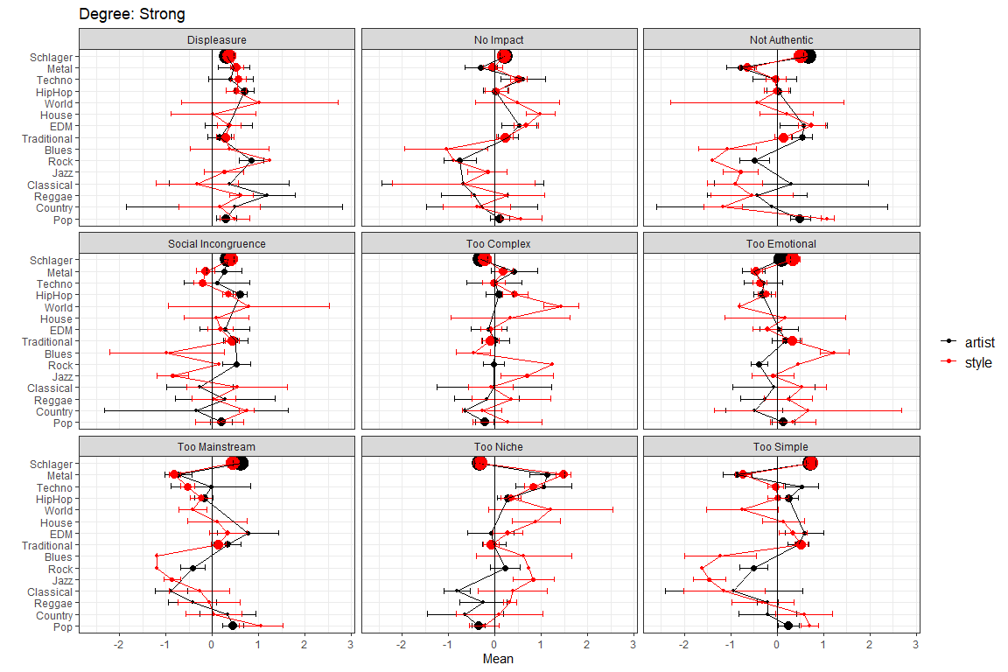

Fig. SM1. Mean value of style ratings in the Strong sub conditions for the Artist/Style main conditions. Error bars are 95% CI, dot size is proportional to total count of style.

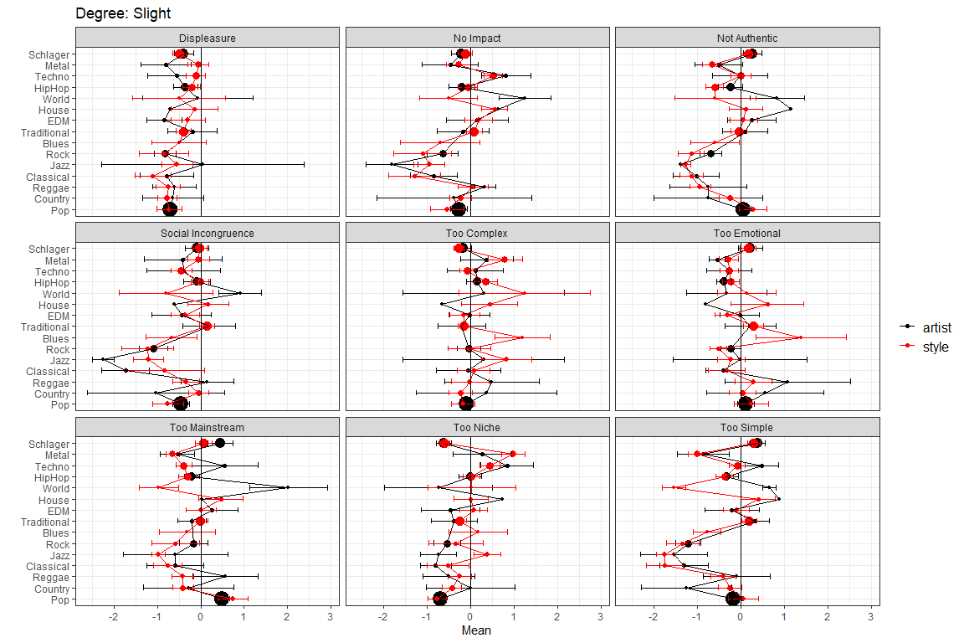

Fig. SM2. Mean value of style ratings in the Slight sub conditions for the Artist/Style main conditions. Error bars are 95% CI, dot size is proportional to total count of style.

## Chi-squared residual plots for covariates

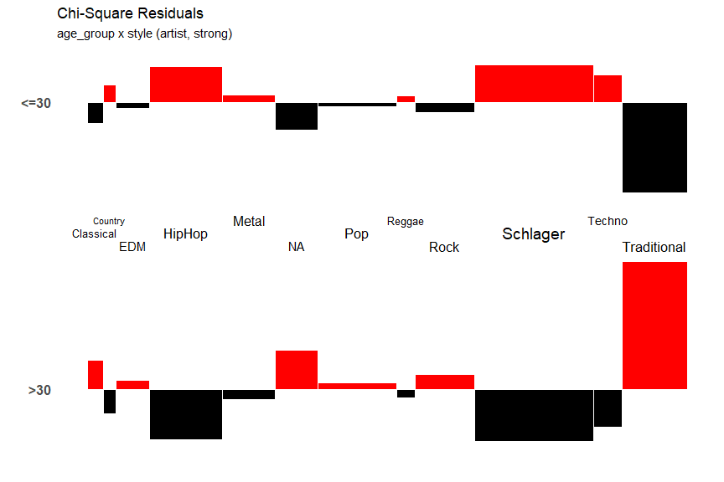

Fig. SC1a. Chi-Squared Residuals for styles in Artist/Strong conditions for Age Group

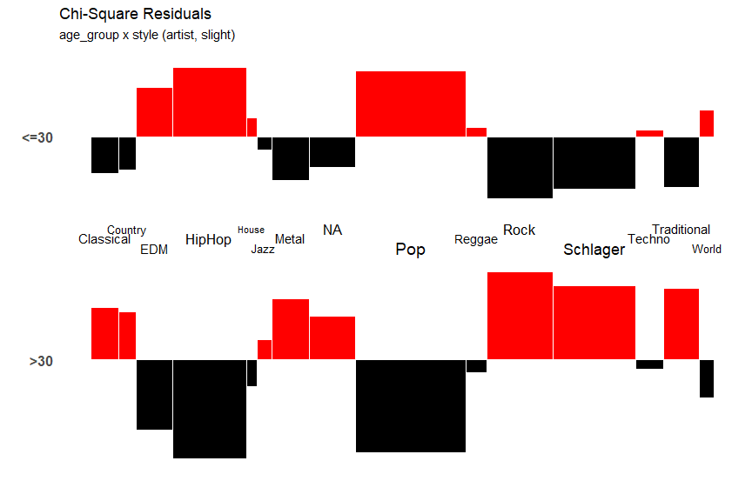

Fig. SC1b. Chi-Squared Residuals for styles in Artist/Slight conditions for Age Group

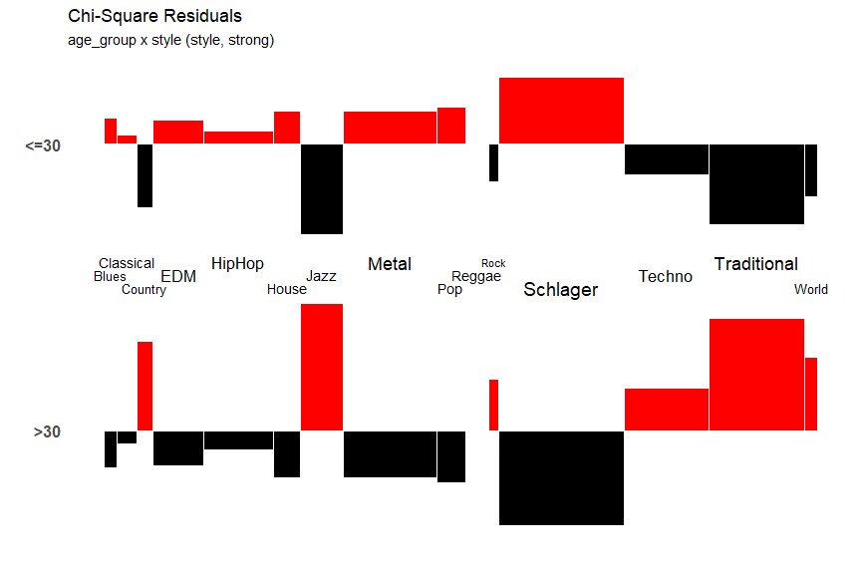

Fig. SC1c. Chi-Squared Residuals for styles in Style/Strong conditions for Age Group

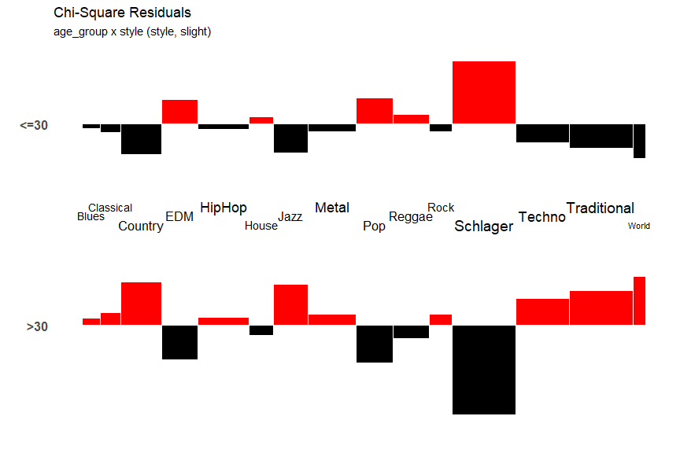

Fig. SC1d. Chi-Squared Residuals for styles in Style/Slight conditions for Age Group

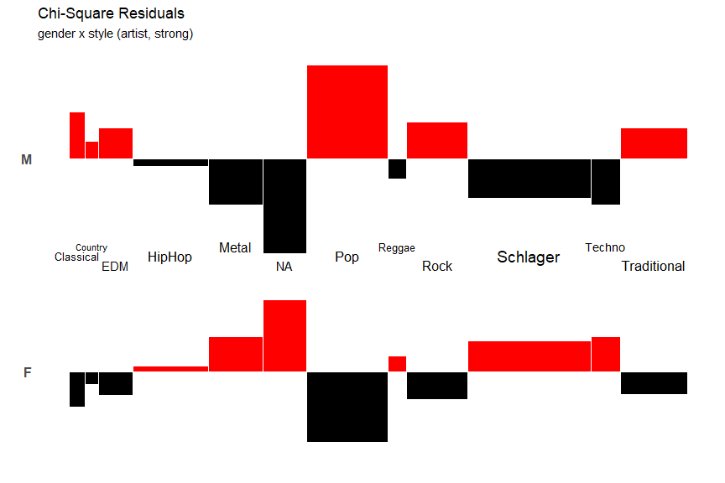

Fig. SC2a. Chi-Squared Residuals for styles in Artist/Strong conditions for Gender

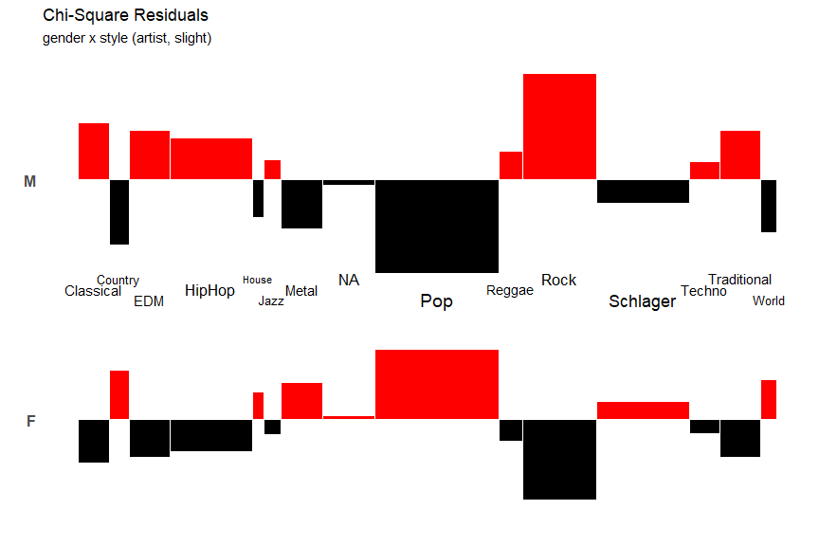

Fig. SC2b. Chi-Squared Residuals for styles in Artist/Slight conditions for Gender

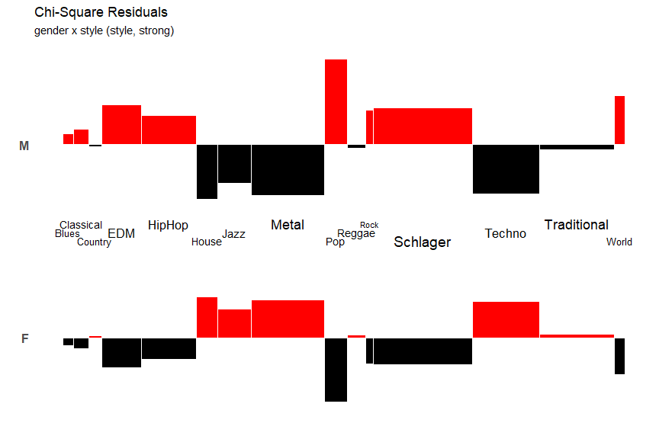

SC2c. Chi-Squared Residuals for styles in Style/Strong conditions for Gender

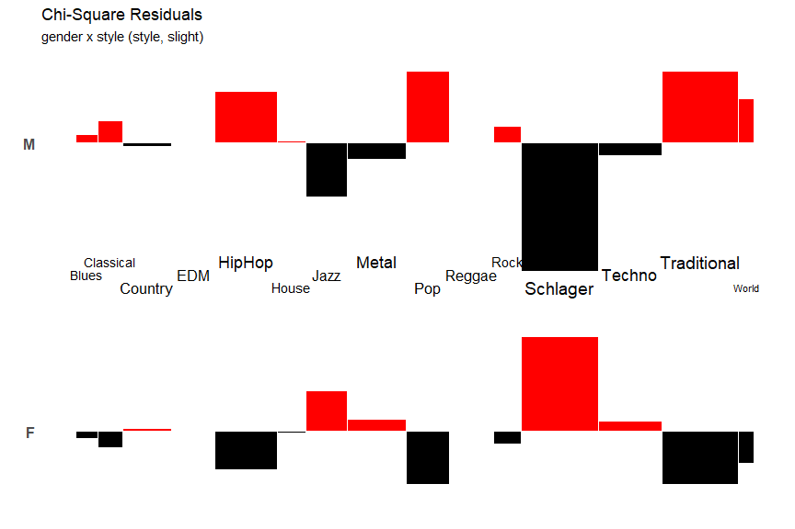

Fig. SC2d. Chi-Squared Residuals for styles in Style/Slight conditions for Gender

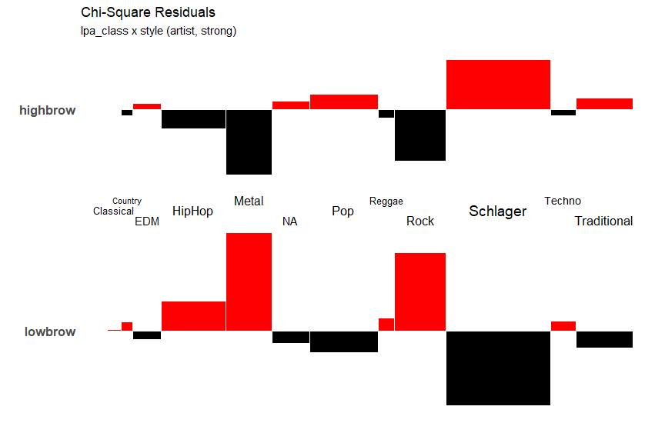

Fig. SC3a. Chi-Squared Residuals for styles in Artist/Strong conditions for LPA Class

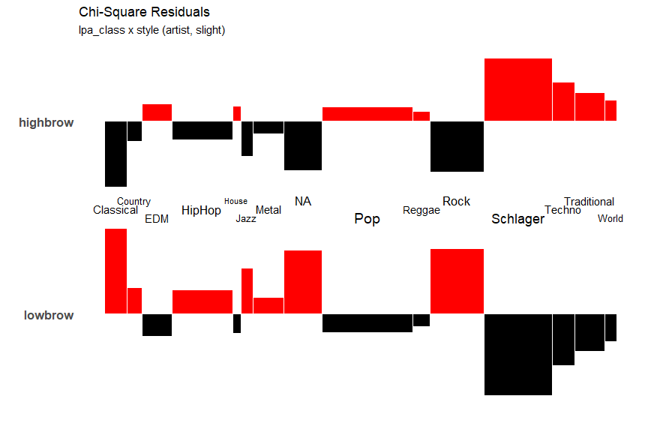

Fig. SC3b. Chi-Squared Residuals for styles in Artist/Slight conditions for LPA Class

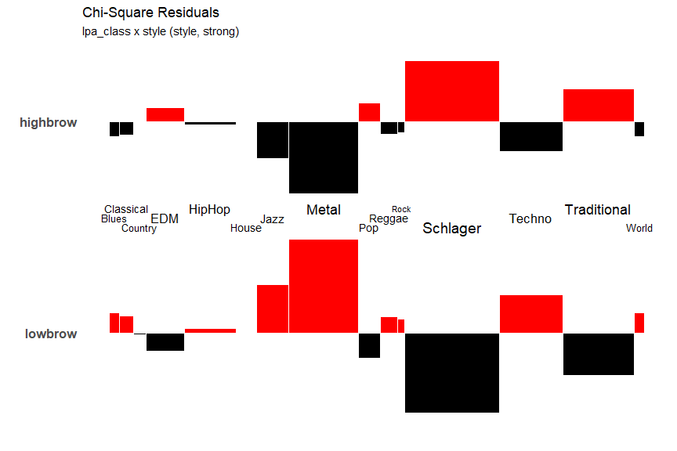

Fig. SC3c. Chi-Squared Residuals for styles in Style/Strong conditions for LPA Class

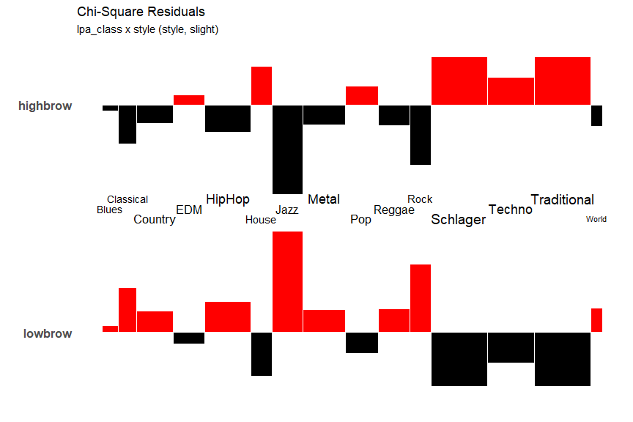

Fig. SC3d. Chi-Squared Residuals for styles in Style/Slight conditions for LPA Class