271 Final

Glenn (Ted) Dunmire, Marlea Gwinn, Julian Phillips

December 18, 2015

## Question 1

*Analyze each of these variables (as well as a combination of them) very carefully and use them (or a subset of them) to build a model and test hypotheses to address the questions. Also address potential (statistical) issues that may be casued by omitted variables.* *The philanthropist group hires a think tank to examine the relationship between the house values and neighborhood characteristics. For instance, they are interested in the extent to which houses in neighbhorhood with desirable features command higher values. They are specifically interested in environmental features, such as proximity to water body (i.e. lake, river, or ocean) or air quality.*

### Preparation for data analysis

#Set Directory  
  
#Ted  
setwd("~/Documents/271 Final")  
  
#Marlea  
#setwd("C://Users/gwina003/Downloads/Final")  
  
#Julian  
#data <- read.csv("//vivica/Documents/MIDS/W271/271-Final/houseValueData.csv")  
  
#Load Relevant Libraries  
library(ggplot2)  
library(car)  
library(reshape2)  
library(grid)  
library(astsa)  
library(forecast)

## Loading required package: zoo  
##   
## Attaching package: 'zoo'  
##   
## The following objects are masked from 'package:base':  
##   
## as.Date, as.Date.numeric  
##   
## Loading required package: timeDate  
## This is forecast 6.2   
##   
##   
## Attaching package: 'forecast'  
##   
## The following object is masked from 'package:astsa':  
##   
## gas

library(quantmod)

## Loading required package: xts  
## Loading required package: TTR  
## Version 0.4-0 included new data defaults. See ?getSymbols.

library(fGarch)

## Loading required package: timeSeries  
##   
## Attaching package: 'timeSeries'  
##   
## The following object is masked from 'package:zoo':  
##   
## time<-  
##   
## Loading required package: fBasics  
##   
##   
## Rmetrics Package fBasics  
## Analysing Markets and calculating Basic Statistics  
## Copyright (C) 2005-2014 Rmetrics Association Zurich  
## Educational Software for Financial Engineering and Computational Science  
## Rmetrics is free software and comes with ABSOLUTELY NO WARRANTY.  
## https://www.rmetrics.org --- Mail to: info@rmetrics.org  
##   
## Attaching package: 'fBasics'  
##   
## The following object is masked from 'package:TTR':  
##   
## volatility  
##   
## The following object is masked from 'package:astsa':  
##   
## nyse  
##   
## The following object is masked from 'package:car':  
##   
## densityPlot

library(tseries)  
library(gridExtra)  
library(scales)  
library(plyr)  
library(GGally)  
library(sandwich)  
library(lmtest)

### Read data and conduct initial variable examination

#Read dataset  
data <- read.csv("houseValueData.csv")  
  
#Changed with water to factor based on documentation; this is a categorical variable rather than an integer  
data$withWater <- as.factor(data$withWater)   
  
#Initial variable examination  
str(data)

## 'data.frame': 400 obs. of 11 variables:  
## $ crimeRate_pc : num 37.6619 0.5783 0.0429 22.5971 0.0664 ...  
## $ nonRetailBusiness: num 0.181 0.0397 0.1504 0.181 0.0405 ...  
## $ withWater : Factor w/ 2 levels "0","1": 1 1 1 1 1 1 1 1 1 1 ...  
## $ ageHouse : num 78.7 67 77.3 89.5 74.4 71.3 68.2 97.3 92.2 96.2 ...  
## $ distanceToCity : num 2.71 4.12 7.82 1.95 5.54 ...  
## $ distanceToHighway: int 24 5 4 24 5 5 5 5 3 5 ...  
## $ pupilTeacherRatio: num 23.2 16 21.2 23.2 19.6 23.9 22.2 17.7 20.8 17.7 ...  
## $ pctLowIncome : int 18 9 13 41 8 9 12 18 5 4 ...  
## $ homeValue : int 245250 1125000 463500 166500 672750 596250 425250 483750 852750 1125000 ...  
## $ pollutionIndex : num 52.9 42.5 31.4 55 36 37 34.9 72.1 33.8 45.5 ...  
## $ nBedRooms : num 4.2 6.3 4.25 3 4.86 ...

sum(is.na(data))

## [1] 0

summary(data)

## crimeRate_pc nonRetailBusiness withWater ageHouse   
## Min. : 0.00632 Min. :0.0074 0:373 Min. : 2.90   
## 1st Qu.: 0.08260 1st Qu.:0.0513 1: 27 1st Qu.: 45.67   
## Median : 0.26600 Median :0.0969 Median : 77.95   
## Mean : 3.76256 Mean :0.1115 Mean : 68.93   
## 3rd Qu.: 3.67481 3rd Qu.:0.1810 3rd Qu.: 94.15   
## Max. :88.97620 Max. :0.2774 Max. :100.00   
## distanceToCity distanceToHighway pupilTeacherRatio pctLowIncome   
## Min. : 1.228 Min. : 1.000 Min. :15.60 Min. : 2.00   
## 1st Qu.: 3.240 1st Qu.: 4.000 1st Qu.:19.90 1st Qu.: 8.00   
## Median : 6.115 Median : 5.000 Median :21.90 Median :14.00   
## Mean : 9.638 Mean : 9.582 Mean :21.39 Mean :15.79   
## 3rd Qu.:13.628 3rd Qu.:24.000 3rd Qu.:23.20 3rd Qu.:21.00   
## Max. :54.197 Max. :24.000 Max. :25.00 Max. :49.00   
## homeValue pollutionIndex nBedRooms   
## Min. : 112500 Min. :23.50 Min. :1.561   
## 1st Qu.: 384188 1st Qu.:29.88 1st Qu.:3.883   
## Median : 477000 Median :38.80 Median :4.193   
## Mean : 499584 Mean :40.61 Mean :4.266   
## 3rd Qu.: 558000 3rd Qu.:47.58 3rd Qu.:4.582   
## Max. :1125000 Max. :72.10 Max. :6.780

The provided dataset contains 400 observations of 11 variables, with no missing values. Below is a view of the histograms of all numeric variables in the dataset.

#Histogram of variables   
ggplot(melt(data[,-3]), aes(value)) + geom_histogram(color = "black", fill = "white") + facet_wrap(~variable, scales = "free") + labs(title = "Histogram of Variables")

## No id variables; using all as measure variables  
## stat_bin: binwidth defaulted to range/30. Use 'binwidth = x' to adjust this.  
## stat_bin: binwidth defaulted to range/30. Use 'binwidth = x' to adjust this.  
## stat_bin: binwidth defaulted to range/30. Use 'binwidth = x' to adjust this.  
## stat_bin: binwidth defaulted to range/30. Use 'binwidth = x' to adjust this.  
## stat_bin: binwidth defaulted to range/30. Use 'binwidth = x' to adjust this.  
## stat_bin: binwidth defaulted to range/30. Use 'binwidth = x' to adjust this.  
## stat_bin: binwidth defaulted to range/30. Use 'binwidth = x' to adjust this.  
## stat_bin: binwidth defaulted to range/30. Use 'binwidth = x' to adjust this.  
## stat_bin: binwidth defaulted to range/30. Use 'binwidth = x' to adjust this.  
## stat_bin: binwidth defaulted to range/30. Use 'binwidth = x' to adjust this.

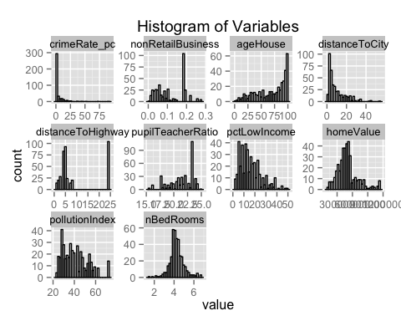

In order to get detailed summary statistics, we use the following function:

#Detailed summary statistics function  
ContStat = function(x,y) {  
#x must be a vector, not a dataframe  
#y is the number of decimal points to round data to  
StatLen = length(x)   
StatNA = sum(is.na(x))  
StatMean = summary(x)["Mean"]  
StatMin = summary(x)["Min."]  
StatMax= summary(x)["Max."]  
StatSd = sd(x)  
  
StatQuan = quantile(x,c(0.01,0.05,0.1,0.25,0.5,0.75,0.9,0.95,0.99))  
  
rownms =c("N", "#NA's","Mean","Min","Max","Std", "1%","5%","10%","25%","50%","75%","90%","95%","99%")  
  
Stats = c(StatLen,StatNA,StatMean,StatMin,StatMax,StatSd, StatQuan)  
  
ContStatDF = as.data.frame(Stats, row.names=rownms)  
ContStatDF = round(ContStatDF,y)  
return(ContStatDF)  
}

In order to output histograms and scatterplots of each variable, we use the following function:

#Histogram and Scatterplot of variables  
Graphs = function(x, y) {  
#vect must be a vector, not a dataframe  
#y is a string, the name of the variable of interest. Used for labeling the graphs  
   
subdata = data[,c(x,'homeValue')]  
names(subdata)[1] = 'variable'  
   
hist = ggplot(data=subdata, aes(variable)) + geom_histogram() + ggtitle("Histogram")+ scale_x_continuous("Bin") + scale_y_continuous("Count")   
  
sp = ggplot(data=subdata, aes(x=variable, y=homeValue)) + geom_point(shape=16) + ggtitle("Scatterplot")+ scale_x_continuous(y) + scale_y_continuous(name = "Home Value", labels = comma)   
   
output = grid.arrange(hist, sp, ncol=2,nrow=1, top = textGrob(paste("Histogram and Scatterplot of" , y , sep=" ") ,gp=gpar(fontsize=12,font=2)))  
   
return(output)   
}

### Detailed Variable Examination

We will now take a more detailed examination of each of the variables and their relationship with our variable of interest: homeValue.

|  |
| --- |
| **HomeValue** First, homeValue itself. From the attached text file, homeValue is defined as *median price of single-family house in the* *neighborhood (measured in dollars)*. |
| getwd() |
| r #Examine HomeValue ggplot(data=data, aes(data$homeValue)) + geom_histogram() |
| ## stat_bin: binwidth defaulted to range/30. Use 'binwidth = x' to adjust this. |
|  |
| r ContStat(data$homeValue,0) |
| ## Stats ## N 400 ## #NA's 0 ## Mean 499600 ## Min 112500 ## Max 1125000 ## Std 196116 ## 1% 157500 ## 5% 229500 ## 10% 291825 ## 25% 384188 ## 50% 477000 ## 75% 558000 ## 90% 749475 ## 95% 871987 ## 99% 1125000 |
| The range of the variable is 112,500 through 1,125,000 There dont appear to be any values that are unreasonable for the homeValue variable. The histogram shows a strong right skew of the variable with many of the values clustered together between the first and third quartile. While this is the target variable of interest, I will also create a log (homeValue) price and use both of them to find the model with the best fit. |

**CrimeRate_pc**

## Next lets take a look at the crimeRatepc variable which is defined as *crime rate per capita, measured by number of crimes per 1000 residents in neighborhood*.

#Examine CrimeRate_pc  
Graphs('crimeRate_pc', 'Crime Rate')

## stat_bin: binwidth defaulted to range/30. Use 'binwidth = x' to adjust this.

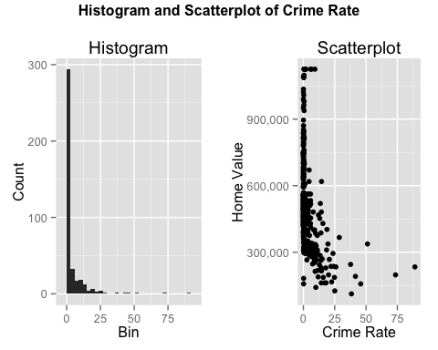

## TableGrob (2 x 2) "arrange": 3 grobs  
## z cells name grob  
## 1 1 (2-2,1-1) arrange gtable[layout]  
## 2 2 (2-2,2-2) arrange gtable[layout]  
## 3 3 (1-1,1-2) arrange text[GRID.text.543]

ContStat(data$crimeRate_pc,2)

## Stats  
## N 400.00  
## #NA's 0.00  
## Mean 3.76  
## Min 0.01  
## Max 88.98  
## Std 8.87  
## 1% 0.01  
## 5% 0.03  
## 10% 0.04  
## 25% 0.08  
## 50% 0.27  
## 75% 3.67  
## 90% 11.20  
## 95% 18.11  
## 99% 41.57

Crime rate per capita shows a slight negative correlation against Home Value. However, there is an extremely large number of neighborhoods that have a crime rate of zero or close to zero. The scatterplot shows that crime rate is more dispersed around areas of lower home value. That being said, there appears to be a small ceiling in the scatterplot- six points that all seem to have the same home value but with varying crime rates. Lets take a closer look at those points.

#Examine ceiling effect  
subset(data, homeValue>1100000)

## crimeRate_pc nonRetailBusiness withWater ageHouse distanceToCity  
## 2 0.57834 0.0397 0 67.0 4.116839  
## 10 2.01019 0.1958 0 96.2 3.143511  
## 18 6.53876 0.1810 1 97.5 1.343007  
## 69 5.66998 0.1810 1 96.8 1.629199  
## 164 1.51902 0.1958 1 93.9 3.433753  
## 172 0.52693 0.0620 0 83.0 5.476381  
## 216 0.61154 0.0397 0 86.9 2.563433  
## 370 9.23230 0.1810 0 100.0 1.283993  
## distanceToHighway pupilTeacherRatio pctLowIncome homeValue  
## 2 5 16.0 9 1125000  
## 10 5 17.7 4 1125000  
## 18 24 23.2 3 1125000  
## 69 24 23.2 4 1125000  
## 164 5 17.7 4 1125000  
## 172 8 20.4 5 1125000  
## 216 5 16.0 6 1125000  
## 370 24 23.2 12 1125000  
## pollutionIndex nBedRooms  
## 2 42.5 6.297  
## 10 45.5 5.929  
## 18 48.1 5.016  
## 69 48.1 4.683  
## 164 45.5 6.375  
## 172 35.4 6.725  
## 216 49.7 6.704  
## 370 48.1 4.216

These points seem to indicate that there is a maximum limit on the homeValue. These values likely represent areas in which the median price is greater than 1125000. This means these data points are not likely to be continuous, and thus will be difficult to accurately predict these points as these observations could have a true median homeValue of 1125000 or even ten or fifty times that value. Having identified this ceiling, we should check to see if there is a floor for the minimum home value.

#Examine potential floor effect  
subset(data, homeValue<126000)

## crimeRate_pc nonRetailBusiness withWater ageHouse distanceToCity  
## 342 38.3518 0.181 0 100 1.891958  
## distanceToHighway pupilTeacherRatio pctLowIncome homeValue  
## 342 24 23.2 39 112500  
## pollutionIndex nBedRooms  
## 342 54.3 3.453

With only one value at the minimum, it seems unlikely that there is a minimum limit to the home value.

|  |
| --- |
| **NonRetailBusiness** |
| Next let's take a look at the nonRetailBusiness variable which is defined as *the proportion of non-retail business acres per neighborhood*. |

#Examine nonRetailBusiness  
Graphs('nonRetailBusiness', 'Non Retail Business')

## stat_bin: binwidth defaulted to range/30. Use 'binwidth = x' to adjust this.

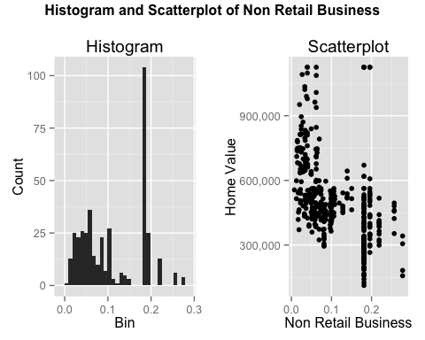

## TableGrob (2 x 2) "arrange": 3 grobs  
## z cells name grob  
## 1 1 (2-2,1-1) arrange gtable[layout]  
## 2 2 (2-2,2-2) arrange gtable[layout]  
## 3 3 (1-1,1-2) arrange text[GRID.text.629]

ContStat(data$nonRetailBusiness,2)

## Stats  
## N 400.00  
## #NA's 0.00  
## Mean 0.11  
## Min 0.01  
## Max 0.28  
## Std 0.07  
## 1% 0.01  
## 5% 0.02  
## 10% 0.03  
## 25% 0.05  
## 50% 0.10  
## 75% 0.18  
## 90% 0.20  
## 95% 0.22  
## 99% 0.26

The range for non retail business is 0.01 through 0.28. There is a negative correlation between the percentage of non retail business and the home value. While the data on the left side of the scatterplot seems to be random according to Non Retail Business, on the right side of the scatterplot, the values create a series of lines. We will now take a deeper look and find the most common values for this variable.

#Frequencies of nonRetailBusiness  
freqs = count(data$nonRetailBusiness)  
freqs[with(freqs,order(-freq)),]

## x freq  
## 66 0.1810 104  
## 67 0.1958 25  
## 54 0.0814 15  
## 47 0.0620 14  
## 68 0.2189 13  
## 30 0.0397 10  
## 57 0.0990 10  
## 58 0.1001 9  
## 55 0.0856 8  
## 59 0.1059 8  
## 18 0.0246 7  
## 32 0.0405 7  
## 42 0.0586 7  
## 49 0.0691 7  
## 56 0.0969 7  
## 14 0.0218 6  
## 26 0.0344 6  
## 38 0.0513 6  
## 39 0.0519 6  
## 52 0.0738 6  
## 62 0.1283 6  
## 69 0.2565 6  
## 36 0.0493 5  
## 6 0.0152 4  
## 20 0.0289 4  
## 41 0.0564 4  
## 43 0.0596 4  
## 53 0.0787 4  
## 70 0.2774 4  
## 15 0.0224 3  
## 22 0.0324 3  
## 23 0.0333 3  
## 25 0.0341 3  
## 37 0.0495 3  
## 40 0.0532 3  
## 46 0.0609 3  
## 48 0.0641 3  
## 50 0.0696 3  
## 60 0.1081 3  
## 64 0.1392 3  
## 65 0.1504 3  
## 2 0.0125 2  
## 5 0.0147 2  
## 7 0.0169 2  
## 13 0.0203 2  
## 21 0.0293 2  
## 24 0.0337 2  
## 27 0.0364 2  
## 33 0.0439 2  
## 34 0.0449 2  
## 35 0.0486 2  
## 44 0.0606 2  
## 45 0.0607 2  
## 63 0.1389 2  
## 1 0.0074 1  
## 3 0.0132 1  
## 4 0.0138 1  
## 8 0.0176 1  
## 9 0.0189 1  
## 10 0.0191 1  
## 11 0.0201 1  
## 12 0.0202 1  
## 16 0.0225 1  
## 17 0.0231 1  
## 19 0.0268 1  
## 28 0.0375 1  
## 29 0.0378 1  
## 31 0.0400 1  
## 51 0.0707 1  
## 61 0.1193 1

There are 104 records here (over 25%!) with the same value of 0.1810 for the percentage of non retail business. This is a curious result. Lets examine these records in detail.

#Subset data  
subset(data, nonRetailBusiness==.181)

## crimeRate_pc nonRetailBusiness withWater ageHouse distanceToCity  
## 1 37.66190 0.181 0 78.7 2.705847  
## 4 22.59710 0.181 0 89.5 1.950823  
## 18 6.53876 0.181 1 97.5 1.343007  
## 22 11.81230 0.181 0 76.5 2.547510  
## 26 19.60910 0.181 0 97.9 1.552272  
## 32 9.33889 0.181 0 95.6 2.954682  
## 33 8.05579 0.181 0 95.4 4.139166  
## 40 8.64476 0.181 0 92.6 2.541151  
## 42 4.64689 0.181 0 67.6 4.423733  
## 54 5.44114 0.181 0 98.2 3.937717  
## 68 11.16040 0.181 0 94.6 3.339460  
## 69 5.66998 0.181 1 96.8 1.629199  
## 71 5.66637 0.181 0 100.0 3.043082  
## 72 13.52220 0.181 0 100.0 1.934814  
## 73 5.87205 0.181 0 96.0 2.286494  
## 78 88.97620 0.181 0 91.9 1.745607  
## 81 13.07510 0.181 0 56.7 5.263925  
## 89 18.49820 0.181 0 100.0 1.228052  
## 91 5.73116 0.181 0 77.0 7.120808  
## 96 8.20058 0.181 0 80.3 5.131823  
## 99 14.23620 0.181 0 100.0 2.066578  
## 102 12.04820 0.181 0 87.6 2.913955  
## 121 10.67180 0.181 0 94.8 3.002142  
## 131 3.77498 0.181 0 84.7 5.407221  
## 139 4.26131 0.181 0 81.3 4.357413  
## 141 3.16360 0.181 0 48.2 6.006601  
## 144 9.51363 0.181 0 94.1 4.321347  
## 150 5.20177 0.181 1 83.4 4.965919  
## 157 14.33370 0.181 0 88.0 2.913955  
## 158 3.67822 0.181 0 96.2 3.286556  
## 159 15.57570 0.181 0 71.0 5.518825  
## 165 3.56868 0.181 0 75.0 5.482740  
## 166 7.02259 0.181 0 95.3 2.733089  
## 170 15.02340 0.181 0 97.3 3.279310  
## 171 4.22239 0.181 1 89.0 2.803642  
## 173 10.23300 0.181 0 96.7 3.455379  
## 175 12.80230 0.181 0 96.6 2.782241  
## 180 45.74610 0.181 0 100.0 2.246048  
## 181 4.54192 0.181 0 88.0 4.382726  
## 183 7.83932 0.181 0 65.4 5.686754  
## 186 14.43830 0.181 0 100.0 1.843221  
## 188 16.81180 0.181 0 98.1 1.764574  
## 189 6.28807 0.181 0 96.4 3.207921  
## 192 5.29305 0.181 0 82.5 3.448504  
## 196 4.66883 0.181 0 87.9 4.557777  
## 197 8.98296 0.181 1 97.4 3.333175  
## 201 14.33370 0.181 0 100.0 2.099021  
## 204 3.84970 0.181 1 91.0 4.346582  
## 206 9.32909 0.181 0 98.7 3.690331  
## 210 7.99248 0.181 0 100.0 1.981129  
## 213 25.04610 0.181 0 100.0 2.097543  
## 214 11.10810 0.181 0 100.0 1.292967  
## 218 28.65580 0.181 0 100.0 2.098810  
## 220 5.82401 0.181 0 64.7 7.166294  
## 226 7.05042 0.181 0 85.1 3.084474  
## 233 23.64820 0.181 0 96.2 1.686053  
## 234 4.75237 0.181 0 86.5 4.155532  
## 235 18.08460 0.181 0 100.0 2.640609  
## 237 9.91655 0.181 0 77.8 1.913953  
## 242 11.08740 0.181 0 100.0 2.696557  
## 245 9.18702 0.181 0 100.0 2.079827  
## 248 9.82349 0.181 0 98.8 1.631697  
## 249 18.81100 0.181 0 100.0 2.024309  
## 252 5.58107 0.181 0 87.9 3.832849  
## 254 3.69311 0.181 0 88.4 4.519688  
## 255 17.86670 0.181 0 100.0 1.686053  
## 257 8.49213 0.181 0 86.1 3.160245  
## 275 8.24809 0.181 0 99.3 4.201759  
## 276 25.94060 0.181 0 89.1 2.222904  
## 278 3.47428 0.181 1 82.9 2.803642  
## 290 3.69695 0.181 0 91.4 2.453429  
## 294 51.13580 0.181 0 100.0 1.738711  
## 296 41.52920 0.181 0 85.4 2.136970  
## 302 14.42080 0.181 0 93.3 3.037741  
## 305 9.92485 0.181 0 96.6 3.525691  
## 312 3.83684 0.181 0 91.1 3.779233  
## 320 13.35980 0.181 0 94.7 2.520527  
## 321 6.39312 0.181 0 97.4 3.546246  
## 325 8.79212 0.181 0 70.6 3.186891  
## 327 15.86030 0.181 0 95.4 2.815191  
## 332 24.39380 0.181 0 100.0 1.846643  
## 336 22.05110 0.181 0 92.4 2.713520  
## 337 6.96215 0.181 0 97.0 2.855160  
## 340 73.53410 0.181 0 100.0 2.567078  
## 341 10.06230 0.181 0 94.3 3.248145  
## 342 38.35180 0.181 0 100.0 1.891958  
## 344 5.69175 0.181 0 79.8 7.578136  
## 347 7.52601 0.181 0 98.3 3.492387  
## 352 5.70818 0.181 0 74.9 6.859073  
## 356 4.87141 0.181 0 93.6 3.805081  
## 357 13.91340 0.181 0 95.0 3.588005  
## 359 7.36711 0.181 0 78.1 2.876769  
## 364 11.57790 0.181 0 97.0 2.493201  
## 365 14.05070 0.181 0 100.0 1.969563  
## 366 20.08490 0.181 0 91.2 1.791178  
## 368 3.67367 0.181 0 51.9 9.159096  
## 370 9.23230 0.181 0 100.0 1.283993  
## 376 9.72418 0.181 0 97.2 3.190845  
## 378 4.55587 0.181 0 87.9 2.149320  
## 382 24.80170 0.181 0 96.0 2.343483  
## 383 7.75223 0.181 0 83.7 5.143350  
## 387 5.82115 0.181 0 89.9 5.198162  
## 389 20.71620 0.181 0 100.0 1.299845  
## 393 4.34879 0.181 0 84.0 5.903200  
## distanceToHighway pupilTeacherRatio pctLowIncome homeValue  
## 1 24 23.2 18 245250  
## 4 24 23.2 41 166500  
## 18 24 23.2 3 1125000  
## 22 24 23.2 29 189000  
## 26 24 23.2 17 337500  
## 32 24 23.2 31 213750  
## 33 24 23.2 23 310500  
## 40 24 23.2 19 310500  
## 42 24 23.2 14 670500  
## 54 24 23.2 22 342000  
## 68 24 23.2 29 301500  
## 69 24 23.2 4 1125000  
## 71 24 23.2 21 414000  
## 72 24 23.2 17 519750  
## 73 24 23.2 24 281250  
## 78 24 23.2 22 234000  
## 81 24 23.2 18 452250  
## 89 24 23.2 49 310500  
## 91 24 23.2 8 562500  
## 96 24 23.2 21 303750  
## 99 24 23.2 26 162000  
## 102 24 23.2 18 468000  
## 121 24 23.2 30 265500  
## 131 24 23.2 21 427500  
## 139 24 23.2 16 508500  
## 141 24 23.2 18 447750  
## 144 24 23.2 24 335250  
## 150 24 23.2 14 510750  
## 157 24 23.2 16 481500  
## 158 24 23.2 12 468000  
## 159 24 23.2 23 429750  
## 165 24 23.2 18 522000  
## 166 24 23.2 20 319500  
## 170 24 23.2 32 270000  
## 171 24 23.2 18 378000  
## 173 24 23.2 23 328500  
## 175 24 23.2 30 243000  
## 180 24 23.2 47 157500  
## 181 24 23.2 9 562500  
## 183 24 23.2 16 481500  
## 186 24 23.2 25 618750  
## 188 24 23.2 39 162000  
## 189 24 23.2 22 335250  
## 192 24 23.2 24 522000  
## 196 24 23.2 24 285750  
## 197 24 23.2 22 400500  
## 201 24 23.2 39 229500  
## 204 24 23.2 16 488250  
## 206 24 23.2 23 317250  
## 210 24 23.2 31 276750  
## 213 24 23.2 34 126000  
## 214 24 23.2 44 310500  
## 218 24 23.2 25 366750  
## 220 24 23.2 13 517500  
## 226 24 23.2 29 301500  
## 233 24 23.2 30 294750  
## 234 24 23.2 23 317250  
## 235 24 23.2 37 162000  
## 237 24 23.2 38 141750  
## 242 24 23.2 19 375750  
## 245 24 23.2 30 254250  
## 248 24 23.2 27 299250  
## 249 24 23.2 44 402750  
## 252 24 23.2 20 321750  
## 254 24 23.2 18 398250  
## 255 24 23.2 28 229500  
## 257 24 23.2 22 326250  
## 275 24 23.2 21 400500  
## 276 24 23.2 34 234000  
## 278 24 23.2 6 492750  
## 290 24 23.2 17 492750  
## 294 24 23.2 12 337500  
## 296 24 23.2 35 191250  
## 302 24 23.2 23 216000  
## 305 24 23.2 21 283500  
## 312 24 23.2 18 447750  
## 320 24 23.2 20 285750  
## 321 24 23.2 31 299250  
## 325 24 23.2 22 263250  
## 327 24 23.2 31 186750  
## 332 24 23.2 36 236250  
## 336 24 23.2 28 236250  
## 337 24 23.2 21 339750  
## 340 24 23.2 26 198000  
## 341 24 23.2 25 317250  
## 342 24 23.2 39 112500  
## 344 24 23.2 19 429750  
## 347 24 23.2 24 292500  
## 352 24 23.2 9 533250  
## 356 24 23.2 23 375750  
## 357 24 23.2 19 263250  
## 359 24 23.2 27 247500  
## 364 24 23.2 33 218250  
## 365 24 23.2 27 387000  
## 366 24 23.2 39 198000  
## 368 24 23.2 13 477000  
## 370 24 23.2 12 1125000  
## 376 24 23.2 25 384750  
## 378 24 23.2 8 618750  
## 382 24 23.2 25 186750  
## 383 24 23.2 20 335250  
## 387 24 23.2 13 454500  
## 389 24 23.2 30 267750  
## 393 24 23.2 20 447750  
## pollutionIndex nBedRooms  
## 1 52.9 4.202  
## 4 55.0 3.000  
## 18 48.1 5.016  
## 22 56.8 4.824  
## 26 52.1 5.313  
## 32 52.9 4.380  
## 33 43.4 3.427  
## 40 54.3 4.193  
## 42 46.4 4.980  
## 54 56.3 4.655  
## 68 59.0 4.629  
## 69 48.1 4.683  
## 71 59.0 4.219  
## 72 48.1 1.863  
## 73 54.3 4.405  
## 78 52.1 4.968  
## 81 43.0 3.713  
## 89 51.8 2.138  
## 91 38.2 5.061  
## 96 56.3 3.936  
## 99 54.3 4.343  
## 102 46.4 3.648  
## 121 59.0 4.459  
## 131 50.5 3.952  
## 139 62.0 4.112  
## 141 50.5 3.759  
## 144 56.3 4.728  
## 150 62.0 4.127  
## 157 46.4 4.229  
## 158 62.0 3.362  
## 159 43.0 3.926  
## 165 43.0 4.437  
## 166 56.8 4.006  
## 170 46.4 3.304  
## 171 62.0 3.803  
## 173 46.4 4.185  
## 175 59.0 3.854  
## 180 54.3 2.519  
## 181 62.0 4.398  
## 183 50.5 4.209  
## 186 44.7 4.852  
## 188 55.0 3.277  
## 189 59.0 4.341  
## 192 55.0 4.051  
## 196 56.3 3.976  
## 197 62.0 4.212  
## 201 55.0 2.880  
## 204 62.0 4.395  
## 206 56.3 4.185  
## 210 55.0 3.520  
## 213 54.3 3.987  
## 214 51.8 2.906  
## 218 44.7 3.155  
## 220 38.2 4.242  
## 226 46.4 4.103  
## 233 52.1 4.380  
## 234 56.3 4.525  
## 235 52.9 4.434  
## 237 54.3 3.852  
## 242 56.8 4.411  
## 245 55.0 3.536  
## 248 52.1 4.794  
## 249 44.7 2.628  
## 252 56.3 4.436  
## 254 56.3 4.376  
## 255 52.1 4.223  
## 257 43.4 4.348  
## 275 56.3 5.393  
## 276 52.9 3.304  
## 278 56.8 6.780  
## 290 56.8 2.963  
## 294 44.7 3.757  
## 296 54.3 3.531  
## 302 59.0 4.461  
## 305 59.0 4.251  
## 312 62.0 4.251  
## 320 54.3 3.887  
## 321 43.4 4.162  
## 325 43.4 3.565  
## 327 52.9 3.896  
## 332 55.0 2.652  
## 336 59.0 3.818  
## 337 55.0 3.713  
## 340 52.9 3.957  
## 341 43.4 4.833  
## 342 54.3 3.453  
## 344 43.3 4.114  
## 347 56.3 4.417  
## 352 38.2 4.750  
## 356 46.4 4.484  
## 357 56.3 4.208  
## 359 52.9 4.193  
## 364 55.0 3.036  
## 365 44.7 4.657  
## 366 55.0 2.368  
## 368 43.3 4.312  
## 370 48.1 4.216  
## 376 59.0 4.406  
## 378 56.8 1.561  
## 382 54.3 3.349  
## 383 56.3 4.301  
## 387 56.3 4.513  
## 389 50.9 2.138  
## 393 43.0 4.167

Not only do these records have the same value for Non Retail Business, but also for distance to highway and pupil teacher ratio. This could indicate a problem because 25% of our records have the same value for 3 of 10 variables. It is very likely that these three can be used together for any model due to multicolinearity.

There was also a high number of records that had a value of 0.1958 for the non retail business variable. Let's take a look at those as well.

#Subset data  
subset(data, nonRetailBusiness==.1958)

## crimeRate_pc nonRetailBusiness withWater ageHouse distanceToCity  
## 8 1.65660 0.1958 0 97.3 2.159562  
## 10 2.01019 0.1958 0 96.2 3.143511  
## 34 2.30040 0.1958 0 96.1 3.277562  
## 43 2.24236 0.1958 0 91.8 4.117927  
## 87 1.12658 0.1958 1 88.0 2.142929  
## 90 1.34284 0.1958 0 100.0 2.464640  
## 97 1.80028 0.1958 0 79.2 4.128541  
## 142 3.53501 0.1958 1 82.6 2.438214  
## 149 1.49632 0.1958 0 100.0 2.103460  
## 161 2.36862 0.1958 0 95.7 1.833771  
## 164 1.51902 0.1958 1 93.9 3.433753  
## 191 2.44953 0.1958 0 95.2 3.692681  
## 198 1.42502 0.1958 0 100.0 2.483967  
## 199 2.14918 0.1958 0 98.5 2.170677  
## 205 2.92400 0.1958 0 93.0 3.747410  
## 262 1.20742 0.1958 0 94.6 4.128541  
## 272 1.41385 0.1958 1 96.0 2.446936  
## 309 2.44668 0.1958 0 94.0 2.417907  
## 323 2.15505 0.1958 0 100.0 1.947124  
## 324 3.32105 0.1958 1 100.0 1.562284  
## 329 1.27346 0.1958 1 92.6 2.557514  
## 334 2.73397 0.1958 0 94.9 1.965851  
## 369 2.77974 0.1958 0 97.8 1.608498  
## 377 2.31390 0.1958 0 97.3 4.027714  
## 390 2.33099 0.1958 0 93.8 1.973898  
## distanceToHighway pupilTeacherRatio pctLowIncome homeValue  
## 8 5 17.7 18 483750  
## 10 5 17.7 4 1125000  
## 34 5 17.7 14 535500  
## 43 5 17.7 14 510750  
## 87 5 17.7 15 344250  
## 90 5 17.7 8 546750  
## 97 5 17.7 15 535500  
## 142 5 17.7 19 351000  
## 149 5 17.7 16 441000  
## 161 5 17.7 38 328500  
## 164 5 17.7 4 1125000  
## 191 5 17.7 14 501750  
## 198 5 17.7 9 524250  
## 199 5 17.7 20 436500  
## 205 5 17.7 12 562500  
## 262 5 17.7 18 391500  
## 272 5 17.7 19 382500  
## 309 5 17.7 20 294750  
## 323 5 17.7 21 351000  
## 324 5 17.7 34 301500  
## 329 5 17.7 6 607500  
## 334 5 17.7 27 346500  
## 369 5 17.7 37 265500  
## 377 5 17.7 15 429750  
## 390 5 17.7 36 400500  
## pollutionIndex nBedRooms  
## 8 72.1 4.122  
## 10 45.5 5.929  
## 34 45.5 4.319  
## 43 45.5 3.854  
## 87 72.1 3.012  
## 90 45.5 4.066  
## 97 45.5 3.877  
## 142 72.1 4.152  
## 149 72.1 3.404  
## 161 72.1 2.926  
## 164 45.5 6.375  
## 191 45.5 4.402  
## 198 72.1 4.510  
## 199 72.1 3.709  
## 205 45.5 4.101  
## 262 45.5 3.875  
## 272 72.1 4.129  
## 309 72.1 3.272  
## 323 72.1 3.628  
## 324 72.1 3.403  
## 329 45.5 4.250  
## 334 72.1 3.597  
## 369 72.1 2.903  
## 377 45.5 3.880  
## 390 72.1 3.186

The same issue as above with another 25 sharing the same values.

#Subset data  
subset(data, nonRetailBusiness==.0814)

## crimeRate_pc nonRetailBusiness withWater ageHouse distanceToCity  
## 48 1.00245 0.0814 0 87.3 10.083736  
## 52 1.38799 0.0814 0 82.0 9.152856  
## 64 0.98843 0.0814 0 100.0 9.542017  
## 103 0.72580 0.0814 0 69.5 8.453050  
## 105 0.75026 0.0814 0 94.1 10.701905  
## 113 0.62739 0.0814 0 56.5 11.089802  
## 120 0.63796 0.0814 0 84.5 10.945402  
## 167 0.85204 0.0814 0 89.2 9.234841  
## 240 0.95577 0.0814 0 88.8 10.912060  
## 258 0.77299 0.0814 0 94.4 10.917157  
## 274 1.25179 0.0814 0 98.1 8.458038  
## 314 0.67191 0.0814 0 90.3 11.821981  
## 358 1.15172 0.0814 0 95.0 8.419944  
## 367 1.23247 0.0814 0 91.7 9.104822  
## 398 0.80271 0.0814 0 36.6 8.453050  
## distanceToHighway pupilTeacherRatio pctLowIncome homeValue  
## 48 4 24 15 472500  
## 52 4 24 35 297000  
## 64 4 24 25 326250  
## 103 4 24 14 409500  
## 105 4 24 20 351000  
## 113 4 24 10 447750  
## 120 4 24 13 409500  
## 167 4 24 17 441000  
## 240 4 24 22 333000  
## 258 4 24 16 414000  
## 274 4 24 27 306000  
## 314 4 24 18 373500  
## 358 4 24 23 294750  
## 367 4 24 24 342000  
## 398 4 24 14 454500  
## pollutionIndex nBedRooms  
## 48 38.8 4.674  
## 52 38.8 3.950  
## 64 38.8 3.813  
## 103 38.8 3.727  
## 105 38.8 3.924  
## 113 38.8 3.834  
## 120 38.8 4.096  
## 167 38.8 3.965  
## 240 38.8 4.047  
## 258 38.8 4.495  
## 274 38.8 3.570  
## 314 38.8 3.813  
## 358 38.8 3.701  
## 367 38.8 4.142  
## 398 38.8 3.456

The same issue with another 15 sharing the same values. These 15 also have the same value for pollutionIndex. In fact, when nonRetailBusiness values of 0.0620, 0.2189, 0.0397, 0.0990, 0.1001 and 0.0856 are further examined, we notice that they all have the same values for pollutionindex, distance to highway and pupil teacher ratio. These variables will likely not contribute much together, as they tend to vary together as a group.

|  |
| --- |
| **WithWater** |
| The next variable is withwater which is defined as *whether the neighborhood is within 5 miles of a water* |
| *body (lake, river, etc); 1 if true and 0 otherwise* |

As this is a binary variable, the functions created above are not appropriate.

#Examine withWater  
table(data$withWater)

##   
## 0 1   
## 373 27

ggplot(data, aes(withWater, homeValue)) + geom_boxplot() + scale_y_continuous(name = "Home Value", labels = comma) + scale_x_discrete(name = "With Water: 1 = Yes, 0 = No")

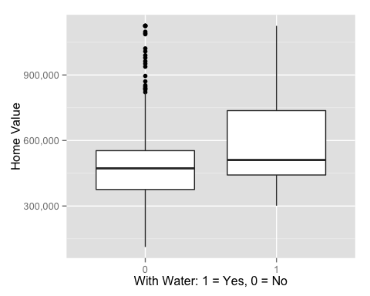

With water tends to have a slightly higher median home value than without water. Neighborhoods without water do tend to see some higher home values, but these are considered outliers that fall outside of the upper whisker.

|  |
| --- |
| **ageHouse** |
| Now we will examine ageHouse, which is defined as *proportion of houses built before 1950* |

#Examine ageHouse  
Graphs('ageHouse', 'Percentage of house built before 1950')

## stat_bin: binwidth defaulted to range/30. Use 'binwidth = x' to adjust this.

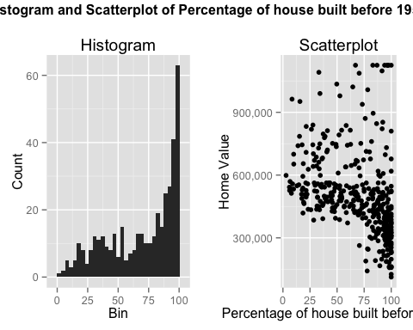

## TableGrob (2 x 2) "arrange": 3 grobs  
## z cells name grob  
## 1 1 (2-2,1-1) arrange gtable[layout]  
## 2 2 (2-2,2-2) arrange gtable[layout]  
## 3 3 (1-1,1-2) arrange text[GRID.text.774]

ContStat(data$ageHouse,1)

## Stats  
## N 400.0  
## #NA's 0.0  
## Mean 68.9  
## Min 2.9  
## Max 100.0  
## Std 28.0  
## 1% 7.8  
## 5% 18.4  
## 10% 27.7  
## 25% 45.7  
## 50% 77.9  
## 75% 94.1  
## 90% 98.4  
## 95% 100.0  
## 99% 100.0

The range here is from 2.9 through 100.0 with a left skew indicating many of these neighborhoods have older homes (built before 1950). With such age buckets, there is ambiguity between neighborhoods built in 1950 and those in 1850. This might account for the larger variation in older neighborhoods home value. Even so, the newer neighborhoods seem to have higher home values, especially given that there is less of a spread than for older homes. Average age of the home would be a better variable in this case.

|  |
| --- |
| **distanceToCity** |
| distanceToCity is next which is *distance to the nearest city (measured in miles)* |

#Examine distanceToCity  
Graphs('distanceToCity', 'Miles to Nearest House')

## stat_bin: binwidth defaulted to range/30. Use 'binwidth = x' to adjust this.

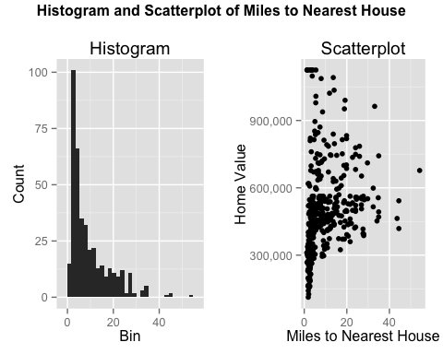

## TableGrob (2 x 2) "arrange": 3 grobs  
## z cells name grob  
## 1 1 (2-2,1-1) arrange gtable[layout]  
## 2 2 (2-2,2-2) arrange gtable[layout]  
## 3 3 (1-1,1-2) arrange text[GRID.text.860]

ContStat(data$distanceToCity ,1)

## Stats  
## N 400.0  
## #NA's 0.0  
## Mean 9.6  
## Min 1.2  
## Max 54.2  
## Std 8.8  
## 1% 1.3  
## 5% 1.9  
## 10% 2.2  
## 25% 3.2  
## 50% 6.1  
## 75% 13.6  
## 90% 22.7  
## 95% 26.9  
## 99% 35.1

Interestingly, the minimum value here is not 0 which indicates that none of these neighborhoods are actually in the city. The histogram tends to be right skewed, indicating that many neighborhoods are close to the city, while a few are over 40 miles from the city.

|  |
| --- |
| **distanceToHighway** |
| distanceToHighway is next which is *distances to the nearest highway (measured in miles)* |

#Examine distance to highway  
Graphs('distanceToHighway', 'Distance to highway in miles')

## stat_bin: binwidth defaulted to range/30. Use 'binwidth = x' to adjust this.

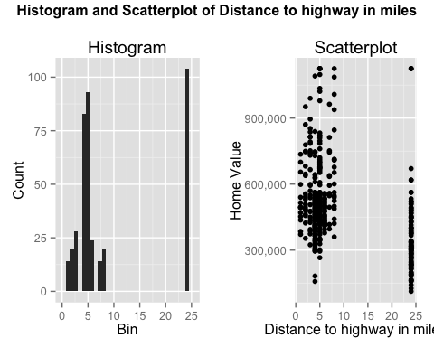

## TableGrob (2 x 2) "arrange": 3 grobs  
## z cells name grob  
## 1 1 (2-2,1-1) arrange gtable[layout]  
## 2 2 (2-2,2-2) arrange gtable[layout]  
## 3 3 (1-1,1-2) arrange text[GRID.text.946]

ContStat(data$distanceToHighway ,1)

## Stats  
## N 400.0  
## #NA's 0.0  
## Mean 9.6  
## Min 1.0  
## Max 24.0  
## Std 8.7  
## 1% 1.0  
## 5% 2.0  
## 10% 3.0  
## 25% 4.0  
## 50% 5.0  
## 75% 24.0  
## 90% 24.0  
## 95% 24.0  
## 99% 24.0

Distance to highway has a mean of 9.6, yet the most frequent value is 24, which occurs over 100 times in the dataset. There doesn't seem to be a clear relationship between home value and distance to highway, especially given the gap in values between 9 and 24. As stated previously, this variable probably will not contribute much to predicting home value.

|  |
| --- |
| **pupilTeacherRatio** |
| pupilTeacherRatio is next which is *average pupil-teacher ratio in all the schools in the neighborhood* |

#Examine pupil teacher ratio  
Graphs('pupilTeacherRatio', 'Pupil Teacher Ratio')

## stat_bin: binwidth defaulted to range/30. Use 'binwidth = x' to adjust this.

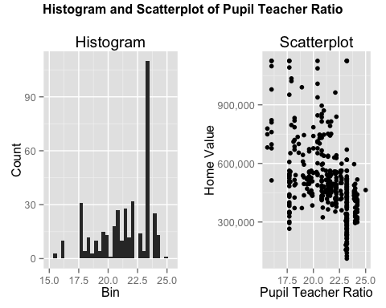

## TableGrob (2 x 2) "arrange": 3 grobs  
## z cells name grob  
## 1 1 (2-2,1-1) arrange gtable[layout]  
## 2 2 (2-2,2-2) arrange gtable[layout]  
## 3 3 (1-1,1-2) arrange text[GRID.text.1032]

ContStat(data$pupilTeacherRatio ,1)

## Stats  
## N 400.0  
## #NA's 0.0  
## Mean 21.4  
## Min 15.6  
## Max 25.0  
## Std 2.2  
## 1% 16.0  
## 5% 17.7  
## 10% 17.7  
## 25% 19.9  
## 50% 21.9  
## 75% 23.2  
## 90% 23.2  
## 95% 24.0  
## 99% 24.2

#Get mode of pupil teacher ratio  
Mode <- function(x) {  
 ux <- unique(x)  
 ux[which.max(tabulate(match(x, ux)))]  
}  
  
Mode(data$pupilTeacherRatio)

## [1] 23.2

Pupil teacher ratio has a mean of 21.4, but has a strikingly frequent amount at 23.2. As discussed previously, this tends to covary with two of the other variables in the dataset. There does seem to be a negative relationship between pupil teacher ratio and home value.

|  |
| --- |
| **pctLowIncome** |
| The next variable is pctLowIncome which is *percentage of low income household in the neighborhood* |

#Examine pctLowIncome  
Graphs('pctLowIncome', 'Percent of low income households in the neighborhood')

## stat_bin: binwidth defaulted to range/30. Use 'binwidth = x' to adjust this.

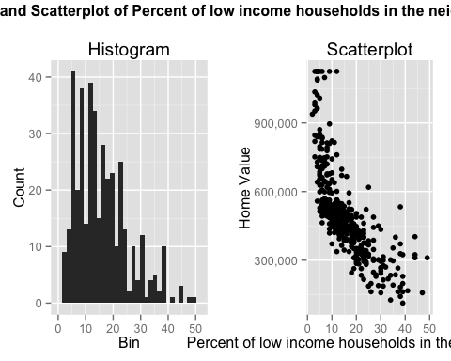

## TableGrob (2 x 2) "arrange": 3 grobs  
## z cells name grob  
## 1 1 (2-2,1-1) arrange gtable[layout]  
## 2 2 (2-2,2-2) arrange gtable[layout]  
## 3 3 (1-1,1-2) arrange text[GRID.text.1118]

ContStat(data$pctLowIncome ,1)

## Stats  
## N 400.0  
## #NA's 0.0  
## Mean 15.8  
## Min 2.0  
## Max 49.0  
## Std 9.3  
## 1% 3.0  
## 5% 4.0  
## 10% 5.0  
## 25% 8.0  
## 50% 14.0  
## 75% 21.0  
## 90% 29.1  
## 95% 35.0  
## 99% 44.0

There is a very strong negative correlation on this scatterplot, unsurprisingly. If you have a low income its unlikely that you can afford a house with a high value. This variable is also right skewed, as demonstrated by the histogram.

|  |
| --- |
| **pollutionIndex** |
| The next variable is pollutionIndex which is defined as *scaled between 0 and 100, with 0 being the best and 100 being the worst (i.e. uninhabitable).* Even though it is highly correlated with non retail business, distance to highway and pupil teacher ratio, we will investigate it because the philanthropist group is interested. |

#Examine pollutionIndex  
Graphs('pollutionIndex', 'Pollution Index')

## stat_bin: binwidth defaulted to range/30. Use 'binwidth = x' to adjust this.

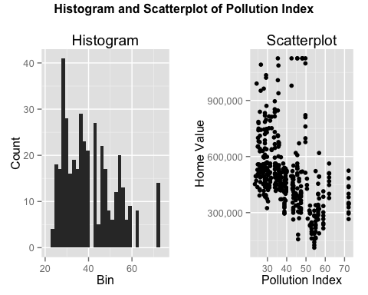

## TableGrob (2 x 2) "arrange": 3 grobs  
## z cells name grob  
## 1 1 (2-2,1-1) arrange gtable[layout]  
## 2 2 (2-2,2-2) arrange gtable[layout]  
## 3 3 (1-1,1-2) arrange text[GRID.text.1204]

ContStat(data$pollutionIndex ,1)

## Stats  
## N 400.0  
## #NA's 0.0  
## Mean 40.6  
## Min 23.5  
## Max 72.1  
## Std 11.8  
## 1% 24.4  
## 5% 25.9  
## 10% 27.6  
## 25% 29.9  
## 50% 38.8  
## 75% 47.6  
## 90% 56.3  
## 95% 62.0  
## 99% 72.1

The scatterplot displays multiple segments: high home values and relativey low polution, medium home value and medium pollution, and low home value and high polution. There does seem to be a negative correlation between pollution index and home value, although the scatterplot shows a lot of variation. The histrogram shows a right skew.

|  |
| --- |
| **nBedRooms** |
| The final variable is nBedRooms which is *the average number of bed rooms in the single family houses in the neighborhood* |

Graphs('nBedRooms', 'Average Number of Bedrooms')

## stat_bin: binwidth defaulted to range/30. Use 'binwidth = x' to adjust this.

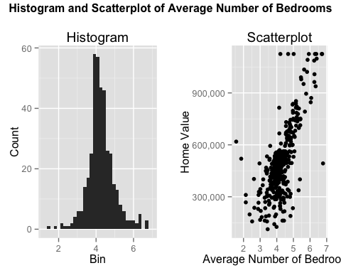

## TableGrob (2 x 2) "arrange": 3 grobs  
## z cells name grob  
## 1 1 (2-2,1-1) arrange gtable[layout]  
## 2 2 (2-2,2-2) arrange gtable[layout]  
## 3 3 (1-1,1-2) arrange text[GRID.text.1290]

ContStat(data$nBedRooms ,1)

## Stats  
## N 400.0  
## #NA's 0.0  
## Mean 4.3  
## Min 1.6  
## Max 6.8  
## Std 0.7  
## 1% 2.4  
## 5% 3.3  
## 10% 3.5  
## 25% 3.9  
## 50% 4.2  
## 75% 4.6  
## 90% 5.1  
## 95% 5.5  
## 99% 6.4

Finally! A normally distributed variable. This one is also positively correlated with home value. This will likely be one of the most useful of the prediction variables. It ranges from 1.6 to 6.4, which are reasonable average bedrooms for houses.

## Decisions based off data exploration:

From the original dataset, the following decisions were then made.

1. Eliminate the variables non retail business, distance to highway and student pupil ratio as they have too much colinearity with each other. We suspect there may be some sampling error or additional information that we would have to ask the client for.
2. While pollutionindex is correlated with the three above, as the group specifically asked about it, it will be kept in the model for now.
3. Create a transformation of home value, log home value, that will be used for fitting the model. Whichever outcome variable performs the best will be used.
4. No other transformations will be used at this time. If the model fit is poor, then transformations will be considered.
5. For home value, there are 8 records that are categorical rather than continuous. These are the values that likely mean 1125000 or greater. Because we do not know the true value, we will not include them in our model.

First, we will subset the data and transform some of the variables:

#Subset data to remove categorical home values (ceiling)  
data = subset(data, homeValue!=1125000)  
  
#Create log home value  
data$loghomeValue = log(data$homeValue)  
  
#Examine Transformation  
ggplot(data=data, aes(data$loghomeValue)) + geom_histogram()

## stat_bin: binwidth defaulted to range/30. Use 'binwidth = x' to adjust this.

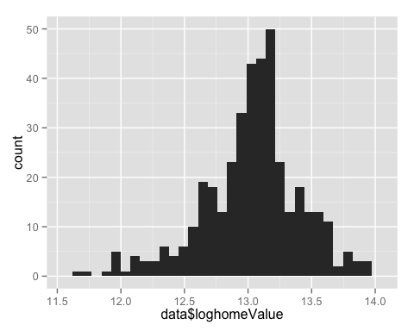

ContStat(data$loghomeValue ,1)

## Stats  
## N 392.0  
## #NA's 0.0  
## Mean 13.0  
## Min 11.6  
## Max 13.9  
## Std 0.4  
## 1% 12.0  
## 5% 12.3  
## 10% 12.6  
## 25% 12.8  
## 50% 13.1  
## 75% 13.2  
## 90% 13.5  
## 95% 13.6  
## 99% 13.8

As expected, the log home value transformation has made the histogram more normal, although there is a tail to the left.

We also will create two new binary variables, crimeRate_zero which indicates a very low crime rate and older neighborhood which indicates if 100% of the houses was built before 1950. Finally we have newerneighborhood which indicates if 25% or less of the houses were built before 1950.

#Create Indicator Variables  
  
data$crimeRate_zero[data$crimeRate_pc < 30.0] <- 1  
data$crimeRate_zero[data$crimeRate_pc >= 30.0] <- 0  
data$crimeRate_zero <-as.factor(data$crimeRate_zero)  
  
data$olderneighborhood [data$ageHouse >= 100.00] <- 1  
data$olderneighborhood [data$ageHouse < 100.00] <- 0  
data$olderneighborhood <- as.factor(data$olderneighborhood )  
  
#crimeRate_zero  
table(data$crimeRate_zero)

##   
## 0 1   
## 7 385

ggplot(data, aes(crimeRate_zero, homeValue)) + geom_boxplot() + scale_y_continuous(name = "Home Value", labels = comma)

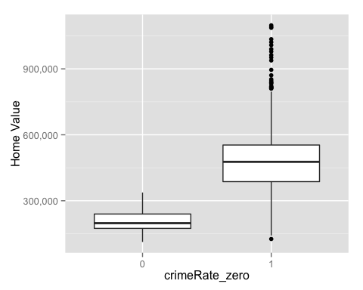

#olderneighborhood  
table(data$olderneighborhood)

##   
## 0 1   
## 359 33

ggplot(data, aes(olderneighborhood, homeValue)) + geom_boxplot() + scale_y_continuous(name = "Home Value", labels = comma)

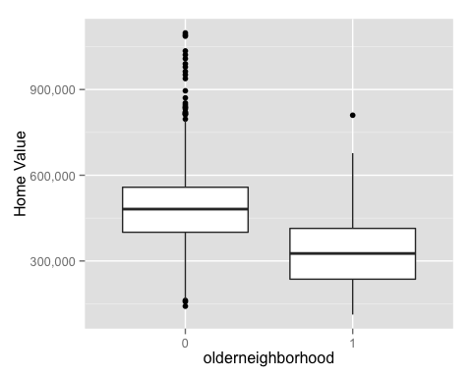

All of the transformations box plots look reasonable.

Now we will create two models using the variables identifed above. One will have homevalue as the dependent variable while the other will have the log of home value.

#Create Models  
  
lm = lm(homeValue ~ crimeRate_pc+crimeRate_zero+olderneighborhood +withWater+ageHouse+distanceToCity+pctLowIncome+pollutionIndex+nBedRooms, data=data)  
  
lmlog = lm(loghomeValue ~ crimeRate_pc+crimeRate_zero+olderneighborhood +withWater+ageHouse+distanceToCity+pctLowIncome+pollutionIndex+nBedRooms, data=data)  
  
#Summarize Models  
summary(lm)

##   
## Call:  
## lm(formula = homeValue ~ crimeRate_pc + crimeRate_zero + olderneighborhood +   
## withWater + ageHouse + distanceToCity + pctLowIncome + pollutionIndex +   
## nBedRooms, data = data)  
##   
## Residuals:  
## Min 1Q Median 3Q Max   
## -330218 -60134 -16285 43761 380624   
##   
## Coefficients:  
## Estimate Std. Error t value Pr(>|t|)   
## (Intercept) 417154.0 75963.4 5.492 7.28e-08 ***  
## crimeRate_pc -3986.5 1016.9 -3.920 0.000105 ***  
## crimeRate_zero1 -41282.7 58995.0 -0.700 0.484499   
## olderneighborhood1 98808.5 19671.4 5.023 7.83e-07 ***  
## withWater1 39616.0 20395.2 1.942 0.052821 .   
## ageHouse -768.0 299.1 -2.568 0.010617 *   
## distanceToCity -3653.5 843.1 -4.334 1.88e-05 ***  
## pctLowIncome -7689.8 894.1 -8.601 < 2e-16 ***  
## pollutionIndex -2455.2 682.6 -3.597 0.000364 ***  
## nBedRooms 100418.7 9345.3 10.745 < 2e-16 ***  
## ---  
## Signif. codes: 0 '***' 0.001 '**' 0.01 '*' 0.05 '.' 0.1 ' ' 1  
##   
## Residual standard error: 94670 on 382 degrees of freedom  
## Multiple R-squared: 0.7183, Adjusted R-squared: 0.7117   
## F-statistic: 108.2 on 9 and 382 DF, p-value: < 2.2e-16

summary(lmlog)

##   
## Call:  
## lm(formula = loghomeValue ~ crimeRate_pc + crimeRate_zero + olderneighborhood +   
## withWater + ageHouse + distanceToCity + pctLowIncome + pollutionIndex +   
## nBedRooms, data = data)  
##   
## Residuals:  
## Min 1Q Median 3Q Max   
## -0.80163 -0.11237 -0.01670 0.09919 0.70865   
##   
## Coefficients:  
## Estimate Std. Error t value Pr(>|t|)   
## (Intercept) 13.2878102 0.1516800 87.604 < 2e-16 ***  
## crimeRate_pc -0.0114508 0.0020304 -5.640 3.32e-08 ***  
## crimeRate_zero1 -0.0418476 0.1177983 -0.355 0.7226   
## olderneighborhood1 0.1669108 0.0392789 4.249 2.70e-05 ***  
## withWater1 0.1014851 0.0407241 2.492 0.0131 *   
## ageHouse -0.0008501 0.0005973 -1.423 0.1554   
## distanceToCity -0.0068534 0.0016834 -4.071 5.69e-05 ***  
## pctLowIncome -0.0220012 0.0017852 -12.324 < 2e-16 ***  
## pollutionIndex -0.0055078 0.0013629 -4.041 6.43e-05 ***  
## nBedRooms 0.1191352 0.0186602 6.384 4.99e-10 ***  
## ---  
## Signif. codes: 0 '***' 0.001 '**' 0.01 '*' 0.05 '.' 0.1 ' ' 1  
##   
## Residual standard error: 0.189 on 382 degrees of freedom  
## Multiple R-squared: 0.7582, Adjusted R-squared: 0.7525   
## F-statistic: 133.1 on 9 and 382 DF, p-value: < 2.2e-16

Let's remove the nonsignificant variables and take another look:

#Create Models  
  
lm = lm(homeValue ~ crimeRate_pc+withWater+olderneighborhood+  
 distanceToCity+pctLowIncome+  
 pollutionIndex+nBedRooms, data=data)  
  
lmlog = lm(loghomeValue ~ crimeRate_pc+withWater+olderneighborhood+  
 distanceToCity+pctLowIncome+  
 pollutionIndex+nBedRooms, data=data)  
  
#Summarize Models  
summary(lm)

##   
## Call:  
## lm(formula = homeValue ~ crimeRate_pc + withWater + olderneighborhood +   
## distanceToCity + pctLowIncome + pollutionIndex + nBedRooms,   
## data = data)  
##   
## Residuals:  
## Min 1Q Median 3Q Max   
## -323388 -60694 -18064 45957 360869   
##   
## Coefficients:  
## Estimate Std. Error t value Pr(>|t|)   
## (Intercept) 376236.5 56293.3 6.684 8.23e-11 ***  
## crimeRate_pc -3309.1 647.5 -5.111 5.07e-07 ***  
## withWater1 41144.9 20483.7 2.009 0.045272 *   
## olderneighborhood1 91740.4 19615.6 4.677 4.04e-06 ***  
## distanceToCity -2812.7 781.5 -3.599 0.000361 ***  
## pctLowIncome -8584.9 829.5 -10.349 < 2e-16 ***  
## pollutionIndex -3126.2 636.6 -4.911 1.35e-06 ***  
## nBedRooms 95459.6 9210.4 10.364 < 2e-16 ***  
## ---  
## Signif. codes: 0 '***' 0.001 '**' 0.01 '*' 0.05 '.' 0.1 ' ' 1  
##   
## Residual standard error: 95280 on 384 degrees of freedom  
## Multiple R-squared: 0.7132, Adjusted R-squared: 0.7079   
## F-statistic: 136.4 on 7 and 384 DF, p-value: < 2.2e-16

summary(lmlog)

##   
## Call:  
## lm(formula = loghomeValue ~ crimeRate_pc + withWater + olderneighborhood +   
## distanceToCity + pctLowIncome + pollutionIndex + nBedRooms,   
## data = data)  
##   
## Residuals:  
## Min 1Q Median 3Q Max   
## -0.80152 -0.11084 -0.01713 0.10312 0.70685   
##   
## Coefficients:  
## Estimate Std. Error t value Pr(>|t|)   
## (Intercept) 13.245866 0.111698 118.587 < 2e-16 ***  
## crimeRate_pc -0.010752 0.001285 -8.369 1.09e-15 ***  
## withWater1 0.103092 0.040644 2.536 0.011593 *   
## olderneighborhood1 0.159125 0.038921 4.088 5.29e-05 ***  
## distanceToCity -0.005922 0.001551 -3.819 0.000156 ***  
## pctLowIncome -0.022982 0.001646 -13.962 < 2e-16 ***  
## pollutionIndex -0.006244 0.001263 -4.943 1.15e-06 ***  
## nBedRooms 0.113694 0.018275 6.221 1.29e-09 ***  
## ---  
## Signif. codes: 0 '***' 0.001 '**' 0.01 '*' 0.05 '.' 0.1 ' ' 1  
##   
## Residual standard error: 0.1891 on 384 degrees of freedom  
## Multiple R-squared: 0.7569, Adjusted R-squared: 0.7524   
## F-statistic: 170.8 on 7 and 384 DF, p-value: < 2.2e-16

Now everything in the model is significantly accounting for variance. Lets take a look at histograms of the residuals.

lmresid = ggplot(data=lm, aes(lm$residuals)) + geom_histogram()   
lmlogresid =ggplot(data=lmlog, aes(lmlog$residuals)) + geom_histogram()   
   
grid.arrange(lmresid, lmlogresid, ncol=2,nrow=1)

## stat_bin: binwidth defaulted to range/30. Use 'binwidth = x' to adjust this.  
## stat_bin: binwidth defaulted to range/30. Use 'binwidth = x' to adjust this.

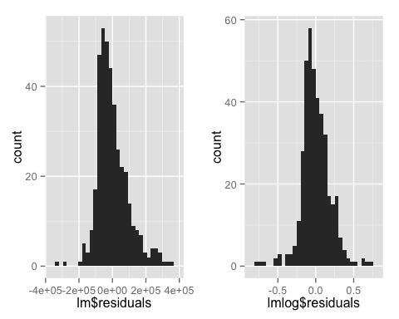

Both sets of residuals are fairly normal, although the log home value residuals are more normal. That in addition to its higher r squared score makes it the favorite thus far. However, lets take a look at the residual disagnostic plots for them before any final decision or addition or transformation of variables is undertaken.

plot(lm)

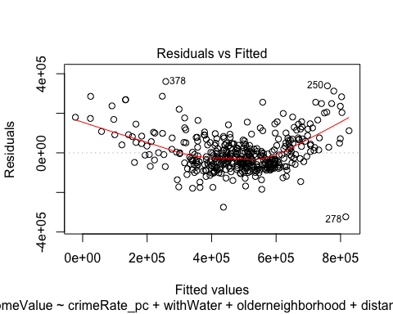 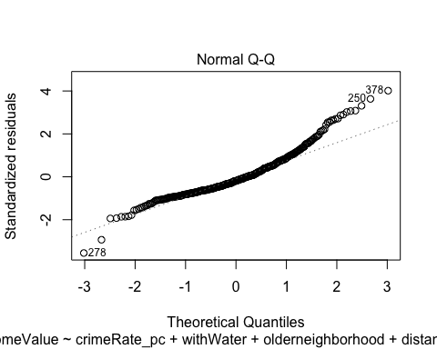 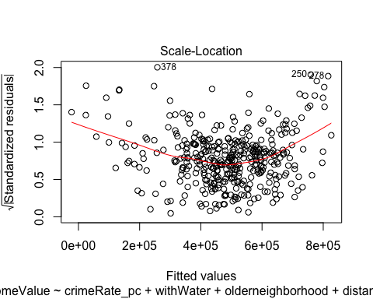 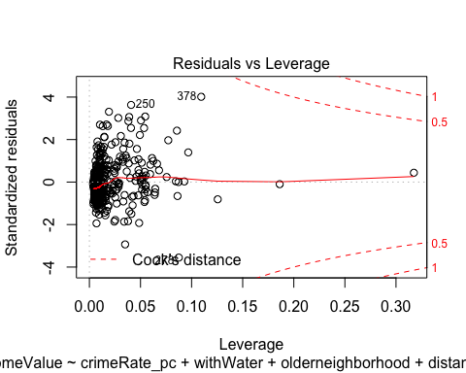

plot(lmlog)

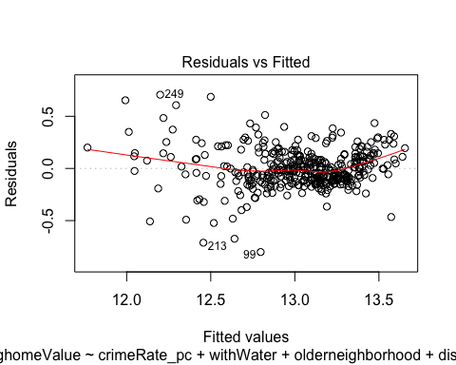 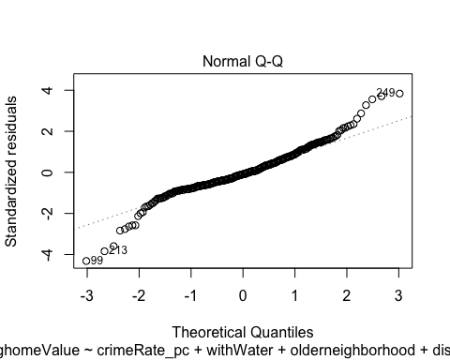 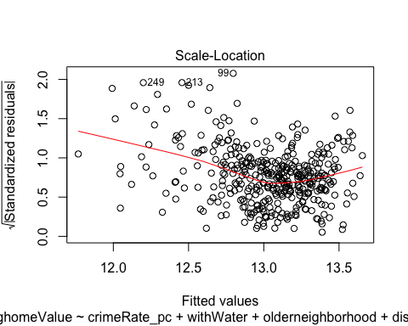 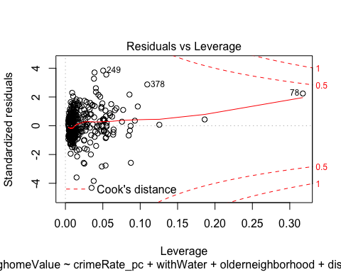

Both models show evidence of heteroscedasticity in their residuals vs fitted plots. We would want the residuals to be an even band with no obvious clustering or curvature. Clearly this is not the case. The log home value model is worse in this sense than the normal one. Both Q-Q plots show that the residuals are pretty normally distributed. We know this because they closely follow the straight line which would indicate a normal distribution.

Both scale-location plots also indicate some heteroscedasticity. Again, if the errors were homoskedastic we would expect an even distribution of errors. There is both clustering and curvature indicated by the smoothing function. Finally, the leverage plot indicates that while there are points with a large amount of leverage, they are within our bounds.

There are several issues with these plots that suggest we do not perfectly meet the definition of the Classical Linear Model. However, we can say that we have met the asymptotic assumptions of linear regression. Generally asymptotic assumptions can be used on a sample that is greater than 30, which we clearly have met. We have already met the first three conditions, by having linear parameters, assuming the data came from a random sample, and showing no multicolinearity. Therefore, we will test for exogeneity. Exogeneity is defined as no correlation between a particular x variable and the error terms in our model.

#Test regular model  
cov(data$crimeRate_pc, lm$residuals)

## [1] -3.869249e-11

cov(data$distanceToCity, lm$residuals)

## [1] -5.075092e-12

cov(data$pctLowIncome, lm$residuals)

## [1] 2.841953e-12

cov(data$pollutionIndex, lm$residuals)

## [1] -1.82579e-10

cov(data$nBedRooms, lm$residuals)

## [1] -1.076656e-11

#Test log model  
cov(data$crimeRate_pc, lmlog$residuals)

## [1] -1.428265e-17

cov(data$distanceToCity, lmlog$residuals)

## [1] -5.448972e-17

cov(data$pctLowIncome, lmlog$residuals)

## [1] 1.906822e-17

cov(data$pollutionIndex, lmlog$residuals)

## [1] -3.48146e-16

cov(data$nBedRooms, lmlog$residuals)

## [1] -2.221271e-17

As all of these values are quite small, we believe it is reasonable to assume we have met exogeneity. This means that we can claim our model parameters are consistent, which means that the bias decreases as the number of observations increases. This means we are reasonably confident we can use these statistics to estimate our population parameters.

Moving forward to improve our model, we can either transform variables or add interaction terms.

From the original variable analysis, we know that crimerate_pc and pctLowIncome are skewed to the left. Let's take a look at their distributions when square rooted.

data$sqrtpctIncome = sqrt(data$pctLowIncome)  
Graphs('sqrtpctIncome', 'Square Root of Percent of low income households in the neighborhood')

## stat_bin: binwidth defaulted to range/30. Use 'binwidth = x' to adjust this.

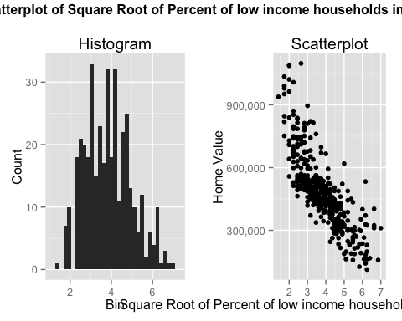

## TableGrob (2 x 2) "arrange": 3 grobs  
## z cells name grob  
## 1 1 (2-2,1-1) arrange gtable[layout]  
## 2 2 (2-2,2-2) arrange gtable[layout]  
## 3 3 (1-1,1-2) arrange text[GRID.text.1622]

The histogram looks far more normal and the scatterplot was not affected negatively which is a great sign.

data$sqrtcrimeRate_pc = sqrt(data$crimeRate_pc)  
Graphs('sqrtcrimeRate_pc', 'Square Root of Crime Rate in the neighborhood')

## stat_bin: binwidth defaulted to range/30. Use 'binwidth = x' to adjust this.

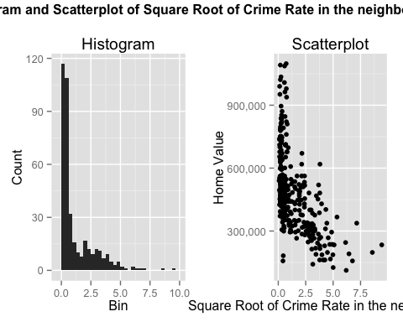

## TableGrob (2 x 2) "arrange": 3 grobs  
## z cells name grob  
## 1 1 (2-2,1-1) arrange gtable[layout]  
## 2 2 (2-2,2-2) arrange gtable[layout]  
## 3 3 (1-1,1-2) arrange text[GRID.text.1708]

With such a strong left skew, even the square root here does not make the data any more normal in the histogram. However, model performance may have improved.

#Adding square root of crime and square root of percent income  
lm = lm(homeValue ~ sqrtcrimeRate_pc+distanceToCity+olderneighborhood+sqrtpctIncome   
 +pollutionIndex+nBedRooms+withWater, data=data)  
lmlog = lm(loghomeValue ~ (crimeRate_pc+distanceToCity+olderneighborhood+sqrtpctIncome  
 +pollutionIndex+nBedRooms+withWater), data=data)

The fit indicated by the r squared value is slightly better, adding the square root of crime and percent low income increased R^2 by a little more than 1%. Given that this is a small increase and it limits interpretability, we will not include this in our final model. The purpose of this model was to aid in explaining, rather than predicting. If we were predicting, we might choose to include these variables.

Let's examine a few of the outliers:

plot(lm)

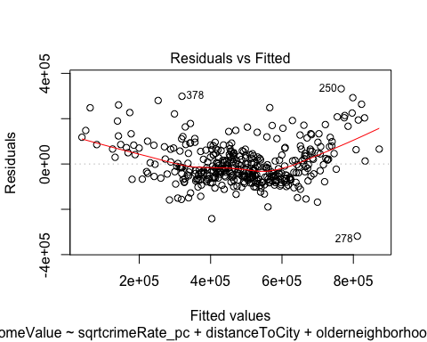 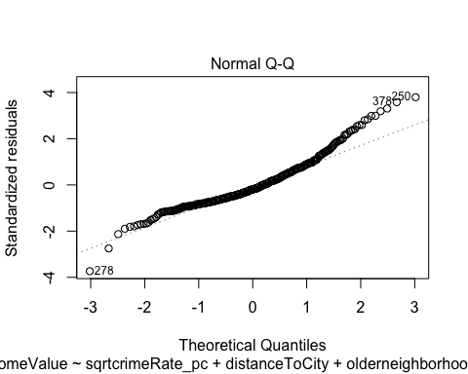 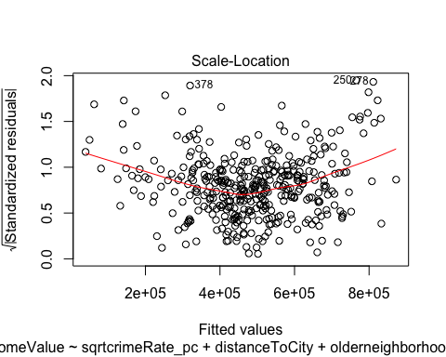 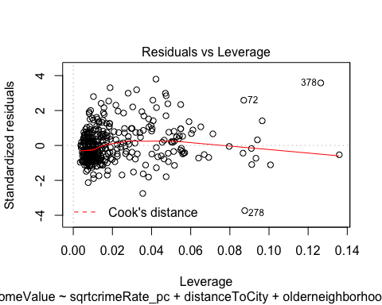

plot(lmlog)

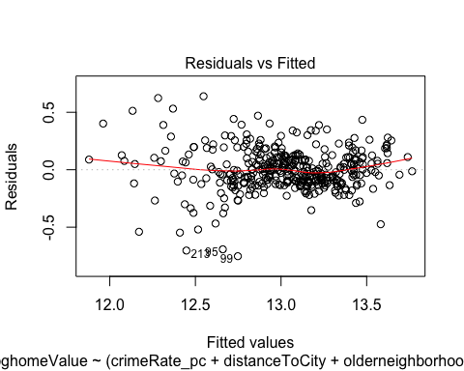 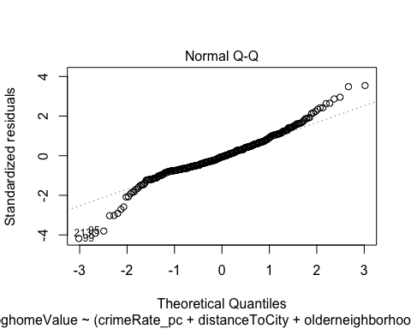 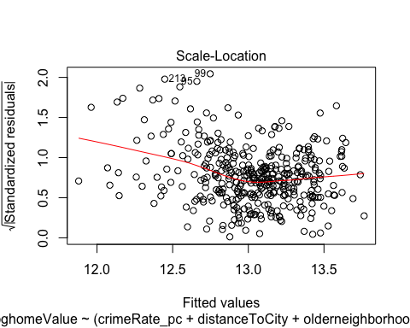 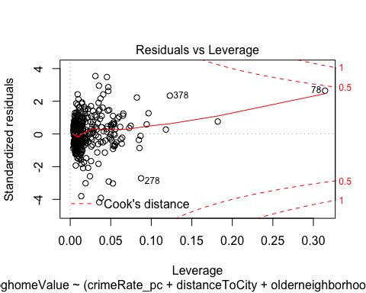

data[c(250,378,278,72,99,95,213),]

## crimeRate_pc nonRetailBusiness withWater ageHouse distanceToCity  
## 257 8.49213 0.1810 0 86.1 3.160245  
## 386 0.24980 0.2189 0 98.2 2.268630  
## 285 0.06162 0.0439 0 52.3 27.933429  
## 76 0.15876 0.1081 0 17.5 14.360658  
## 103 0.72580 0.0814 0 69.5 8.453050  
## 99 14.23620 0.1810 0 100.0 2.066578  
## 220 5.82401 0.1810 0 64.7 7.166294  
## distanceToHighway pupilTeacherRatio pctLowIncome homeValue  
## 257 24 23.2 22 326250  
## 386 4 24.2 27 299250  
## 285 3 21.8 16 387000  
## 76 4 22.2 12 488250  
## 103 4 24.0 14 409500  
## 99 24 23.2 26 162000  
## 220 24 23.2 13 517500  
## pollutionIndex nBedRooms loghomeValue crimeRate_zero olderneighborhood  
## 257 43.4 4.348 12.69542 1 0  
## 386 47.4 3.857 12.60903 1 0  
## 285 29.2 3.898 12.86618 1 0  
## 76 26.3 3.961 13.09858 1 0  
## 103 38.8 3.727 12.92269 1 0  
## 99 54.3 4.343 11.99535 1 1  
## 220 38.2 4.242 13.15676 1 0  
## sqrtpctIncome sqrtcrimeRate_pc  
## 257 4.690416 2.9141259  
## 386 5.196152 0.4998000  
## 285 4.000000 0.2482338  
## 76 3.464102 0.3984470  
## 103 3.741657 0.8519390  
## 99 5.099020 3.7730889  
## 220 3.605551 2.4132986

Quite a few of these outliers are areas of low income but have a relatively large number of bed rooms. Let's test for a potential interaction.

#Add interaction term  
lm = lm(homeValue ~ (crimeRate_pc+distanceToCity+olderneighborhood+pctLowIncome +pollutionIndex+nBedRooms+pctLowIncome*nBedRooms+withWater), data=data)  
  
lmlog = lm(loghomeValue ~ (crimeRate_pc+distanceToCity+olderneighborhood+pctLowIncome +pollutionIndex+nBedRooms+pctLowIncome*nBedRooms+withWater), data=data)  
summary(lmlog)

##   
## Call:  
## lm(formula = loghomeValue ~ (crimeRate_pc + distanceToCity +   
## olderneighborhood + pctLowIncome + pollutionIndex + nBedRooms +   
## pctLowIncome * nBedRooms + withWater), data = data)  
##   
## Residuals:  
## Min 1Q Median 3Q Max   
## -0.72420 -0.09643 -0.00864 0.09582 0.63097   
##   
## Coefficients:  
## Estimate Std. Error t value Pr(>|t|)   
## (Intercept) 12.702517 0.119465 106.328 < 2e-16 ***  
## crimeRate_pc -0.010757 0.001174 -9.161 < 2e-16 ***  
## distanceToCity -0.006161 0.001417 -4.347 1.77e-05 ***  
## olderneighborhood1 0.082214 0.036641 2.244 0.02542 *   
## pctLowIncome 0.014223 0.004507 3.156 0.00173 **   
## pollutionIndex -0.004704 0.001168 -4.028 6.79e-05 ***  
## nBedRooms 0.239389 0.022023 10.870 < 2e-16 ***  
## withWater1 0.082158 0.037224 2.207 0.02790 *   
## pctLowIncome:nBedRooms -0.009979 0.001140 -8.757 < 2e-16 ***  
## ---  
## Signif. codes: 0 '***' 0.001 '**' 0.01 '*' 0.05 '.' 0.1 ' ' 1  
##   
## Residual standard error: 0.1728 on 383 degrees of freedom  
## Multiple R-squared: 0.7974, Adjusted R-squared: 0.7932   
## F-statistic: 188.4 on 8 and 383 DF, p-value: < 2.2e-16

#Summarize Models  
summary(lmlog)

##   
## Call:  
## lm(formula = loghomeValue ~ (crimeRate_pc + distanceToCity +   
## olderneighborhood + pctLowIncome + pollutionIndex + nBedRooms +   
## pctLowIncome * nBedRooms + withWater), data = data)  
##   
## Residuals:  
## Min 1Q Median 3Q Max   
## -0.72420 -0.09643 -0.00864 0.09582 0.63097   
##   
## Coefficients:  
## Estimate Std. Error t value Pr(>|t|)   
## (Intercept) 12.702517 0.119465 106.328 < 2e-16 ***  
## crimeRate_pc -0.010757 0.001174 -9.161 < 2e-16 ***  
## distanceToCity -0.006161 0.001417 -4.347 1.77e-05 ***  
## olderneighborhood1 0.082214 0.036641 2.244 0.02542 *   
## pctLowIncome 0.014223 0.004507 3.156 0.00173 **   
## pollutionIndex -0.004704 0.001168 -4.028 6.79e-05 ***  
## nBedRooms 0.239389 0.022023 10.870 < 2e-16 ***  
## withWater1 0.082158 0.037224 2.207 0.02790 *   
## pctLowIncome:nBedRooms -0.009979 0.001140 -8.757 < 2e-16 ***  
## ---  
## Signif. codes: 0 '***' 0.001 '**' 0.01 '*' 0.05 '.' 0.1 ' ' 1  
##   
## Residual standard error: 0.1728 on 383 degrees of freedom  
## Multiple R-squared: 0.7974, Adjusted R-squared: 0.7932   
## F-statistic: 188.4 on 8 and 383 DF, p-value: < 2.2e-16

summary(lm)

##   
## Call:  
## lm(formula = homeValue ~ (crimeRate_pc + distanceToCity + olderneighborhood +   
## pctLowIncome + pollutionIndex + nBedRooms + pctLowIncome *   
## nBedRooms + withWater), data = data)  
##   
## Residuals:  
## Min 1Q Median 3Q Max   
## -459631 -50600 -9029 42418 422714   
##   
## Coefficients:  
## Estimate Std. Error t value Pr(>|t|)   
## (Intercept) -9294.6 53964.3 -0.172 0.863343   
## crimeRate_pc -3312.8 530.4 -6.246 1.12e-09 ***  
## distanceToCity -2982.3 640.3 -4.658 4.42e-06 ***  
## olderneighborhood1 37168.5 16551.5 2.246 0.025297 *   
## pctLowIncome 17813.8 2035.9 8.750 < 2e-16 ***  
## pollutionIndex -2033.2 527.5 -3.854 0.000136 ***  
## nBedRooms 184646.7 9948.2 18.561 < 2e-16 ***  
## withWater1 26291.2 16814.8 1.564 0.118744   
## pctLowIncome:nBedRooms -7080.8 514.8 -13.755 < 2e-16 ***  
## ---  
## Signif. codes: 0 '***' 0.001 '**' 0.01 '*' 0.05 '.' 0.1 ' ' 1  
##   
## Residual standard error: 78050 on 383 degrees of freedom  
## Multiple R-squared: 0.808, Adjusted R-squared: 0.804   
## F-statistic: 201.5 on 8 and 383 DF, p-value: < 2.2e-16

Wow! Adding this interaction term increased our R^2 by four percent, indicating that we are now explaining four percentage points more variance than we were previously. Let's briefly examine this interaction:

#Examine Relationship  
plot(data$nBedRooms,data$pctLowIncome)

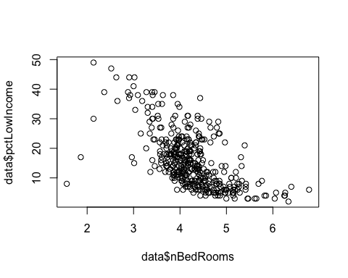

#Create high/low indicators based on the mean  
mean(data$pctLowIncome)

## [1] 15.99745

data$lowincome[data$pctLowIncome >= 16] <- 1  
data$lowincome[data$pctLowIncome < 16] <- 0  
mean(data$nBedRooms)

## [1] 4.235551

data$fewrooms[data$nBedRooms >= 4.2] <- 1  
data$fewrooms[data$nBedRooms < 4.2] <- 0  
data$fewrooms <-as.factor(data$fewrooms)  
  
#plot relationships  
lows <- subset(data, lowincome==1)  
plot(lows$nBedRooms,lows$homeValue)

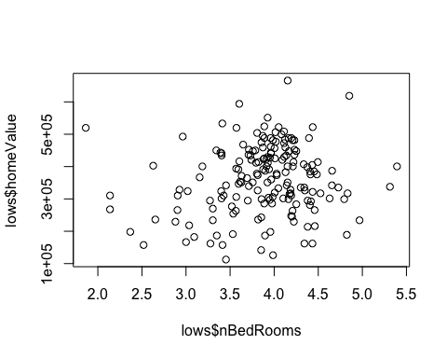

highs <- subset(data, lowincome==0)  
plot(highs$nBedRooms,highs$homeValue)

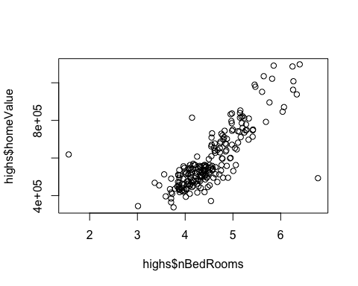

#Plot mean of income and number of bedrooms  
mean(highs$nBedRooms)

## [1] 4.52466

mean(lows$nBedRooms)

## [1] 3.884373

#Show means between group 1 (low income) by group 2 (few rooms)  
mytable <- table(data$homeValue, data$fewrooms, data$lowincome)   
aggregate(data$homeValue, by=list(data$fewrooms, data$lowincome), mean)

## Group.1 Group.2 x  
## 1 0 0 477353.6  
## 2 1 0 643779.3  
## 3 0 1 367380.7  
## 4 1 1 346150.0

This is very interesting. There is a clear positive relationship between number of bedrooms and home value among high income groups. However, among low income groups, there is not nearly as clear of a relationship between number of bedrooms and home value. This is also evident in the means across groups. For low income areas, the difference in home value between houses with few rooms and many rooms is 21,230.70, while the difference in home value for high income areas between few rooms and many rooms is 166,425.70. That's quite a difference and is an interesting finding. Let's plot the residuals one last time:

plot(lm)

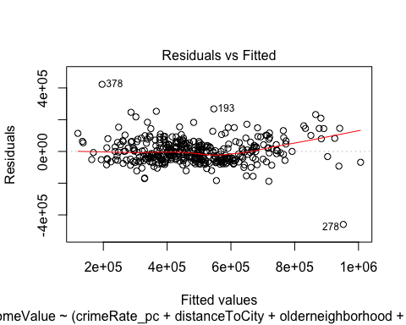 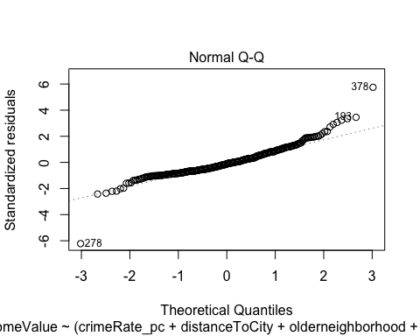 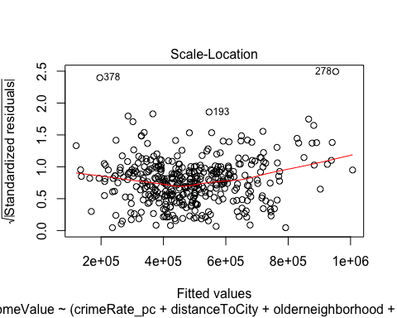 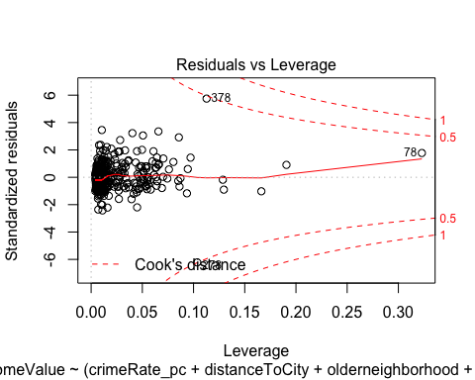

plot(lmlog)

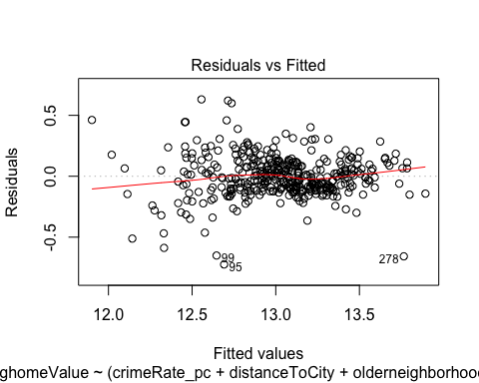 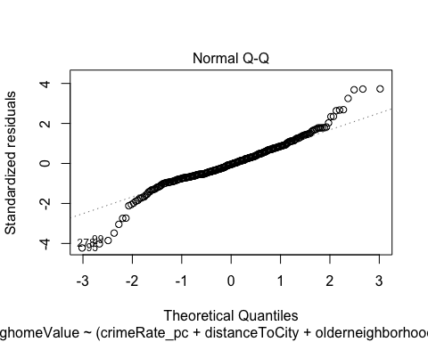 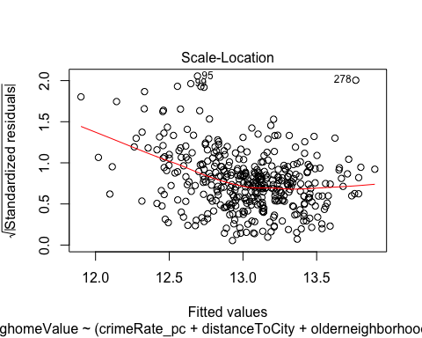 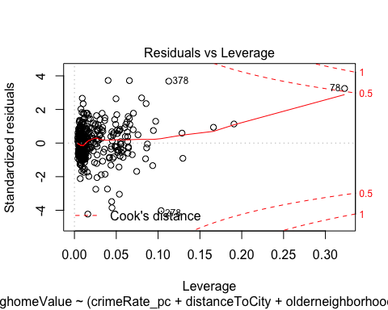

There still seems to be slight heteroscedasticity, but the plots look much better. To account for the slight heteroskedasticity, We will use robust standard errors to answer the questions of the group.

lmlog$newse<-vcovHC(lmlog)  
coeftest(lmlog,lmlog$newse)

##   
## t test of coefficients:  
##   
## Estimate Std. Error t value Pr(>|t|)   
## (Intercept) 12.7025175 0.1980926 64.1241 < 2.2e-16 ***  
## crimeRate_pc -0.0107574 0.0028246 -3.8084 0.0001628 ***  
## distanceToCity -0.0061615 0.0012493 -4.9318 1.217e-06 ***  
## olderneighborhood1 0.0822142 0.0622091 1.3216 0.1870977   
## pctLowIncome 0.0142231 0.0074476 1.9098 0.0569116 .   
## pollutionIndex -0.0047037 0.0014274 -3.2953 0.0010747 **   
## nBedRooms 0.2393895 0.0380374 6.2935 8.496e-10 ***  
## withWater1 0.0821581 0.0373887 2.1974 0.0285896 *   
## pctLowIncome:nBedRooms -0.0099793 0.0017491 -5.7054 2.326e-08 ***  
## ---  
## Signif. codes: 0 '***' 0.001 '**' 0.01 '*' 0.05 '.' 0.1 ' ' 1

Once we move to a robust standard error, there are some variables that are no long significant. Olderneighborhood no longer is significant with robust standard errors so we will remove it.

lmlog = lm(loghomeValue ~ (crimeRate_pc+distanceToCity+pctLowIncome +pollutionIndex+nBedRooms+pctLowIncome*nBedRooms+withWater), data=data)  
  
  
lmlog$newse<-vcovHC(lmlog)  
coeftest(lmlog,lmlog$newse)

##   
## t test of coefficients:  
##   
## Estimate Std. Error t value Pr(>|t|)   
## (Intercept) 12.6736307 0.1979277 64.0316 < 2.2e-16 ***  
## crimeRate_pc -0.0101023 0.0024499 -4.1235 4.577e-05 ***  
## distanceToCity -0.0061694 0.0012584 -4.9024 1.400e-06 ***  
## pctLowIncome 0.0169351 0.0070690 2.3957 0.017066 *   
## pollutionIndex -0.0045145 0.0013893 -3.2495 0.001258 **   
## nBedRooms 0.2444539 0.0381704 6.4043 4.418e-10 ***  
## withWater1 0.0822809 0.0379385 2.1688 0.030711 *   
## pctLowIncome:nBedRooms -0.0105921 0.0016262 -6.5136 2.303e-10 ***  
## ---  
## Signif. codes: 0 '***' 0.001 '**' 0.01 '*' 0.05 '.' 0.1 ' ' 1

This is the model to be used.

Specifically, the group wanted to know how environmental features affect the value of a home. There are two variables in our model that address this, the binary withWater variable and the pollution index.

Because we are using a log scale for home Value, we have to interpret this as follows:

The neighborhood being within 5 miles of water had increases the value of the home 8.2% versus not being in that proximity.

For every one unit increase in the pollutionIndex as it is calculated, the value of the home descreases by 0.45%.

We did find a significant interaction between number of rooms and percent low income. For higher income areas, the more rooms typically means the higher value of house. For lower income areas, the relationship between number of rooms and house value is not as clear.

Additionally, we found that crime rate tended to show a 1.0% decrease in value per unit increase in crime rate, and distance to city showed a .06% decrease in home value as the neighborhood got closer to the city.

This evidence does suggest that environmental features affect the value of a home. They may not be as impactful as other features, but there is still a link between the environment and the value of a house.

## Question 2

*Build a time-series model for the series in series02.txt and use it to perform a 24-step ahead forecast.*

#Import data  
series <- read.table("series02.txt")  
series <- ts(series$V1)  
  
#Plot data  
par(mfrow = c(2,2))  
plot.ts(series, col = "navy", xlab = "Time Period", ylab = "Values", main = "Time Series for Series 02")  
hist(series, main = "Histogram of Values of Series 02")  
acf(series, main = "ACF of Series 02")  
pacf(series, main = "PACF of Series 02")

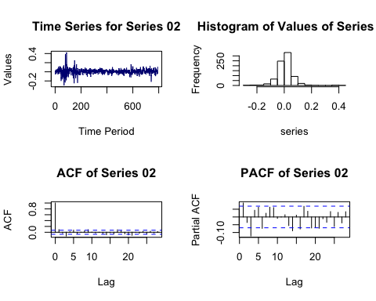

Notice the general structure of the series. There seems to be a long run average, where the values are fluctuating around a central axis but with with a major series of spikes in the beginning signaling serious volatility. There does not seem to be seasonality or a trend. The ACF interestingly shows a sharp drop after the 0 lag, but slightly statistically significant lags throughout the series. The PACF also shows slight significance at several lags after the most significant at what looks like the 3rd lag.

We suspect there is non-constant variance present in this series, so we will plot a correlogram of the squared values of a mean adjusted version of this series (adjusted so the mean is zero).

#Autocorrelation Function  
par(mfrow = c(1,1))  
acf((series - mean(series))^2, main = "ACF of Squared Terms")

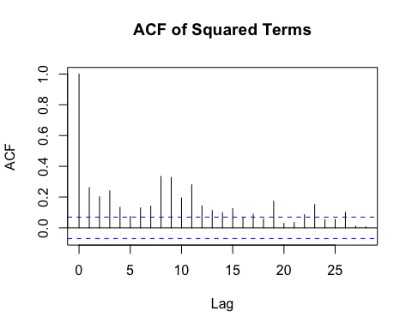

The square values that are plotted are equivalent to the variance. What the statistically significant values indicate is that there is serial correlation, meaning conditional heteroskedasticity. In plain English, this means that the variance is not constant throughout the series, rather the variance depends on what window of time we are looking at. This violates a core assumption of stationarity, meaning we will have to use a non-stationary model to fit this data.

garch.fit <- garchFit(~garch(1,1), data = series, trace = FALSE, include.mean = FALSE)  
garch.fit

##   
## Title:  
## GARCH Modelling   
##   
## Call:  
## garchFit(formula = ~garch(1, 1), data = series, include.mean = FALSE,   
## trace = FALSE)   
##   
## Mean and Variance Equation:  
## data ~ garch(1, 1)  
## <environment: 0x7fc86bfb20e0>  
## [data = series]  
##   
## Conditional Distribution:  
## norm   
##   
## Coefficient(s):  
## omega alpha1 beta1   
## 7.8467e-05 1.1530e-01 8.6147e-01   
##   
## Std. Errors:  
## based on Hessian   
##   
## Error Analysis:  
## Estimate Std. Error t value Pr(>|t|)   
## omega 7.847e-05 2.915e-05 2.692 0.00711 **   
## alpha1 1.153e-01 2.124e-02 5.428 5.7e-08 ***  
## beta1 8.615e-01 2.183e-02 39.462 < 2e-16 ***  
## ---  
## Signif. codes: 0 '***' 0.001 '**' 0.01 '*' 0.05 '.' 0.1 ' ' 1  
##   
## Log Likelihood:  
## 1257.974 normalized: 1.588351   
##   
## Description:  
## Fri Dec 18 09:32:09 2015 by user:

par(mfrow = c(2,1))  
#Note standardized residuals because garchFit calculates residuals differently  
acf(residuals(garch.fit, standardize = TRUE), main = "Residuals of Garch Model")  
acf(residuals(garch.fit, standardize = TRUE)^2, main = "Residuals of Garch Model Squared")

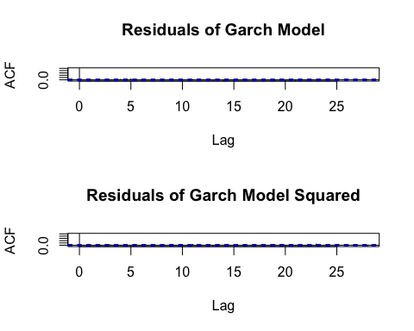

Box.test(residuals(garch.fit, standardize = TRUE), type = "Ljung-Box")

##   
## Box-Ljung test  
##   
## data: residuals(garch.fit, standardize = TRUE)  
## X-squared = 0.87562, df = 1, p-value = 0.3494

Notice that with the ACF of both the series residuals and squared residuals there is no autocorrelation. This suggests the residuals are behaving like white noise and thus the model is a good fit. The residuals also fail to reject the null hypothesis that the residuals are independent. The coefficients are all statistically significant, meaning we reject the null hypothesis that the coefficients are 0. Therefore, we believe this model is a good fit for forecasting.

preds <- predict(garch.fit, n.ahead = 24)  
lower <- preds$meanForecast - 1.96 * preds$meanError  
upper <- preds$meanForecast + 1.96 * preds$meanError  
cbind(lower, preds$meanForecast, upper)

## lower upper  
## [1,] -0.1077285 0 0.1077285  
## [2,] -0.1078761 0 0.1078761  
## [3,] -0.1080200 0 0.1080200  
## [4,] -0.1081604 0 0.1081604  
## [5,] -0.1082973 0 0.1082973  
## [6,] -0.1084309 0 0.1084309  
## [7,] -0.1085613 0 0.1085613  
## [8,] -0.1086884 0 0.1086884  
## [9,] -0.1088125 0 0.1088125  
## [10,] -0.1089335 0 0.1089335  
## [11,] -0.1090517 0 0.1090517  
## [12,] -0.1091669 0 0.1091669  
## [13,] -0.1092793 0 0.1092793  
## [14,] -0.1093890 0 0.1093890  
## [15,] -0.1094961 0 0.1094961  
## [16,] -0.1096006 0 0.1096006  
## [17,] -0.1097025 0 0.1097025  
## [18,] -0.1098020 0 0.1098020  
## [19,] -0.1098991 0 0.1098991  
## [20,] -0.1099939 0 0.1099939  
## [21,] -0.1100864 0 0.1100864  
## [22,] -0.1101766 0 0.1101766  
## [23,] -0.1102647 0 0.1102647  
## [24,] -0.1103507 0 0.1103507

We have printed the forecast above. The 0 predicted value should make sense, this is a model of volatility. We will plot the results below

par(mfrow = c(1,1))  
plot.ts(c(series, preds$meanForecast), xlab = "Time Period", ylab = "Value", main = "Forecast Plot")  
lines(c(rep(NA, 792), preds$meanForecast), col = "blue")  
lines(c(rep(NA, 792), lower), col = "blue")  
lines(c(rep(NA, 792), upper), col = "blue")

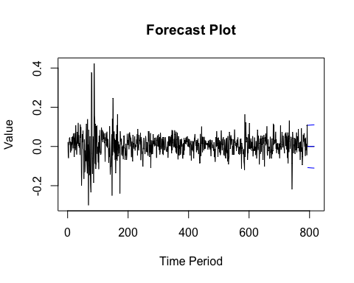

The two blue lines represent the 95% confidence interval of the predicted volatility. These seem to be in line with the long run average of the series.

## Question 3

*Build a time-series model for the series in series03.csv and use it to perform a 24-step ahead forecast*

#Load data  
series <- read.csv("series03.csv")  
series <- ts(series$X9.88)  
  
#Plot data  
par(mfrow = c(2,2))  
plot.ts(series, xlab = "Time Period", ylab = "Value", main = "Time Series Plot of Series 03", col = "navy")  
hist(series, main = "Histogram of Series 03")  
acf(series, main = "ACF of Series 03")  
pacf(series, main = "PACF of Series 03")

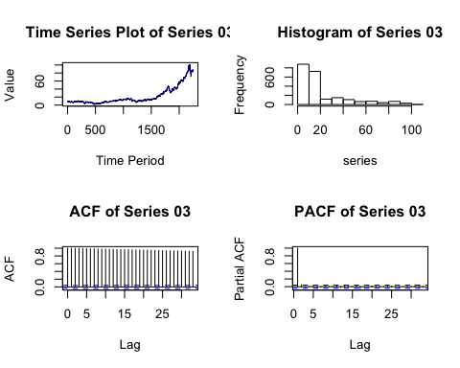

Notice from the time series plot that there is significant trend going on, specifically, a long term upward trend. The ACF shows significance through all past lags while the PACF is only siginficant for the first lag. There does not seem to be any seasonality. This looks like the realization of a random walk with drift process.

#Plot different time series to suggest differencing  
par(mfrow = c(3, 2))  
plot.ts(series, main = "Original Time Series")  
plot.ts(log(series), main = "Log of Time Series")  
plot.ts(diff(series), main = "First Difference of Time Series")  
plot.ts(diff(series, d = 2), main = "Second Difference of Time Series")  
plot.ts(diff(log(series)), main = "First Difference of Log Time Series")  
plot.ts(diff(log(series), d = 2), main = "Second Difference of Log Time Series")

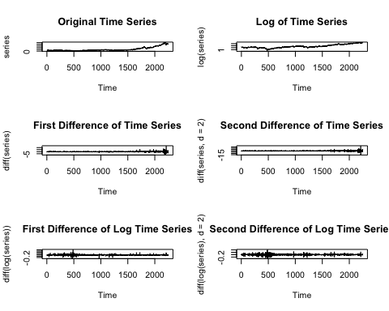

It is clear from the original time series plot that the series is not stationary. Before proceeding to build a model we must render the series as stationary.

#Transform the series for stationarity  
par(mfrow = c(2,2))  
acf(diff(series), main = "ACF of First order Difference")  
pacf(diff(series), main = "PACF of First order Difference")  
acf(diff(series, d= 2), main = "ACF of Second order Difference")  
pacf(diff(series, d = 2), main = "PACF of Second order Difference")

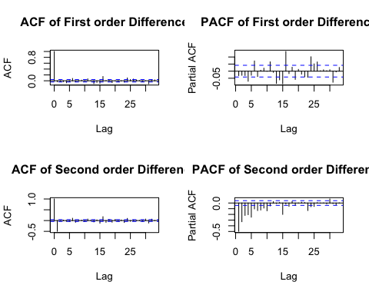

acf(diff(log(series)), main = "ACF of First Order Difference of Log")  
pacf(diff(log(series)), main = "PACF of First Order Difference of Log")  
acf(diff(log(series), d = 2), main = "ACF of Second Order Difference of Log")  
pacf(diff(log(series), d = 2), main = "PACF of Second Order Difference of Log")

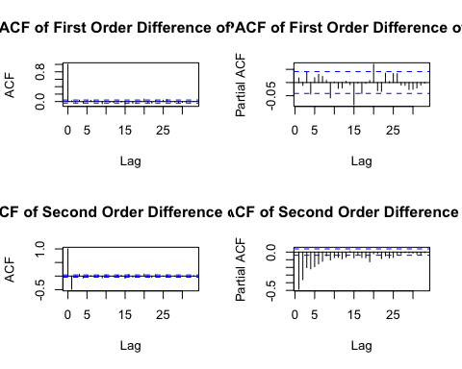

From examining these plots, it seems as though the second order difference provides the best transformation into white noise. In both cases the ACF shows a sharp cut off (suggesting an MA term) while the PACF gradually declines. The first order difference shows a lot of volatility in the PACF, suggesting correlations that are not easily captured.

Between the second order difference and the second order difference of the log, the second order difference of the log seems to look more like white noise. There are fewer significant autocorrelations (which might be due to sampling) in the second order difference of the log and it decays more smoothly. Therefore, we will use the second order difference of the log to estimate the model.

#Function to select the best ARIMA based on AIC  
get.best.arima <- function(x.ts, maxord = c(1,1,1))  
{  
 best.aic <- 1e8  
 n <- length(x.ts)  
 for (p in 0:maxord[1]) for (d in 0:maxord[2]) for (q in 0:maxord[3])  
 {  
 fit <- arima(x.ts, order = c(p, d, q), method = "ML")  
 fit.aic <- -2 * fit$loglik + (log(n) + 1) * length(fit$coef)  
 if (fit.aic < best.aic)  
 {  
 best.aic <- fit.aic  
 best.fit <- fit  
 best.model <- c(p, d, q)  
 }  
 }  
 list(best.aic, best.fit, best.model)  
}  
  
auto.arima(log(series), allowdrift = FALSE)

## Series: log(series)   
## ARIMA(0,1,0)   
##   
## sigma^2 estimated as 0.001456: log likelihood=4146.46  
## AIC=-8290.91 AICc=-8290.91 BIC=-8285.2

mod <- auto.arima(log(series), d = 2)

## Warning in auto.arima(log(series), d = 2): Unable to fit final model using  
## maximum likelihood. AIC value approximated

mod

## Series: log(series)   
## ARIMA(2,2,1)   
##   
## Coefficients:  
## ar1 ar2 ma1  
## 0.0139 -0.0120 -0.9886  
## s.e. 0.0212 0.0213 0.0030  
##   
## sigma^2 estimated as 0.001476: log likelihood=4129.66  
## AIC=-8238.81 AICc=-8238.79 BIC=-8215.94

t(confint(mod))

## ar1 ar2 ma1  
## 2.5 % -0.02770088 -0.05363241 -0.9944319  
## 97.5 % 0.05550080 0.02970417 -0.9828398

Here we try using the auto.arima() function to find the best model. When using the auto.arima() function it suggests the first order difference of the log series. However, we saw above that this was not the best model examining the ACF and PACF so we instead specificed the order of differencing to be 2. When doing this, the suggested model is an ARIMA(2, 2, 1) model. However, examining the confidence intervals, we find that the 2 AR terms contain 0 in their confidence interval. That means we will fail to reject the null hypothesis these coefficients are 0. The MA term however does not contain 0 in its confidence interval and therefore we can reject the null hypothesis. Therefore, we will construct an ARIMA(0, 2, 1) model.

#Fit ARIMA (0,2,1)  
model <- arima(log(series), order = c(0, 2, 1))  
model

##   
## Call:  
## arima(x = log(series), order = c(0, 2, 1))  
##   
## Coefficients:  
## ma1  
## -0.9997  
## s.e. 0.0026  
##   
## sigma^2 estimated as 0.001456: log likelihood = 4141, aic = -8278

t(confint(model))

## ma1  
## 2.5 % -1.0048193  
## 97.5 % -0.9944951

0 is not contained in the confidence interval so this coefficient is statistically significant.

#Diagnostic plots of residuals  
resids <- model$residuals  
par(mfrow = c(2,2))  
plot.ts(resids, main = "Residuals of ARIMA Model")  
hist(resids, main = "Histogram of Residuals")  
acf(resids, main = "ACF of Residuals")  
pacf(resids, main = "PACF of Residuals")

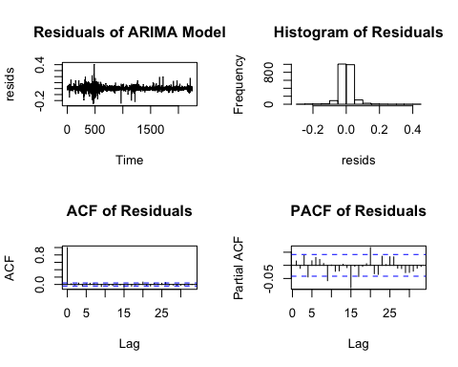

These residual diagnostics suggest a reasonably good approximation of white noise. The ACF and PACF however do show quite a bit of volatility, so we will examine the squared residuals because we suspect there is non-constant variance.

#Plot residuals and squared residuals  
par(mfrow = c(2,1))  
acf(resids, main = "ACF of Residuals")  
acf(resids^2, main = "ACF of Squared Residuals")

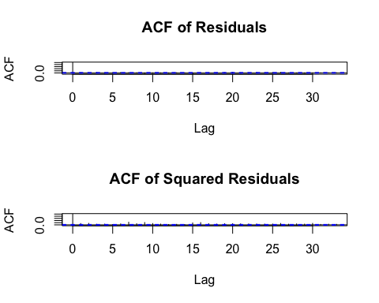

As we had suspected, the squared residuals show statistically significant terms at different intervals. Clearly, this suggests there is non-constant variance. Therefore, we will fit a GARCH model to the residuals.

#Fit GARCH model  
garch.fit <- garchFit(~garch(1,1), data = resids, include.mean = FALSE, trace = FALSE)  
garch.fit

##   
## Title:  
## GARCH Modelling   
##   
## Call:  
## garchFit(formula = ~garch(1, 1), data = resids, include.mean = FALSE,   
## trace = FALSE)   
##   
## Mean and Variance Equation:  
## data ~ garch(1, 1)  
## <environment: 0x7fc86d057510>  
## [data = resids]  
##   
## Conditional Distribution:  
## norm   
##   
## Coefficient(s):  
## omega alpha1 beta1   
## 5.5007e-05 8.2207e-02 8.7660e-01   
##   
## Std. Errors:  
## based on Hessian   
##   
## Error Analysis:  
## Estimate Std. Error t value Pr(>|t|)   
## omega 5.501e-05 1.540e-05 3.572 0.000354 ***  
## alpha1 8.221e-02 2.102e-02 3.911 9.18e-05 ***  
## beta1 8.766e-01 2.986e-02 29.355 < 2e-16 ***  
## ---  
## Signif. codes: 0 '***' 0.001 '**' 0.01 '*' 0.05 '.' 0.1 ' ' 1  
##   
## Log Likelihood:  
## 4453.374 normalized: 1.982802   
##   
## Description:  
## Fri Dec 18 09:32:11 2015 by user:

par(mfrow = c(2,1))  
acf(residuals(garch.fit, standardize = TRUE), main = "ACF of GARCH Residuals")  
acf(residuals(garch.fit, standardize = TRUE)^2, main = "ACF of GARCH Residuals Squared")

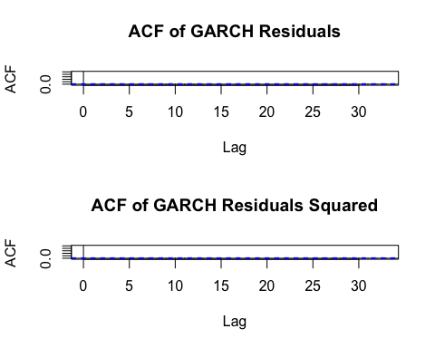

Box.test(residuals(garch.fit, standardize = TRUE), type = "Ljung-Box")

##   
## Box-Ljung test  
##   
## data: residuals(garch.fit, standardize = TRUE)  
## X-squared = 0.0083375, df = 1, p-value = 0.9272

The GARCH model shows statistically significant coefficients, meaning we will reject our null hypothesis that the coefficients are 0. Further, notice that the residuals now are not significant, meaning this series approximates white noise. The residuals also fail to reject the null hypothesis of the Ljung-Box test, meaning we cannot say the residuals are not independent. Therefore, we will use this model for forecasting.

According to Cowpertwait, the fitted GARCH model on the residuals will not affect the average prediction, because the mean of residual errors is 0. However, it does affect the variance of predicted values. Therefore, we will use the ARIMA component of our model to provide point estimates for our forecast and the GARCH model to supply the standard error for the confidence interval.

preds <- forecast(model, h = 24)  
std <- predict(garch.fit, n.ahead = 24)  
  
#set confidence intervals  
lower <- c(preds$mean - 1.96 * std$meanError)  
upper <- c(preds$mean + 1.96 * std$meanError)  
#display  
cbind(exp(lower), exp(preds$mean), exp(upper))

## Time Series:  
## Start = 2247   
## End = 2270   
## Frequency = 1   
## exp(lower) exp(preds$mean) exp(upper)  
## 2247 82.95421 87.86284 93.06193  
## 2248 82.98800 87.95579 93.22096  
## 2249 83.02458 88.04883 93.37712  
## 2250 83.06379 88.14197 93.53061  
## 2251 83.10546 88.23521 93.68159  
## 2252 83.14946 88.32854 93.83021  
## 2253 83.19565 88.42198 93.97662  
## 2254 83.24391 88.51551 94.12095  
## 2255 83.29412 88.60914 94.26333  
## 2256 83.34618 88.70288 94.40385  
## 2257 83.39999 88.79671 94.54264  
## 2258 83.45546 88.89064 94.67979  
## 2259 83.51251 88.98467 94.81539  
## 2260 83.57106 89.07880 94.94952  
## 2261 83.63103 89.17303 95.08227  
## 2262 83.69236 89.26736 95.21371  
## 2263 83.75498 89.36178 95.34392  
## 2264 83.81883 89.45631 95.47296  
## 2265 83.88386 89.55094 95.60088  
## 2266 83.95000 89.64567 95.72776  
## 2267 84.01722 89.74050 95.85365  
## 2268 84.08545 89.83543 95.97860  
## 2269 84.15467 89.93046 96.10265  
## 2270 84.22482 90.02559 96.22586

par(mfrow = c(1,1))  
plot.ts(c(series, exp(preds$mean)), xlab = "Time Period", ylab = "Value", main = "Time Series Plot with Forecast")  
lines(c(rep(NA, 2246), exp(preds$mean)), col = "blue")  
lines(c(rep(NA, 2246), exp(upper)), col = "red")  
lines(c(rep(NA, 2246), exp(lower)), col = "red")

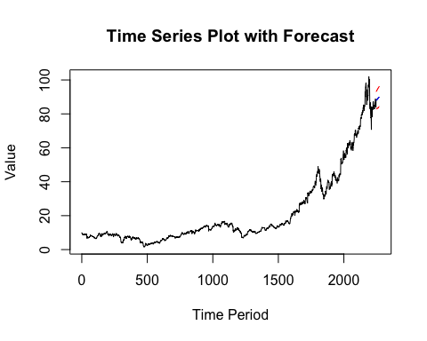

Above we have displayed and plotted a 24 step forecast. The bounds in red represent the a 95% confidence interval, while the blue line is the mean forecast. The general trend upwards seems to continue, which logically makes sense.

## Question 4

*Build a time-series model for the series in series04.csv and use it to perform a 24-step ahead forecast. Possible models include AR, MA, ARMA, ARIMA, Seasonal ARIMA, GARCH, ARIMA-GARCH, or Seasonal ARIMA-GARCH models. Note that the original series may need to be transformed before it be modelled.*

#Import data  
series <- read.csv("series04.csv")  
series <- ts(series$X25182)  
  
#Plot data  
par(mfrow = c(2,2))  
plot.ts(series, xlab = "Time Period", ylab = "Values", main = "Time Series Plot of Series 04")  
hist(series, main = "Histogram of Series 04")  
acf(series, main = "ACF of Series 04")  
pacf(series, main = "PACF of Series 04")

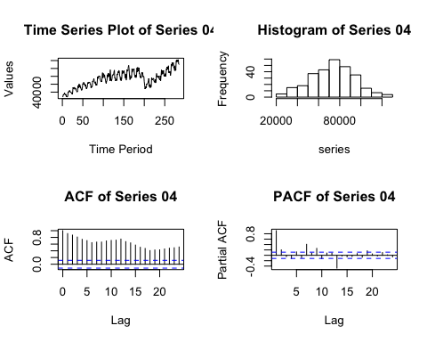

From the time series plot it should be obvious that there is seasonality in this series, suggesting seasonal lag terms will be needed. The series shows a general upwards trend, and we would argue this series is definitely not stationary. The ACF show statistically significant lags persisting but at different heights, further suggesting non-stationarity and seasonality.

#Transform series for stationary  
series <- read.csv("series04.csv")  
series <- ts(series$X25182, frequency = 12)  
  
par(mfrow = c(2,2))  
plot.ts(diff(log(series)), main = "Time Series of Log First Difference")  
hist(diff(log(series)), main = "Histogram of Log First Difference")  
acf(diff(log(series)), main = "ACF of Log First Difference")  
pacf(diff(log(series)), main = "PACF of Log First Difference")

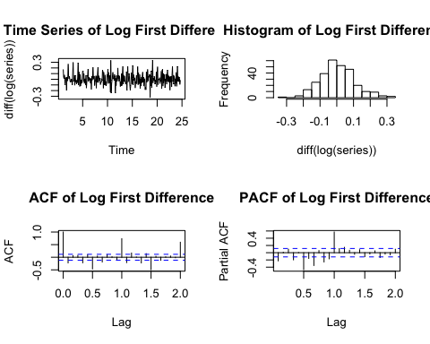

We are reimporting the series and setting the frequency to 12. We suspect the seasonality occurs on a monthly basis and counted 24 trough to peak cycles, indicating a seasonal period of 12. As is generally good practice we will take the log of the series and take the first difference to render the series more stationary.

The time series plot of the differenced series resembles white noise. However, the ACF shows regular significance suggesting seasonal terms will be needed there. The PACF also shows seasonality although somewhat less as it decreases eventually. Both plots also show significance at the first lag suggesting non-seasonal terms will also be needed.

#Function to find the best ARIMA model. Credit to Cowpertwait and Metcalfe.  
get.best.arima.seas <- function(x.ts, maxord = c(1,1,1,1,1,1)) {  
 best.aic <- 1e8  
 n <- length(x.ts)  
 for (p in 0:maxord[1]) for(d in 0:maxord[2]) for(q in 0:maxord[3])  
 for (P in 0:maxord[4]) for(D in 0:maxord[5]) for(Q in maxord[6])  
 {  
 fit <- arima(x.ts, order = c(p, d, q), seas = list(order = c(P,D,Q), 12), method = "CSS")  
 fit.aic <- -2 * fit$loglik + (log(n) + 1) * length(fit$coef)  
 if (fit.aic < best.aic)  
 {  
 best.aic <- fit.aic  
 best.fit <- fit  
 best.model <- c(p, d, q, P, D, Q)  
 }  
 }  
 list(best.aic, best.fit, best.model)  
}  
  
get.best.arima.seas(log(series), maxord = rep(3, 6))

## [[1]]  
## [1] -811.9272  
##   
## [[2]]  
##   
## Call:  
## arima(x = x.ts, order = c(p, d, q), seasonal = list(order = c(P, D, Q), 12),   
## method = "CSS")  
##   
## Coefficients:  
## ar1 ar2 ar3 ma1 ma2 ma3 sar1 sar2  
## -0.1864 0.1633 0.9602 0.8195 0.4838 -0.4573 0.6859 0.2926  
## s.e. 0.0059 0.0021 0.0098 0.0081 NaN NaN 0.0671 0.0702  
## sma1 sma2 sma3 intercept  
## -0.3415 -0.3488 0.0524 11.1926  
## s.e. 0.0862 0.0749 0.0606 2.0218  
##   
## sigma^2 estimated as 0.002562: part log likelihood = 445.88  
##   
## [[3]]  
## [1] 3 0 3 2 0 3

auto.arima(log(series), d = 1, D = 1) #note specified the use of seasonality

## Series: log(series)   
## ARIMA(2,1,0)(2,1,2)[12]   
##   
## Coefficients:  
## ar1 ar2 sar1 sar2 sma1 sma2  
## -0.3788 -0.2638 0.5919 -0.2884 -1.2183 0.4125  
## s.e. 0.0620 0.0601 0.2195 0.0892 0.2195 0.1862  
##   
## sigma^2 estimated as 0.003037: log likelihood=396.79  
## AIC=-779.57 AICc=-779.15 BIC=-754.33

#get.best -> (3, 0, 3) (2, 0, 3) [12]  
#auto -> (2, 1, 0) (2, 1, 2) [12]  
  
mod <- auto.arima(log(series), d = 1, D = 1)  
mod2 <- arima(log(series), order = c(3, 0, 3), seasonal = list(order = c(2, 0, 3), 12))  
mod

## Series: log(series)   
## ARIMA(2,1,0)(2,1,2)[12]   
##   
## Coefficients:  
## ar1 ar2 sar1 sar2 sma1 sma2  
## -0.3788 -0.2638 0.5919 -0.2884 -1.2183 0.4125  
## s.e. 0.0620 0.0601 0.2195 0.0892 0.2195 0.1862  
##   
## sigma^2 estimated as 0.003037: log likelihood=396.79  
## AIC=-779.57 AICc=-779.15 BIC=-754.33

mod2

##   
## Call:  
## arima(x = log(series), order = c(3, 0, 3), seasonal = list(order = c(2, 0, 3),   
## 12))  
##   
## Coefficients:  
## ar1 ar2 ar3 ma1 ma2 ma3 sar1 sar2  
## -0.1859 0.1848 0.9720 0.8376 0.4928 -0.4074 0.8325 0.1519  
## s.e. 0.0131 0.0126 0.0124 0.0598 0.0755 0.0587 0.6131 0.6077  
## sma1 sma2 sma3 intercept  
## -0.5152 -0.2522 0.0995 11.1842  
## s.e. 0.6123 0.3912 0.1020 1.5779  
##   
## sigma^2 estimated as 0.002691: log likelihood = 421.43, aic = -816.86

We utilized both the auto.arima() function and the get.best.arima.seas() function (from the time series textbook) to acquire suggested model fits. However, we know the model should include a first difference and a seasonal difference from our previous investigation. Otherwise the model will not be stationary, and we will be unable to fit a model to it. The auto.arima() model's AIC is slightly higher -779.5714051 versus -816.8591981, but we believe that the model suggested by auto arima will better satisfy our assumptions. Therefore, we will investigate this model going forward.

#Model comparisons  
t(confint(mod))

## ar1 ar2 sar1 sar2 sma1 sma2  
## 2.5 % -0.5003736 -0.3816227 0.1616603 -0.4632530 -1.6484367 0.04750577  
## 97.5 % -0.2572684 -0.1459414 1.0222092 -0.1134823 -0.7882052 0.77746222

#Base comparison model is (2, 1, 0)(2, 1, 2)[12] with AIC -779.5714  
mod3 <- arima(log(series), order = c(3, 1, 0), seasonal = list(order = c(2, 1, 2), 12))  
mod4 <- arima(log(series), order = c(2, 1, 1), seasonal = list(order = c(2, 1, 2), 12))  
mod5 <- arima(log(series), order = c(2, 1, 0), seasonal = list(order = c(3, 1, 2), 12))  
mod6 <- arima(log(series), order = c(2, 1, 0), seasonal = list(order = c(2, 1, 3), 12))  
AIC(mod3)

## [1] -778.6494

AIC(mod4)

## [1] -779.2913

AIC(mod5)

## [1] -775.8237

AIC(mod6)

## [1] -774.8587

Note that 0 is not contained in the confidence intervals of any of the terms for our model, which is currently ARIMA(2, 1, 0)(2, 1, 2)[12]. This means that we reject the null hypothesis and conclude that the evidence supports the alternative hypothesis that our model coefficients are different from 0. Further, above we have deliberately attempted to overfit our data by providing additional parameters. In all cases the AIC increases, suggesting that these models do not do a better job of explaining our data simply. In general, one wants a model that minimizes the AIC.

Therefore, we will continue with residual diagnostics for our chosen model:

#Examine model residuals  
par(mfrow = c(2,2))  
resids <- mod$residuals  
plot.ts(resids, main = "Time Series Plot of Residuals")  
hist(resids, main = "Time Series Plot of Residuals")  
acf(resids, main = "ACF Plot of Residuals")  
pacf(resids, main = "ACF Plot of Residuals")

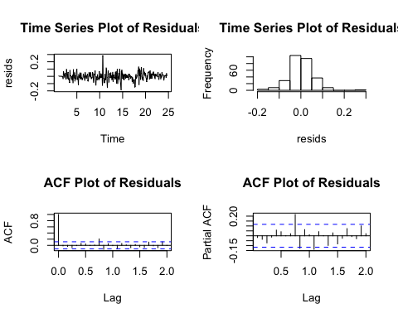

par(mfrow = c(2, 1))  
acf(resids, main = "ACF of Residuals")  
acf(resids^2, main = "ACF of Residuals^2")

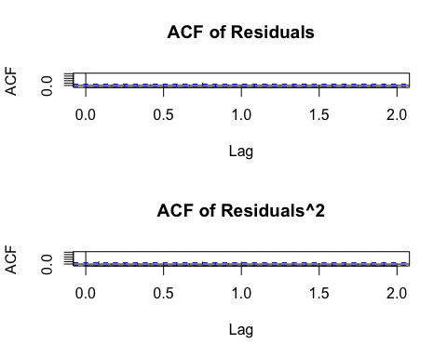

Box.test(resids, type = "Ljung-Box")

##   
## Box-Ljung test  
##   
## data: resids  
## X-squared = 0.087567, df = 1, p-value = 0.7673

Overall, the residuals appear to largely resemble white noise. The time series plot looks fairly like white noise, with no obvious patterns suggesting seasonality or a trend. There is one large spike, which we would need to know more about this data to properly try to account for. This was noted in the time series plot of the original data. The ACF shows one significant term at around 3/4 and the PACF shows two significant terms around the same area. However, there are no highly significant terms in the early part of the model (beyond the expected term of the ACF) and there is no repeating pattern of terms that are significant. Further, the residuals fail to reject the null hypothesis of the Ljung-Box test, meaning that the evidence suggests the observations are independent. There are some terms that are significant in the residual squared ACF, but none are highly significant and as there are only three, this does not represent a large enough number to suggest our residuals are behaving other than white noise.

We will note here that the residuals do not perfectly resemble white noise. There are still several lags showing statistical significant, which is not what we would want to see. However, we believe that we have fit the best possible model with the available information that we have. We would like to know more about the data and sampling methods to be able to fit the most appropriate possible model. We do however believe that we have satistified the conditions of stationarity and residuals behaving as white noise sufficiently to be able to forecast.

preds <- forecast(mod, h = 24)  
  
cbind(exp(preds$lower[,2]), exp(preds$mean), exp(preds$upper[,2]))

## exp(preds$lower[, 2]) exp(preds$mean) exp(preds$upper[, 2])  
## Oct 24 90775.86 101129.7 112664.4  
## Nov 24 101196.08 114917.2 130498.9  
## Dec 24 88706.19 101851.3 116944.2  
## Jan 25 92278.71 107730.5 125769.7  
## Feb 25 112843.37 133594.9 158162.5  
## Mar 25 105095.66 125894.4 150809.2  
## Apr 25 109064.58 132183.1 160202.0  
## May 25 103982.17 127423.5 156149.2  
## Jun 25 105605.76 130754.3 161891.6  
## Jul 25 107464.20 134377.2 168030.2  
## Aug 25 93413.05 117920.8 148858.3  
## Sep 25 92079.99 117300.2 149428.1  
## Oct 25 84114.30 109561.5 142707.2  
## Nov 25 92911.16 122869.7 162488.2  
## Dec 25 81203.66 108784.0 145731.8  
## Jan 26 86415.40 117407.7 159515.3  
## Feb 26 105062.60 144638.6 199122.5  
## Mar 26 97389.68 135741.1 189195.2  
## Apr 26 101601.04 143333.0 202206.2  
## May 26 96168.30 137264.1 195921.4  
## Jun 26 97658.32 140970.3 203491.4  
## Jul 26 100016.30 145963.3 213018.0  
## Aug 26 85810.67 126572.0 186695.5  
## Sep 26 85226.66 127019.1 189305.3

plot.ts(c(series, exp(preds$mean)), ylim = c(20000, 190000), xlab = "Time", ylab = "Exponentiated (Real) Value", main = "Forecast of Original Series")  
lines(c(rep(NA, 285), exp(preds$mean)), col = "blue")  
lines(c(rep(NA, 285), exp(preds$lower[,2])), col = "red")  
lines(c(rep(NA, 285), exp(preds$upper[,2])), col = "red")

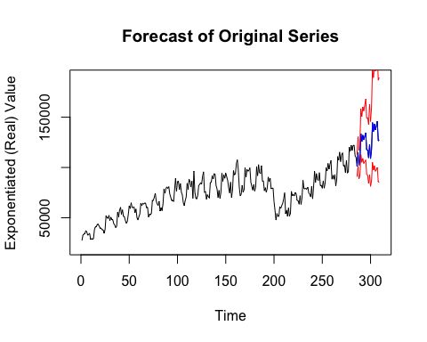

Again the blue value is the mean prediction while the red represent 95% confidence intervals. Notice the upper limit really takes off, which is probably in part due to the general rising trend. The mean predictions actually look very logically like what might be expected from this series.