**Detecting exceptional temporal changes in genetic diversity using limited information**

Julian Wittische1, Pierre Legendre1, Patrick M. A. James1,2

1 Département de Sciences Biologiques, Université de Montréal, Pavillon Marie-Victorin, Montréal, QC, Canada, H3C 3J7

2 Forestry, John H. Daniels Faculty of Architecture, Landscape, and Design, University of Toronto, 33 Willcocks St., Toronto, ON, Canada, M5S 2J5

Correspondence: Julian Wittische; E-mail: [jwittische@gmail.com](mailto:jwittische@gmail.com)

Running title: Testing spatio-temporal genetic change

**INTRODUCTION**

Globally, biodiversity at multiple levels of organization is being lost at an increasing rate with significant consequences for ecosystem functioning and long term viability of the biosphere (Bellard, Bertelsmeier, Leadley, Thuiller, & Courchamp, 2012; Dirzo et al., 2014; Leigh, Hendry, Vázquez‐Domínguez, & Friesen, 2019). Novel monitoring techniques are needed to track these losses and to inform conservation efforts. Further, it is recognized that it is no longer sufficient to study spatial patterns in biodiversity loss at a single point in time. Instead, one must examine trends and patterns in biodiversity through both space and time.

Spatial and temporal variation in genetic diversity can tell us a great deal about demography and population connectivity (Bradburd & Ralph, 2019; Lowe & Allendorf, 2010). Indeed, population genetics have proven essential to translating observed genetic variation into meaningful inferences regarding connectivity and demography that are necessary for conservation efforts (Allendorf, Hohenlohe, & Luikart, 2010; Harrisson, Pavlova, Telonis-Scott, & Sunnucks, 2014; Segelbacher et al., 2010). More specifically, the field of landscape genetics examines interactions between micro-evolutionary processes and landscape features (Manel & Holderegger, 2013; Manel, Schwartz, Luikart, & Taberlet, 2003; Wagner & Fortin, 2013) in order to improve understanding of how spatial heterogeneity influences population genetic processes. The historically spatial focus of landscape genetics, where sampling and/or analysis is done at a single point in time (*e.g.* Wittische, Janes, & James, 2019), may limit the quality and usefulness of inference (Anderson et al., 2010; Draheim, Moore, Fortin, & Scribner, 2018; Martensen, Saura, & Fortin, 2017; Sun & Hedgecock, 2017). Demographically dynamic systems, such as outbreaks, invasions and species declines especially require both a spatial and a temporal perspective.

Temporal variation in genetic diversity, and its drivers, are at the crux of many conservation and public health issues. For example, spatio-temporal genetic studies have led to a better understanding of the invasion history of a major diseases vector species (Maynard et al., 2017) and to the impacts of landscape fragmentation on a food web (Nair, Fountain, Ikonen, Ojanen, & Van Nouhuys, 2016). Temporal genetic variation reflects the evolutionary potential of a population and the probability of its persistence (Aeschbacher, Selby, Willis, & Coop, 2016; Bolnick & Nosil, 2007; Kremer et al., 2012). However, assessing change in spatial genetic variation through time is challenging because population genetic diversity is under the combined influences of recombination, mutation, and demographically-induced genetic drift. Nonetheless, it remains important to develop the capacity to identify changes in genetic diversity through time, specifically when searching for signals of recent demographic changes in the context of ongoing worldwide biodiversity loss.

It is unfortunately rarely possible to directly observe the effects of landscape and climate change on spatial and temporal genetic variation. We can, however, observe these effects through their population genetic legacies (Banks et al., 2013). Although genetic legacies may not be detectable as rapidly as the demographic consequences of change, they can persist for several generations (Bolliger, Lander, & Balkenhol, 2014; Epps & Keyghobadi, 2015). Researchers commonly use spatio-temporal population genetic legacies to study isolation-by-distance (Rousset, 1997; Wright, 1943), population bottlenecks (Gattepaille, Jakobsson, & Blum, 2013; Maruyama & Fuerstt, 1985), migration between isolated populations (Bezemer, Krauss, Roberts, & Hopper, 2019; Buschbom, Yanbaev, & Degen, 2011), and outbreak expansions (Larroque et al., 2019; Wittische et al., 2019). Identifying meaningful and statistically significant relationships between temporal landscape-change and the spatial apportionment of genetic variation can give us important insights about the eco-evolutionary dynamics of a species, and be used to inform conservation strategies (e.g. Landguth, Holden, Mahalovich, & Cushman, 2017).

Spatio-temporal population genetics methods to detect significant past demographic events exist, but they are generally purpose-built for information-rich genetic datasets, which span great sections or the whole genome or are the result of deep sequencing, and are collected at a single point in time. For example, simulation-based frameworks may be used to infer demographic history from at least tens of thousands of loci, based on different demographic scenarios (Excoffier, Dupanloup, Huerta-Sánchez, Sousa, & Foll, 2013; Gutenkunst, Hernandez, Williamson, & Bustamante, 2009; Kamm, Terhorst, Durbin, & Song, 2019). In general, these methods require input beyond simple allele counts, such as information about recombination processes (Gattepaille et al., 2013) and ascertainment bias (Albrechtsen, Nielsen, & Nielsen, 2010; Clark, Hubisz, Bustamante, Williamson, & Nielsen, 2005; Marth, Czabarka, Murvai, & Sherry, 2004) to estimate demographic parameters and history. Some other studies have directly used genetic differentiation metrics such as FST, to evaluate temporal change between genetic datasets (e.g. Larroque et al 2019; Segura-García et al., 2019). However, translating our spatial understanding of FST-based results to the temporal dimension is not always straightforward. Indeed, appropriate use and interpretation of pairwise FST requires that certain assumptions such as equal amounts of drift in both populations be respected (Bhatia, Patterson, Sankararaman, & Price, 2013) and translated in a temporal context. Additionally, disentangling spatial from temporal effects is a challenge because the additivity of genetic drift means than genetic differentiation can be associated with both temporal structure or population divergence (Murray et al., 2016; Skoglund, Sjödin, Skoglund, Lascoux, & Jakobsson, 2014). Detecting significant population genetic changes, relative to what would be expected due to drift, based on limited time series of genetic data remains a challenge, but is highly necessary.

There are many situations where such as detection would prove precious. For example, we could use such a framework to identify which previously sampled populations have undergone significant genetic changes, after a major weather event could have led to higher mortality (Poff et al., 2018; Suárez, Betancor, Fregel, Rodríguez, & Pestano, 2012) or immigration from distantly related populations (Apodaca, Trexler, Jue, Schrader, & Travis, 2013), through long-distance dispersal events. Another example would be the monitoring of the genetic diversity of a pest throughout the landscape during an outbreak or a large spawning event, to have a more accurate understanding of when and where populations undergo drastic genetic changes through mass migration (*e.g.* Larroque et al., 2019; Segura-García et al., 2019). Finally, yet another example could be the evaluation of how the genetic diversities of populations have changed after facing intense and heterogeneous anthropogenic pressure, such as habitat fragmentation and alteration (*e.g.* Baker et al., 2018; Nair et al., 2016). Detecting atypical change in the genetic diversity of populations in all those examples could help with better management, including the prioritization of conservation or mitigation efforts.

Temporal Beta-diversity Indices (TBI; Legendre 2019) have been used to assess the significance of changes in community composition through time. Given the conceptual similarity between the question of how multi-species communities change through time and that of how genetic diversity changes through time, we expect that TBI can be applied to spatial-temporal multi-locus genotypic data. The TBI approach quantifies temporal change in sampling sites between two points in time using a dissimilarity index. The significance of these dissimilarities is then tested using permutation. The TBI approach has been extensively tested on community composition data (Legendre, 2019b), but its ability to detect meaningful changes in genetic diversity has not yet been examined.

In this study, we expand the TBI framework to be applicable to spatial temporal population genetic data. The objective of our new method, Temporal Genetic diversity Indices (TGI), is to quantify and statistically assess temporal variation in spatial genetic diversity. Quantifying relative temporal genetic change among locations will allow us to infer the existence of past demographic events and to provide sensible information to policy-makers and managers. Persisting spatial legacies in genetic diversity can also be used to identify sites that were most strongly impacted by previous demographic events. To demonstrate the effectiveness and applicability of the approach, we used a spatially-explicit gene flow simulator (Landguth, Bearlin, Day, & Dunham, 2017). We simulated scenarios in which portions of a landscape are affected by a non-selective demographic change. We then used TGI to measure changes in the genetic diversity of our populations under different demographic contexts. Specifically, we explored how dispersal ability, the number of populations affected a demographic event, and time between two sampling efforts affected our detection of temporal variation in genetic diversity. Performance was quantified using standard false positive/negative rates binary classification. We predict that our ability to detect historical demographic changes would be lower with increasing dispersal ability because of the homogenizing effect of higher gene flow. We also predict that the longer the time between samplings, regardless of when an event occurred between them, the harder it will be to identify where and when a demographic event occurred.

**METHODS**

*Adapting Temporal Beta diversity Indices for genetic data*

Calculating TBI involves computing dissimilarities in species composition between temporal surveys of the same sites and testing their significance through permutations of the site-species input matrices. In extending TBI to TGI, we considered population-level genotype frequency matrices as input, used genetic distances as dissimilarity, and the null hypothesis became that genetic diversity did not differ between the two points in time that were sampled.

One of the most crucial steps in this comparison is to evaluate the significance of the change. Indeed, without a mean to determine adequate significance thresholds for their analyses, decision-makers and researchers would be left to arbitrarily set thresholds for what constitutes change for their specific genetic dataset. Permutation-based approaches can be used to generate a distribution of values against which an observed value (here temporal change in genetic diversity) can be compared. Such a permutation-based statistical inference method for the analysis of spatial-temporal changes in community composition have recently been proposed (Legendre & Gauthier, 2014; Shimadzu, Dornelas, & Magurran, 2015). Testing the significance of TGI involved permuting the input genotypic matrices.

There are several different ways that one can permute spatial-temporal genetic data and choosing the right way to permute can be important to make the correct inference (Adams & Collyer, 2015). We chose to permute a locus with another in the same way in both temporal datasets, as it was highlighted as the best permutation method for community composition data (here loci replace species), and because it was the only one which provided sensible performance in our early testing of TGI (the other permutation approaches would never detect any true positive). We used 999 permutations in all analyses.

*Genetic distance*

Genetic distances between points in time for a given location were calculated using the Rogers’ genetic distance (Avise, 1994; Rogers, 1972), which is very similar to the Euclidean genetic distance. It makes no assumptions about base-pair substitutions or time since separation and is suitable to study short-term dynamics. We computed the distance using the *dist.genpop* function from the *adegenet* R package (see *Software*).

*Simulation framework*

To simulate the dynamics of population genetic changes through time, we used the spatially-explicit gene flow simulation software *CDMetaPOP* (Landguth, Bearlin, et al., 2017). *CDMetaPOP* simulates dispersal and mating of individuals across a landscape and allows the user to define initial genetic structure, spatial distribution of individuals, dispersal characteristics, and life-history traits of the population. The physical landscape we simulated was modelled as a homogeneous and interconnected square grid of 5 by 5 cells, with each cell representing a population. Each population had a maximum carrying capacity of 50 individuals. Structural connectivity between populations was modelled following geographical distance alone. The populated landscape, therefore, represents a maximum of 1250 individuals. Each simulation was run for 100 generations before a demographic event (see below) was imposed on up to three populations in the landscape. 10 more generations were simulated after this event. The mutation rate was set at 10-8 to reflect empirically-derived mutation rates found in many taxa. The genotypic information of each individual was recorded and consisted of 100 neutral, unlinked, bi-allelic SNP loci. Sampling was done before and after the event unless specified.

We simulated 180 replicates for each scenario. For each replicate, we initialized the simulation with random and unique allocation of alleles among individuals, therefore reaching maximum diversity (Landguth, Bearlin, Day, & Dunham, 2016). Those parameters were chosen as a compromise between realism and computational time limitations, and we believe they were appropriate to produce the complex evolutionary dynamics necessary to produce reasonably realistic and useful simulated genetic data.

We chose to simulate immigration from a diverged population to our landscape, as a punctual demographic event affecting part of our landscape. Our goal was to apply the TGI approach to detect these historical population changes using genetic data. In simulating immigration, we allowed individuals from a 26th separate population to be added to our study area. This independent source population otherwise shared the same attributes as other populations in our simulated landscape. Only during the demographic event, were individuals from the 26th isolated population allowed to disperse to *a priori* defined parts of the landscape by reducing dispersal distance between the 26th population and those parts.

We examined the influence of dispersal and demographic event spatial extent (number of populations) on the persistence of genetic spatial legacies using this simulation model. We examined three levels of dispersal, and three different numbers of populations affected for a total of 9 unique scenarios, each of which was replicated 180 times, for a total of 1620 (9 × 180) unique simulations for this experiment, aside from the control simulations (see below). In the next sections, we detail how we modelled these two experimental factors.

*Dispersal*

To model dispersal, we simply transformed distances between populations by using ${10}^{-B * distance}$, where *B* represents how hard it is to disperse with high values of B correspond to low dispersal capacity (elaborated below). We then rescaled the values, using the maximum $(4√2)$ and the minimum (0) distances, possible in this virtual landscape, as described in the *CDMetaPOP* (Landguth, Bearlin, et al., 2017) user manual (p.63). This gave us a probability that an individual disperses at a distance (Fig.1). We chose this way of modelling dispersal to allow both within-population movement and long-distance dispersal.

The population to which an individual disperses was selected randomly from the set of populations available at the distance which was itself randomly sampled in the previous step. Individuals always stay within our simulated landscape, and any individual may disperse to one of our 25 populations at each generation. To investigate the effect of different levels of dispersal, we used three different values of *B*: low (*B* = 2), moderate (*B* = 1.301) and high (*B* = 0.6015) dispersal levels (Fig.1; Table 1).

**Table 1:** Two-factor simulation experiment with scenario abbreviations used throughout the manuscript. The numbers in parentheses indicate the number of unique simulations ran for each factor level or combination of factor levels. We executed 2160 simulations in total.

|  |  |  |  |
| --- | --- | --- | --- |
| *Pop. number \ Dispersal* | **Low** (720) | **Moderate** (720) | **High** (720) |
| **1** (540) | L1 (180) | M1 (180) | H1 (180) |
| **2** (540) | L2 (180) | M2 (180) | H2 (180) |
| **3** (540) | L3 (180) | M3 (180) | H3 (180) |
| **0: control** (540) | CL (180) | CM (180) | CH (180) |

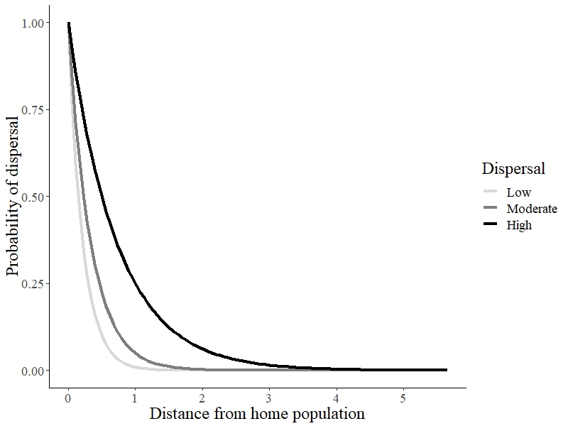

**Fig.1:** Probability of dispersal of an individual in three different dispersal scenarios.

*Number and position of populations with spatial legacies*

We also wanted to evaluate how the number of populations bearing spatio-temporal population genetic legacies influenced the performance of our testing procedure. To achieve this, we triggered demographic events from 1 to 3 populations among the 25. When only 1 population was affected we partitioned the 180 replicates of that scenario equally among 6 populations in the landscape. Because our landscape is square and homogenous, and therefore symmetric, only 6 positions need to be assessed. When several (2 or 3) populations underwent a demographic event, we randomly sampled 1 position among the 6 previously described and randomly picked 1 or 2 additional populations directly adjacent (when possible) to it. We did this 6 times (30 replicates for each different set of populations). We chose to pick populations this way to respect the spatial autocorrelation often exhibited in demographic events.

*Time since demographic change*

To assess how the time since the simulated demographic event affects our ability to detect genetic change, we used TGI on simulation data collected each year, up to 10 years after the event, and compared them with data from the event year. We did the same with the earliest sampling period, that is how far back an earlier sampling can be compared with a sampling done after the event. We chose 10 years as the maximum time between samplings as this time gap would represent most of the “before/after” population genetic studies we encountered, and because most long-term ecological research programs monitor at a shorter interval. Specifically, for our analyses concerning the timing of sampling, we chose the 0.05 *p*-value threshold as it was a good compromise between decent FPR and FNR in our earlier results.

*Statistical performance*

We used the False Positive Rate (FPR) and False Negative Rate (FNR) to assess statistical performance of the TGI testing procedure. A false positive is a population that we know *a priori* did not undergo the atypical demographic change we forced on it during the simulation but has been classified as having experienced a demographic event by the testing procedure. A false negative is a population that we had set as target for a demographic event but that was not classified as having been affected by the testing procedure. FPR represents the number of false positives over the total number of negatives, and FNR represents the number of false negative over the total number of positives. A high FPR means that we often select the wrong population(s), and researchers generally want to keep it as low as possible when there are, for example, heavy costs to focusing on wrong populations such as limited money to invest in a conservation action. A different aspect of performance, a high FNR means that we often miss the right population(s). The higher the FNR, the lower the power of our testing procedure. Researchers may want to minimize the FNR in situations where finding the right population is the most important aspect, for example, if there is limited time to take a conservation action. Because choosing a proper threshold for the TGI permutation tests is important in order to find a compromise between power (1- FNR) and selectivity (1 – FPR), we showcased it to potential TGI users by evaluating statistical performance across a range of thresholds: 0.001, 0.0025, 0.005, 0.0075, 0.01, 0.025, 0.05, 0.075, 0.1.

*Controls*

Control populations are never affected by any punctual demographic event and therefore are only subject to the processes of gene flow, drift, and mutation. Dispersal ability was the only parameter varied for the controls, resulting in 3 control scenarios (Table 1). We evaluated the FPR of those three control scenarios (no need for FNR because there are no true positives/false negatives so it was always equal to 0). When describing the performance of other scenarios with similar dispersal parameters, we always used control values as a reference.

*Software  
CDMetaPOP* runs on *Python 2.7* (Landguth, Bearlin, et al., 2017). We used the *R* software (R Core Team, 2019) in the RStudio IDE (RStudio Team, 2018) for all analyses and illustration. We used the *adegenet* (Jombart, 2008; Jombart & Ahmed, 2011), *pegas* (Paradis, 2010), and *adespatial* (Dray et al., 2019) R packages for the calculations.

**RESULTS***Dispersal*

As hypothesized, the dispersal capacity influenced our ability to detect temporal changes in genetic diversity.

FNR substantially increased with dispersal intensity (Fig. 2). Two scenarios (Table 1) with high dispersal (H2, H3) were the only ones with FNR values above 10% regardless of which threshold was used. FNR values for all scenarios with lower dispersal and two scenarios with moderate dispersal (M1, M2) stayed below 5% except for the lowest threshold which has a value of 1 for all scenarios as it is so conservative that it never selects a population as positive. One high dispersal scenario with the lowest number of affected populations (H1) had overlapping 95% confidence intervals with other, lower dispersal scenarios (Fig. 2). Taking the average from scenarios sharing the same dispersal parameters for the ubiquitous 0.05 threshold, we had FNRs of 0.0046 for low dispersal, 0.0235 for moderate dispersal, and 0.2164 for high dispersal. FNR values overall decreased with threshold, with a sharp decrease before 0.025 followed by a slower decrease until 0.1 (Fig. 2).

FPR substantially decreased with dispersal intensity (Fig. 3). Low dispersal scenarios systematically had higher FPR values than moderate dispersal scenarios, which in turn had higher FPR values than higher dispersal scenario (Fig. 3), although there was some overlap between the performance of M1 and L3 (Fig. 3). If we conservatively define the appropriateness of a FPR value by whether it is below the threshold used in the test, then higher dispersal scenarios more often offered appropriate FPR values (Table 2). Only the high dispersal scenarios (H1, H2, H3) presented appropriate FPR values across all thresholds (Table 2). Conversely, one low dispersal scenario (L1) never satisfied the condition with FPR values consistently higher than the threshold, except for the first one which value is always 0 across all scenarios. FPR averages from scenario sharing the same dispersal parameters, for 0.05 threshold, were 0.0796 for low dispersal, 0.0322 for moderate dispersal, and 0.0035 for high dispersal. FPR values overall increased with threshold, with a sharp increase at low thresholds followed by a continued but saturating increase until 0.1 (Fig. 3).

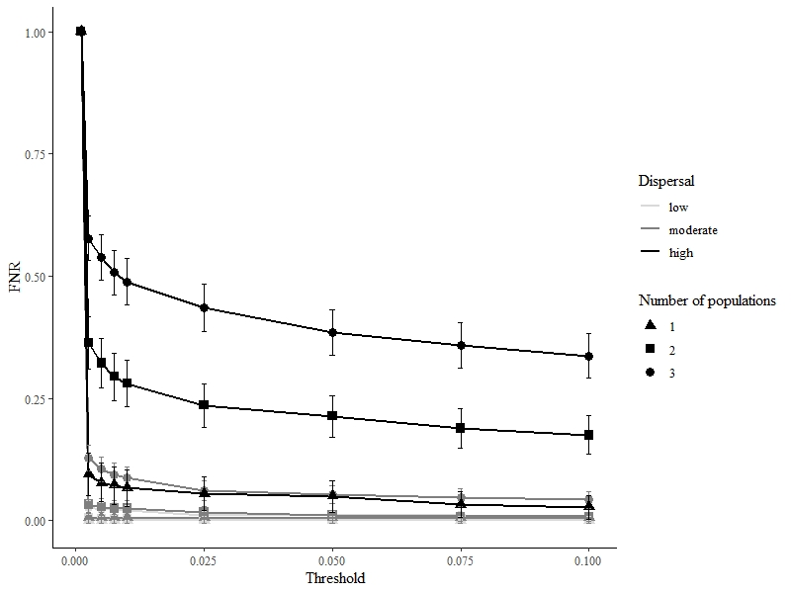

**Fig 2.** FNR across all threshold and scenarios. There are no control experiment results displayed for FNR because there are no possible true positives in control experiments, hence no false negatives either. Those values are for samplings done at the 100 and 101 generations (right before and right after the event). 95% confidence intervals are displayed by bars.

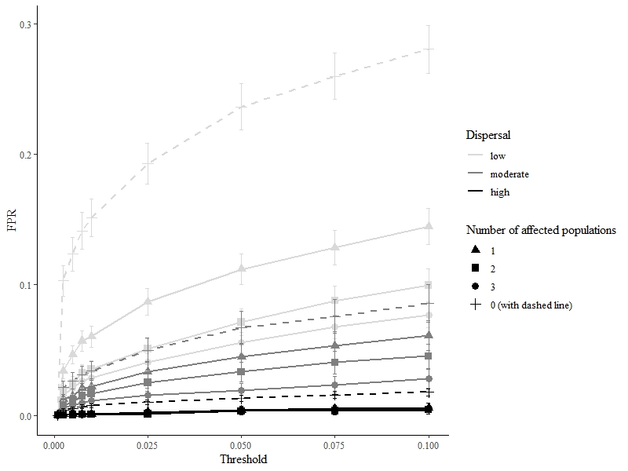

**Fig 3.** FPR across all threshold and scenarios. Control experiments are shown with dashed lines. Those values are for samplings done at the 100 and 101 generations (right before and right after the event). 95% confidence intervals are displayed by bars.

**Table 2.** Are FPR values staying below the thresholds used in the TGI tests? T stands for “True” and F stands for “False”.

|  |  |  |  |  |  |  |  |  |  |
| --- | --- | --- | --- | --- | --- | --- | --- | --- | --- |
| *Scenario*  *--- Threshold* | **L1** | **L2** | **L3** | **M1** | **M2** | **M3** | **H1** | **H2** | **H3** |
| **0.0010** | **T** | **T** | **T** | **T** | **T** | **T** | **T** | **T** | **T** |
| **0.0025** | F | F | F | F | F | F | **T** | **T** | **T** |
| **0.0050** | F | F | F | F | F | F | **T** | **T** | **T** |
| **0.0075** | F | F | F | F | F | F | **T** | **T** | **T** |
| **0.0100** | F | F | F | F | F | F | **T** | **T** | **T** |
| **0.0250** | F | F | F | F | **T** | **T** | **T** | **T** | **T** |
| **0.0500** | F | F | F | **T** | **T** | **T** | **T** | **T** | **T** |
| **0.0750** | F | F | **T** | **T** | **T** | **T** | **T** | **T** | **T** |
| **0.1000** | F | **T** | **T** | **T** | **T** | **T** | **T** | **T** | **T** |

*Number of populations affected*

The number of populations affected by an event also affects our ability to detect exceptional temporal change. Scenarios with a lower number of populations consistently performed better according to FNR, while the opposite is true for FPR (Fig.2, 3). As shown by the overlapping of FPR and FNR values across scenarios with similar dispersal, the effect of the number of populations did not affect the performance as much as dispersal, with the levels we used (Table 2; Fig. 2, 3). The effect of the number of populations was generally the most substantial on performance, for the lowest-performing scenarios in either FNR (high dispersal; Fig. 2) or FPR (low dispersal; Fig. 3).

*Lag time between samplings*

As hypothesized from the nature of genetic processes in connected populations, the genetic signal of the demographic event inflicted upon populations disappears gradually over time. Generally, the longer the interval between a pre-event sampling and post-event sampling, the less power we have to detect the demographic event, as evidenced by the increase in false positives and false negatives for several scenarios (Fig. 4, 5). However, this is strongly affected by the dispersal level present in the landscape, and by the number of populations to a lower degree.

For example, for low and moderate dispersal scenarios, sampling undertaken 9 years before the punctual event led to more than five times the FPR as sampling undertaken the year immediately before (Fig. 5). However, for scenarios with high dispersal, the absolute difference in FPR performance between old samplings and recent samplings is not substantial (Fig. 5). A near symmetric relationship between time lag, FPR and dispersal level exists (Fig. 5). For sampling prior to the event, FPR values from moderate dispersal scenarios, although lower close to the event, converged with FPR values from low dispersal scenarios (Fig. 5). For sampling after the event, moderate dispersal values become even higher than that of low dispersal scenarios, despite large overlaps in their confidence intervals (Fig. 5). The previously described relationship between FPR and the number of populations affected by the demographic event also changed for moderate scenarios in distant second samplings with M2 displaying higher values than M3, on average (Fig. 5). Apart for high dispersal scenarios, FPR changed sharply for time lags of 4 years or less and then more slowly (Fig. 5), and generally became higher than 50%, one false positive for each true positive, after 5 years.

Regarding FNR, there is one major difference compared to FPR, besides the opposite effects of dispersal and the number of affected populations: the relationship between FNR and time lag is not symmetric in that the timing of a sampling conducted before the event matters much less than that of the posterior sampling, for high dispersal scenarios (Fig. 4). The FNR became prohibitive for second samplings done after two years after the event (Fig .4). FNR also increased with time lag for the posterior sampling and for low and moderate dispersal scenarios, but rather linearly, and never reaching 25% in the scope of our analyses, even after 9 years (Fig. 4). The increase of FNR with time lag for the prior sampling was weaker than that for the posterior sampling for moderate dispersal scenarios and was similar for low dispersal scenarios (Fig .4).

When considering the scenarios most likely to preserve the signal according to earlier results on FNR and FPR (M1, M2, M3), the TGI approach was still able to avoid false negatives reasonably (Fig. 4) but average FPR sharply increased, reached more than 10% of false positives after only two years (Fig. 5) regardless of whether the first or second sampling is responsible for the time lag. Given the large variation in performance, for each parameter we considered, we believe that the parameters we chose to define different scenarios produced sufficiently complex, and useful simulations.

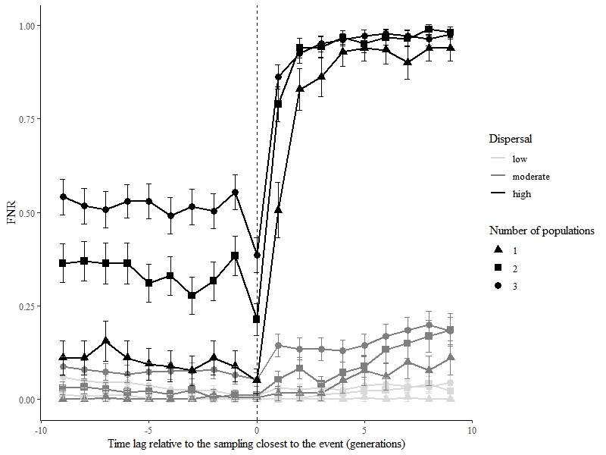

Influence of the timing of the posterior sampling

(0 represents sampling right after the event)

Influence of the timing of the prior sampling

(0 represents sampling right before the event)

**Fig 4**. FNR from TGI tests performed between sampling executed up to 9 years before or after the event (arrow) when compared with sampling done the year after the event for prior samplings, or the year before the event for posterior samplings. 95% confidence intervals are displayed by bars.

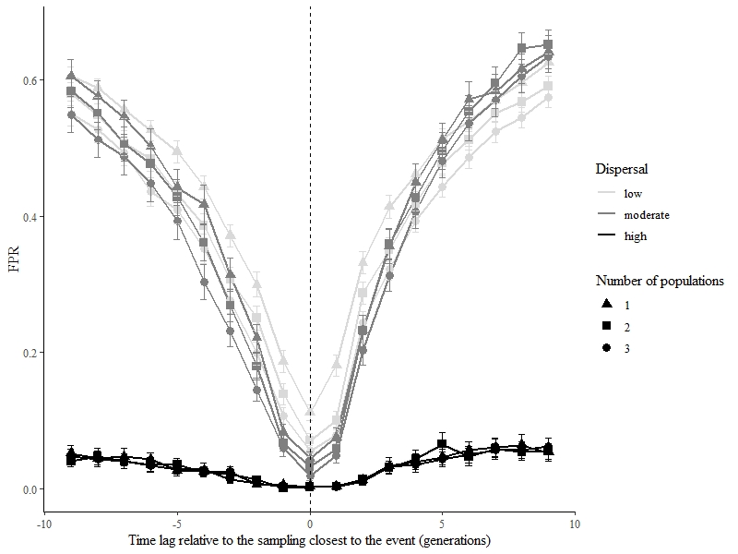

Influence of the timing of the posterior sampling

(0 represents sampling right after the event)

Influence of the timing of the prior sampling

(0 represents sampling right before the event)

**Fig 5**. FPR from TGI tests performed between sampling executed up to 9 years before or after the event (arrow) when compared with sampling done the year after the event for prior samplings, or the year before the event for posterior samplings. 95% confidence intervals are displayed by bars.

*Control simulations*

Experimental FPR values consistently stayed below control FPR values, which performance according to their dispersal parameters, followed the same order as experimental FPR values (Fig. 3). This means that in the presence of an actual event, we were always less likely to wrongfully identify a population as having been affected. Finally, control FPR values for scenarios with low dispersal reached a high value, which was about twice as high as the maximum experimental FPR values (L1).

**DISCUSSION**

In many wildlife management projects, researchers may bring crucial information on the decision table by comparing the genetic information sampled in several populations throughout the landscape at two different survey dates. Indeed, managers would often need to know where in the landscape have there been an exceptional change in genetic diversity, as such a change would hint at a past demographic event, which could be detrimental (*e.g.* loss of diversity, maladaptation) or beneficial (*e.g.* higher effective population size, genetic rescue). Of course, such a change in one or more populations would warrant higher monitoring and an investigation about the origin of the change. Detecting which populations have changed significantly over time, from genetic data, has always been a challenge for researchers. When genetic data is available at several points in time, we believe the aforementioned challenge is within reach for biologists, even if given genetic datasets with limited genomic information (*e.g.* hundreds of SNPs), as is common when first sequencing new non-model organisms. Indeed, our permutation approach was generally able to achieve this goal, under certain conditions.

We investigated how dispersal, the spatial extent of a demographic event, and the timing of sampling affects our ability to identify populations which underwent significant changes, using a new permutation-based testing procedure, TGI, we described. We used a spatially-explicit gene flow simulation software (Landguth, Bearlin, et al., 2017) to model the effect of a punctual and atypical demographic event on one to three populations within a larger landscape of connected populations bearing more than a thousand individuals. We aimed to evaluate how often TGI would fail to identify populations that truly experienced exceptional genetic change, under different dispersal, event spatial extent, and sampling timing scenarios. We found that those three factors all influence our ability to detect exceptional temporal changes in genetic diversity using limited information. Beyond the introduction to our new approach and a test of its performance, our results could serve as a guide on how to use it alongside simulations, for evaluate the information loss cost of different sampling schemes.

Detecting exceptional change depends on the level of landscape functional connectivity. Indeed, we found that false negatives increased with dispersal ability, while false positives increased (Fig. 2,3). This has important implications as there is a clear trade-off between avoiding the detection of wrong populations and avoiding the rejection of the right population(s). This trade-off in performance according to dispersal ability exists even with only one generation separating two temporal samples (right before and right after the event), and is made worse with time (Fig.4, 5). This suggests that studying highly connected systems might require more frequent sampling if the researchers’ objective is to ensure they have detected the right population no matter the investment in monitoring false positives. Conversely, more frequent sampling should be conducted in less connected systems if the objective is to have as little false positives as possible, for example in order to use limited resources carefully. High dispersal, and higher gene flowing through it (Cayuela et al., 2018), is implicated in many short-term or long-term mechanisms which lower our ability to understand the eco-evolutionary dynamics of species. For example, high dispersal during range expansion lowers our ability to correctly detect loci under natural selection (Mayrand, Filotas, Wittische, & James, 2019). However, high gene flow may not always be associated with a strong decrease in measured structure (Landguth, Cushman, Murphy, & Luikart, 2010) or early detections of barriers to gene flow (Landguth, Cushman, Schwartz, et al., 2010).

The spatial extent of an event, represented by the number of populations affected by the punctual demographic event in our study, increases our ability to correctly reject populations which have not truly changed (Fig. 3), but it decreases our ability to correctly detect populations which have truly changed (Fig. 2). This trade-off is apparent for all scenarios but whether it is substantial depends on the dispersal level within the landscape. Indeed, the number of populations affected by the punctual demographic event greatly influenced the FPR in low dispersal landscapes and greatly influenced the FNR in high dispersal landscapes. Although the spatial extent of a legacy may help researchers detect the legacy as the chance of the legacy being sampled increases, it also increased the risk of not identifying the legacy at all, especially in high dispersal landscapes (Fig.2). We targeted adjacent populations with the punctual demographic event and whether lowering the degree of spatial autocorrelation in the spatial genetic legacy, that is targeting populations not necessarily adjacent to each other, influences detection, has not been investigated in our paper. Spatial autocorrelation may greatly affect many genetic analyses, and solutions are being developed to integrate it within them (Rousset & Ferdy, 2014). We believe explicitly taking spatial autocorrelation into account in temporal analyses of genetic diversity (Bradburd & Ralph, 2019) represents a promising and challenging avenue of research.

As expected, demographic processes generally dilute the signal in spatial genetic legacies, by transferring the initial effect of an event on genetic diversity, to other populations (Fig. 4, 5). However, two main points emerged from our analysis of the timing of sampling to detect exceptional genetic change. First, although the previously described double trade-off generally holds with increasing time lags around the event, that is an earlier first sampling and a later second sampling, the timing of the first sampling is much less important for limiting false negatives than the timing of the second sampling, especially in high dispersal systems (Fig. 4). The main implication of this results is that while it could reassure researchers that they may use an old sample to compare it to a sample made soon after an event without fear, they should not wait to sample after an event, or TBI may well become too conservative and unable to identify the right population(s). Second, the opposite is not true for false positives as the consequences of sampling too early or too late are very similar, and means the researchers would have to accept as many false positives as true positives after sampling only a few years before or after an event, in low and moderate dispersal scenarios (Fig. 5). This has serious implications as in the case the demographic parameters of their study system would be similar to our inputs, moderate dispersal, for example, they might systematically spend 50+% of their resources on monitoring or treating the wrong populations. Although the spatial legacy of a past demographic event could be kept in richer genomic data (*e.g.* probability of mutational configurations in sequence blocks), limited biallelic gene frequency data may not retain most of the signal beyond a few years, even in the best situations. In contrast, the previous investigations using TBI, which used community composition data, have not focused on the timing of sampling. Although community composition data (species x sites) generally varies at a larger time scale than genetic data, we encourage future investigations of the influence of timing on TBI performance.

Our analyses have shown that our TGI testing procedure works, but there are certain considerations to keep in mind when using it regardless of simulation inputs. For example, stricter values (lower values) for the TGI *p*-value threshold expectedly bring a better FPR but may also bring a pathological FNR (low power) (Fig. 2, 3). Regarding FNR, lower performance is not very dependent on user choice for threshold, past a low threshold value, regardless of dispersal level and spatial extent. TGI can also readily be used on microsatellite data which expands its usefulness to researchers. Future work is needed to explore how the performance of TGI, as well as other methods, varies with other factors than we considered in this study. We believe among the most interesting factors would be the choice of the genetic distance used in the algorithm, the influence of the degree of spatial autocorrelation in genetic legacies, varying effective population sizes, and spatial heterogeneity in landscape resistance to movement. To be clear, although it is completely possible for casual users to run TGI on their datasets, we do encourage future users, especially those studying systems with extreme demographics parameters (*e.g.* outbreaks) to run simulations to pick the best *p-value* threshold for example.

Simulations provide a very useful tool for the planning researchers who would want to investigate change in their study landscape. Simulations have been used with much success in a variety of applications (Epperson et al., 2010), from investigating a species evolutionary ecology to protect it (Creech et al., 2017; Landguth, Holden, et al., 2017), to showcasing the performance of various approach to extract valuable information from genetic data (Cubry, Vigouroux, & François, 2017; Forester, Jones, Joost, Landguth, & Lasky, 2016; Mayrand et al., 2019). We do not advise future users of TGI, or other permutation approaches, to arbitrarily choose a *p*-value threshold to pick which populations display significant changes, or to base the timing of their sampling, of course, on default simulations, or our simulations. Instead, we encourage them to run simulations with a reasonable realism, that is by inputting demographic parameters, such as reproduction parameters, available in the literature (if any) and by carefully creating a virtual landscape resembling their study area. If accurate demographic parameters are not available, we encourage them to simulate scenarios with wide-ranging parameters values as we did in this study. In order to test more complex and competing hypotheses for specific phenomenon using spatio-temporal data, adequate process-based null models should be created. Such spatial null models can be generated by simulations involving the modelling major phenomena that are not generating the pattern of interest so that tests can be better calibrated to reliably identify significance (Gardner & Urban, 2007; James, Fleming, & Fortin, 2010; Paz-Vinas, Loot, Stevens, & Blanchet, 2015). This increased realism, and evaluation of uncertainty, would provide more accurate tests, to pick the best *p*-value threshold, as well as understand when is it still adequate to sample, to get the best out of spatial genetic legacies. A number of programs such as *CDMetaPOP* (Landguth, Bearlin, et al., 2017), *Nemo* (Guillaume & Rougemont, 2006), *SPLATCHE* (Currat, Ray, & Excoffier, 2004), or *SLIM* (Haller & Messer, 2019) provide very flexible and sophisticated ways to implement such simulations.

We believe that TGI could be useful to many landscape ecologists and natural resources managers thanks to its focus on spotting conservation-relevant changes in genetic diversity in the landscape. By allowing researchers to confidently identify the most interesting populations to more closely monitor, even from limited genetic data, TGI could also help focus resources for conservation actions and guide investigations.

**DATA AND SOFTWARE AVAILABILITY**

All simulation data used for this paper will be deposited online upon acceptance. Functions used to analyze the simulations will be available on a public repository on *GitHub*. *TGI,* which is the function that would be most useful to potential users of our approach, will continue to be maintained and developed and may be contributed to a package in the near future.

**ACKNOWLEDGEMENTS**

This research was supported by a grant to PMAJ and the TRIA Network from the Natural Sciences and Engineering Research Council of Canada (grant no. NET GP 434810-12), with contributions from Alberta Agriculture and Forestry, fRI Research, Manitoba Conservation and Water Stewardship, Canadian Forest Service (Natural Resources Canada), Northwest Territories Environment and Natural Resources, Ontario Ministry of Natural Resources and Forestry, Saskatchewan Ministry of Environment, West Fraser, and Weyerhaeuser. JW was also supported by a scholarship from the Forest Complexity Modelling (FCM) NSERC CREATE. Computations were made on the supercomputer CEDAR managed by Compute Canada ([www.computecanada.ca](http://www.computecanada.ca)). Finally, we thank Jeremy Larroque, Hinatea Ariey and others, for their comments on an earlier version of the manuscript.

**REFERENCES**

Adams, D. C., & Collyer, M. L. (2015). Permutation tests for phylogenetic comparative analyses of high-dimensional shape data: What you shuffle matters. *Evolution*, *69*(3), 823–829. doi: 10.1111/evo.12596

Aeschbacher, S., Selby, J. P., Willis, J. H., & Coop, G. M. (2016). *Population-genomic inference of the strength and timing of selection against gene flow*. (18), 1–6. doi: 10.1101/072736

Albrechtsen, A., Nielsen, F. C., & Nielsen, R. (2010). Ascertainment biases in SNP chips affect measures of population divergence. *Molecular Biology and Evolution*, *27*(11), 2534–2547. doi: 10.1093/molbev/msq148

Allendorf, F. W., Hohenlohe, P. A., & Luikart, G. (2010). Genomics and the future of conservation genetics. *Nature Reviews. Genetics*, *11*(10), 697–709. doi: 10.1038/nrg2844

Anderson, C. D., Epperson, B. K., Fortin, M.-J., Holderegger, R., James, P. M. a., Rosenberg, M. S., … Spear, S. F. (2010). Considering spatial and temporal scale in landscape-genetic studies of gene flow. *Molecular Ecology*, *19*(17), 3565–3575. doi: 10.1111/j.1365-294X.2010.04757.x

Apodaca, J. J., Trexler, J. C., Jue, N. K., Schrader, M., & Travis, J. (2013). Large-scale natural disturbance alters genetic population structure of the sailfin molly, poecilia latipinna. *American Naturalist*, *181*(2), 254–263. doi: 10.1086/668831

Avise, J. C. (1994). *Molecular markers, natural history and evolution*. London, UK: Chapman & Hall.

Baker, S. J., Anthonysamy, W. J. B., Davis, M. A., Dreslik, M. J., Douglas, M. R., Douglas, M. E., & Phillips, C. A. (2018). Temporal Patterns of Genetic Diversity in an Imperiled Population of the Eastern Massasauga Rattlesnake ( Sistrurus catenatus ) . *Copeia*, *106*(3), 414–420. doi: 10.1643/cg-17-682

Banks, S. C., Cary, G. J., Smith, A. L., Davies, I. D., Driscoll, D. A., Gill, A. M., … Peakall, R. (2013). How does ecological disturbance influence genetic diversity? *Trends in Ecology and Evolution*, *28*(11), 670–679. doi: 10.1016/j.tree.2013.08.005

Bellard, C., Bertelsmeier, C., Leadley, P., Thuiller, W., & Courchamp, F. (2012). Impacts of climate change on the future of biodiversity. *Ecology Letters*, *15*(4), 365–377. doi: 10.1111/j.1461-0248.2011.01736.x

Bezemer, N., Krauss, S. L., Roberts, D. G., & Hopper, S. D. (2019). Conservation of old individual trees and small populations is integral to maintain species’ genetic diversity of a historically fragmented woody perennial. *Molecular Ecology*, (January), 3339–3357. doi: 10.1111/mec.15164

Bhatia, G., Patterson, N., Sankararaman, S., & Price, A. L. (2013). Estimating and interpreting F. *Genome Research*, (2), 1–9. doi: 10.1101/gr.154831.113.23

Bolliger, J., Lander, T., & Balkenhol, N. (2014). Landscape genetics since 2003: Status, challenges and future directions. *Landscape Ecology*, *29*(3), 361–366. doi: 10.1007/s10980-013-9982-x

Bolnick, D. I., & Nosil, P. (2007). Natural selection in populations subject to a migration load. *Evolution*, *61*(9), 2229–2243. doi: 10.1111/j.1558-5646.2007.00179.x

Bradburd, G. S., & Ralph, P. L. (2019). Spatial Population Genetics: It’s About Time. *Annual Review of Ecology, Evolution, and Systematics*, *50*(1), 427–449. doi: 10.1146/annurev-ecolsys-110316-022659

Buschbom, J., Yanbaev, Y., & Degen, B. (2011). Efficient long-distance gene flow into an isolated relict oak stand. *Journal of Heredity*, *102*(4), 464–472. doi: 10.1093/jhered/esr023

Cayuela, H., Rougemont, Q., Prunier, J. G., Moore, J. S., Clobert, J., Besnard, A., & Bernatchez, L. (2018). Demographic and genetic approaches to study dispersal in wild animal populations: A methodological review. *Molecular Ecology*, *27*(20), 3976–4010. doi: 10.1111/mec.14848

Clark, A. G., Hubisz, M. J., Bustamante, C. D., Williamson, S. H., & Nielsen, R. (2005). Ascertainment bias in studies of human genome-wide polymorphism. *Genome Research*, *15*(11), 1496–1502. doi: 10.1101/gr.4107905

Creech, T. G., Epps, C. W., Landguth, E. L., Wehausen, J. D., Crowhurst, R. S., Holton, B., & Monello, R. J. (2017). Simulating the spread of selection-driven genotypes using landscape resistance models for desert bighorn sheep. *PLoS ONE*, *12*(5), 1–26. doi: 10.1371/journal.pone.0176960

Cubry, P., Vigouroux, Y., & François, O. (2017). The Empirical Distribution of Singletons for Geographic Samples of DNA Sequences. *Frontiers in Genetics*, *8*(September), 1–10. doi: 10.3389/fgene.2017.00139

Currat, M., Ray, N., & Excoffier, L. (2004). SPLATCHE: A program to simulate genetic diversity taking into account environmental heterogeneity. *Molecular Ecology Notes*, *4*(1), 139–142. doi: 10.1046/j.1471-8286.2003.00582.x

Dirzo, R., Young, H. S., Galetti, M., Ceballos, G., Isaac, N. J. B., & Collen, B. (2014). Defaunation in the Antrhopocene. *Science*, *401*(6195), 401–406. doi: 10.1126/science.1251817

Draheim, H. M., Moore, J. A., Fortin, M. J., & Scribner, K. T. (2018). Beyond the snapshot: Landscape genetic analysis of time series data reveal responses of American black bears to landscape change. *Evolutionary Applications*, *11*(8), 1219–1230. doi: 10.1111/eva.12617

Dray, S., Bauman, D., Blanchet, G., Borcard, D., Clappe, S., Guenard, G., … Wagner, H. H. (2019). *adespatial: Multivariate Multiscale Spatial Analysis.* Retrieved from https://cran.r-project.org/package=adespatial

Epperson, B. K., McRae, B. H., Scribner, K., Cushman, S. a, Rosenberg, M. S., Fortin, M.-J., … Dale, M. R. T. (2010). Utility of computer simulations in landscape genetics. *Molecular Ecology*, *19*(17), 3549–3564. doi: 10.1111/j.1365-294X.2010.04678.x

Epps, C. W., & Keyghobadi, N. (2015). Landscape genetics in a changing world: Disentangling historical and contemporary influences and inferring change. *Molecular Ecology*, *24*(24), 6021–6040. doi: 10.1111/mec.13454

Excoffier, L., Dupanloup, I., Huerta-Sánchez, E., Sousa, V. C., & Foll, M. (2013). Robust Demographic Inference from Genomic and SNP Data. *PLoS Genetics*, *9*(10). doi: 10.1371/journal.pgen.1003905

Forester, B. R., Jones, M. R., Joost, S., Landguth, E. L., & Lasky, J. R. (2016). Detecting spatial genetic signatures of local adaptation in heterogeneous landscapes. *Molecular Ecology*, *25*(1), 104–120. doi: 10.1111/mec.13476

Gardner, R. H., & Urban, D. L. (2007). Neutral models for testing landscape hypotheses. *Landscape Ecology*, *22*(1), 15–29. doi: 10.1007/s10980-006-9011-4

Gattepaille, L. M., Jakobsson, M., & Blum, M. G. B. (2013). Inferring population size changes with sequence and SNP data: Lessons from human bottlenecks. *Heredity*, *110*(5), 409–419. doi: 10.1038/hdy.2012.120

Guillaume, F., & Rougemont, J. (2006). Nemo: An evolutionary and population genetics programming framework. *Bioinformatics*, *22*(20), 2556–2557. doi: 10.1093/bioinformatics/btl415

Gutenkunst, R. N., Hernandez, R. D., Williamson, S. H., & Bustamante, C. D. (2009). Inferring the joint demographic history of multiple populations from multidimensional SNP frequency data. *PLoS Genetics*, *5*(10). doi: 10.1371/journal.pgen.1000695

Haller, B. C., & Messer, P. W. (2019). SLiM 3: Forward Genetic Simulations Beyond the Wright-Fisher Model. *Molecular Biology and Evolution*, *36*(3), 632–637. doi: 10.1093/molbev/msy228

Harrisson, K. A., Pavlova, A., Telonis-Scott, M., & Sunnucks, P. (2014). Using genomics to characterize evolutionary potential for conservation of wild populations. *Evolutionary Applications*, *7*(9), 1008–1025. doi: 10.1111/eva.12149

James, P. M. a., Fleming, R. a., & Fortin, M. J. (2010). Identifying significant scale-specific spatial boundaries using wavelets and null models: Spruce budworm defoliation in Ontario, Canada as a case study. *Landscape Ecology*, *25*, 873–887. doi: 10.1007/s10980-010-9465-2

Jombart, T. (2008). Adegenet: A R package for the multivariate analysis of genetic markers. *Bioinformatics*, *24*(11), 1403–1405. doi: 10.1093/bioinformatics/btn129

Jombart, T., & Ahmed, I. (2011). adegenet 1.3-1: New tools for the analysis of genome-wide SNP data. *Bioinformatics*, *27*(21), 3070–3071. doi: 10.1093/bioinformatics/btr521

Kamm, J., Terhorst, J., Durbin, R., & Song, Y. S. (2019). Efficiently Inferring the Demographic History of Many Populations With Allele Count Data. *Journal of the American Statistical Association*, *0*(0), 1–16. doi: 10.1080/01621459.2019.1635482

Kremer, A., Ronce, O., Robledo-Arnuncio, J. J., Guillaume, F., Bohrer, G., Nathan, R., … Schueler, S. (2012). Long-distance gene flow and adaptation of forest trees to rapid climate change. *Ecology Letters*, *15*(4), 378–392. doi: 10.1111/j.1461-0248.2012.01746.x

Landguth, E. L., Bearlin, A., Day, C. C., & Dunham, J. (2016). CDMetaPOP: an individual-based, eco-evolutionary model for spatially-explicit simulation of landscape demogenetics. *Methods in Ecology and Evolution*. doi: 10.1111/2041-210X.12608

Landguth, E. L., Bearlin, A., Day, C. C., & Dunham, J. (2017). CDMetaPOP: an individual-based, eco-evolutionary model for spatially explicit simulation of landscape demogenetics. *Methods in Ecology and Evolution*, *8*(1), 4–11. doi: 10.1111/2041-210X.12608

Landguth, E. L., Cushman, S. a., Schwartz, M. K., McKelvey, K. S., Murphy, M., & Luikart, G. (2010). Quantifying the lag time to detect barriers in landscape genetics. *Molecular Ecology*, *19*, 4179–4191. doi: 10.1111/j.1365-294X.2010.04808.x

Landguth, E. L., Cushman, S. a, Murphy, M. a, & Luikart, G. (2010). Relationships between migration rates and landscape resistance assessed using individual-based simulations. *Molecular Ecology Resources*, *10*(5), 854–862. doi: 10.1111/j.1755-0998.2010.02867.x

Landguth, E. L., Holden, Z. A., Mahalovich, M. F., & Cushman, S. A. (2017). Using landscape genetics simulations for planting blister rust resistant whitebark pine in the US Northern Rocky Mountains. *Frontiers in Genetics*, *8*(FEB), 1–12. doi: 10.3389/fgene.2017.00009

Larroque, J., Legault, S., Johns, R., Lumley, L., Cusson, M., Renaut, S., … James, P. M. A. (2019). Temporal variation in spatial genetic structure during population outbreaks: Distinguishing among different potential drivers of spatial synchrony. *Evolutionary Applications*, (July), 1–15. doi: 10.1111/eva.12852

Legendre, P. (2019a). A temporal beta-diversity index to identify sites that have changed in exceptional ways in space–time surveys. *Ecology and Evolution*, *9*(6), 3500–3514. doi: 10.1002/ece3.4984

Legendre, P. (2019b). A temporal beta‐diversity index to identify sites that have changed in exceptional ways in space-time surveys. *Ecology and Evolution*, *9*, 3500–3514. doi: 10.1002/ece3.4984

Legendre, P., & Gauthier, O. (2014). Statistical methods for temporal and space-time analysis of community composition data. *Proceedings of the Royal Society B: Biological Sciences*, *281*(1778). doi: 10.1098/rspb.2013.2728

Leigh, D. M., Hendry, A. P., Vázquez‐Domínguez, E., & Friesen, V. L. (2019). Estimated six percent loss of genetic variation in wild populations since the industrial revolution. *Evolutionary Applications*, (April), 1–8. doi: 10.1111/eva.12810

Lepais, O., Chancerel, E., Boury, C., Salin, F., Manicki, A., Taillebois, L., … Guichoux, E. (2019). Fast sequence-based microsatellite genotyping development workflow for any non-model species. *BioRxiv*, 649772. doi: 10.1101/649772

Lowe, W. H., & Allendorf, F. W. (2010). What can genetics tell us about population connectivity? *Molecular Ecology*, *19*(15), 3038–3051. doi: 10.1111/j.1365-294X.2010.04688.x

Manel, S., & Holderegger, R. (2013). Ten years of landscape genetics. *Trends in Ecology & Evolution*, *28*(10), 614–621. doi: 10.1016/j.tree.2013.05.012

Manel, S., Schwartz, M. K., Luikart, G., & Taberlet, P. (2003). Landscape genetics: combining landscape ecology and population genetics. *Trends in Ecology & Evolution*, *18*(4), 189–197. doi: 10.1016/S0169-5347(03)00008-9

Martensen, A. C., Saura, S., & Fortin, M. J. (2017). Spatio-temporal connectivity: assessing the amount of reachable habitat in dynamic landscapes. *Methods in Ecology and Evolution*, *8*(10), 1253–1264. doi: 10.1111/2041-210X.12799

Marth, G. T., Czabarka, E., Murvai, J., & Sherry, S. T. (2004). The Allele Frequency Spectrum in Genome-Wide Human Variation Data Reveals Signals of Differential Demographic History in Three Large World Populations. *Genetics*, *166*(1), 351–372. doi: 10.1534/genetics.166.1.351

Maruyama, T., & Fuerstt, P. A. (1985). Population bottlenecks and nonequilibrium models in opulation genetics. II. Number of alleles in a small population that was formed by a recent bottleneck. *Genetics*, *111*(3), 675–689. Retrieved from https://www.ncbi.nlm.nih.gov/pmc/articles/PMC1202664/pdf/675.pdf

Maynard, A. J., Ambrose, L., Cooper, R. D., Chow, W. K., Davis, J. B., Muzari, M. O., … Beebe, N. W. (2017). Tiger on the prowl: Invasion history and spatio-temporal genetic structure of the Asian tiger mosquito Aedes albopictus (Skuse 1894) in the Indo-Pacific. *PLoS Neglected Tropical Diseases*, *11*(4), 1–27. doi: 10.1371/journal.pntd.0005546

Mayrand, P., Filotas, E., Wittische, J., & James, P. M. A. (2019). The role of dispersal, selection, and timing of sampling on the false discovery rate of loci under selection during geographic range expansion. *Genome*, *13*(July), 1–13. doi: 10.1139/gen-2019-0004

Murray, G. G. R., Wang, F., Harrison, E. M., Paterson, G. K., Mather, A. E., Harris, S. R., … Welch, J. J. (2016). The effect of genetic structure on molecular dating and tests for temporal signal. *Methods in Ecology and Evolution*, *7*(1), 80–89. doi: 10.1111/2041-210X.12466

Nair, A., Fountain, T., Ikonen, S., Ojanen, S. P., & Van Nouhuys, S. (2016). Spatial and temporal genetic structure at the fourth trophic level in a fragmented landscape. *Proceedings of the Royal Society B: Biological Sciences*, *283*(1831), 1–8. doi: 10.1098/rspb.2016.0668

Paradis, E. (2010). Pegas: An R package for population genetics with an integrated-modular approach. *Bioinformatics*, *26*(3), 419–420. doi: 10.1093/bioinformatics/btp696

Paz-Vinas, I., Loot, G., Stevens, V. M., & Blanchet, S. (2015). Evolutionary processes driving spatial patterns of intraspecific genetic diversity in river ecosystems. *Molecular Ecology*, *24*(18), 4586–4604. doi: 10.1111/mec.13345

Poff, N. L. R., Larson, E. I., Salerno, P. E., Morton, S. G., Kondratieff, B. C., Flecker, A. S., … Funk, W. C. (2018). Extreme streams: species persistence and genomic change in montane insect populations across a flooding gradient. *Ecology Letters*, *21*(4), 525–535. doi: 10.1111/ele.12918

R Core Team. (2019). *R: A language and environment for statistical computing*. Retrieved from https://www.r-project.org/

Rogers, J. S. (1972). Measures of genetic similarity and genetic distances. In M. R. Wheeler (Ed.), *Studies in Genetics VII* (pp. 145–153). Austin: The University of Texas.

Rousset, F. (1997). Genetic Differentiation and Estimation of Gene Flow from FStatistics Under Isolation by Distance. *Genetics*, *145*(4), 1219–1228.

Rousset, F., & Ferdy, J.-B. (2014). Testing environmental and genetic effects in the presence of spatial autocorrelation. *Ecography*, *37*(December 2013), 781–790. doi: 10.1111/ecog.00566

RStudio Team. (2018). *RStudio: Integrated Development for R*. Retrieved from http://www.rstudio.com/

Segelbacher, G., Cushman, S. A., Epperson, B. K., Fortin, M. J., Francois, O., Hardy, O. J., … Manel, S. (2010). Applications of landscape genetics in conservation biology: Concepts and challenges. *Conservation Genetics*, *11*(2), 375–385. doi: 10.1007/s10592-009-0044-5

Segura-García, I., Garavelli, L., Tringali, M., Matthews, T., Chérubin, L. M., Hunt, J., & Box, S. J. (2019). Reconstruction of larval origins based on genetic relatedness and biophysical modeling. *Scientific Reports*, *9*(1), 1–9. doi: 10.1038/s41598-019-43435-9

Shimadzu, H., Dornelas, M., & Magurran, A. E. (2015). Measuring temporal turnover in ecological communities. *Methods in Ecology and Evolution*, *6*(12), 1384–1394. doi: 10.1111/2041-210X.12438

Skoglund, P., Sjödin, P., Skoglund, T., Lascoux, M., & Jakobsson, M. (2014). Investigating population history using temporal genetic differentiation. *Molecular Biology and Evolution*, *31*(9), 2516–2527. doi: 10.1093/molbev/msu192

Suárez, N. M., Betancor, E., Fregel, R., Rodríguez, F., & Pestano, J. (2012). Genetic signature of a severe forest fire on the endangered Gran Canaria blue chaffinch (Fringilla teydea polatzeki). *Conservation Genetics*, *13*(2), 499–507. doi: 10.1007/s10592-011-0302-1

Sun, X., & Hedgecock, D. (2017). Temporal genetic change in North American Pacific oyster populations suggests caution in seascape genetics analyses of high gene-flow species. *Marine Ecology Progress Series*, *565*, 79–93. doi: 10.3354/meps12009

Wagner, H. H., & Fortin, M.-J. (2013). A conceptual framework for the spatial analysis of landscape genetic data. *Conservation Genetics*, *14*(2), 253–261. doi: 10.1007/s10592-012-0391-5

Wittische, J., Janes, J. K., & James, P. M. A. (2019). Modelling landscape genetic connectivity of the mountain pine beetle in western Canada. *Canadian Journal of Forest Research*, *1348*(September), 1339–1348. doi: 10.1139/cjfr-2018-0417

Wright, S. (1943). Isolation by Distance. *Genetics*, *28*(2), 114–138.