**Detecting exceptional temporal changes in genetic diversity using limited information**

Julian Wittische1, Pierre Legendre1, Patrick M. A. James1,2

1 Département de Sciences Biologiques, Campus MIL, Université de Montréal, C.P. 6128, succ. Centre-ville, Montréal, QC, Canada, H3C 3J7

2 Graduate Department ofForestry, University of Toronto, 33 Willcocks St., Toronto, ON, Canada, M5S 2J5

Correspondence: Julian Wittische; E-mail: [jwittische@gmail.com](mailto:jwittische@gmail.com)

Running title: Testing spatio-temporal genetic change

In preparation for: 1) Molecular Ecology Resources, 2) Environmental Modelling & Software, 3) Ecology and Evolution.

### Abstract? ###

**INTRODUCTION**

Global biodiversity in terms of genes, species, populations, and ecosystems is being lost at an increasing rate with significant consequences for ecosystem functioning and long term viability of the biosphere (Bellard, Bertelsmeier, Leadley, Thuiller, & Courchamp, 2012; Dirzo et al., 2014; Leigh, Hendry, Vázquez‐Domínguez, & Friesen, 2019). Novel monitoring techniques are needed to track these losses and to inform conservation efforts. Further, it is recognized that it is no longer sufficient to study spatial patterns in biodiversity loss at a single point in time. Instead, one must examine trends and patterns in biodiversity through both space and time (Fenderson, Kovach, & Llamas, 2019).

Analysis of spatial and temporal variation in genetic diversity can tell us a great deal about demography and population connectivity (Bradburd & Ralph, 2019; Lowe & Allendorf, 2010). Indeed, population genetics has proven essential to translate the observed genetic variation into meaningful inferences regarding connectivity and demography that are essential for conservation efforts (Allendorf, Hohenlohe, & Luikart, 2010; Harrisson, Pavlova, Telonis-Scott, & Sunnucks, 2014; Segelbacher et al., 2010). The field of landscape genetics takes these ideas further and examines interactions between micro-evolutionary processes and landscape features (Manel & Holderegger, 2013; Manel, Schwartz, Luikart, & Taberlet, 2003; Wagner & Fortin, 2013) in order to improve our understanding of how spatial heterogeneity influences population genetic processes. Landscape genetics has historically mostly had a spatial focus, in studies where sampling and analysis was carried out at a single point in time (*e.g.* Wittische, Janes, & James, 2019). Adding a temporal dimension to landscape genetics represents a great opportunity for improving the quality and usefulness of inference (Anderson et al., 2010; Draheim, Moore, Fortin, & Scribner, 2018; Martensen, Saura, & Fortin, 2017; Sun & Hedgecock, 2017). New conceptual approaches and tools that allow for the integration of spatial and temporal variation in studies of genetic variation hold great promises of further elucidating the processes that govern demographically dynamic systems such as insect outbreaks, invasions, and species declines (Allendorf et al., 2010; Fenderson et al., 2019).

Temporal variation in genetic diversity, and its drivers, are at the crux of many conservation and public health issues (Díez-del-Molino, Sánchez-Barreiro, Barnes, Gilbert, & Dalén, 2018; Lauterjung et al., 2019; Moraes et al., 2017). For example, spatio-temporal genetic studies have led to a better understanding of the invasion history of the vector species of major diseases (Maynard et al., 2017) and of the impacts of landscape fragmentation on food webs (Nair, Fountain, Ikonen, Ojanen, & Van Nouhuys, 2016). Temporal genetic variation reflects the evolutionary potential of a population and the probability of its persistence (Aeschbacher, Selby, Willis, & Coop, 2016; Bolnick & Nosil, 2007; Kremer et al., 2012); relating it to temporal landscape change can give us important insights about the eco-evolutionary dynamics of a species, and be used to inform conservation strategies (e.g. Landguth, Holden, Mahalovich, & Cushman, 2017). However, assessing meaningful change in spatial genetic variation through time, and relating it to landscape changes, is challenging because population genetic diversity is under the combined influences of other processes. Indeed, distinguishing between natural variation in temporal genetic structure due to the processes of recombination, mutation, and demographically-induced genetic drift from the changes wrought by external landscape variation is not straightforward. Although genetic legacies (Banks et al., 2013), which represent the signal that is left after a change, may not be detectable as rapidly as the demographic consequences of landscape and climate change, they can persist for several generations (Bolliger, Lander, & Balkenhol, 2014; Epps & Keyghobadi, 2015), and this represents an opportunity for detection by scientists. Indeed, researchers commonly use spatio-temporal population genetic legacies to study isolation-by-distance (Rousset, 1997; Wright, 1943), population bottlenecks (Gattepaille, Jakobsson, & Blum, 2013; Maruyama & Fuerstt, 1985), migration between isolated populations (Bezemer, Krauss, Roberts, & Hopper, 2019; Buschbom, Yanbaev, & Degen, 2011), and outbreak expansions (Larroque et al., 2019; Wittische et al., 2019). Therefore, it remains important to develop the capacity to identify meaningful changes in genetic diversity through time, specifically when searching for signals of recent demographic events, describing the population-level consequences of past landscape changes in the context of ongoing worldwide biodiversity loss.

Spatio-temporal population genetics methods to detect such significant demographic events exist, but they are generally purpose-built for information-rich genetic datasets, which span great sections or the genome or are the result of deep sequencing. Such data are usually collected at a single point in time. For example, a number of sophisticated frameworks have been used to infer demographic history from at least tens of thousands of loci, based on different demographic scenarios and evolutionary assumptions (Excoffier, Dupanloup, Huerta-Sánchez, Sousa, & Foll, 2013; Gutenkunst, Hernandez, Williamson, & Bustamante, 2009; Kamm, Terhorst, Durbin, & Song, 2019). In general, these methods require input beyond simple allele counts, such as information about recombination processes (Gattepaille et al., 2013) and ascertainment bias (Albrechtsen, Nielsen, & Nielsen, 2010; Clark, Hubisz, Bustamante, Williamson, & Nielsen, 2005; Marth, Czabarka, Murvai, & Sherry, 2004) to estimate demographic parameters and history. In practice, many research projects have fewer genetic markers and/or information about those markers because they focus on non-model species (e.g. Legault et al. 2020), or want to use older and potentially more restricted genetic samples or datasets (*e.g.* Moraes et al., 2017). Some other studies have directly used genetic differentiation metrics, such as FST, to evaluate temporal changes between genetic datasets (e.g. Larroque et al 2019; Segura-García et al., 2019). However, translating our spatial understanding of FST-based results to the temporal dimension is not always straightforward. Appropriate use and interpretation of pairwise FST requires that certain assumptions such as equal amounts of drift in both populations be respected (Bhatia, Patterson, Sankararaman, & Price, 2013) and translated to a temporal context; a situation for which the FST metric was not designed. Additionally, disentangling spatial from temporal effects is a challenge because the additivity of genetic drift means than genetic differentiation can be associated with both space and time (Murray et al., 2016; Skoglund, Sjödin, Skoglund, Lascoux, & Jakobsson, 2014). Detecting significant population genetic changes, relative to what would be expected due to drift, based on limited time series of genetic data remains a challenge.

Temporal genetic analyses are needed to help identify which populations have experienced high mortality as a result of disturbance such as a forest fire, major weather event, or disease outbreaks (Poff et al., 2018; Suárez, Betancor, Fregel, Rodríguez, & Pestano, 2012). This is highly relevant to conservation because it could help prioritize conservation efforts. Similarly, such analysis could identify which, among a set of previously sampled populations, received migrants from a long-distance dispersal event (Apodaca, Trexler, Jue, Schrader, & Travis, 2013). Another example would be the monitoring of the genetic diversity of a pest throughout the landscape during an outbreak to develop a more accurate understanding of when and where populations undergo drastic genetic changes through mass migration (*e.g.* Larroque et al., 2019). Yet another example is the evaluation of how the population genetic diversity has been affected by habitat fragmentation and alteration (*e.g.* Baker et al., 2018; Nair et al., 2016). Improved capacity to detect meaningful changes in genetic diversity of populations, and from which to infer the effects of historical demographic events, hold great potential to improve management, including guiding the prioritization of areas for conservation or mitigation efforts.

Temporal Beta-diversity Indices (TBI; Legendre 2019) have been used to assess the significance of changes in ecological community composition through time. Given the conceptual similarity between the question of how multi-species communities change through time and how genetic diversity changes through time, we can assume that this analysis could be applied to spatio-temporal multi-locus genotypic data. The TBI approach quantifies temporal changes in sampling sites between two points in time using a dissimilarity index. The significance of these dissimilarities is then tested using permutation. The TBI approach has been extensively tested on simulated community composition data (Legendre, 2019), but its ability to detect meaningful changes in genetic diversity has not yet been examined.

In this study, we expand the TBI framework to apply it to spatio-temporal population genetic data. The objective of our new analysis, Temporal Genetic diversity Indices (TGI), is to quantify and statistically assess temporal variation in spatial genetic diversity. Quantifying relative temporal genetic change among locations will allow us to infer the existence of past demographic events and provide sensible information extracted from genetic data through assumption-light and purpose-designed tests to policy makers and managers, regardless of the availability of very large genetic datasets. Persisting spatial legacies in genetic diversity can also be used to identify sites that were most strongly impacted by previous demographic events. We demonstrate the effectiveness and applicability of the approach using simulated genetic data generated using a spatially-explicit demo-genetic simulator (*CDMetaPOP*; Landguth, Bearlin, Day, & Dunham, 2017). Our general approach was to simulate multiple scenarios in which portions of a landscape are affected by a non-selective demographic change. We then used TGI to measure changes in the genetic diversity of our populations under these different demographic contexts. Specifically, we explored how dispersal ability, the number of populations affected by a demographic event (i.e., spatial extent), and time between two sampling efforts affected our capacity to detect significant temporal variation in genetic diversity. Performance was quantified using standard false positive/negative rates binary classification (Legendre & Legendre, 2012). We predict that our ability to detect historical demographic changes would be lower with increasing dispersal ability because of the homogenizing effect of higher gene flow. We also predict that the longer the time between successive sampling, regardless of when an event occurred between them, the harder it will be to identify where and when a demographic event occurred.

**METHODS**

*Adapting Temporal Beta diversity Indices for genetic data*

Calculating TBI involves computing dissimilarities in species composition (see Legendre & Legendre 2012 for an overview of available dissimilarities, and Legendre & De Cáceres, 2013 for criteria to determine the indices that are appropriate for beta diversity studies) between the data sampled at two different times at each site, and testing the significance of these indices through simultaneous permutations of the two site-by-species input matrices. In extending TBI to TGI, we considered population-level genotype frequency matrices as input, and used as dissimilarity the genetic distances that measure the genetic separation between populations sampled at two different times, based on some geometrical and evolutionary assumptions. In this case, the null hypothesis is that genetic composition does not differ between the two points in time that were sampled.

One of the challenges, given background genetic processes such as drift, is to evaluate the significance of the temporal changes at the different sites. There are no reference distributions for what constitutes significant temporal genetic change available to researchers and decision-makers. Instead, we will use a permutation-based approach to generate a distribution of values to which the observed value can be compared. Permutation-based methods have been previously developed and applied to the analysis of spatio-temporal changes in community composition (for reviews: Legendre & Gauthier, 2014; Shimadzu, Dornelas, & Magurran, 2015).

Although several permutation approaches have been described, they are not all usable to support meaningful inference for all types of scientific questions (for genetic questions, see Adams & Collyer, 2015). Testing the significance of TGI involved permuting the input genotypic matrices. Here, we permuted the values at each locus in the same way in both time samples; this was shown to be the best permutation method for community composition data (Legendre, 2019; here loci replace species). It was also the only one that provided adequate performance in our early testing of TGI; alternative permutation approaches detected any true positive. We used 999 permutations in all analyses.

*Genetic distance*

Genetic distances between points in time for a given location were calculated using the Rogers’ genetic distance (Avise, 1994; Rogers, 1972), which is very similar to the Euclidean genetic distance (see Annex A). It makes no assumptions about base-pair substitutions or time since separation and is suitable to study short-term dynamics. It has recently been used to investigate spatial genetic structure in a pond turtle (Pereira, Teixeira, & Velo-Antón, 2018) and a fungus (Bennett & Stone, 2019). We computed the distance using the *dist.genpop* function from the *adegenet* R package (see *Software*).

*Simulation framework*

To simulate the dynamics of population genetic changes through time, we used the spatially-explicit gene flow simulation software *CDMetaPOP* (Landguth, Bearlin, et al., 2017). *CDMetaPOP* simulates dispersal and mating of individuals across a landscape and allows the user to define the initial genetic structure, spatial distribution of individuals, dispersal characteristics, and life-history traits of the population. The physical landscape we simulated was modelled as a homogeneous and interconnected square grid containing 5 × 5 cells, each cell representing a population. Each population had a maximum carrying capacity of 50 individuals. Structural connectivity between populations was strictly a function of geographic distance. The populated landscape, therefore, contains a maximum of 1250 individuals. Each simulation was run for 100 generations before a demographic event (see below) was imposed on up to three populations in the landscape. 10 more generations were simulated after this event. The mutation rate was set at 10-8 to reflect empirically-derived mutation rates found in many taxa (Allio, Donega, Galtier, & Nabholz, 2017). The genotypic information of each individual was recorded and consisted of 100 neutral, unlinked, bi-allelic SNP loci. Sampling was done before and after the event unless otherwise specified.

We simulated 180 replicates for each scenario (see below). For each replicate, we initialized the simulation with random and unique allocations of alleles among individuals, therefore reaching maximum diversity (Landguth, Bearlin, Day, & Dunham, 2016). Those parameters were chosen as a compromise between realism and computational time limitations, and they seemed appropriate to produce the complex evolutionary dynamics necessary to produce reasonably realistic and useful simulated genetic data.

Many demographic processes may alter the genetic diversity of a local population and we chose our demographic event to be immigration from a previously isolated population because it is a commonly studied process in the empirical literature. When modelling immigration, we simulated immigration from a population that was separate from our 5×5 grid (i.e., population #26). Our goal was to apply the TGI approach to detect historical population changes in genetic data due to immigration. This independent source population otherwise shared the same attributes as other populations in our simulated landscape. Only during simulated demographic events were individuals from the 26th isolated population allowed to disperse into the simulation grid.

We examined the influence of dispersal and the spatial extent of demographic events (number of affected populations), which were simulation parameters, on the persistence of genetic spatial legacies, using this simulation model. We examined three levels of dispersal (see below), and three different numbers of populations (1, 2, 3) affected for a total of 9 unique scenarios, each of which was replicated 180 times, for a total of 1620 (9 × 180) unique simulations for this experiment, aside from the control simulations described below (Table 1). In the next sections, we detail how we modelled the two experimental factors.

*Dispersal*

To model dispersal, we weighted the geographic distances between populations using a power law function, , where *B* represents how difficult it is to disperse and high values of *B* correspond to low dispersal capacity (elaborated below). We then rescaled the values, using the maximum and the minimum (0) distances possible in this virtual landscape, as described in the *CDMetaPOP* (Landguth, Bearlin, et al., 2017) user manual (p.63). This produced values in the [0,1] range, which are considered to represent probabilities that an individual disperses to a cell located at that distance (Fig.1). We chose this way of modelling dispersal to allow both within-population movements and long-distance dispersal.

The population to which an individual disperses was selected randomly from the set of populations available at the given distance. Individuals always stay within our simulated landscape, and any individual may disperse to one of our 25 populations at each generation. To investigate the effect of different levels of dispersal, we used three different values of *B*: low (*B* = 2), moderate (*B* = 1.301) and high (*B* = 0.6015) dispersal levels (Fig.1; Table 1).

*Number and position of populations with spatial legacies*

We also wanted to evaluate how the number of populations bearing spatio-temporal population genetic legacies influenced the performance of our testing procedure. To achieve this, we triggered demographic events at 1 to 3 populations randomly selected among the 25. When only 1 population was affected, we partitioned the 180 replicates of that scenario equally among 6 populations in the landscape. The positions of these 6 populations were randomly selected once and identical across runs. Indeed, because our landscape is square and homogeneously resistant to movement, it is therefore symmetric and only 6 positions need to be assessed. When several (2 or 3) populations underwent a demographic event, we randomly sampled 1 position among the 6 previously described and randomly picked 1 or 2 additional populations directly adjacent (when possible) to it. We did this 6 times (30 replicates for each different set of populations). We chose to pick populations this way to respect the spatial autocorrelation often exhibited in demographic events.

*Time since demographic change*

To assess how the time since the simulated demographic event affects our ability to detect genetic changes, we used TGI on simulated data collected up to 10 years before, and after, the event, and compared them with data collected respectively right after, and right before the event year. We chose 10 years as the maximum time between samplings as this time gap would represent most of the “before/after” population genetic studies we encountered, and because most long-term ecological research programs monitor during a shorter time interval. Specifically, for our analyses concerning the timing of sampling, rather than arbitrarily choosing a threshold, we chose the 0.05 *p*-value threshold as it was a good compromise between decent FPR and FNR in our earlier results (next paragraph)..

*Statistical performance*

We used the False Positive Rate (FPR) and False Negative Rate (FNR) to assess statistical performance of the TGI testing procedure. A false positive is a population that we know *a priori* did not undergo the demographic change we imposed but has been found to have done so by the TGI test. A false negative is a population that did experience a demographic event but was not found to have done so. FPR represents the number of false positives over the total number of negative tests, and FNR represents the number of false negatives over the total number of positive tests. A high FPR means that we often select the wrong population(s) as significant, and researchers generally want to keep it as low as possible when there are, for example, heavy costs to focusing on wrong populations, because of the limited money available to invest in conservation actions. The higher the FPR, the lower the selectivity of our testing procedure. A high FNR means that we often miss the population(s) that were actually affected. The higher the FNR, the lower the power of our testing procedure. Researchers may want to minimize the FNR in situations where finding the right population is the most important aspect, for example if there is limited time to take conservation action. Selecting a proper threshold for permutation tests is often important to identify a compromise between power (1 – FNR) and selectivity (1 – FPR). To characterise this compromise, we evaluated the statistical performance of TGI using a range of thresholds: 0.001, 0.0025, 0.005, 0.0075, 0.01, 0.025, 0.05, 0.075, 0.10.

*Controls*

Control simulations were run, in which no populations were affected by demographic events and were therefore only subject to the processes of gene flow, drift, and mutation. Dispersal was the only parameter that varied among the control simulations, resulting in three control scenarios (Table 1). We evaluated the FPR of these control scenarios; there was no need to compute FNR because there were no true positives/false negatives so it was always equal to 0). When describing the performance of other scenarios with similar dispersal parameters, we always used these control values as reference.

*Software  
CDMetaPOP* runs on *Python 2.7* (Landguth, Bearlin, et al., 2017). We used the *R* software (R Core Team, 2019) in the RStudio IDE (RStudio Team, 2018) for all analyses and illustration. We used the *adegenet* (Jombart, 2008; Jombart & Ahmed, 2011), *pegas* (Paradis, 2010), and *adespatial* (Dray et al., 2019) *R* packages for calculations.

**RESULTS**

*Dispersal*

As hypothesized, dispersal capacity influenced our ability to detect temporal changes in genetic diversity. FNR substantially increased with dispersal intensity (Fig. 2). Two scenarios (Table 1) with high dispersal (H2, H3) were the only ones with FNR values above 10% regardless of which threshold was used (Fig. 1). FNR values for all scenarios with low dispersal and two scenarios with moderate dispersal (M1, M2) stayed below 5%, except for the lowest threshold which had a value of 1 for all scenarios; this scenario is so conservative that it never correctly identifies the affected populations. Our high dispersal scenario with the fewest affected populations (H1) had overlapping 95% confidence intervals with other, lower dispersal scenarios. Taking the average from scenarios sharing the same dispersal parameters for the ubiquitous 0.05 threshold (e.g.one value for L1, L2, and L3 grouped together), we had mean FNRs of 0.0046 (0.0012-0.0080; 95% CI) for low dispersal, 0.0235 (0.0152-0.0317; 95% CI) for moderate dispersal, and 0.2164 (0.1901-0.2426; 95% CI) for high dispersal. FNR values overall decreased with threshold, with a sharp decrease before 0.025 followed by a slower decrease until 0.1.

FPR substantially decreased as dispersal capacity increased (Fig. 3). Low dispersal consistently resulted in higher FPR than moderate dispersal, which had higher FPR values than high dispersal scenarios (Fig. 3). However, we did identify some overlap between the performance of scenarios M1 and L3. Conservatively defining FPR as acceptable by whether it is below the threshold used in the test, we notice that higher dispersal scenarios more often offered acceptable FPR values (Table 2). Only the high dispersal scenarios (H1, H2, H3) presented acceptable FPR values across all thresholds (Table 2). Conversely, one low dispersal scenario (L1) presented FPR values consistently higher than the threshold, except for the first one whose value is always 0 across all scenarios. FPR averages from scenario sharing the same dispersal parameters, for the 0.05 threshold, were 0.0796 (0.0735-0.0857; 95% CI) for low dispersal, 0.0322 (0.0275-0.0368; 95% CI) for moderate dispersal, and 0.0035 (0.0020-0.0049; 95% CI) for high dispersal. FPR values overall increased with threshold, with a sharp increase at low thresholds followed by a continued but saturating increase until threshold 0.1).

*Number of populations affected*

The number of populations affected by a migration event also affects our ability to detect meaningful temporal change. Scenarios with a lower number of populations consistently performed better according to FNR, while the opposite is true for FPR (Figs. 2, 3). As shown by the overlap of FPR and FNR values across scenarios with similar dispersal, the effect of the number of populations did not affect the performance as much as dispersal, for the levels we used in the simulations (Table 2; Figs. 2, 3). The effect of the number of populations on performance was generally the most important, for the lowest-performing scenarios in either FNR (high dispersal; Fig. 2) or FPR (low dispersal; Fig. 3).

*Time interval between samplings*

As hypothesized from the nature of genetic processes in connected populations, the genetic signal of the demographic event (migration), inflicted upon populations, decays over time. Generally, the longer the interval between a pre-event and a post-event sampling, the lower the power available to detect the demographic event, as evidenced by the increase in false positives and false negatives for several scenarios (Fig. 4, 5). However, this is strongly affected by the dispersal level present in the landscape and, to a lower degree, by the number of populations.

For example, for low and moderate dispersal scenarios, sampling undertaken 9 years before the punctual migration event led to more than five times the FPR values of sampling undertaken the year immediately before (Fig. 5). However, for scenarios with high dispersal, the absolute difference in FPR performance between old samplings and recent samplings is not substantial. A near symmetric relationship between time lag, FPR and dispersal level exists. For sampling prior to the event, FPR values from moderate dispersal scenarios, although lower close to the event, converged with FPR values from low dispersal scenarios. For sampling after the event, moderate dispersal values became even higher than in low dispersal scenarios, despite large overlaps in their confidence intervals. The previously described relationship between FPR and the number of populations affected by the demographic event also changed for moderate scenarios in distant second samplings, with M2 displaying, on average, higher values than M3. Except for high dispersal scenarios, FPR changed sharply for time lags of 4 years or less and then more slowly, and generally became higher than 50%, one false positive for each true positive, after 5 years.

In contrast to FPR, the relationship between FNR and time lag is not symmetric. Instead, the timing of sampling prior to a simulated event is less important than that of the posterior sampling and is particularly so for high dispersal scenarios (Fig. 4). The FNR became pathological for second samplings done after two years after the event. FNR also increased with time lag for the posterior sampling and for low and moderate dispersal scenarios, but rather linearly, and never reached 25% in the scope of our analyses, even after 9 years (Fig. 4). The increase of FNR with time lag for the prior sampling was weaker than that for the posterior sampling for moderate dispersal scenarios and was similar for low dispersal scenarios.

When considering the scenarios most likely to preserve the signal according to earlier results on FNR and FPR (M1, M2, M3), the TGI approach was still able to avoid false negatives reasonably well (Fig. 4) but average FPR sharply increased, reaching more than 10% of false positives after only two years (Fig. 5), regardless of whether the first or second sampling is responsible for the time lag. Given the large variation in performance for each parameter that we considered, the parameter values we chose to define different scenarios produced sufficiently complex, and useful simulation results.

*Control simulations*

Experimental FPR values consistently stayed below control FPR values corresponding to their dispersal scenario for low and moderate dispersal (Fig. 3). This means that in the presence of an actual migration event, we were always less likely to incorrectly identify a population as having been affected than without such an event. For high dispersal, control FPR values were very low and similar to experimental values (Fig. 3). Also, low dispersal control FPR values were approximately twice as high as the maximum experimental FPR values (L1). This means that even for the worst scenario, TGI was much more effective at avoiding false positives, in the presence of an event, than in its absence (as shown in the control simulations).

**DISCUSSION**

We investigated how dispersal, the spatial extent of a demographic event, and the timing of sampling affects our ability to identify populations having undergone significant changes in genetic diversity. Using a new permutation-based testing procedure, TGI, we showed that useful information about temporal changes in the genetic structure of populations can be obtained. Performance of the new procedure was evaluated using data generated using a spatially-explicit gene flow simulation software (Landguth, Bearlin, et al., 2017). Using this model, we explored our ability to detect punctual and significant demographic events in one to three local populations, within a larger landscape of connected populations bearing more than a thousand individuals in total. We aimed at evaluating how often TGI would fail to identify populations that truly experienced significant genetic changes under different dispersal intensities, event spatial extents, and sampling timing scenarios. We found that those three factors all influence our ability to detect exceptional temporal changes in genetic diversity, using limited genetic information. Beyond the interest of our new approach for population genetics and the fact that we tested its performance in an extensive simulation study, our results could serve as a guide on how to use the new method, alongside simulations, to evaluate the information loss of different sampling schemes.

Detecting significant change depends on the level of landscape functional connectivity. Indeed, our simulations showed that false negatives increased with dispersal ability, whereas false positives decreased (Figs. 2, 3). This has important implications as there is a clear trade-off between avoiding the detection of unaffected populations and increasing the detection of those that have been genetically changed. This trade-off in performance, which varies with dispersal ability, exists even with only one generation separating two temporal samples (right before and right after the event), and is made worse when time between samplings increases (Figs. 4, 5). Considering that connectedness among thelocal populations increases dispersal ability, this suggests that studying highly connected systems might require more frequent sampling if the researchers’ objective is to ensure they have detected the affected populations no matter the investment in monitoring false positives. Conversely, more frequent sampling should be conducted in less connected systems if the objective is to have as few false positives as possible, for example in order to use limited resources carefully. High dispersal, and higher gene flowing through it (Cayuela et al., 2018), is implicated in many short-term or long-term mechanisms, and lowers our ability to understand the eco-evolutionary dynamics of species. For example, high dispersal during range expansion lowers our ability to correctly detect loci under natural selection (Mayrand, Filotas, Wittische, & James, 2019). However, high gene flow may not always be associated with a strong decrease in measured structure (Landguth, Cushman, Murphy, & Luikart, 2010) or early detection of barriers to gene flow (Landguth, Cushman, Schwartz, et al., 2010).

The spatial extent of an event, represented by the number of local populations affected by the punctual demographic event in our study, also displayed a performance trade-off. Indeed, the spatial extent increases our ability to correctly reject populations that have not truly changed (Fig. 3), but it decreases our ability to correctly detect populations that have truly changed (Fig. 2). This trade-off is apparent for all scenarios but whether it is substantial depends on the dispersal level within the landscape. Although the spatial extent of a legacy may help researchers detect the legacy as the chance of the legacy being sampled increases, it also increases the risk of not identifying the legacy at all, especially in high dispersal landscapes (Fig.2). When several populations were targeted by the punctual demographic event, we chose adjacent populations; whether lowering the degree of spatial autocorrelation in the spatial genetic legacy, that is targeting populations not necessarily adjacent to each other, influences detection, has not been investigated in our paper. Spatial autocorrelation may greatly affect many genetic analyses, and solutions are being developed to integrate it within them (Rousset & Ferdy, 2014). We believe that explicitly taking spatial autocorrelation into account in temporal analyses of genetic diversity (Bradburd & Ralph, 2019) represents a promising and challenging avenue of research.

As expected, spatial genetic legacies tend to decay over time (Figs. 4, 5). However, two main points emerged from our analysis of the timing of sampling required to detect significant genetic change. First, although the trade-off between FNR and FPR generally holds with increasing time between first and second sampling centred around a simulated event, the timing of the first sampling appears to be less important for limiting false negatives than the timing of the second sampling (Fig. 4). This is especially true in high dispersal systems (Fig. 4). The main implication of this result is that while it could reassure researchers that they may compare an older sample to a recent one obtained shortly after the event, the power to detect change decreases rapidly (Fig. 5). Second, the opposite is not true for false positives as the consequences of sampling too early or too late are very similar, which means the researchers would have to accept as many false positives as true positives after sampling only a few years before or after an event, in low and moderate dispersal scenarios (Fig. 5). This has serious implications: if the demographic parameters of the models of a study system would be similar to our inputs (moderate dispersal for example), researchers might systematically spend 50+% of their resources on monitoring or treating unaffected populations. For example, if 10 guards would be hired to protect populations of a threatened salamander identified as having recently lost more genetic diversity than expected, 5 of them would protect populations that have actually been stable, and may, therefore, be less important to protect. Although the spatial legacy of a past demographic event could be perceptible in richer genomic data (*e.g.* probability of mutational configurations in sequence blocks), limited biallelic gene frequency data may not retain most of the signal beyond a few years, even in the best situations. In contrast, the previous investigations using TBI, which used community composition data, have not focused on the timing of sampling. Although community composition data (species x sites) generally varies at a larger time scale than genetic data, we encourage future investigations of the influence of timing on TBI performance.

Our analyses have shown that our TGI testing procedure is adequate to study genetic change, but there are certain considerations to keep in mind when using it. For example, stricter values (lower values) for the TGI *p*-value threshold expectedly bring a better FPR but may also bring a pathological FNR (low power) (Fig. 2, 3). Regarding FNR, lower performance is not very dependent on user choice for threshold past a low threshold value, regardless of dispersal level and spatial extent. TGI can also readily be used on other types of genetic data, such as microsatellites. Although TGI already represents a more transparent alternative to arbitrarily comparing pairwise genetic differentiation, or node-based genetic diversity values, future work is needed to explore how the performance of TGI, as well as other methods, varies with other factors not considered in this study. Among the most interesting factors would be the choice of the genetic distance used in the algorithm, the influence of the degree of spatial autocorrelation in genetic legacies, varying effective population sizes, and spatial heterogeneity in landscape resistance to movement. Successful implementation of TGI will require some a priori understanding of the range of useful threshold values to use. Simulation is a powerful tool for investigating how demography and spatial context influence population genetic dynamics (Epperson et al., 2010), and can be used to help identify those appropriate threshold values, as we have demonstrated here. A number of programs such as *CDMetaPOP* (Landguth, Bearlin, et al., 2017), *Nemo* (Guillaume & Rougemont, 2006), *SPLATCHE* (Currat, Ray, & Excoffier, 2004), or *SLIM* (Haller & Messer, 2019) provide very flexible and sophisticated ways to implement such simulations. We expect greater sensitivity to threshold selection in systems that exhibit dramatic demographic fluctuations, as is the case in outbreaking or invasive species.

Identifying changes in genetic diversity, beyond what one would expect due to background micro-evolutionary processes, can help researchers and conservation managers identify locations that have experienced important past demographic events. These events could be detrimental (*e.g.* loss of diversity, maladaptation) or beneficial (*e.g.* higher effective population size, genetic rescue). Such sites could then be prioritized for increased monitoring and further investigation into the origin of these changes. Our approach to detecting temporal genetic differentiation does not require extensive genomic information and can be used to explore the temporal dynamics of demographically induced genetic diversity using relatively small genetic datasets (*e.g.* hundreds of SNPs). As such, our approach holds great promises to facilitate spatio-temporal analysis of wild, non-model organisms for which extensive genomic resources are yet to be developed.

**ACKNOWLEDGEMENTS**

This research was supported by a grant to PMAJ and the TRIA Network from the Natural Sciences and Engineering Research Council of Canada (grant no. NET GP 434810-12), with contributions from Alberta Agriculture and Forestry, fRI Research, Manitoba Conservation and Water Stewardship, Canadian Forest Service (Natural Resources Canada), Northwest Territories Environment and Natural Resources, Ontario Ministry of Natural Resources and Forestry, Saskatchewan Ministry of Environment, West Fraser, and Weyerhaeuser. JW was also supported by a scholarship from the Forest Complexity Modelling (FCM) NSERC CREATE. Computations were made on the supercomputer CEDAR managed by Compute Canada ([www.computecanada.ca](http://www.computecanada.ca)). Finally, we thank Jeremy Larroque, Hinatea Ariey and Charlotte Van Engeland for their comments on an earlier version of the manuscript.

**REFERENCES**

Adams, D. C., & Collyer, M. L. (2015). Permutation tests for phylogenetic comparative analyses of high-dimensional shape data: What you shuffle matters. *Evolution*, *69*(3), 823–829. doi: 10.1111/evo.12596

Aeschbacher, S., Selby, J. P., Willis, J. H., & Coop, G. M. (2016). *Population-genomic inference of the strength and timing of selection against gene flow*. (18), 1–6. doi: 10.1101/072736

Albrechtsen, A., Nielsen, F. C., & Nielsen, R. (2010). Ascertainment biases in SNP chips affect measures of population divergence. *Molecular Biology and Evolution*, *27*(11), 2534–2547. doi: 10.1093/molbev/msq148

Allendorf, F. W., Hohenlohe, P. A., & Luikart, G. (2010). Genomics and the future of conservation genetics. *Nature Reviews. Genetics*, *11*(10), 697–709. doi: 10.1038/nrg2844

Allio, R., Donega, S., Galtier, N., & Nabholz, B. (2017). Large variation in the ratio of mitochondrial to nuclear mutation rate across animals: Implications for genetic diversity and the use of mitochondrial DNA as a molecular marker. *Molecular Biology and Evolution*, *34*(11), 2762–2772. doi: 10.1093/molbev/msx197

Anderson, C. D., Epperson, B. K., Fortin, M.-J., Holderegger, R., James, P. M. a., Rosenberg, M. S., … Spear, S. F. (2010). Considering spatial and temporal scale in landscape-genetic studies of gene flow. *Molecular Ecology*, *19*(17), 3565–3575. doi: 10.1111/j.1365-294X.2010.04757.x

Apodaca, J. J., Trexler, J. C., Jue, N. K., Schrader, M., & Travis, J. (2013). Large-scale natural disturbance alters genetic population structure of the sailfin molly, poecilia latipinna. *American Naturalist*, *181*(2), 254–263. doi: 10.1086/668831

Avise, J. C. (1994). *Molecular markers, natural history and evolution*. London, UK: Chapman & Hall.

Baker, S. J., Anthonysamy, W. J. B., Davis, M. A., Dreslik, M. J., Douglas, M. R., Douglas, M. E., & Phillips, C. A. (2018). Temporal Patterns of Genetic Diversity in an Imperiled Population of the Eastern Massasauga Rattlesnake ( Sistrurus catenatus ) . *Copeia*, *106*(3), 414–420. doi: 10.1643/cg-17-682

Banks, S. C., Cary, G. J., Smith, A. L., Davies, I. D., Driscoll, D. A., Gill, A. M., … Peakall, R. (2013). How does ecological disturbance influence genetic diversity? *Trends in Ecology and Evolution*, *28*(11), 670–679. doi: 10.1016/j.tree.2013.08.005

Bellard, C., Bertelsmeier, C., Leadley, P., Thuiller, W., & Courchamp, F. (2012). Impacts of climate change on the future of biodiversity. *Ecology Letters*, *15*(4), 365–377. doi: 10.1111/j.1461-0248.2011.01736.x

Bennett, P. I., & Stone, J. K. (2019). Environmental variables associated with Nothophaeocryptopus gaeumannii population structure and Swiss needle cast severity in Western Oregon and Washington. *Ecology and Evolution*, *9*(19), 11379–11394. doi: 10.1002/ece3.5639

Bezemer, N., Krauss, S. L., Roberts, D. G., & Hopper, S. D. (2019). Conservation of old individual trees and small populations is integral to maintain species’ genetic diversity of a historically fragmented woody perennial. *Molecular Ecology*, (January), 3339–3357. doi: 10.1111/mec.15164

Bhatia, G., Patterson, N., Sankararaman, S., & Price, A. L. (2013). Estimating and interpreting F. *Genome Research*, (2), 1–9. doi: 10.1101/gr.154831.113.23

Bolliger, J., Lander, T., & Balkenhol, N. (2014). Landscape genetics since 2003: Status, challenges and future directions. *Landscape Ecology*, *29*(3), 361–366. doi: 10.1007/s10980-013-9982-x

Bolnick, D. I., & Nosil, P. (2007). Natural selection in populations subject to a migration load. *Evolution*, *61*(9), 2229–2243. doi: 10.1111/j.1558-5646.2007.00179.x

Bradburd, G. S., & Ralph, P. L. (2019). Spatial Population Genetics: It’s About Time. *Annual Review of Ecology, Evolution, and Systematics*, *50*(1), 427–449. doi: 10.1146/annurev-ecolsys-110316-022659

Buschbom, J., Yanbaev, Y., & Degen, B. (2011). Efficient long-distance gene flow into an isolated relict oak stand. *Journal of Heredity*, *102*(4), 464–472. doi: 10.1093/jhered/esr023

Cayuela, H., Rougemont, Q., Prunier, J. G., Moore, J. S., Clobert, J., Besnard, A., & Bernatchez, L. (2018). Demographic and genetic approaches to study dispersal in wild animal populations: A methodological review. *Molecular Ecology*, *27*(20), 3976–4010. doi: 10.1111/mec.14848

Clark, A. G., Hubisz, M. J., Bustamante, C. D., Williamson, S. H., & Nielsen, R. (2005). Ascertainment bias in studies of human genome-wide polymorphism. *Genome Research*, *15*(11), 1496–1502. doi: 10.1101/gr.4107905

Currat, M., Ray, N., & Excoffier, L. (2004). SPLATCHE: A program to simulate genetic diversity taking into account environmental heterogeneity. *Molecular Ecology Notes*, *4*(1), 139–142. doi: 10.1046/j.1471-8286.2003.00582.x

Díez-del-Molino, D., Sánchez-Barreiro, F., Barnes, I., Gilbert, M. T. P., & Dalén, L. (2018). Quantifying Temporal Genomic Erosion in Endangered Species. *Trends in Ecology and Evolution*, *33*(3), 176–185. doi: 10.1016/j.tree.2017.12.002

Dirzo, R., Young, H. S., Galetti, M., Ceballos, G., Isaac, N. J. B., & Collen, B. (2014). Defaunation in the Antrhopocene. *Science*, *401*(6195), 401–406. doi: 10.1126/science.1251817

Draheim, H. M., Moore, J. A., Fortin, M. J., & Scribner, K. T. (2018). Beyond the snapshot: Landscape genetic analysis of time series data reveal responses of American black bears to landscape change. *Evolutionary Applications*, *11*(8), 1219–1230. doi: 10.1111/eva.12617

Dray, S., Bauman, D., Blanchet, G., Borcard, D., Clappe, S., Guenard, G., … Wagner, H. H. (2019). *adespatial: Multivariate Multiscale Spatial Analysis.* Retrieved from https://cran.r-project.org/package=adespatial

Epperson, B. K., McRae, B. H., Scribner, K., Cushman, S. a, Rosenberg, M. S., Fortin, M.-J., … Dale, M. R. T. (2010). Utility of computer simulations in landscape genetics. *Molecular Ecology*, *19*(17), 3549–3564. doi: 10.1111/j.1365-294X.2010.04678.x

Epps, C. W., & Keyghobadi, N. (2015). Landscape genetics in a changing world: Disentangling historical and contemporary influences and inferring change. *Molecular Ecology*, *24*(24), 6021–6040. doi: 10.1111/mec.13454

Excoffier, L., Dupanloup, I., Huerta-Sánchez, E., Sousa, V. C., & Foll, M. (2013). Robust Demographic Inference from Genomic and SNP Data. *PLoS Genetics*, *9*(10). doi: 10.1371/journal.pgen.1003905

Fenderson, L. E., Kovach, A. I., & Llamas, B. (2019). Spatiotemporal Landscape Genetics: Investigating Ecology and Evolution through Space and Time. *Molecular Ecology*, (November 2019), mec.15315. doi: 10.1111/mec.15315

Gattepaille, L. M., Jakobsson, M., & Blum, M. G. B. (2013). Inferring population size changes with sequence and SNP data: Lessons from human bottlenecks. *Heredity*, *110*(5), 409–419. doi: 10.1038/hdy.2012.120

Guillaume, F., & Rougemont, J. (2006). Nemo: An evolutionary and population genetics programming framework. *Bioinformatics*, *22*(20), 2556–2557. doi: 10.1093/bioinformatics/btl415

Gutenkunst, R. N., Hernandez, R. D., Williamson, S. H., & Bustamante, C. D. (2009). Inferring the joint demographic history of multiple populations from multidimensional SNP frequency data. *PLoS Genetics*, *5*(10). doi: 10.1371/journal.pgen.1000695

Haller, B. C., & Messer, P. W. (2019). SLiM 3: Forward Genetic Simulations Beyond the Wright-Fisher Model. *Molecular Biology and Evolution*, *36*(3), 632–637. doi: 10.1093/molbev/msy228

Harrisson, K. A., Pavlova, A., Telonis-Scott, M., & Sunnucks, P. (2014). Using genomics to characterize evolutionary potential for conservation of wild populations. *Evolutionary Applications*, *7*(9), 1008–1025. doi: 10.1111/eva.12149

Jombart, T. (2008). Adegenet: A R package for the multivariate analysis of genetic markers. *Bioinformatics*, *24*(11), 1403–1405. doi: 10.1093/bioinformatics/btn129

Jombart, T., & Ahmed, I. (2011). adegenet 1.3-1: New tools for the analysis of genome-wide SNP data. *Bioinformatics*, *27*(21), 3070–3071. doi: 10.1093/bioinformatics/btr521

Kamm, J., Terhorst, J., Durbin, R., & Song, Y. S. (2019). Efficiently Inferring the Demographic History of Many Populations With Allele Count Data. *Journal of the American Statistical Association*, *0*(0), 1–16. doi: 10.1080/01621459.2019.1635482

Kremer, A., Ronce, O., Robledo-Arnuncio, J. J., Guillaume, F., Bohrer, G., Nathan, R., … Schueler, S. (2012). Long-distance gene flow and adaptation of forest trees to rapid climate change. *Ecology Letters*, *15*(4), 378–392. doi: 10.1111/j.1461-0248.2012.01746.x

Landguth, E. L., Bearlin, A., Day, C. C., & Dunham, J. (2016). CDMetaPOP: an individual-based, eco-evolutionary model for spatially-explicit simulation of landscape demogenetics. *Methods in Ecology and Evolution*. doi: 10.1111/2041-210X.12608

Landguth, E. L., Bearlin, A., Day, C. C., & Dunham, J. (2017). CDMetaPOP: an individual-based, eco-evolutionary model for spatially explicit simulation of landscape demogenetics. *Methods in Ecology and Evolution*, *8*(1), 4–11. doi: 10.1111/2041-210X.12608

Landguth, E. L., Cushman, S. a., Schwartz, M. K., McKelvey, K. S., Murphy, M., & Luikart, G. (2010). Quantifying the lag time to detect barriers in landscape genetics. *Molecular Ecology*, *19*, 4179–4191. doi: 10.1111/j.1365-294X.2010.04808.x

Landguth, E. L., Cushman, S. a, Murphy, M. a, & Luikart, G. (2010). Relationships between migration rates and landscape resistance assessed using individual-based simulations. *Molecular Ecology Resources*, *10*(5), 854–862. doi: 10.1111/j.1755-0998.2010.02867.x

Landguth, E. L., Holden, Z. A., Mahalovich, M. F., & Cushman, S. A. (2017). Using landscape genetics simulations for planting blister rust resistant whitebark pine in the US Northern Rocky Mountains. *Frontiers in Genetics*, *8*(FEB), 1–12. doi: 10.3389/fgene.2017.00009

Larroque, J., Legault, S., Johns, R., Lumley, L., Cusson, M., Renaut, S., … James, P. M. A. (2019). Temporal variation in spatial genetic structure during population outbreaks: Distinguishing among different potential drivers of spatial synchrony. *Evolutionary Applications*, (July), 1–15. doi: 10.1111/eva.12852

Lauterjung, M. B., Montagna, T., Bernardi, A. P., da Silva, J. Z., da Costa, N. C. F., Steiner, F., … dos Reis, M. S. (2019). Temporal changes in population genetics of six threatened Brazilian plant species in a fragmented landscape. *Forest Ecology and Management*, *435*(October 2018), 144–150. doi: 10.1016/j.foreco.2018.12.058

Legendre, P. (2019). A temporal beta-diversity index to identify sites that have changed in exceptional ways in space–time surveys. *Ecology and Evolution*, *9*(6), 3500–3514. doi: 10.1002/ece3.4984

Legendre, P., & De Cáceres, M. (2013). Beta diversity as the variance of community data: Dissimilarity coefficients and partitioning. *Ecology Letters*, *16*(8), 951–963. doi: 10.1111/ele.12141

Legendre, P., & Gauthier, O. (2014). Statistical methods for temporal and space-time analysis of community composition data. *Proceedings of the Royal Society B: Biological Sciences*, *281*(1778). doi: 10.1098/rspb.2013.2728

Legendre, P., & Legendre, L. (2012). *Numerical Ecology* (Third Engl). Amsterdam: Elsevier.

Leigh, D. M., Hendry, A. P., Vázquez‐Domínguez, E., & Friesen, V. L. (2019). Estimated six percent loss of genetic variation in wild populations since the industrial revolution. *Evolutionary Applications*, (April), 1–8. doi: 10.1111/eva.12810

Lowe, W. H., & Allendorf, F. W. (2010). What can genetics tell us about population connectivity? *Molecular Ecology*, *19*(15), 3038–3051. doi: 10.1111/j.1365-294X.2010.04688.x

Manel, S., & Holderegger, R. (2013). Ten years of landscape genetics. *Trends in Ecology & Evolution*, *28*(10), 614–621. doi: 10.1016/j.tree.2013.05.012

Manel, S., Schwartz, M. K., Luikart, G., & Taberlet, P. (2003). Landscape genetics: combining landscape ecology and population genetics. *Trends in Ecology & Evolution*, *18*(4), 189–197. doi: 10.1016/S0169-5347(03)00008-9

Martensen, A. C., Saura, S., & Fortin, M. J. (2017). Spatio-temporal connectivity: assessing the amount of reachable habitat in dynamic landscapes. *Methods in Ecology and Evolution*, *8*(10), 1253–1264. doi: 10.1111/2041-210X.12799

Marth, G. T., Czabarka, E., Murvai, J., & Sherry, S. T. (2004). The Allele Frequency Spectrum in Genome-Wide Human Variation Data Reveals Signals of Differential Demographic History in Three Large World Populations. *Genetics*, *166*(1), 351–372. doi: 10.1534/genetics.166.1.351

Maruyama, T., & Fuerstt, P. A. (1985). Population bottlenecks and nonequilibrium models in opulation genetics. II. Number of alleles in a small population that was formed by a recent bottleneck. *Genetics*, *111*(3), 675–689. Retrieved from https://www.ncbi.nlm.nih.gov/pmc/articles/PMC1202664/pdf/675.pdf

Maynard, A. J., Ambrose, L., Cooper, R. D., Chow, W. K., Davis, J. B., Muzari, M. O., … Beebe, N. W. (2017). Tiger on the prowl: Invasion history and spatio-temporal genetic structure of the Asian tiger mosquito Aedes albopictus (Skuse 1894) in the Indo-Pacific. *PLoS Neglected Tropical Diseases*, *11*(4), 1–27. doi: 10.1371/journal.pntd.0005546

Mayrand, P., Filotas, E., Wittische, J., & James, P. M. A. (2019). The role of dispersal, selection, and timing of sampling on the false discovery rate of loci under selection during geographic range expansion. *Genome*, *13*(July), 1–13. doi: 10.1139/gen-2019-0004

Moraes, A. M., Ruiz-Miranda, C. R., Ribeiro, M. C., Grativol, A. D., da S. Carvalho, C., Dietz, J. M., … Galetti, P. M. (2017). Temporal genetic dynamics of reintroduced and translocated populations of the endangered golden lion tamarin (Leontopithecus rosalia). *Conservation Genetics*, *18*(5), 995–1009. doi: 10.1007/s10592-017-0948-4

Murray, G. G. R., Wang, F., Harrison, E. M., Paterson, G. K., Mather, A. E., Harris, S. R., … Welch, J. J. (2016). The effect of genetic structure on molecular dating and tests for temporal signal. *Methods in Ecology and Evolution*, *7*(1), 80–89. doi: 10.1111/2041-210X.12466

Nair, A., Fountain, T., Ikonen, S., Ojanen, S. P., & Van Nouhuys, S. (2016). Spatial and temporal genetic structure at the fourth trophic level in a fragmented landscape. *Proceedings of the Royal Society B: Biological Sciences*, *283*(1831), 1–8. doi: 10.1098/rspb.2016.0668

Paradis, E. (2010). Pegas: An R package for population genetics with an integrated-modular approach. *Bioinformatics*, *26*(3), 419–420. doi: 10.1093/bioinformatics/btp696

Pereira, P., Teixeira, J., & Velo-Antón, G. (2018). Allele surfing shaped the genetic structure of the European pond turtle via colonization and population expansion across the Iberian Peninsula from Africa. *Journal of Biogeography*, *45*(9), 2202–2215. doi: 10.1111/jbi.13412

Poff, N. L. R., Larson, E. I., Salerno, P. E., Morton, S. G., Kondratieff, B. C., Flecker, A. S., … Funk, W. C. (2018). Extreme streams: species persistence and genomic change in montane insect populations across a flooding gradient. *Ecology Letters*, *21*(4), 525–535. doi: 10.1111/ele.12918

R Core Team. (2019). *R: A language and environment for statistical computing*. Retrieved from https://www.r-project.org/

Rogers, J. S. (1972). Measures of genetic similarity and genetic distances. In M. R. Wheeler (Ed.), *Studies in Genetics VII* (pp. 145–153). Austin: The University of Texas.

Rousset, F. (1997). Genetic Differentiation and Estimation of Gene Flow from FStatistics Under Isolation by Distance. *Genetics*, *145*(4), 1219–1228.

Rousset, F., & Ferdy, J.-B. (2014). Testing environmental and genetic effects in the presence of spatial autocorrelation. *Ecography*, *37*(December 2013), 781–790. doi: 10.1111/ecog.00566

RStudio Team. (2018). *RStudio: Integrated Development for R*. Retrieved from http://www.rstudio.com/

Segelbacher, G., Cushman, S. A., Epperson, B. K., Fortin, M. J., Francois, O., Hardy, O. J., … Manel, S. (2010). Applications of landscape genetics in conservation biology: Concepts and challenges. *Conservation Genetics*, *11*(2), 375–385. doi: 10.1007/s10592-009-0044-5

Segura-García, I., Garavelli, L., Tringali, M., Matthews, T., Chérubin, L. M., Hunt, J., & Box, S. J. (2019). Reconstruction of larval origins based on genetic relatedness and biophysical modeling. *Scientific Reports*, *9*(1), 1–9. doi: 10.1038/s41598-019-43435-9

Shimadzu, H., Dornelas, M., & Magurran, A. E. (2015). Measuring temporal turnover in ecological communities. *Methods in Ecology and Evolution*, *6*(12), 1384–1394. doi: 10.1111/2041-210X.12438

Skoglund, P., Sjödin, P., Skoglund, T., Lascoux, M., & Jakobsson, M. (2014). Investigating population history using temporal genetic differentiation. *Molecular Biology and Evolution*, *31*(9), 2516–2527. doi: 10.1093/molbev/msu192

Suárez, N. M., Betancor, E., Fregel, R., Rodríguez, F., & Pestano, J. (2012). Genetic signature of a severe forest fire on the endangered Gran Canaria blue chaffinch (Fringilla teydea polatzeki). *Conservation Genetics*, *13*(2), 499–507. doi: 10.1007/s10592-011-0302-1

Sun, X., & Hedgecock, D. (2017). Temporal genetic change in North American Pacific oyster populations suggests caution in seascape genetics analyses of high gene-flow species. *Marine Ecology Progress Series*, *565*, 79–93. doi: 10.3354/meps12009

Wagner, H. H., & Fortin, M.-J. (2013). A conceptual framework for the spatial analysis of landscape genetic data. *Conservation Genetics*, *14*(2), 253–261. doi: 10.1007/s10592-012-0391-5

Wittische, J., Janes, J. K., & James, P. M. A. (2019). Modelling landscape genetic connectivity of the mountain pine beetle in western Canada. *Canadian Journal of Forest Research*, *1348*(September), 1339–1348. doi: 10.1139/cjfr-2018-0417

Wright, S. (1943). Isolation by Distance. *Genetics*, *28*(2), 114–138.

**DATA ACCESSIBILITY**

All simulation data used for this paper will be deposited online upon acceptance. Functions used to analyze the simulations will be available on a public repository on *GitHub*.TGI, the function that would be most useful to potential users of our approach, will continue to be maintained and developed and may be contributed to a CRAN package in the near future.

**AUTHOR CONTRIBUTIONS**

J.W. designed the study, created the simulation inputs, ran the simulations, transformed the TBI function to TGI, and performed the analyses. P.L. and P.M.A.J. provided advice on the study design, analysis, and the vizualisation. J.W., P.L. and P.M.A.J. wrote the paper.

**TABLES AND FIGURES**

**Table 1:** Two-factor simulation experiment with scenario abbreviations used throughout the manuscript. Rows: number of populations with spatio-temporal population genetic legacies. Columns: dispersal values. Numbers in parentheses indicate the number of unique simulations ran for each factor level or combination of factor levels. We ran 2160 simulations in total.

|  |  |  |  |
| --- | --- | --- | --- |
| *Dispersal (B)*  *No. populations* | **Low** (720) | **Moderate** (720) | **High** (720) |
| **1** (540) | L1 (180) | M1 (180) | H1 (180) |
| **2** (540) | L2 (180) | M2 (180) | H2 (180) |
| **3** (540) | L3 (180) | M3 (180) | H3 (180) |
| **0: control** (540) | CL (180) | CM (180) | CH (180) |

**Table 2.** Are FPR values staying below the thresholds used in the TGI tests? True (T) or False (F).

|  |  |  |  |  |  |  |  |  |  |
| --- | --- | --- | --- | --- | --- | --- | --- | --- | --- |
| *Scenarios*  *--- Thresholds* | **L1** | **L2** | **L3** | **M1** | **M2** | **M3** | **H1** | **H2** | **H3** |
| **0.0010** | **T** | **T** | **T** | **T** | **T** | **T** | **T** | **T** | **T** |
| **0.0025** | F | F | F | F | F | F | **T** | **T** | **T** |
| **0.0050** | F | F | F | F | F | F | **T** | **T** | **T** |
| **0.0075** | F | F | F | F | F | F | **T** | **T** | **T** |
| **0.0100** | F | F | F | F | F | F | **T** | **T** | **T** |
| **0.0250** | F | F | F | F | **T** | **T** | **T** | **T** | **T** |
| **0.0500** | F | F | F | **T** | **T** | **T** | **T** | **T** | **T** |
| **0.0750** | F | F | **T** | **T** | **T** | **T** | **T** | **T** | **T** |
| **0.1000** | F | **T** | **T** | **T** | **T** | **T** | **T** | **T** | **T** |

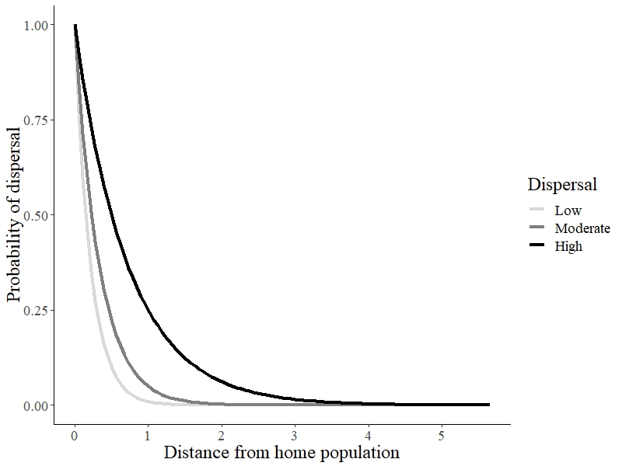

**Fig.1:** Probability of dispersal of an individual as a function of geographic distance, in three different dispersal scenarios.

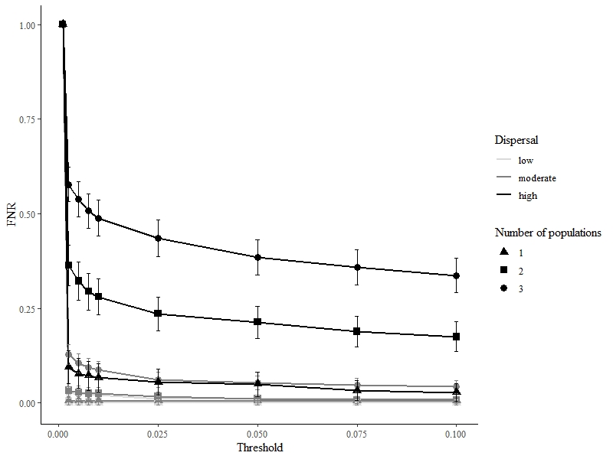

**Fig 2.** FNR across all threshold and scenarios. There are no control experiment results displayed for FNR because there are no possible true positives in control experiments, hence no false negatives either. Those values are for samplings done at generations 100 and 101, i.e. right before and after the migration event. 95% confidence intervals of the FNR estimates are displayed by bars. ### Je suggère d’utiliser des couleurs différenes pour les lignes correspondant aux trois valeurs de *dispersal*. Je suggère aussi d’écrire dans la légende de la figure les abréviations qui sont utilisées dans le texte: “low (L)”, “moderate (M)”, “high (H)”. ###

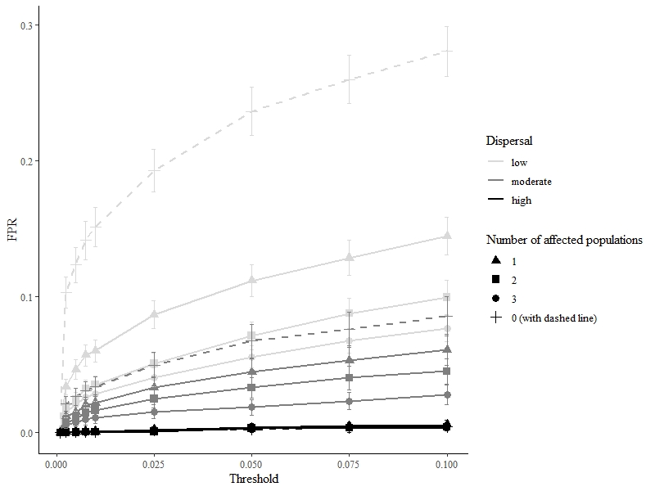

**Fig 3.** FPR across all threshold and scenarios. Control experiments are shown with dashed lines. Those values are for samplings done at the 100 and 101 generations 100 and 101, i.e. right before and after the migration event. 95% confidence intervals of the FPR estimates are displayed by bars. ### Traits et légende: même suggestions que pour Fig. 2. ###

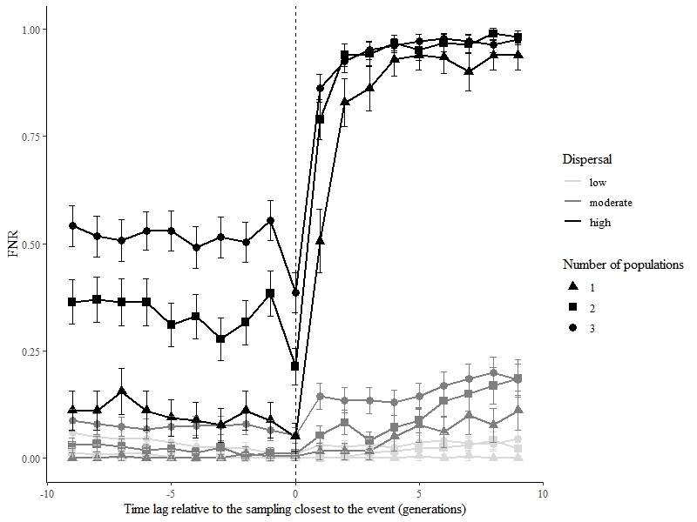

Influence of the timing of the posterior sampling

(0 represents sampling right after the event)

Influence of the timing of the prior sampling

(0 represents sampling right before the event)

**Fig 4**. FNR from TGI tests performed between samplings carried out up to 9 generations before or after the migration event (arrow) when compared with sampling done the generation after the event for prior samplings, or the generation before the event for posterior samplings. 95% confidence intervals are displayed by bars.

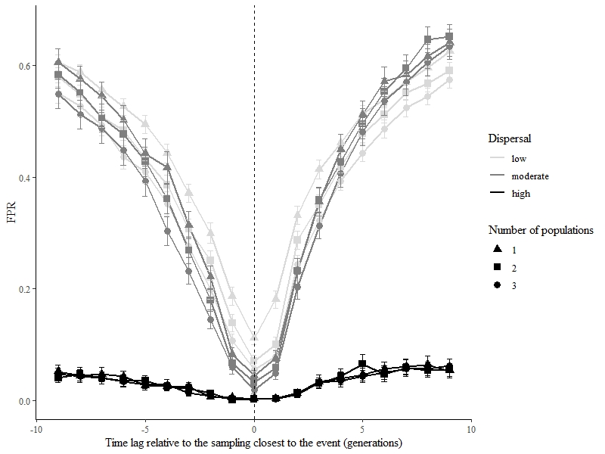

Influence of the timing of the posterior sampling

(0 represents sampling right after the event)

Influence of the timing of the prior sampling

(0 represents sampling right before the event)

**Fig 5**. FPR from TGI tests performed between sampling executed up to 9 generations before or after the event (arrow) when compared with sampling done the generation after the event for prior samplings, or the generation before the event for posterior samplings. 95% confidence intervals are displayed by bars. ### Mêmes corrections et remarques que pour la Fig. 4. ###

**ANNEX A:** Roger’s genetic distance

Given loci and alleles:

**ANNEX B:**