**Detecting temporal changes in genetic diversity using limited information: a new tool for molecular ecology studies with repeated samples.**

Julian Wittische1, Pierre Legendre1, Patrick M. A. James1,2

1 Département de Sciences Biologiques, Campus MIL, Université de Montréal, C.P. 6128, succ. Centre-ville, Montréal, QC, Canada, H3C 3J7

2 Graduate Department ofForestry, University of Toronto, 33 Willcocks St., Toronto, ON, Canada, M5S 2J5

Correspondence: Julian Wittische; E-mail: [jwittische@gmail.com](mailto:jwittische@gmail.com)

Running title: Testing spatio-temporal genetic change

In preparation for: 1) Molecular Ecology Resources (hope is limited), 2) Ecography, 3) Ecological Modelling, 3) Environmental Modelling & Software, 4) Ecology and Evolution, 5) Ecological Informatics.

**ABSTRACT**

Understanding spatio-temporal changes in biodiversity, including genetic diversity, is essential to track the effects of global change and to inform effective conservation plans. Although, temporal questions are common in community ecology, they are not in landscape genetics. Indeed, detecting changes in local genetic diversity beyond what one would expect from common processes involved at multiple scales such as drift, is challenging. Our capacity to detect such changes is also very information dependent. Existing methods to detect meaningful genetic changes through time typically require large genetic datasets containing information beyond simple allele counts. However, there are many situations where we want to understand temporal change in genetic diversity, for example are induced by demographic events like immigration, or population cycles, but in which such extensive information is not available. In this paper, we describe Temporal Genetic Indices (TGI), a new method to identify significant changes in genetic diversity through time. This method uses permutations of genotypic matrices to test the significance of genetic temporal change at sites, given genetic change in other sampling sites in the study landscape. TGI overcomes existing challenges to detecting temporal genetic change in genetic datasets with minimal genetic information. We demonstrate the utility of TGI for identifying the genetic legacies of important historical demographic events using demo-genetic simulations. We further demonstrate the ability of our TGI approach to identify such legacies under different levels of dispersal, spatial extent of the demographic event, and the timing of sampling relative to the event. Finally, we successfully applied TGI to an empirical dataset, with our application providing a straightforward test for genetic change, and supporting previous conclusions about the dataset. An R function to implement the method is now available, as well as convenience functions for those wishing to further simulate and analyze their simulations.

**INTRODUCTION**

Global biodiversity in terms of genes, species, populations, and ecosystems is being lost at an increasing rate with significant consequences for ecosystem functioning and long term viability of the biosphere (Bellard, Bertelsmeier, Leadley, Thuiller, & Courchamp, 2012; Dirzo et al., 2014; Leigh, Hendry, Vázquez‐Domínguez, & Friesen, 2019). Novel monitoring techniques are needed to track these losses and to inform conservation efforts. Further, it is recognized that it is no longer sufficient to study spatial patterns in biodiversity loss at a single point in time. Instead, one must examine trends and patterns in biodiversity through both space and time (Bradburd & Ralph, 2019; Fenderson, Kovach, & Llamas, 2019).

Spatial and temporal variation in genetic diversity can tell us a great deal about population demography connectivity (Bradburd & Ralph, 2019; Lowe & Allendorf, 2010). Indeed, population genetics has proven essential to translate observed genetic variation into meaningful inferences that are essential for conservation efforts (Allendorf, Hohenlohe, & Luikart, 2010; Harrisson, Pavlova, Telonis-Scott, & Sunnucks, 2014; Segelbacher et al., 2010). The field of landscape genetics takes these ideas further and examines interactions between micro-evolutionary processes and landscape features (Manel & Holderegger, 2013; Manel, Schwartz, Luikart, & Taberlet, 2003; Wagner & Fortin, 2013) to improve our understanding of how spatial heterogeneity influences population genetic processes. Landscape genetics has historically mostly had a spatial focus, in studies where sampling and analysis were carried out at a single point in time. Adding a temporal dimension to landscape genetics represents a great opportunity for improving the quality and usefulness of inference (Anderson et al., 2010; Draheim, Moore, Fortin, & Scribner, 2018; Martensen, Saura, & Fortin, 2017; Sun & Hedgecock, 2017). New conceptual approaches and tools that allow for the integration of spatial and temporal variation in studies of genetic variation hold great promises of further elucidating the processes that govern demographically dynamic systems such as insect outbreaks, invasions, disease spread, and species declines (Allendorf et al., 2010; Bradburd & Ralph, 2019; Fenderson et al., 2019).

Temporal variation in genetic diversity, and its drivers, are at the crux of many conservation and public health issues (Díez-del-Molino, Sánchez-Barreiro, Barnes, Gilbert, & Dalén, 2018; Lauterjung et al., 2019; Moraes et al., 2017). Researchers commonly use patterns in spatio-temporal population genetic data (Banks et al., 2013), to quantify isolation-by-distance (Rousset, 1997; Wright, 1943), time since population bottlenecks (Gattepaille, Jakobsson, & Blum, 2013; Maruyama & Fuerstt, 1985), rates of migration between isolated populations (Bezemer, Krauss, Roberts, & Hopper, 2019; Buschbom, Yanbaev, & Degen, 2011), and timing and extent of outbreak expansions (Larroque et al., 2019; Wittische, Janes, & James, 2019). Further development of temporally-explicit approaches is needed to quantify and evaluate changes in genetic variation through time. Specifically, such tools are needed to identify populations that have experienced important historical mortality as a result of demographic events that affect population sizes and influence landscape scale population connectivity. Such events may include disturbances such as a wildfire, major weather events, invasions of predators or competitors, or outbreaks of disease (Poff et al., 2018; Suárez, Betancor, Fregel, Rodríguez, & Pestano, 2012). Similarly, such analyses could identify which, among a set of previously sampled populations, received migrants from a long-distance dispersal event (Apodaca, Trexler, Jue, Schrader, & Travis, 2013). Because temporal genetic variation reflects the evolutionary potential of a population and the probability of its persistence (Aeschbacher, Selby, Willis, & Coop, 2016; Bolnick & Nosil, 2007; Kremer et al., 2012), relating it to landscape change can give us important insights about the eco-evolutionary dynamics of a species, and be used to inform conservation strategies (e.g. Landguth, Holden, Mahalovich, & Cushman, 2017). However, distinguishing between natural variation in temporal genetic structure due to the processes of recombination, mutation, and demographically-induced genetic drift from the changes wrought by external landscape variation is challenging.

Methods to infer demographic history using genetic data typically require tens of thousands of loci and require further information on different demographic scenarios and evolutionary assumptions (Excoffier, Dupanloup, Huerta-Sánchez, Sousa, & Foll, 2013; Gutenkunst, Hernandez, Williamson, & Bustamante, 2009; Kamm, Terhorst, Durbin, & Song, 2019). In general, these methods require input beyond simple allele counts, such as information about recombination processes (Gattepaille et al., 2013) and ascertainment bias (Albrechtsen, Nielsen, & Nielsen, 2010; Clark, Hubisz, Bustamante, Williamson, & Nielsen, 2005; Marth, Czabarka, Murvai, & Sherry, 2004) to estimate demographic parameters and history. Researchers are also interested however in examining spatial-temporal patterns of genetic variation in systems where less information (e.g., fewer markers) is available. Such systems may include non-model species (e.g. Legault et al. 2020) or systems that were sampled historically and there is now interest in comparing contemporary patterns with these older data. (*e.g.* Moraes et al., 2017).

In addition to challenges associated with information availability for temporal comparisons of spatial genetic structure, there are challenges related to how to meaningfully quantify these changes. Some studies have used genetic differentiation metrics such as FST (REF) to evaluate temporal changes between genetic datasets (e.g. Larroque et al 2019; Segura-García et al., 2019). However, translating our spatial understanding of FST-based results to the temporal dimension is not straightforward (Bhatia, Patterson, Sankararaman, & Price, 2013). Additionally, disentangling spatial from temporal effects is a challenge because the additivity of genetic drift means than genetic differentiation can be associated with both space and time (Murray et al., 2016; Skoglund, Sjödin, Skoglund, Lascoux, & Jakobsson, 2014). Detecting significant population genetic changes, relative to what would be expected due to drift, based on limited time series of genetic data, remains a challenge.

Temporal Beta-diversity Indices (TBI; Legendre 2019) are used to quantify and assess the significance of changes in ecological community composition through time using a dissimilarity index. The significance of these dissimilarities is then tested using permutation. The TBI approach has been extensively tested on simulated community composition data (Legendre, 2019), but its ability to detect meaningful changes in genetic diversity has not yet been examined. Given the conceptual similarity between the question of how diversity in multi-species communities and multi-locus genetic diversity changes through time, we sought to determine if TBI could be successfully applied to spatio-temporal genotypic data. We also set out to determine how different demographic contexts influence the ability of this method to identify historical events.

To address these questions, we extend the TBI framework to spatio-temporal population genetic data. The objective of our new framework, Temporal Genetic diversity Indices (TGI), is to identify significanttemporal variation in spatial genetic diversity with which one can infer the existence, strength, of past demographic events using relatively information-poor genetic data. We demonstrate the effectiveness and applicability of the approach using simulated genetic data generated using a spatially-explicit demo-genetic simulator (*CDMetaPOP*; Landguth, Bearlin, Day, & Dunham, 2017). Our general approach was to simulate multiple scenarios in which portions of a landscape are affected by a non-selective demographic change. We then used TGI to measure changes in the genetic diversity of our populations under these different demographic contexts. Specifically, we explored how dispersal ability, the number of populations affected by a demographic event (i.e., spatial extent), and time between two sampling efforts affected our capacity to detect significant temporal variation in genetic diversity. Performance was quantified using standard false positive/negative rates binary classification (Legendre & Legendre, 2012). We predict that our ability to detect historical demographic changes would be lower with increasing dispersal ability because of the homogenizing effect of higher gene flow. We also predict that the longer the time between successive sampling, regardless of when an event occurred between them, the harder it will be to identify where and when a demographic event occurred. Finally, we illustrate our approach by applying it to a real genetic dataset and compare our results with earlier indirect analyses.

**METHODS**

*Adapting Temporal Beta diversity Indices for genetic data*

Calculating TBI involves computing dissimilarities in species composition between the data sampled at two different times at all sampling sites, and testing the significance of these indices through simultaneous permutations of the two site-by-species input matrices. In extending TBI to TGI, we used genetic distances calculated from site-level allele frequencies instead of community dissimilarities to compare the two different sample times (Fig. 1 A). In this case, the null hypothesis is that genetic composition does not differ between the two points in time that were sampled.

Background genetic processes such as drift can also result in temporal differences in genetic structure. The challenge is therefore to identify temporal changes that are significantly different from what one would expect under a drift only scenario. Because there are no reference distributions for what constitutes a significant temporal genetic change, we use a permutation-based approach to generate a distribution of values to which an observed value can be compared. Permutation-based methods have been previously developed and applied to the analysis of spatio-temporal changes in community composition (for reviews: Legendre & Gauthier, 2014; Shimadzu, Dornelas, & Magurran, 2015).

Although several permutation approaches have been described, they are not all usable to support meaningful inference for all types of scientific questions (for genetic questions, see Adams & Collyer, 2015). Testing the significance of TGI involved permuting the input genotypic matrices. Here, we permuted the genotypes at each locus in the same way in both time samples (Fig. 1 B) using the *poppr* R package (see *Software*). This permutation was chosen because it maintains allelic structure and heterozygosity (Agapow & Burt, 2001). We used 999 permutations in all analyses.

*Genetic distance*

Genetic distances between points in time for a given location were calculated using the Rogers’ genetic distance (Rogers, 1972), which is very similar to the Euclidean genetic distance (see Annex A). It makes no assumptions about base-pair substitutions or time since separation and is suitable to study short-term dynamics. It has recently been used to investigate spatial genetic structure in a pond turtle (Pereira, Teixeira, & Velo-Antón, 2018) and a fungus (Bennett & Stone, 2019). We computed the distance using the *dist.genpop* function from the *adegenet* R package (see *Software*).

*Simulation framework*

To simulate the dynamics of population genetic changes through time and test the performance of TGI, we used the spatially-explicit gene flow simulator *CDMetaPOP* (Landguth, Bearlin, et al., 2017). *CDMetaPOP* simulates dispersal and mating of individuals across a landscape and allows the user to define initial genetic structure, spatial distribution of individuals, dispersal characteristics, and life-history traits of the population. The physical landscape we simulated was a homogeneous and interconnected square grid containing 5 × 5 cells, each cell representing a population. Each population had a maximum carrying capacity of 50 individuals. Structural connectivity between populations was strictly a function of geographic distance. The populated landscape, therefore, contains a maximum of 1250 individuals. The genotypic information of each individual was recorded and consisted of 100 neutral, unlinked, bi-allelic SNP loci. Sampling was done before and after the event unless otherwise specified. The mutation rate was set at 10-8 (Allio, Donega, Galtier, & Nabholz, 2017).

We simulated 180 replicates for each scenario (see below). For each replicate, we initialized the simulation with random and unique allocations of alleles among individuals, therefore reaching maximum diversity (Landguth, Bearlin, Day, & Dunham, 2016). Those parameters were chosen as a compromise between realism and computational time limitations, and they seemed appropriate to produce the complex evolutionary dynamics necessary to produce reasonably realistic and useful simulated genetic data. Each simulation was run for 100 generations before a demographic event (see below) was imposed on up to three populations in the landscape. 10 more generations were simulated after this event.

Multiple demographic processes affect the spatial apportionment of genetic variation. For this study, we chose to investigate the influence of immigration from a previously isolated population. When modelling immigration, we simulated immigration from a population that was separate from our 5×5 grid (i.e., population #26). Our goal was to apply the TGI approach to detect historical population changes in genetic data due to immigration. This independent source population otherwise shared the same attributes as other populations in our simulated landscape. Only during simulated demographic events were individuals from the 26th isolated population allowed to disperse into the simulation grid.

Using this model, we examined the influence of dispersal and the spatial extent of demographic events (number of affected populations) on the persistence of genetic spatial legacies. We examined three levels of dispersal (see below), and three different numbers of populations affected (1, 2, 3) for a total of 9 unique scenarios, each of which was replicated 180 times, for a total of 1620 (9 × 180) unique simulations for this experiment, aside from the control simulations described below (Table 1). In the next sections, we detail how we modelled the two experimental factors.

*Dispersal*

To model dispersal, we weighted the geographic distances between populations using a power law function, , where *B* represents how difficult it is to disperse and high values of *B* correspond to low dispersal capacity (elaborated below). We then rescaled the values, using the maximum and the minimum (0) distances possible in this virtual landscape, as described in the *CDMetaPOP* (Landguth, Bearlin, et al., 2017) user manual (p.63). This produced values in the [0,1] range, which are considered to represent probabilities that an individual disperses to a cell located at that distance (Fig.1). We chose this way of modelling dispersal to allow both within-population movements and long-distance dispersal.

The population to which an individual disperses was selected randomly from the set of populations available at the given distance. Individuals always stay within our simulated landscape, and any individual may disperse to one of our 25 populations at each generation. To investigate the effect of different levels of dispersal, we used three different values of *B*: low (*B* = 2), moderate (*B* = 1.301) and high (*B* = 0.6015) dispersal levels (Fig.1; Table 1).

*Spatial extent of demographic disturbance*

We also wanted to evaluate how the number of populations bearing spatio-temporal population genetic legacies influenced the performance of our testing procedure. To achieve this, we triggered demographic events at 1 to 3 populations randomly selected among the 25. Xxx When only 1 population was affected, we partitioned the 180 replicates of that scenario equally among six populations in the landscape. The positions of these six populations were randomly selected once and identical across runs. Indeed, because our landscape is square and homogeneously resistant to movement, it is therefore symmetric and only six positions need to be assessed. When several (2 or 3) populations underwent a demographic event, we randomly sampled 1 position among the six previously described and randomly picked 1 or 2 additional populations directly adjacent (when possible) to it. We did this six times (30 replicates for each different set of populations). We chose to pick populations this way to respect the spatial autocorrelation often exhibited in demographic events.

*Time since demographic change*

To assess how the time since the simulated demographic event affects our ability to detect genetic changes, we used TGI on simulated data collected up to 9 years before, and after, the event, and compared them with data collected respectively right after, and right before the event year. We chose 9 years as the maximum time between samplings as this time lag would represent most of the “before/after” population genetic studies we encountered, and because most long-term ecological research programs monitor during a shorter time interval.

*Statistical performance*

Specifically, for our analyses concerning the timing of sampling, rather than arbitrarily choosing a threshold, we chose the 0.05 *p*-value threshold as it was a good compromise between decent FPR and FNR in our earlier results.

We used the False Positive Rate (FPR) and False Negative Rate (FNR) to assess the statistical performance of the TGI testing procedure. A false positive is a population that we know *a priori* did not undergo the demographic change we imposed but has been found to have done so by the TGI test. A false negative is a population that did experience a demographic event but was not found to have done so. FPR represents the number of false positives over the total number of negative tests (i.e., true negatives and false positives). FNR represents the number of false negatives over the total number of positive tests (i.e., true positives and false negatives). A high FPR means that we often identify the wrong population(s) as significant, and researchers generally want to keep it as low as possible when there are, for example, limited resources available for conservation efforts. The higher the FPR, the lower the selectivity of our testing procedure. In contrast, a high FNR means that we often fail to identify the population(s) that were actually affected. The higher the FNR, the lower the power of our testing procedure. Researchers may want to minimiz

e the FNR in situations where finding the right population is the most important aspect, for example, if there is limited time to take conservation action. Selecting a proper threshold for permutation tests is often important to identify a compromise between power (1 – FNR) and selectivity (1 – FPR). To characterise this compromise, we evaluated the statistical performance of TGI using a range of thresholds: 0.001, 0.005, 0.01, 0.015, 0.020, 0.025, 0.030, 0.035, 0.040, 0.045, 0.050, 0.055, 0.060, 0.065, 0.070, 0.075, 0.080, 0.085, 0.090, 0.095, and 0.1.

*Controls*

Control simulations were run in which no populations were affected by demographic events and were therefore only subject to the processes of gene flow, drift, and mutation. Dispersal was the only parameter that varied among the control simulations, resulting in three control scenarios (Table 1). We evaluated the FPR of these control scenarios; there was no need to compute FNR because there were no true positives/false negatives so it was always equal to 0. When describing the performance of other scenarios with similar dispersal parameters, we always used these control values as reference.

*Software  
CDMetaPOP* runs on *Python 2.7* (Landguth, Bearlin, et al., 2017). We used the *R* software (R Core Team, 2019) in the RStudio IDE (RStudio Team, 2018) for all analyses and illustration. We used the *adegenet* (Jombart, 2008; Jombart & Ahmed, 2011), *pegas* (Paradis, 2010), *poppr* (Kamvar, Brooks, & Grünwald, 2015; Kamvar, Tabima, & Gr̈unwald, 2014) and *adespatial* (Dray et al., 2019) *R* packages for calculations. Our *TGI* function coded in *R* is available in the appendix.

*Application example: an endangered fish*

To showcase TGI’s general ability to provide sensible information about temporal change in a real system with conservation implications, we chose to apply it to a threatened vertebrate: the Northern tidewater goby. We chose this example because it uses a different genetic data type than we the one we simulated, to make it clear TGI is usable on a diversity of markers, and because the authors suggested that one population had undergone change among other more stable local populations, which allows to test a hypothesis, and go beyond a simple illustration of our method (Kinziger, Hellmair, McCraney, Jacobs, & Goldsmith, 2015). The dataset was available through DRYAD (doi:10.5061/ dryad.871db). We used 9999 permutations for this application.

**RESULTS**

*Dispersal*

As hypothesized, dispersal capacity influenced our ability to detect temporal changes in genetic diversity. FNR generally increased with dispersal intensity (Fig. 3). Only one scenario (H3; Table 1) exhibited FNR values above 1% regardless of the threshold used (Fig. 3). Among the four scenarios never reaching an average FNR of 0 (L3, M3, H2, H3), two involve high dispersal. Taking the average from scenarios sharing the same dispersal parameters for the ubiquitous 0.05 threshold (e.g.one value for L1, L2, and L3 grouped together), we had mean FNRs of 0.0037 (0.0007 - 0.0066; 95% CI) for low dispersal, 0.0049 (0.0015 - 0.0083; 95% CI) for moderate dispersal, and 0.0108 (0.0055 - 0.0161; 95% CI) for high dispersal. FNR values overall decreased with threshold, with a sharp decrease (most notable for H3) before 0.025 followed by a slower decrease until 0.1.

FPR did not substantially change as a function of dispersal capacity (Fig. 4). Low dispersal did not consistently result in higher FPR than moderate dispersal, or high dispersal (Fig. 4). Indeed, given the same number of affected populations we can see that L1 has slightly higher values than M1 and H1, L2 has slightly lower values than M2 and H2, and L3 has intermediate values, between that of M3 and H3. Conservatively defining FPR as acceptable by whether it is below the threshold used in the test, we notice that low dispersal scenarios had, on average, acceptable FPR values at more thresholds than higher dispersal scenarios, which overall presented the same performance by this metric (Table 2). FPR averages from scenario sharing the same dispersal parameters, for the 0.05 threshold, were 0.0599 (0.0558 - 0.0641; 95% CI) for low dispersal, 0.0621 (0.0580 - 0.0662; 95% CI) for moderate dispersal, and 0.0600 (0.0562 - 0.0638; 95% CI) for high dispersal. FPR values overall increased with threshold, with a sharp increase at low thresholds followed by a continued but saturating increase until threshold 0.1).

While the order of the performances of scenarios differing in dispersal capacity stayed the same, independently of the number of populations affected, for FNR (H>M>L for a given number of populations affected; Fig. 3), it was not the case for FPR where this order changes depending on the number of populations affected (Fig. 4).

*Number of populations affected*

The number of populations affected by a demographic event also influenced our ability to detect meaningful temporal change. Scenarios with fewer populations affected exhibited reduced FNRs, and an increased FPR (Figs. 3, 4).

Scenarios in which a single population was affected (i.e., L1, M1, H1) showed perfect FNR (0; Fig. 3), while L2 and M2 reached this perfect FNR only for liberal thresholds (i.e., >0.03; Fig ??). Taking the average from scenarios sharing the same number of populations affected, for the ubiquitous 0.05 threshold (e.g.one value for L1, M1, and H1 grouped together), we had mean FNRs of 0 for scenarios with one affected population as previously stated, 0.0028 (0 - 0.0059; 95% CI) for scenarios with two affected populations, and 0.0167 (0.0105 – 0.0228; 95% CI) for scenarios with three affected populations. FNR values overall decreased with increasing threshold, with a sharp decrease in FNR (most notable for H3) before 0.025 followed by a slower decrease until 0.1.

As shown by the overlap of FPR values across scenarios with similar numbers of populations affected rather than across scenarios with similar dispersal, the number of populations affected generally influenced the FPR performance more than dispersal, for the levels we used in the simulations (Table 2; Figs. 3, 4). Using the same conservative definition of an acceptable FPR as previously described (< alpha), we can see that scenarios with only one affected population never offered acceptable FPR values while those with two and three populations offered acceptable FPR values at thresholds higher than 0.0750 and 0.0450, respectively (Table 2). FPR averages from scenario sharing the same number of populations affected, for the 0.05 threshold, were 0.0820 (0.0778 - 0.0863; 95% CI) for scenarios with one affected population, 0.0553 (0.0516 - 0.0591; 95% CI) for scenarios with two affected populations, and 0.0447 (0.0413 - 0.0481; 95% CI) for scenarios with three affected populations.

*Time interval between samplings*

We found that the genetic signal of the demographic event decays over time, and that TGI is useful for identifying significant changes in genetic diversity at a time scale of XX-YY years. The longer the interval between a pre- and a post-event sampling, the lower the power available to detect the demographic event, as evidenced by the increase in false positives and false negatives for several scenarios (Fig. 5, 6). However, this effect is strongly affected by the dispersal capacity and the extent of the event.

The timing of sampling prior to a simulated event was, as expected, generally less important than that of the posterior sampling. For example, for the worst-performing scenario for sampling undertaken 9 years before the demographic event (M3), the FNR was more than 30 times that of the FNR for sampling undertaken the year immediately before, almost halving the power of the test (Fig. 5). For second samplings done 9 years after a first sampling done before the event, we observe high FNR values especially with high and moderate dispersal scenarios (Fig. 5). One very interesting point is that the number of populations affected is the main factor increasing FNR values in older first samplings (3>2>1; left side of Fig. 5), while dispersal capacity is the main factor increasing FNR values with the time lag of second samplings (H>M>L; right side of Fig. 5). For a same number of populations affected, moderate dispersal scenarios showed the worst performance for first sampling time lags, while high dispersal scenarios generally showed the worst performance for second sampling time lags (Fig .5). FNR changed the least for the L1 scenario, and the most for the H3 scenario(Fig. 5).

While the relative differences in FPR performance given different time lags were not as high as for FNR, FPR nonetheless increased with sampling time lag, for example, up to more than twice the value of the threshold for first samplings for L1, and even higher for the largest time lags possible for second samplings (Fig. 6). There are not clear patterns for whether dispersal or the number of populations affected most influenced FPR change for pre-event samplings (Fig .6). However, for time gaps attributed to the second sampling, dispersal becomes the main factor in driving FPR (Fig. 6). The previously described strong relationship between FPR and the number of populations affected by the demographic event, therefore, changed as dispersal became more influential. FPR did not change much for the L1 scenario, and changed the most dramatically for the H3 scenario (Fig. 6), again denoting large differences in the influence of time between our two most extreme scenarios.

Although FNR became quickly became pathological for second samplings done after event for high dispersal scenarios, FNR also increased with time lag for the posterior sampling for low and moderate dispersal scenarios, but more linearly, and never reaching 30% in the scope of our analyses, even after 9 years, for low dispersal scenarios (Fig. 5). The increase in FPR with posterior time lag was also the strongest for high dispersal scenarios.

When considering the scenario most likely to preserve the signal according to earlier results on FNR and FPR (L1), the TGI approach was still able to keep false negatives below 15% and false positives below 10%, even for a second sampling done 9 years after the event (Fig. 5, 6), regardless of whether the first or second sampling is responsible for the time lag.

*Control simulations*

Experimental FPR values consistently stayed below control FPR values corresponding to their dispersal scenario for low and moderate dispersal (Fig. 4). This means that in the presence of an actual migration event, we were always less likely to incorrectly identify a population as having been affected, than without such an event. The higher the dispersal, the lower the control FPR (Fig. 4). Control FPR values were generally at least twice as high as the maximum experimental FPR values (L1, M1), regardless of the threshold used. This means that even for the worst scenarios, TGI was much more effective at avoiding false positives, in the presence of an event, than in its absence (as shown in the control simulations).

*Application example*

The tidewater goby is… Previous work investigated… The Elk River population was the population where unexpected temporal genetic change was suggested to have taken place (Kinziger et al., 2015). Using TGI, we undertook a direct hypothesis test of… .

Using TGI, we found that the Elk River population of Northern tidewater goby (Kinziger et al., 2015) has indeed changed significantly relative to the other populations sampled in the study area (p-value = 0.0005), even after using strict adjustments (Holm-Bonferroni; p.value = 0.004). The results describe a loss of genetic diversity in that population between 2006 and 2011, confirming previous findings.

**DISCUSSION**

Xxx

We investigated how dispersal, the spatial extent of a demographic event, and the timing of sampling affects our ability to identify populations having undergone significant changes in genetic diversity. Performance of our permutation-based TGI procedure was evaluated using a spatially-explicit gene flow simulator (Landguth, Bearlin, et al., 2017). We found that dispersal intensity, event spatial extent, and sampling timing all influence TGI’s capacity to detect significant temporal changes in genetic diversity. Beyond the interest of our new approach for population genetics and the fact that we tested its performance in an extensive simulation study, our results could serve as a guide on how to use the new method, alongside simulations, to evaluate the information loss of different sampling schemes. Therefore, TGI has clear implications on the design of empirical field studies

The ability of our method to detect temporal genetic changes is sensitive to the dispersal capacity of the organism of interest. Indeed, false negatives increased with dispersal, whereas false positives did not show a trend (Figure?). The influence of dispersal on the false negative rate increases with increasing time lags between an event and the subsequent sampling. The effect of dispersal on the FNR is present when only one generation separates two temporal samples (right before and right after the event), and increases as the time between samplings increases. Considering that we used dispersal ability as a proxy for landscape functional connectivity, this result suggests that well-connected landscapes might require more frequent sampling to overcome the negative effect of connectivity on our ability to correctly identify affected populations. High dispersal, and higher rates of gene flow both reduce our ability to understand the effects of local eco-evolutionary dynamics on spatial-temporal genetic variation. For example, high dispersal during range expansion lowers our ability to correctly detect loci under natural selection (Mayrand, Filotas, Wittische, & James, 2019). However, high gene flow may not always be associated with a strong decrease in measured structure (Landguth, Cushman, Murphy, & Luikart, 2010) or early detection of barriers to gene flow (Landguth, Cushman, Schwartz, et al., 2010).

The spatial extent of an event increases our ability to correctly reject populations that have not truly changed (lower FPR), but it decreases our ability to correctly detect populations that have truly changed (higher FNR). This trade-off is apparent for all scenarios its strength appears to depend on dispersal. Although the spatial extent of a legacy may help researchers detect the legacy as the chance of the legacy being sampled increases, it may also increase the risk of not identifying the legacy at all, especially in high dispersal landscapes. xxx

When several populations were affected, we chose adjacent populations; whether lowering the degree of spatial autocorrelation in the spatial genetic legacy, that is targeting populations not necessarily adjacent to each other, influences detection, has not been investigated in our paper. Spatial autocorrelation may greatly affect many genetic analyses, and solutions are being developed to integrate it within them (Rousset & Ferdy, 2014). We believe that explicitly taking spatial autocorrelation into account in temporal analyses of genetic diversity (Bradburd & Ralph, 2019) represents a promising and challenging avenue of research.

*Subheading?*

As expected, spatial genetic legacies tend to decay over time and TGI appears best suited to identify changes at a temporal scale of 1-10 years depending on . However, two main points emerged from our analysis of the timing of sampling required to detect significant genetic change. First, spatial extent is important to take into account when we have access to sampling immediately following a suspected event. This is true when we compare it to old or recent pre-event sampling. The main implication of this result is that while it could reassure researchers that they may compare an older sample to a recent one obtained shortly after the event, the power to detect change decreases sharply if the event affected a large part of the landscape. However, the timing of the pre-event sampling is generally less important than that of the post-event sampling. Indeed, dispersal becomes the most important factor in driving the performance of TGI, especially its power, when the time lag between the event and the post-event sampling increases. This means that researchers may for example have to accept as many as 50% of false negatives and 10% of false positives after sampling only a few years after an event if their system presents high dispersal. This has serious implications: if the demographic parameters of the models of a study system would be similar to our inputs (moderate dispersal for example), researchers might systematically spend a substantial part of their resources on monitoring or treating unaffected populations, while missing half the affected populations. For a cartoon example, if 10 guards would be hired to protect populations of a threatened salamander identified as having recently lost more genetic diversity than expected, 1 of them would protect populations that have actually been stable, and may, therefore, be less important to protect, and the guards would not protect 10 populations that should be protected.

Although the spatial legacy of a past demographic event could be perceptible in richer genomic data, limited biallelic gene frequency data may not retain most of the signal beyond a few years, even in the best situations.

In contrast, the previous investigations using TBI, which used community composition data, have not focused on the timing of sampling. Although community composition data (species x sites) generally varies at a larger time scale than genetic data, we encourage future investigations of the influence of timing on TBI performance.

Our TGI procedure is adequate to study genetic change, but there are certain considerations to keep in mind when using it. For example, stricter values (lower values) for the TGI *p*-value threshold expectedly bring a better FPR but may also bring a worse FNR (lower power). Identifying this threshold would be valuable to better understand the trade-offs of different sampling schemes in specific systems. TGI can also readily be used on other types of genetic data, such as microsatellites.

TGI represents a more transparent alternative to arbitrarily comparing pairwise genetic differentiation, or node-based genetic diversity values. Nonetheless, more work is needed to explore how the performance of TGI varies with other factors such as: 1) genetic distance; 2) spatial autocorrelation in genetic legacies; 3) effective population size; and 4) spatial heterogeneity in landscape resistance to movement.

Finally, successful implementation of TGI in new systems will require some *a priori* understanding of the range of useful threshold values to use. These values represent… Simulation is a powerful tool for investigating how demography and spatial context influence population genetic dynamics (Epperson et al., 2010), and can be used to help identify those appropriate threshold values, as we have demonstrated here. Several programs such as *CDMetaPOP* (Landguth, Bearlin, et al., 2017), *Nemo* (Guillaume & Rougemont, 2006), *SPLATCHE* (Currat, Ray, & Excoffier, 2004), or *SLIM* (Haller & Messer, 2019) provide very flexible and sophisticated ways to implement such simulations. We expect greater sensitivity to threshold selection in systems that exhibit dramatic demographic fluctuations, as is the case in outbreaking or invasive species.

XX

*Conclusions*

Identifying changes in genetic diversity, beyond what one would expect due to background micro-evolutionary processes, can help researchers and conservation managers identify locations that have experienced important past demographic events. These events could be detrimental (*e.g.* loss of diversity, maladaptation) or beneficial (*e.g.* higher effective population size, genetic rescue). Such sites could then be prioritized for increased monitoring and further investigation into the origin of these changes. As shown in our application of TGI on an endangered animal system, our method provides a direct test of the hypothesis of exceptional temporal genetic change. Our approach to detecting temporal genetic differentiation does not require extensive genomic information and can be used to explore the temporal dynamics of demographically induced genetic diversity using relatively small genetic datasets (*e.g.* hundreds of SNPs). As such, our approach holds great promises to facilitate spatio-temporal analysis of wild, non-model organisms for which extensive genomic resources are yet to be developed.

**ACKNOWLEDGEMENTS**

This research was supported by a grant to PMAJ and the TRIA Network from the Natural Sciences and Engineering Research Council of Canada (grant no. NET GP 434810-12), with contributions from Alberta Agriculture and Forestry, fRI Research, Manitoba Conservation and Water Stewardship, Canadian Forest Service (Natural Resources Canada), Northwest Territories Environment and Natural Resources, Ontario Ministry of Natural Resources and Forestry, Saskatchewan Ministry of Environment, West Fraser, and Weyerhaeuser. JW was also supported by a scholarship from the Forest Complexity Modelling (FCM) NSERC CREATE. Computations were made on the supercomputer CEDAR managed by Compute Canada ([www.computecanada.ca](http://www.computecanada.ca)). Finally, we thank Jeremy Larroque, Hinatea Ariey and Charlotte Van Engeland for their comments on an earlier version of the manuscript.

**REFERENCES**

Adams, D. C., & Collyer, M. L. (2015). Permutation tests for phylogenetic comparative analyses of high-dimensional shape data: What you shuffle matters. *Evolution*, *69*(3), 823–829. doi: 10.1111/evo.12596

Aeschbacher, S., Selby, J. P., Willis, J. H., & Coop, G. M. (2016). *Population-genomic inference of the strength and timing of selection against gene flow*. (18), 1–6. doi: 10.1101/072736

Agapow, P. M., & Burt, A. (2001). Indices of multilocus linkage disequilibrium. *Molecular Ecology Notes*, *1*(1–2), 101–102. doi: 10.1046/j.1471-8278.2000.00014.x

Albrechtsen, A., Nielsen, F. C., & Nielsen, R. (2010). Ascertainment biases in SNP chips affect measures of population divergence. *Molecular Biology and Evolution*, *27*(11), 2534–2547. doi: 10.1093/molbev/msq148

Allendorf, F. W., Hohenlohe, P. A., & Luikart, G. (2010). Genomics and the future of conservation genetics. *Nature Reviews. Genetics*, *11*(10), 697–709. doi: 10.1038/nrg2844

Allio, R., Donega, S., Galtier, N., & Nabholz, B. (2017). Large variation in the ratio of mitochondrial to nuclear mutation rate across animals: Implications for genetic diversity and the use of mitochondrial DNA as a molecular marker. *Molecular Biology and Evolution*, *34*(11), 2762–2772. doi: 10.1093/molbev/msx197

Anderson, C. D., Epperson, B. K., Fortin, M.-J., Holderegger, R., James, P. M. a., Rosenberg, M. S., … Spear, S. F. (2010). Considering spatial and temporal scale in landscape-genetic studies of gene flow. *Molecular Ecology*, *19*(17), 3565–3575. doi: 10.1111/j.1365-294X.2010.04757.x

Apodaca, J. J., Trexler, J. C., Jue, N. K., Schrader, M., & Travis, J. (2013). Large-scale natural disturbance alters genetic population structure of the sailfin molly, poecilia latipinna. *American Naturalist*, *181*(2), 254–263. doi: 10.1086/668831

Banks, S. C., Cary, G. J., Smith, A. L., Davies, I. D., Driscoll, D. A., Gill, A. M., … Peakall, R. (2013). How does ecological disturbance influence genetic diversity ? *Trends in Ecology & Evolution*, *28*(11), 670–679. doi: 10.1016/j.tree.2013.08.005

Bellard, C., Bertelsmeier, C., Leadley, P., Thuiller, W., & Courchamp, F. (2012). Impacts of climate change on the future of biodiversity. *Ecology Letters*, *15*(4), 365–377. doi: 10.1111/j.1461-0248.2011.01736.x

Bennett, P. I., & Stone, J. K. (2019). Environmental variables associated with Nothophaeocryptopus gaeumannii population structure and Swiss needle cast severity in Western Oregon and Washington. *Ecology and Evolution*, *9*(19), 11379–11394. doi: 10.1002/ece3.5639

Bezemer, N., Krauss, S. L., Roberts, D. G., & Hopper, S. D. (2019). Conservation of old individual trees and small populations is integral to maintain species’ genetic diversity of a historically fragmented woody perennial. *Molecular Ecology*, (January), 3339–3357. doi: 10.1111/mec.15164

Bhatia, G., Patterson, N., Sankararaman, S., & Price, A. L. (2013). Estimating and interpreting F. *Genome Research*, (2), 1–9. doi: 10.1101/gr.154831.113.23

Bolnick, D. I., & Nosil, P. (2007). Natural selection in populations subject to a migration load. *Evolution*, *61*(9), 2229–2243. doi: 10.1111/j.1558-5646.2007.00179.x

Bradburd, G. S., & Ralph, P. L. (2019). Spatial Population Genetics: It’s About Time. *Annual Review of Ecology, Evolution, and Systematics*, *50*(1), 427–449. doi: 10.1146/annurev-ecolsys-110316-022659

Buschbom, J., Yanbaev, Y., & Degen, B. (2011). Efficient long-distance gene flow into an isolated relict oak stand. *Journal of Heredity*, *102*(4), 464–472. doi: 10.1093/jhered/esr023

Clark, A. G., Hubisz, M. J., Bustamante, C. D., Williamson, S. H., & Nielsen, R. (2005). Ascertainment bias in studies of human genome-wide polymorphism. *Genome Research*, *15*(11), 1496–1502. doi: 10.1101/gr.4107905

Currat, M., Ray, N., & Excoffier, L. (2004). SPLATCHE: A program to simulate genetic diversity taking into account environmental heterogeneity. *Molecular Ecology Notes*, *4*(1), 139–142. doi: 10.1046/j.1471-8286.2003.00582.x

Díez-del-Molino, D., Sánchez-Barreiro, F., Barnes, I., Gilbert, M. T. P., & Dalén, L. (2018). Quantifying Temporal Genomic Erosion in Endangered Species. *Trends in Ecology and Evolution*, *33*(3), 176–185. doi: 10.1016/j.tree.2017.12.002

Dirzo, R., Young, H. S., Galetti, M., Ceballos, G., Isaac, N. J. B., & Collen, B. (2014). Defaunation in the Anthropocene. *Science*, *401*(6195), 401–406. doi: 10.1126/science.1251817

Draheim, H. M., Moore, J. A., Fortin, M. J., & Scribner, K. T. (2018). Beyond the snapshot: Landscape genetic analysis of time series data reveal responses of American black bears to landscape change. *Evolutionary Applications*, *11*(8), 1219–1230. doi: 10.1111/eva.12617

Dray, S., Bauman, D., Blanchet, F. G., Borcard, D., Clappe, S., Guenard, G., … Wagner, H. H. (2019). *adespatial: multivariate multiscale spatial analysis.* Retrieved from https://cran.r-project.org/package=adespatial

Epperson, B. K., McRae, B. H., Scribner, K., Cushman, S. a, Rosenberg, M. S., Fortin, M.-J., … Dale, M. R. T. (2010). Utility of computer simulations in landscape genetics. *Molecular Ecology*, *19*(17), 3549–3564. doi: 10.1111/j.1365-294X.2010.04678.x

Excoffier, L., Dupanloup, I., Huerta-Sánchez, E., Sousa, V. C., & Foll, M. (2013). Robust Demographic Inference from Genomic and SNP Data. *PLoS Genetics*, *9*(10). doi: 10.1371/journal.pgen.1003905

Fenderson, L. E., Kovach, A. I., & Llamas, B. (2019). Spatiotemporal Landscape Genetics: Investigating Ecology and Evolution through Space and Time. *Molecular Ecology*, (November 2019), mec.15315. doi: 10.1111/mec.15315

Gattepaille, L. M., Jakobsson, M., & Blum, M. G. B. (2013). Inferring population size changes with sequence and SNP data: Lessons from human bottlenecks. *Heredity*, *110*(5), 409–419. doi: 10.1038/hdy.2012.120

Guillaume, F., & Rougemont, J. (2006). Nemo: An evolutionary and population genetics programming framework. *Bioinformatics*, *22*(20), 2556–2557. doi: 10.1093/bioinformatics/btl415

Gutenkunst, R. N., Hernandez, R. D., Williamson, S. H., & Bustamante, C. D. (2009). Inferring the joint demographic history of multiple populations from multidimensional SNP frequency data. *PLoS Genetics*, *5*(10). doi: 10.1371/journal.pgen.1000695

Haller, B. C., & Messer, P. W. (2019). SLiM 3: Forward Genetic Simulations Beyond the Wright-Fisher Model. *Molecular Biology and Evolution*, *36*(3), 632–637. doi: 10.1093/molbev/msy228

Harrisson, K. A., Pavlova, A., Telonis-Scott, M., & Sunnucks, P. (2014). Using genomics to characterize evolutionary potential for conservation of wild populations. *Evolutionary Applications*, *7*(9), 1008–1025. doi: 10.1111/eva.12149

Jombart, T. (2008). Adegenet: A R package for the multivariate analysis of genetic markers. *Bioinformatics*, *24*(11), 1403–1405. doi: 10.1093/bioinformatics/btn129

Jombart, T., & Ahmed, I. (2011). adegenet 1.3-1: New tools for the analysis of genome-wide SNP data. *Bioinformatics*, *27*(21), 3070–3071. doi: 10.1093/bioinformatics/btr521

Kamm, J., Terhorst, J., Durbin, R., & Song, Y. S. (2019). Efficiently Inferring the Demographic History of Many Populations With Allele Count Data. *Journal of the American Statistical Association*, *0*(0), 1–16. doi: 10.1080/01621459.2019.1635482

Kamvar, Z. N., Brooks, J. C., & Grünwald, N. J. (2015). Novel R tools for analysis of genome-wide population genetic data with emphasis on clonality. *Frontiers in Genetics*, *6*(JUN), 1–10. doi: 10.3389/fgene.2015.00208

Kamvar, Z. N., Tabima, J. F., & Gr̈unwald, N. J. (2014). Poppr: An R package for genetic analysis of populations with clonal, partially clonal, and/or sexual reproduction. *PeerJ*, *2014*(1), 1–14. doi: 10.7717/peerj.281

Kinziger, A. P., Hellmair, M., McCraney, W. T., Jacobs, D. K., & Goldsmith, G. (2015). Temporal genetic analysis of the endangered tidewater goby: Extinction-colonization dynamics or drift in isolation? *Molecular Ecology*, *24*(22), 5544–5560. doi: 10.1111/mec.13424

Kremer, A., Ronce, O., Robledo-Arnuncio, J. J., Guillaume, F., Bohrer, G., Nathan, R., … Schueler, S. (2012). Long-distance gene flow and adaptation of forest trees to rapid climate change. *Ecology Letters*, *15*(4), 378–392. doi: 10.1111/j.1461-0248.2012.01746.x

Landguth, E. L., Bearlin, A., Day, C. C., & Dunham, J. (2016). CDMetaPOP: an individual-based, eco-evolutionary model for spatially-explicit simulation of landscape demogenetics. *Methods in Ecology and Evolution*. doi: 10.1111/2041-210X.12608

Landguth, E. L., Bearlin, A., Day, C. C., & Dunham, J. (2017). CDMetaPOP: an individual-based, eco-evolutionary model for spatially explicit simulation of landscape demogenetics. *Methods in Ecology and Evolution*, *8*(1), 4–11. doi: 10.1111/2041-210X.12608

Landguth, E. L., Cushman, S. a., Schwartz, M. K., McKelvey, K. S., Murphy, M., & Luikart, G. (2010). Quantifying the lag time to detect barriers in landscape genetics. *Molecular Ecology*, *19*, 4179–4191. doi: 10.1111/j.1365-294X.2010.04808.x

Landguth, E. L., Cushman, S. a, Murphy, M. a, & Luikart, G. (2010). Relationships between migration rates and landscape resistance assessed using individual-based simulations. *Molecular Ecology Resources*, *10*(5), 854–862. doi: 10.1111/j.1755-0998.2010.02867.x

Landguth, E. L., Holden, Z. A., Mahalovich, M. F., & Cushman, S. A. (2017). Using landscape genetics simulations for planting blister rust resistant whitebark pine in the US Northern Rocky Mountains. *Frontiers in Genetics*, *8*(FEB), 1–12. doi: 10.3389/fgene.2017.00009

Larroque, J., Legault, S., Johns, R., Lumley, L., Cusson, M., Renaut, S., … James, P. M. A. (2019). Temporal variation in spatial genetic structure during population outbreaks: Distinguishing among different potential drivers of spatial synchrony. *Evolutionary Applications*, (July), 1–15. doi: 10.1111/eva.12852

Lauterjung, M. B., Montagna, T., Bernardi, A. P., da Silva, J. Z., da Costa, N. C. F., Steiner, F., … dos Reis, M. S. (2019). Temporal changes in population genetics of six threatened Brazilian plant species in a fragmented landscape. *Forest Ecology and Management*, *435*(October 2018), 144–150. doi: 10.1016/j.foreco.2018.12.058

Legendre, P. (2019). A temporal beta-diversity index to identify sites that have changed in exceptional ways in space–time surveys. *Ecology and Evolution*, *9*(6), 3500–3514. doi: 10.1002/ece3.4984

Legendre, P., & De Cáceres, M. (2013). Beta diversity as the variance of community data: Dissimilarity coefficients and partitioning. *Ecology Letters*, *16*(8), 951–963. doi: 10.1111/ele.12141

Legendre, P., & Gauthier, O. (2014). Statistical methods for temporal and space-time analysis of community composition data. *Proceedings of the Royal Society B: Biological Sciences*, *281*(1778). doi: 10.1098/rspb.2013.2728

Legendre, P., & Legendre, L. (2012). *Numerical Ecology* (Third Engl). Amsterdam: Elsevier.

Leigh, D. M., Hendry, A. P., Vázquez‐Domínguez, E., & Friesen, V. L. (2019). Estimated six percent loss of genetic variation in wild populations since the industrial revolution. *Evolutionary Applications*, (April), 1–8. doi: 10.1111/eva.12810

Lowe, W. H., & Allendorf, F. W. (2010). What can genetics tell us about population connectivity? *Molecular Ecology*, *19*(15), 3038–3051. doi: 10.1111/j.1365-294X.2010.04688.x

Manel, S., & Holderegger, R. (2013). Ten years of landscape genetics. *Trends in Ecology & Evolution*, *28*(10), 614–621. doi: 10.1016/j.tree.2013.05.012

Manel, S., Schwartz, M. K., Luikart, G., & Taberlet, P. (2003). Landscape genetics: combining landscape ecology and population genetics. *Trends in Ecology & Evolution*, *18*(4), 189–197. doi: 10.1016/S0169-5347(03)00008-9

Martensen, A. C., Saura, S., & Fortin, M. J. (2017). Spatio-temporal connectivity: assessing the amount of reachable habitat in dynamic landscapes. *Methods in Ecology and Evolution*, *8*(10), 1253–1264. doi: 10.1111/2041-210X.12799

Marth, G. T., Czabarka, E., Murvai, J., & Sherry, S. T. (2004). The Allele Frequency Spectrum in Genome-Wide Human Variation Data Reveals Signals of Differential Demographic History in Three Large World Populations. *Genetics*, *166*(1), 351–372. doi: 10.1534/genetics.166.1.351

Maruyama, T., & Fuerstt, P. A. (1985). Population bottlenecks and nonequilibrium models in opulation genetics. II. Number of alleles in a small population that was formed by a recent bottleneck. *Genetics*, *111*(3), 675–689. Retrieved from https://www.ncbi.nlm.nih.gov/pmc/articles/PMC1202664/pdf/675.pdf

Mayrand, P., Filotas, E., Wittische, J., & James, P. M. A. (2019). The role of dispersal, selection, and timing of sampling on the false discovery rate of loci under selection during geographic range expansion. *Genome*, *13*(July), 1–13. doi: 10.1139/gen-2019-0004

Moraes, A. M., Ruiz-Miranda, C. R., Ribeiro, M. C., Grativol, A. D., da S. Carvalho, C., Dietz, J. M., … Galetti, P. M. (2017). Temporal genetic dynamics of reintroduced and translocated populations of the endangered golden lion tamarin (Leontopithecus rosalia). *Conservation Genetics*, *18*(5), 995–1009. doi: 10.1007/s10592-017-0948-4

Murray, G. G. R., Wang, F., Harrison, E. M., Paterson, G. K., Mather, A. E., Harris, S. R., … Welch, J. J. (2016). The effect of genetic structure on molecular dating and tests for temporal signal. *Methods in Ecology and Evolution*, *7*(1), 80–89. doi: 10.1111/2041-210X.12466

Paradis, E. (2010). Pegas: An R package for population genetics with an integrated-modular approach. *Bioinformatics*, *26*(3), 419–420. doi: 10.1093/bioinformatics/btp696

Pereira, P., Teixeira, J., & Velo-Antón, G. (2018). Allele surfing shaped the genetic structure of the European pond turtle via colonization and population expansion across the Iberian Peninsula from Africa. *Journal of Biogeography*, *45*(9), 2202–2215. doi: 10.1111/jbi.13412

Poff, N. L. R., Larson, E. I., Salerno, P. E., Morton, S. G., Kondratieff, B. C., Flecker, A. S., … Funk, W. C. (2018). Extreme streams: species persistence and genomic change in montane insect populations across a flooding gradient. *Ecology Letters*, *21*(4), 525–535. doi: 10.1111/ele.12918

R Core Team. (2019). *R: A language and environment for statistical computing*. Retrieved from https://www.r-project.org/

Rogers, J. S. (1972). Measures of genetic similarity and genetic distances. In M. R. Wheeler (Ed.), *Studies in Genetics VII* (pp. 145–153). Austin: The University of Texas.

Rousset, F. (1997). Genetic Differentiation and Estimation of Gene Flow from FStatistics Under Isolation by Distance. *Genetics*, *145*(4), 1219–1228.

Rousset, F., & Ferdy, J.-B. (2014). Testing environmental and genetic effects in the presence of spatial autocorrelation. *Ecography*, *37*(December 2013), 781–790. doi: 10.1111/ecog.00566

RStudio Team. (2018). *RStudio: Integrated Development for R*. Retrieved from http://www.rstudio.com/

Segelbacher, G., Cushman, S. A., Epperson, B. K., Fortin, M. J., Francois, O., Hardy, O. J., … Manel, S. (2010). Applications of landscape genetics in conservation biology: Concepts and challenges. *Conservation Genetics*, *11*(2), 375–385. doi: 10.1007/s10592-009-0044-5

Segura-García, I., Garavelli, L., Tringali, M., Matthews, T., Chérubin, L. M., Hunt, J., & Box, S. J. (2019). Reconstruction of larval origins based on genetic relatedness and biophysical modeling. *Scientific Reports*, *9*(1), 1–9. doi: 10.1038/s41598-019-43435-9

Shimadzu, H., Dornelas, M., & Magurran, A. E. (2015). Measuring temporal turnover in ecological communities. *Methods in Ecology and Evolution*, *6*(12), 1384–1394. doi: 10.1111/2041-210X.12438

Skoglund, P., Sjödin, P., Skoglund, T., Lascoux, M., & Jakobsson, M. (2014). Investigating population history using temporal genetic differentiation. *Molecular Biology and Evolution*, *31*(9), 2516–2527. doi: 10.1093/molbev/msu192

Suárez, N. M., Betancor, E., Fregel, R., Rodríguez, F., & Pestano, J. (2012). Genetic signature of a severe forest fire on the endangered Gran Canaria blue chaffinch (Fringilla teydea polatzeki). *Conservation Genetics*, *13*(2), 499–507. doi: 10.1007/s10592-011-0302-1

Sun, X., & Hedgecock, D. (2017). Temporal genetic change in North American Pacific oyster populations suggests caution in seascape genetics analyses of high gene-flow species. *Marine Ecology Progress Series*, *565*, 79–93. doi: 10.3354/meps12009

Wagner, H. H., & Fortin, M.-J. (2013). A conceptual framework for the spatial analysis of landscape genetic data. *Conservation Genetics*, *14*(2), 253–261. doi: 10.1007/s10592-012-0391-5

Wittische, J., Janes, J. K., & James, P. M. A. (2019). Modelling landscape genetic connectivity of the mountain pine beetle in western Canada. *Canadian Journal of Forest Research*, *1348*(September), 1339–1348. doi: 10.1139/cjfr-2018-0417

Wright, S. (1943). Isolation by Distance. *Genetics*, *28*(2), 114–138.

**DATA ACCESSIBILITY**

All simulation data used for this paper will be deposited online upon acceptance. Functions used to analyze the simulations will be available on a public repository on *GitHub*.TGI, the function that would be most useful to potential users of our approach, will continue to be maintained and developed and may be contributed to a CRAN package in the near future.

**AUTHOR CONTRIBUTIONS**

J.W. designed the study, created the simulation inputs, ran the simulations, transformed the TBI function to TGI, and performed the analyses. P.L. and P.M.A.J. provided advice on the study design, analysis, and the visualization. J.W., P.L. and P.M.A.J. wrote the paper.

**TABLES AND FIGURES**

**Table 1:** Two-factor simulation experiment with scenario abbreviations used throughout the manuscript. Rows: number of populations with spatio-temporal population genetic legacies. Columns: dispersal values. Numbers in parentheses indicate the number of unique simulations ran for each factor level or combination of factor levels. We ran 2160 simulations in total.

|  |  |  |  |
| --- | --- | --- | --- |
| *Dispersal (B)*  *No. populations* | **Low** (720) | **Moderate** (720) | **High** (720) |
| **1** (540) | L1 (180) | M1 (180) | H1 (180) |
| **2** (540) | L2 (180) | M2 (180) | H2 (180) |
| **3** (540) | L3 (180) | M3 (180) | H3 (180) |
| **0: control** (540) | CL (180) | CM (180) | CH (180) |

**Table 2.** Are average FPR values staying below the thresholds used in the TGI tests? True (T) or False (F).

|  |  |  |  |  |  |  |  |  |  |
| --- | --- | --- | --- | --- | --- | --- | --- | --- | --- |
| *Scenarios*  *--- Thresholds* | **L1** | **L2** | **L3** | **M1** | **M2** | **M3** | **H1** | **H2** | **H3** |
| **0.0010** | **T** | **T** | **T** | **T** | **T** | **T** | **T** | **T** | **T** |
| **0.0050** | F | F | F | F | F | F | F | F | F |
| **0.0100** | F | F | F | F | F | F | F | F | F |
| **0.0150** | F | F | F | F | F | F | F | F | F |
| **0.0200** | F | F | F | F | F | F | F | F | F |
| **0.0250** | F | F | F | F | F | F | F | F | F |
| **0.0300** | F | F | F | F | F | F | F | F | F |
| **0.0350** | F | F | F | F | F | F | F | F | F |
| **0.0400** | F | F | **T** | F | F | **T** | F | F | F |
| **0.0450** | F | F | **T** | F | F | **T** | F | F | **T** |
| **0.0500** | F | **T** | **T** | F | F | **T** | F | F | **T** |
| **0.0550** | F | **T** | **T** | F | F | **T** | F | F | **T** |
| **0.0600** | F | **T** | **T** | F | F | **T** | F | F | **T** |
| **0.0650** | F | **T** | **T** | F | F | **T** | F | F | **T** |
| **0.0700** | F | **T** | **T** | F | F | **T** | F | **T** | **T** |
| **0.0750** | F | **T** | **T** | F | **T** | **T** | F | **T** | **T** |
| **0.0800** | F | **T** | **T** | F | **T** | **T** | F | **T** | **T** |
| **0.0850** | F | **T** | **T** | F | **T** | **T** | F | **T** | **T** |
| **0.0900** | F | **T** | **T** | F | **T** | **T** | F | **T** | **T** |
| **0.0950** | F | **T** | **T** | F | **T** | **T** | F | **T** | **T** |
| **0.1000** | F | **T** | **T** | F | **T** | **T** | F | **T** | **T** |

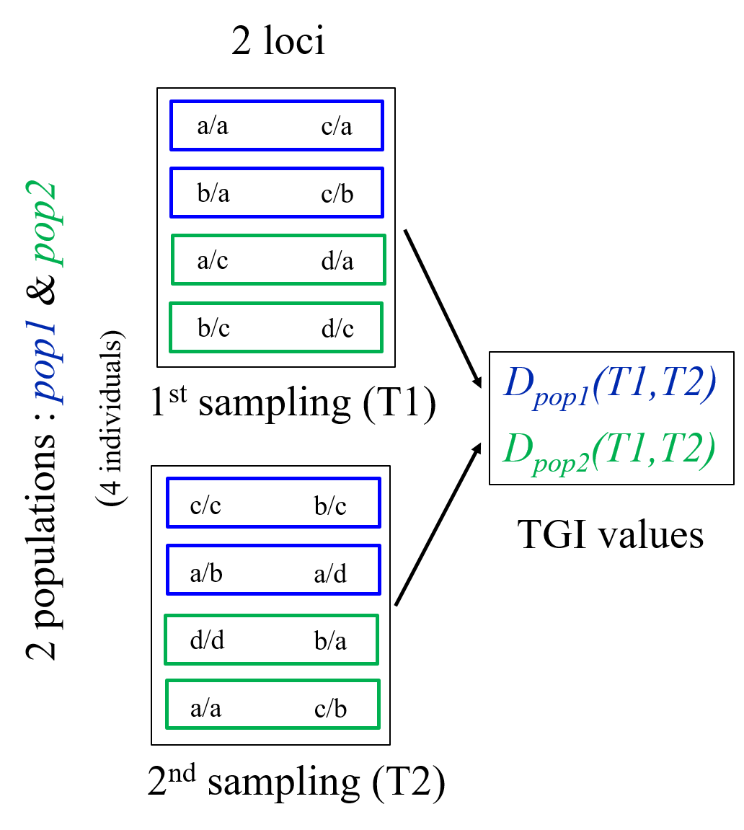

A)

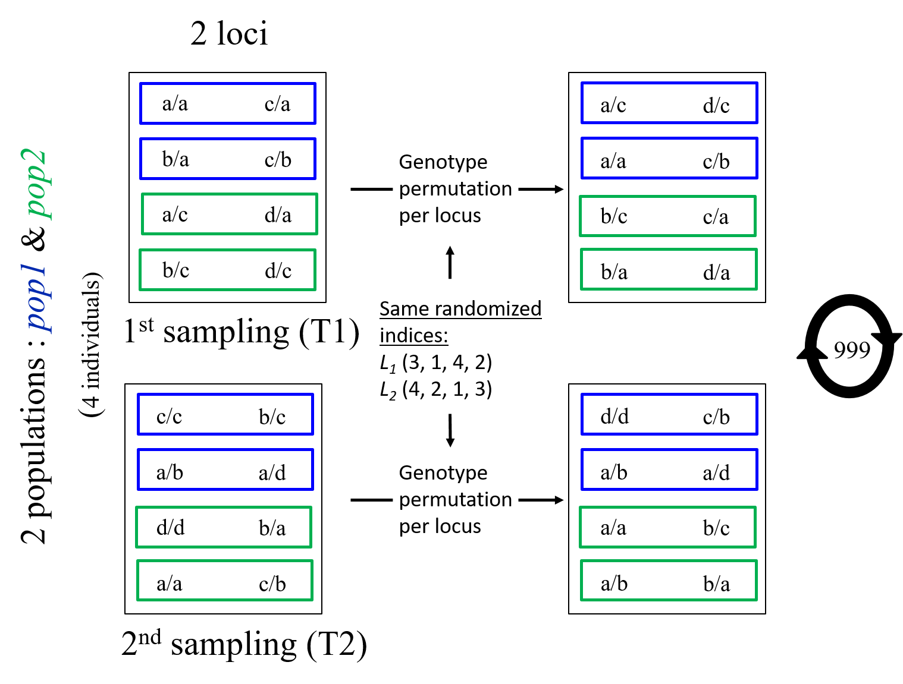

B)

**Figure 1.** Schematic representations of A) the computation of the original TGI values and B) the way we permutated input genotypic matrices to create a distribution to test TGI significance.

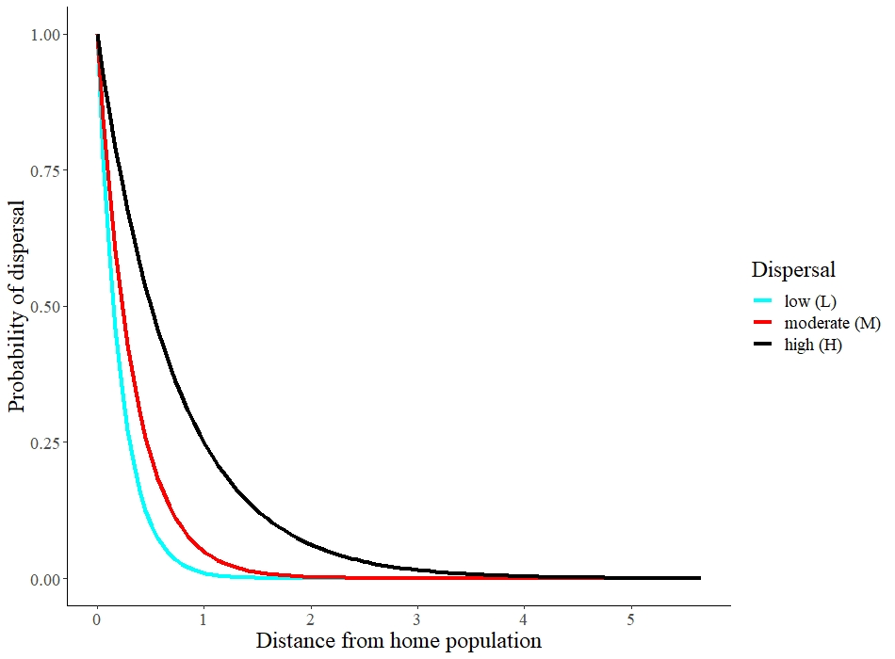

**Figure 2.** Probability of dispersal of an individual as a function of geographic distance, in three different dispersal scenarios.

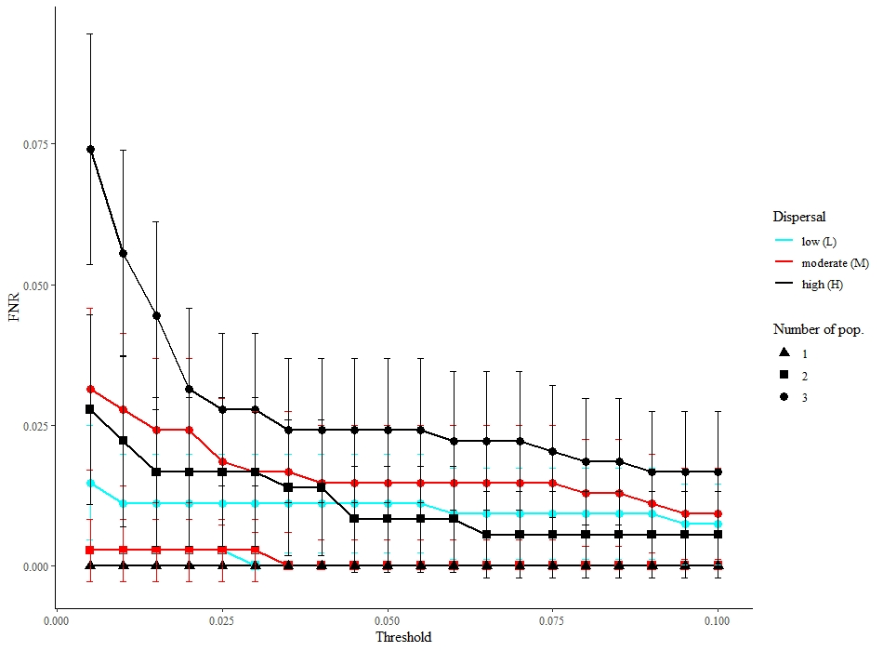

**Figure 3.** FNR across all threshold and scenarios. There are no control experiment results displayed for FNR because there are no possible true positives in control experiments, hence no false negatives either. Those values are for samplings done at generations 100 and 101, i.e. right before and after the migration event. 95% confidence intervals of the FNR estimates are displayed by bars. For better visualization, we included only thresholds with FNR values not equal to 1.

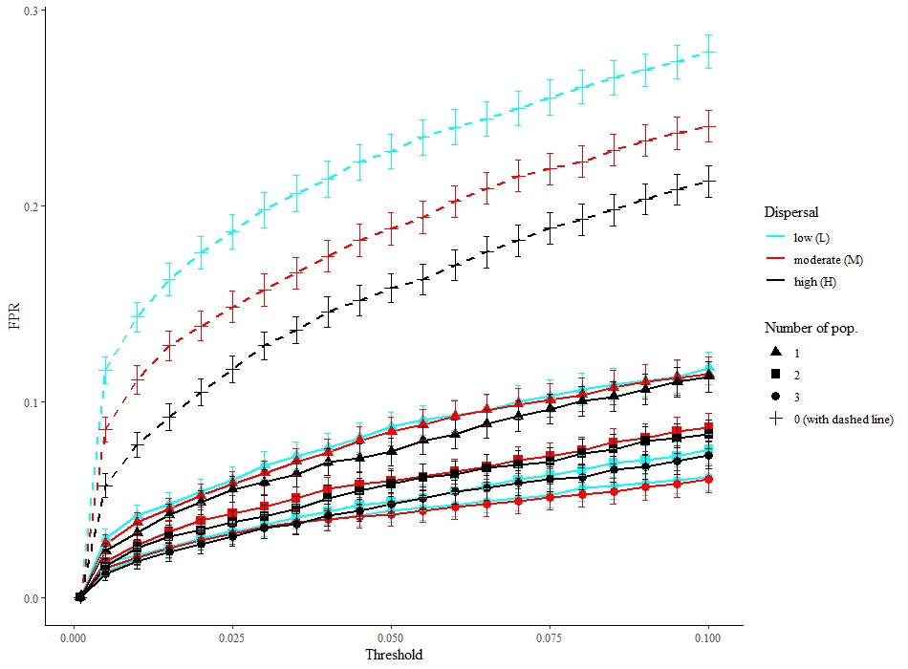

**Figure 4.** FPR across all threshold and scenarios. Control experiments are shown with dashed lines. Those values are for samplings done at the 100 and 101 generations 100 and 101, i.e. right before and after the migration event. 95% confidence intervals of the FPR estimates are displayed by bars.

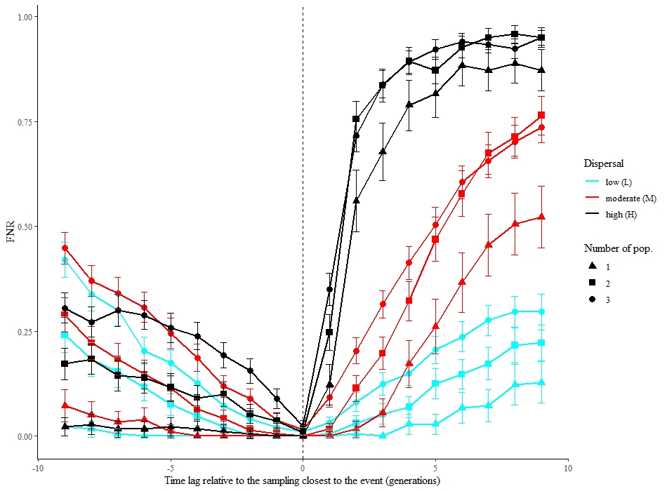

Influence of the timing of the posterior sampling

(0 represents sampling right after the event)

Influence of the timing of the prior sampling

(0 represents sampling right before the event)

**Figure 5**. FNR from TGI tests performed between samplings carried out up to 9 generations before or after the migration event (arrow) when compared with sampling done the generation after the event for prior samplings, or the generation before the event for posterior samplings. 95% confidence intervals are displayed by bars.

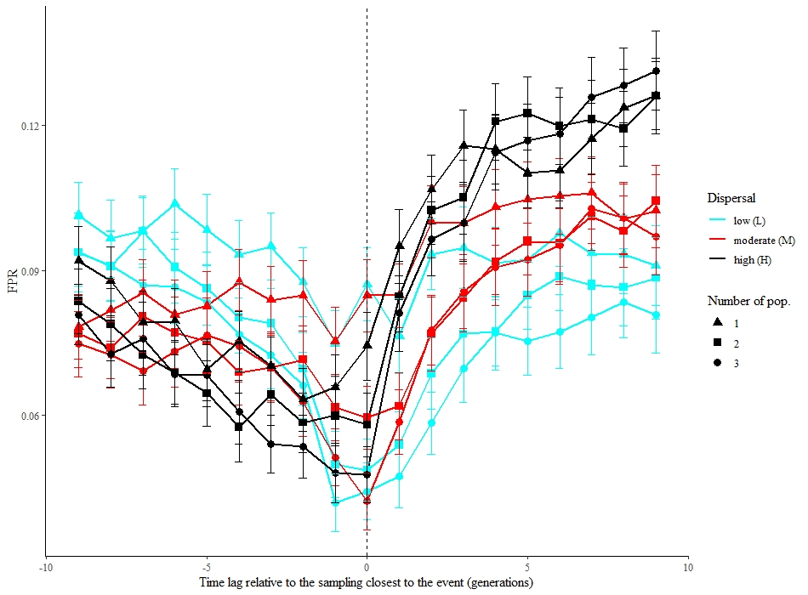

Influence of the timing of the posterior sampling

(0 represents sampling right after the event)

Influence of the timing of the prior sampling

(0 represents sampling right before the event)

**Figure 6**. FPR from TGI tests performed between sampling executed up to 9 generations before or after the event (arrow) when compared with sampling done the generation after the event for prior samplings, or the generation before the event for posterior samplings. 95% confidence intervals are displayed by bars.

**ANNEX A:** Roger’s genetic distance

Given loci and alleles:

**ANNEX B:** TGI function

**# mat1: the genotypic matrix associated with the first sampling; must be a genind object**

**# mat2: the genotypic matrix associated with the second sampling; must be a genind object**

**# nperm: the the number of permutations used in the evaluation of significance**

**# seed.: you may specify a seed by using this argument**

**# method: see ?adegenet::dist.genpop**

**# correc: correction for multiple inference; see ?p.adjust**

**# thresh_for_GL: indicate here the threshold you want to use**

**TGI <- function (mat1, mat2, nperm = 999, replace = FALSE, seed. = NULL,**

**method = 4, correc = "holm", thresh_for_GL = 0.05) {**

**#### Dependency on packages**

**library(adegenet)**

**library(poppr)**

**#### Conversion from genind to genpop objects**

**mat1p <- genind2genpop(mat1)**

**mat1p <- mat1p[,order(colnames(mat1p@tab))]**

**mat2p <- genind2genpop(mat2)**

**mat2p <- mat2p[,order(colnames(mat2p@tab))]**

**##### Function to compute genetic distances**

**dissim <- function(mat1p, mat2p, method) {**

**dis <- vector(mode = "numeric", length = nrow(mat1p@tab))**

**for (i in 1:nrow(mat1p@tab)){**

**if (i == 1){**

**trick <- 2**

**} else {**

**trick <- 1**

**}**

**temp_genpop <- mat1p**

**temp_genpop@tab[trick,] <- mat2p@tab[i,]**

**dis[i] <- dist.genpop(temp_genpop[c(trick, i),], method = method)**

**}**

**list(dis = dis)**

**}**

**##### Initialization of seed, tolerance**

**if (!is.null(seed.)){**

**set.seed(seed.)**

**}**

**epsilon <- sqrt(.Machine$double.eps)**

**##### Dimensions check**

**n <- nrow(mat1p@tab)**

**p <- ncol(mat1p@tab)**

**if ((nrow(mat2p@tab) != n) | (ncol(mat2p@tab) != p)){**

**stop("The matrices are not of the same size!")**

**}**

**##### Empirical genetic distances**

**tmp <- dissim(mat1p, mat2p, method)**

**dis.ref <- tmp$dis**

**##### Permutations**

**if (nperm > 0) {**

**my.vec <- sample(1:(10 * nperm), size = nperm)**

**outlier.count = rep(1, n)**

**for (iperm in 1:nperm) {**

**set.seed(my.vec[iperm])**

**mat1.perm <- mat1p**

**mat1.perm <- shufflepop(mat1.perm, method=4)**

**set.seed(my.vec[iperm])**

**mat2.perm <- mat2p**

**mat2.perm <- shufflepop(mat2.perm, method=4)**

**tmp <- dissim(mat1.perm, mat2.perm, method)**

**dis.perm <- tmp$dis**

**ge <- which(dis.perm + epsilon >= dis.ref)**

**if (length(ge) > 0) {**

**outlier.count[ge] <- outlier.count[ge] + 1**

**}**

**}**

**p.dist <- outlier.count/(nperm + 1)**

**}**

**p.adj <- p.adjust(p.dist, method = correc)**

**##### Simple gain or loss?**

**n.pop1 <- seppop(mat1)**

**n.pop2 <- seppop(mat2)**

**mean.hexp1 <- do.call("c", lapply(n.pop1, function(x) mean(summary(x)$Hexp)))**

**mean.hexp2 <- do.call("c", lapply(n.pop2, function(x) mean(summary(x)$Hexp)))**

**mean.hexp1[is.nan(mean.hexp1)] <- NA**

**mean.hexp2[is.nan(mean.hexp2)] <- NA**

**simple_diff <- mean.hexp2 - mean.hexp1**

**# Please only take note of the sign of this difference, not the absolute value**

**output <- list(TBI = dis.ref, p.TBI = p.dist, p.adj = p.adj, gainloss = simple_diff[p.adj < thresh_for_GL])**

**class(output) <- "TGI"**

**return(output)**

**}**