**Detecting temporal changes in genetic diversity: a new tool for molecular ecology studies with repeated surveys**

Julian Wittische1, Pierre Legendre1, Patrick M. A. James1,2

1 Département de Sciences Biologiques, Campus MIL, Université de Montréal, C.P. 6128, succ. Centre-ville, Montréal, QC, Canada, H3C 3J7

2 Institute of Forestry and Conservation, University of Toronto, 33 Willcocks St., Toronto, ON, Canada, M5S 2J5

Correspondence: Julian Wittische; E-mail: [jwittische@gmail.com](mailto:jwittische@gmail.com)

Running title: Testing spatiotemporal genetic change

In preparation for (in order of preference): 1) Molecular Ecology Resources, 2) Ecography, 3) Ecological Modelling, 3) Environmental Modelling & Software, 4) Ecology and Evolution, 5) Ecological Informatics.

**ABSTRACT**

Understanding spatiotemporal changes in biodiversity, including genetic diversity, is essential to track the effects of global change and to inform effective conservation plans. Although temporal questions are common in community ecology, they are less often investigated in population genetics. Indeed, detecting changes in local genetic diversity beyond what one would expect from common processes involved at multiple scales, such as drift, is challenging. Our capacity to detect such changes is also very information-dependent. Existing methods to detect meaningful genetic changes through time typically require large genetic datasets containing information beyond simple allele counts. However, when such extensive information is not available, methods are still needed to detect and understand temporal changes in genetic diversity induced by demographic events. In this paper, we describe Temporal Genetic Indices (TGI), a new method to identify significant changes in genetic diversity through time. This method uses permutations of genotypic matrices to test the significance of genetic temporal change at sites, given genetic change at other sampling sites in the study landscape. TGI overcomes existing challenges to detecting temporal genetic changes in genetic datasets with minimal genetic information. We demonstrate the utility of TGI for identifying the genetic legacies of important historical demographic events using demo-genetic simulations. We further demonstrate the ability of our TGI approach to identify such legacies under different levels of dispersal, spatial extent of the demographic events, and the timing of sampling relative to the events. Finally, we successfully apply TGI to an empirical dataset, with our application providing a straightforward test for genetic change, and supporting previous conclusions about the data. An R function to implement the method is now available, as well as utility functions for those wishing to further simulate and analyze their simulations.

# INTRODUCTION

Global biodiversity at the gene, species, population, and ecosystem scales is being altered at an increasing rate, with significant consequences for ecosystem functioning and the long-term viability of the biosphere (Bellard, Bertelsmeier, Leadley, Thuiller, & Courchamp, 2012; Dirzo et al., 2014; Leigh, Hendry, Vázquez‐Domínguez, & Friesen, 2019). Given this global change-driven mass extinction and the inherent temporal variation of biological systems, conservation biologists are increasingly recognizing that it is no longer sufficient to study spatial patterns in biodiversity at a single point in time. Instead, trends in biodiversity must be observed across both space and time (Allendorf, Hohenlohe, & Luikart, 2010; Bradburd & Ralph, 2019; Fenderson, Kovach, & Llamas, 2019). Important events in populations’ history can be detected using genetic data, and novel monitoring techniques are needed to track these events across both space and time.

Spatiotemporal variation in genetic diversity can provide important insights into the connectivity and demographic history of different populations (Draheim, Moore, Fortin, & Scribner, 2018; Moraes et al., 2017). Indeed, population genetics has proven essential for translating observed genetic variation into meaningful inferences that can inform conservation efforts (Allendorf et al., 2010; Harrisson, Pavlova, Telonis-Scott, & Sunnucks, 2014; Segelbacher et al., 2010), and the causes and consequences of temporal variation in genetic diversity are at the crux of many conservation and public health issues (Díez-del-Molino, Sánchez-Barreiro, Barnes, Gilbert, & Dalén, 2018; Lauterjung et al., 2019; Moraes et al., 2017). Researchers commonly explore patterns in spatiotemporal population genetic data (Banks et al., 2013) to quantify isolation-by-distance (Rousset, 1997; Wright, 1943), time since population bottlenecks (Gattepaille, Jakobsson, & Blum, 2013; Maruyama & Fuerstt, 1985), rates of migration between isolated populations (Bezemer, Krauss, Roberts, & Hopper, 2019; Buschbom, Yanbaev, & Degen, 2011), and the timing and extent of outbreak expansions (Larroque et al., 2019; Wittische, Janes, & James, 2019).

However, new approaches are needed to detect atypical temporal variation in genetic diversity. Detecting such unusual temporal changes represents a first step in elucidating the processes that govern demographically dynamic systems such as those found during population outbreaks (Fisher & Garner, 2020; Maynard et al., 2017) , major weather events (Poff et al., 2018), species invasions (Mack et al., 2000), or other disturbances such as a wildfire (Suárez et al., 2012). Temporal genetic analyses could similarly identify which populations, among a set of previously sampled populations, received migrants from long-distance dispersal events (Apodaca, Trexler, Jue, Schrader, & Travis, 2013). Because temporal genetic variation reflects the evolutionary potential of a population and the probability of its persistence (Aeschbacher, Selby, Willis, & Coop, 2016; Bolnick & Nosil, 2007; Kremer et al., 2012), relating temporal genetic variation to landscape change can provide important insights about the eco-evolutionary dynamics of a species and be used to inform conservation strategies (e.g., Landguth, Holden, Mahalovich, & Cushman, 2017).

There are currently two general approaches for investigating temporal genetic variation. The first suite of approaches uses statistical models to infer demographic history from genetic data obtained at a single time point (Excoffier, Dupanloup, Huerta-Sánchez, Sousa, & Foll, 2013; Gutenkunst, Hernandez, Williamson, & Bustamante, 2009; Kamm, Terhorst, Durbin, & Song, 2019). This approach is often computationally intensive, requires high-quality microsatellite or extensive SNP datasets. This approach is also tributary of extensive knowledge of the biological system, including information on recombination processes (Gattepaille et al., 2013) and ascertainment bias (Albrechtsen, Nielsen, & Nielsen, 2010; Clark, Hubisz, Bustamante, Williamson, & Nielsen, 2005; Marth, Czabarka, Murvai, & Sherry, 2004). The second suite of approaches compares genetic diversity between samples taken from the same sites over time using any genetic markers through either qualitative comparison or statistical models. These repeated-survey approaches are more readily usable in systems where less information is available, such as non-model species. Repeated-survey approaches can also be used in systems that were sampled historically, with a goal of comparing contemporary patterns with these older data (Moraes et al., 2017).

Despite our ability to compare genetic diversity at two points in time, several technical and conceptual challenges remain. One such challenge is determining how to meaningfully quantify and detect temporal changes. Some studies have used genetic differentiation metrics such as Jost’s D or FST or its analogs (Knight, Vaghefi, Hansen, Kikkert, & Pethybridge, 2018; Larroque et al., 2019; Segura-García et al., 2019) to evaluate temporal changes between genetic datasets. However, translating our spatial understanding of these genetic differentiation indices to the temporal dimension is not straightforward (Bhatia, Patterson, Sankararaman, & Price, 2013). An additional challenge for temporal genetic analyses is disentangling spatial from temporal effects, because the additivity of genetic drift means that genetic differentiation can be associated with both space and time (Murray et al., 2016; Skoglund, Sjödin, Skoglund, Lascoux, & Jakobsson, 2014). Finally, repeated-survey analyses remain challenging because we lack sufficiently developed tools to distinguish natural temporal variation in genetic structure due to recombination, mutation, and demographically-induced drift from the changes caused by external forces.

Although its objectives differ from those of population genetics, the field of community ecology has a history of explicitly examining change in community composition through time. Temporal beta-diversity indices (TBI; Legendre 2019) are used to quantify and assess temporal changes in ecological community composition using a dissimilarity index calculated between samples taken at different times and at several sites. The significance of these dissimilarities is then tested using a permutational procedure. The TBI approach has effectively demonstrated temporal variation in simulated community composition (Legendre, 2019), but the potential of a TBI-inspired tool to detect meaningful temporal changes in genetic diversity has not yet been examined. Given the conceptual similarity in data structure between species diversity in multi-species community composition data and genetic diversity in multi-locus genotype data, we sought to determine how TBI could be modified to identify significant variation in spatiotemporal genotypic data.

In this paper, we propose and evaluate a method for extending the TBI framework to spatiotemporal population genetic data. Our new framework, which we call temporal genetic diversity indices (TGI), is designed to identify significant temporal variation in spatial genetic diversity using relatively information-poor genetic data while accounting for confounding forces such as drift. We demonstrate the effectiveness and applicability of the TGI approach using simulated genetic data, where each simulation combined multiple scenarios in which portions of a landscape were affected by a non-selective demographic change. We additionally determined how the ability of TGI to detect significant, atypical temporal variation in genetic diversity was affected by three different demographic contexts: population dispersal ability, the number of populations affected by a demographic event (i.e., spatial extent of the event), and the time between two surveys. With respect to these demographic contexts, we predicted that our ability to detect temporal genetic changes would decrease in populations with higher dispersal capacity because of the homogenizing effect of higher gene flow and decrease when the time between successive sampling events increased, regardless of when an event occurred between surveys. Finally, we illustrate how TGI provides a functional testing framework by applying it to a real genetic dataset representing a large landscape with many populations of a threatened vertebrate. A better understanding of the factors that influence temporal changes in genetic diversity through time and improved techniques to monitor these changes is essential to describe and understand global biodiversity losses in the context of the current sixth mass extinction.

# METHODS

## Adapting TBI for genetic data

Temporal beta-diversity indices (TBI) are calculated by computing dissimilarities in species composition between data surveyed at two different times for all sampling sites. TBI give local measures of the change in community composition at each site; significance of these indices is then tested through simultaneous permutations of the two site-by-species input matrices. To extend TBI to TGI, we substituted community dissimilarities with genetic distances calculated from site-level allele frequencies in order to compare two different temporal surveys (see Table 1A) for a simple example showing how we transformed two temporal surveys into a genetic distance, for a two-site landscape). The null hypothesis in this case is that genetic composition between the two time points does not differ more than would be expected due to background processes typical to the landscape.

Indeed, background genetic processes, such as drift, can also produce temporal differences in genetic structure, and so the challenge in designing TGI was to identify temporal changes that are significantly different from what would be expected under a scenario with drift and other common sources of variation. Because there are no reference criteria for the changes in genetic diversity that would constitute a significant temporal genetic change, we used a permutation-based approach to generate a distribution of genetic distances to which an observed genetic distance can be compared. This randomly generated distribution of genetic distances allows us to approximate a large number of landscapes where only typical random processes (e.g. drift) take place. For each of the two input genotypic matrices, which were computed from two temporally distinct surveys containing data about the same alleles, loci and sites, we permuted the genotypes at each locus; see Table 1B for a simple example showing how we conducted the permutations, for a two-population landscape. Permutations were performed using the *poppr* R package (see *Software*) to maintain allelic structure and heterozygosity (Agapow & Burt, 2001). We used 999 random permutations in all analyses.

## Genetic distance

Genetic distances between time points for a given location were calculated using Rogers’ genetic distance (Rogers, 1972), which is similar to the Euclidean genetic distance (see Annex A). Rogers’ distance makes no assumptions about base-pair substitutions or time since separation and is therefore appropriate to study short-term dynamics influenced by environmental forces. One advantage is that Rogers’distance is that it is easy to understand (see Annex A). It has most recently been used to investigate genetic diversity in a pond turtle (Pereira, Teixeira, & Velo-Antón, 2018) and a fungus (Bennett & Stone, 2019). We computed Rogers’ distance using the *dist.genpop* function from the *adegenet* R package (see *Software*). Other genetic distances, such as the ones offered by the package, can readily be used with our function.

## Simulation framework

To simulate the dynamics of population genetic changes through time and test the performance of TGI, we used the spatially-explicit gene flow simulator *CDMetaPOP* (Landguth, Bearlin, Day, & Dunham, 2017; see section *Software*). *CDMetaPOP* simulates dispersal and mating of individuals across a landscape and allows the user to define the initial genetic structure, spatial distribution of individuals, dispersal characteristics, and life history traits of the populations. The physical landscape we simulated was a homogeneous, interconnected 5 × 5 square grid, with each of the 25 cells representing a population. Each population had a maximum carrying capacity of 50 individuals; the populated landscape therefore contained a maximum of 1,250 (25 × 50) individuals. Distance between populations was set as the Euclidean geographic distance. The genotypic information of each individual consisted of 100 neutral, unlinked, bi-allelic single nucleotide polymorphism (SNP) loci. The nuclear mutation rate (per base pair per generation) was set at 10-8 (Allio, Donega, Galtier, & Nabholz, 2017).

Multiple demographic processes affect the spatial apportionment of genetic variation. For this study, we investigated the influence of a single demographic event: immigration from a previously isolated population. We simulated immigration from a population that was separate from our 5 × 5 grid (i.e., population #26), with the goal of applying the TGI approach to detect historical changes in population genetic data due to immigration. This independent source population shared the same attributes as other populations in our simulated landscape and was only allowed to disperse into the 5 × 5 simulation grid during simulated demographic events.

Using this model, we examined the influence of dispersal (movement among our 25 populations) and the spatial extent of demographic events (number of populations that received immigrants from population #26) on the persistence of spatial genetic legacies. We examined three levels of dispersal capacity (described below) and three different numbers of affected populations (1, 2, or 3) for a total of nine unique scenarios (Table 1). Each scenario was then simulated 180 times, for a total of 1,620 (9 × 180) unique replicates for this experiment, excluding the control simulations (Table 1). In the next sections, we detail how we modeled dispersal and spatial extent.

For each replicate, we initialized the simulation by randomly distributing alleles among individuals, therefore approaching the maximum (p=q=0.5 maximizes p*q) genetic diversity (Landguth, Bearlin, Day, & Dunham, 2016). Those parameters were chosen as a compromise between realistic allele distributions and computational limitations, and were appropriate for producing simulated genetic data that could reasonably recreate the complex evolutionary dynamics in real populations. Each simulation was run for 100 before the demographic event was imposed on up to three populations in the landscape. Ten additional generations were simulated after the event. Sampling was performed up to 9 generations before and after the event unless otherwise specified.

## Dispersal

To model dispersal, we weighted the geographic distances between populations using a power law function, , where *B* represents the difficulty of dispersal. High values of *B* correspond to low dispersal capacity. Within a simulation run, *B* was constant while we randomly picked distances at which individuals dispersed based on the power law function. To do that, we rescaled the values of all distances in the landscape, using the maximum and the minimum (0) distances possible in this virtual landscape, as described in the *CDMetaPOP* (Landguth, Bearlin, et al., 2017) user’s manual (p. 63). This produced values in the [0,1] range. Rescaled values were considered to represent probabilities that an individual disperses to a cell located at that distance (Fig. 1). We chose this way of modeling dispersal to allow for both within-population movement and landscape-wide dispersal.

The population to which an individual dispersed was selected randomly from the set of populations available at the distance which was randomly picked following the probability distribution described in the previous paragraph. Individuals always stayed within our simulated landscape, and any individual could disperse to any one of the 25 populations at each generation. To investigate the effect of different levels of dispersal, we ran separate simulations using three different values of *B*: low (*B* = 2), moderate (*B* = 1.301) and high (*B* = 0.6015) dispersal capacity (Fig. 1; Table 1).

## Spatial extent

We also wanted to evaluate how the spatial extent of the simulated immigration event affected the performance of our TGI method. To do this, we allowed individuals from population #26 to immigrate into one, two, or three populations that were randomly selected from the original 25. We varied the position of where the demographic event occurred in the landscape because deme topology may influence the outcomes of population genetic analyses (Robledo-Arnuncio & Rousset, 2010). For scenarios in which only one population was affected, we partitioned the 180 simulations equally among six populations in the landscape. Because our landscape is square and homogeneously resistant to movement, it is symmetric and there are only six unique positions. Systematically choosing those six positions as a pool of potential targets for our demographic event therefore covered all possible spatial patterns in our simulations. One or more populations among these six populations were randomly selected once, and were identical across runs. When multiple (two or three) populations underwent a demographic event, we randomly chose one of these six geographically unique populations and randomly picked one or two additional populations directly adjacent to it. We chose to pick adjacent populations to respect the spatial autocorrelation often exhibited in demographic events. For each of the two- and three-population simulations, we repeated this population selection procedure six times and ran 30 replicate simulations for each set of populations.

## Statistical performance

We assessed the statistical performance of our TGI testing procedure using the false positive rate (FPR) and false negative rate (FNR). In our study, a false positive was a population that we knew did not undergo the demographic change we imposed but was found to have done so using the TGI test, whereas a false negative was a population that experienced the demographic event but exhibited no significant change in the TGI test. The FPR is expressed as the ratio of false positives to the total number of negative tests (i.e., true negatives and false positives), and the FNR is expressed as the ratio of false negatives to the total number of positive tests (i.e., true positives and false negatives).

A high FPR would indicate that our TGI measure often selected the wrong population(s) as having changed substantially and that our testing procedure was less selective. Researchers generally want to minimize the FPR when there are, for example, limited resources available for conservation efforts. In contrast, a high FNR would mean that we often failed to identify the population(s) that were actually affected and that our testing procedure had low discriminatory power. Researchers may want to minimize the FNR in situations where finding all affected populations is the most important aspect, for example, if there is limited time to take conservation action. Selecting a proper significance threshold for the p-value calculated from the TGI test permutations, and therefore defining which changes in genetic diversity are significant or not, is important for balancing selectivity (1 – FPR) and power (1 – FNR). To characterize this compromise, we evaluated the statistical performance of TGI using a range of significance thresholds for calculating FPR and FNR: 0.0001, 0.001, 0.005, 0.01, 0.015, 0.020, 0.025, 0.030, 0.035, 0.040, 0.045, 0.050, 0.055, 0.060, 0.065, 0.070, 0.075, 0.080, 0.085, 0.090, 0.095, and 0.1. We did not conduct corrections for multiple tests (e.g. Bonferroni) because in our simulation experiment, that would simply translate to choosing another range of thresholds. However, choosing to correct for multiple tests is possible in our function.

## Time

To assess how the time since the simulated demographic event affected our ability to detect genetic changes in each of the nine dispersal/spatial extent scenarios, we calculated the TGI for simulated data collected up to nine generations before and after the event and compared it to the TGI calculated from data collected immediately before and after the event generation. We chose nine generations as the maximum time between samplings (nine generations before the event, or nine generations after the event) because this timeline is longer than most “before/after” population genetic studies in the literature and most long-term ecological research programs monitor at a shorter time interval. Comparisons between TGI results were based on the FPR and FNR calculated at a significance threshold of p ≤ 0.05, as this threshold was a good compromise between different performance metrics in our earlier results.

## Controls

We additionally ran control simulations in which populations were not affected by demographic events and were therefore only subject to the processes of gene flow, drift, and mutation. Dispersal was the only parameter that varied among the control simulations, resulting in three control scenarios (Table 1). We only evaluated the FPR of these control scenarios; because there were no true positives or false negatives for populations affected by the demographic event, the FNR was always equal to 0. The performance of experimental scenarios was always compared to the control scenario with the same dispersal capacity.

## Software

*CDMetaPOP* runs on *Python 2.7* (Landguth, Bearlin, et al., 2017). We used the *R* software (R Core Team, 2019) in the *RStudio* IDE (RStudio Team, 2018) for all analyses and illustrations. We used the *adegenet* (Jombart, 2008; Jombart & Ahmed, 2011), *pegas* (Paradis, 2010), *poppr* (Kamvar, Brooks, & Grünwald, 2015; Kamvar, Tabima, & Gr̈unwald, 2014) and *adespatial* (Dray et al., 2019) *R* packages for calculations. Our *TGI* function is available in the appendix as an *R* script. The function enables the user to choose among five different genetic distance metrics for the calculations of TGI indices via the “*method”* argument.

## Applied example: an endangered fish

To demonstrate that our TGI measure provides valuable information about temporal change in a real system with conservation implications, we applied it to real genetic data from a study of a threatened vertebrate, the Northern tidewater goby (Kinziger, Hellmair, McCraney, Jacobs, & Goldsmith, 2015). We chose this example because it uses a different type of genetic data than we used for our simulations, thus demonstrating that TGI is applicable to a variety of genetic markers. In addition, the study authors suggested that one goby population had undergone more genetic change than the other, more stable local populations, allowing us to test a real hypothesis and go beyond a simple illustration of our method (Kinziger et al., 2015). The dataset was downloaded from DRYAD (doi: 10.5061/dryad.871db), and we used 9,999 permutations for this analysis.

# RESULTS

We were able to translate the TBI framework to TGI by adapting it to the specific structure of genetic data. Although our results in the present section support the general efficacy of TGI and warrant its use on empirical datasets, the performance of the TGI approach was sensitive to dispersal capacity, spatial extent of the demographic event producing the genetic change, and the time difference between sampling and the demographic event. We will thus structure the presentation of our results along these lines.

Experimental FPR values were consistently lower than control FPR values, regardless of dispersal parameters (Fig. 2). This suggests that, following an atypical demographic event, using TGI, we were always more likely to correctly identify a population as having been affected. Among the control simulations, runs with higher dispersal capacity had a lower FPR (Fig. 2). Control FPR values were generally at least twice as high as the maximum experimental FPR values encountered (L1, M1), regardless of the significance threshold used. This means that, even for the lowest-performing scenarios in our simulations, TGI was much more effective at avoiding false positives in the presence of an event than in the absence of one.

## Dispersal

Dispersal capacity influenced our ability to detect temporal changes in genetic diversity, as the FNR generally increased with dispersal capacity (Fig. 3 ). However, only one scenario (H3; Table 1) exhibited FNR values above a very conservative limit of 1%, regardless of the p-value threshold used (Fig. 3 ). Of the four scenarios that did not achieve an average FNR of 0 (L3, M3, H2, and H3), two involved high dispersal. When we averaged the FNR values calculated at the traditional p ≤ 0.05 threshold across scenarios sharing the same dispersal parameters (e.g.averaging FNR value for L1, L2, and L3 grouped together), the mean FNRs were 0.0037 (0.0007 – 0.0066; 95% confidence interval [CI]) for low dispersal, 0.0049 (0.0015 – 0.0083; 95% CI) for moderate dispersal, and 0.0108 (0.0055 – 0.0161; 95% CI) for high dispersal.

In contrast, dispersal capacity did not substantially affect the FPR (Fig. 2). There were no consistent trends in FPR when comparing scenarios with different dispersal capacities but the same number of affected populations: L1 had slightly higher values than M1 and H1; L2 had slightly lower values than M2 and H2; and L3 had intermediate values between those of M3 and H3. Average FPR values for scenarios sharing the same dispersal parameters, calculated using FPRs at the p < 0.05 threshold as before, were 0.0599 (0.0558 – 0.0641; 95% CI) for low dispersal, 0.0621 (0.0580 – 0.0662; 95% CI) for moderate dispersal, and 0.0600 (0.0562 – 0.0638; 95% CI) for high dispersal (Fig. 2).

## Spatial extent

The number of populations affected by a demographic event also influenced our ability to detect meaningful temporal change. Scenarios in which fewer populations were affected exhibited a reduced FNR and an increased FPR (Figs. 3, 4). Scenarios in which a single population was affected (i.e., L1, M1, H1) had a perfect FNR (0; Fig. 2), while scenarios L2 and M2 only reached this perfect FNR at more liberal significance thresholds (i.e., above p ≤ 0.03; Fig. 3 ). The mean FNRs at p ≤ 0.05, averaged across scenarios sharing the same number of affected populations (e.g.one averaged value for L1, M1, and H1 grouped together), were zero for scenarios with one affected population, 0.0028 (0 – 0.0059; 95% CI) for scenarios with two affected populations, and 0.0167 (0.0105 – 0.0228; 95% CI) for scenarios with three affected populations.

The number of affected populations influenced the FPR more than dispersal for the dispersal capacities and spatial extents used in our simulations. FPR values were consistent across scenarios with different dispersal but the same number of affected populations rather than across scenarios with similar dispersal but different numbers of affected populations (Figs. 3, 4). The average FPRs from scenarios with the same number of affected populations, determined at the p ≤ 0.05 significance threshold, were 0.0820 (0.0778 – 0.0863; 95% CI) for scenarios with one affected population, 0.0553 (0.0516 – 0.0591; 95% CI) for scenarios with two affected populations, and 0.0447 (0.0413 – 0.0481; 95% CI) for scenarios with three affected populations.

## Time

We found that the genetic signal of the demographic event decayed over time, but that the TGI test was still able to identify significant changes in genetic diversity at a time scale of 1–10 generations. However, as the time interval between pre- and post-event sampling increased, the ability of TGI to detect the demographic event decreased, evidenced by the increase in false positives and false negatives for several demographic scenarios (Fig. 5, 6). The effect of time between sampling periods on the sensitivity of TGI was strongly affected by dispersal capacity and the extent of the event.

The timing of sampling prior to a simulated event was, as expected, generally less important than the timing of the post-event sampling. The decrease in genetic signal over time — which would be found with any comparative method, not just TGI — was considerably strong in our simulations. For example, if the second (post-event) survey was taken nine generations after the first (pre-event) survey, we observed high FNR values that approached 75–90% in high- and moderate-dispersal scenarios (Fig. 5). The FNR also increased with the time lag in low-dispersal scenarios, but the increase was more linear and values never reached 30%, even after nine generations (Fig. 5). One interesting result was that the number of affected populations was the main factor driving increasing FNR values when the pre-event survey was older (3>2>1; left side of Fig. 5), while dispersal capacity was the main factor driving increasing FNR values when the post-event survey was older (H>M>L; right side of Fig. 5). For scenarios with the same number of affected populations, moderate-dispersal scenarios showed the worst performance with pre-event sampling time lags, whereas high-dispersal scenarios generally showed the worst performance with post-event sampling time lags (Fig .5). Over our nine-generation sampling window, the FNR changed the least for the L1 scenario and the most for the H3 scenario (Fig. 5).

While the relative differences in FPR performance given different time lags were not as high as for FNR, FPR nonetheless increased with the sampling time lag. There were no clear patterns for whether dispersal or the number of affected populations most influenced the change in FPR associated with pre-event sampling time (Fig. 6); however, dispersal was the main factor driving FPR for time gaps associated with post-event sampling (Fig. 6). The strong relationship that we observed between FPR and the number of populations affected by the demographic event therefore became less pronounced as dispersal became more influential. As with the FNR, the FPR did not change much for the L1 scenario and changed the most dramatically for the H3 scenario (Fig. 6), indicating differences in how time affects our two most extreme scenarios that could be a useful consideration for potential TGI users.

The simulation that was most likely to preserve the signal of the demographic event was the low-dispersal scenario with a single affected population (L1). In this scenario, the TGI approach was still able to keep false negatives below 15% and false positives below 10%, even when the second sampling was done nine generations after the event (Fig. 5, 6) and regardless of whether the first or second sampling was responsible for the time lag.

## Thresholds

A trade-off based on significance threshold values between FNR and FPR was present across scenarios. FNR values decreased with the chosen significance threshold, with a sharp decrease (most notable for H3) before 0.025 followed by a slower decrease until 0.1. FPR values increased with the chosen significance threshold, with a sharp increase at low thresholds followed by a continued but saturating increase until p ≤ 0.10.

## Applied example

The Northern tidewater goby (*Eucyclogobius newberryi*) is a small endangered fish that lives in brackish estuaries and lagoons along the coast of California. This species represents an interesting model for population genetic studies because dispersal between suitable habitat patches only occurs during rare, discrete events. A previous study investigated extinction–colonization dynamics in the tidewater goby by evaluating genetic diversity across the landscape at several points in time (Kinziger et al., 2015). These authors suggested that the Elk River goby population had experienced unexpected temporal genetic change between 2006 and 2011 (Kinziger et al., 2015). We used the TGI method to re-analyze these data and determine if significant temporal genetic changes had indeed occurred in any population in this landscape.

Using our TGI measure, we found that the genetic structure of the Elk River population (Supp. Fig. 1) of Northern tidewater goby (Kinziger et al., 2015) had indeed changed significantly relative to the other populations surveyed in the study area (permutation p-value = 0.0004), even after using strict p-value adjustments (Holm-Bonferroni adjusted permutation p-value = 0.0032). The average expected heterozygosity decreased by 0.046 in the Elk River population from an original value of 0.2646, which represents a loss of around 17%. Our results thus confirmed the purely descriptive results of the previous study, that there was a loss of genetic diversity in the Elk River population, as shown here through a robust statistical framework.

# DISCUSSION

In this study, we specifically investigated how dispersal, the spatial extent of a demographic event, and the timing of sampling affected our ability to identify populations that have experienced significant changes in genetic diversity. We chose those factors because they are relevant in many conservation studies. Indeed, dispersal is a key element in understanding population connectivity (Kool, Moilanen, & Treml, 2013; McRae, 2006) and can be approximated through increasingly accurate and diverse ways (Cayuela et al., 2018). As for the spatial extent of the demographic event, recent studies have advocated and paved the way for a more comprehensive integration of space in evolutionary ecology research (Battey, Ralph, & Kern, 2020; Bradburd & Ralph, 2019; Velázquez, Martínez, Getzin, Moloney, & Wiegand, 2016).

## TGI: a new and useful framework

TGI fills a gap: it provides a framework for comparing temporally-repeated surveys and testing whether an observed change in genetic diversity is significant relative to the ubiquitous and landscape-wide changes associated with genetic drift. Our successful application of TBI to genetic data involved translating a site-by-species approach to a site-by-genotype approach and changing the permutation algorithm to accommodate the specific structure of various genetic data formats such as SNPs in our simulations and microsatellites in our application. In addition to describing our new framework, we also evaluated its power and specificity and found that TGI is functional over a wide range of parameter values. One main contrast between our new TGI approach and previous investigations of the performance of TBI, which was developed for community composition data, is that we also examined how the timing of surveys may affect the downstream conclusions.

Our results indicate that TGI consistently and accurately identifies populations that have experienced a demographic event.

## Dispersal and spatial extent

Detection of temporal genetic changes was sensitive to dispersal; false negatives increased with dispersal capacity, although false positives did not show a clear trend (Figs. 3, 4). The influence of dispersal on the FNR was also affected by the time lag between an event and the subsequent sampling effort; the effects of different dispersal capacities were evident even when surveys were separated by only one generation (i.e., samples were collected immediately before and after the event) and were magnified as the time between surveys increased. The effects of sampling time and dispersal capacity on the FNR suggest that species with high dispersal capacity in well-connected landscapes might require more frequent sampling to overcome the negative effect of gene flow on our ability to correctly identify affected populations.

The spatial extent of a demographic event increased our ability to correctly identify populations that have not truly changed (lower FPR), but it also decreased our ability to correctly identify populations that did change (higher FNR). The magnitude of this trade-off varied with dispersal capacity. Although a broader spatial extent may help researchers detect an event, as the chance of sampling an affected population increases, it may also increase the risk of not identifying the genetic legacy of the event at all, especially in high-dispersal landscapes. It is less effective for analyzing gradual, landscape-wide disturbances. In addition, when multiple populations were affected in our simulations, we always chose to affect adjacent populations; we did not investigate whether lowering the degree of spatial autocorrelation in the spatial genetic legacy (e.g., two independent catastrophic events, a pollution and a flood for example, affecting the landscape) influenced our ability to detect the event.

## Time between sampling efforts

As expected, spatial genetic legacies decayed over time due to gene flow and drift. Specifically, in this study we found that TGI was suitable for identifying changes over 1-9 generations (e.g. years) depending on landscape and demographic parameters. Two main points emerged from our analysis of how the timing of sampling affected the detection of significant genetic changes. First, when comparing an old survey to a survey realized soon after a demographic event, the spatial extent of the disturbance affected the power of TGI, with smaller spatial extents preserving high power even with large time gaps. Second, when comparing a survey realized immediately before a disturbance to one collected several years after, dispersal was the most important factor driving the performance of TGI, with low-dispersal scenarios better preserving the performance of TGI in the context of genetic drift through time. Researchers in high-dispersal systems could find as many as 10% of false positives even when sampling only a few years after an event. This result has serious implications: arbitrary and potentially inappropriate significance thresholds may result in misallocation of resources to monitoring or treating unaffected populations while missing some affected populations. In contrast, by considering the population dynamics and, if possible, planning relatively simple and short model-specific simulations, one can enhance the usefulness of TGI and proceed with a more appropriate sampling/monitoring strategy. Given the fact that FNR reach high values at the highest time gaps for some scenarios (Fig. 5), we believe that our choice of a maximum of 9 generations (e.g. years) between surveys was appropriate.

## Empirical application of the method

We successfully applied TGI to an empirical dataset from an endangered vertebrate, the Northern tidewater goby, for which temporal genetic change had been described but not tested (Kinziger et al., 2015). The authors of the original publication hypothesized that one goby population had undergone atypical genetic change relative to the rest of the landscape; our application of TGI supported this hypothesis. We therefore clearly showed that the straightforward TGI testing procedure can be used to strengthen the results from temporal genetic studies that use repeated surveys.

## Considerations about the use of TGI

Different empirical datasets and research objectives may require TGI users to customize our procedure, but the TGI function is transparent and flexible, and different permutation and genetic distance algorithms could easily be used by simply changing a few lines of R code in the annotated TGI function provided in the supplementary material. Evaluating the performance of distance metrics with different statistical properties (Legendre & De Cáceres, 2013) could be an avenue for future work. TGI can also readily be used on other types of genetic data, such as microsatellites. TGI provides a robust statistical framework more trustworthy than arbitrary comparison of pairwise genetic differences, or node-based genetic diversity values.

Despite these advantages, there are still several important considerations for the effective use of TGI tests. The implementation of TGI in new systems will ultimately be more successful if researchers have an *a priori* understanding of the population dynamics of their system and the nature and scale of possible disturbances in their study area. Indeed, this prior knowledge could guide researchers in the choice of survey intervals after important historical demographic events. These values ultimately represent trade-offs in potential conservation costs, and it is therefore essential that researchers grasp their importance and choose these values deliberately. Stricter (lower) values for the TGI p-value threshold expectedly result in a lower FPR but may also result in a higher FNR (lower power). Identifying the most sensible threshold for a chosen objective would be valuable to better understand the trade-offs of different sampling schemes in specific empirical systems. Purpose-designed spatially-explicit simulations can be used to address this challenge. Insome cases, it may be desirable to minimize false negatives relative to false positives – thus ensuring that we detect all the affected populations no matter the cost of detecting, and therefore monitoring and preserving, some populations that do not need preservation.

TGI was not developed as an alternative for inferring demographic history from large genetic datasets collected at a single time. Instead, it was designed to help research teams collecting repeated surveys from non-model organisms with limited genotypic information, and especially teams wanting to compare new surveys to older ones. Nonetheless, more studies in different types of genetic systems, involving different historical demographic events, are needed to explore how the performance of TGI varies with factors that were not tested in our simulations, including 1) the chosen genetic distance algorithm; 2) spatial-temporal autocorrelation in genetic legacies; 3) effective population size; and 4) spatial heterogeneity in landscape resistance to movement.

## Conclusions

At the crux of many conservation biology questions, identifying changes in genetic diversity, beyond the expected changes due to background micro-evolutionary processes, can help geneticists identify locations or populations that have experienced important past demographic events. These events could be detrimental (e.g., loss of diversity or maladaptation) or beneficial (e.g.,higher effective population size or genetic rescue), and are often relevant for monitoring and conservation efforts. Such locations and populations could then be prioritized for increased monitoring and further investigation into the origin of these changes. As shown in our application of TGI to empirical data from the endangered Northern tidewater goby, our method provides a framework for detecting and pinpointing exceptional temporal genetic changes. Our approach to detect temporal genetic differentiation does not require extensive genomic information and can therefore be used to explore the temporal dynamics of genetic diversity changes using relatively small genetic datasets (e.g., hundreds of SNPs). We believe that the TGI approach is a promising tool for the spatiotemporal analysis of wild, non-model organisms for which extensive genomic resources are yet to be developed.

**ACKNOWLEDGEMENTS**

This research was supported by a grant to PMAJ and the TRIA Network from the Natural Sciences and Engineering Research Council of Canada (grant no. NET GP 434810-12), with contributions from Alberta Agriculture and Forestry, fRI Research, Manitoba Conservation and Water Stewardship, Canadian Forest Service (Natural Resources Canada), Northwest Territories Environment and Natural Resources, Ontario Ministry of Natural Resources and Forestry, Saskatchewan Ministry of Environment, West Fraser, and Weyerhaeuser. This research was also supported by a Discovery Grant to PMAJ. JW was also supported by a scholarship from the Forest Complexity Modelling (FCM) NSERC CREATE. Computations were made on the supercomputer CEDAR managed by Compute Canada ([www.computecanada.ca](http://www.computecanada.ca)). We thank Jeremy Larroque, Hinatea Ariey and Charlotte Van Engeland for their comments on an earlier version of the manuscript.

**DATA ACCESSIBILITY**

All simulation data used for this paper will be deposited online upon acceptance. Functions used to analyze the simulations will be available on a public repository on *GitHub*.TGI, the function that would be most useful to potential users of our approach, will continue to be maintained and developed and may be contributed to a CRAN package in the near future.

**AUTHOR CONTRIBUTIONS**

J.W. designed the study, created the simulation inputs, ran the simulations, transformed the TBI function to TGI, and performed the analyses. P.L. and P.M.A.J. provided advice on the study design, analysis, and the visualization. J.W., P.L. and P.M.A.J. wrote the paper.

**REFERENCES**

Aeschbacher, S., Selby, J. P., Willis, J. H., & Coop, G. M. (2016). *Population-genomic inference of the strength and timing of selection against gene flow*. (18), 1–6. doi: 10.1101/072736

Agapow, P. M., & Burt, A. (2001). Indices of multilocus linkage disequilibrium. *Molecular Ecology Notes*, *1*(1–2), 101–102. doi: 10.1046/j.1471-8278.2000.00014.x

Albrechtsen, A., Nielsen, F. C., & Nielsen, R. (2010). Ascertainment biases in SNP chips affect measures of population divergence. *Molecular Biology and Evolution*, *27*(11), 2534–2547. doi: 10.1093/molbev/msq148

Allendorf, F. W., Hohenlohe, P. A., & Luikart, G. (2010). Genomics and the future of conservation genetics. *Nature Reviews. Genetics*, *11*(10), 697–709. doi: 10.1038/nrg2844

Allio, R., Donega, S., Galtier, N., & Nabholz, B. (2017). Large variation in the ratio of mitochondrial to nuclear mutation rate across animals: Implications for genetic diversity and the use of mitochondrial DNA as a molecular marker. *Molecular Biology and Evolution*, *34*(11), 2762–2772. doi: 10.1093/molbev/msx197

Apodaca, J. J., Trexler, J. C., Jue, N. K., Schrader, M., & Travis, J. (2013). Large-scale natural disturbance alters genetic population structure of the sailfin molly, poecilia latipinna. *American Naturalist*, *181*(2), 254–263. doi: 10.1086/668831

Banks, S. C., Cary, G. J., Smith, A. L., Davies, I. D., Driscoll, D. A., Gill, A. M., … Peakall, R. (2013). How does ecological disturbance influence genetic diversity ? *Trends in Ecology & Evolution*, *28*(11), 670–679. doi: 10.1016/j.tree.2013.08.005

Battey, C. J., Ralph, P. L., & Kern, A. D. (2020). Space is the place: Effects of continuous spatial structure on analysis of population genetic data. *Genetics*, *215*(1), 193–214. doi: 10.1534/genetics.120.303143

Bellard, C., Bertelsmeier, C., Leadley, P., Thuiller, W., & Courchamp, F. (2012). Impacts of climate change on the future of biodiversity. *Ecology Letters*, *15*(4), 365–377. doi: 10.1111/j.1461-0248.2011.01736.x

Bennett, P. I., & Stone, J. K. (2019). Environmental variables associated with Nothophaeocryptopus gaeumannii population structure and Swiss needle cast severity in Western Oregon and Washington. *Ecology and Evolution*, *9*(19), 11379–11394. doi: 10.1002/ece3.5639

Bezemer, N., Krauss, S. L., Roberts, D. G., & Hopper, S. D. (2019). Conservation of old individual trees and small populations is integral to maintain species’ genetic diversity of a historically fragmented woody perennial. *Molecular Ecology*, (January), 3339–3357. doi: 10.1111/mec.15164

Bhatia, G., Patterson, N., Sankararaman, S., & Price, A. L. (2013). Estimating and interpreting F. *Genome Research*, (2), 1–9. doi: 10.1101/gr.154831.113.23

Bolnick, D. I., & Nosil, P. (2007). Natural selection in populations subject to a migration load. *Evolution*, *61*(9), 2229–2243. doi: 10.1111/j.1558-5646.2007.00179.x

Bradburd, G. S., & Ralph, P. L. (2019). Spatial Population Genetics: It’s About Time. *Annual Review of Ecology, Evolution, and Systematics*, *50*(1), 427–449. doi: 10.1146/annurev-ecolsys-110316-022659

Buschbom, J., Yanbaev, Y., & Degen, B. (2011). Efficient long-distance gene flow into an isolated relict oak stand. *Journal of Heredity*, *102*(4), 464–472. doi: 10.1093/jhered/esr023

Cayuela, H., Rougemont, Q., Prunier, J. G., Moore, J. S., Clobert, J., Besnard, A., & Bernatchez, L. (2018). Demographic and genetic approaches to study dispersal in wild animal populations: A methodological review. *Molecular Ecology*, *27*(20), 3976–4010. doi: 10.1111/mec.14848

Clark, A. G., Hubisz, M. J., Bustamante, C. D., Williamson, S. H., & Nielsen, R. (2005). Ascertainment bias in studies of human genome-wide polymorphism. *Genome Research*, *15*(11), 1496–1502. doi: 10.1101/gr.4107905

Díez-del-Molino, D., Sánchez-Barreiro, F., Barnes, I., Gilbert, M. T. P., & Dalén, L. (2018). Quantifying Temporal Genomic Erosion in Endangered Species. *Trends in Ecology and Evolution*, *33*(3), 176–185. doi: 10.1016/j.tree.2017.12.002

Dirzo, R., Young, H. S., Galetti, M., Ceballos, G., Isaac, N. J. B., & Collen, B. (2014). Defaunation in the Anthropocene. *Science*, *401*(6195), 401–406. doi: 10.1126/science.1251817

Draheim, H. M., Moore, J. A., Fortin, M.-J., & Scribner, K. T. (2018). Beyond the snapshot: Landscape genetic analysis of time series data reveal responses of American black bears to landscape change. *Evolutionary Applications*, *11*(8), 1219–1230. doi: 10.1111/eva.12617

Dray, S., Bauman, D., Blanchet, F. G., Borcard, D., Clappe, S., Guenard, G., … Wagner, H. H. (2019). *adespatial: multivariate multiscale spatial analysis.* Retrieved from https://cran.r-project.org/package=adespatial

Excoffier, L., Dupanloup, I., Huerta-Sánchez, E., Sousa, V. C., & Foll, M. (2013). Robust Demographic Inference from Genomic and SNP Data. *PLoS Genetics*, *9*(10). doi: 10.1371/journal.pgen.1003905

Fenderson, L. E., Kovach, A. I., & Llamas, B. (2019). Spatiotemporal landscape genetics: Investigating ecology and evolution through space and time. *Molecular Ecology*, *29*(2), 218–246. doi: 10.1111/mec.15315

Fisher, M. C., & Garner, T. W. J. (2020). Chytrid fungi and global amphibian declines. *Nature Reviews Microbiology*, *18*(6), 332–343. doi: 10.1038/s41579-020-0335-x

Gattepaille, L. M., Jakobsson, M., & Blum, M. G. B. (2013). Inferring population size changes with sequence and SNP data: Lessons from human bottlenecks. *Heredity*, *110*(5), 409–419. doi: 10.1038/hdy.2012.120

Gutenkunst, R. N., Hernandez, R. D., Williamson, S. H., & Bustamante, C. D. (2009). Inferring the joint demographic history of multiple populations from multidimensional SNP frequency data. *PLoS Genetics*, *5*(10). doi: 10.1371/journal.pgen.1000695

Harrisson, K. A., Pavlova, A., Telonis-Scott, M., & Sunnucks, P. (2014). Using genomics to characterize evolutionary potential for conservation of wild populations. *Evolutionary Applications*, *7*(9), 1008–1025. doi: 10.1111/eva.12149

Jombart, T. (2008). Adegenet: A R package for the multivariate analysis of genetic markers. *Bioinformatics*, *24*(11), 1403–1405. doi: 10.1093/bioinformatics/btn129

Jombart, T., & Ahmed, I. (2011). adegenet 1.3-1: New tools for the analysis of genome-wide SNP data. *Bioinformatics*, *27*(21), 3070–3071. doi: 10.1093/bioinformatics/btr521

Kamm, J., Terhorst, J., Durbin, R., & Song, Y. S. (2019). Efficiently Inferring the Demographic History of Many Populations With Allele Count Data. *Journal of the American Statistical Association*, *0*(0), 1–16. doi: 10.1080/01621459.2019.1635482

Kamvar, Z. N., Brooks, J. C., & Grünwald, N. J. (2015). Novel R tools for analysis of genome-wide population genetic data with emphasis on clonality. *Frontiers in Genetics*, *6*(JUN), 1–10. doi: 10.3389/fgene.2015.00208

Kamvar, Z. N., Tabima, J. F., & Gr̈unwald, N. J. (2014). Poppr: An R package for genetic analysis of populations with clonal, partially clonal, and/or sexual reproduction. *PeerJ*, *2014*(1), 1–14. doi: 10.7717/peerj.281

Kinziger, A. P., Hellmair, M., McCraney, W. T., Jacobs, D. K., & Goldsmith, G. (2015). Temporal genetic analysis of the endangered tidewater goby: Extinction-colonization dynamics or drift in isolation? *Molecular Ecology*, *24*(22), 5544–5560. doi: 10.1111/mec.13424

Knight, N. L., Vaghefi, N., Hansen, Z. R., Kikkert, J. R., & Pethybridge, S. J. (2018). Temporal Genetic Differentiation of Cercospora beticola Populations in New York Table Beet Fields. *Plant Disease*, *102*(11), 2074–2082. doi: 10.1094/PDIS-01-18-0175-RE

Kool, J. T., Moilanen, A., & Treml, E. A. (2013). Population connectivity: Recent advances and new perspectives. *Landscape Ecology*, *28*(2), 165–185. doi: 10.1007/s10980-012-9819-z

Kremer, A., Ronce, O., Robledo-Arnuncio, J. J., Guillaume, F., Bohrer, G., Nathan, R., … Schueler, S. (2012). Long-distance gene flow and adaptation of forest trees to rapid climate change. *Ecology Letters*, *15*(4), 378–392. doi: 10.1111/j.1461-0248.2012.01746.x

Landguth, E. L., Bearlin, A., Day, C. C., & Dunham, J. (2016). CDMetaPOP: an individual-based, eco-evolutionary model for spatially-explicit simulation of landscape demogenetics. *Methods in Ecology and Evolution*. doi: 10.1111/2041-210X.12608

Landguth, E. L., Bearlin, A., Day, C. C., & Dunham, J. (2017). CDMetaPOP: an individual-based, eco-evolutionary model for spatially explicit simulation of landscape demogenetics. *Methods in Ecology and Evolution*, *8*(1), 4–11. doi: 10.1111/2041-210X.12608

Landguth, E. L., Holden, Z. A., Mahalovich, M. F., & Cushman, S. A. (2017). Using landscape genetics simulations for planting blister rust resistant whitebark pine in the US Northern Rocky Mountains. *Frontiers in Genetics*, *8*(FEB), 1–12. doi: 10.3389/fgene.2017.00009

Larroque, J., Legault, S., Johns, R., Lumley, L., Cusson, M., Renaut, S., … James, P. M. A. (2019). Temporal variation in spatial genetic structure during population outbreaks: Distinguishing among different potential drivers of spatial synchrony. *Evolutionary Applications*, (July), 1–15. doi: 10.1111/eva.12852

Lauterjung, M. B., Montagna, T., Bernardi, A. P., da Silva, J. Z., da Costa, N. C. F., Steiner, F., … dos Reis, M. S. (2019). Temporal changes in population genetics of six threatened Brazilian plant species in a fragmented landscape. *Forest Ecology and Management*, *435*(October 2018), 144–150. doi: 10.1016/j.foreco.2018.12.058

Legendre, P. (2019). A temporal beta-diversity index to identify sites that have changed in exceptional ways in space–time surveys. *Ecology and Evolution*, *9*(6), 3500–3514. doi: 10.1002/ece3.4984

Legendre, P., & De Cáceres, M. (2013). Beta diversity as the variance of community data: Dissimilarity coefficients and partitioning. *Ecology Letters*, *16*(8), 951–963. doi: 10.1111/ele.12141

Leigh, D. M., Hendry, A. P., Vázquez‐Domínguez, E., & Friesen, V. L. (2019). Estimated six percent loss of genetic variation in wild populations since the industrial revolution. *Evolutionary Applications*, (April), 1–8. doi: 10.1111/eva.12810

Mack, R. N., Simberloff, D., Lonsdale, W. M., Evans, H., Clout, M., & Bazzaz, F. a. (2000). Biotic invasions: Causes, epidemiology, global consequences, and control. *Ecological Applications*, *10*(3), 689–710. doi: 10.1890/1051-0761(2000)010[0689:BICEGC]2.0.CO;2

Marth, G. T., Czabarka, E., Murvai, J., & Sherry, S. T. (2004). The Allele Frequency Spectrum in Genome-Wide Human Variation Data Reveals Signals of Differential Demographic History in Three Large World Populations. *Genetics*, *166*(1), 351–372. doi: 10.1534/genetics.166.1.351

Maruyama, T., & Fuerstt, P. A. (1985). Population bottlenecks and nonequilibrium models in opulation genetics. II. Number of alleles in a small population that was formed by a recent bottleneck. *Genetics*, *111*(3), 675–689. Retrieved from https://www.ncbi.nlm.nih.gov/pmc/articles/PMC1202664/pdf/675.pdf

Maynard, A. J., Ambrose, L., Cooper, R. D., Chow, W. K., Davis, J. B., Muzari, M. O., … Beebe, N. W. (2017). Tiger on the prowl: Invasion history and spatio-temporal genetic structure of the Asian tiger mosquito Aedes albopictus (Skuse 1894) in the Indo-Pacific. *PLoS Neglected Tropical Diseases*, *11*(4), 1–27. doi: 10.1371/journal.pntd.0005546

McRae, B. H. (2006). Isolation By Resistance. *Evolution*, *60*(8), 1551–1561. doi: 10.1554/05-321.1

Moraes, A. M., Ruiz-Miranda, C. R., Ribeiro, M. C., Grativol, A. D., da S. Carvalho, C., Dietz, J. M., … Galetti, P. M. (2017). Temporal genetic dynamics of reintroduced and translocated populations of the endangered golden lion tamarin (Leontopithecus rosalia). *Conservation Genetics*, *18*(5), 995–1009. doi: 10.1007/s10592-017-0948-4

Murray, G. G. R., Wang, F., Harrison, E. M., Paterson, G. K., Mather, A. E., Harris, S. R., … Welch, J. J. (2016). The effect of genetic structure on molecular dating and tests for temporal signal. *Methods in Ecology and Evolution*, *7*(1), 80–89. doi: 10.1111/2041-210X.12466

Paradis, E. (2010). Pegas: An R package for population genetics with an integrated-modular approach. *Bioinformatics*, *26*(3), 419–420. doi: 10.1093/bioinformatics/btp696

Pereira, P., Teixeira, J., & Velo-Antón, G. (2018). Allele surfing shaped the genetic structure of the European pond turtle via colonization and population expansion across the Iberian Peninsula from Africa. *Journal of Biogeography*, *45*(9), 2202–2215. doi: 10.1111/jbi.13412

Poff, N. L. R., Larson, E. I., Salerno, P. E., Morton, S. G., Kondratieff, B. C., Flecker, A. S., … Funk, W. C. (2018). Extreme streams: species persistence and genomic change in montane insect populations across a flooding gradient. *Ecology Letters*, *21*(4), 525–535. doi: 10.1111/ele.12918

R Core Team. (2019). *R: A language and environment for statistical computing*. Vienna, Austria: R Foundation for Statistical Computing. Retrieved from https://www.r-project.org/

Robledo-Arnuncio, J. J., & Rousset, F. (2010). Isolation by distance in a continuous population under stochastic demographic fluctuations. *Journal of Evolutionary Biology*, *23*(1), 53–71. doi: 10.1111/j.1420-9101.2009.01860.x

Rogers, J. S. (1972). Measures of genetic similarity and genetic distances. In M. R. Wheeler (Ed.), *Studies in Genetics VII* (pp. 145–153). Austin: The University of Texas.

Rousset, F. (1997). Genetic Differentiation and Estimation of Gene Flow from FStatistics Under Isolation by Distance. *Genetics*, *145*(4), 1219–1228.

RStudio Team. (2018). *RStudio: Integrated Development for R*. Boston, MA: RStudio, Inc. Retrieved from http://www.rstudio.com/

Segelbacher, G., Cushman, S. A., Epperson, B. K., Fortin, M.-J., Francois, O., Hardy, O. J., … Manel, S. (2010). Applications of landscape genetics in conservation biology: Concepts and challenges. *Conservation Genetics*, *11*(2), 375–385. doi: 10.1007/s10592-009-0044-5

Segura-García, I., Garavelli, L., Tringali, M., Matthews, T., Chérubin, L. M., Hunt, J., & Box, S. J. (2019). Reconstruction of larval origins based on genetic relatedness and biophysical modeling. *Scientific Reports*, *9*(1), 1–9. doi: 10.1038/s41598-019-43435-9

Skoglund, P., Sjödin, P., Skoglund, T., Lascoux, M., & Jakobsson, M. (2014). Investigating population history using temporal genetic differentiation. *Molecular Biology and Evolution*, *31*(9), 2516–2527. doi: 10.1093/molbev/msu192

Suárez, N. M., Betancor, E., Fregel, R., Rodríguez, F., Pestano, J., Sua, N. M., & Pestano, J. (2012). Genetic signature of a severe forest fire on the endangered Gran Canaria blue chaffinch (Fringilla teydea polatzeki). *Conservation Genetics*, *13*(2), 499–507. doi: 10.1007/s10592-011-0302-1

Velázquez, E., Martínez, I., Getzin, S., Moloney, K. A., & Wiegand, T. (2016). An evaluation of the state of spatial point pattern analysis in ecology. *Ecography*, *39*(11), 1042–1055. doi: 10.1111/ecog.01579

Wittische, J., Janes, J. K., & James, P. M. A. (2019). Modelling landscape genetic connectivity of the mountain pine beetle in western Canada. *Canadian Journal of Forest Research*, *49*(11), 1339–1348. doi: 10.1139/cjfr-2018-0417

Wright, S. (1943). Isolation by Distance. *Genetics*, *28*(2), 114–138.

# TABLES AND FIGURES

**Table 1.** Two-factor simulation experiment with scenario abbreviations used throughout the manuscript. Rows: number of affected populations with spatio-temporal population genetic legacies. Columns: dispersal values. Numbers in parentheses indicate the number of unique simulations run for each factor level or, in the top row and the first column, for all cells in columns or rows inside the table. We ran 2160 simulations in total.

|  |  |  |  |
| --- | --- | --- | --- |
| *Dispersal (B)*  *No. of affected populations* | **Low** (720) | **Moderate** (720) | **High** (720) |
| **1** (540) | L1 (180) | M1 (180) | H1 (180) |
| **2** (540) | L2 (180) | M2 (180) | H2 (180) |
| **3** (540) | L3 (180) | M3 (180) | H3 (180) |
| **0: control** (540) | CL (180) | CM (180) | CH (180) |

**Table 2.** Examples of A) the computation of the original TGI values for a biallelic marker (the method works for microsatellites too!) and B) the way we permutated input genotypic matrices to create a distribution to test TGI significance. The numbers in the table represent the number of copies of an allele in a sampled population.

**A)**

|  |  |  |  |  |  |  |  |  |  |
| --- | --- | --- | --- | --- | --- | --- | --- | --- | --- |
|  | **Locus Allele** | **1**  **A** | **1**  **B** | **2**  **A** | **2**  **B** | **3**  **A** | **3**  **B** | **4**  **A** | **4**  **B** |
| **FIRST**  **SURVEY T1** | **Pop. 1** | 4 | 0 | 4 | 0 | 4 | 0 | 3 | 1 |
| **Pop. 2** | 0 | 4 | 1 | 3 | 2 | 2 | 3 | 1 |
| **Pop. 3** | 1 | 3 | 1 | 3 | 0 | 4 | 0 | 4 |
| **Pop. 4** | 0 | 4 | 0 | 4 | 1 | 3 | 1 | 3 |
|  |  |  |  |  |  |  |  |  |  |
| **SECOND**  **SURVEY T2** | **Pop. 1** | 2 | 2 | 3 | 1 | 3 | 1 | 2 | 2 |
| **Pop. 2** | 3 | 1 | 1 | 3 | 1 | 3 | 2 | 2 |
| **Pop. 3** | 1 | 3 | 2 | 2 | 1 | 3 | 0 | 4 |
| **Pop. 4** | 0 | 4 | 0 | 4 | 2 | 2 | 1 | 3 |

TGI value for Population 1 between T1 and T2 (see Supp. Mat.):

|  |  |  |  |  |  |  |  |  |
| --- | --- | --- | --- | --- | --- | --- | --- | --- |
| **Locus Allele** | **1**  **A** | **1**  **B** | **2**  **A** | **2**  **B** | **3**  **A** | **3**  **B** | **4**  **A** | **4**  **B** |
| **Pop. 1** | 4 | 0 | 4 | 0 | 4 | 0 | 3 | 1 |
| **Pop. 2** | 0 | 4 | 1 | 3 | 2 | 2 | 3 | 1 |
| **Pop. 3** | 1 | 3 | 1 | 3 | 0 | 4 | 0 | 4 |
| **Pop. 4** | 0 | 4 | 0 | 4 | 1 | 3 | 1 | 3 |

**B)**

Permutation example: this is done for both surveys and repeated 999 times to create the test for TGI. Permutation index 2, 4, 1, 3.

|  |  |  |  |  |  |  |  |  |
| --- | --- | --- | --- | --- | --- | --- | --- | --- |
| **Locus Allele** | **1**  **A** | **1**  **B** | **2**  **A** | **2**  **B** | **3**  **A** | **3**  **B** | **4**  **A** | **4**  **B** |
| **Pop. 1** | 0 | 4 | 1 | 3 | 2 | 2 | 3 | 1 |
| **Pop. 2** | 0 | 4 | 0 | 4 | 1 | 3 | 1 | 3 |
| **Pop. 3** | 4 | 0 | 4 | 0 | 4 | 0 | 3 | 1 |
| **Pop. 4** | 1 | 3 | 1 | 3 | 0 | 4 | 0 | 4 |

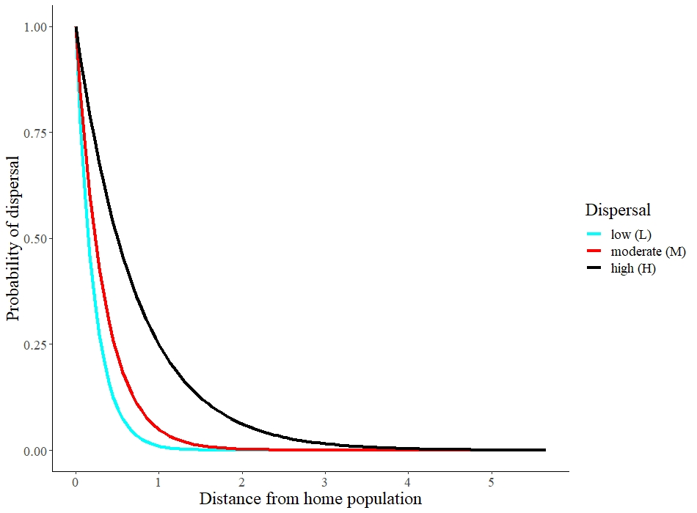

**Figure 1.** Probability of dispersal of an individual as a function of geographic distance, in three different dispersal scenarios.

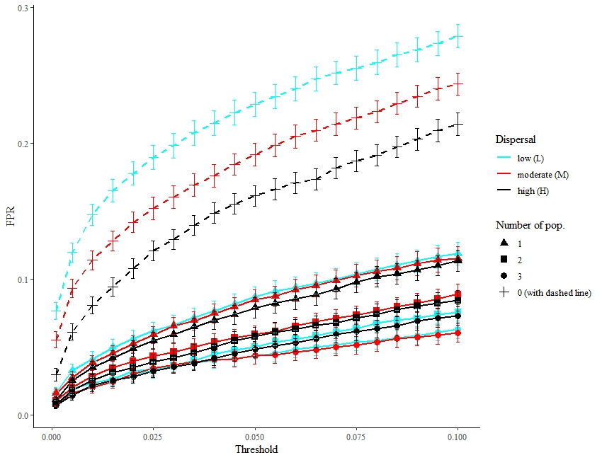

**Figure 2.** FPR across all threshold and scenarios. Control experiments are shown with dashed lines. Those values are for samplings done at the 100 and 101 generations 100 and 101, i.e. right before and after the migration event. 95% confidence intervals of the FPR estimates are displayed by bars.

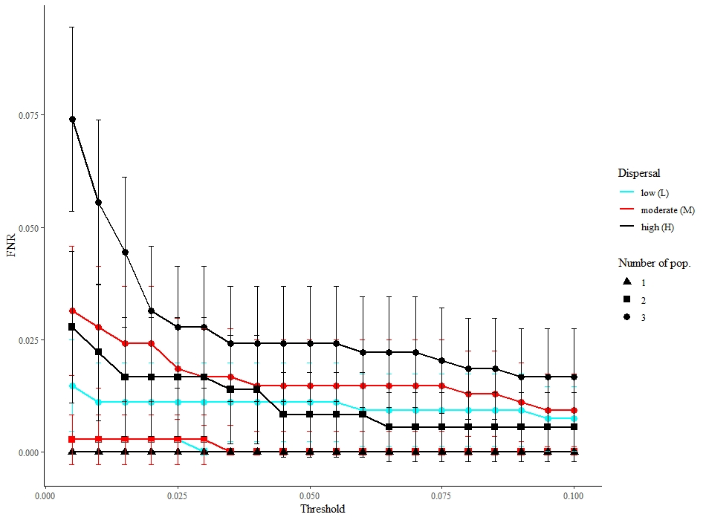

**Figure 3.** FNR across all threshold and scenarios. There are no control experiment results displayed for FNR because there are no possible true positives in control experiments, hence no false negatives either. Those values are for samplings done at generations 100 and 101, i.e. right before and after the migration event. 95% confidence intervals of the FNR estimates are displayed by bars. For better visualization, we included only thresholds with FNR values not equal to 1. Indeed, very low thresholds are so conservative that they lead to no population being selected including truly affected populations, hence a FNR of 1. Symbols overlap for some scenarios (those with only one affected population for example), which reach a null FNR.

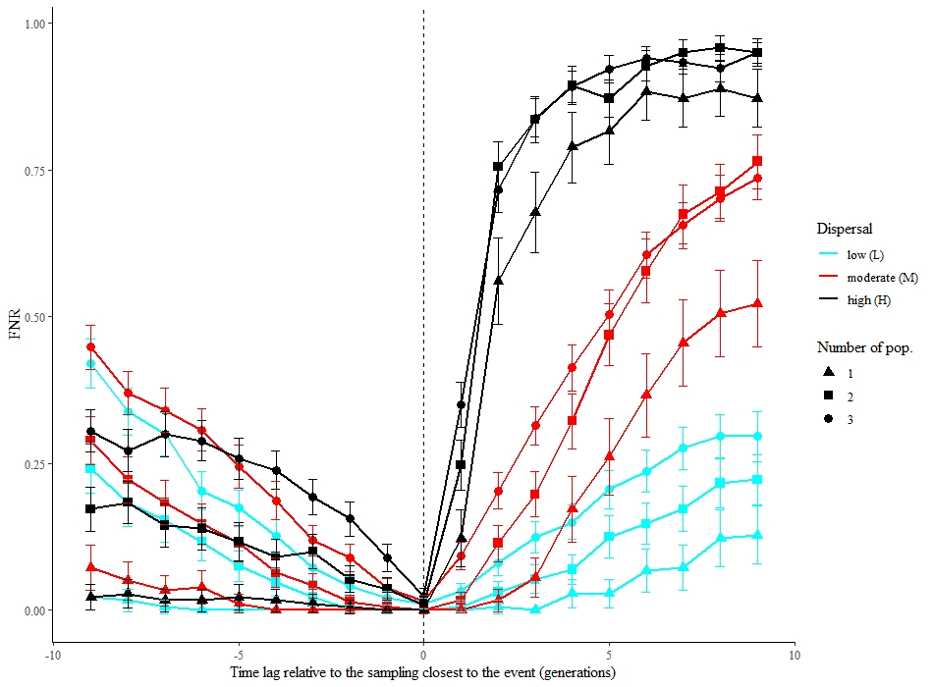

Influence of the timing of the posterior sampling

(0 represents sampling right after the event)

Influence of the timing of the prior sampling

(0 represents sampling right before the event)

**Figure 4**. FNR from TGI tests performed between samplings carried out up to 9 generations before or after the migration event (arrow) when compared with sampling done the generation after the event for prior samplings, or the generation before the event for posterior samplings. 95% confidence intervals are displayed by bars.

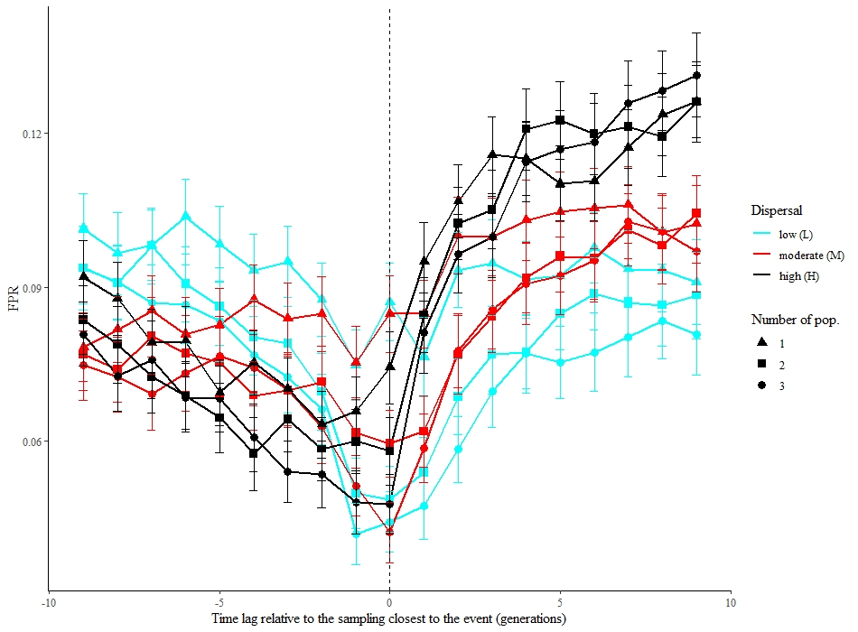

Influence of the timing of the posterior sampling

(0 represents sampling right after the event)

Influence of the timing of the prior sampling

(0 represents sampling right before the event)

**Figure 5.** FPR from TGI tests performed between sampling executed up to 9 generations before or after the event (arrow) when compared with sampling done the generation after the event for prior samplings, or the generation before the event for posterior samplings. 95% confidence intervals are displayed by bars.

**ANNEX A:** Rogers’ genetic distance

Given the number of loci, the number ofalleles observed in locus *k*, and and the proportions of allele *j* at locus *k* in populations 1 and 2, respectively,:

The sum of the allele proportions for any locus in any population is 1.

For biallelic markers such as SNP, the calculation becomes even simpler as seen in the example in Table 1, A. Indeed, because the proportion of an allele is always 1 minus the proportion of the other allele, the sum per locus is always twice the term for the a single allele and the equation simplifies to:

**ANNEX B:** TGI function and output

# mat1: the genotypic matrix associated with the first sampling; must be a genind object

# mat2: the genotypic matrix associated with the second sampling; must be a genind object

# nperm: the the number of permutations used in the evaluation of significance

# seed.: you may specify a seed by using this argument

# method : a number between 1 and 5. Five genetic distances are available in function dist.genpop # of the adegenet package.

# They are : (1) Nei’s D, (2) Edwards’ angular D, (3) Reynolds’ coancestry coefficient, (4)

# Rogers’ D, (5) Prevosti’s absolute genetic D. Methods 2, 3 and 4 produce Euclidean distances,

# whereas methods 1 and 5 produce non-Euclidean distances, which produce negative eigenvalues and # complex eigenvectors in principal coordinate analysis.

# correc: correction for multiple # inference; see ?p.adjust

# thresh_for_GL: indicate here the threshold you want to use

TGI <- function (mat1, mat2, nperm = 999, replace = FALSE, seed. = NULL, method = 4, correc = "holm", thresh_for_GL = 0.05) {

#### genind to genpop objects

mat1p <- genind2genpop(mat1)

mat1p <- mat1p[,order(colnames(mat1p@tab))]

mat2p <- genind2genpop(mat2)

mat2p <- mat2p[,order(colnames(mat2p@tab))]

##### Function to compute genetic distances

dissim <- function(mat1p, mat2p, method) {

dis <- vector(mode = "numeric", length = nrow(mat1p@tab))

for (i in 1:nrow(mat1p@tab)){

if (i == 1){

trick <- 2

} else {

trick <- 1

}

temp_genpop <- mat1p

temp_genpop@tab[trick,] <- mat2p@tab[i,]

dis[i] <- dist.genpop(temp_genpop[c(trick, i),], method = method)

}

list(dis = dis)

}

##### Initialization of seed, tolerance

if (!is.null(seed.)){

set.seed(seed.)

}

epsilon <- sqrt(.Machine$double.eps)

##### Dimensions check

n <- nrow(mat1p@tab)

p <- ncol(mat1p@tab)

if ((nrow(mat2p@tab) != n) | (ncol(mat2p@tab) != p)){

stop("The matrices are not of the same size!")

}

##### Empirical genetic distances

tmp <- dissim(mat1p, mat2p, method)

dis.ref <- tmp$dis

##### Permutations

if (nperm > 0) {

my.vec <- sample(1:(10 * nperm), size = nperm)

outlier.count = rep(1, n)

for (iperm in 1:nperm) {

set.seed(my.vec[iperm])

mat1.perm <- mat1p

mat1.perm <- shufflepop(mat1.perm, method=4)

set.seed(my.vec[iperm])

mat2.perm <- mat2p

mat2.perm <- shufflepop(mat2.perm, method=4)

tmp <- dissim(mat1.perm, mat2.perm, method)

dis.perm <- tmp$dis

ge <- which(dis.perm + epsilon >= dis.ref)

if (length(ge) > 0) {

outlier.count[ge] <- outlier.count[ge] + 1

}

}

p.dist <- outlier.count/(nperm + 1)

}

p.adj <- p.adjust(p.dist, method = correc)

##### Gain or loss?

n.pop1 <- seppop(mat1)

n.pop2 <- seppop(mat2)

mean.hexp1 <- do.call("c", lapply(n.pop1, function(x) mean(summary(x)$Hexp)))

mean.hexp2 <- do.call("c", lapply(n.pop2, function(x) mean(summary(x)$Hexp)))

mean.hexp1[is.nan(mean.hexp1)] <- NA

mean.hexp2[is.nan(mean.hexp2)] <- NA

simple_diff <- mean.hexp2 - mean.hexp1

output <- list(TBI = dis.ref, p.TBI = p.dist, p.adj = p.adj, gainloss = simple_diff[p.adj < thresh_for_GL])

class(output) <- "TGI"

return(output)

}

#############################################################################

**> goby_test <- TGI(goby_first, goby_second, nperm = 9999, method = 4)**

**> goby_test**

$TBI #index values

[1] 0.06432131 0.06089485 **0.15212258** 0.02258920 0.07247326 0.04463856 0.06672004 0.02238467

$p.TBI #unadjusted permutation p-values

[1] 0.4283 0.4891 **0.0004** 0.9943 0.3188 0.7756 0.3947 0.9949

$p.adj #adjusted p-values

[1] 1.0000 1.0000 **0.0032** 1.0000 1.0000 1.0000 1.0000 1.0000

$gainloss #difference in expected heterozygosity

**ELK**

**-0.04567755**

attr(,"class")

[1] "TGI"

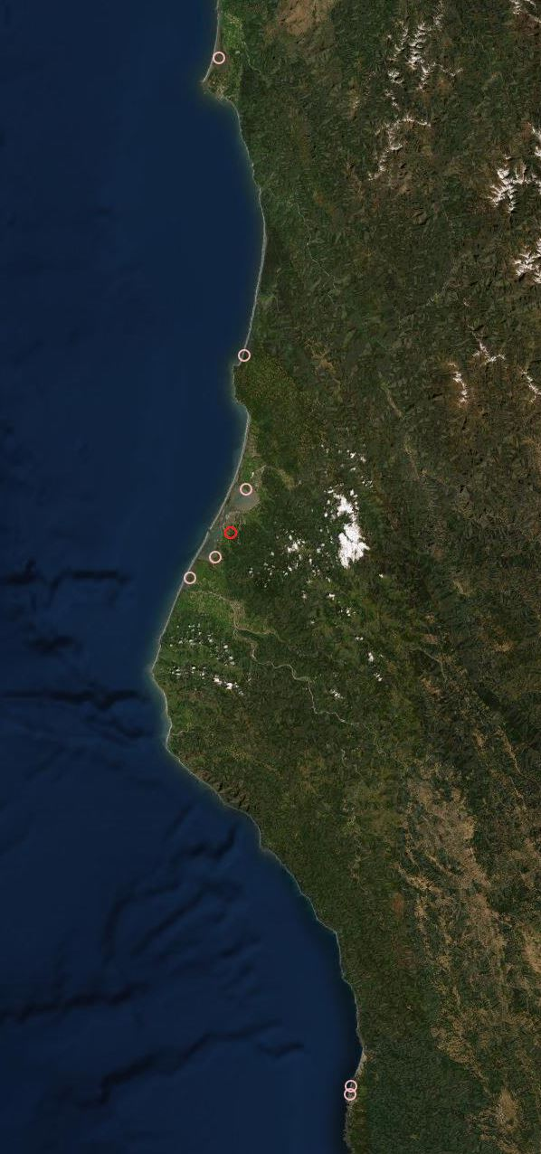

20km

N

20km

N

**Supp. Fig. 1** Satellite map of the sampling stations used in the goby analysis. The red circle marks the Elk population which was the only one found to have significantly changed.